**CHAPTER 2**

**PROJECT SYSTEM / SYSTEM DEVELOPMENT**

**2.1 DESIGN / LAYOUT**

**2.1.1 Flowchart**

**2.1.1.1 Login**

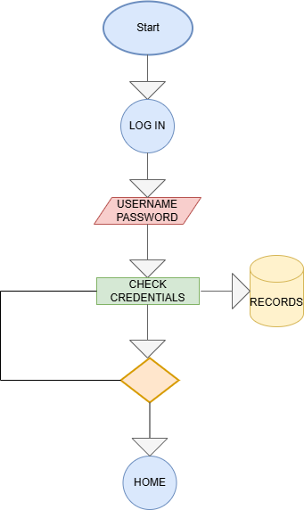

**Figure 2.1: Login Flow Chart**

**2.1.1.2 Dashboard**

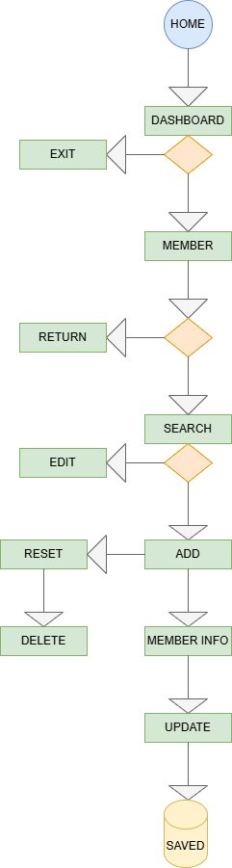

**Figure 2.2: Member’s Tab Flow Chart**

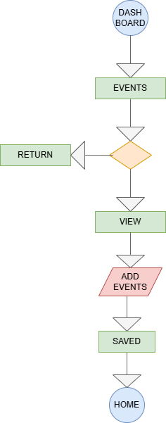

**Figure 2.3: Event’s Tab Flow Chart**

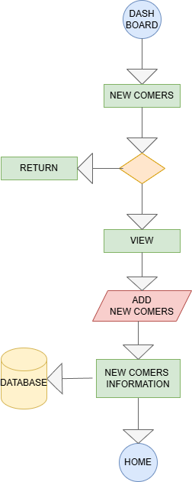

**Figure 2.4: New Comer’s Tab Flow Chart**

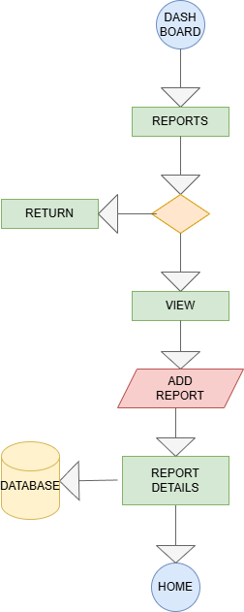

**Figure 2.5: Report’s Tab Flow Chart**