Visibility of two photon interference of QDs in photonic crystal structures
Refs. | Cavity | Q factor | Purcell factor | QD | Visibility of two photon interference | HOM measurement? | Remarks
Wakes Optica, 3, 2334 (2016)  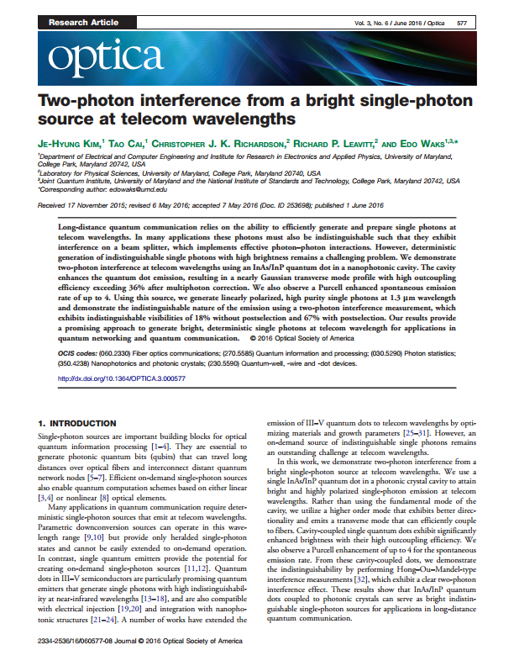 | L3 | M3: 380  (M1: 7000) | Measured: 4  (Calculated: 44) | InAs/InP QDs.  line width: 50 ueV.  Lfietime: 650 ps  T2: 150 ps from the fitting. | 0.18 without postselection,  0.67 with temporal postselection and 0.97 after deconvolution | Yes | Telecom wavelengths.  Outcoupling efficiency > 36%.

