Monte-Carlo Discounted Cash Flow Model and Buffett Analysis

# TICKER: MMM

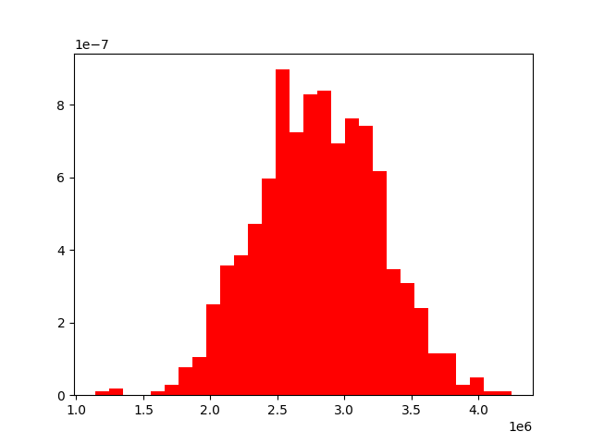

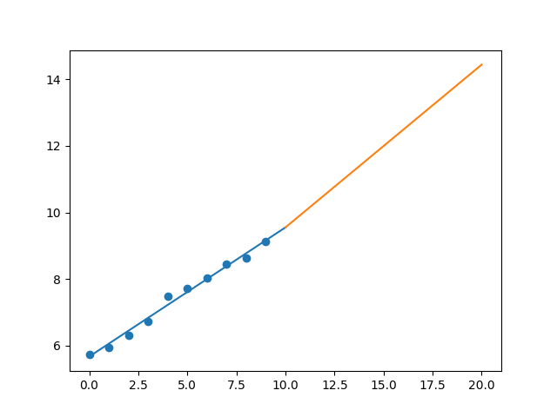

R-Value ROE: 0.89

R-Value EPS: 0.994

CAGR EPS: 0.047

PE Min: 16.017

PE Max: 26.298

Projected AGR Min: 3.368

Projected AGR Max: 8.623

# TICKER: AOS

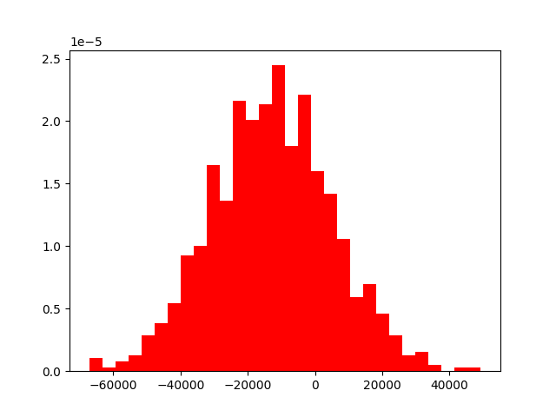

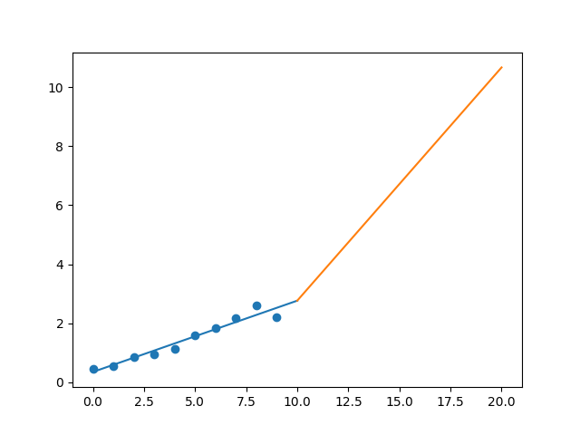

R-Value ROE: 0.412

R-Value EPS: 0.972

CAGR EPS: 0.17

PE Min: 16.545

PE Max: 29.194

Projected AGR Min: 12.471

Projected AGR Max: 19.043

# TICKER: ABBV

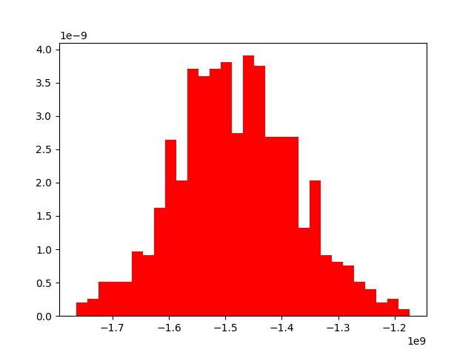

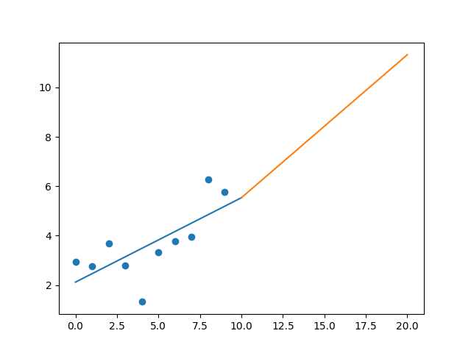

R-Value ROE: 0.407

R-Value EPS: 0.711

CAGR EPS: 0.07

PE Min: 13.856

PE Max: 33.903

Projected AGR Min: 4.961

Projected AGR Max: 14.786

# TICKER: ABMD

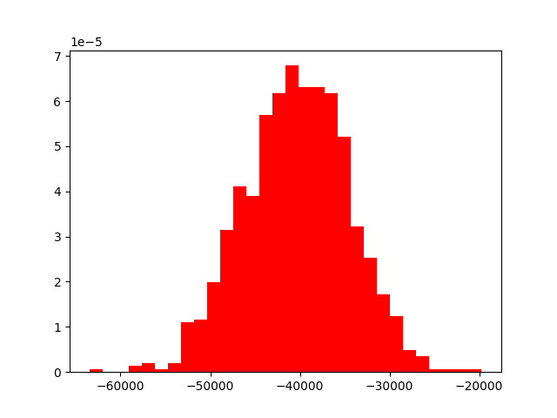

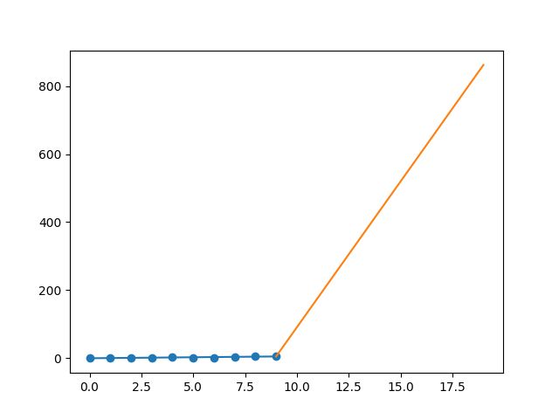

R-Value ROE: 0.628

R-Value EPS: 0.867

CAGR EPS: 0.691

PE Min: 31.861

PE Max: 133.497

Projected AGR Min: 58.825

Projected AGR Max: 83.29

# TICKER: ACN

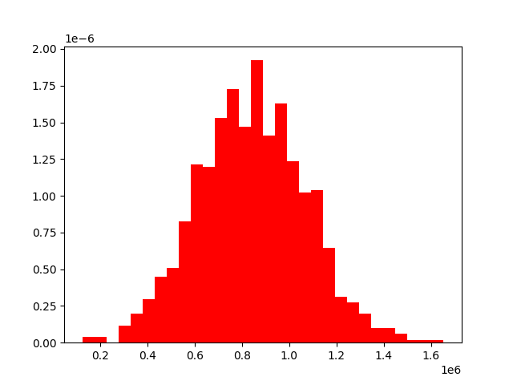

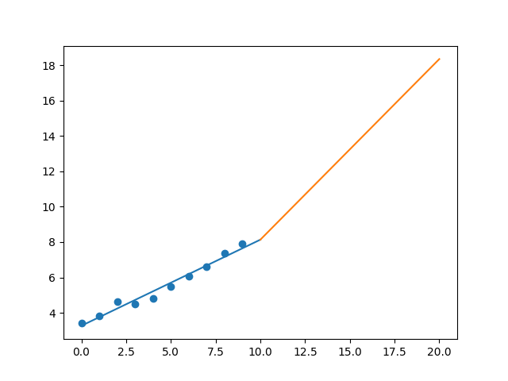

R-Value ROE: 0.922

R-Value EPS: 0.986

CAGR EPS: 0.088

PE Min: 17.436

PE Max: 30.26

Projected AGR Min: 2.97

Projected AGR Max: 8.806

# TICKER: ATVI

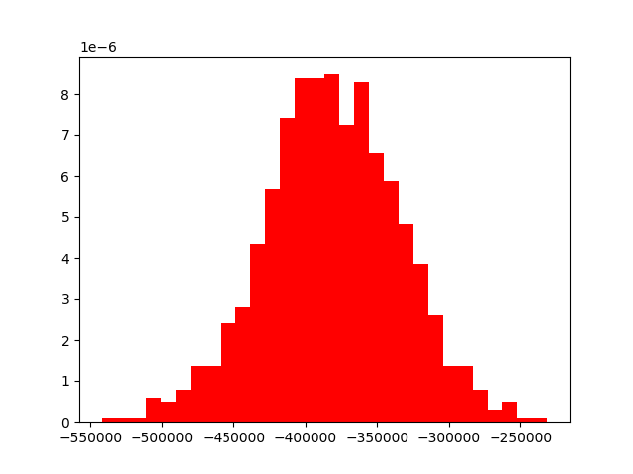

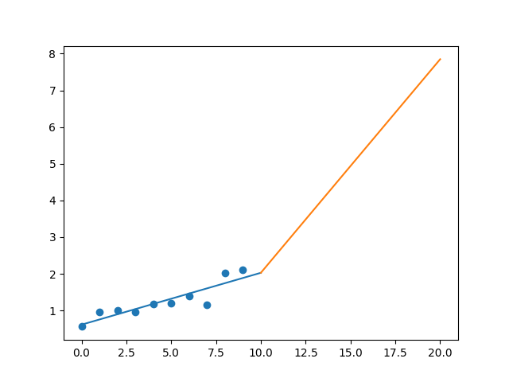

R-Value ROE: 0.26

R-Value EPS: 0.895

CAGR EPS: 0.141

PE Min: 23.792

PE Max: 53.181

Projected AGR Min: 9.824

Projected AGR Max: 19.023

# TICKER: ADBE

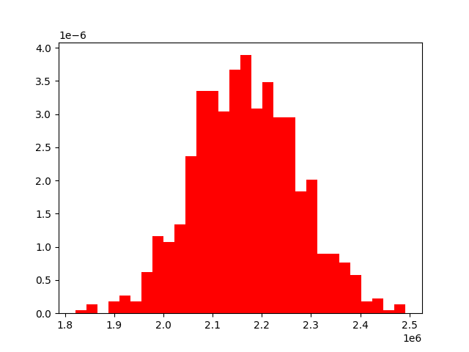

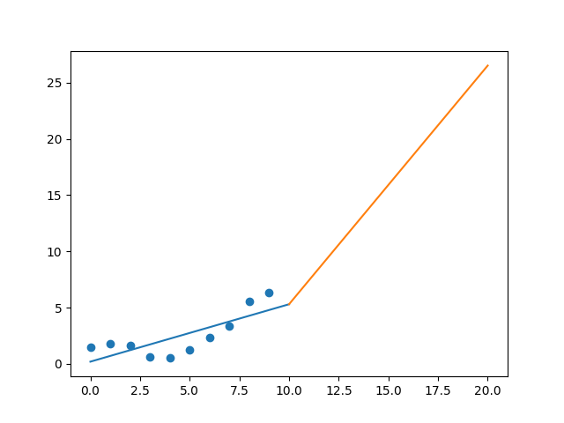

R-Value ROE: 0.561

R-Value EPS: 0.772

CAGR EPS: 0.154

PE Min: 42.978

PE Max: 74.156

Projected AGR Min: 9.596

Projected AGR Max: 15.74

# TICKER: AAP

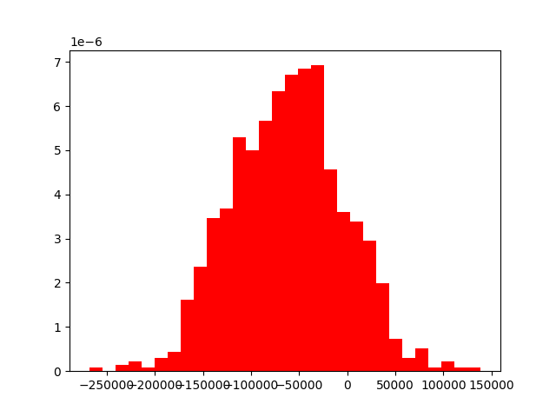

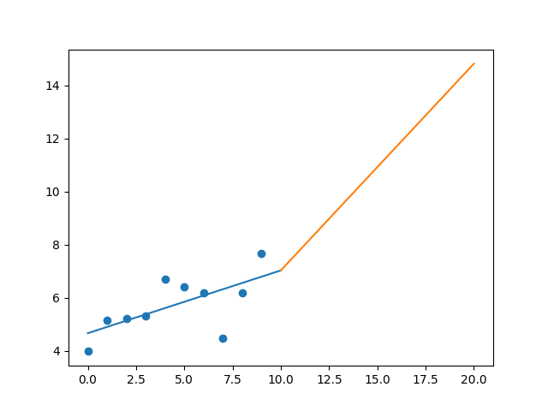

R-Value ROE: 0.902

R-Value EPS: 0.648

CAGR EPS: 0.068

PE Min: 19.774

PE Max: 35.854

Projected AGR Min: 6.621

Projected AGR Max: 13.158

# TICKER: A

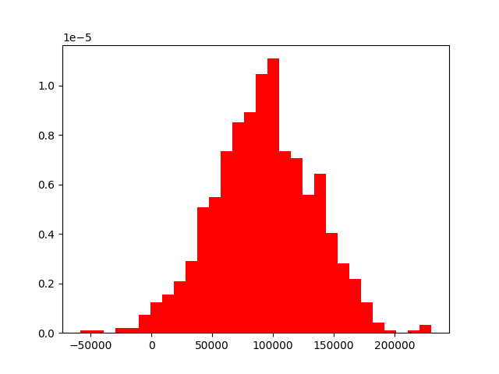

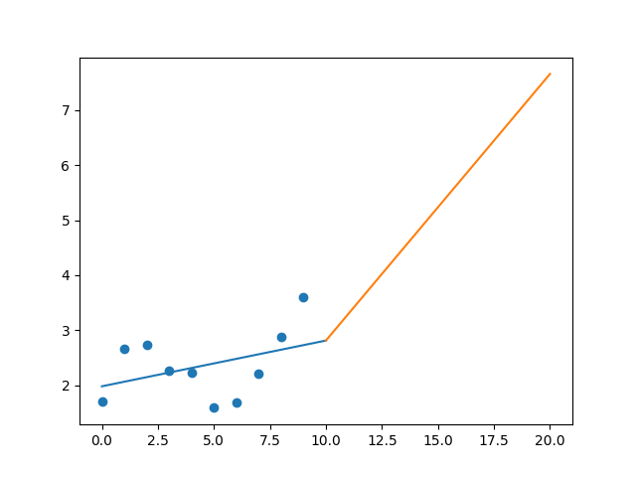

R-Value ROE: 0.441

R-Value EPS: 0.399

CAGR EPS: 0.078

PE Min: 20.407

PE Max: 43.535

Projected AGR Min: 3.31

Projected AGR Max: 11.442

# TICKER: AKAM

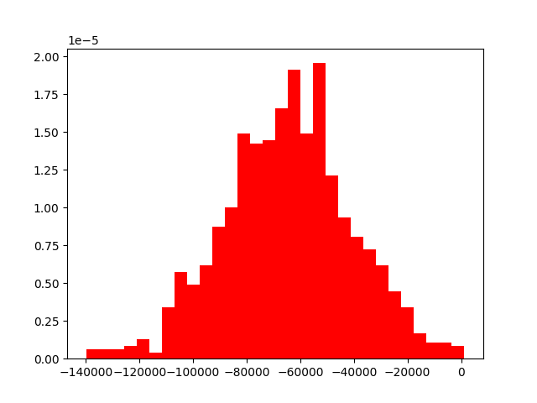

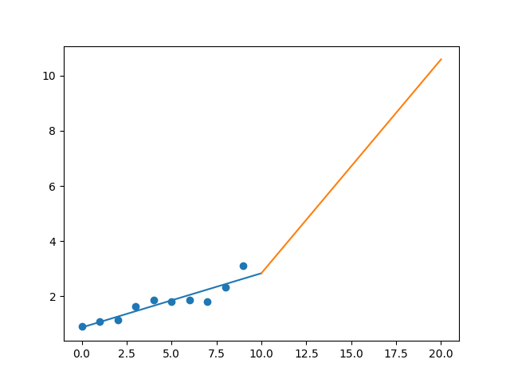

R-Value ROE: 0.318

R-Value EPS: 0.924

CAGR EPS: 0.131

PE Min: 29.153

PE Max: 58.663

Projected AGR Min: 12.319

Projected AGR Max: 20.454

# TICKER: ALK

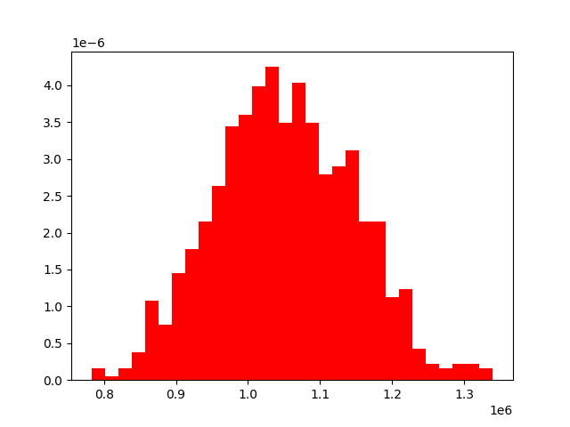

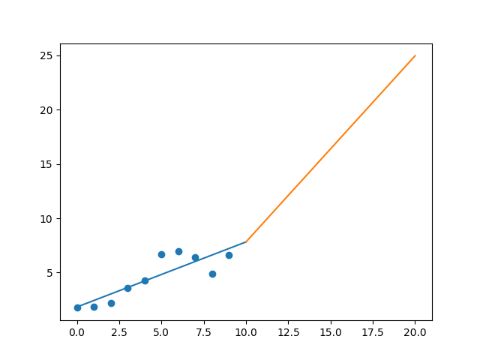

R-Value ROE: 0.194

R-Value EPS: 0.858

CAGR EPS: 0.142

PE Min: 6.68

PE Max: 86.599

Projected AGR Min: 13.678

Projected AGR Max: 46.876

# TICKER: ARE

Something wrong happened

# TICKER: ALXN

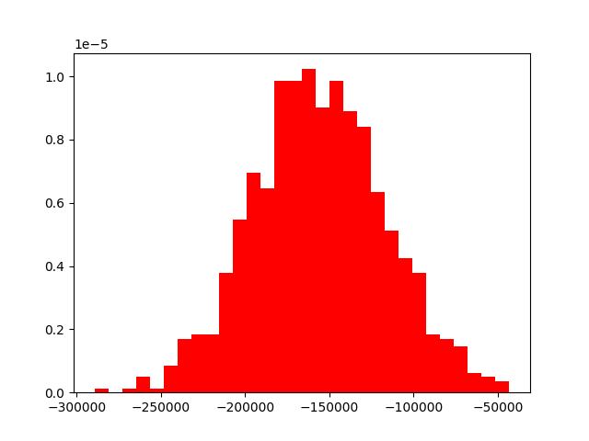

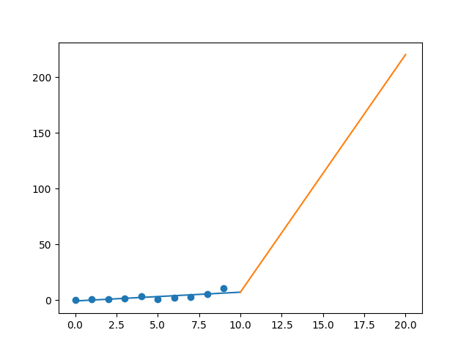

R-Value ROE: 0.222

R-Value EPS: 0.766

CAGR EPS: 0.353

PE Min: 8.461

PE Max: 1267.873

Projected AGR Min: 31.033

Projected AGR Max: 116.245

# TICKER: ALLE

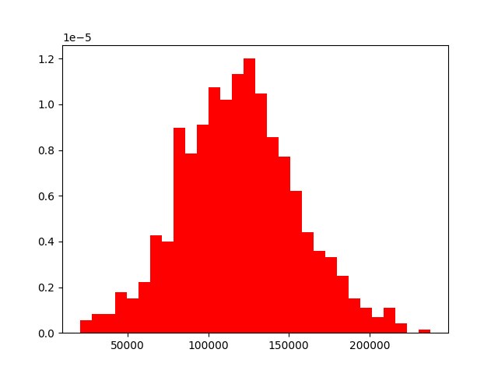

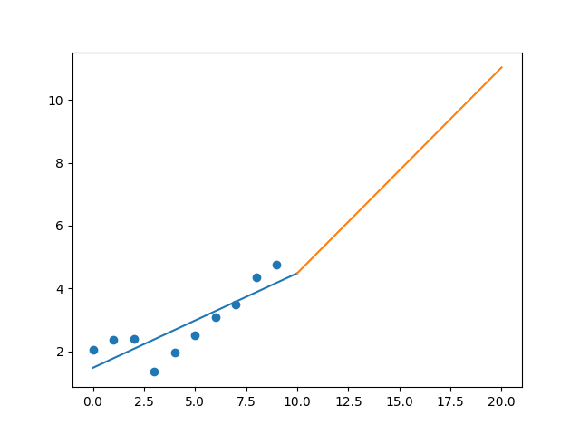

R-Value ROE: 0.157

R-Value EPS: 0.839

CAGR EPS: 0.088

PE Min: 18.458

PE Max: 41.438

Projected AGR Min: 5.911

Projected AGR Max: 14.832

# TICKER: LNT

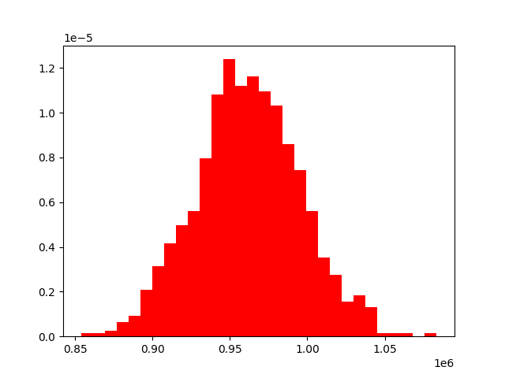

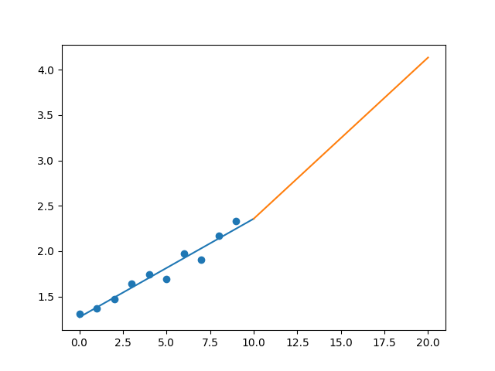

R-Value ROE: 0.382

R-Value EPS: 0.977

CAGR EPS: 0.059

PE Min: 18.142

PE Max: 25.131

Projected AGR Min: 2.842

Projected AGR Max: 6.249

# TICKER: ALL

Something wrong happened

# TICKER: GOOGL

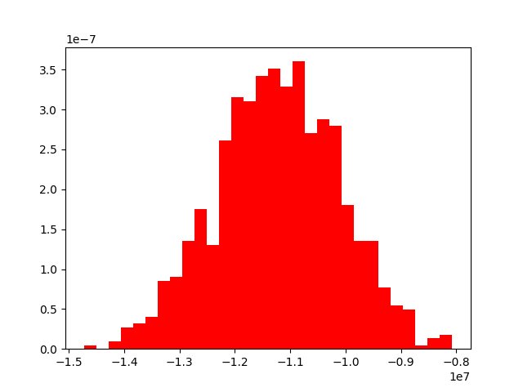

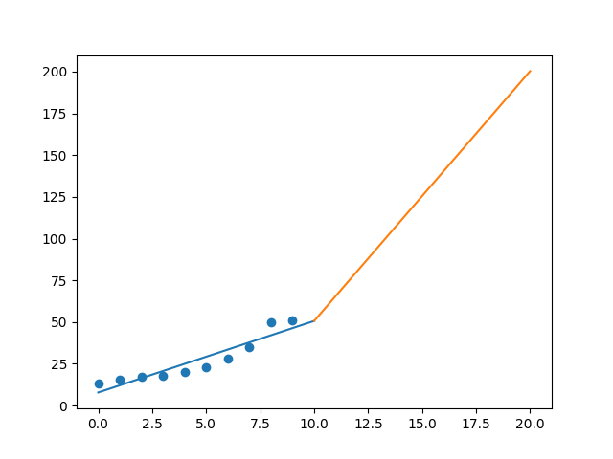

R-Value ROE: 0.277

R-Value EPS: 0.93

CAGR EPS: 0.146

PE Min: 21.859

PE Max: 34.085

Projected AGR Min: 9.577

Projected AGR Max: 14.555

# TICKER: AMZN

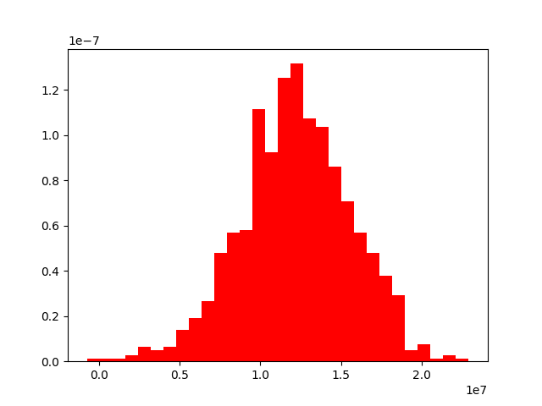

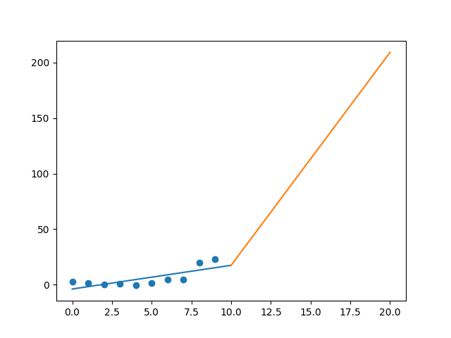

R-Value ROE: 0.465

R-Value EPS: 0.76

CAGR EPS: 0.247

PE Min: 75.276

PE Max: 545.011

Projected AGR Min: 17.85

Projected AGR Max: 43.649

# TICKER: AMCR

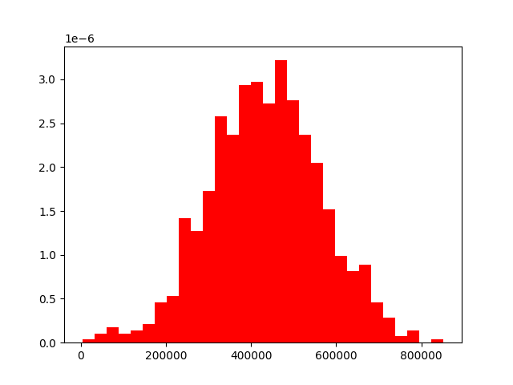

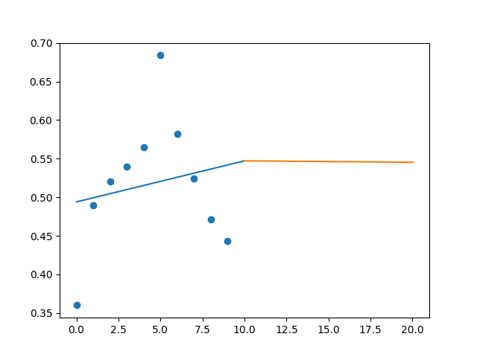

R-Value ROE: 0.315

R-Value EPS: 0.185

CAGR EPS: 0.021

PE Min: 24.073

PE Max: 33.795

Projected AGR Min: 1.037

Projected AGR Max: 4.524

# TICKER: AEE

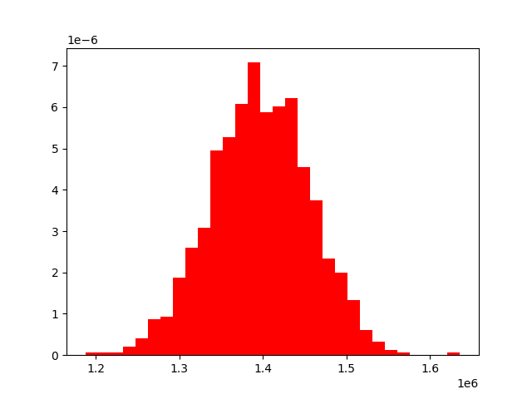

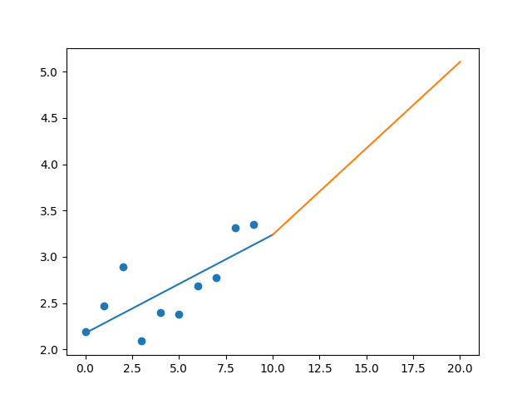

R-Value ROE: 0.558

R-Value EPS: 0.74

CAGR EPS: 0.043

PE Min: 18.172

PE Max: 24.664

Projected AGR Min: 1.122

Projected AGR Max: 4.258

# TICKER: AAL

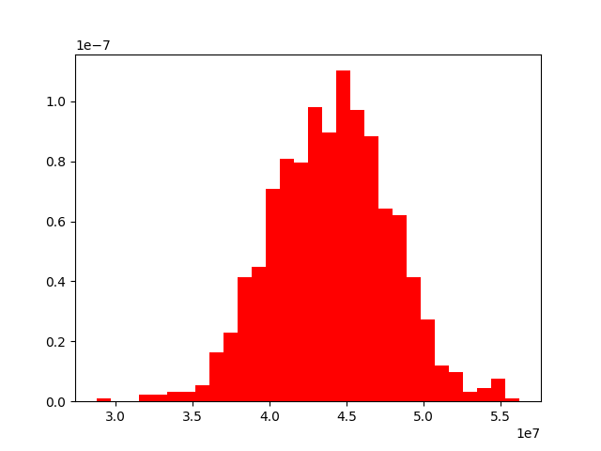

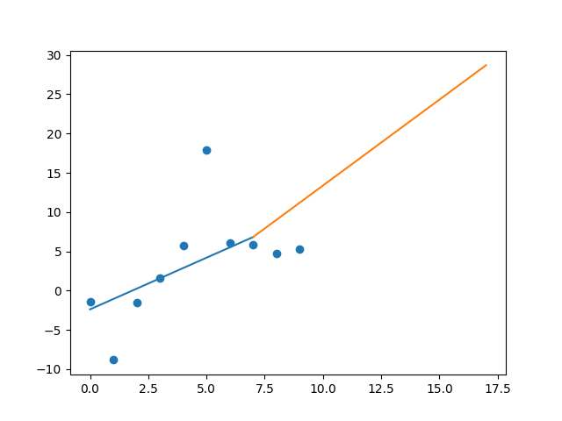

R-Value ROE: 0.704

R-Value EPS: 0.574

CAGR EPS: 0.185

PE Min: 2.721

PE Max: 14.549

Projected AGR Min: 19.82

Projected AGR Max: 41.69

# TICKER: AEP

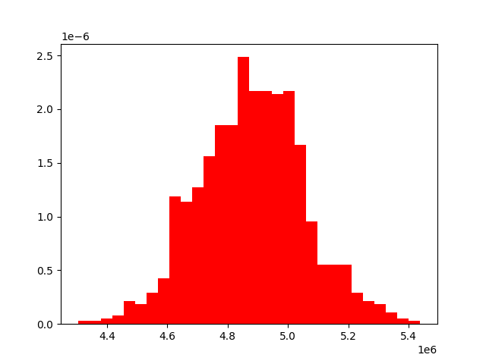

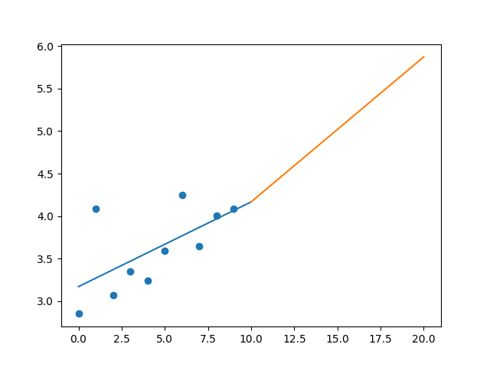

R-Value ROE: 0.136

R-Value EPS: 0.626

CAGR EPS: 0.037

PE Min: 16.208

PE Max: 71.093

Projected AGR Min: 0.504

Projected AGR Max: 16.518

# TICKER: AXP

Something wrong happened

# TICKER: AMT

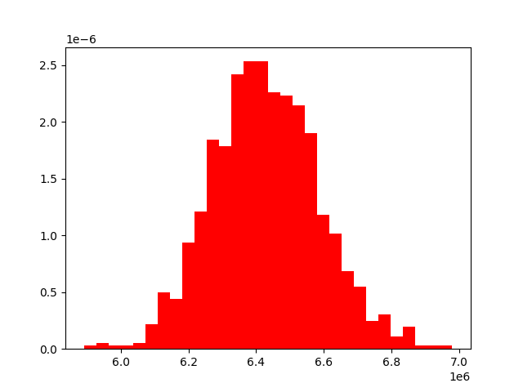

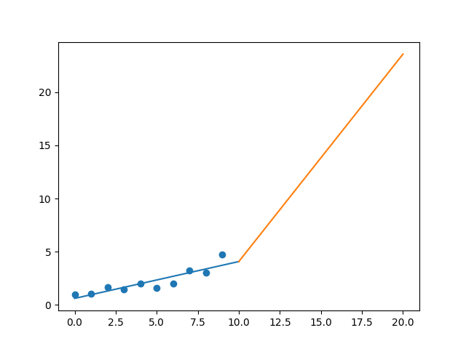

R-Value ROE: 0.715

R-Value EPS: 0.89

CAGR EPS: 0.174

PE Min: 50.944

PE Max: 70.358

Projected AGR Min: 17.709

Projected AGR Max: 21.572

# TICKER: AWK

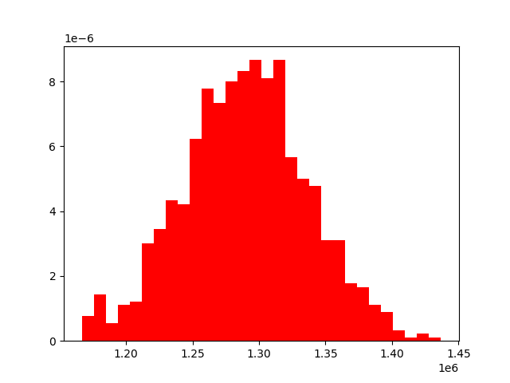

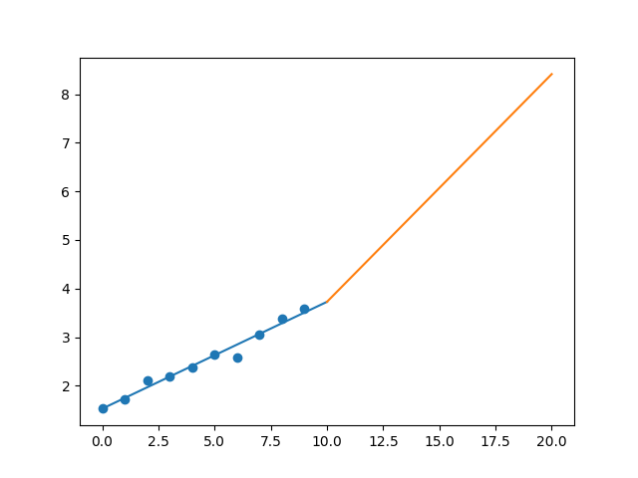

R-Value ROE: 0.856

R-Value EPS: 0.987

CAGR EPS: 0.089

PE Min: 22.6

PE Max: 39.597

Projected AGR Min: 1.567

Projected AGR Max: 7.426

# TICKER: AMP

Something wrong happened

# TICKER: ABC

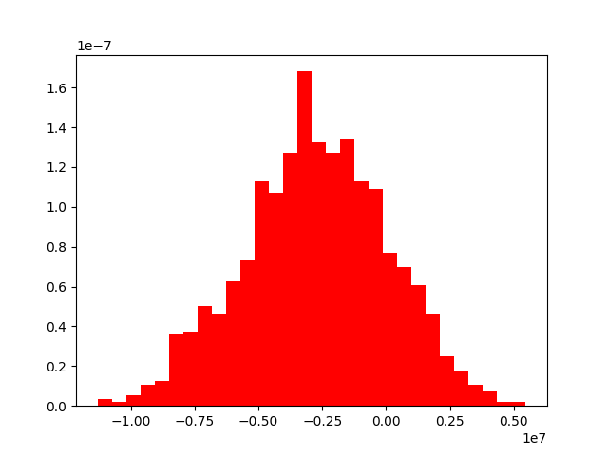

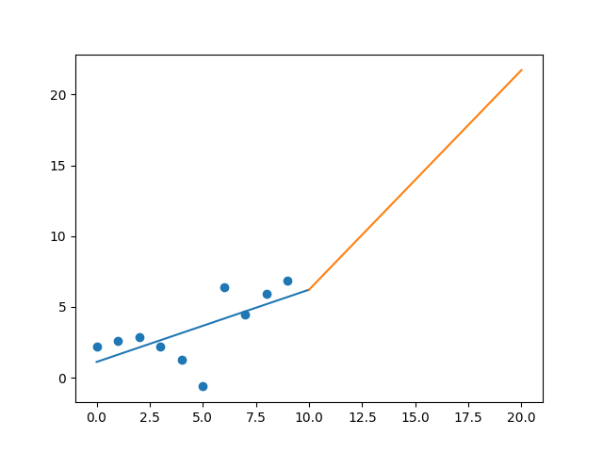

R-Value ROE: 0.263

R-Value EPS: 0.636

CAGR EPS: 0.122

PE Min: 10.739

PE Max: 72.759

Projected AGR Min: 7.98

Projected AGR Max: 30.747

# TICKER: AME

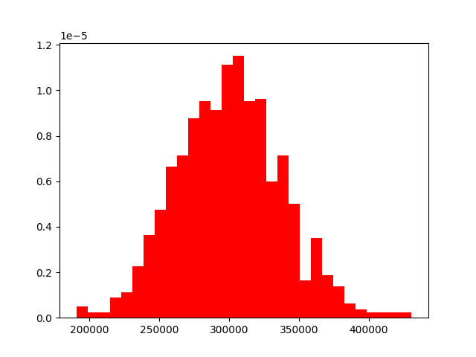

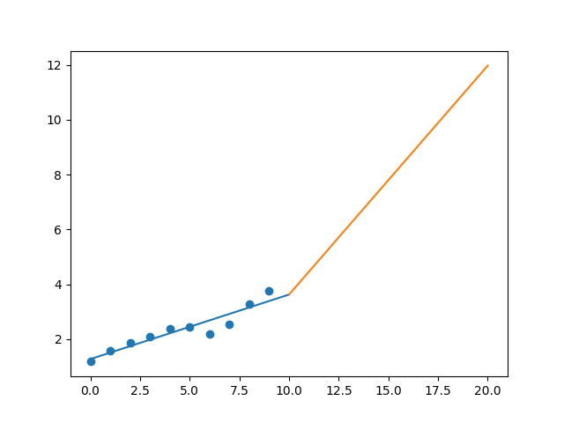

R-Value ROE: 0.056

R-Value EPS: 0.939

CAGR EPS: 0.123

PE Min: 17.666

PE Max: 28.486

Projected AGR Min: 6.183

Projected AGR Max: 11.379

# TICKER: AMGN

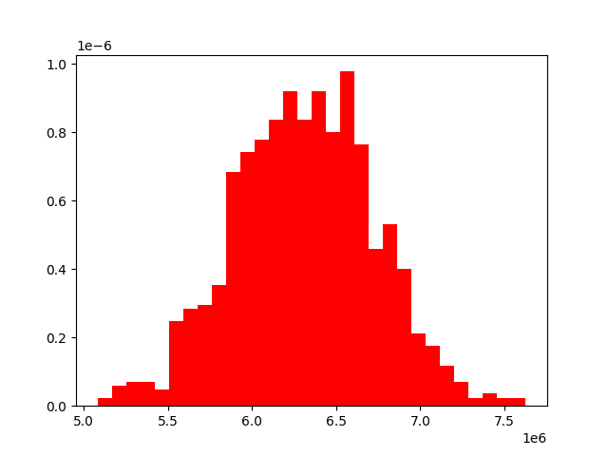

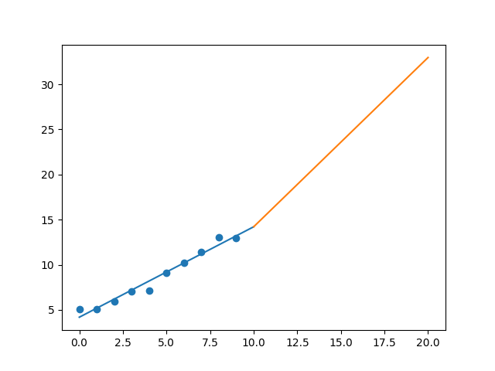

R-Value ROE: 0.649

R-Value EPS: 0.984

CAGR EPS: 0.098

PE Min: 14.251

PE Max: 20.494

Projected AGR Min: 6.877

Projected AGR Max: 10.832

# TICKER: APH

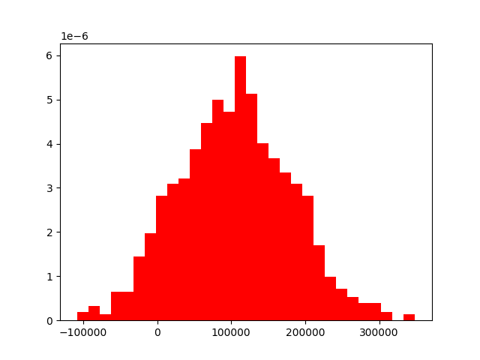

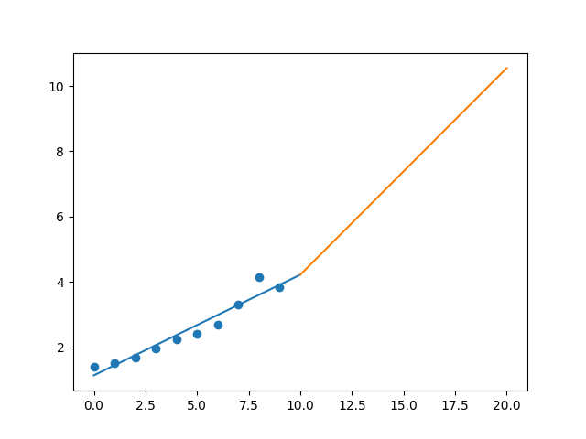

R-Value ROE: 0.225

R-Value EPS: 0.966

CAGR EPS: 0.106

PE Min: 19.583

PE Max: 28.857

Projected AGR Min: 5.333

Projected AGR Max: 9.497

# TICKER: ANSS

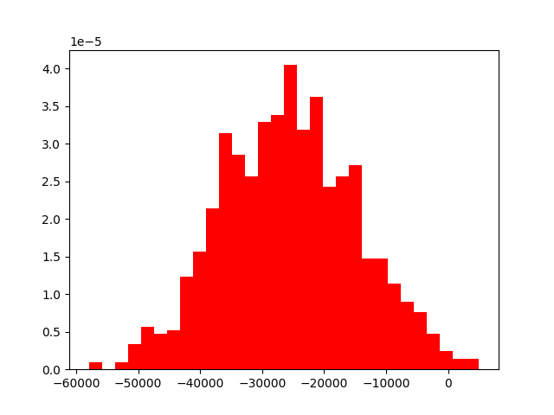

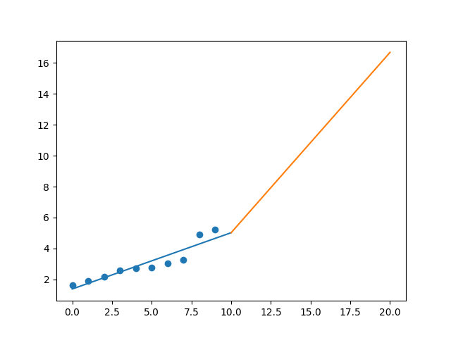

R-Value ROE: 0.799

R-Value EPS: 0.928

CAGR EPS: 0.123

PE Min: 29.196

PE Max: 74.175

Projected AGR Min: 4.232

Projected AGR Max: 14.418

# TICKER: ANTM

Something wrong happened

# TICKER: AON

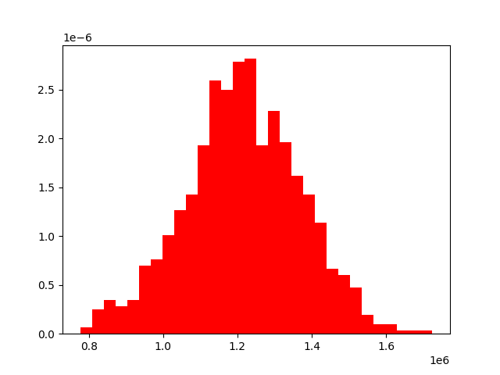

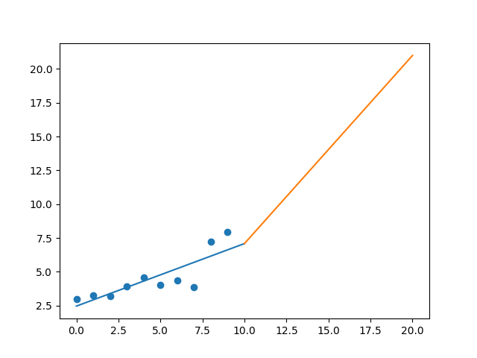

R-Value ROE: 0.929

R-Value EPS: 0.827

CAGR EPS: 0.102

PE Min: 18.79

PE Max: 50.692

Projected AGR Min: 7.296

Projected AGR Max: 18.49

# TICKER: AIV

Something wrong happened

# TICKER: AMAT

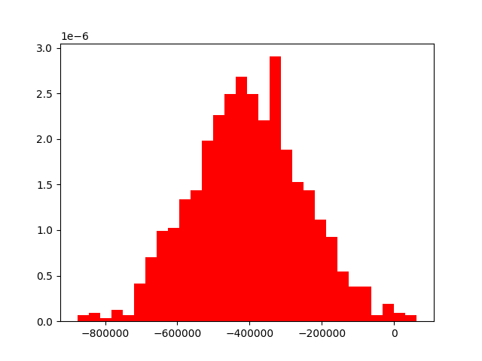

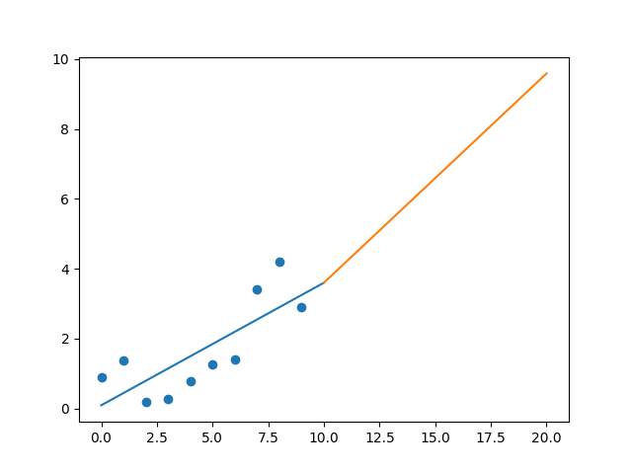

R-Value ROE: 0.764

R-Value EPS: 0.777

CAGR EPS: 0.127

PE Min: 8.025

PE Max: 20.568

Projected AGR Min: 0.806

Projected AGR Max: 10.755