Monte-Carlo Discounted Cash Flow Model and Buffett Analysis

# TICKER: ANET

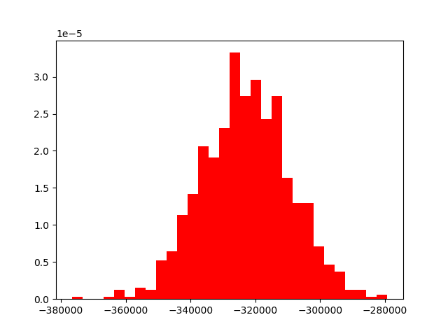

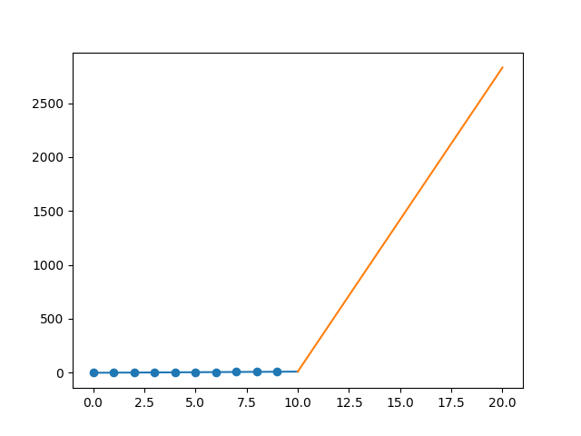

R-Value ROE: 0.417

R-Value EPS: 0.897

CAGR EPS: 0.748

PE Min: 19.126

PE Max: 74.058

Projected AGR Min: 70.541

Projected AGR Max: 95.264

# TICKER: AJG

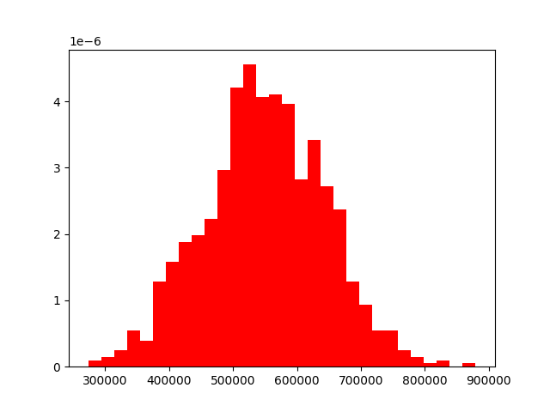

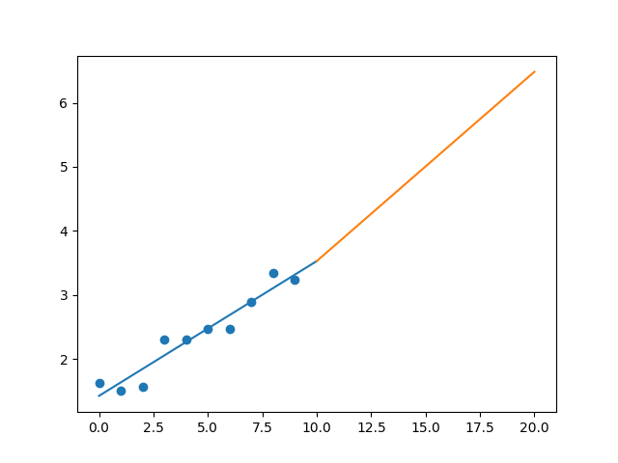

R-Value ROE: 0.138

R-Value EPS: 0.961

CAGR EPS: 0.072

PE Min: 17.51

PE Max: 27.601

Projected AGR Min: 0.09

Projected AGR Max: 4.75

# TICKER: ATO

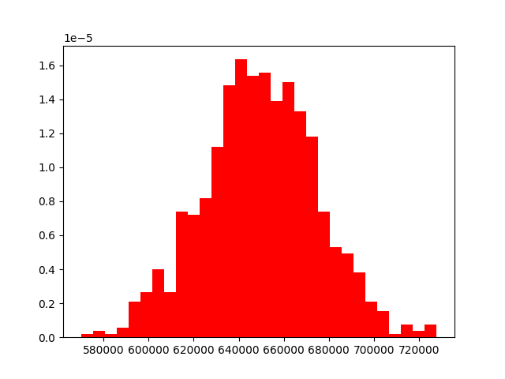

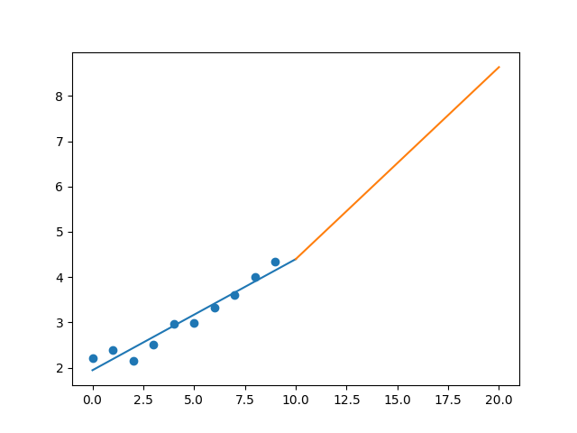

R-Value ROE: 0.455

R-Value EPS: 0.97

CAGR EPS: 0.071

PE Min: 15.512

PE Max: 26.288

Projected AGR Min: 2.91

Projected AGR Max: 8.483

# TICKER: ADP

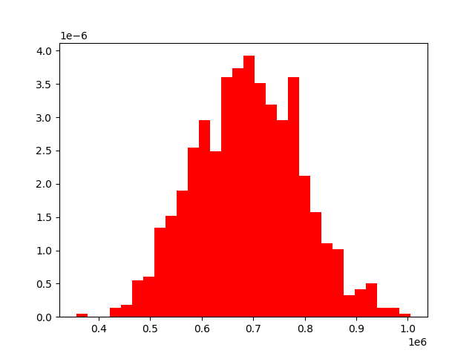

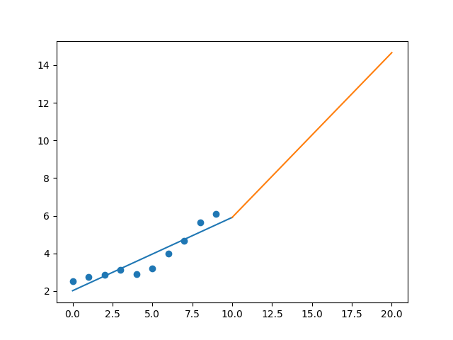

R-Value ROE: 0.932

R-Value EPS: 0.923

CAGR EPS: 0.092

PE Min: 22.528

PE Max: 36.566

Projected AGR Min: 6.667

Projected AGR Max: 11.961

# TICKER: AZO

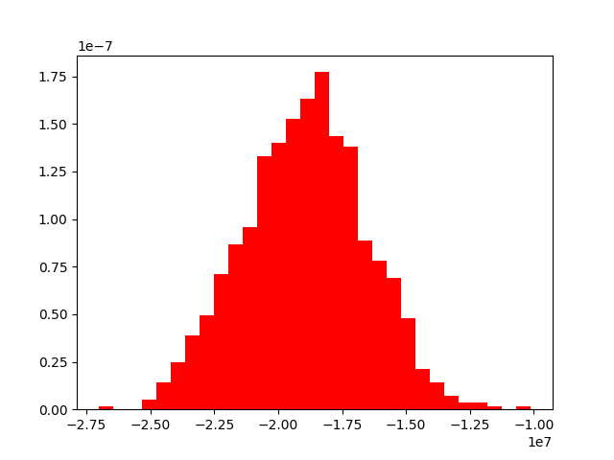

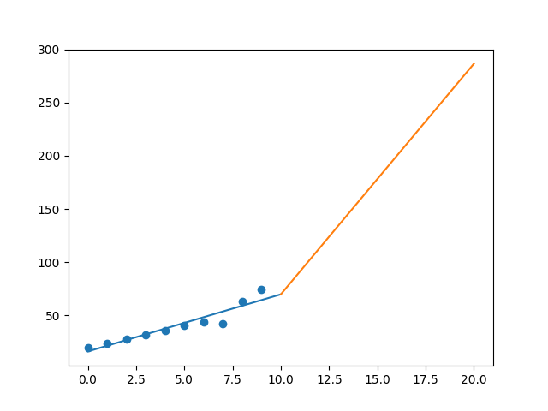

R-Value ROE: 0.724

R-Value EPS: 0.942

CAGR EPS: 0.144

PE Min: 11.951

PE Max: 21.062

Projected AGR Min: 11.293

Projected AGR Max: 17.782

# TICKER: AVB

Something wrong happened

# TICKER: AVY

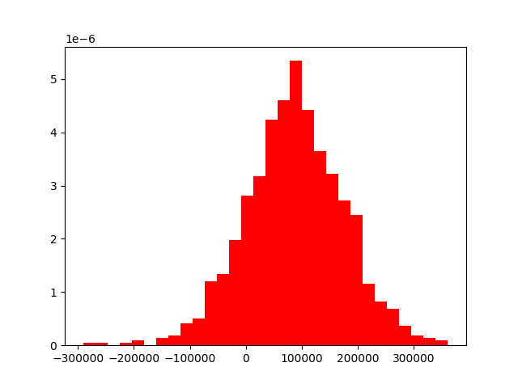

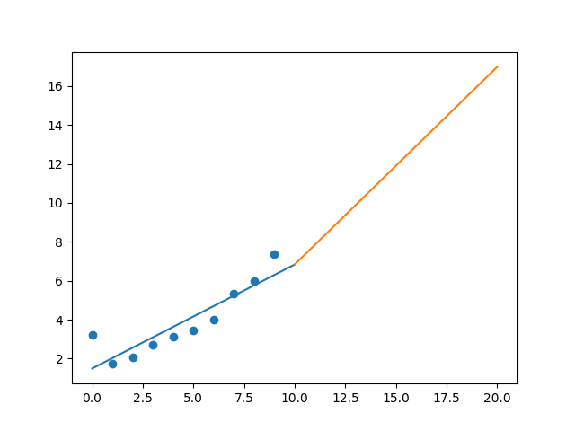

R-Value ROE: 0.731

R-Value EPS: 0.894

CAGR EPS: 0.087

PE Min: 14.528

PE Max: 51.601

Projected AGR Min: 5.171

Projected AGR Max: 19.382

# TICKER: BKR

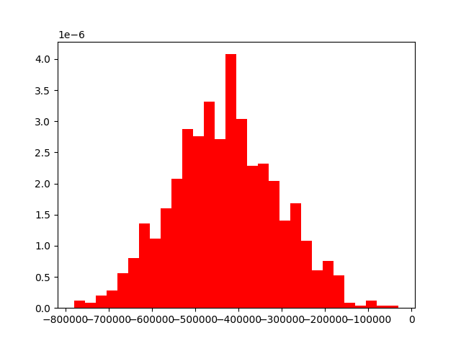

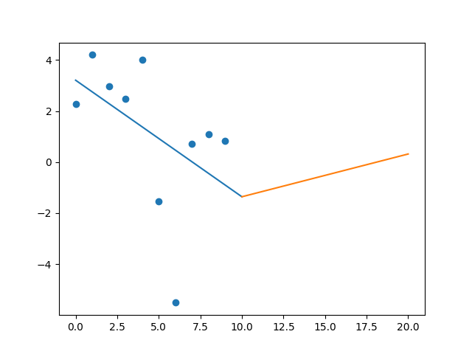

R-Value ROE: 0.476

R-Value EPS: 0.477

CAGR EPS: -0.094

PE Min: 105.911

PE Max: 279.605

Projected AGR Min: 6.747

Projected AGR Max: 17.629

# TICKER: BAC

Something wrong happened

# TICKER: BDX

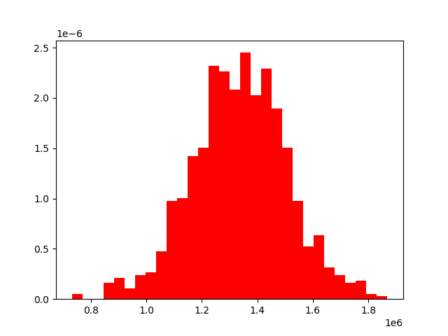

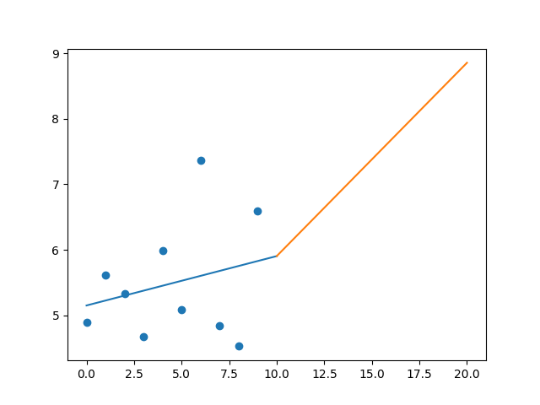

R-Value ROE: 0.905

R-Value EPS: 0.249

CAGR EPS: 0.03

PE Min: 27.507

PE Max: 292.297

Projected AGR Min: 0.136

Projected AGR Max: 26.832

# TICKER: BIO

Something wrong happened

# TICKER: BIIB

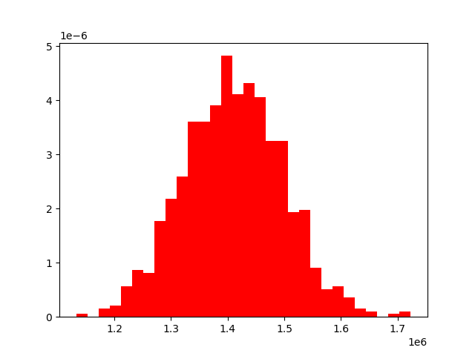

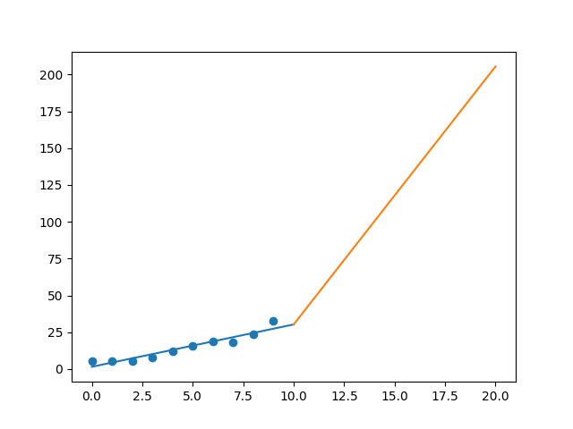

R-Value ROE: 0.758

R-Value EPS: 0.956

CAGR EPS: 0.202

PE Min: 7.837

PE Max: 19.199

Projected AGR Min: 20.906

Projected AGR Max: 32.239

# TICKER: BLK

Something wrong happened

# TICKER: BA

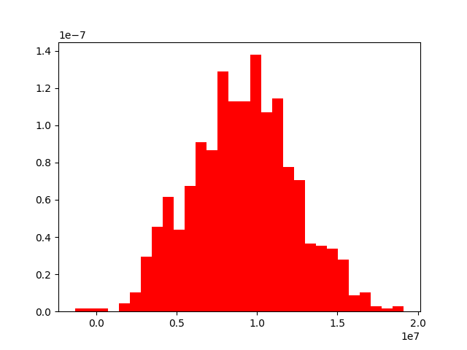

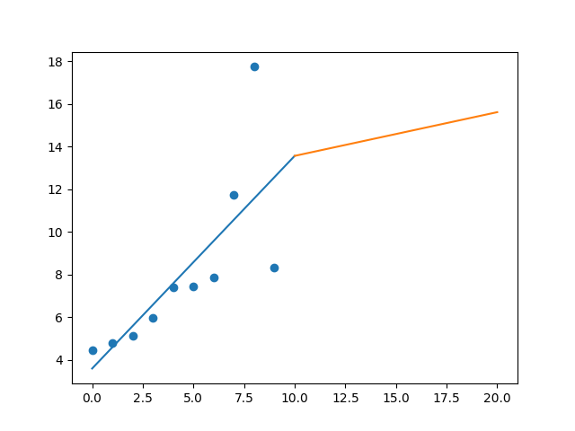

R-Value ROE: 0.463

R-Value EPS: 0.752

CAGR EPS: 0.065

PE Min: 16.729

PE Max: 58.37

Projected AGR Min: 3.149

Projected AGR Max: 16.879

# TICKER: BKNG

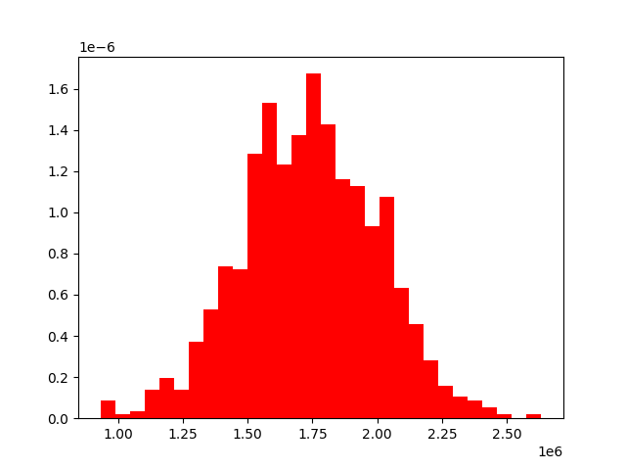

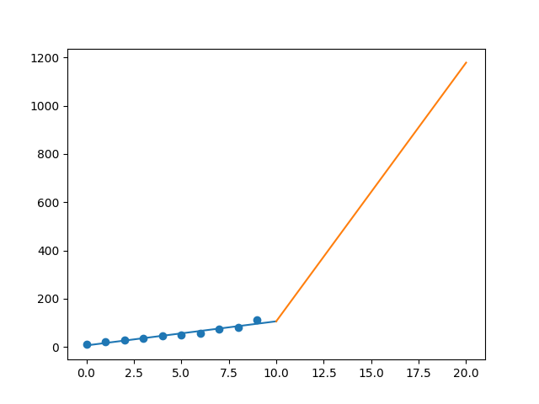

R-Value ROE: 0.422

R-Value EPS: 0.977

CAGR EPS: 0.266

PE Min: 17.119

PE Max: 40.194

Projected AGR Min: 25.94

Projected AGR Max: 37.161

# TICKER: BWA

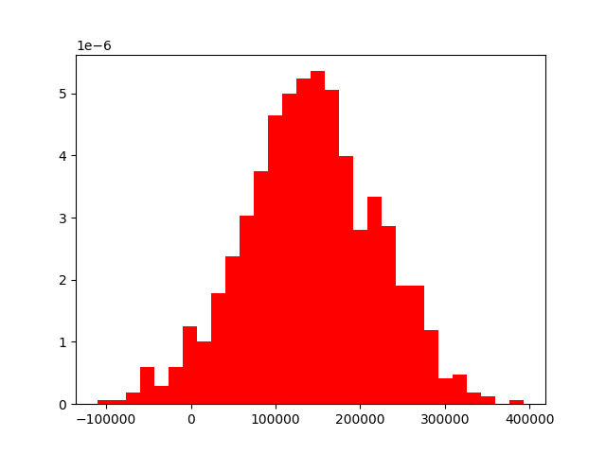

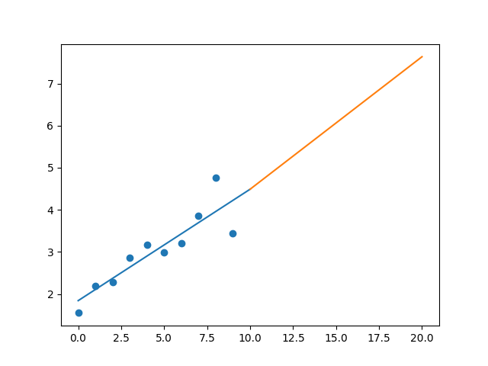

R-Value ROE: 0.206

R-Value EPS: 0.885

CAGR EPS: 0.083

PE Min: 7.04

PE Max: 22.148

Projected AGR Min: 3.409

Projected AGR Max: 15.967

# TICKER: BXP

Something wrong happened

# TICKER: BSX

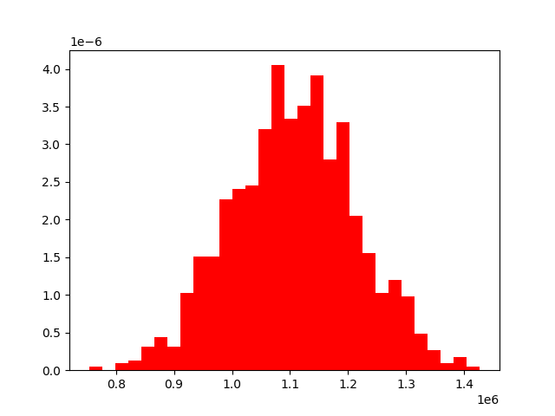

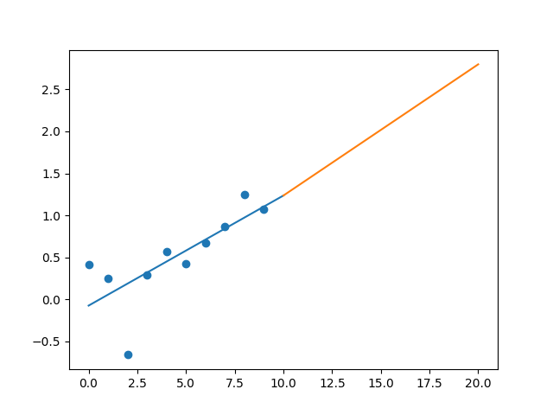

R-Value ROE: 0.628

R-Value EPS: 0.749

CAGR EPS: 0.101

PE Min: 30.875

PE Max: 417.471

Projected AGR Min: 8.431

Projected AGR Max: 40.687

# TICKER: AVGO

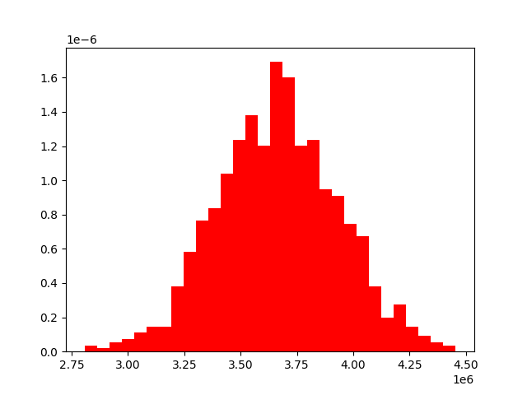

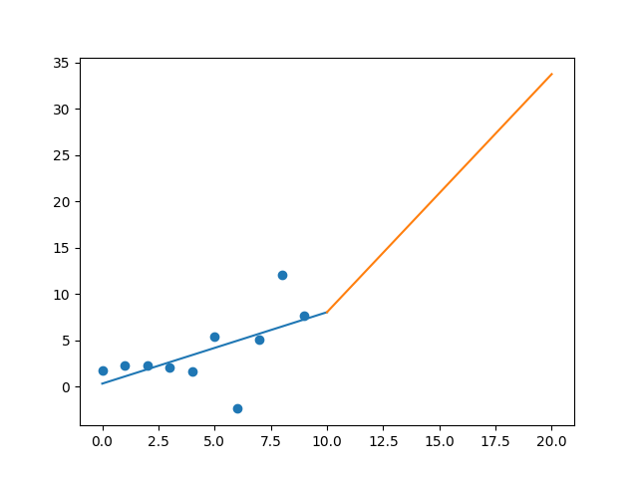

R-Value ROE: 0.191

R-Value EPS: 0.585

CAGR EPS: 0.159

PE Min: 19.381

PE Max: 205.702

Projected AGR Min: 6.016

Projected AGR Max: 34.264

# TICKER: BR

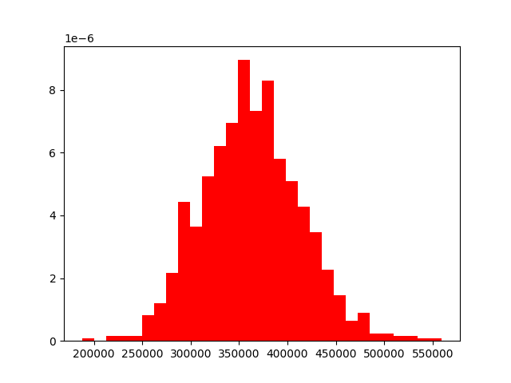

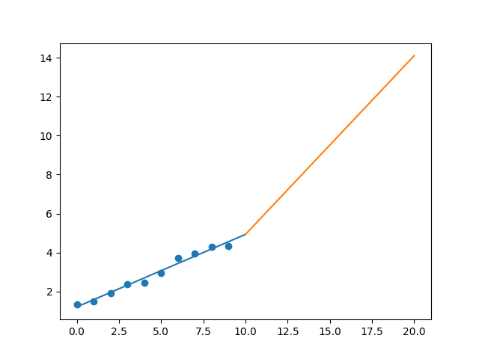

R-Value ROE: 0.88

R-Value EPS: 0.988

CAGR EPS: 0.125

PE Min: 22.458

PE Max: 34.55

Projected AGR Min: 8.017

Projected AGR Max: 12.772

# TICKER: BF.B

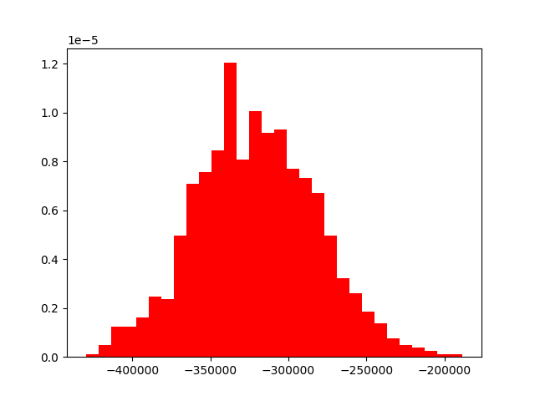

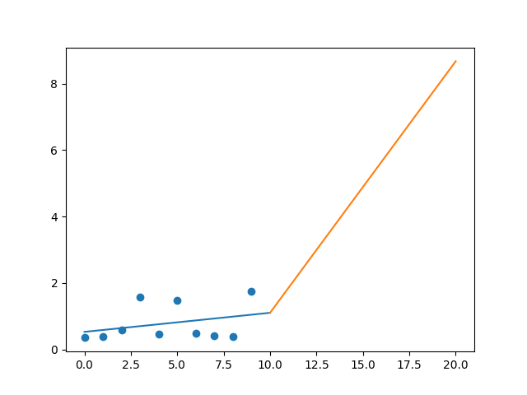

R-Value ROE: 0.133

R-Value EPS: 0.305

CAGR EPS: 0.174

PE Min: 16.959

PE Max: 39.383

Projected AGR Min: 6.509

Projected AGR Max: 15.872

# TICKER: CHRW

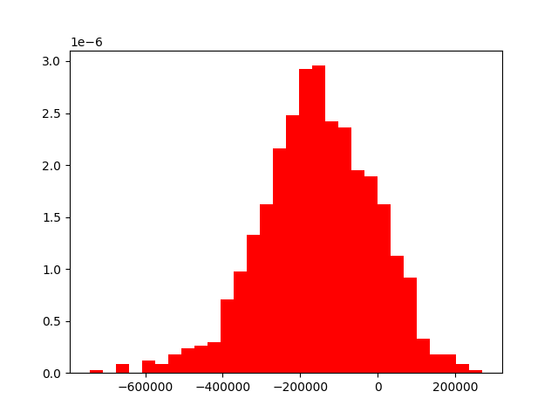

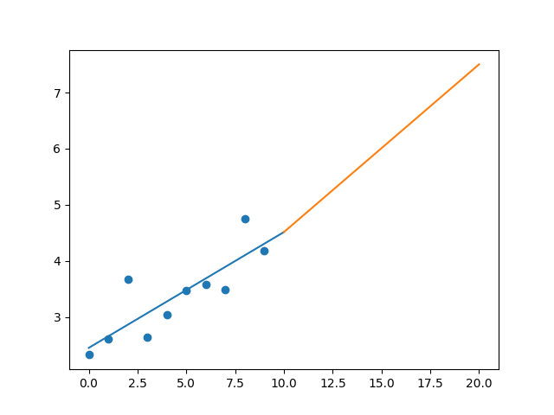

R-Value ROE: 0.17

R-Value EPS: 0.836

CAGR EPS: 0.06

PE Min: 16.863

PE Max: 30.409

Projected AGR Min: 3.071

Projected AGR Max: 9.331

# TICKER: COG

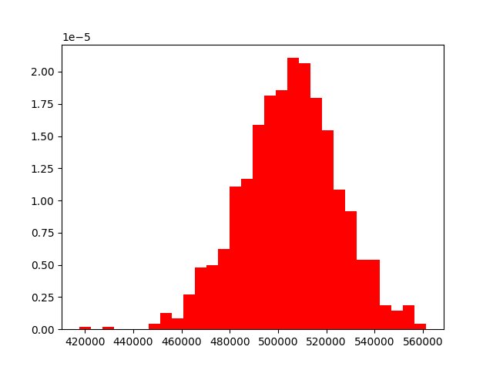

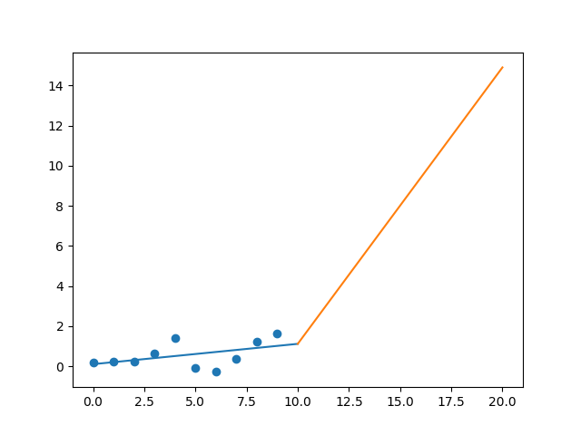

R-Value ROE: 0.36

R-Value EPS: 0.465

CAGR EPS: 0.247

PE Min: 9.39

PE Max: 10008.89

Projected AGR Min: 23.593

Projected AGR Max: 148.179

# TICKER: CDNS

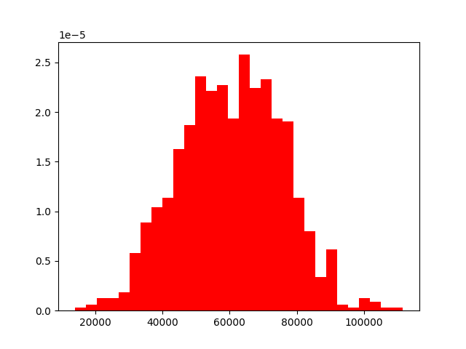

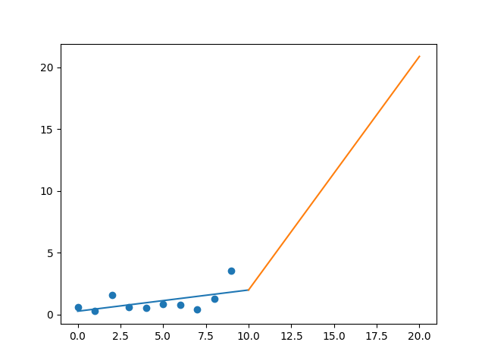

R-Value ROE: 0.019

R-Value EPS: 0.542

CAGR EPS: 0.194

PE Min: 17.579

PE Max: 111.636

Projected AGR Min: 12.564

Projected AGR Max: 35.42

# TICKER: COF

Something wrong happened

# TICKER: KMX

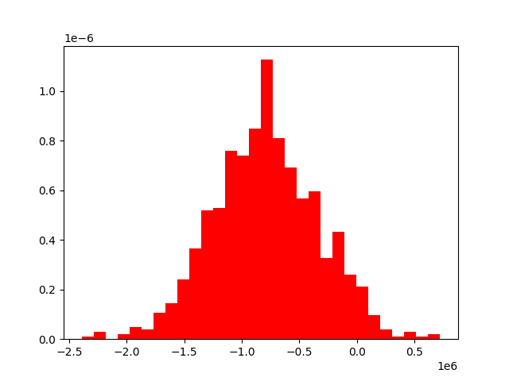

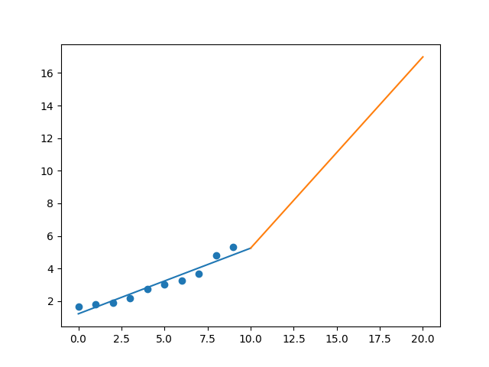

R-Value ROE: 0.876

R-Value EPS: 0.964

CAGR EPS: 0.123

PE Min: 12.955

PE Max: 25.718

Projected AGR Min: 8.747

Projected AGR Max: 16.466

# TICKER: CCL

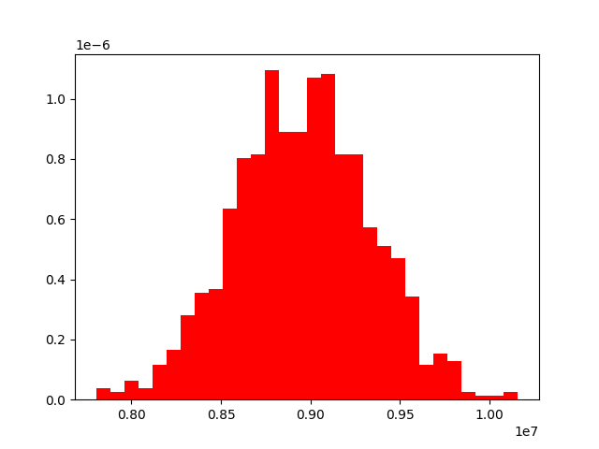

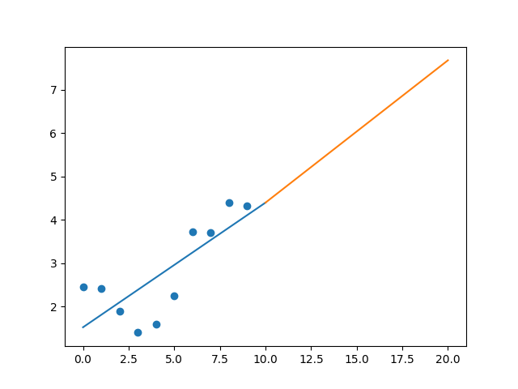

R-Value ROE: 0.675

R-Value EPS: 0.775

CAGR EPS: 0.059

PE Min: 9.985

PE Max: 22.425

Projected AGR Min: 15.999

Projected AGR Max: 25.774

# TICKER: CAT

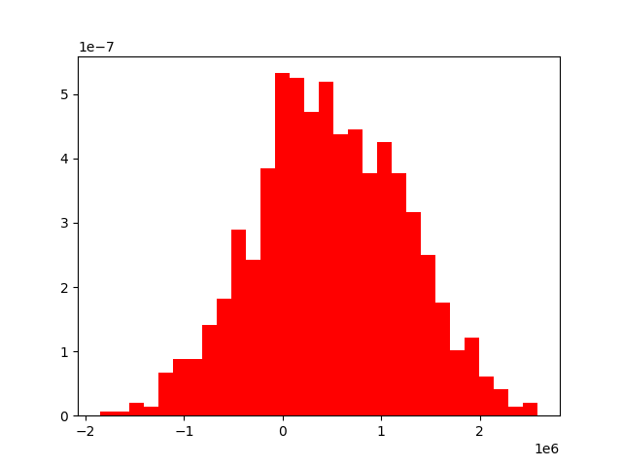

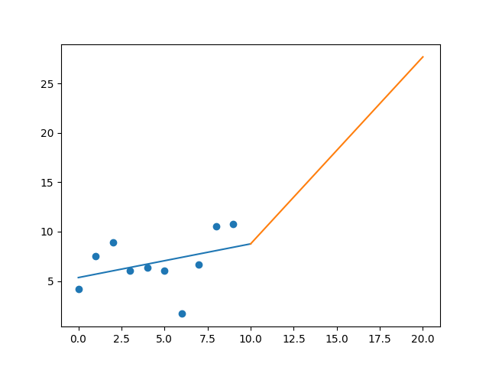

R-Value ROE: 0.007

R-Value EPS: 0.373

CAGR EPS: 0.099

PE Min: 12.258

PE Max: 708.512

Projected AGR Min: 7.002

Projected AGR Max: 60.541

# TICKER: CBOE

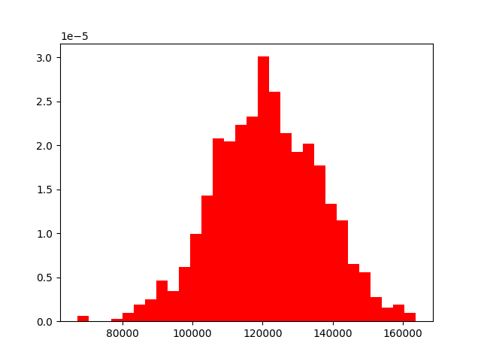

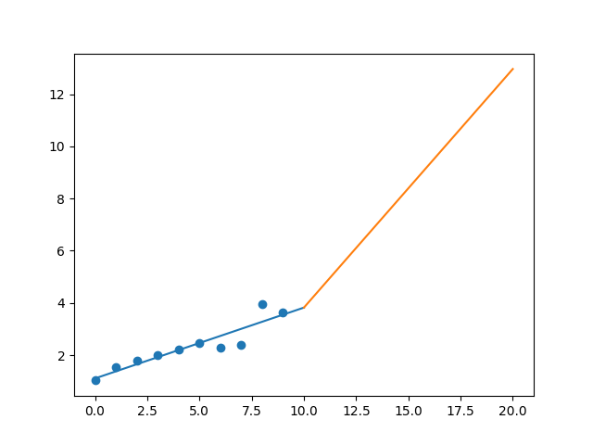

R-Value ROE: 0.691

R-Value EPS: 0.92

CAGR EPS: 0.135

PE Min: 20.718

PE Max: 67.111

Projected AGR Min: 12.006

Projected AGR Max: 25.975

# TICKER: CBRE

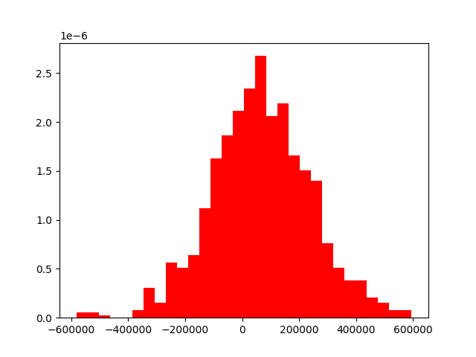

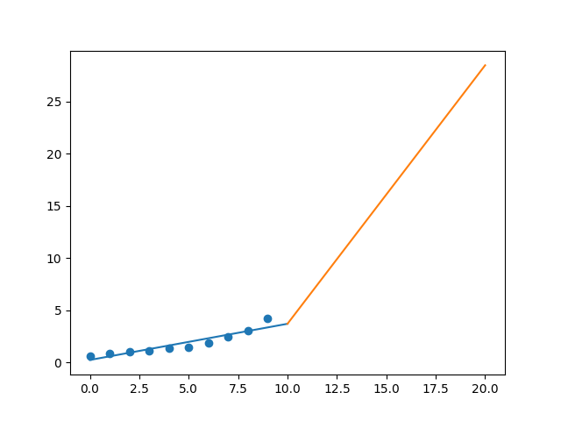

R-Value ROE: 0.199

R-Value EPS: 0.932

CAGR EPS: 0.211

PE Min: 9.951

PE Max: 21.27

Projected AGR Min: 17.269

Projected AGR Max: 26.525

# TICKER: CDW

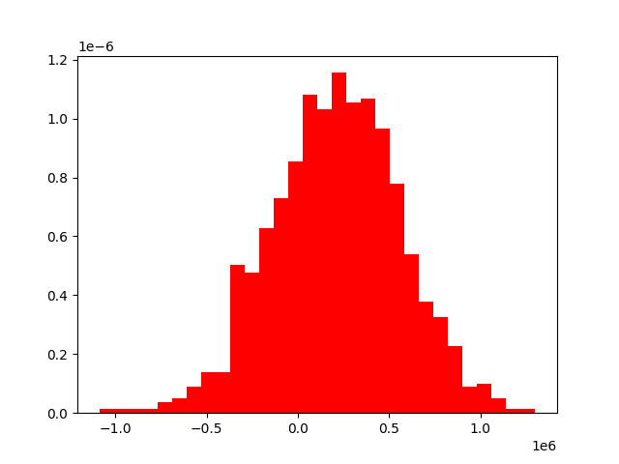

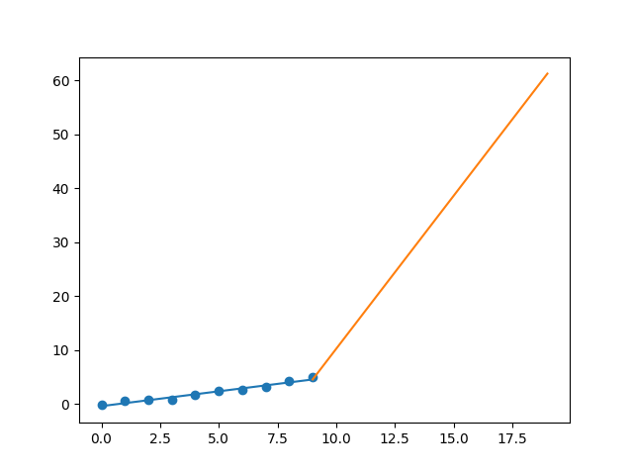

R-Value ROE: 0.413

R-Value EPS: 0.982

CAGR EPS: 0.284

PE Min: 15.581

PE Max: 28.644

Projected AGR Min: 20.993

Projected AGR Max: 28.589

# TICKER: CE

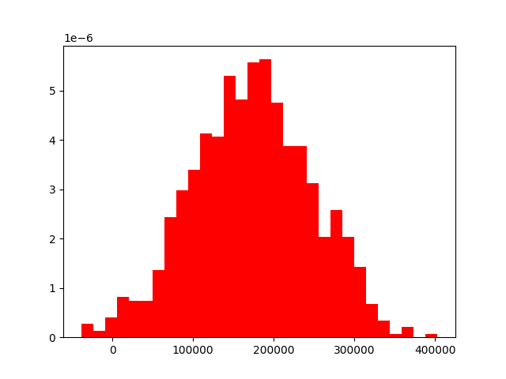

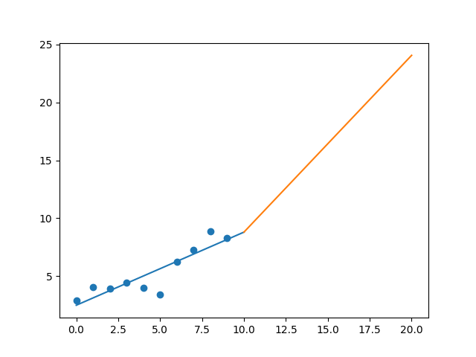

R-Value ROE: 0.281

R-Value EPS: 0.885

CAGR EPS: 0.112

PE Min: 10.135

PE Max: 35.156

Projected AGR Min: 6.682

Projected AGR Max: 20.811

# TICKER: CNC

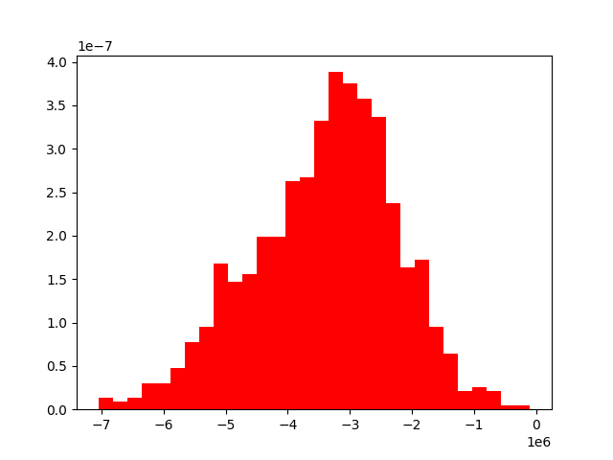

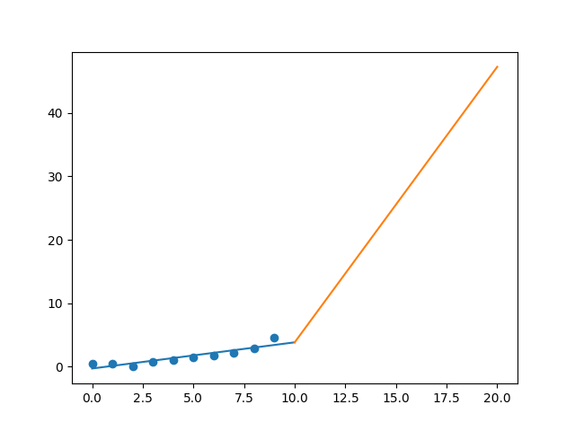

R-Value ROE: 0.043

R-Value EPS: 0.909

CAGR EPS: 0.262

PE Min: 13.423

PE Max: 35.316

Projected AGR Min: 24.54

Projected AGR Max: 37.189

# TICKER: CNP

Something wrong happened

# TICKER: CERN

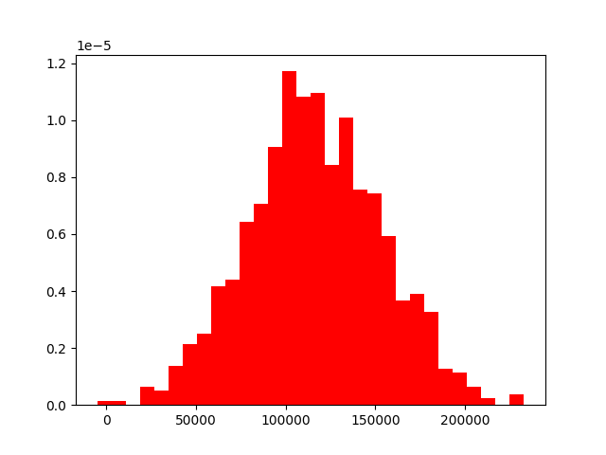

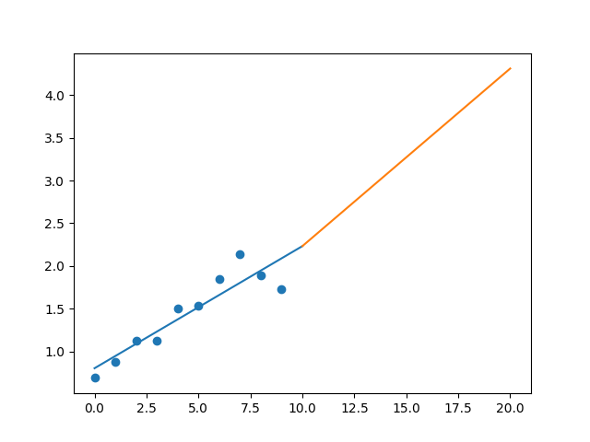

R-Value ROE: 0.249

R-Value EPS: 0.915

CAGR EPS: 0.096

PE Min: 25.579

PE Max: 44.512

Projected AGR Min: 4.134

Projected AGR Max: 10.066

# TICKER: CF

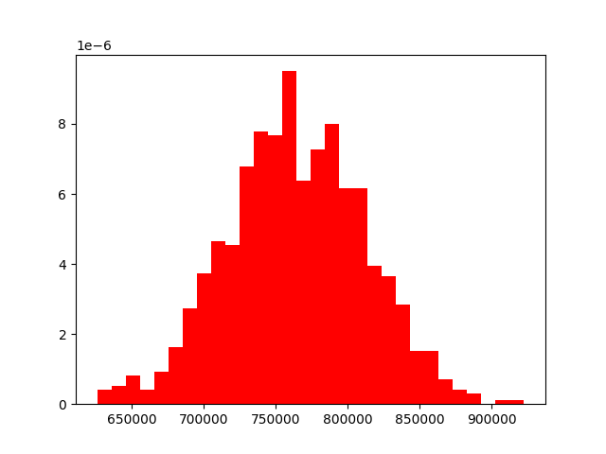

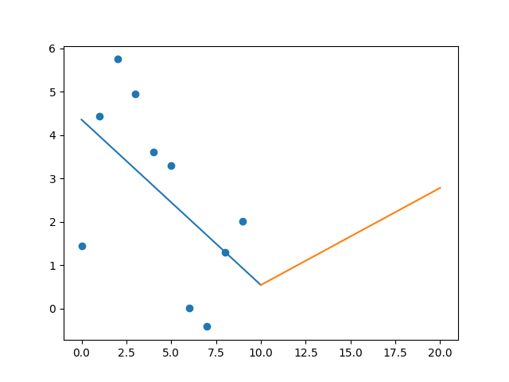

R-Value ROE: 0.438

R-Value EPS: 0.551

CAGR EPS: 0.033

PE Min: 12.753

PE Max: 106.954

Projected AGR Min: 1.978

Projected AGR Max: 26.143

# TICKER: SCHW

Something wrong happened