Monte-Carlo Discounted Cash Flow Model and Buffett Analysis

# TICKER: CHD

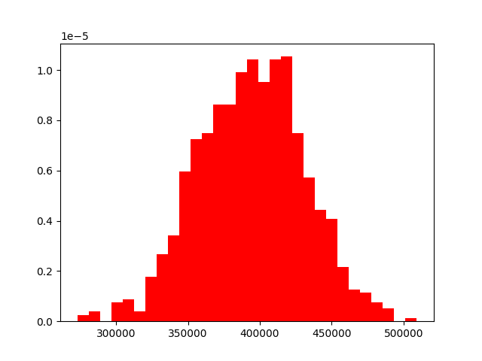

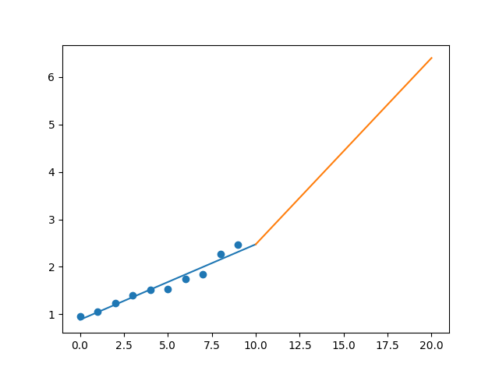

R-Value ROE: 0.774

R-Value EPS: 0.978

CAGR EPS: 0.1

PE Min: 24.118

PE Max: 30.924

Projected AGR Min: 5.978

Projected AGR Max: 8.645

# TICKER: CI

Something wrong happened

# TICKER: CINF

Something wrong happened

# TICKER: CTAS

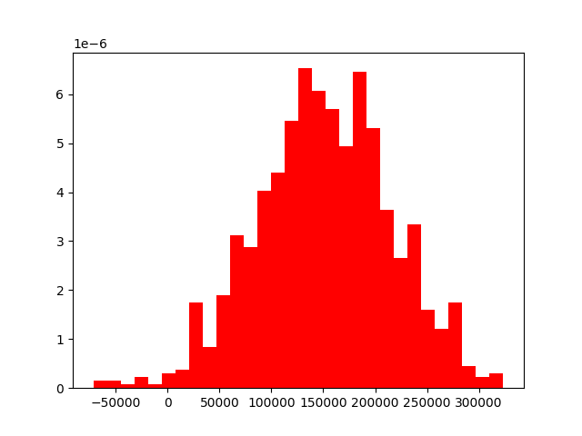

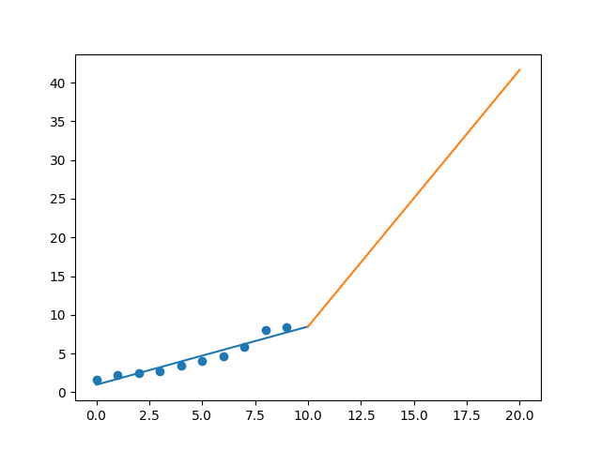

R-Value ROE: 0.765

R-Value EPS: 0.956

CAGR EPS: 0.174

PE Min: 21.912

PE Max: 38.941

Projected AGR Min: 9.692

Projected AGR Max: 16.184

# TICKER: CSCO

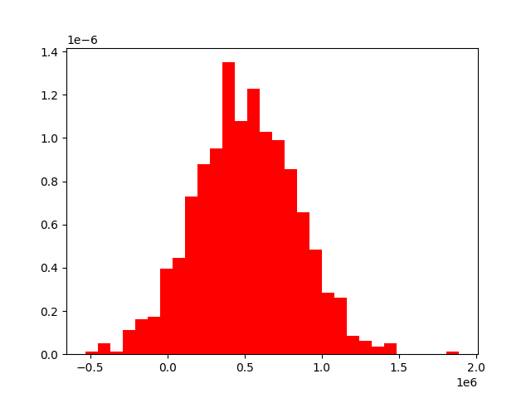

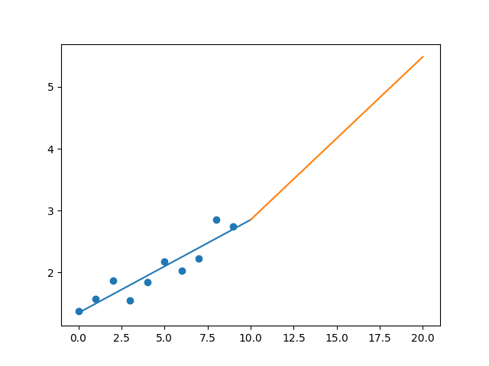

R-Value ROE: 0.386

R-Value EPS: 0.926

CAGR EPS: 0.072

PE Min: 11.576

PE Max: 22.483

Projected AGR Min: 5.049

Projected AGR Max: 12.259

# TICKER: C

Something wrong happened

# TICKER: CFG

Something wrong happened

# TICKER: CTXS

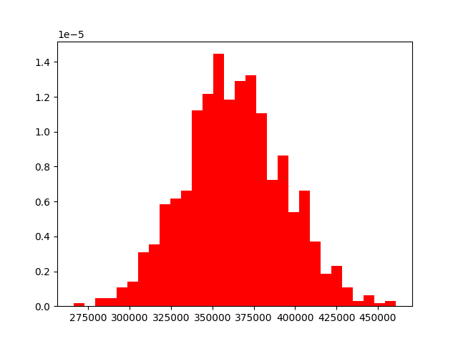

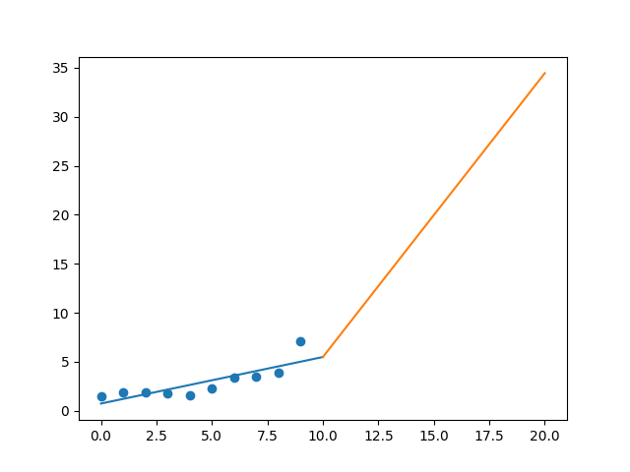

R-Value ROE: 0.647

R-Value EPS: 0.834

CAGR EPS: 0.171

PE Min: 21.505

PE Max: 45.143

Projected AGR Min: 20.725

Projected AGR Max: 30.018

# TICKER: CMS

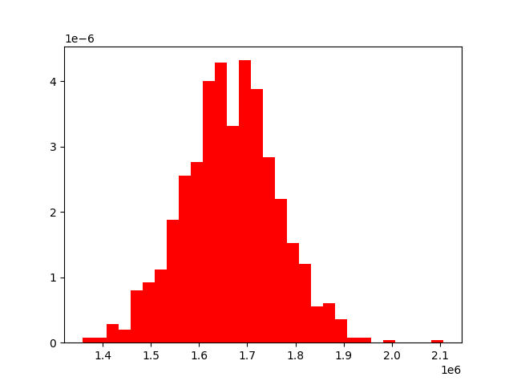

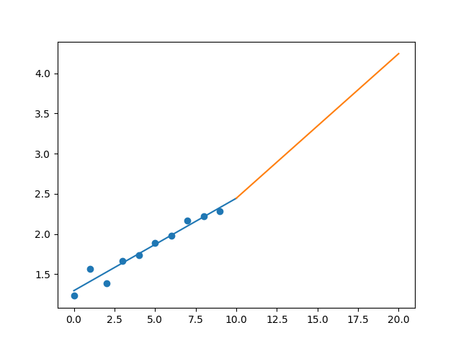

R-Value ROE: 0.089

R-Value EPS: 0.975

CAGR EPS: 0.064

PE Min: 19.067

PE Max: 30.904

Projected AGR Min: 1.864

Projected AGR Max: 6.904

# TICKER: KO

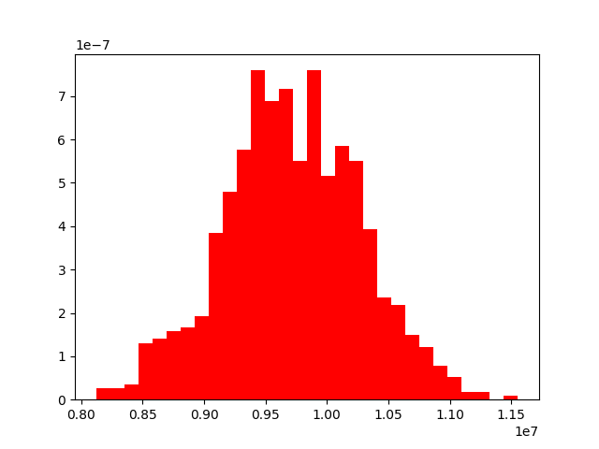

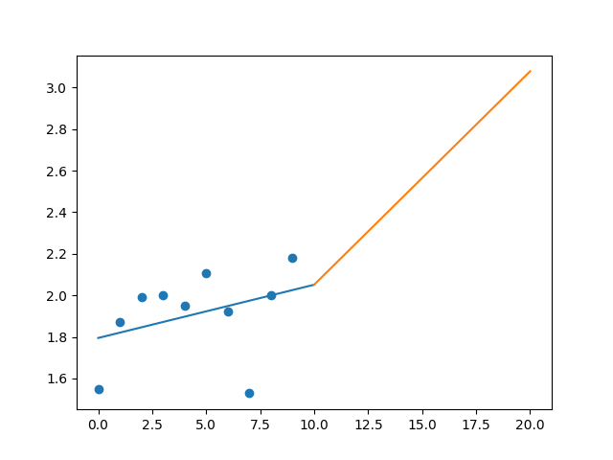

R-Value ROE: 0.117

R-Value EPS: 0.362

CAGR EPS: 0.035

PE Min: 18.455

PE Max: 46.923

Projected AGR Min: 0.496

Projected AGR Max: 10.325

# TICKER: CTSH

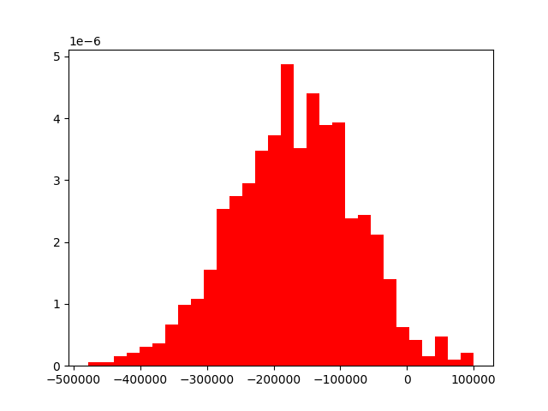

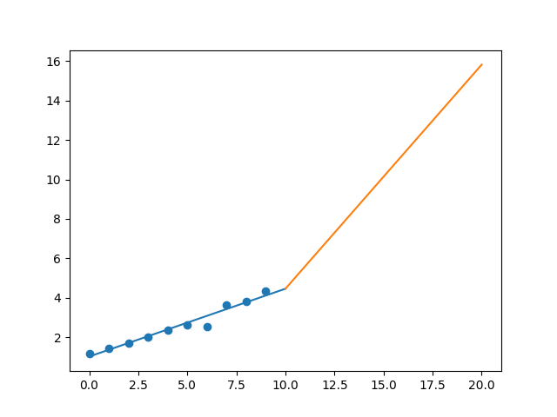

R-Value ROE: 0.767

R-Value EPS: 0.978

CAGR EPS: 0.138

PE Min: 14.551

PE Max: 25.738

Projected AGR Min: 12.03

Projected AGR Max: 18.604

# TICKER: CMCSA

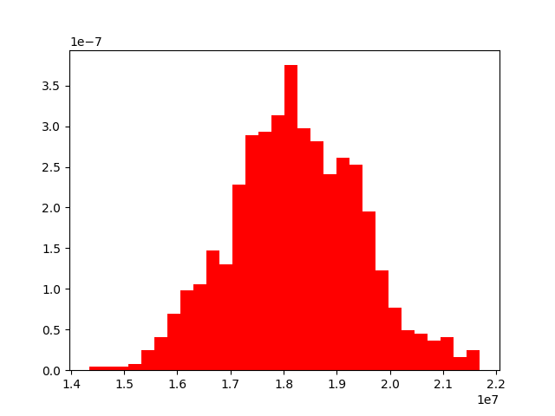

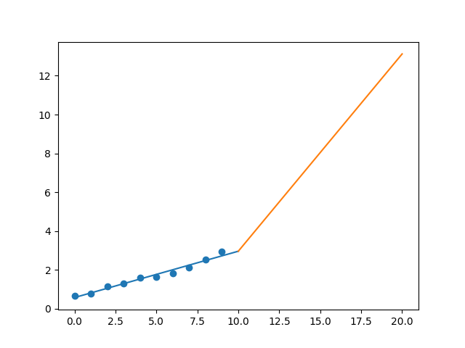

R-Value ROE: 0.62

R-Value EPS: 0.986

CAGR EPS: 0.162

PE Min: 13.451

PE Max: 20.707

Projected AGR Min: 14.073

Projected AGR Max: 19.102

# TICKER: CMA

Something wrong happened

# TICKER: CAG

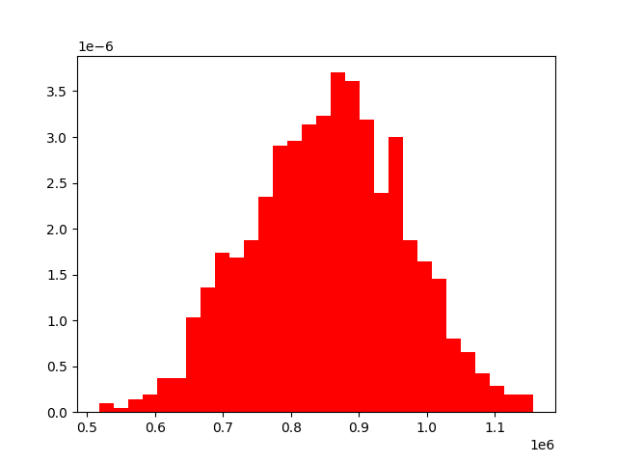

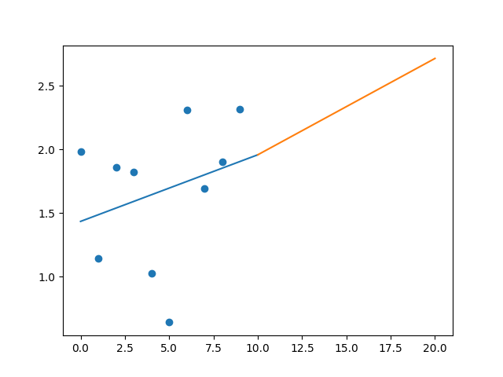

R-Value ROE: 0.06

R-Value EPS: 0.285

CAGR EPS: 0.016

PE Min: 16.123

PE Max: 137.543

Projected AGR Min: 2.335

Projected AGR Max: 26.802

# TICKER: CXO

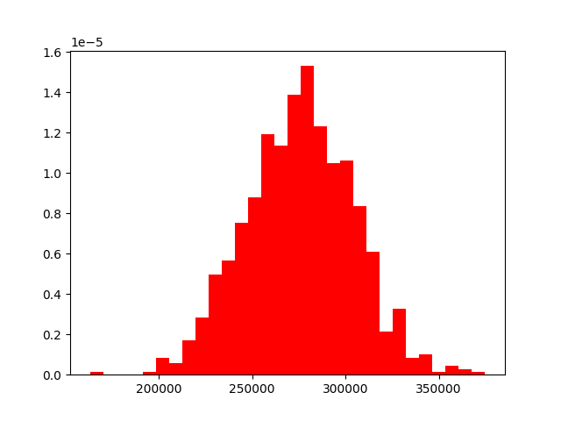

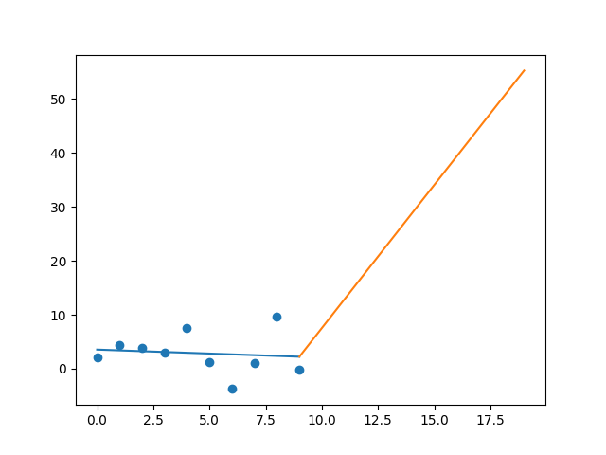

R-Value ROE: 0.43

R-Value EPS: 0.116

CAGR EPS: 0.19

PE Min: 7.918

PE Max: 172.776

Projected AGR Min: 23.99

Projected AGR Max: 68.763

# TICKER: COP

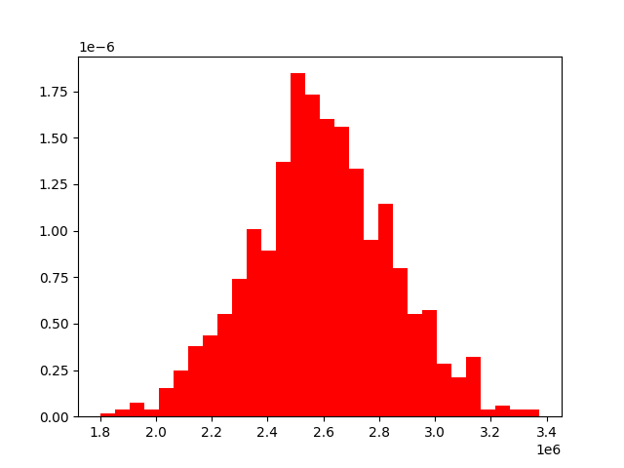

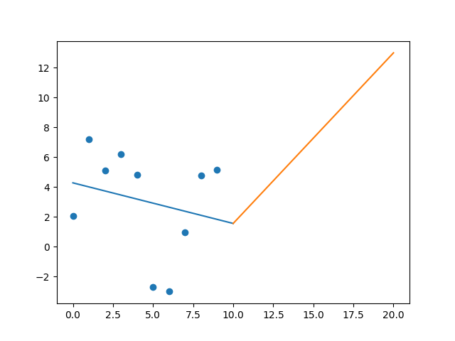

R-Value ROE: 0.244

R-Value EPS: 0.229

CAGR EPS: 0.097

PE Min: 7.76

PE Max: 22.513

Projected AGR Min: 11.135

Projected AGR Max: 23.625

# TICKER: CPRT

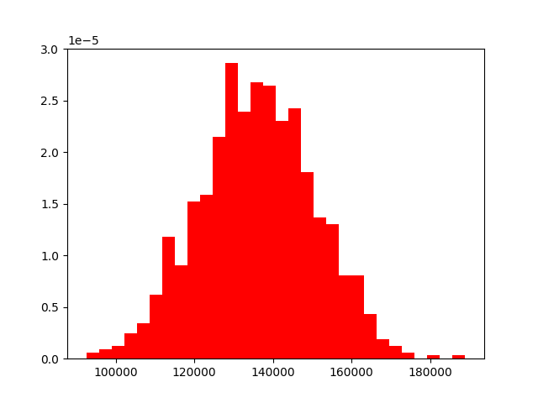

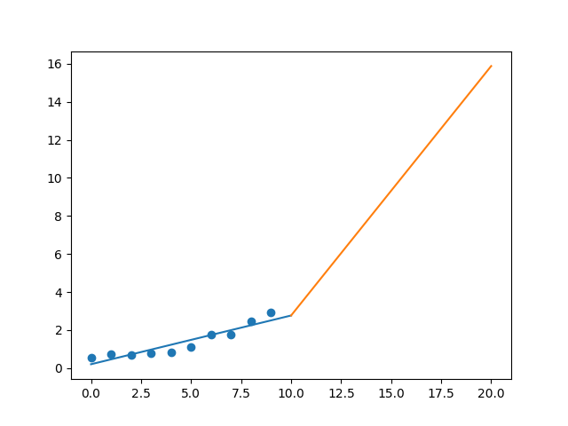

R-Value ROE: 0.217

R-Value EPS: 0.934

CAGR EPS: 0.184

PE Min: 16.31

PE Max: 32.986

Projected AGR Min: 8.215

Projected AGR Max: 16.111

# TICKER: COST

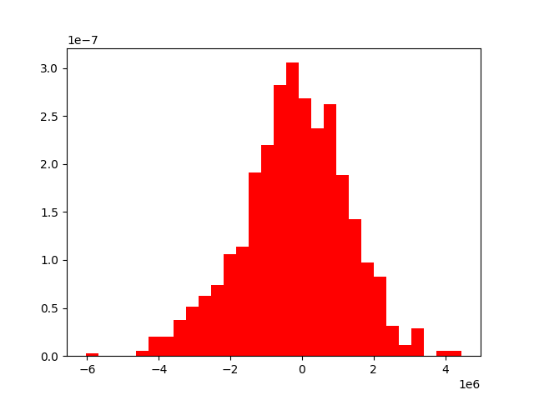

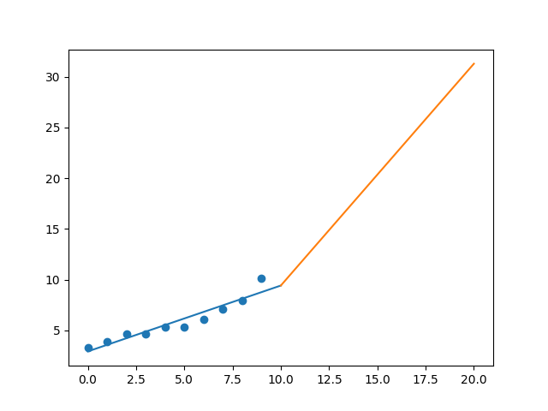

R-Value ROE: 0.854

R-Value EPS: 0.949

CAGR EPS: 0.119

PE Min: 26.05

PE Max: 38.646

Projected AGR Min: 8.268

Projected AGR Max: 12.624

# TICKER: COTY

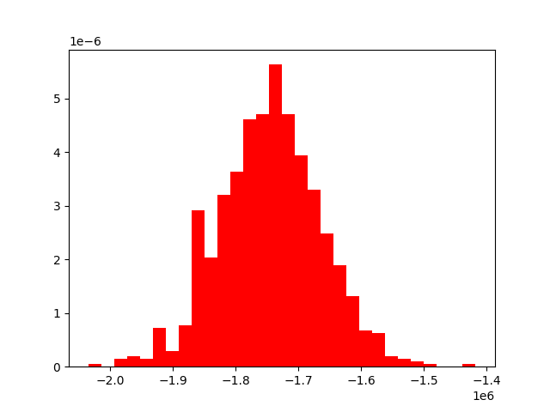

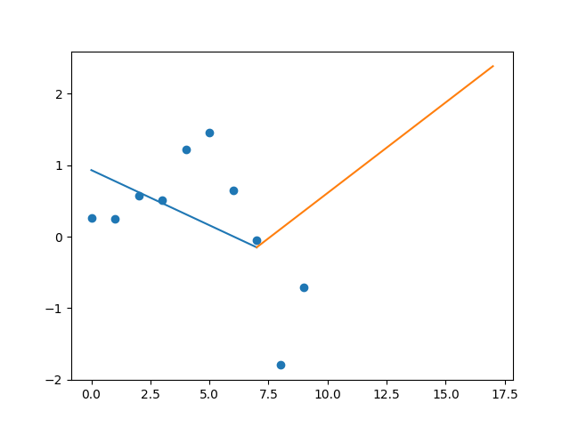

R-Value ROE: 0.351

R-Value EPS: 0.498

CAGR EPS: 0.139

PE Min: 29.78

PE Max: 292.507

Projected AGR Min: 32.543

Projected AGR Max: 66.562

# TICKER: CCI

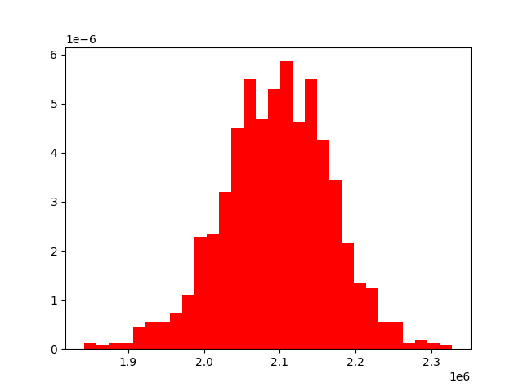

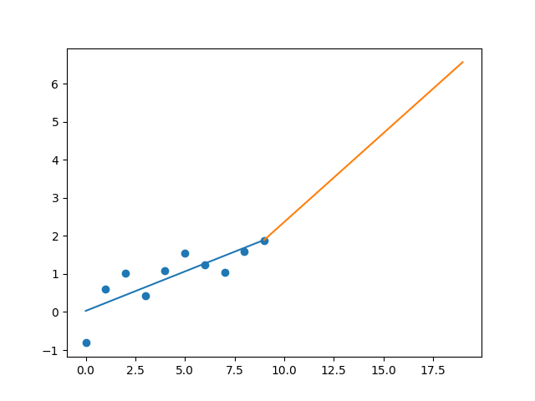

R-Value ROE: 0.409

R-Value EPS: 0.823

CAGR EPS: 0.134

PE Min: 60.006

PE Max: 146.755

Projected AGR Min: 9.583

Projected AGR Max: 19.835

# TICKER: CSX

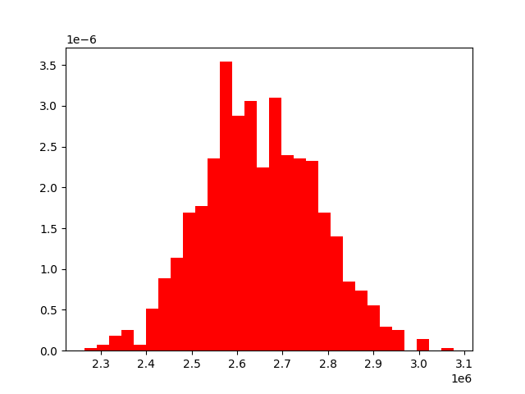

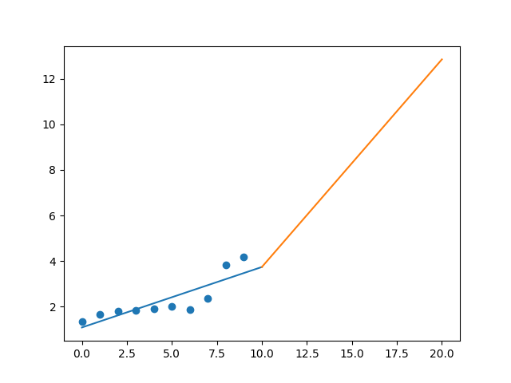

R-Value ROE: 0.527

R-Value EPS: 0.847

CAGR EPS: 0.119

PE Min: 13.079

PE Max: 28.491

Projected AGR Min: 6.378

Projected AGR Max: 14.992

# TICKER: CMI

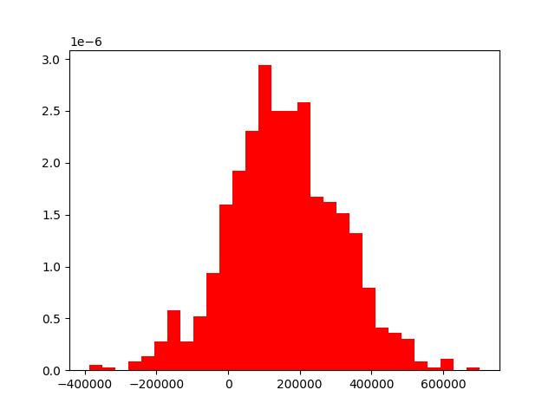

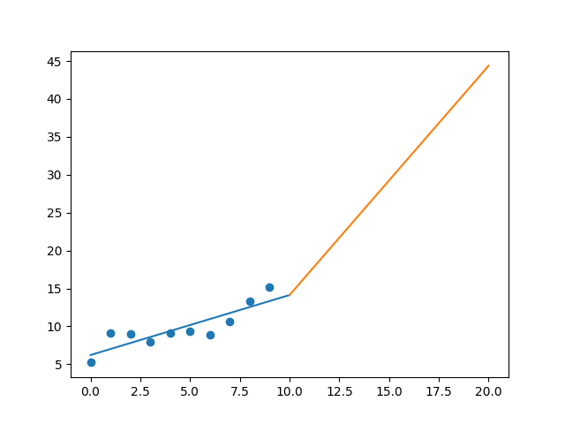

R-Value ROE: 0.061

R-Value EPS: 0.865

CAGR EPS: 0.113

PE Min: 9.661

PE Max: 19.656

Projected AGR Min: 6.244

Projected AGR Max: 14.065

# TICKER: CVS

Something wrong happened

# TICKER: DHI

Something wrong happened

# TICKER: DVA

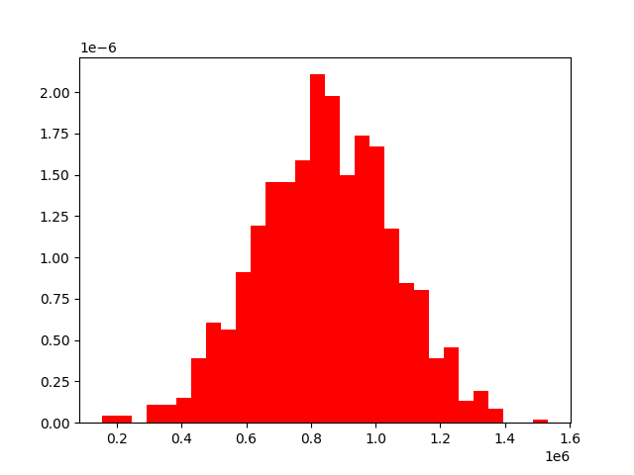

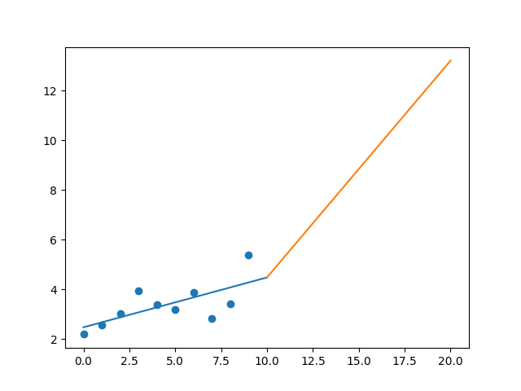

R-Value ROE: 0.07

R-Value EPS: 0.684

CAGR EPS: 0.094

PE Min: 8.759

PE Max: 56.56

Projected AGR Min: 0.752

Projected AGR Max: 21.411

# TICKER: DE

Something wrong happened

# TICKER: DAL

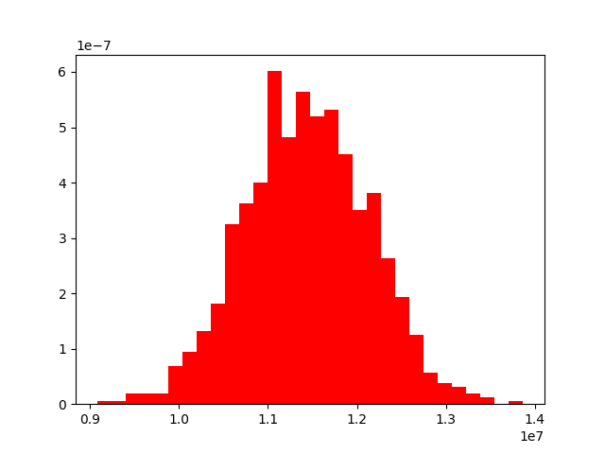

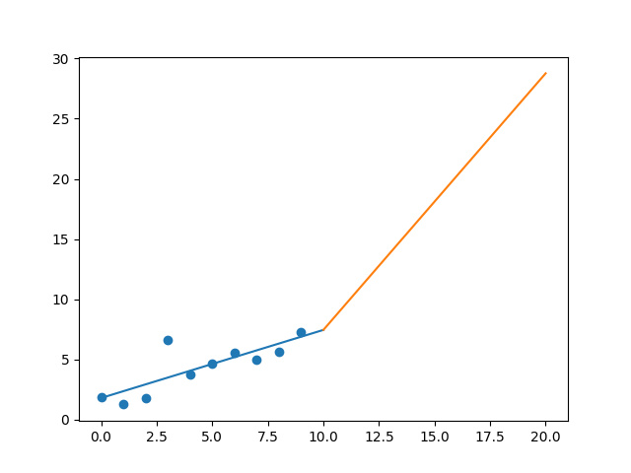

R-Value ROE: 0.216

R-Value EPS: 0.81

CAGR EPS: 0.147

PE Min: 5.296

PE Max: 11.466

Projected AGR Min: 15.238

Projected AGR Max: 24.492

# TICKER: DXCM

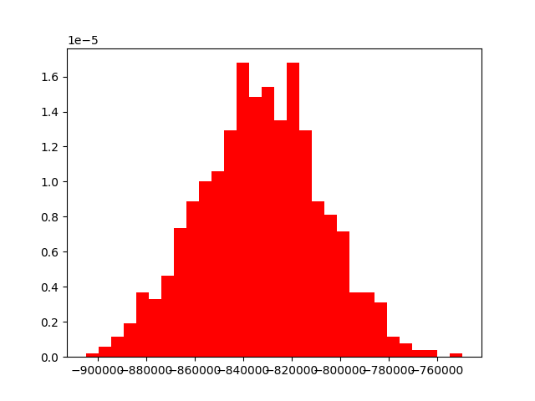

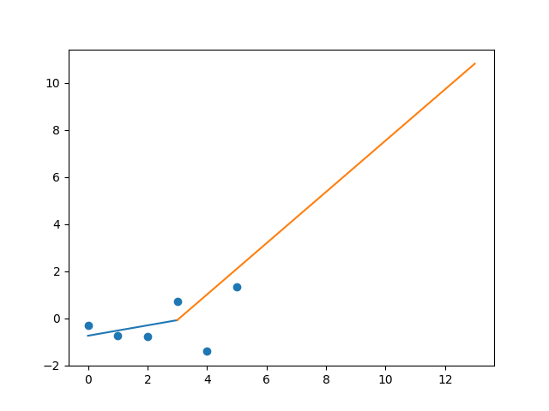

R-Value ROE: 0.669

R-Value EPS: 0.399

CAGR EPS: 0.231

PE Min: 82.901

PE Max: 201.965

Projected AGR Min: 10.297

Projected AGR Max: 20.569

# TICKER: FANG

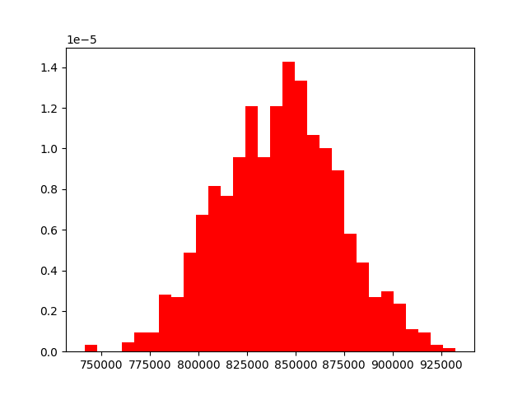

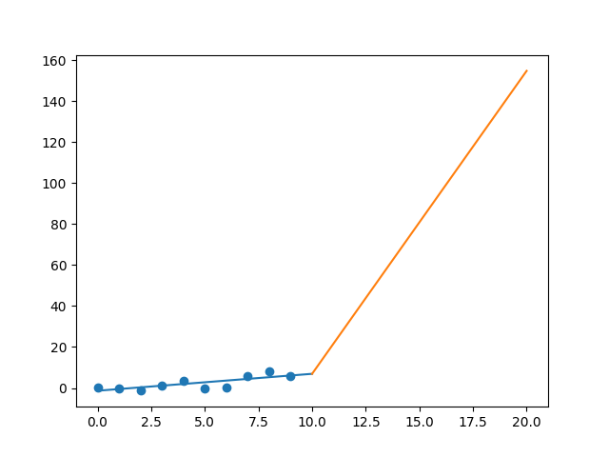

R-Value ROE: 0.007

R-Value EPS: 0.766

CAGR EPS: 0.385

PE Min: 11.664

PE Max: 65.137

Projected AGR Min: 48.914

Projected AGR Max: 76.862

# TICKER: DFS

Something wrong happened

# TICKER: DISCA

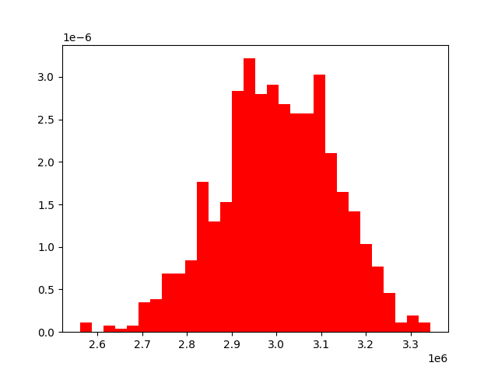

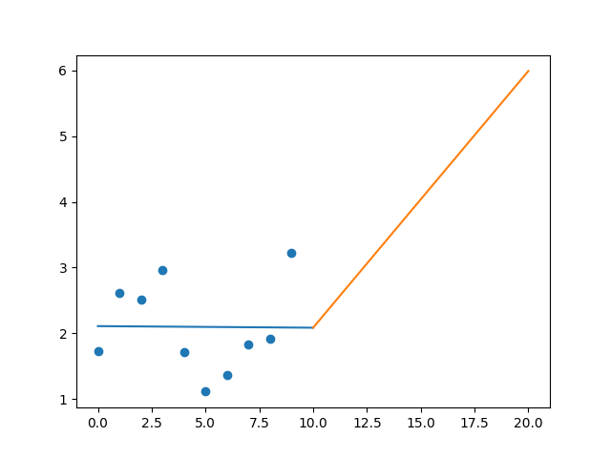

R-Value ROE: 0.15

R-Value EPS: 0.01

CAGR EPS: 0.064

PE Min: 6.698

PE Max: 30.256

Projected AGR Min: 5.818

Projected AGR Max: 23.039

# TICKER: DG

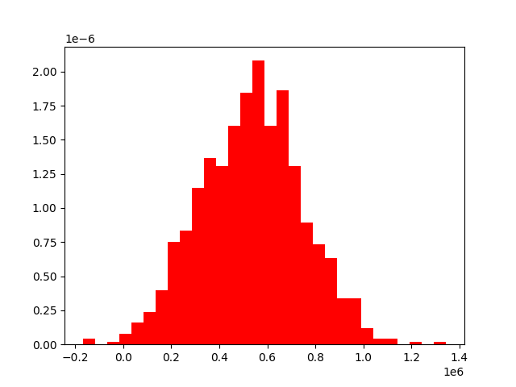

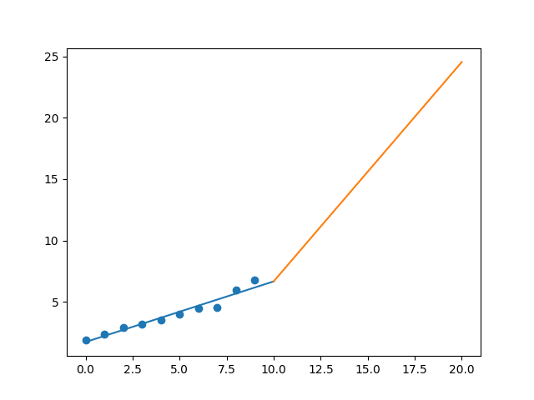

R-Value ROE: 0.972

R-Value EPS: 0.975

CAGR EPS: 0.138

PE Min: 16.103

PE Max: 25.228

Projected AGR Min: 6.503

Projected AGR Max: 11.393

# TICKER: DLTR

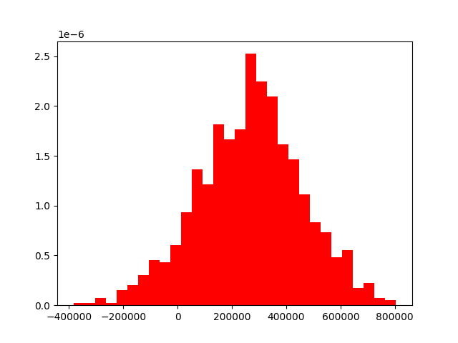

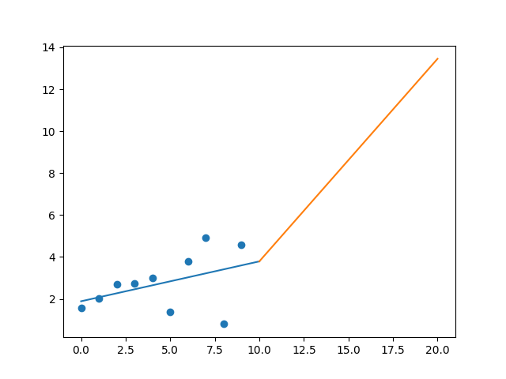

R-Value ROE: 0.649

R-Value EPS: 0.421

CAGR EPS: 0.114

PE Min: 17.004

PE Max: 68.47

Projected AGR Min: 9.326

Projected AGR Max: 25.667

# TICKER: D

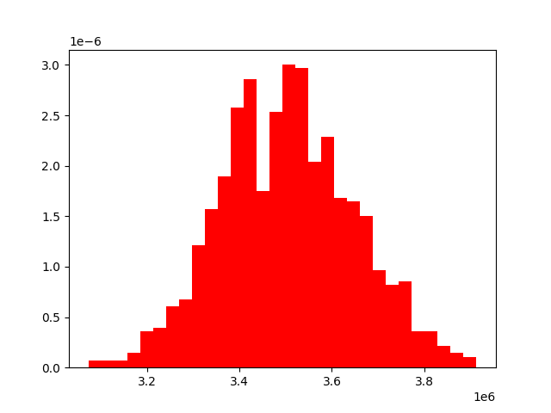

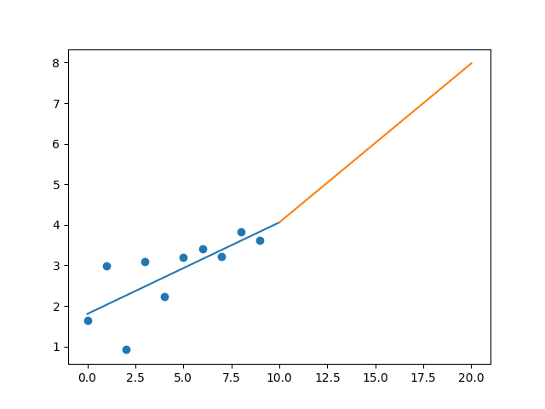

R-Value ROE: 0.278

R-Value EPS: 0.736

CAGR EPS: 0.082

PE Min: 18.787

PE Max: 121.786

Projected AGR Min: 5.747

Projected AGR Max: 27.48