Monte-Carlo Discounted Cash Flow Model and Buffett Analysis

# TICKER: DPZ

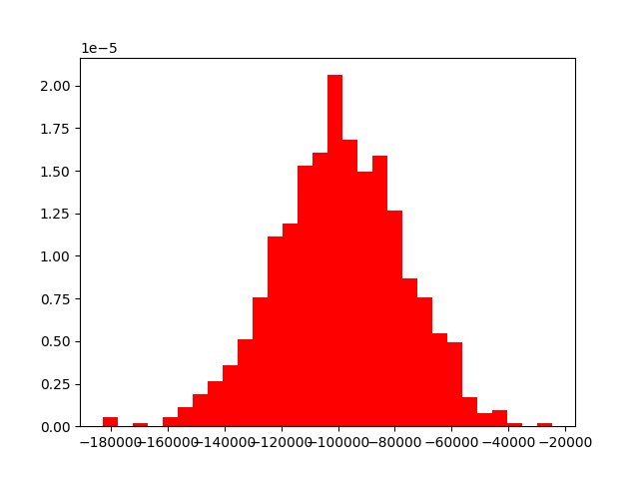

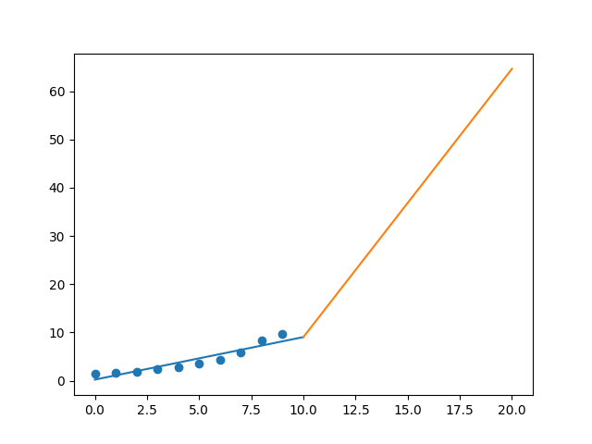

R-Value ROE: 0.69

R-Value EPS: 0.937

CAGR EPS: 0.21

PE Min: 26.151

PE Max: 41.933

Projected AGR Min: 15.966

Projected AGR Max: 21.573

# TICKER: DTE

Something wrong happened

# TICKER: DXC

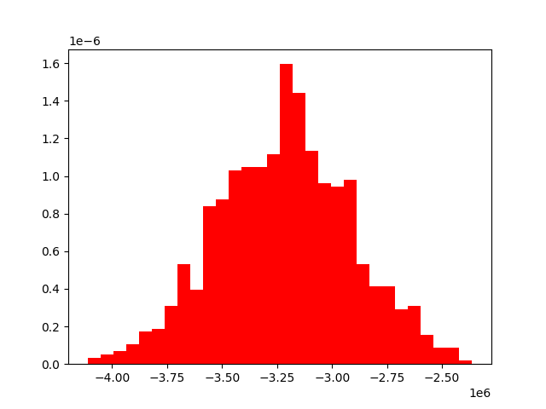

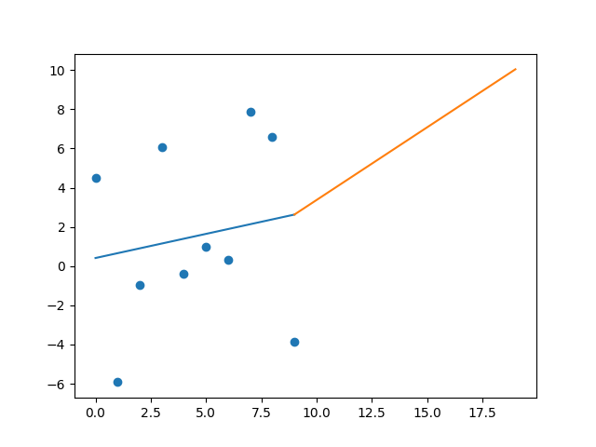

R-Value ROE: 0.037

R-Value EPS: 0.162

CAGR EPS: 0.043

PE Min: 10.273

PE Max: 442.309

Projected AGR Min: 17.187

Projected AGR Max: 70.72

# TICKER: ETFC

Something wrong happened

# TICKER: EMN

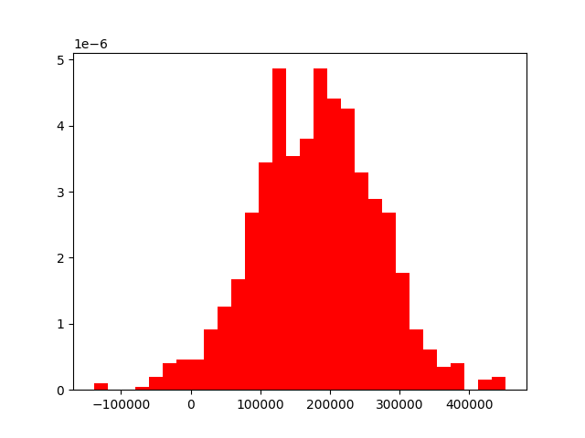

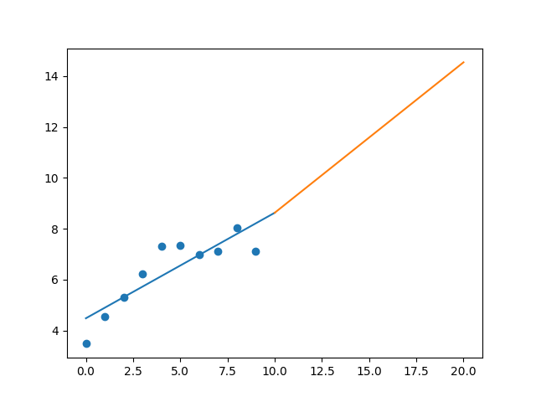

R-Value ROE: 0.592

R-Value EPS: 0.867

CAGR EPS: 0.074

PE Min: 7.943

PE Max: 22.584

Projected AGR Min: 2.146

Projected AGR Max: 13.398

# TICKER: ETN

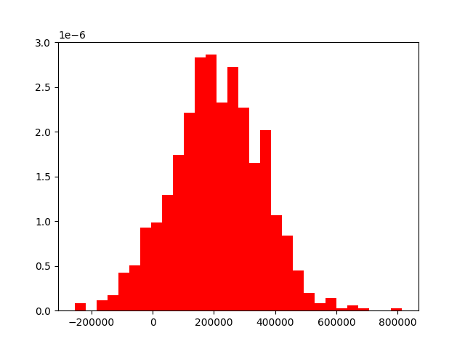

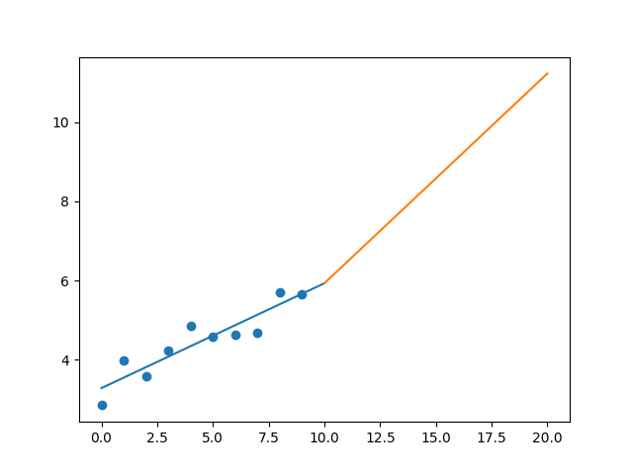

R-Value ROE: 0.189

R-Value EPS: 0.918

CAGR EPS: 0.071

PE Min: 10.784

PE Max: 30.111

Projected AGR Min: 0.521

Projected AGR Max: 11.391

# TICKER: ECL

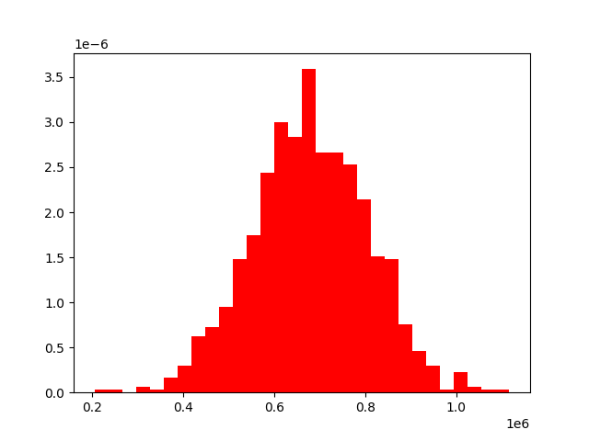

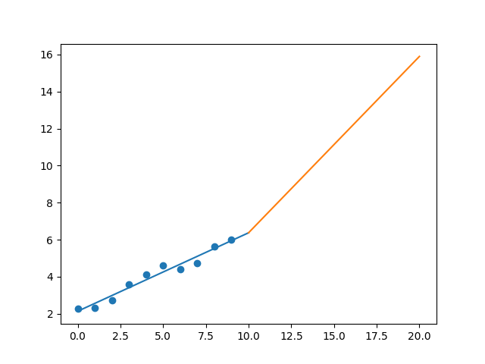

R-Value ROE: 0.231

R-Value EPS: 0.98

CAGR EPS: 0.102

PE Min: 28.21

PE Max: 52.835

Projected AGR Min: 7.827

Projected AGR Max: 14.81

# TICKER: EIX

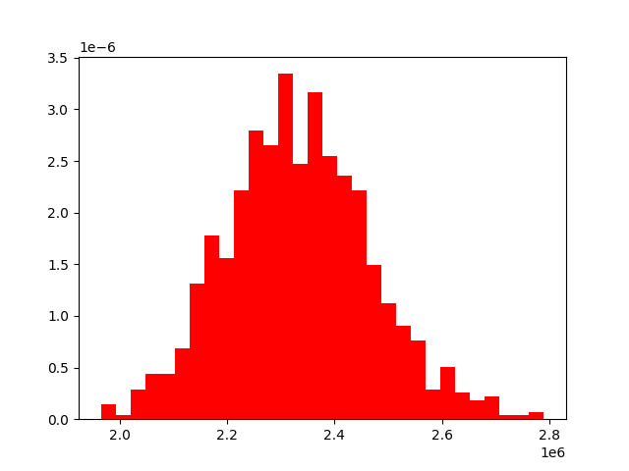

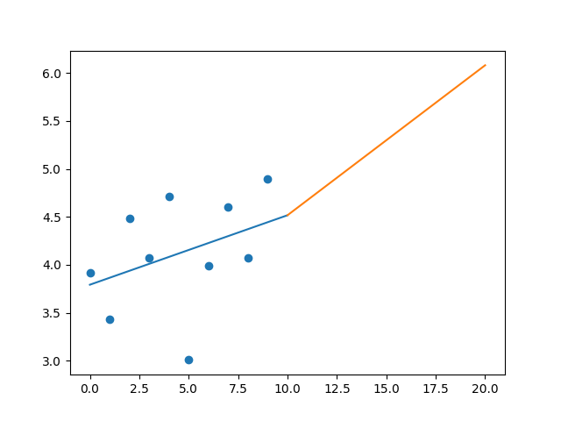

R-Value ROE: 0.035

R-Value EPS: 0.375

CAGR EPS: 0.022

PE Min: 15.899

PE Max: 51.792

Projected AGR Min: 4.409

Projected AGR Max: 17.498

# TICKER: EW

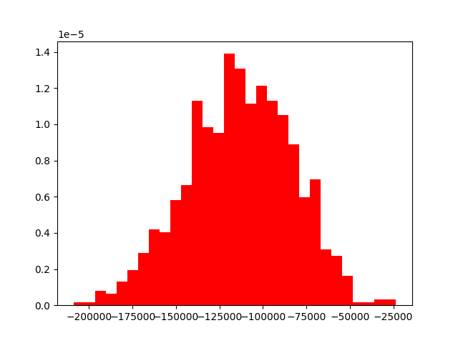

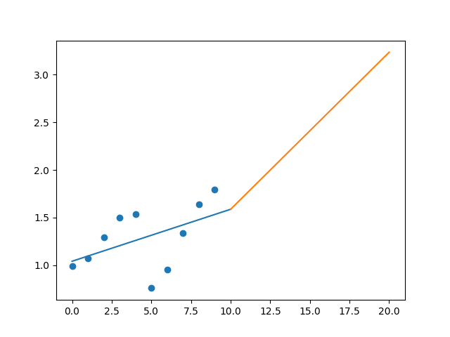

R-Value ROE: 0.273

R-Value EPS: 0.492

CAGR EPS: 0.061

PE Min: 27.514

PE Max: 63.763

Projected AGR Min: 0.897

Projected AGR Max: 9.744

# TICKER: EA

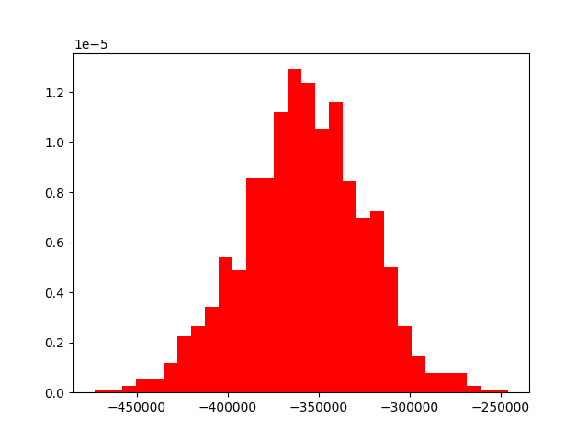

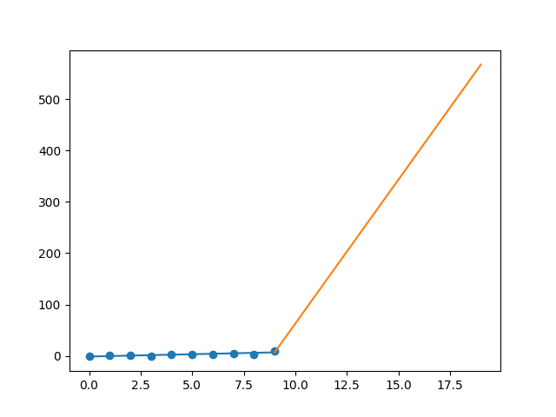

R-Value ROE: 0.822

R-Value EPS: 0.859

CAGR EPS: 0.493

PE Min: 9.776

PE Max: 47.384

Projected AGR Min: 46.775

Projected AGR Max: 71.869

# TICKER: EOG

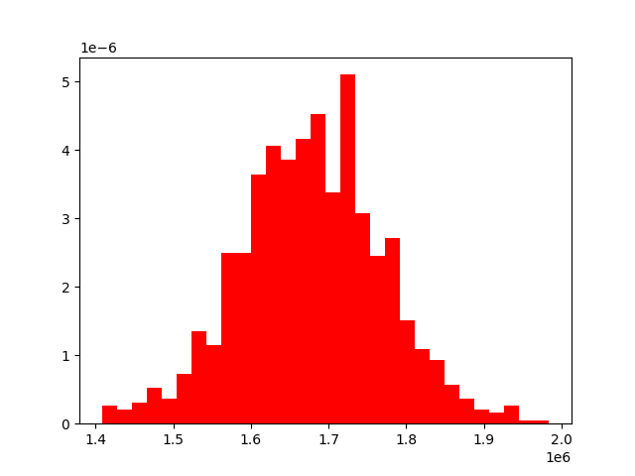

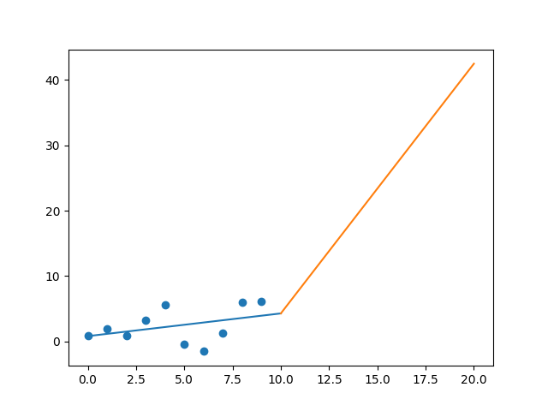

R-Value ROE: 0.117

R-Value EPS: 0.385

CAGR EPS: 0.214

PE Min: 9.883

PE Max: 6984.837

Projected AGR Min: 25.865

Projected AGR Max: 142.568

# TICKER: EQIX

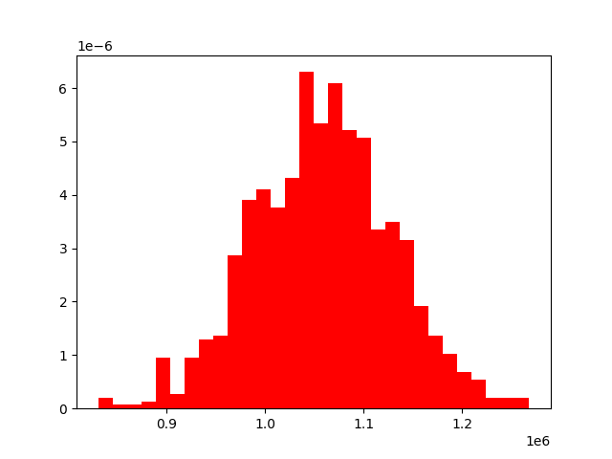

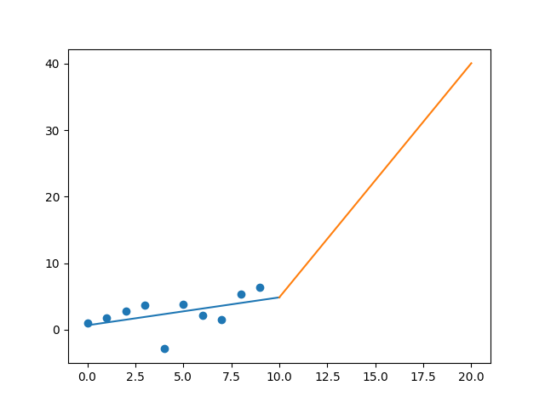

R-Value ROE: 0.156

R-Value EPS: 0.495

CAGR EPS: 0.201

PE Min: 78.844

PE Max: 734.352

Projected AGR Min: 15.793

Projected AGR Max: 44.743

# TICKER: EQR

Something wrong happened

# TICKER: ESS

Something wrong happened

# TICKER: EL

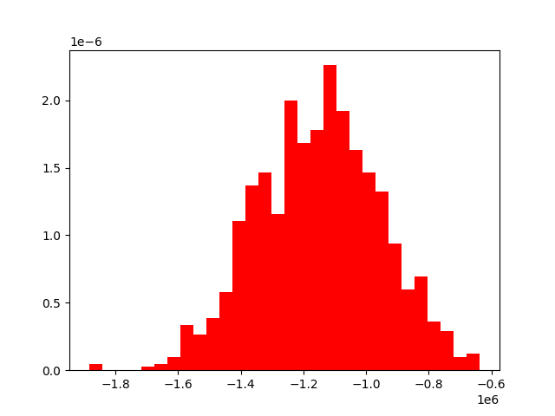

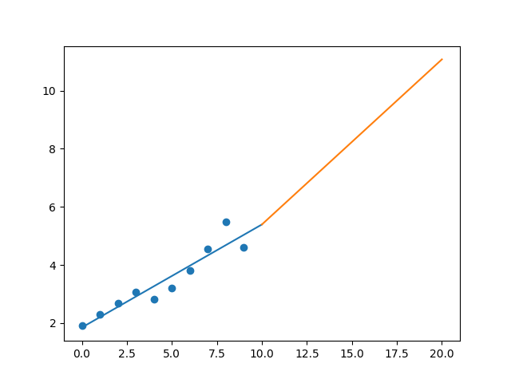

R-Value ROE: 0.189

R-Value EPS: 0.942

CAGR EPS: 0.092

PE Min: 26.446

PE Max: 132.644

Projected AGR Min: 1.667

Projected AGR Max: 19.457

# TICKER: RE

Something wrong happened

# TICKER: EVRG

Something wrong happened

# TICKER: EXPD

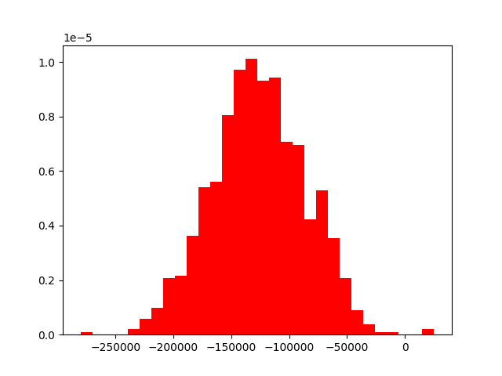

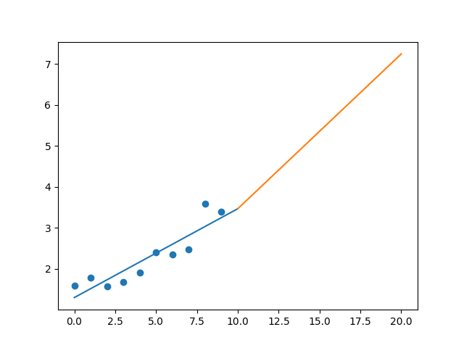

R-Value ROE: 0.81

R-Value EPS: 0.909

CAGR EPS: 0.079

PE Min: 18.755

PE Max: 26.106

Projected AGR Min: 4.353

Projected AGR Max: 7.862

# TICKER: EXR

Something wrong happened

# TICKER: FFIV

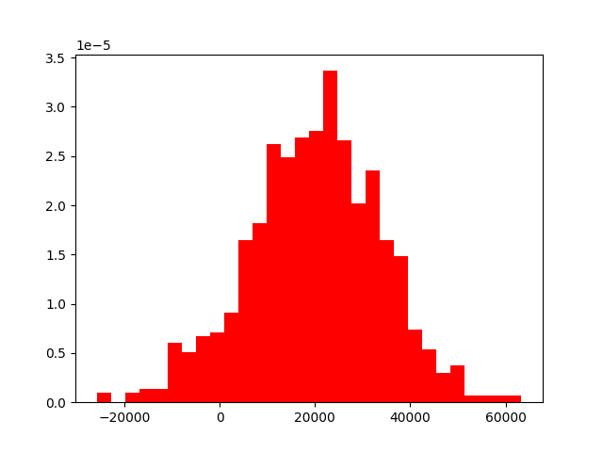

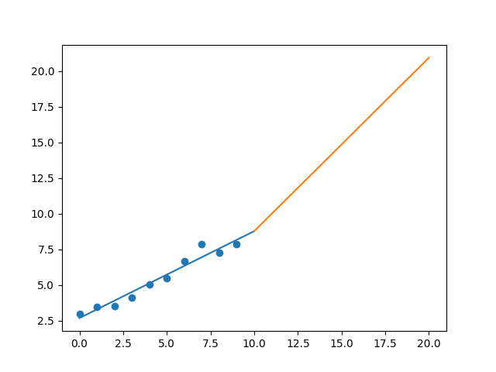

R-Value ROE: 0.2

R-Value EPS: 0.974

CAGR EPS: 0.103

PE Min: 18.507

PE Max: 26.194

Projected AGR Min: 9.337

Projected AGR Max: 13.202

# TICKER: FB

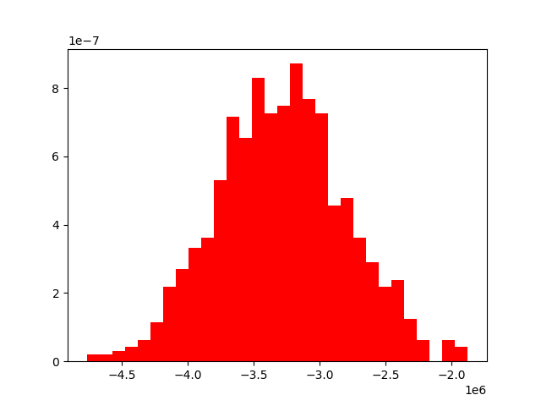

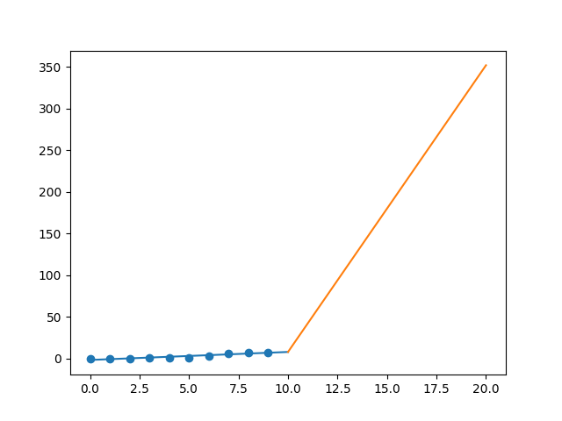

R-Value ROE: 0.168

R-Value EPS: 0.921

CAGR EPS: 0.465

PE Min: 17.293

PE Max: 81.247

Projected AGR Min: 36.357

Projected AGR Max: 59.174

# TICKER: FAST

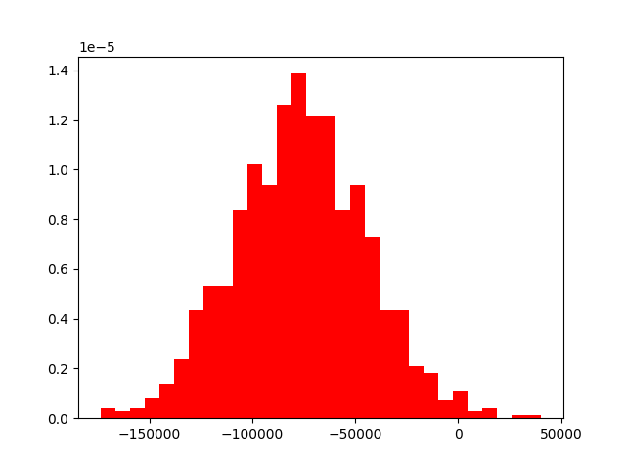

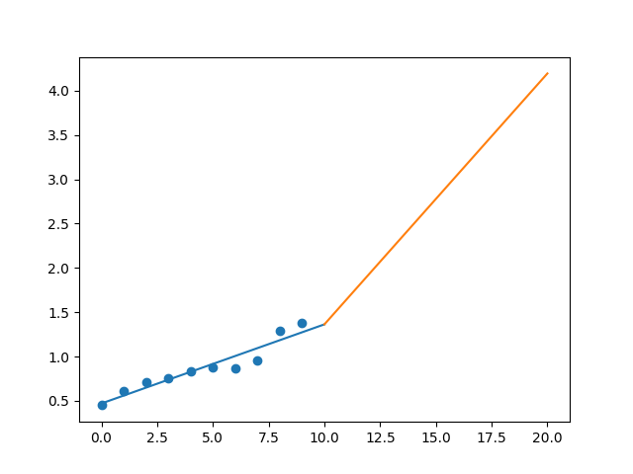

R-Value ROE: 0.829

R-Value EPS: 0.952

CAGR EPS: 0.118

PE Min: 20.25

PE Max: 30.819

Projected AGR Min: 6.126

Projected AGR Max: 10.678

# TICKER: FITB

Something wrong happened

# TICKER: FRC

Something wrong happened

# TICKER: FISV

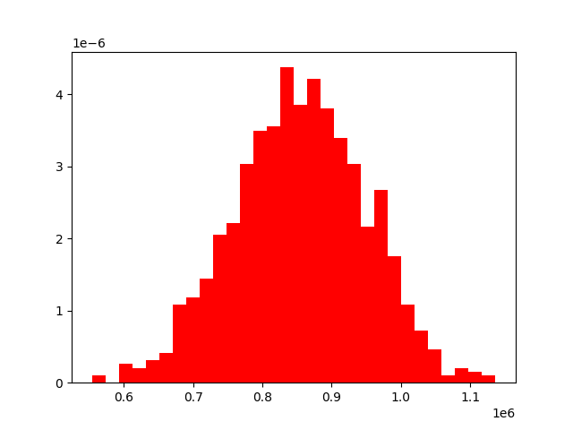

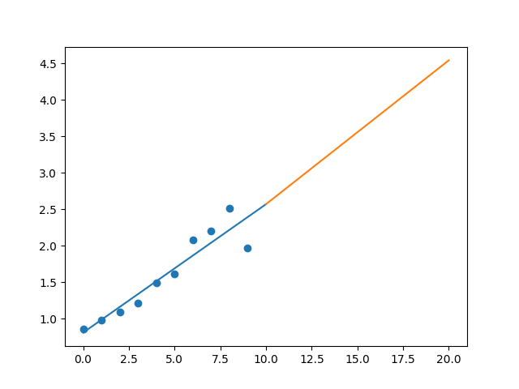

R-Value ROE: 0.416

R-Value EPS: 0.935

CAGR EPS: 0.087

PE Min: 24.944

PE Max: 78.447

Projected AGR Min: 0.562

Projected AGR Max: 12.771

# TICKER: FLT

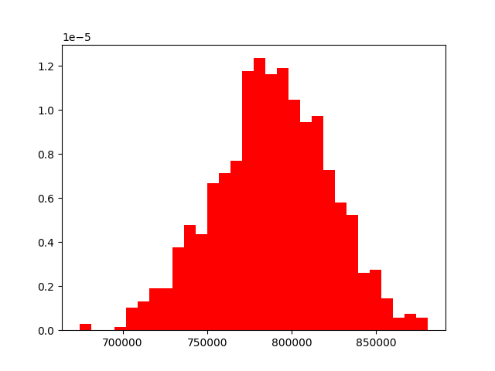

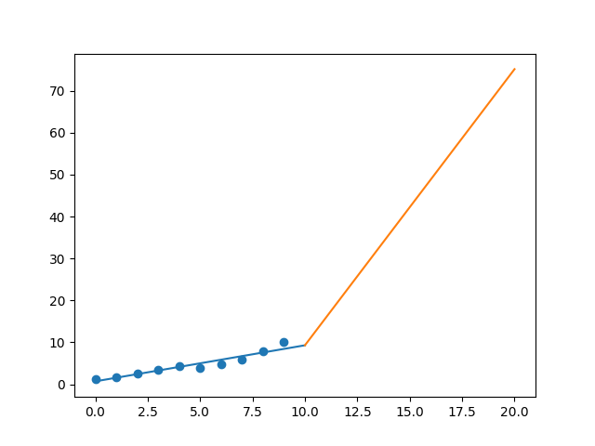

R-Value ROE: 0.254

R-Value EPS: 0.951

CAGR EPS: 0.223

PE Min: 19.288

PE Max: 40.317

Projected AGR Min: 17.92

Projected AGR Max: 26.943

# TICKER: FMC

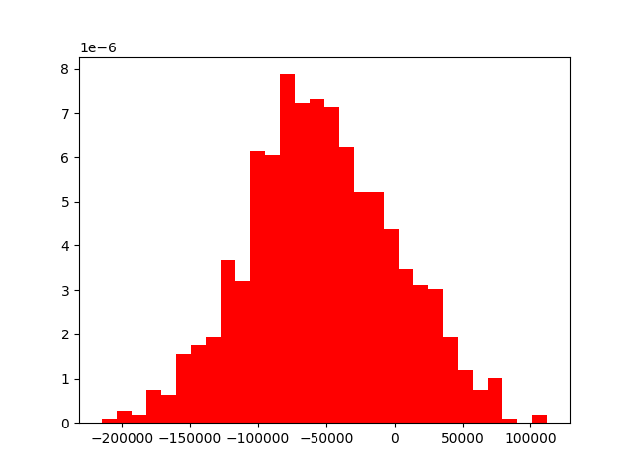

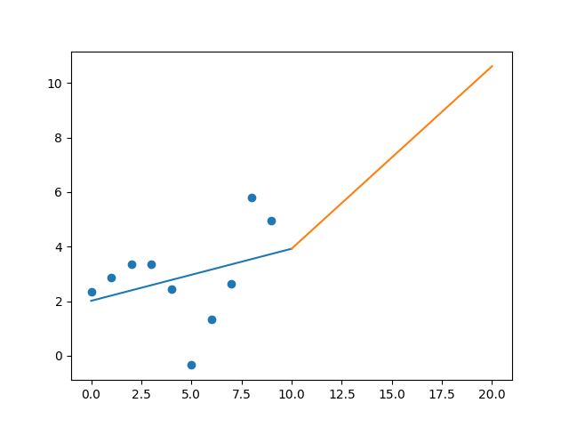

R-Value ROE: 0.376

R-Value EPS: 0.336

CAGR EPS: 0.079

PE Min: 16.499

PE Max: 61.186

Projected AGR Min: 4.75

Projected AGR Max: 19.419

# TICKER: F

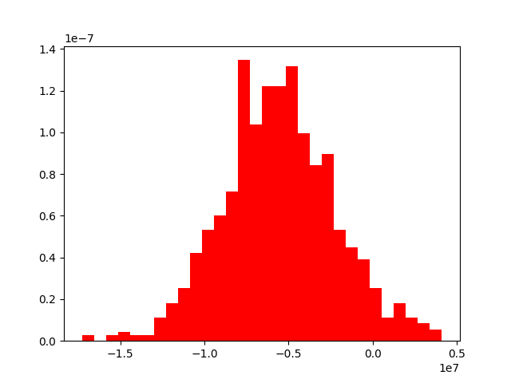

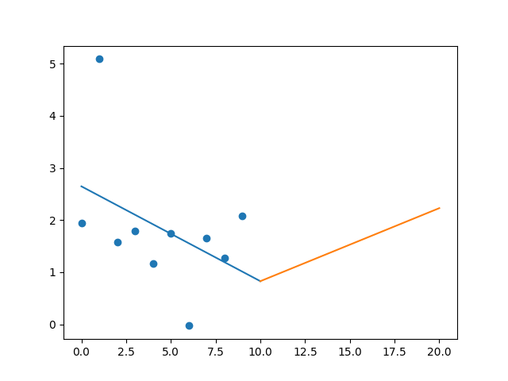

R-Value ROE: 0.447

R-Value EPS: 0.427

CAGR EPS: 0.007

PE Min: 5.362

PE Max: 295.896

Projected AGR Min: 3.576

Projected AGR Max: 54.681

# TICKER: FTNT

Something wrong happened

# TICKER: FBHS

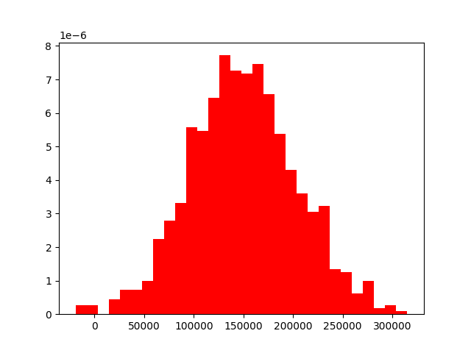

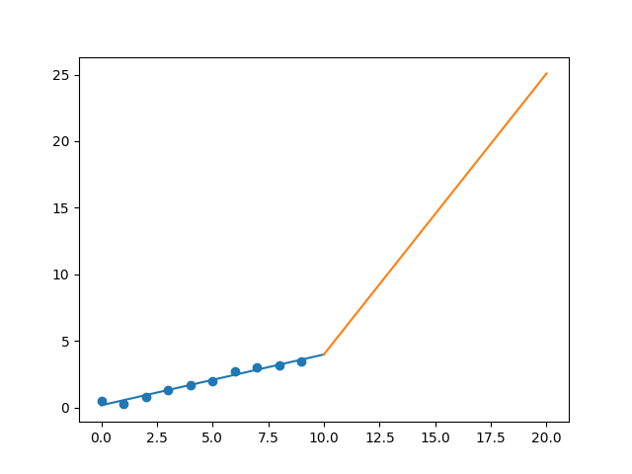

R-Value ROE: 0.656

R-Value EPS: 0.986

CAGR EPS: 0.22

PE Min: 13.366

PE Max: 29.578

Projected AGR Min: 15.44

Projected AGR Max: 24.983