Monte-Carlo Discounted Cash Flow Model and Buffett Analysis

# TICKER: BEN

Something wrong happened

# TICKER: IT

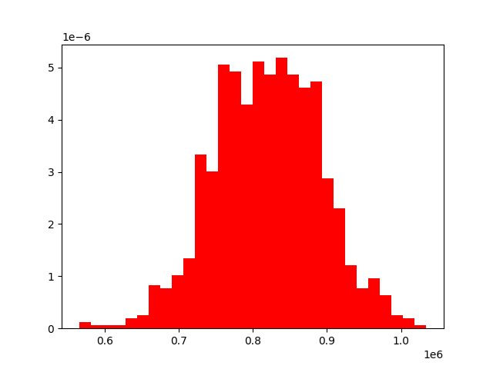

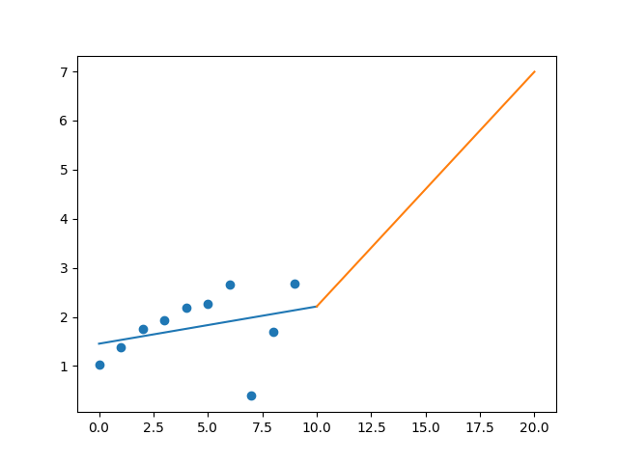

R-Value ROE: 0.062

R-Value EPS: 0.32

CAGR EPS: 0.101

PE Min: 31.407

PE Max: 515.796

Projected AGR Min: 3.4

Projected AGR Max: 36.794

# TICKER: GD

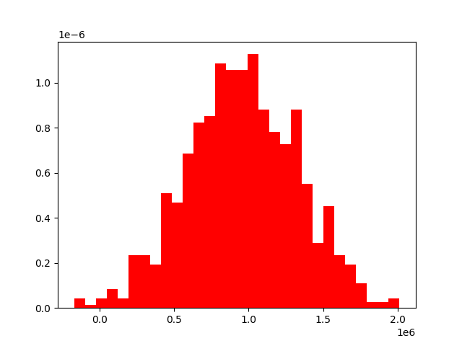

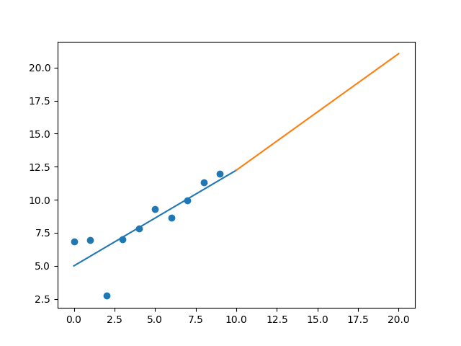

R-Value ROE: 0.586

R-Value EPS: 0.826

CAGR EPS: 0.058

PE Min: 10.974

PE Max: 22.027

Projected AGR Min: 4.299

Projected AGR Max: 11.825

# TICKER: GIS

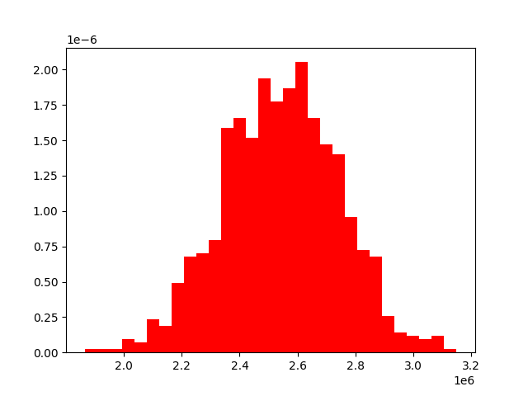

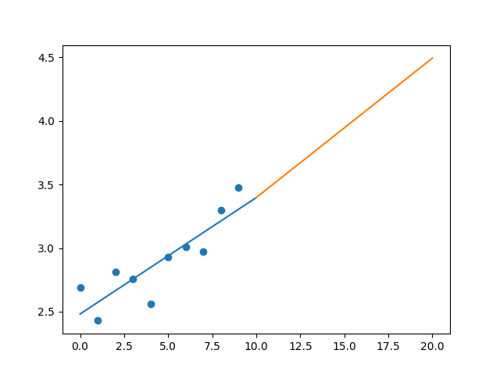

R-Value ROE: 0.256

R-Value EPS: 0.868

CAGR EPS: 0.026

PE Min: 15.217

PE Max: 25.788

Projected AGR Min: 1.542

Projected AGR Max: 7.042

# TICKER: GPC

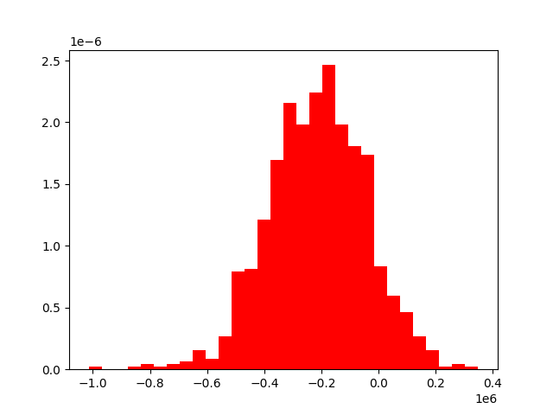

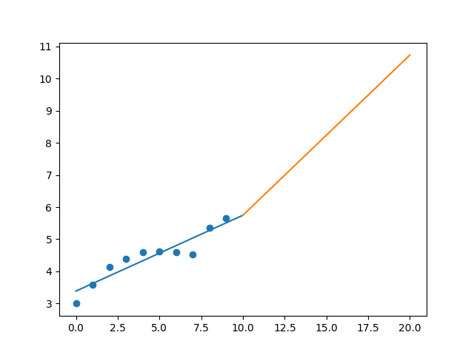

R-Value ROE: 0.06

R-Value EPS: 0.927

CAGR EPS: 0.066

PE Min: 17.334

PE Max: 3817.489

Projected AGR Min: 6.415

Projected AGR Max: 82.512

# TICKER: GILD

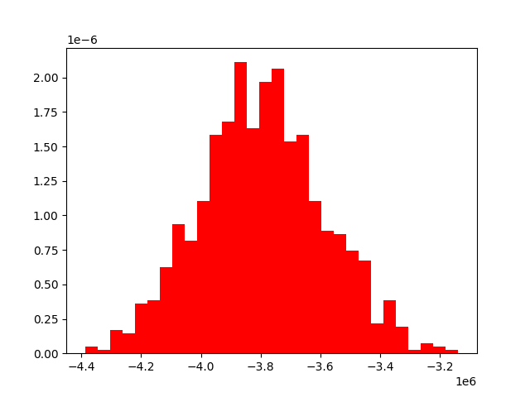

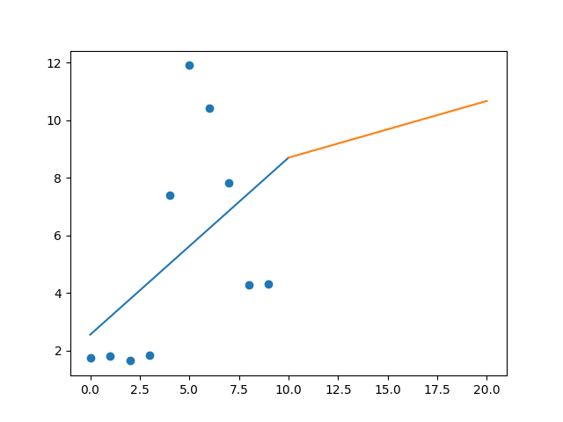

R-Value ROE: 0.147

R-Value EPS: 0.484

CAGR EPS: 0.095

PE Min: 7.179

PE Max: 65.662

Projected AGR Min: 2.298

Projected AGR Max: 27.64

# TICKER: GPN

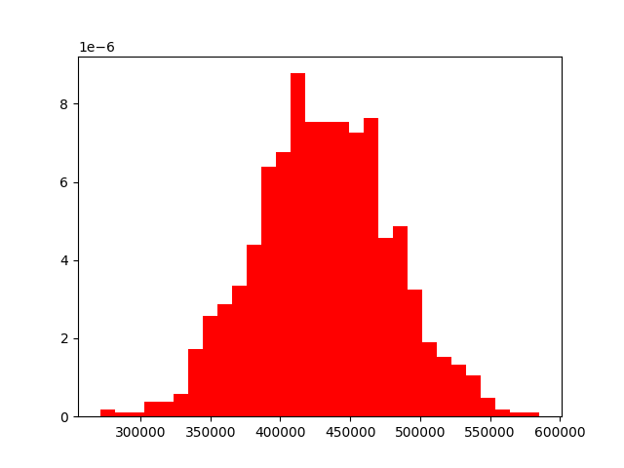

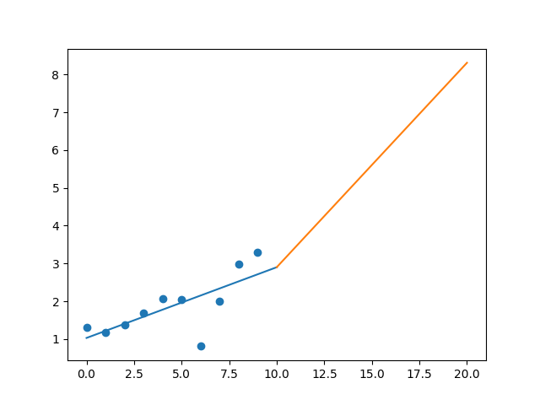

R-Value ROE: 0.54

R-Value EPS: 0.723

CAGR EPS: 0.097

PE Min: 26.625

PE Max: 114.959

Projected AGR Min: 1.262

Projected AGR Max: 17.211

# TICKER: GL

Something wrong happened

# TICKER: GS

Something wrong happened

# TICKER: GWW

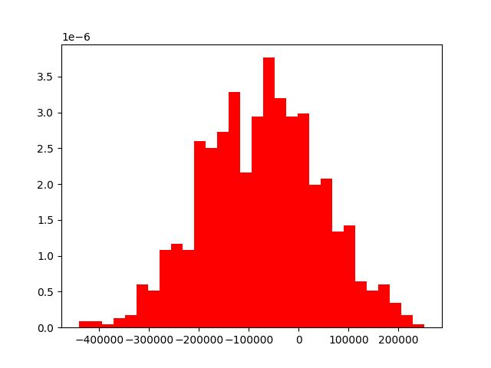

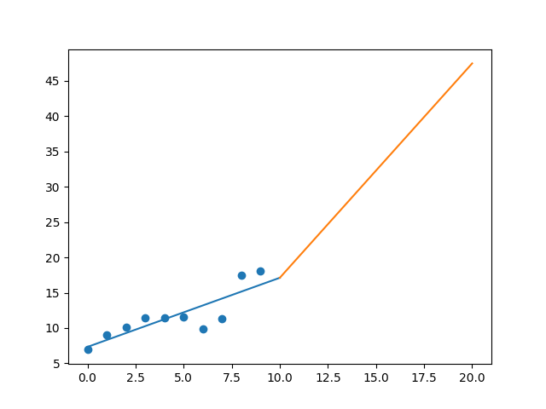

R-Value ROE: 0.932

R-Value EPS: 0.847

CAGR EPS: 0.101

PE Min: 17.31

PE Max: 30.489

Projected AGR Min: 7.348

Projected AGR Max: 13.6

# TICKER: HAL

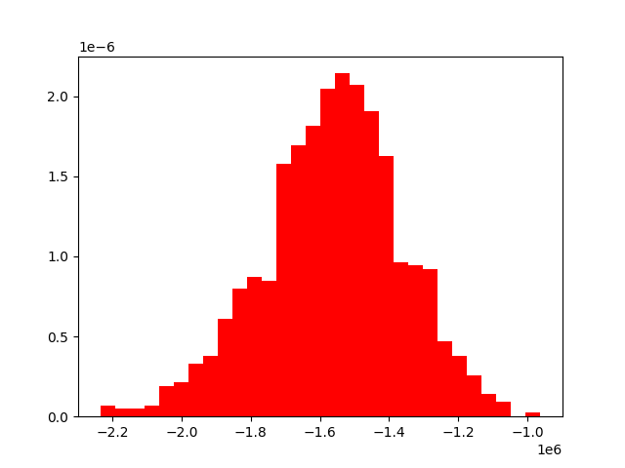

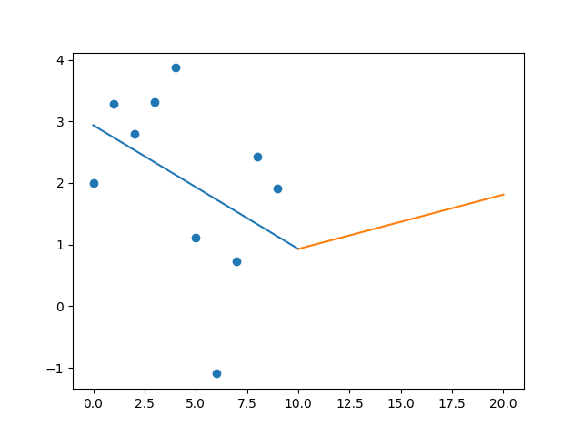

R-Value ROE: 0.485

R-Value EPS: 0.411

CAGR EPS: -0.005

PE Min: 14.454

PE Max: 191.083

Projected AGR Min: 6.242

Projected AGR Max: 37.537

# TICKER: HBI

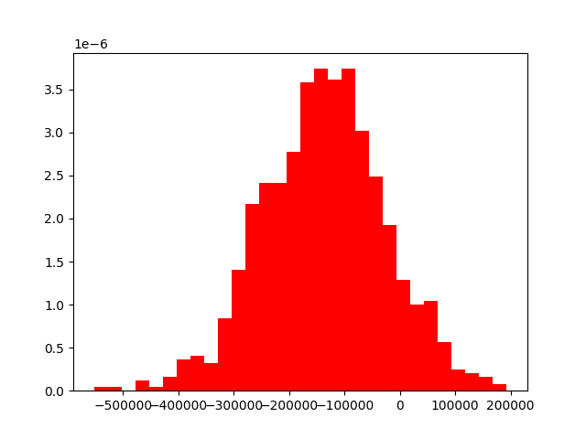

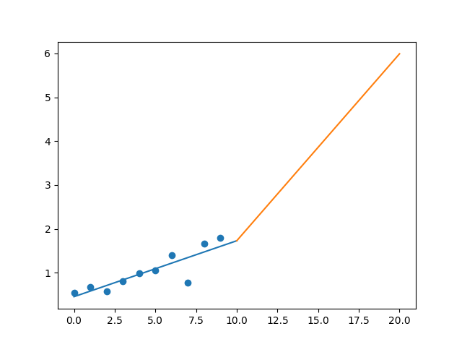

R-Value ROE: 0.341

R-Value EPS: 0.864

CAGR EPS: 0.128

PE Min: 5.885

PE Max: 29.52

Projected AGR Min: 10.486

Projected AGR Max: 29.822

# TICKER: HIG

Something wrong happened

# TICKER: HAS

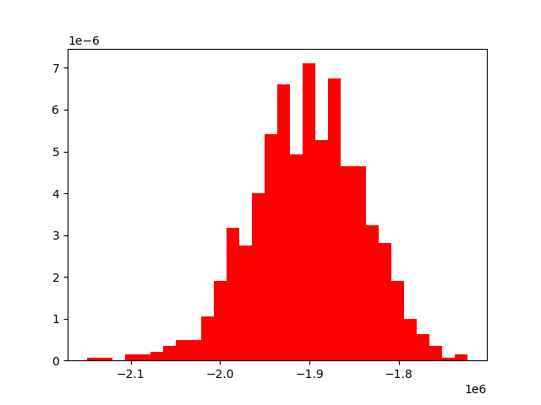

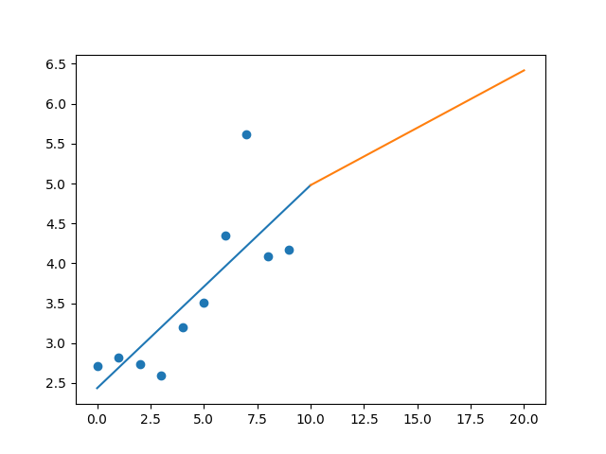

R-Value ROE: 0.435

R-Value EPS: 0.793

CAGR EPS: 0.044

PE Min: 16.04

PE Max: 55.528

Projected AGR Min: 1.871

Projected AGR Max: 15.341

# TICKER: HCA

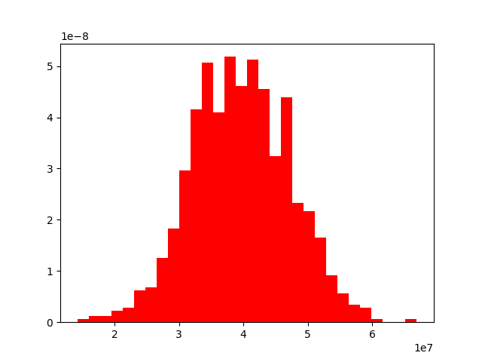

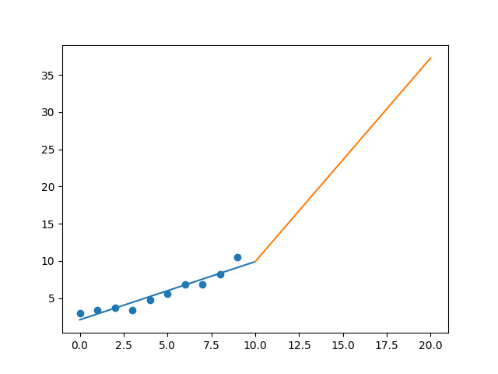

R-Value ROE: 0.791

R-Value EPS: 0.955

CAGR EPS: 0.135

PE Min: 10.009

PE Max: 15.667

Projected AGR Min: 9.501

Projected AGR Max: 14.519

# TICKER: HSIC

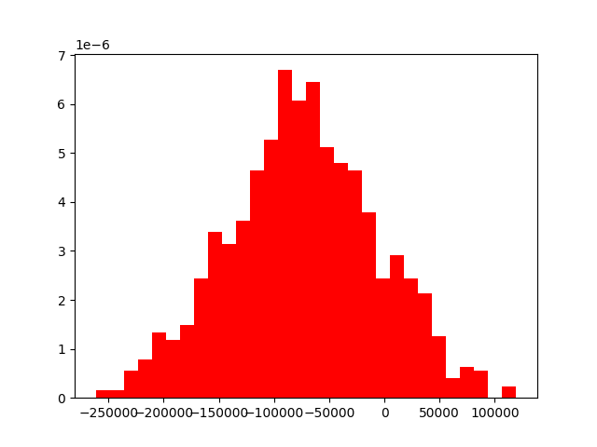

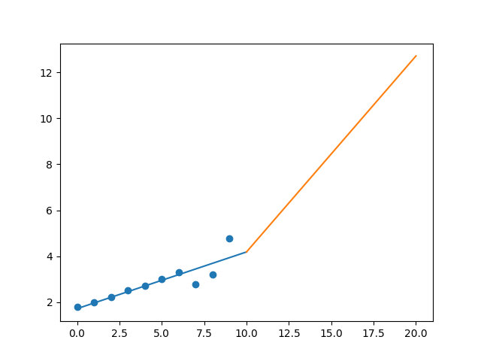

R-Value ROE: 0.756

R-Value EPS: 0.885

CAGR EPS: 0.103

PE Min: 10.316

PE Max: 24.529

Projected AGR Min: 6.786

Projected AGR Max: 16.447

# TICKER: HPE

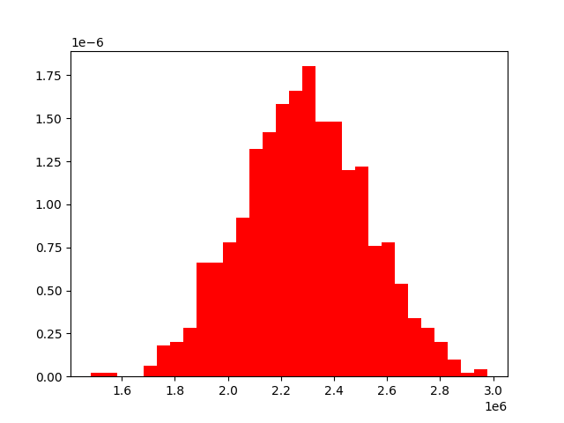

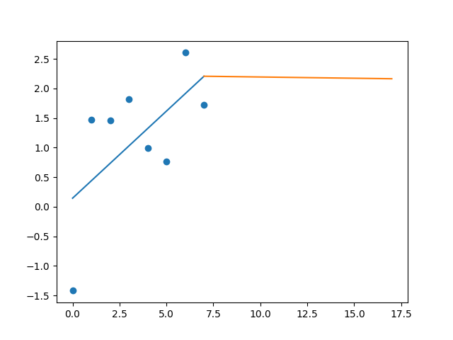

R-Value ROE: 0.143

R-Value EPS: 0.608

CAGR EPS: 0.023

PE Min: 4.634

PE Max: 159.733

Projected AGR Min: 0.111

Projected AGR Max: 42.636

# TICKER: HLT

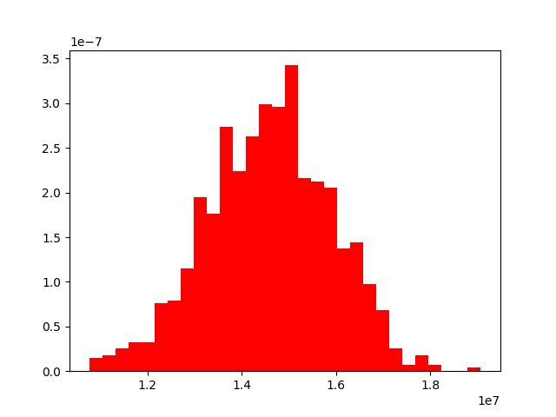

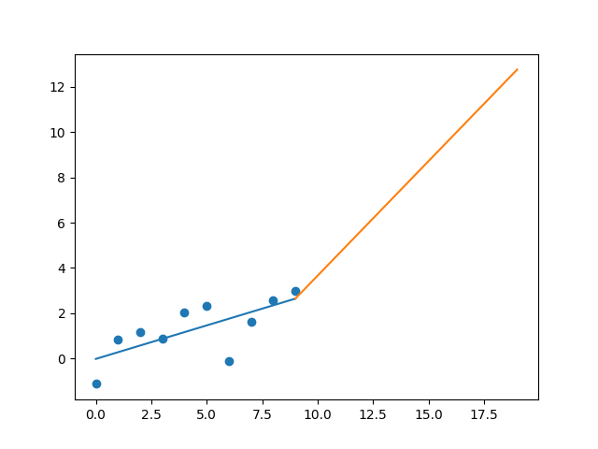

R-Value ROE: 0.139

R-Value EPS: 0.707

CAGR EPS: 0.156

PE Min: 17.18

PE Max: 573.201

Projected AGR Min: 7.804

Projected AGR Max: 53.096

# TICKER: HFC

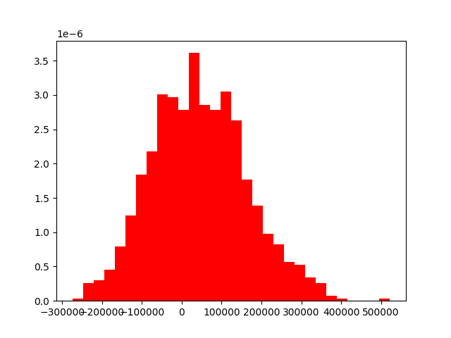

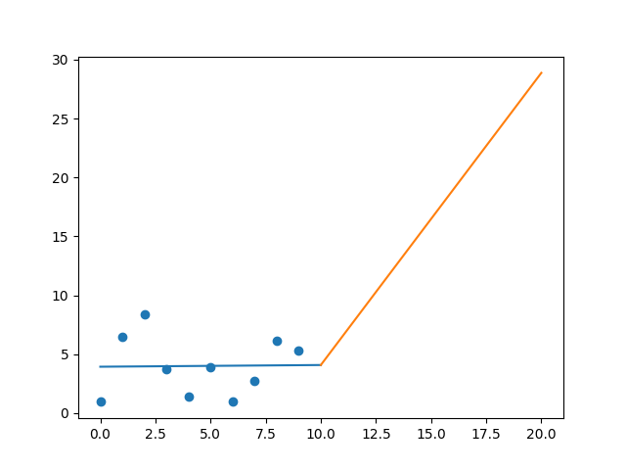

R-Value ROE: 0.281

R-Value EPS: 0.017

CAGR EPS: 0.185

PE Min: 8.072

PE Max: 34.726

Projected AGR Min: 26.785

Projected AGR Max: 46.701

# TICKER: HOLX

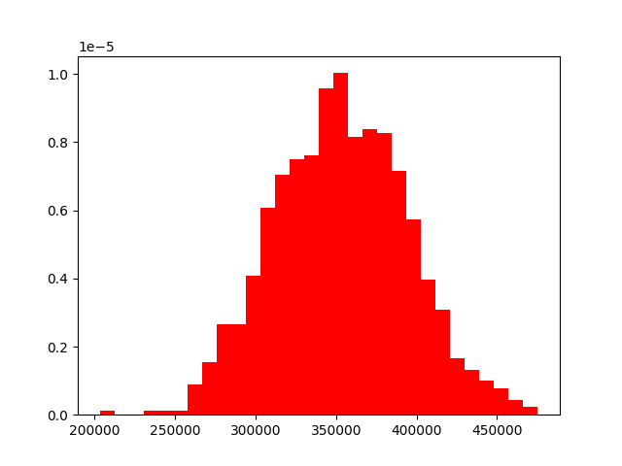

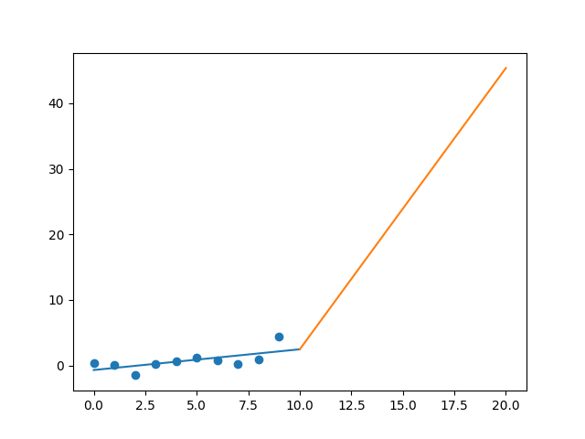

R-Value ROE: 0.438

R-Value EPS: 0.651

CAGR EPS: 0.264

PE Min: 13.879

PE Max: 170.86

Projected AGR Min: 25.143

Projected AGR Max: 60.855

# TICKER: HD

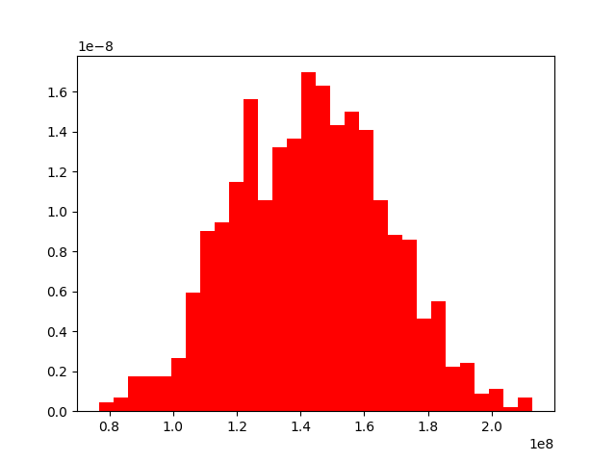

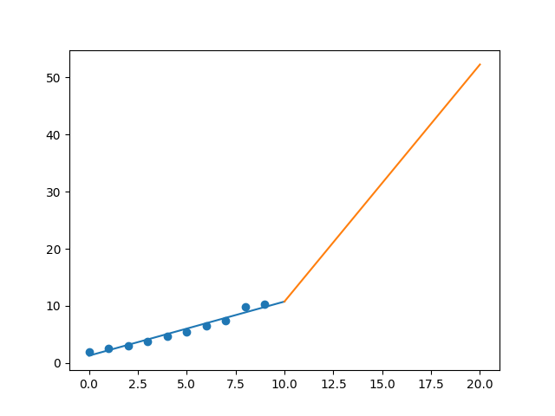

R-Value ROE: 0.257

R-Value EPS: 0.982

CAGR EPS: 0.177

PE Min: 18.774

PE Max: 28.009

Projected AGR Min: 13.602

Projected AGR Max: 18.238

# TICKER: HON

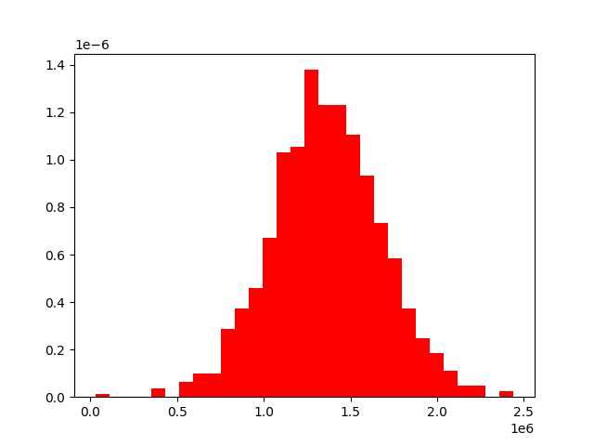

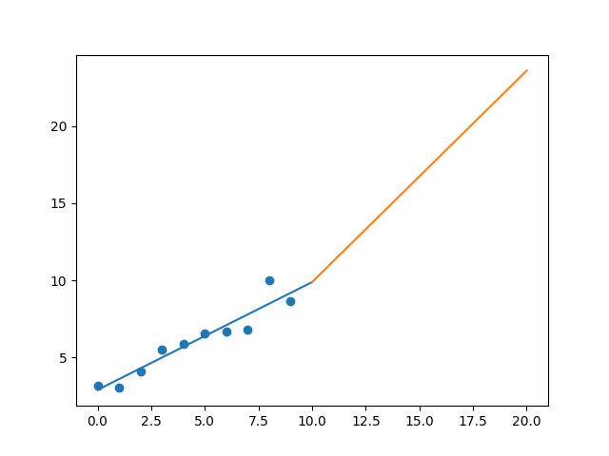

R-Value ROE: 0.473

R-Value EPS: 0.948

CAGR EPS: 0.106

PE Min: 15.731

PE Max: 24.817

Projected AGR Min: 6.276

Projected AGR Max: 11.233

# TICKER: HRL

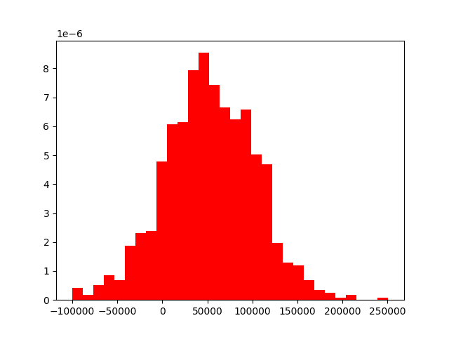

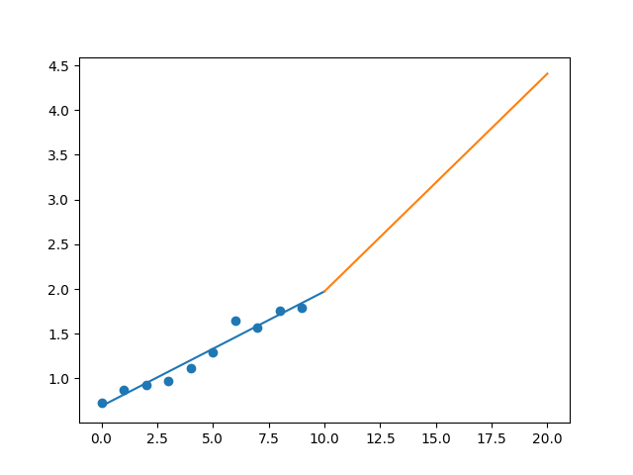

R-Value ROE: 0.189

R-Value EPS: 0.978

CAGR EPS: 0.094

PE Min: 19.344

PE Max: 29.507

Projected AGR Min: 5.313

Projected AGR Max: 9.855

# TICKER: HST

Something wrong happened

# TICKER: HWM

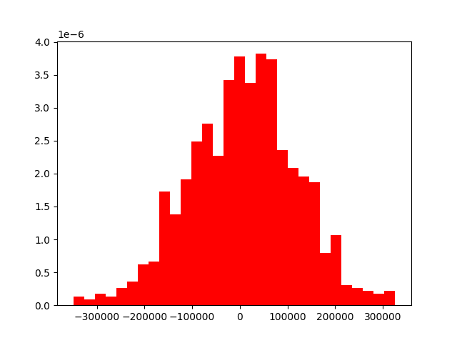

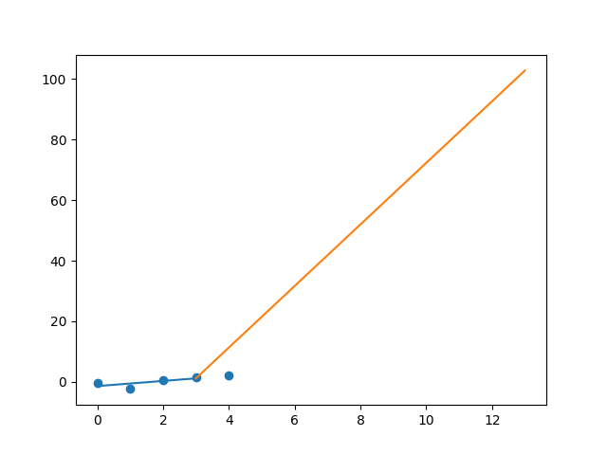

R-Value ROE: 0.728

R-Value EPS: 0.776

CAGR EPS: 0.473

PE Min: 9.148

PE Max: 63.94

Projected AGR Min: 44.875

Projected AGR Max: 75.969

# TICKER: HUM

Something wrong happened

# TICKER: HBAN

Something wrong happened

# TICKER: HII

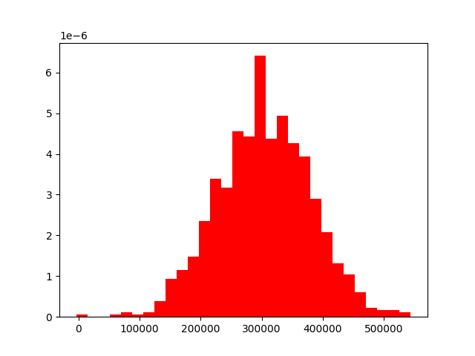

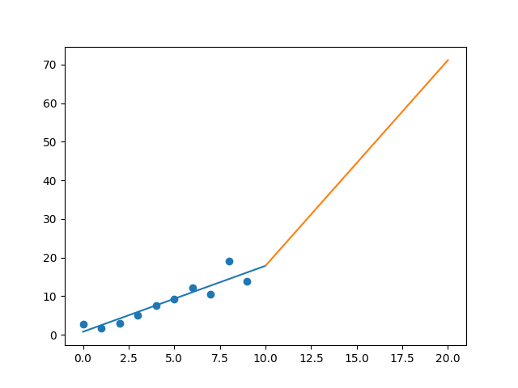

R-Value ROE: 0.815

R-Value EPS: 0.927

CAGR EPS: 0.178

PE Min: 9.96

PE Max: 22.664

Projected AGR Min: 15.941

Projected AGR Max: 25.876

# TICKER: IEX

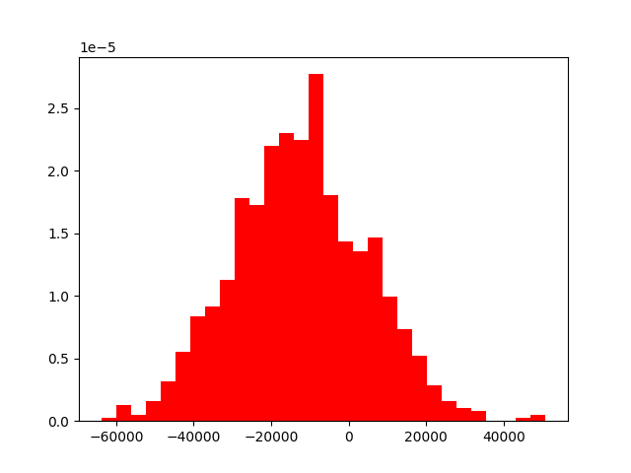

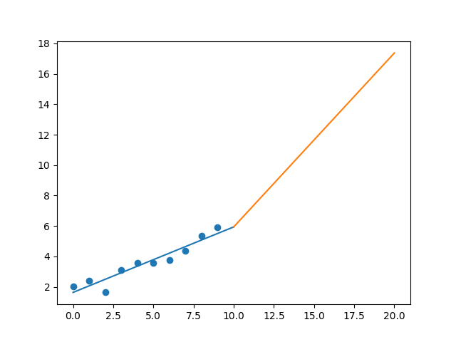

R-Value ROE: 0.683

R-Value EPS: 0.952

CAGR EPS: 0.114

PE Min: 21.116

PE Max: 37.265

Projected AGR Min: 6.426

Projected AGR Max: 12.647

# TICKER: IDXX

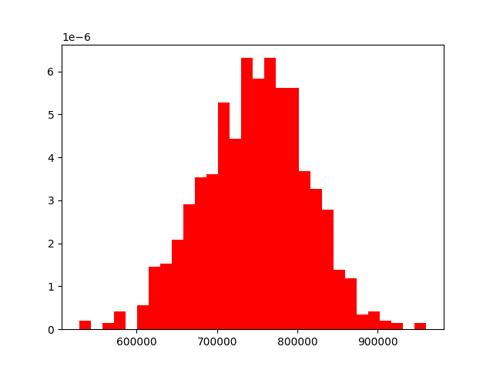

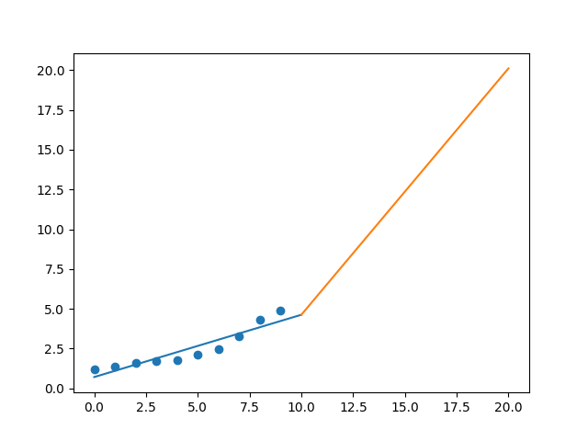

R-Value ROE: 0.433

R-Value EPS: 0.931

CAGR EPS: 0.152

PE Min: 35.565

PE Max: 68.519

Projected AGR Min: 4.968

Projected AGR Max: 12.082

# TICKER: ITW

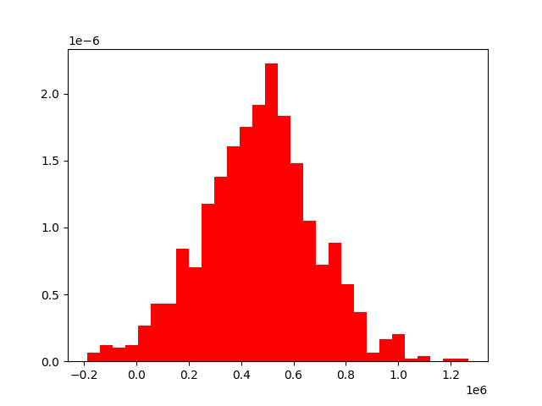

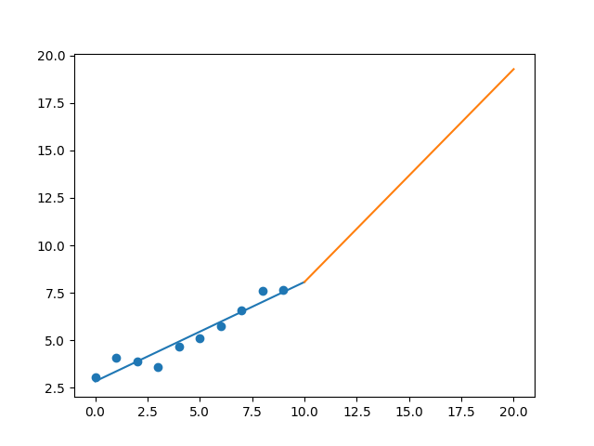

R-Value ROE: 0.882

R-Value EPS: 0.962

CAGR EPS: 0.097

PE Min: 16.666

PE Max: 29.304

Projected AGR Min: 3.893

Projected AGR Max: 9.925

# TICKER: ILMN

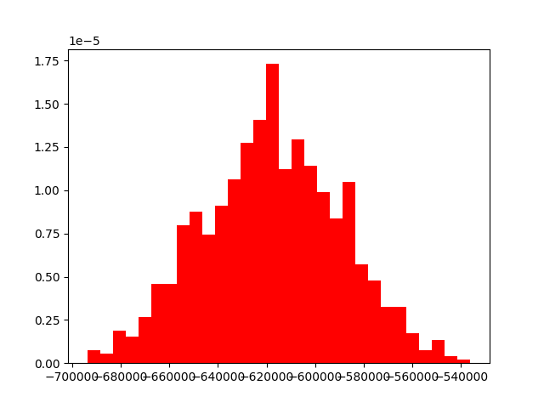

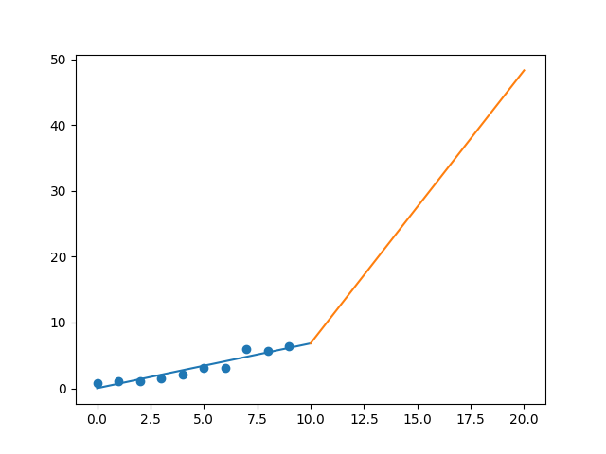

R-Value ROE: 0.778

R-Value EPS: 0.946

CAGR EPS: 0.224

PE Min: 34.003

PE Max: 77.079

Projected AGR Min: 18.484

Projected AGR Max: 28.589

# TICKER: INCY

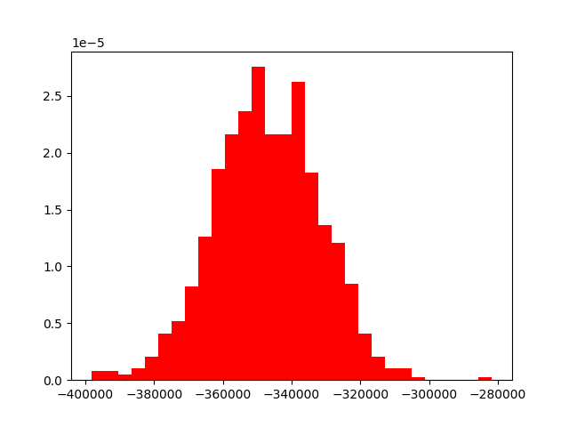

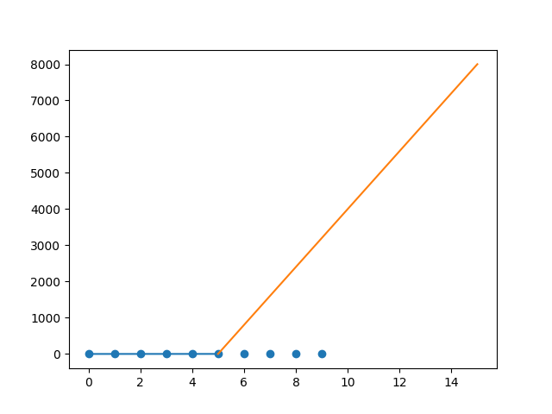

R-Value ROE: 0.652

R-Value EPS: 0.583

CAGR EPS: 1.277

PE Min: 39.816

PE Max: 344.047

Projected AGR Min: 128.19

Projected AGR Max: 183.108

# TICKER: INTC

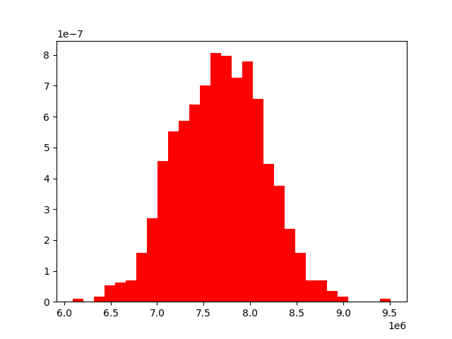

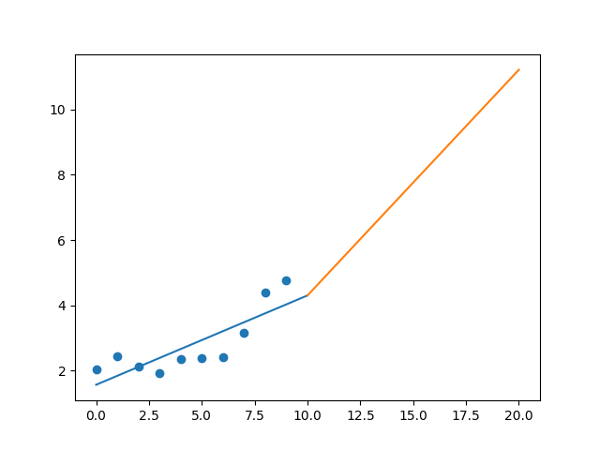

R-Value ROE: 0.036

R-Value EPS: 0.824

CAGR EPS: 0.089

PE Min: 9.793

PE Max: 17.751

Projected AGR Min: 9.262

Projected AGR Max: 15.958

# TICKER: ICE

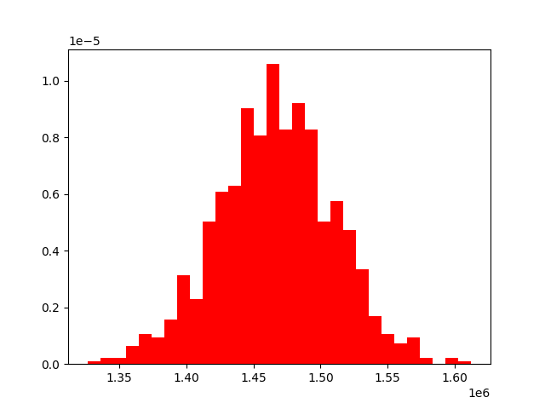

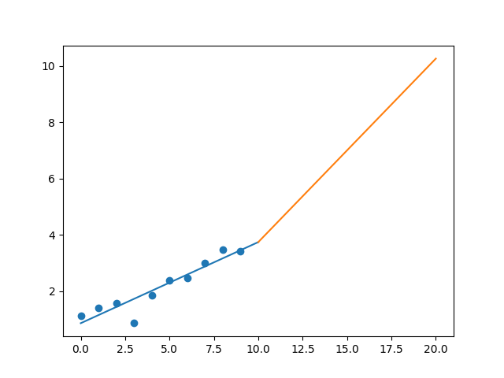

R-Value ROE: 0.172

R-Value EPS: 0.931

CAGR EPS: 0.116

PE Min: 20.163

PE Max: 27.571

Projected AGR Min: 7.764

Projected AGR Max: 11.19

# TICKER: IBM

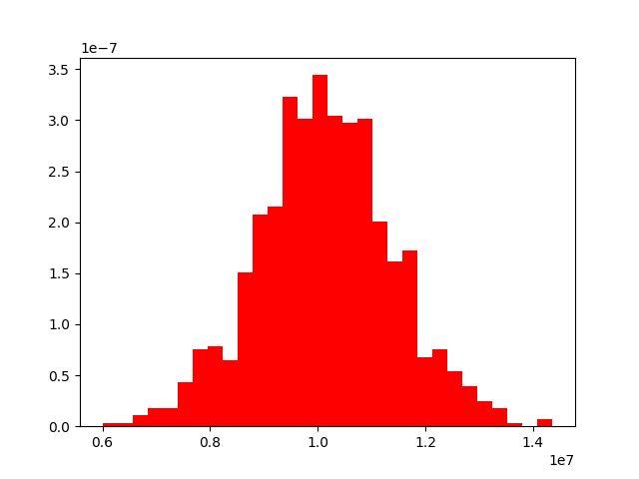

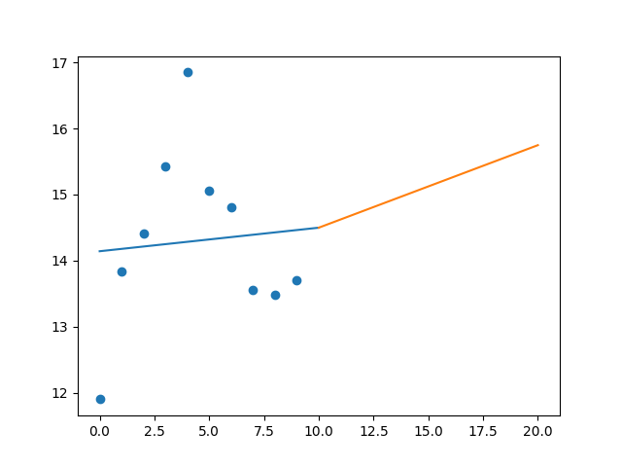

R-Value ROE: 0.561

R-Value EPS: 0.081

CAGR EPS: 0.014

PE Min: 9.657

PE Max: 14.312

Projected AGR Min: 2.585

Projected AGR Max: 6.7

# TICKER: IFF

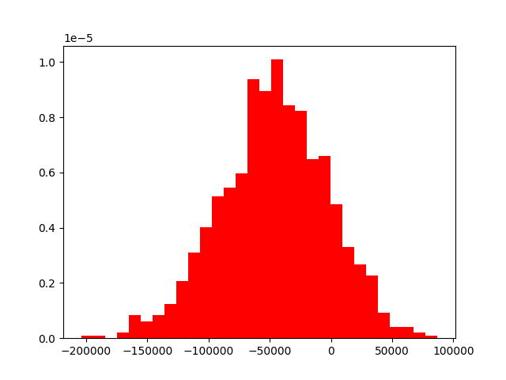

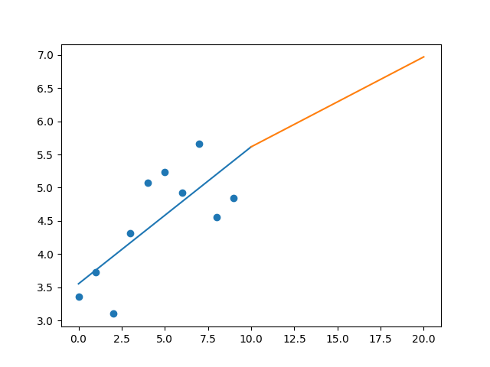

R-Value ROE: 0.727

R-Value EPS: 0.74

CAGR EPS: 0.037

PE Min: 19.562

PE Max: 39.394

Projected AGR Min: 1.986

Projected AGR Max: 9.381