Monte-Carlo Discounted Cash Flow Model and Buffett Analysis

# TICKER: IP

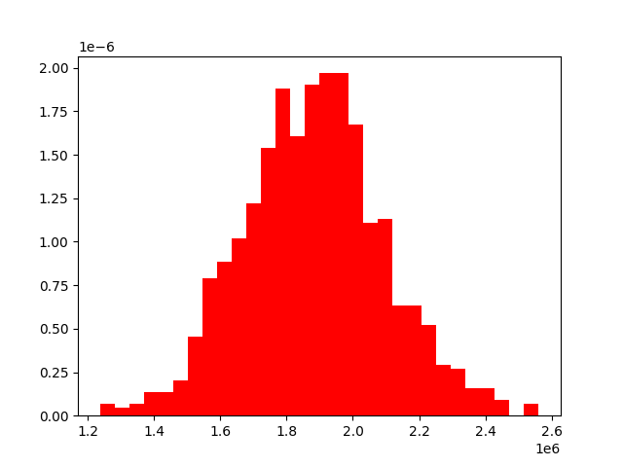

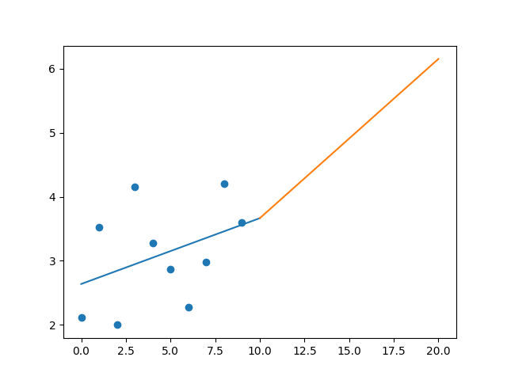

R-Value ROE: 0.571

R-Value EPS: 0.389

CAGR EPS: 0.055

PE Min: 10.253

PE Max: 33.668

Projected AGR Min: 2.585

Projected AGR Max: 15.536

# TICKER: IPG

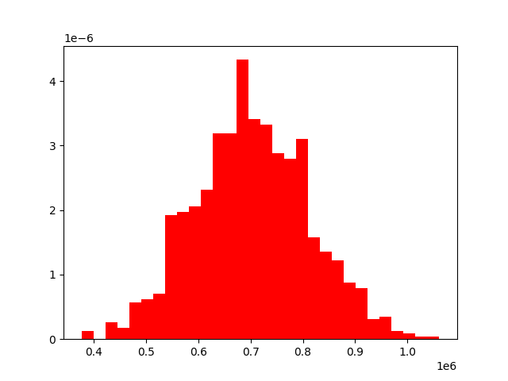

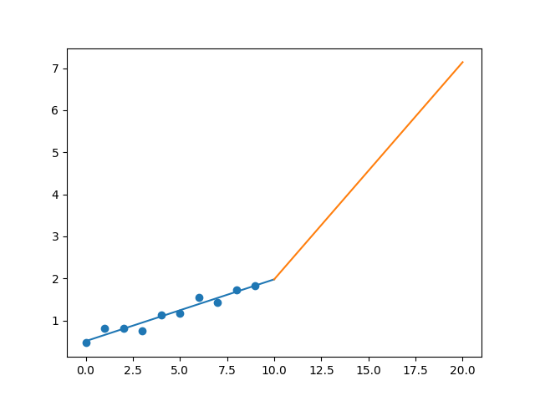

R-Value ROE: 0.713

R-Value EPS: 0.968

CAGR EPS: 0.146

PE Min: 9.507

PE Max: 21.198

Projected AGR Min: 12.183

Projected AGR Max: 21.549

# TICKER: INTU

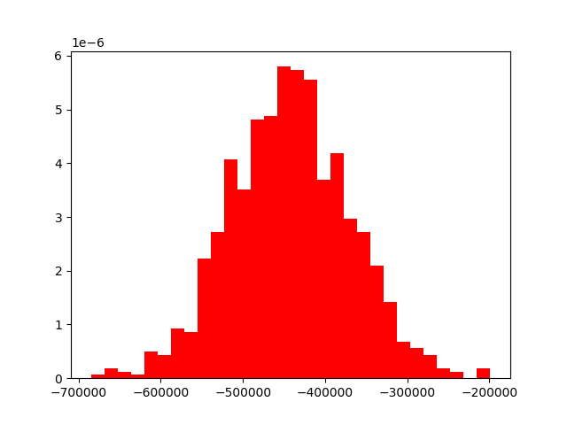

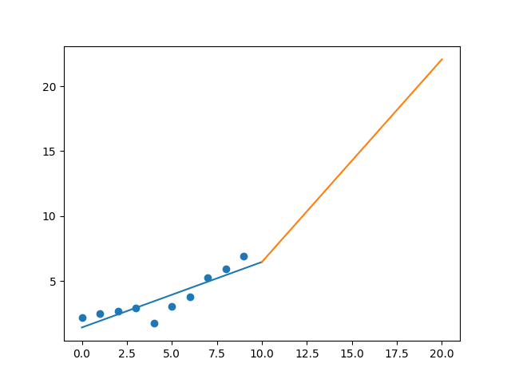

R-Value ROE: 0.418

R-Value EPS: 0.877

CAGR EPS: 0.123

PE Min: 29.12

PE Max: 53.303

Projected AGR Min: 6.492

Projected AGR Max: 13.129

# TICKER: ISRG

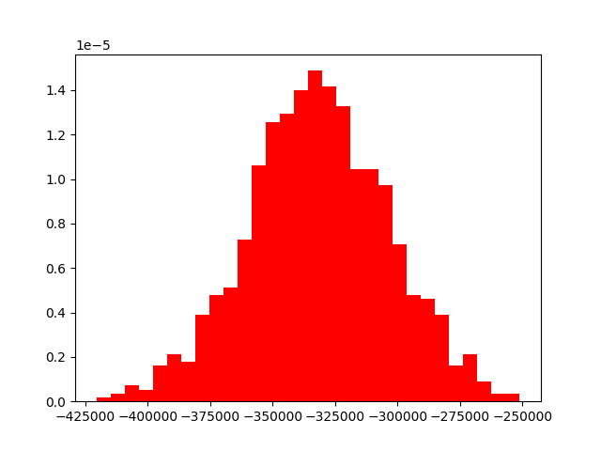

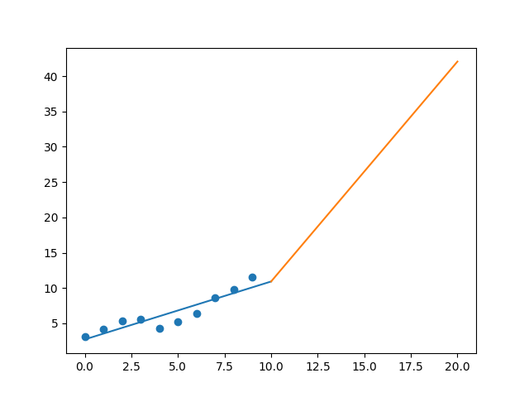

R-Value ROE: 0.485

R-Value EPS: 0.912

CAGR EPS: 0.138

PE Min: 33.775

PE Max: 80.872

Projected AGR Min: 6.639

Projected AGR Max: 16.369

# TICKER: IVZ

Something wrong happened

# TICKER: IRM

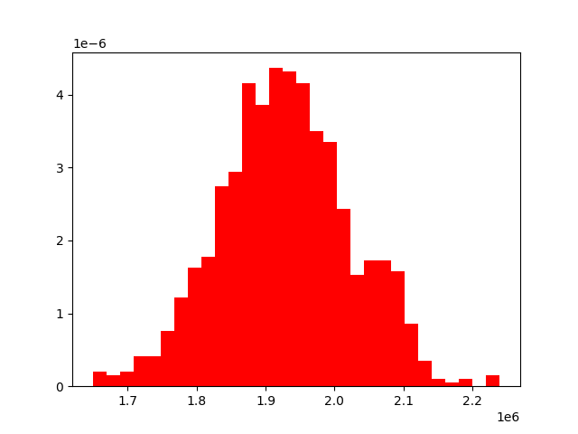

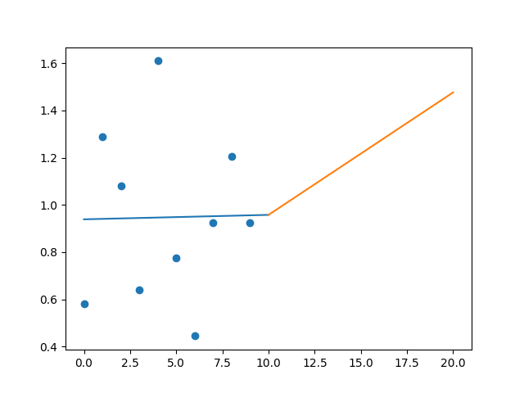

R-Value ROE: 0.056

R-Value EPS: 0.016

CAGR EPS: 0.048

PE Min: 22.708

PE Max: 134.879

Projected AGR Min: 2.088

Projected AGR Max: 21.997

# TICKER: JBHT

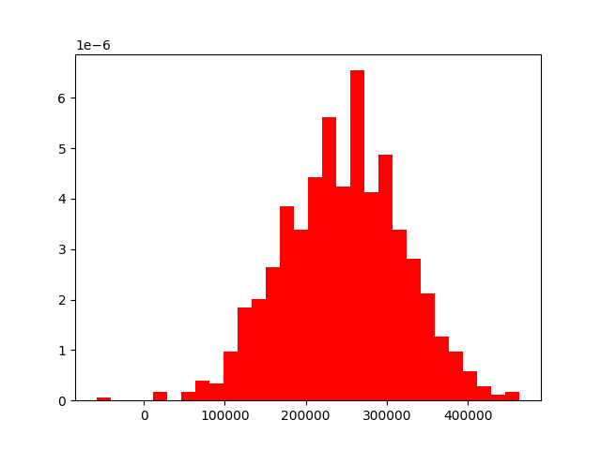

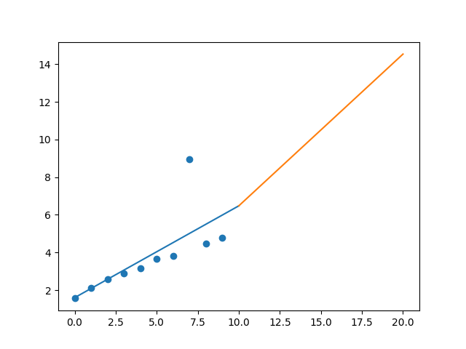

R-Value ROE: 0.752

R-Value EPS: 0.713

CAGR EPS: 0.118

PE Min: 12.169

PE Max: 29.59

Projected AGR Min: 3.255

Projected AGR Max: 12.85

# TICKER: JKHY

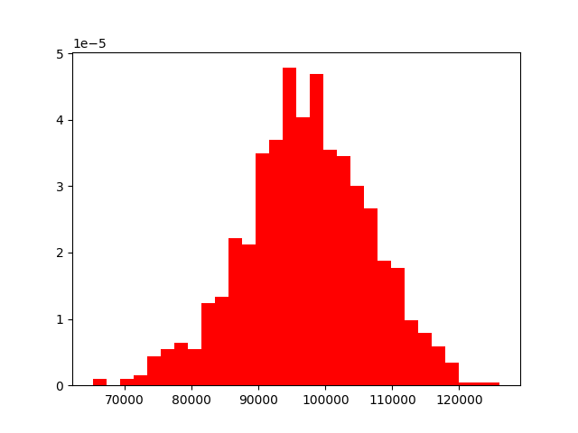

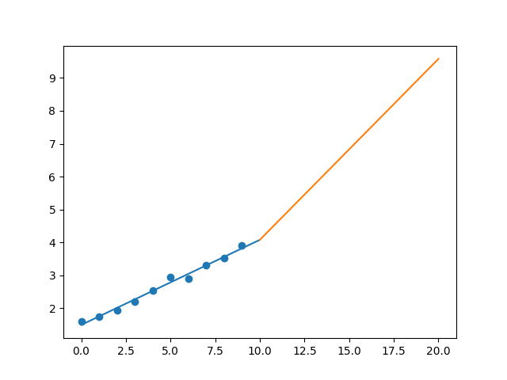

R-Value ROE: 0.573

R-Value EPS: 0.993

CAGR EPS: 0.094

PE Min: 25.996

PE Max: 47.73

Projected AGR Min: 4.475

Projected AGR Max: 11.021

# TICKER: J

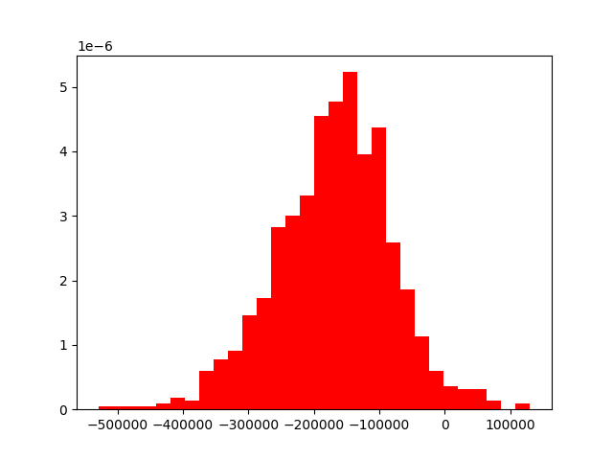

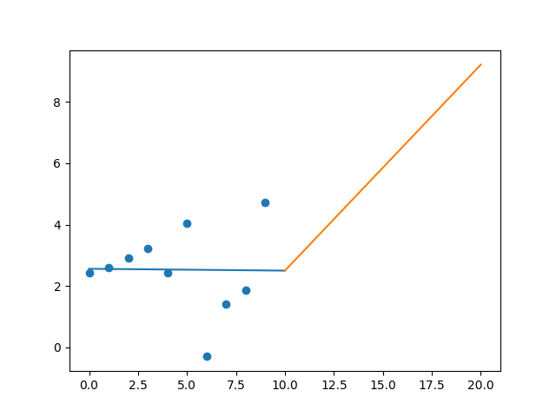

R-Value ROE: 0.155

R-Value EPS: 0.013

CAGR EPS: 0.069

PE Min: 15.657

PE Max: 49.548

Projected AGR Min: 3.566

Projected AGR Max: 16.211

# TICKER: SJM

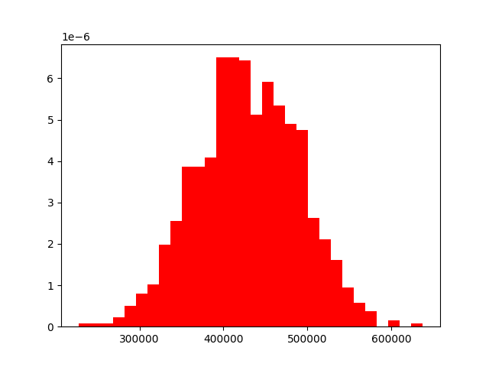

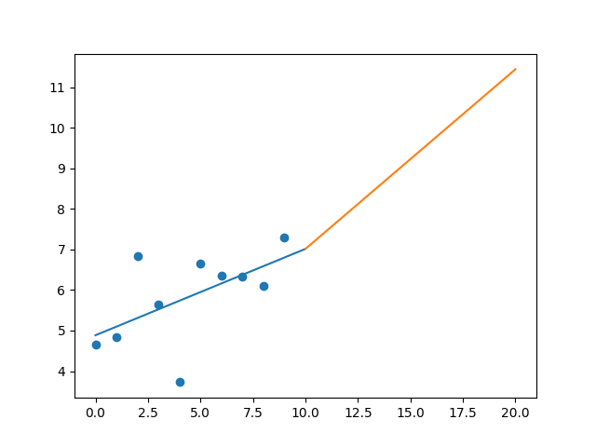

R-Value ROE: 0.093

R-Value EPS: 0.576

CAGR EPS: 0.046

PE Min: 14.48

PE Max: 38.483

Projected AGR Min: 3.473

Projected AGR Max: 14.099

# TICKER: JNJ

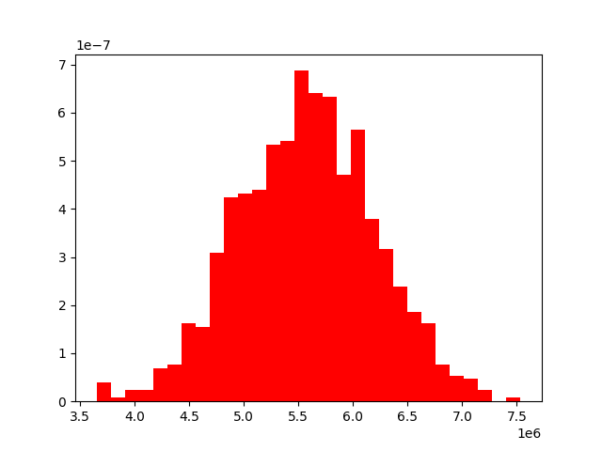

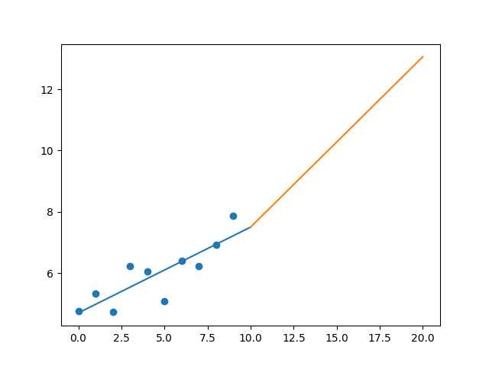

R-Value ROE: 0.045

R-Value EPS: 0.846

CAGR EPS: 0.052

PE Min: 18.748

PE Max: 26.725

Projected AGR Min: 5.127

Projected AGR Max: 8.92

# TICKER: JPM

Something wrong happened

# TICKER: KSU

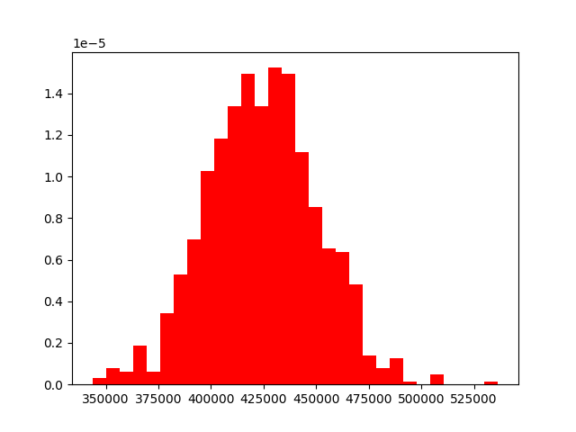

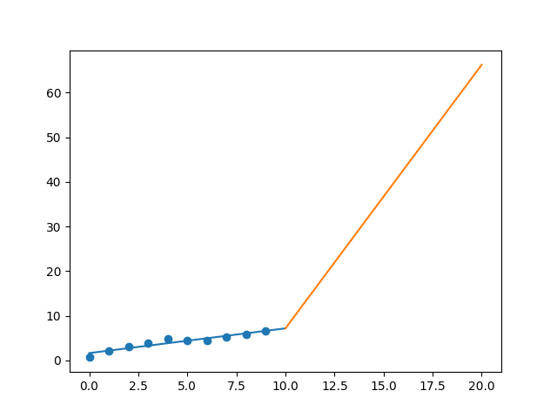

R-Value ROE: 0.522

R-Value EPS: 0.948

CAGR EPS: 0.26

PE Min: 16.096

PE Max: 29.929

Projected AGR Min: 18.991

Projected AGR Max: 26.605

# TICKER: KEY

Something wrong happened

# TICKER: KMB

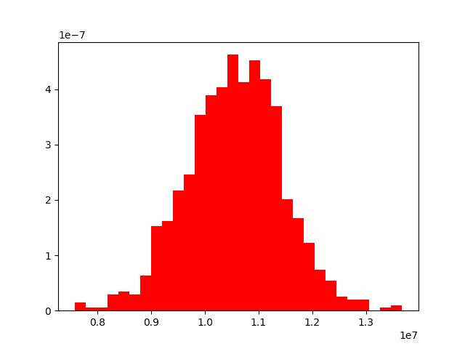

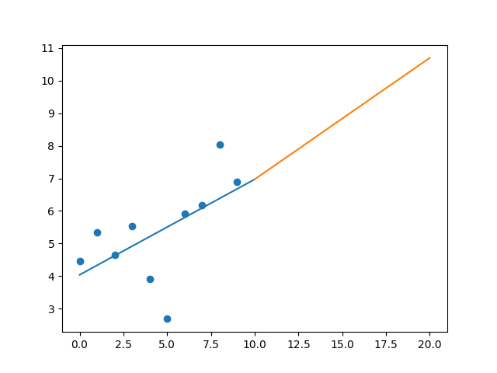

R-Value ROE: 0.597

R-Value EPS: 0.58

CAGR EPS: 0.045

PE Min: 18.673

PE Max: 46.119

Projected AGR Min: 3.847

Projected AGR Max: 13.674

# TICKER: KMI

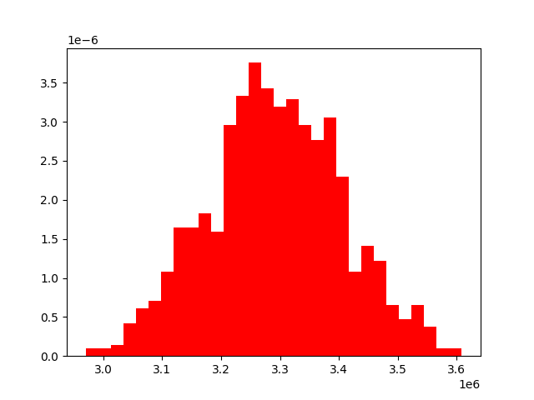

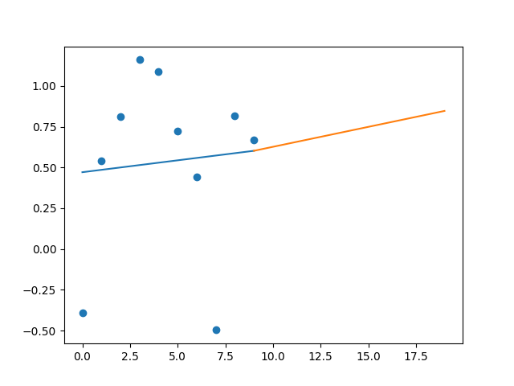

R-Value ROE: 0.18

R-Value EPS: 0.079

CAGR EPS: 0.024

PE Min: 20.921

PE Max: 484.221

Projected AGR Min: 3.212

Projected AGR Max: 41.311

# TICKER: KSS

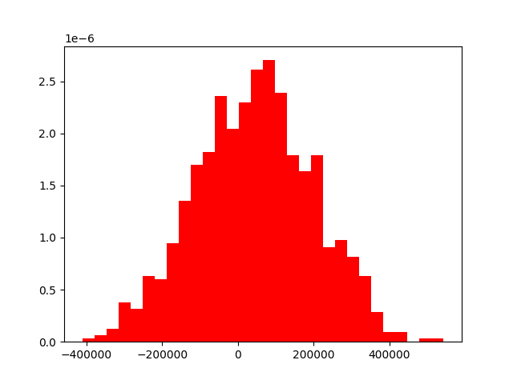

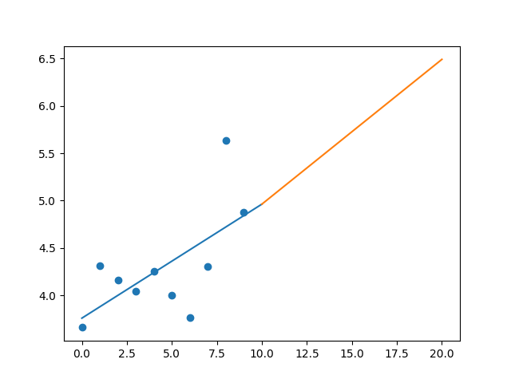

R-Value ROE: 0.484

R-Value EPS: 0.633

CAGR EPS: 0.029

PE Min: 9.735

PE Max: 35.575

Projected AGR Min: 9.242

Projected AGR Max: 24.358

# TICKER: KHC

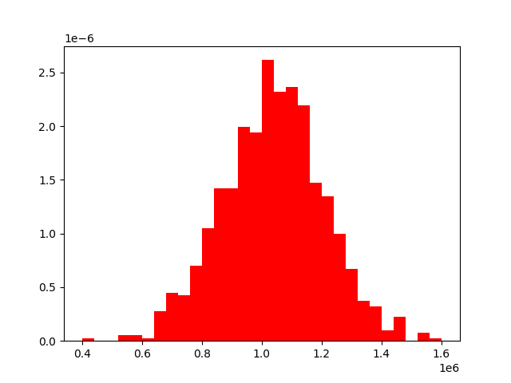

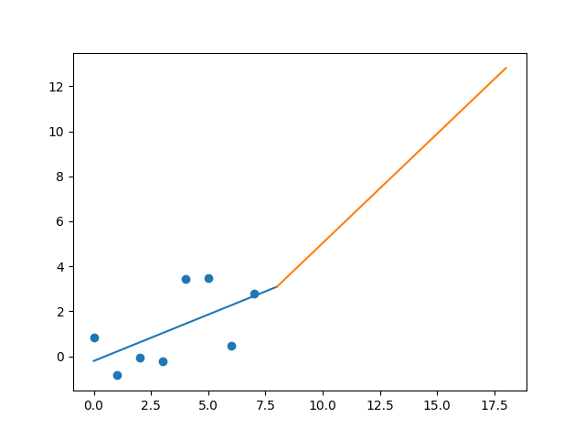

R-Value ROE: 0.139

R-Value EPS: 0.582

CAGR EPS: 0.165

PE Min: 15.542

PE Max: 182.338

Projected AGR Min: 20.655

Projected AGR Max: 54.342

# TICKER: KR

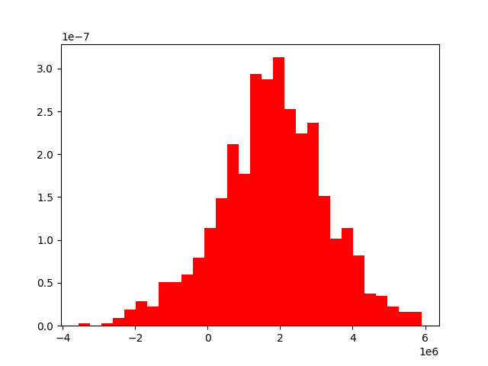

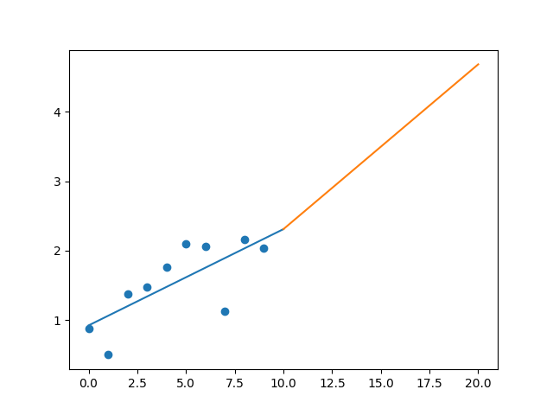

R-Value ROE: 0.285

R-Value EPS: 0.728

CAGR EPS: 0.087

PE Min: 7.588

PE Max: 27.534

Projected AGR Min: 1.113

Projected AGR Max: 15.022

# TICKER: LH

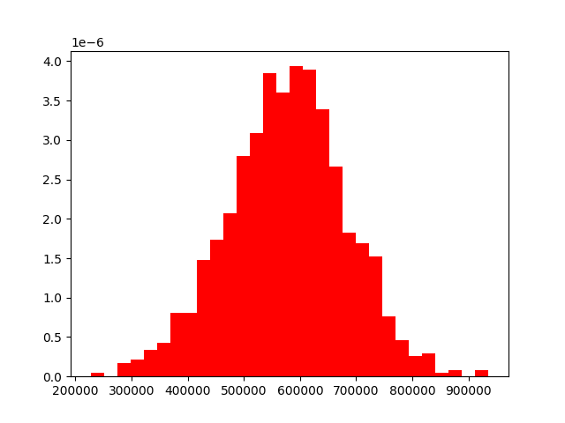

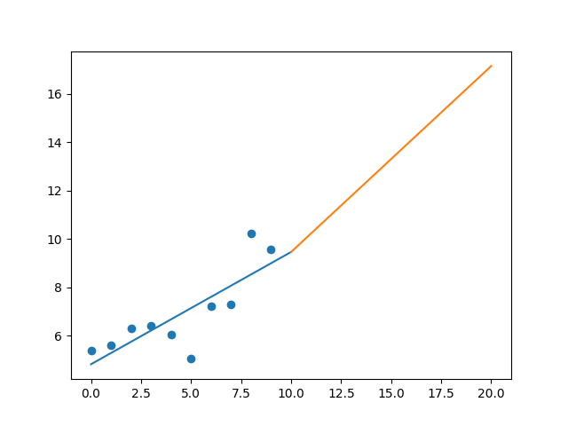

R-Value ROE: 0.772

R-Value EPS: 0.806

CAGR EPS: 0.06

PE Min: 13.97

PE Max: 45.266

Projected AGR Min: 1.712

Projected AGR Max: 14.401

# TICKER: LVS

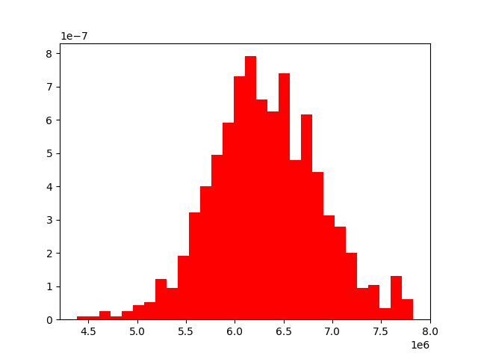

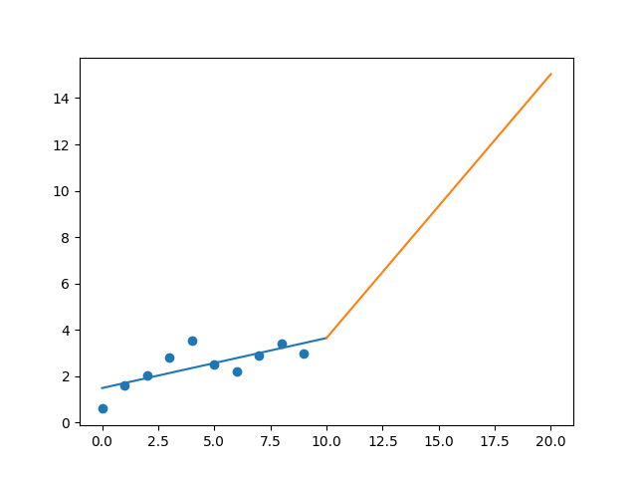

R-Value ROE: 0.899

R-Value EPS: 0.735

CAGR EPS: 0.175

PE Min: 15.463

PE Max: 104.089

Projected AGR Min: 14.733

Projected AGR Max: 38.836

# TICKER: LEG

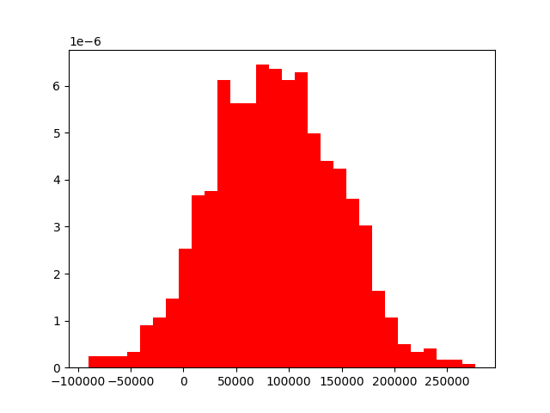

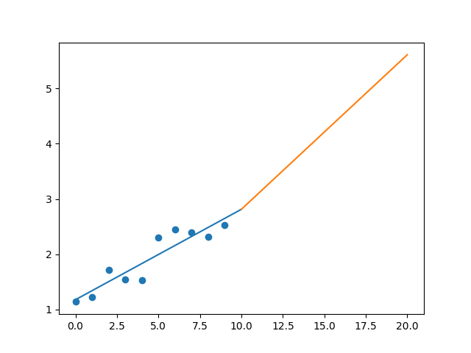

R-Value ROE: 0.707

R-Value EPS: 0.922

CAGR EPS: 0.083

PE Min: 11.361

PE Max: 24.213

Projected AGR Min: 4.007

Projected AGR Max: 12.183

# TICKER: LEN

Something wrong happened

# TICKER: LLY

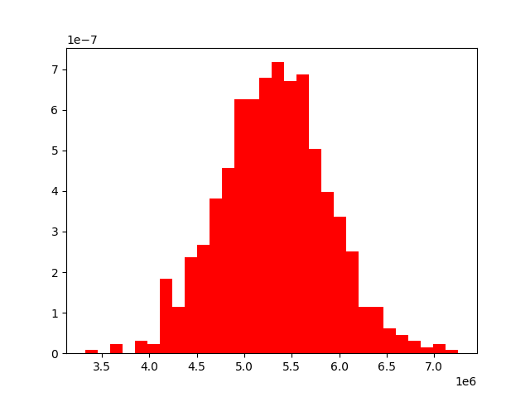

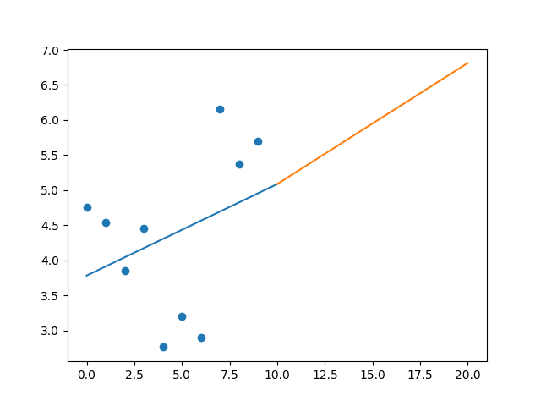

R-Value ROE: 0.456

R-Value EPS: 0.335

CAGR EPS: 0.018

PE Min: 22.998

PE Max: 52.099

Projected AGR Min: 0.691

Projected AGR Max: 9.271

# TICKER: LNC

Something wrong happened

# TICKER: LYV

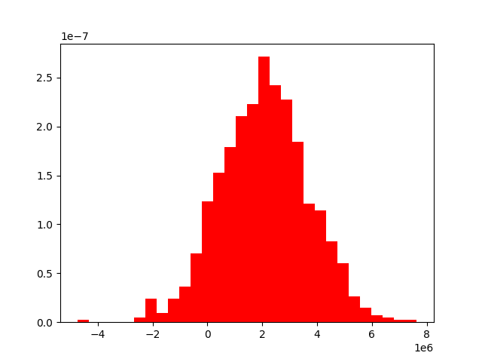

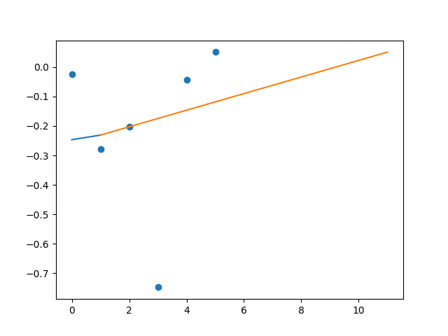

R-Value ROE: 0.96

R-Value EPS: 0.1

CAGR EPS: 0.0

PE Min: 27389.94

PE Max: 27389.94

Projected AGR Min: 35.853

Projected AGR Max: 35.853

# TICKER: LMT

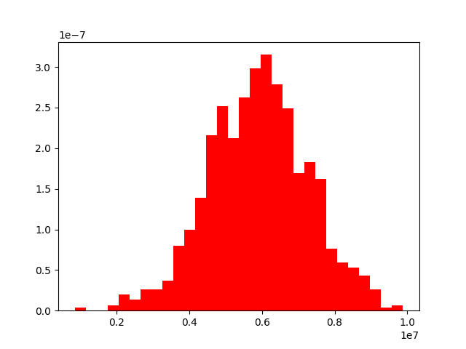

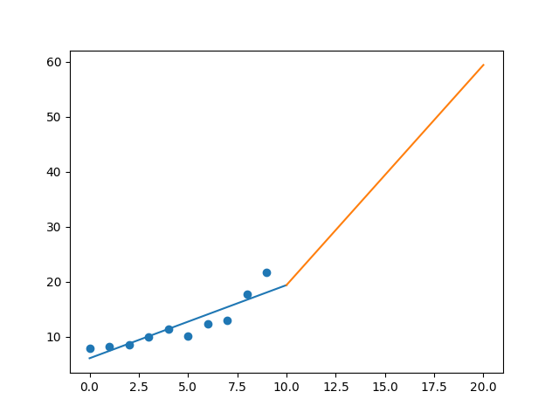

R-Value ROE: 0.283

R-Value EPS: 0.9

CAGR EPS: 0.106

PE Min: 15.01

PE Max: 24.627

Projected AGR Min: 9.147

Projected AGR Max: 14.687

# TICKER: L

Something wrong happened

# TICKER: LOW

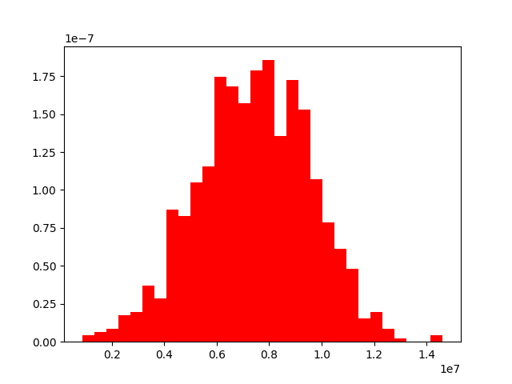

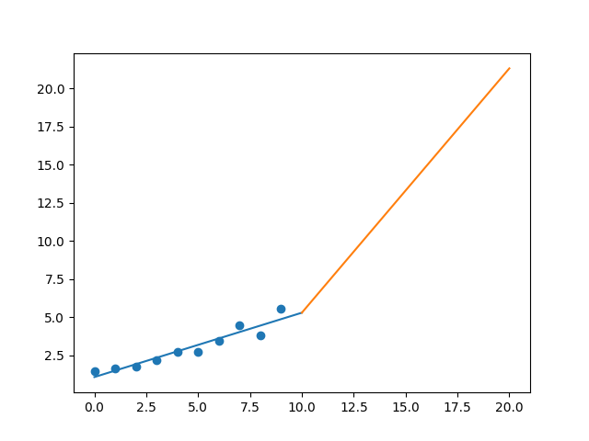

R-Value ROE: 0.754

R-Value EPS: 0.952

CAGR EPS: 0.144

PE Min: 17.628

PE Max: 38.416

Projected AGR Min: 9.189

Projected AGR Max: 18.035

# TICKER: LYB

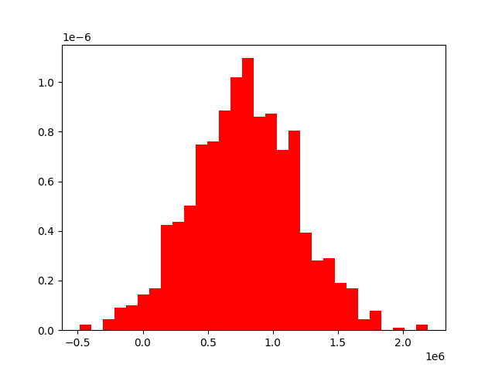

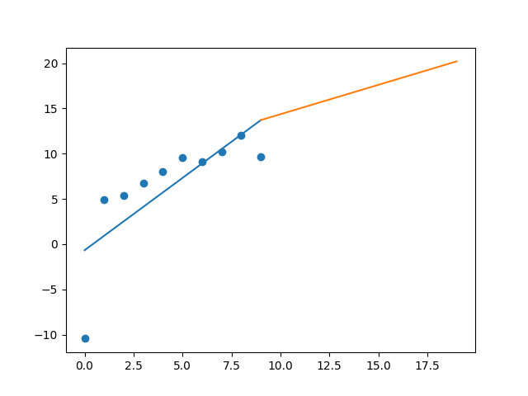

R-Value ROE: 0.024

R-Value EPS: 0.761

CAGR EPS: 0.077

PE Min: 6.323

PE Max: 19.856

Projected AGR Min: 4.606

Projected AGR Max: 17.288

# TICKER: MTB

Something wrong happened

# TICKER: MPC

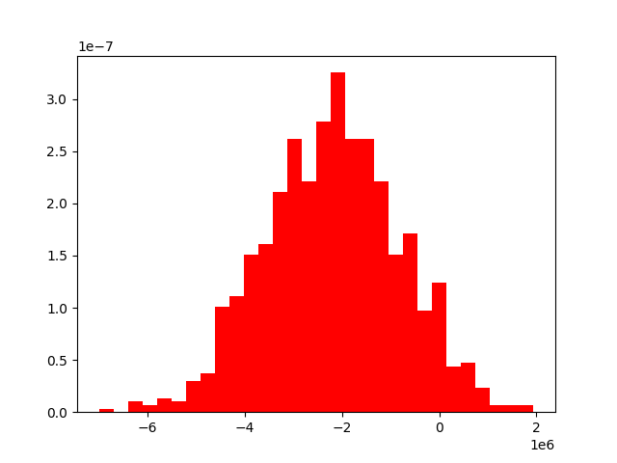

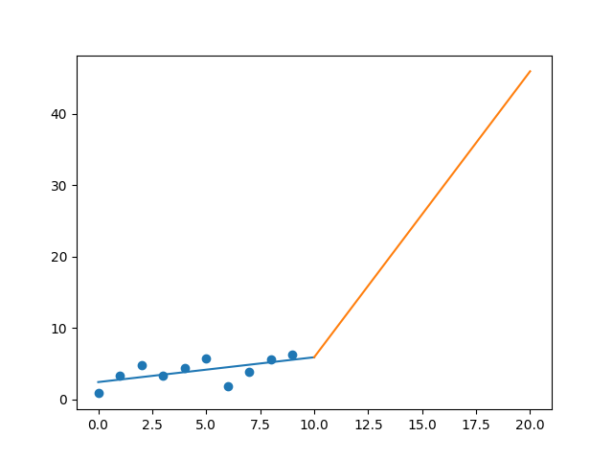

R-Value ROE: 0.375

R-Value EPS: 0.609

CAGR EPS: 0.22

PE Min: 9.823

PE Max: 30.9

Projected AGR Min: 28.236

Projected AGR Max: 43.807

# TICKER: MKTX

Something wrong happened

# TICKER: MAR

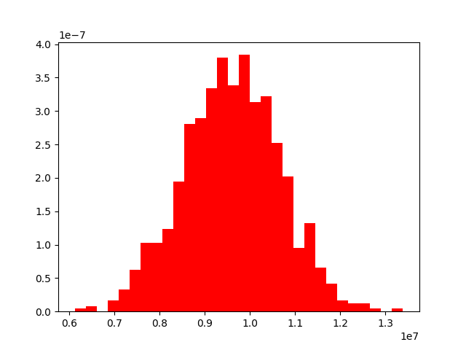

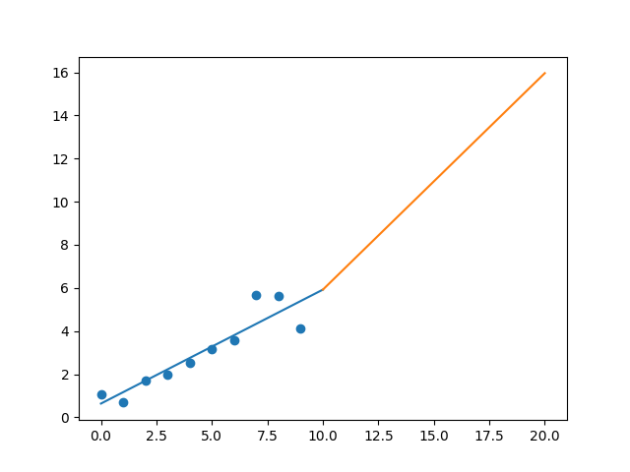

R-Value ROE: 0.709

R-Value EPS: 0.913

CAGR EPS: 0.145

PE Min: 19.772

PE Max: 61.928

Projected AGR Min: 10.339

Projected AGR Max: 23.683