Monte-Carlo Discounted Cash Flow Model and Buffett Analysis

# TICKER: MMC

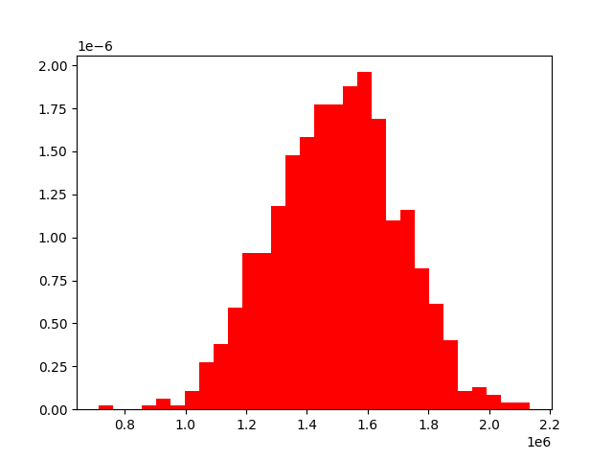

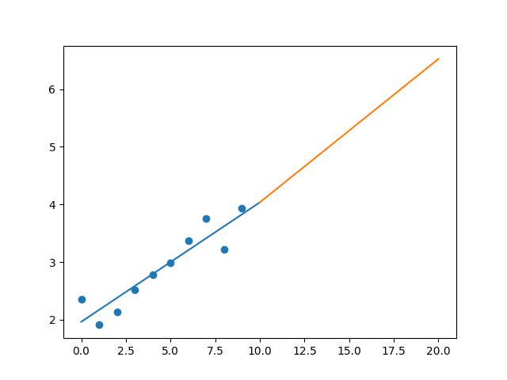

R-Value ROE: 0.704

R-Value EPS: 0.924

CAGR EPS: 0.052

PE Min: 18.605

PE Max: 34.68

Projected AGR Min: 0.702

Projected AGR Max: 7.173

# TICKER: MLM

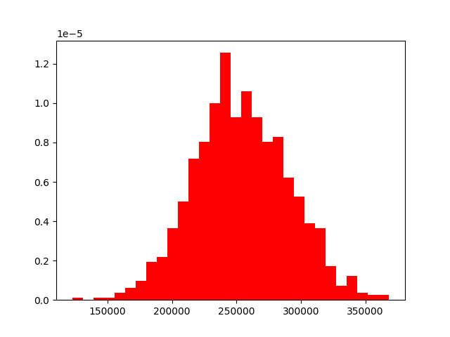

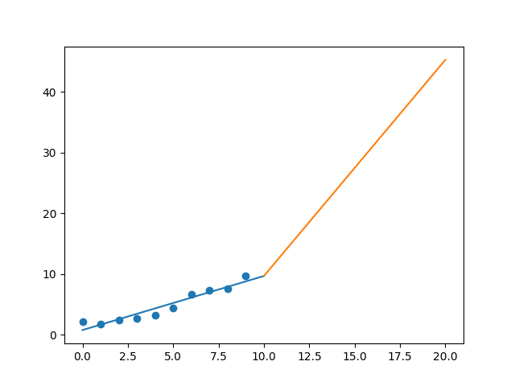

R-Value ROE: 0.681

R-Value EPS: 0.958

CAGR EPS: 0.166

PE Min: 19.958

PE Max: 34.219

Projected AGR Min: 13.126

Projected AGR Max: 19.393

# TICKER: MAS

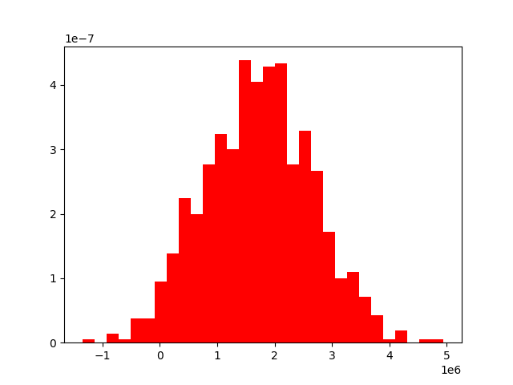

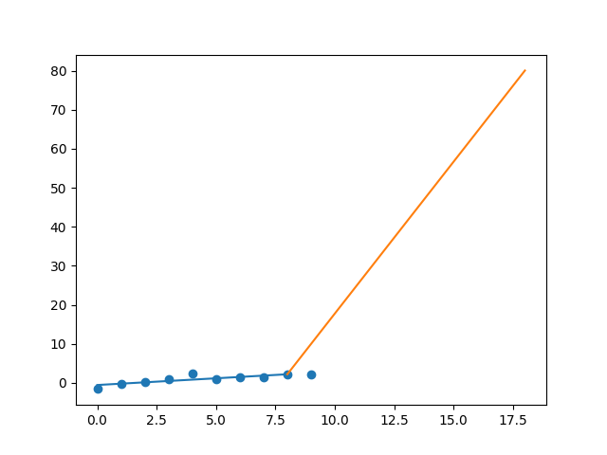

R-Value ROE: 0.671

R-Value EPS: 0.834

CAGR EPS: 0.429

PE Min: 14.196

PE Max: 34.501

Projected AGR Min: 35.515

Projected AGR Max: 48.1

# TICKER: MA

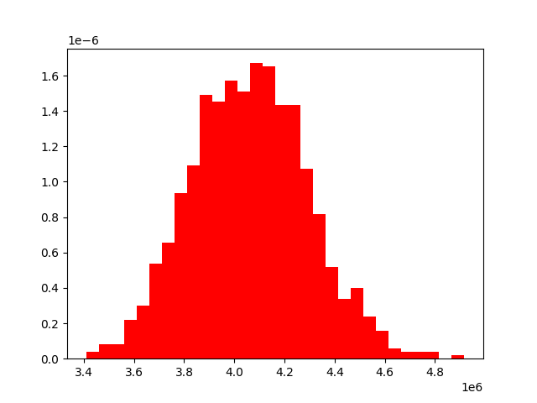

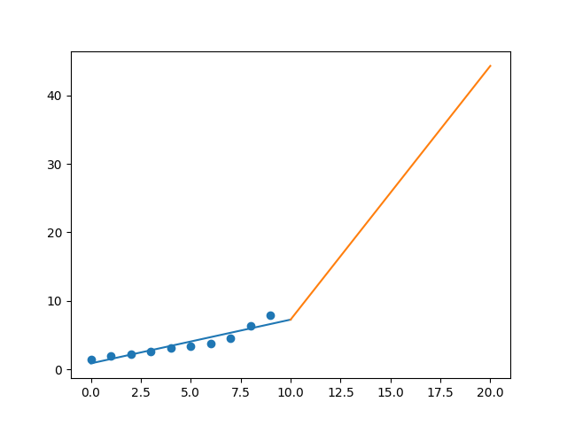

R-Value ROE: 0.919

R-Value EPS: 0.942

CAGR EPS: 0.188

PE Min: 25.866

PE Max: 50.953

Projected AGR Min: 13.149

Projected AGR Max: 21.087

# TICKER: MKC

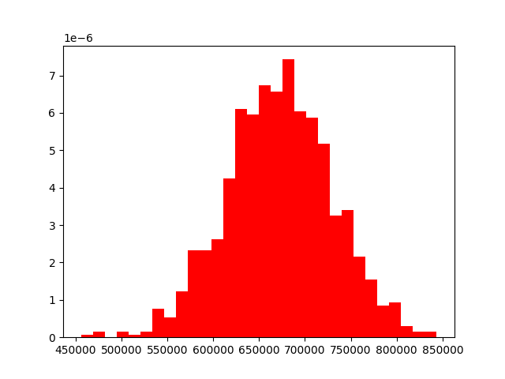

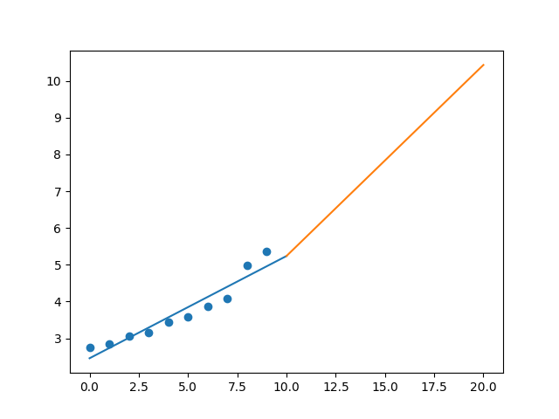

R-Value ROE: 0.023

R-Value EPS: 0.955

CAGR EPS: 0.069

PE Min: 24.695

PE Max: 36.477

Projected AGR Min: 3.309

Projected AGR Max: 7.419

# TICKER: MCD

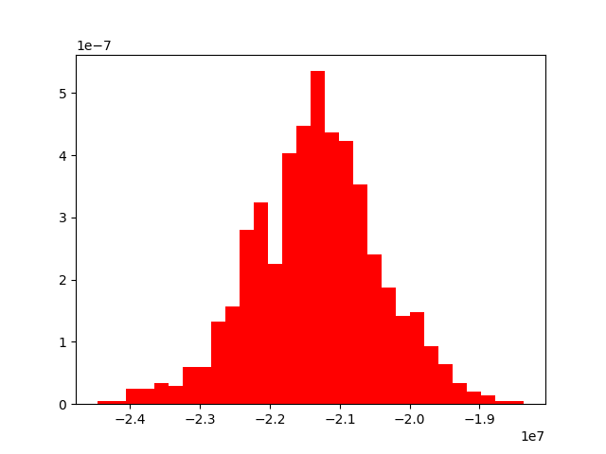

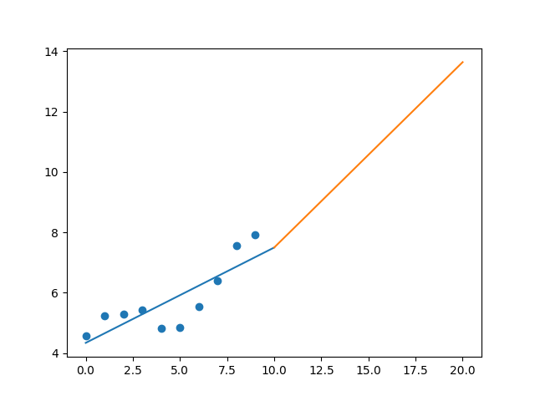

R-Value ROE: 0.67

R-Value EPS: 0.828

CAGR EPS: 0.056

PE Min: 20.234

PE Max: 29.248

Projected AGR Min: 2.386

Projected AGR Max: 6.229

# TICKER: MRK

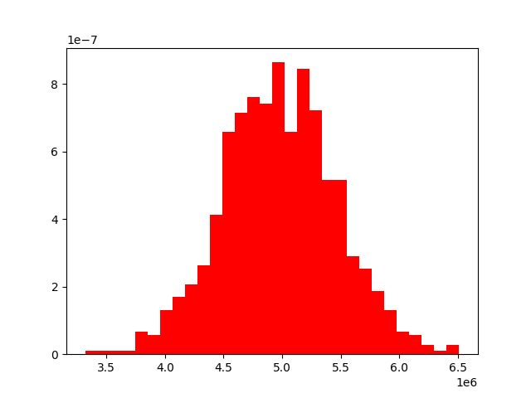

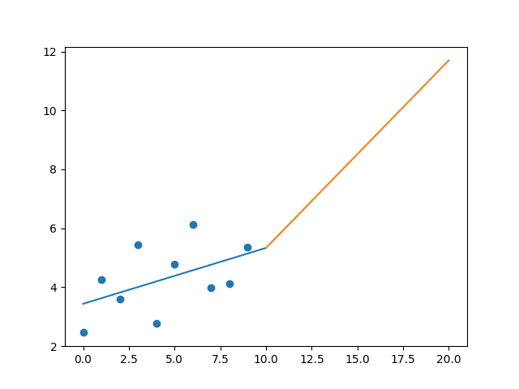

R-Value ROE: 0.639

R-Value EPS: 0.491

CAGR EPS: 0.081

PE Min: 18.244

PE Max: 62.074

Projected AGR Min: 10.193

Projected AGR Max: 24.546

# TICKER: MTD

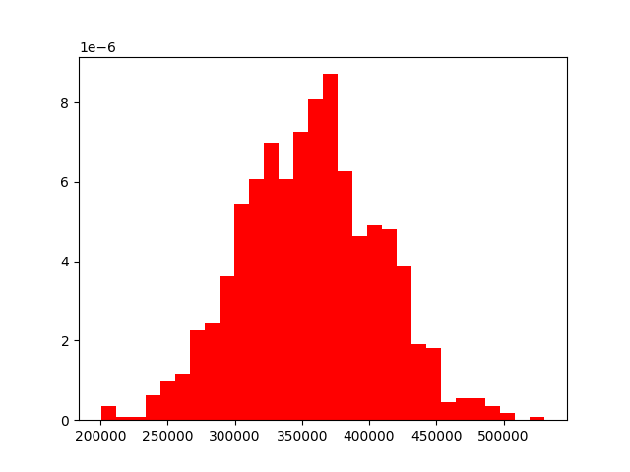

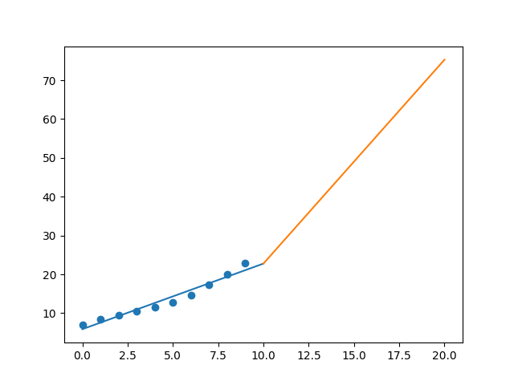

R-Value ROE: 0.904

R-Value EPS: 0.976

CAGR EPS: 0.126

PE Min: 27.08

PE Max: 40.631

Projected AGR Min: 6.018

Projected AGR Max: 10.408

# TICKER: MU

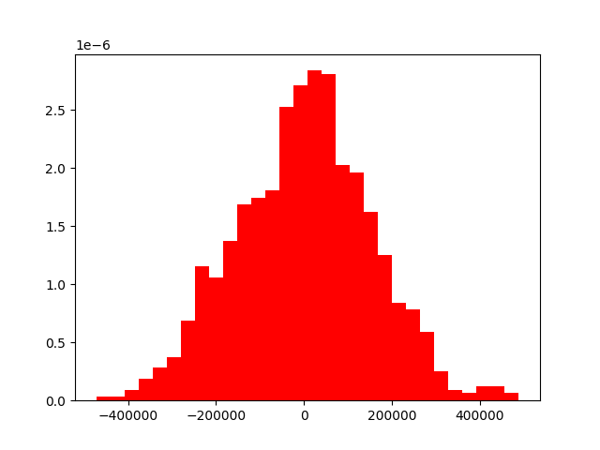

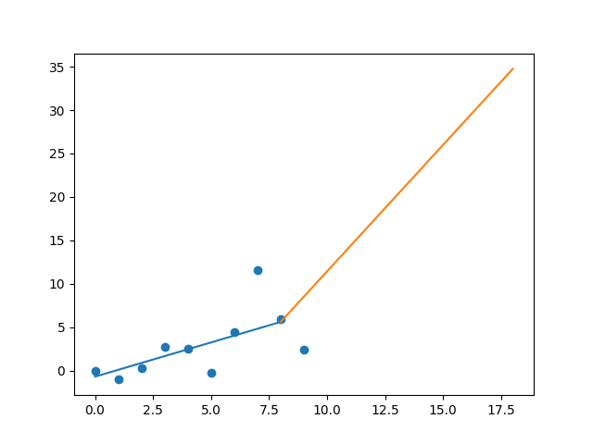

R-Value ROE: 0.419

R-Value EPS: 0.63

CAGR EPS: 0.307

PE Min: 3.153

PE Max: 43.753

Projected AGR Min: 6.812

Projected AGR Max: 38.949

# TICKER: MSFT

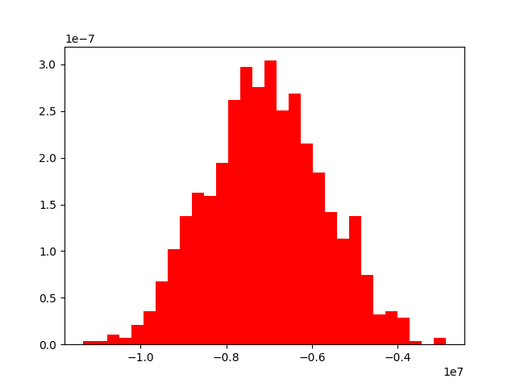

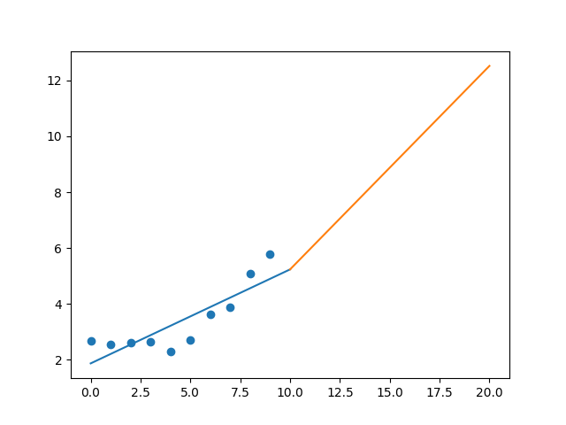

R-Value ROE: 0.112

R-Value EPS: 0.846

CAGR EPS: 0.08

PE Min: 19.945

PE Max: 42.361

Projected AGR Min: 1.354

Projected AGR Max: 9.283

# TICKER: MAA

Something wrong happened

# TICKER: MHK

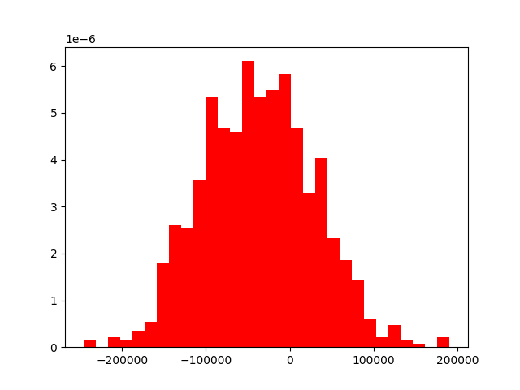

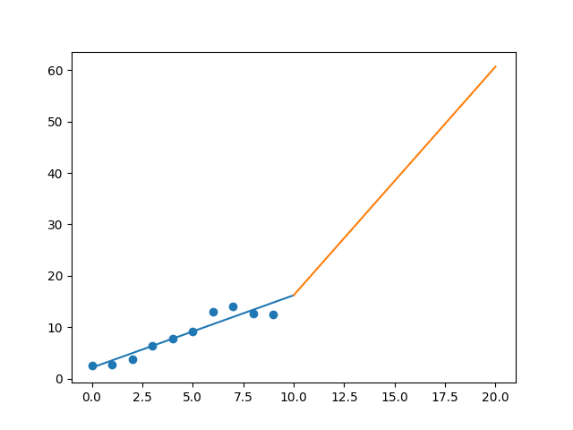

R-Value ROE: 0.682

R-Value EPS: 0.949

CAGR EPS: 0.171

PE Min: 7.663

PE Max: 22.833

Projected AGR Min: 14.49

Projected AGR Max: 27.698

# TICKER: MNST

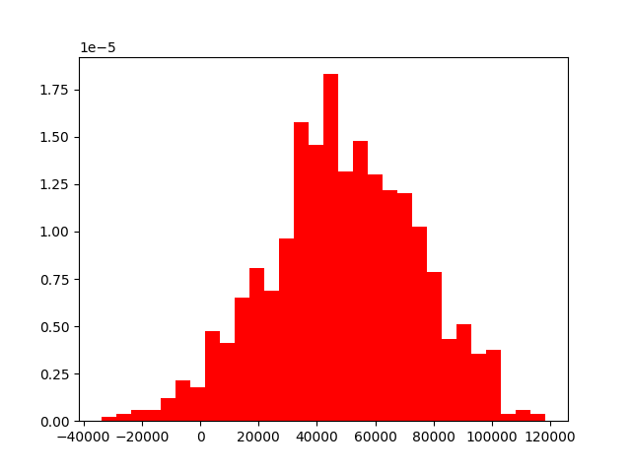

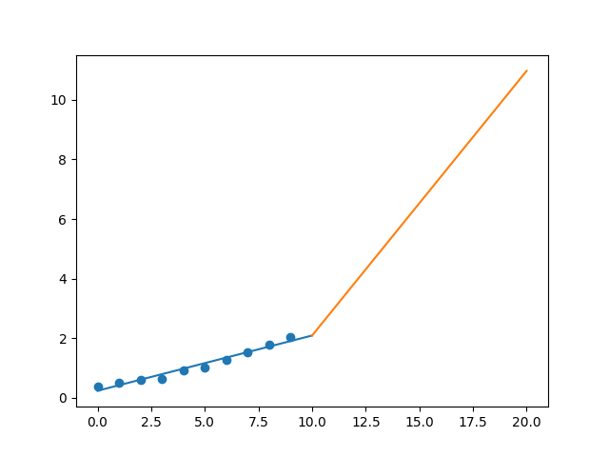

R-Value ROE: 0.376

R-Value EPS: 0.982

CAGR EPS: 0.183

PE Min: 27.238

PE Max: 53.195

Projected AGR Min: 13.465

Projected AGR Max: 21.32

# TICKER: MCO

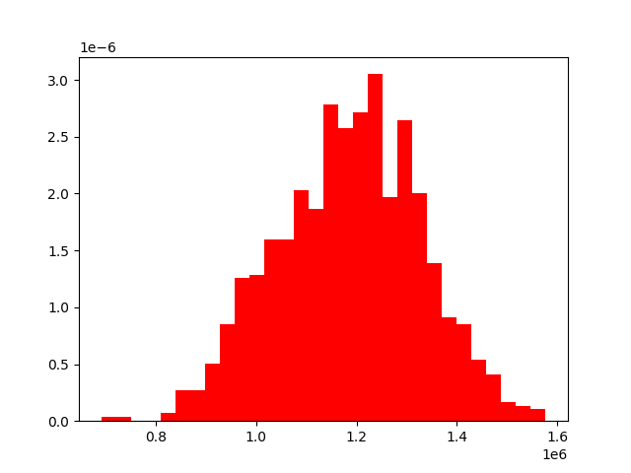

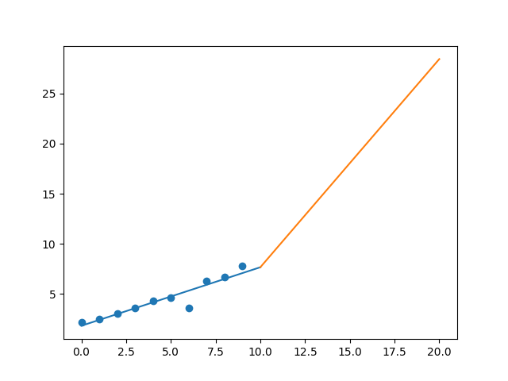

R-Value ROE: 0.328

R-Value EPS: 0.937

CAGR EPS: 0.138

PE Min: 20.967

PE Max: 72.211

Projected AGR Min: 7.758

Projected AGR Max: 21.942

# TICKER: MS

Something wrong happened

# TICKER: MSI

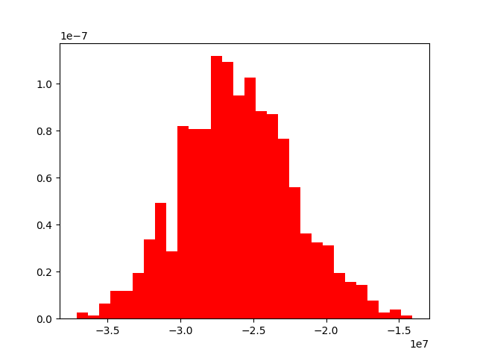

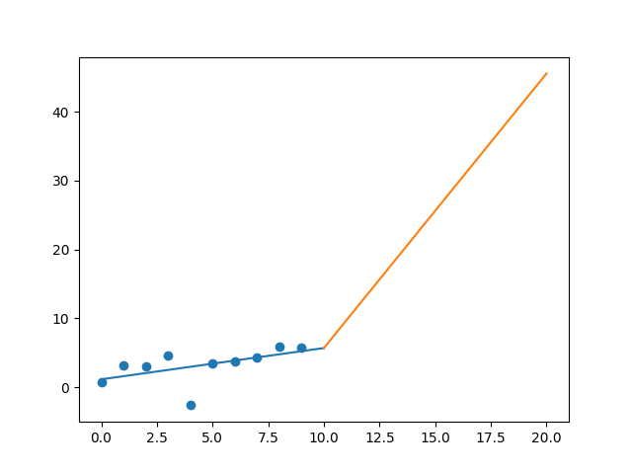

R-Value ROE: 0.277

R-Value EPS: 0.545

CAGR EPS: 0.229

PE Min: 20.845

PE Max: 34.488

Projected AGR Min: 18.759

Projected AGR Max: 24.891

# TICKER: MSCI

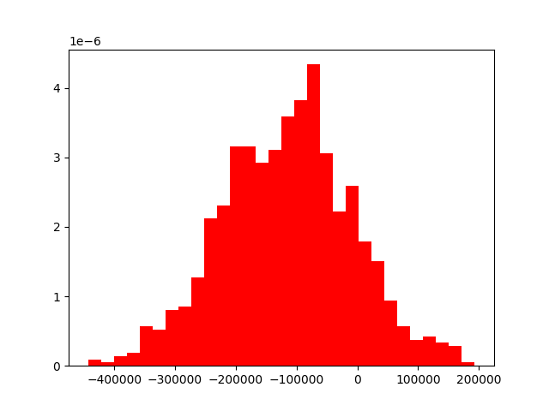

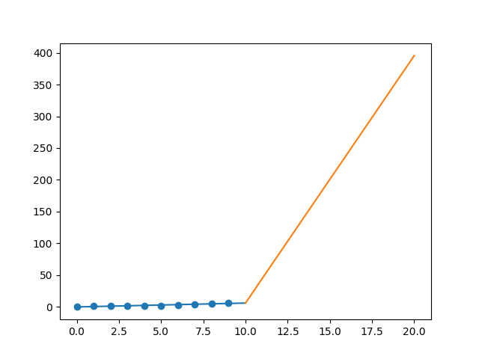

R-Value ROE: 0.6

R-Value EPS: 0.926

CAGR EPS: 0.506

PE Min: 26.477

PE Max: 54.515

Projected AGR Min: 38.623

Projected AGR Max: 49.004

# TICKER: MYL

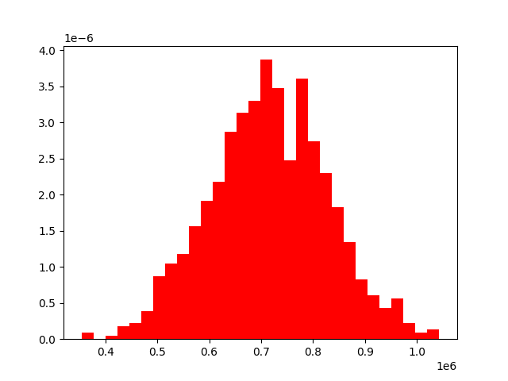

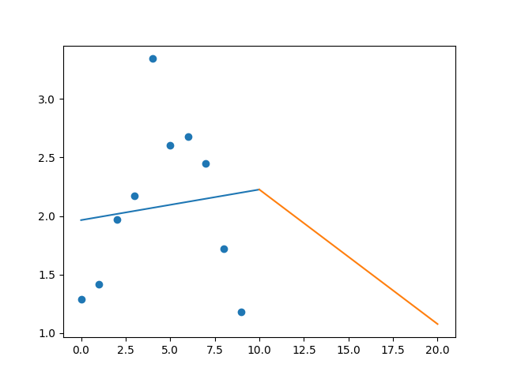

R-Value ROE: 0.622

R-Value EPS: 0.113

CAGR EPS: -0.009

PE Min: 19.37

PE Max: 633.27

Projected AGR Min: 2.94

Projected AGR Max: 45.891

# TICKER: NDAQ

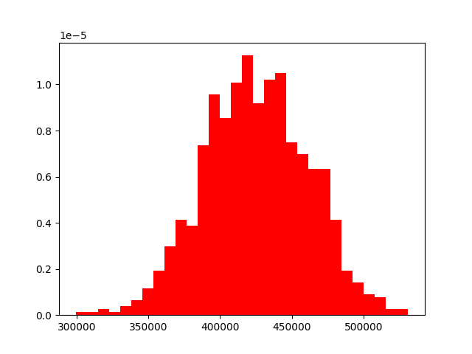

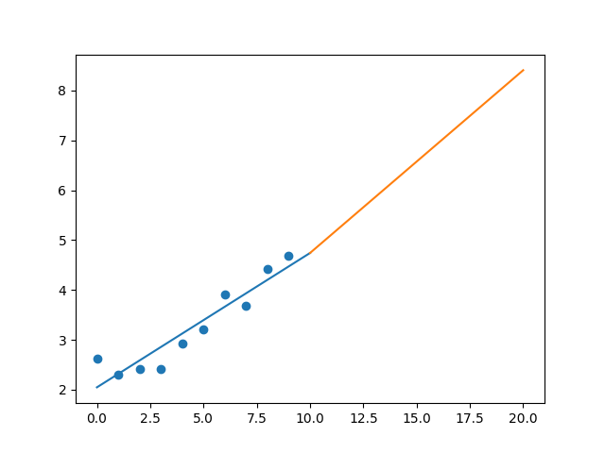

R-Value ROE: 0.269

R-Value EPS: 0.937

CAGR EPS: 0.06

PE Min: 17.906

PE Max: 108.945

Projected AGR Min: 1.483

Projected AGR Max: 21.567

# TICKER: NTAP

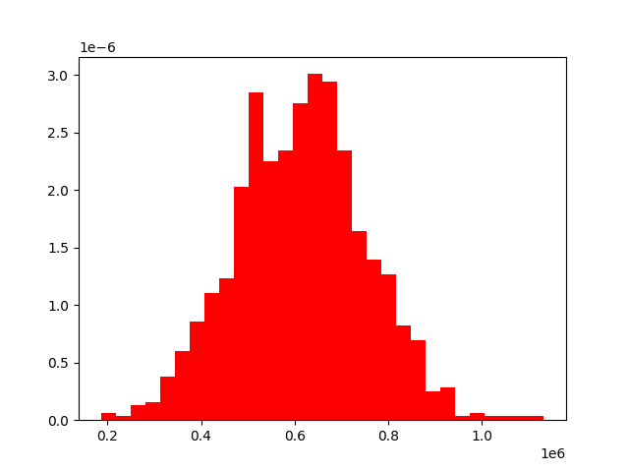

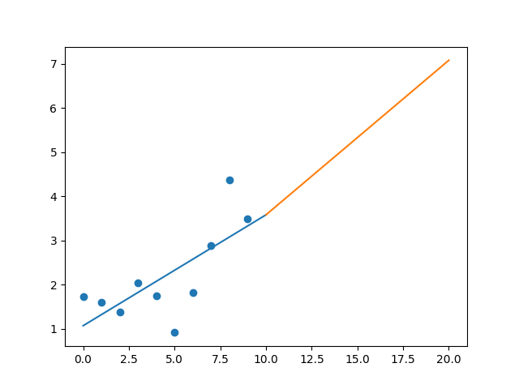

R-Value ROE: 0.618

R-Value EPS: 0.715

CAGR EPS: 0.073

PE Min: 12.17

PE Max: 34.248

Projected AGR Min: 5.687

Projected AGR Max: 17.207

# TICKER: NFLX

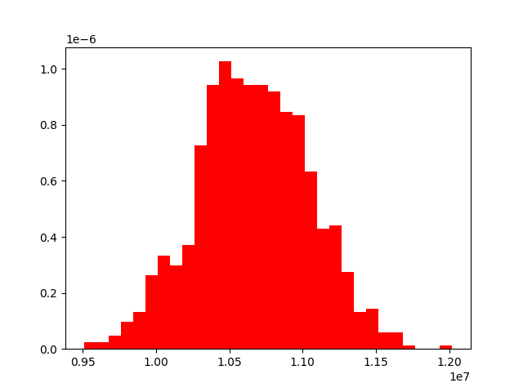

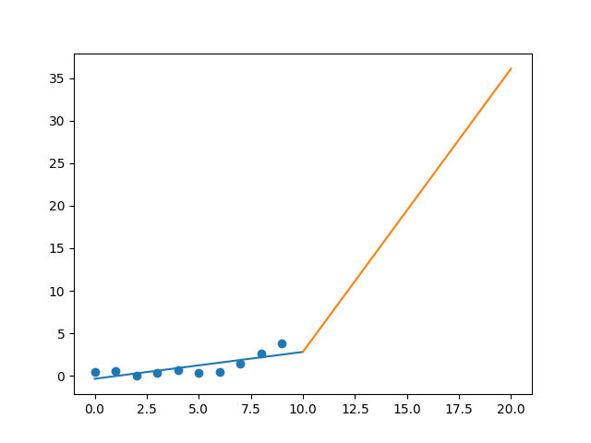

R-Value ROE: 0.347

R-Value EPS: 0.772

CAGR EPS: 0.251

PE Min: 80.614

PE Max: 407.351

Projected AGR Min: 19.587

Projected AGR Max: 40.618

# TICKER: NWL

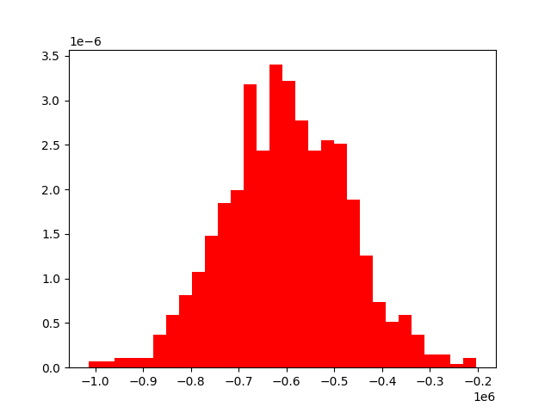

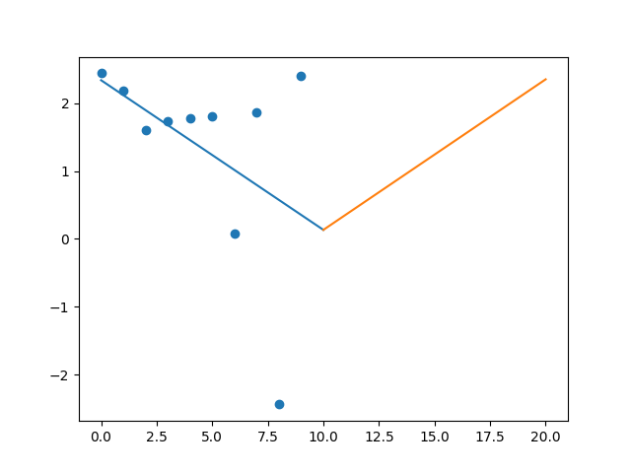

R-Value ROE: 0.449

R-Value EPS: 0.45

CAGR EPS: -0.002

PE Min: 19.437

PE Max: 97.907

Projected AGR Min: 8.894

Projected AGR Max: 28.003

# TICKER: NLSN

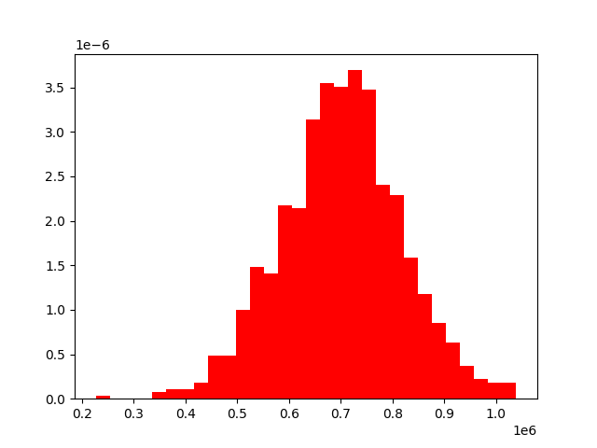

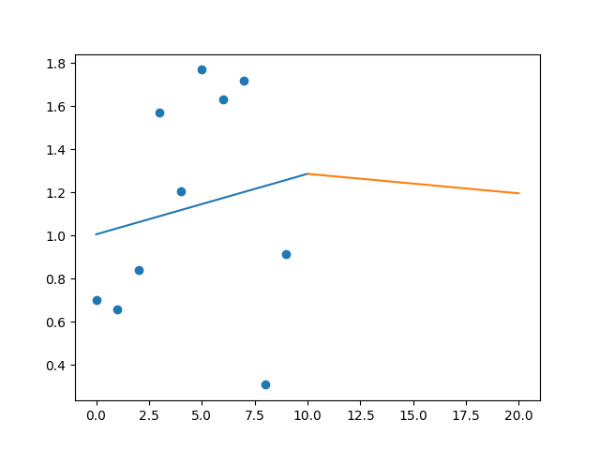

R-Value ROE: 0.509

R-Value EPS: 0.164

CAGR EPS: 0.027

PE Min: 21.29

PE Max: 32.857

Projected AGR Min: 5.071

Projected AGR Max: 9.731

# TICKER: NI

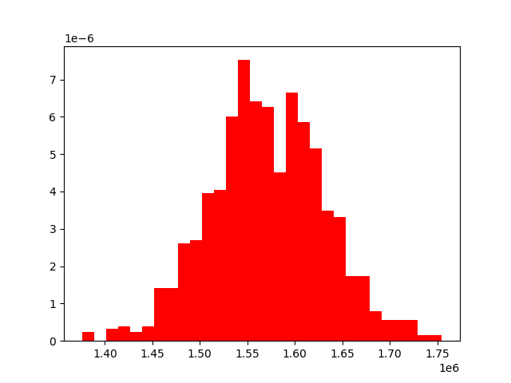

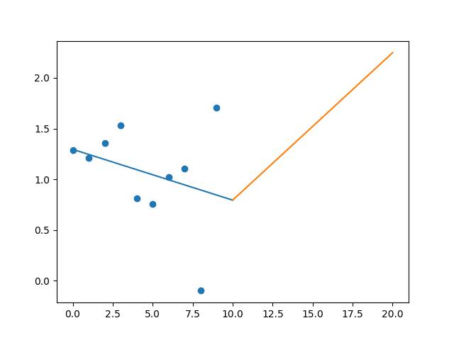

R-Value ROE: 0.429

R-Value EPS: 0.3

CAGR EPS: 0.028

PE Min: 21.128

PE Max: 98.343

Projected AGR Min: 6.834

Projected AGR Max: 24.595

# TICKER: NSC

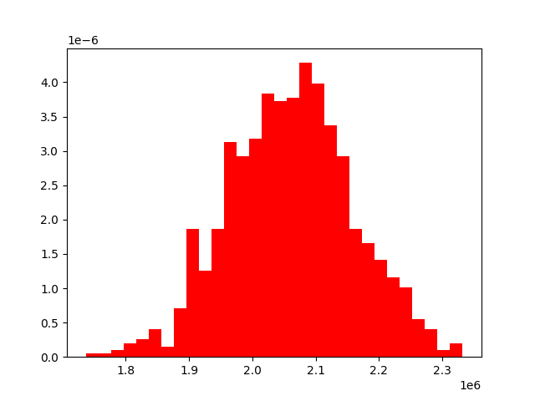

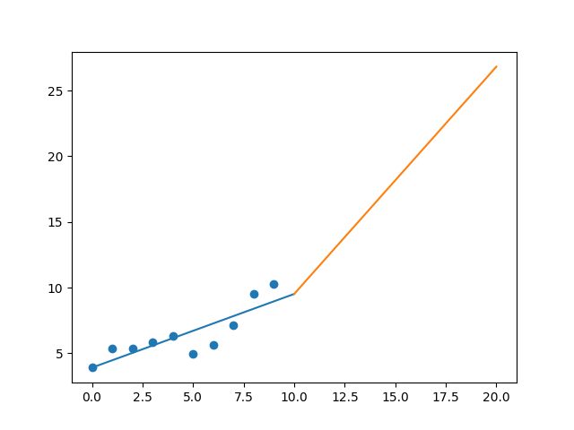

R-Value ROE: 0.265

R-Value EPS: 0.847

CAGR EPS: 0.101

PE Min: 15.448

PE Max: 27.594

Projected AGR Min: 5.885

Projected AGR Max: 12.21

# TICKER: NTRS

Something wrong happened

# TICKER: NOC

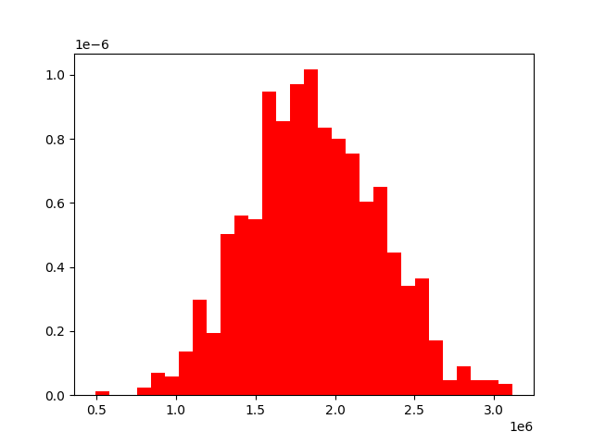

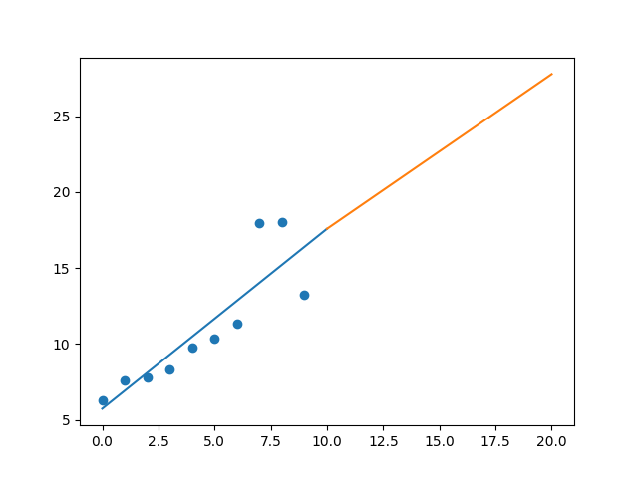

R-Value ROE: 0.749

R-Value EPS: 0.863

CAGR EPS: 0.077

PE Min: 13.266

PE Max: 26.109

Projected AGR Min: 1.704

Projected AGR Max: 8.829

# TICKER: NCLH

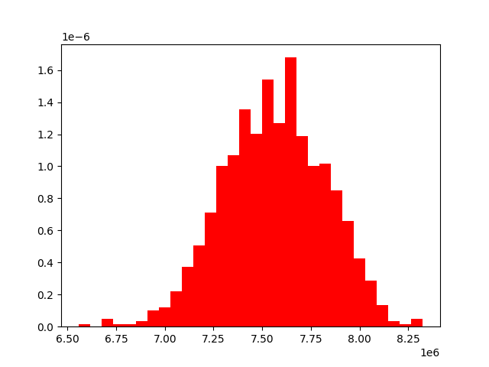

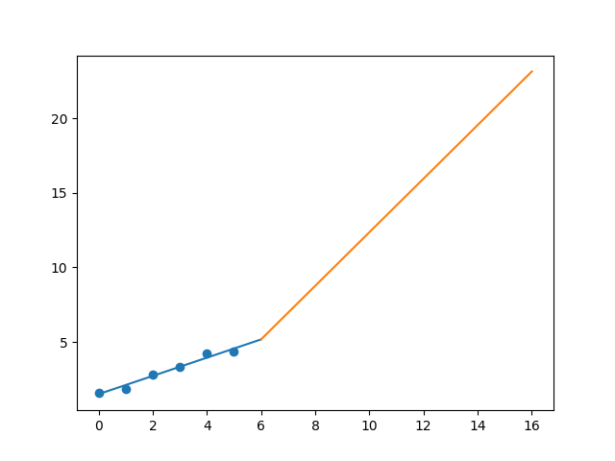

R-Value ROE: 0.861

R-Value EPS: 0.983

CAGR EPS: 0.182

PE Min: 9.927

PE Max: 36.594

Projected AGR Min: 27.736

Projected AGR Max: 45.537

# TICKER: NRG

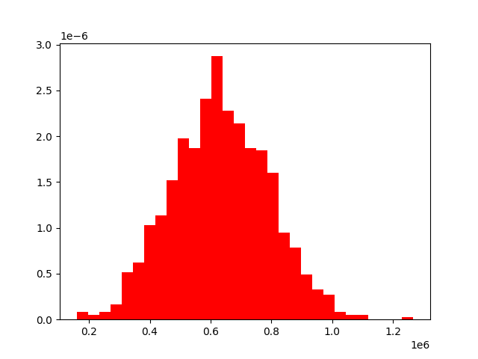

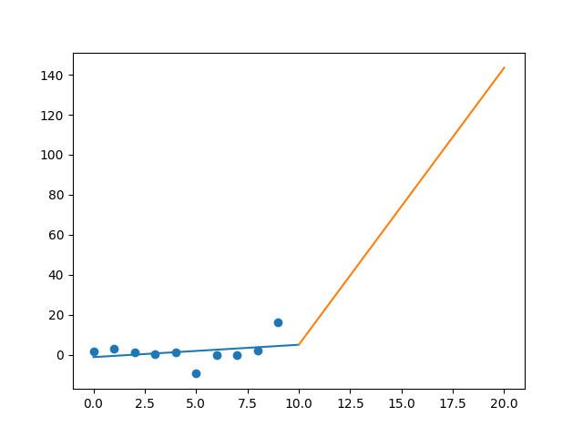

R-Value ROE: 0.4

R-Value EPS: 0.303

CAGR EPS: 0.245

PE Min: 1.664

PE Max: 52.838

Projected AGR Min: 22.143

Projected AGR Max: 72.606

# TICKER: NUE

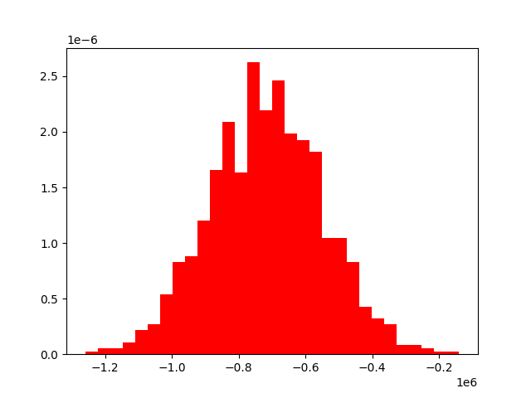

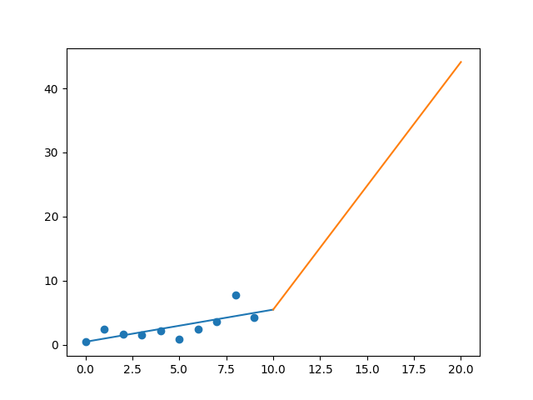

R-Value ROE: 0.647

R-Value EPS: 0.722

CAGR EPS: 0.262

PE Min: 6.933

PE Max: 163.529

Projected AGR Min: 19.614

Projected AGR Max: 64.078

# TICKER: NVDA

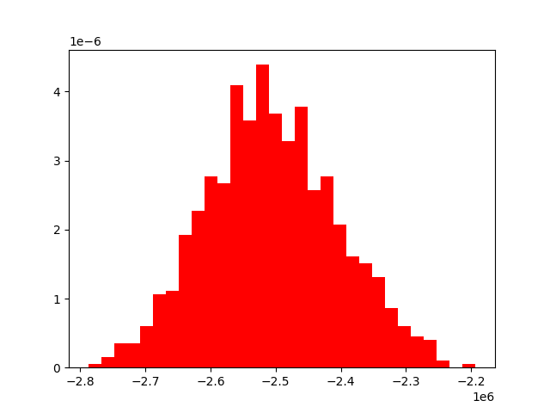

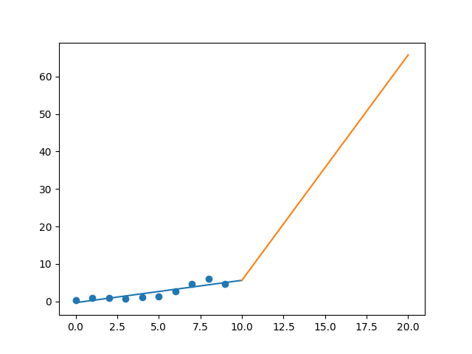

R-Value ROE: 0.773

R-Value EPS: 0.886

CAGR EPS: 0.305

PE Min: 26.558

PE Max: 74.767

Projected AGR Min: 12.587

Projected AGR Max: 24.865

# TICKER: NVR

Something wrong happened

# TICKER: ORLY

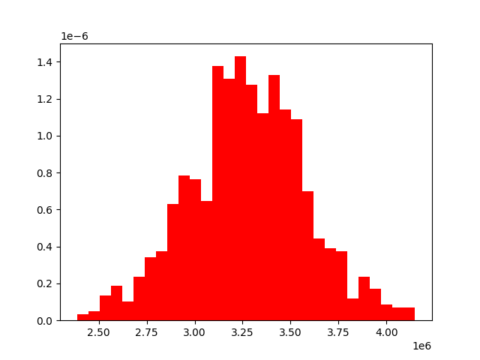

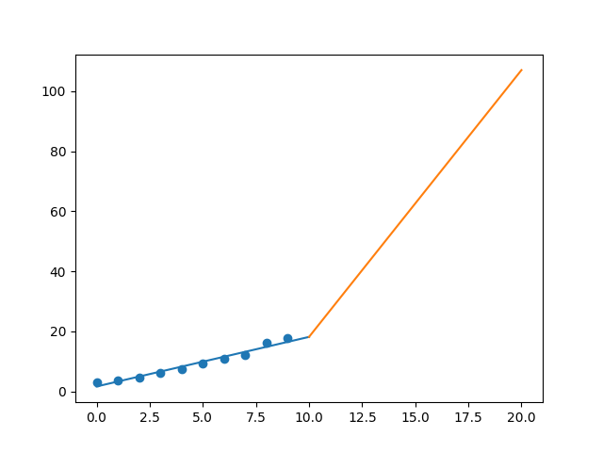

R-Value ROE: 0.841

R-Value EPS: 0.98

CAGR EPS: 0.196

PE Min: 16.901

PE Max: 28.189

Projected AGR Min: 14.528

Projected AGR Max: 20.539