Monte-Carlo Discounted Cash Flow Model and Buffett Analysis

# TICKER: ODFL

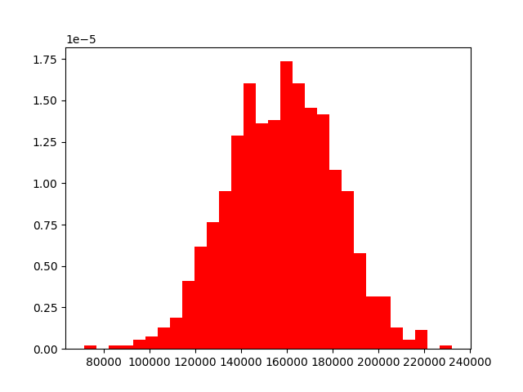

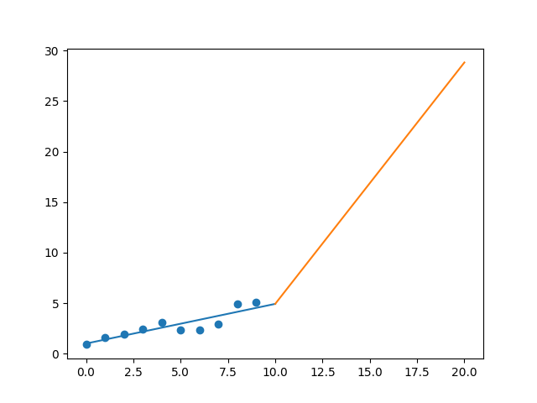

R-Value ROE: 0.835

R-Value EPS: 0.889

CAGR EPS: 0.189

PE Min: 16.55

PE Max: 34.397

Projected AGR Min: 9.305

Projected AGR Max: 17.602

# TICKER: OMC

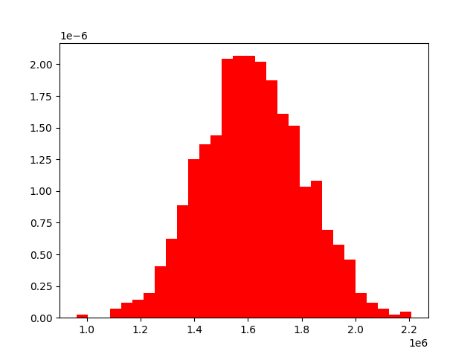

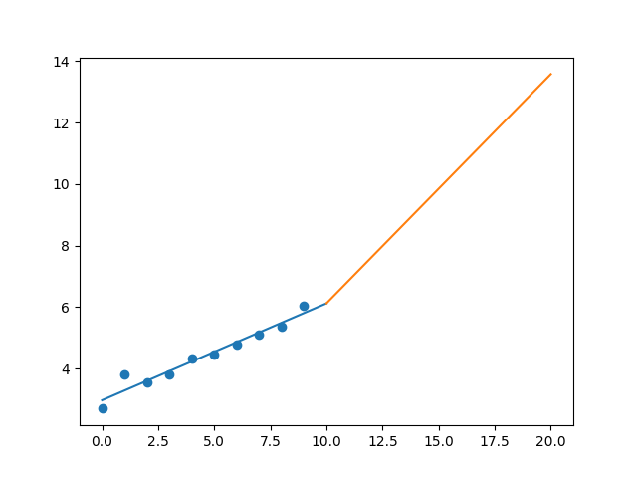

R-Value ROE: 0.891

R-Value EPS: 0.973

CAGR EPS: 0.084

PE Min: 9.027

PE Max: 18.375

Projected AGR Min: 7.956

Projected AGR Max: 15.909

# TICKER: OKE

Something wrong happened

# TICKER: ORCL

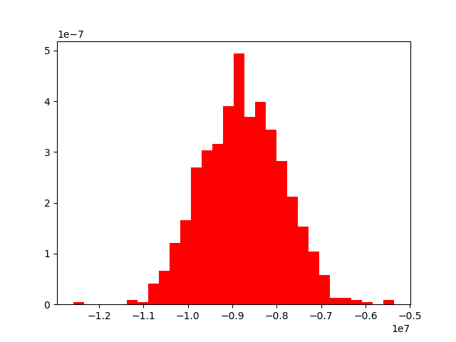

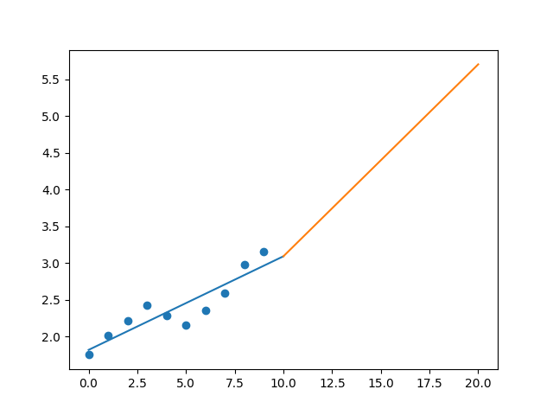

R-Value ROE: 0.544

R-Value EPS: 0.907

CAGR EPS: 0.061

PE Min: 15.57

PE Max: 22.089

Projected AGR Min: 4.48

Projected AGR Max: 8.198

# TICKER: PCAR

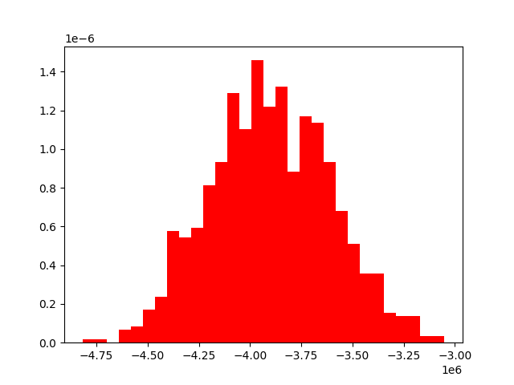

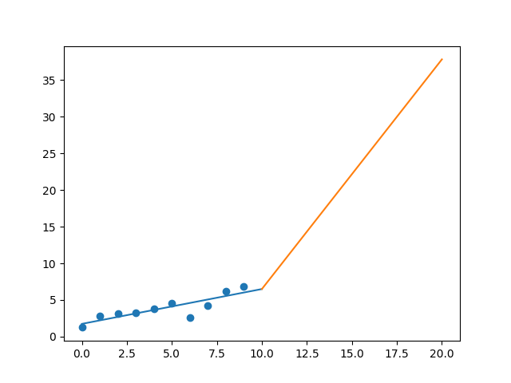

R-Value ROE: 0.511

R-Value EPS: 0.853

CAGR EPS: 0.186

PE Min: 8.901

PE Max: 39.825

Projected AGR Min: 14.114

Projected AGR Max: 32.559

# TICKER: PKG

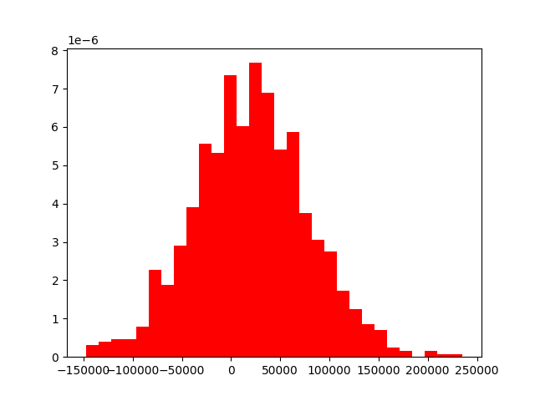

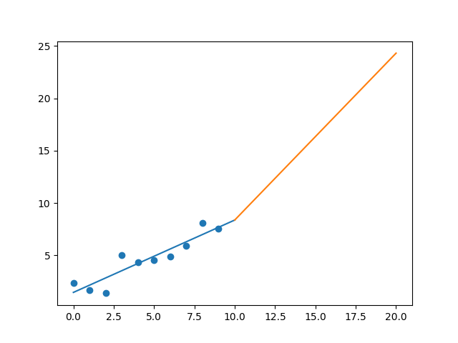

R-Value ROE: 0.479

R-Value EPS: 0.918

CAGR EPS: 0.124

PE Min: 10.729

PE Max: 21.883

Projected AGR Min: 7.361

Projected AGR Max: 15.292

# TICKER: PAYX

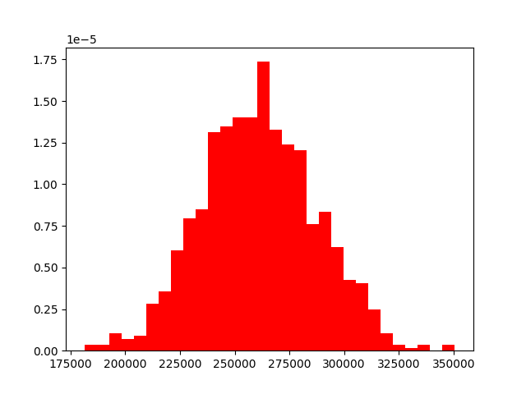

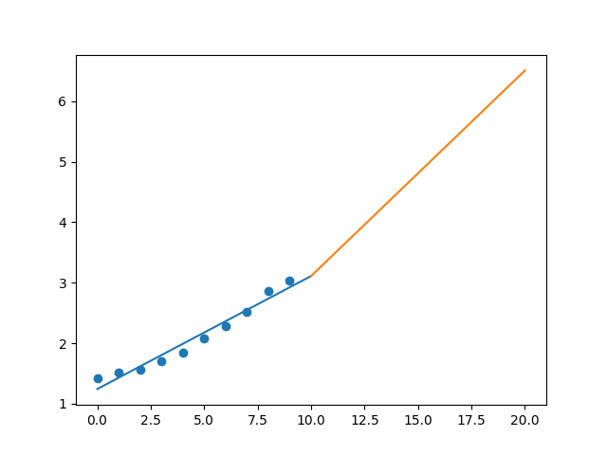

R-Value ROE: 0.813

R-Value EPS: 0.981

CAGR EPS: 0.079

PE Min: 23.76

PE Max: 30.109

Projected AGR Min: 5.444

Projected AGR Max: 7.971

# TICKER: PAYC

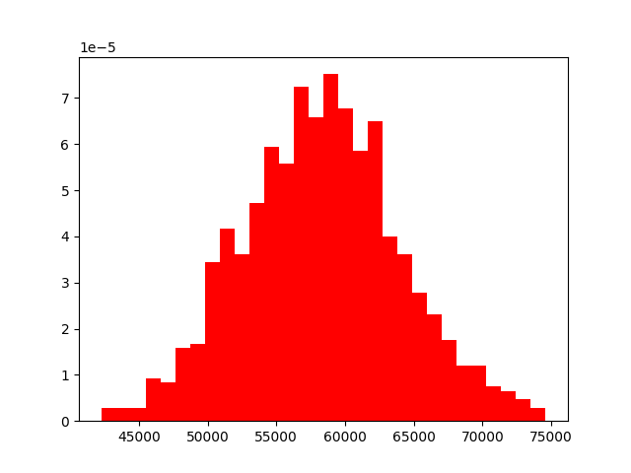

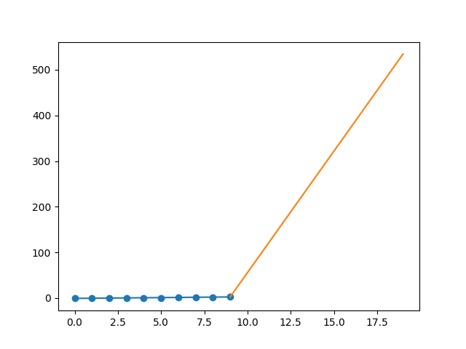

R-Value ROE: 0.821

R-Value EPS: 0.91

CAGR EPS: 0.674

PE Min: 38.455

PE Max: 110.298

Projected AGR Min: 48.932

Projected AGR Max: 65.482

# TICKER: PYPL

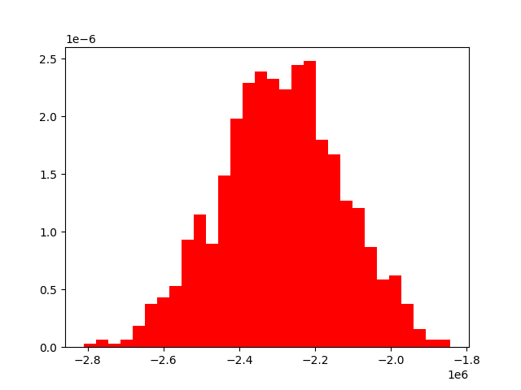

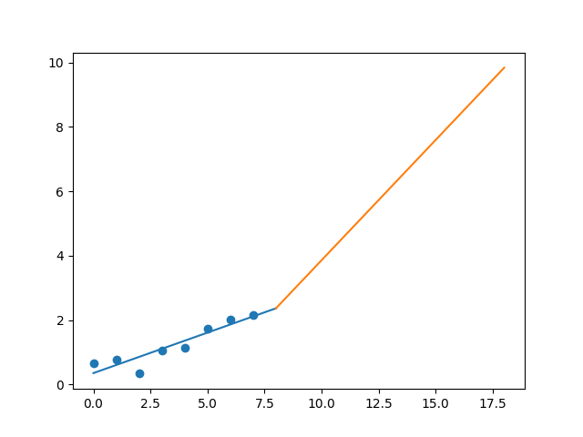

R-Value ROE: 0.565

R-Value EPS: 0.921

CAGR EPS: 0.163

PE Min: 33.002

PE Max: 79.967

Projected AGR Min: 5.347

Projected AGR Max: 15.096

# TICKER: PBCT

Something wrong happened

# TICKER: PKI

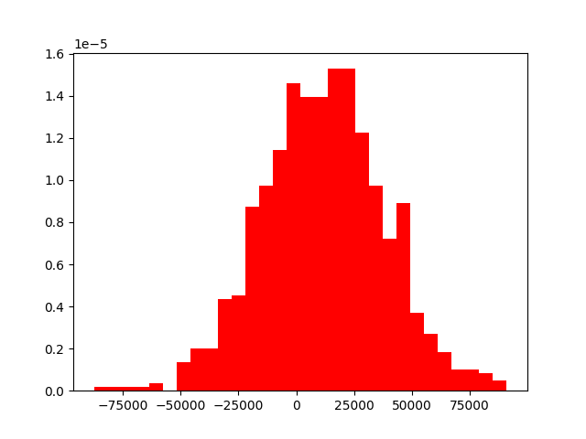

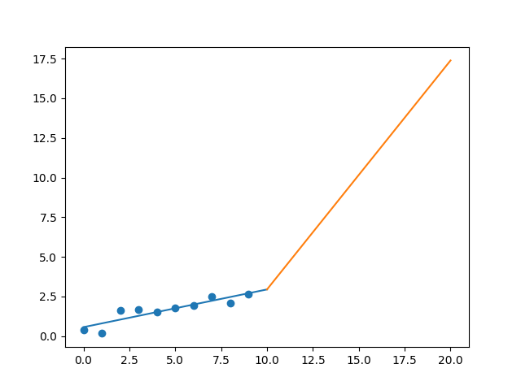

R-Value ROE: 0.018

R-Value EPS: 0.899

CAGR EPS: 0.206

PE Min: 26.611

PE Max: 47.193

Projected AGR Min: 13.704

Projected AGR Max: 20.408

# TICKER: PRGO

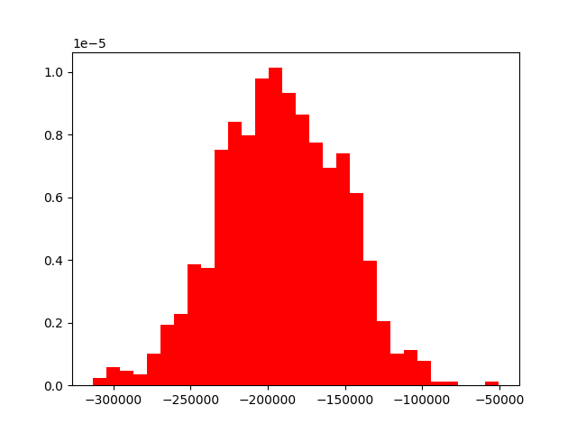

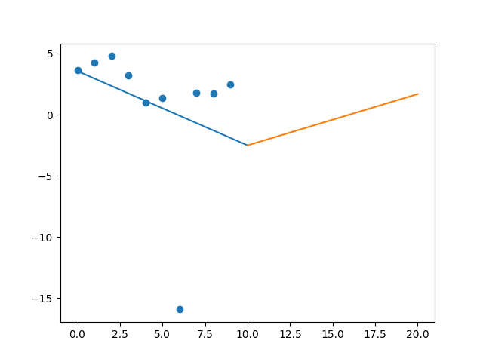

R-Value ROE: 0.436

R-Value EPS: 0.305

CAGR EPS: -0.038

PE Min: 30.431

PE Max: 456.611

Projected AGR Min: 0.846

Projected AGR Max: 32.215

# TICKER: PM

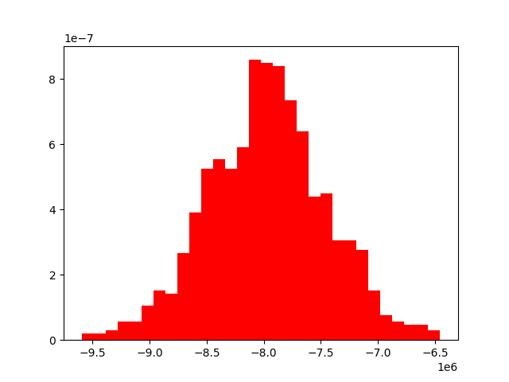

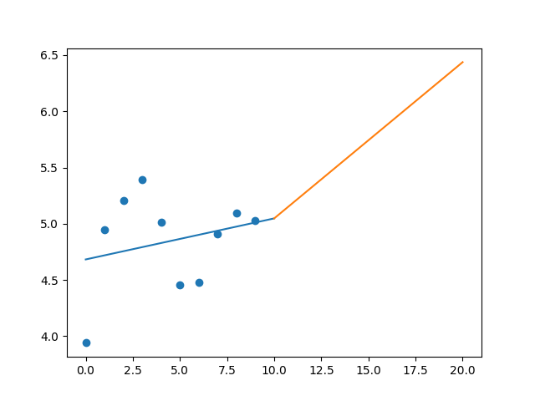

R-Value ROE: 0.424

R-Value EPS: 0.256

CAGR EPS: 0.025

PE Min: 13.096

PE Max: 26.033

Projected AGR Min: 1.159

Projected AGR Max: 8.353

# TICKER: PSX

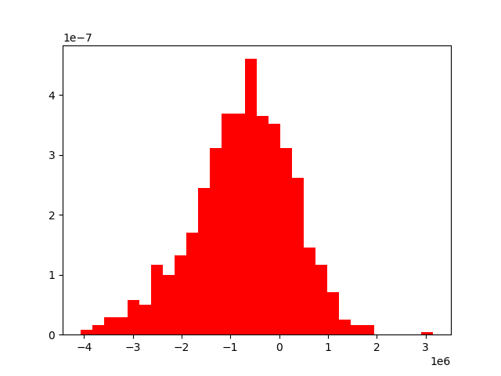

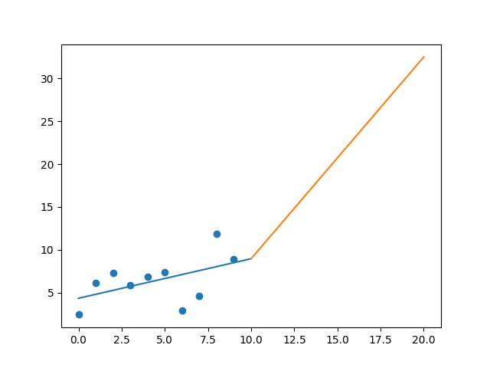

R-Value ROE: 0.189

R-Value EPS: 0.503

CAGR EPS: 0.138

PE Min: 7.194

PE Max: 68.724

Projected AGR Min: 14.861

Projected AGR Max: 43.94

# TICKER: PXD

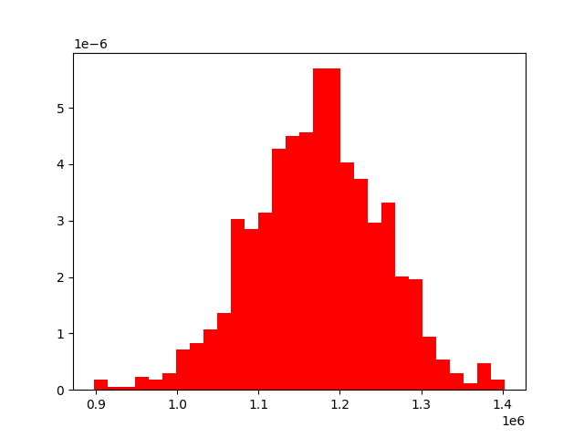

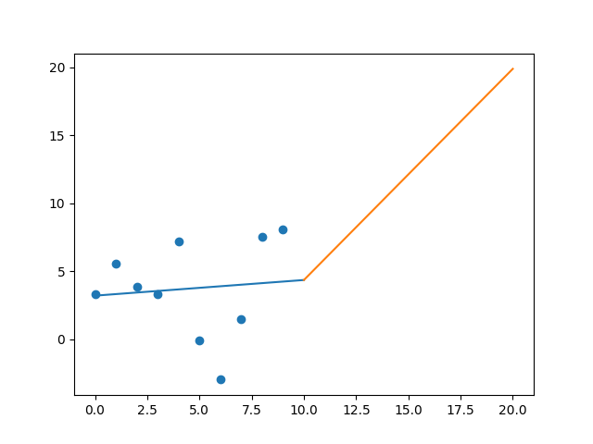

R-Value ROE: 0.199

R-Value EPS: 0.098

CAGR EPS: 0.094

PE Min: 16.712

PE Max: 201.063

Projected AGR Min: 13.923

Projected AGR Max: 46.097

# TICKER: PNC

Something wrong happened

# TICKER: PPG

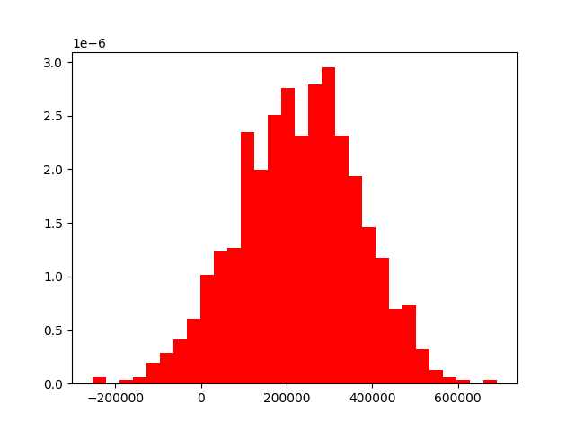

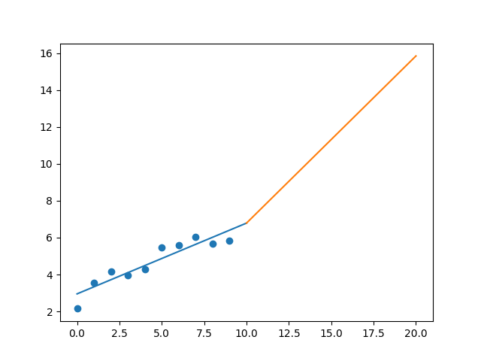

R-Value ROE: 0.186

R-Value EPS: 0.924

CAGR EPS: 0.105

PE Min: 16.963

PE Max: 50.309

Projected AGR Min: 6.588

Projected AGR Max: 18.83

# TICKER: PFG

Something wrong happened

# TICKER: PGR

Something wrong happened

# TICKER: PLD

Something wrong happened

# TICKER: PRU

Something wrong happened

# TICKER: PSA

Something wrong happened

# TICKER: PHM

Something wrong happened

# TICKER: PVH

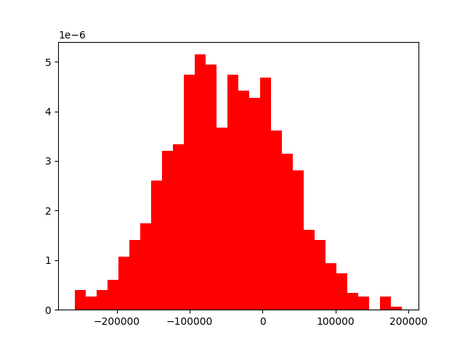

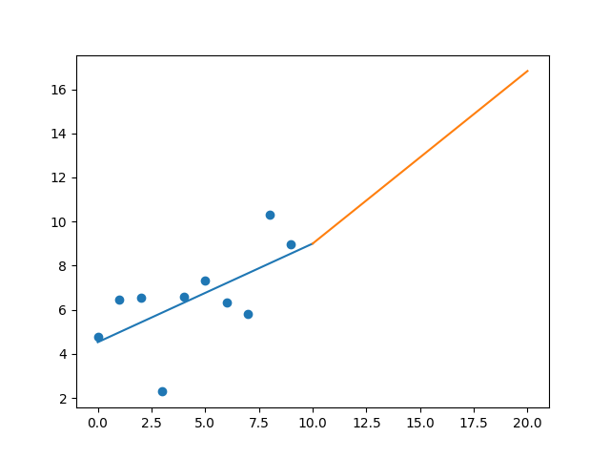

R-Value ROE: 0.284

R-Value EPS: 0.622

CAGR EPS: 0.065

PE Min: 9.392

PE Max: 32.752

Projected AGR Min: 8.903

Projected AGR Max: 23.392

# TICKER: QRVO

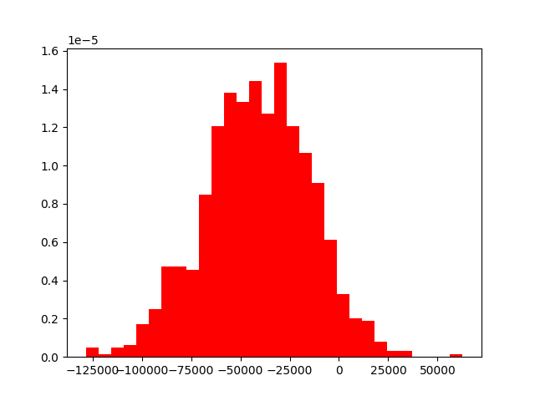

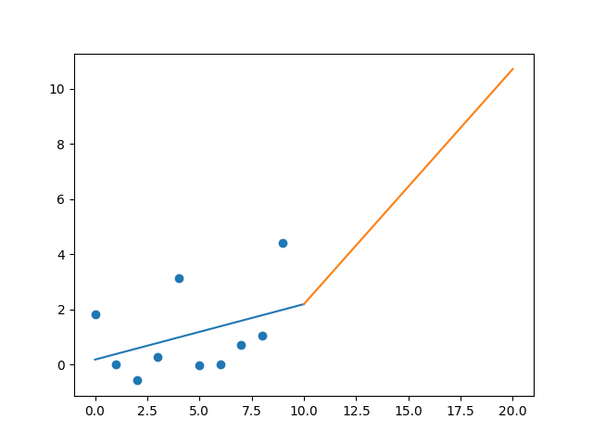

R-Value ROE: 0.128

R-Value EPS: 0.383

CAGR EPS: 0.093

PE Min: 28.707

PE Max: 8671.21

Projected AGR Min: 7.656

Projected AGR Max: 90.566

# TICKER: PWR

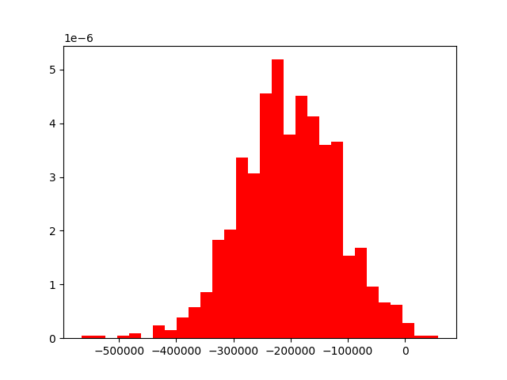

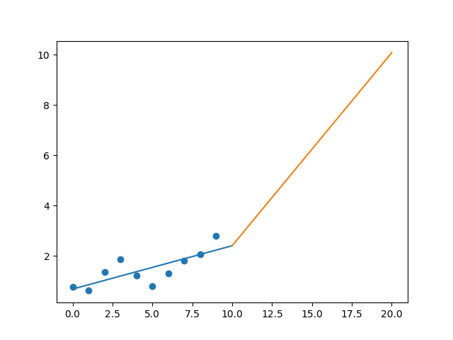

R-Value ROE: 0.602

R-Value EPS: 0.767

CAGR EPS: 0.137

PE Min: 14.652

PE Max: 52.015

Projected AGR Min: 8.256

Projected AGR Max: 22.878

# TICKER: DGX

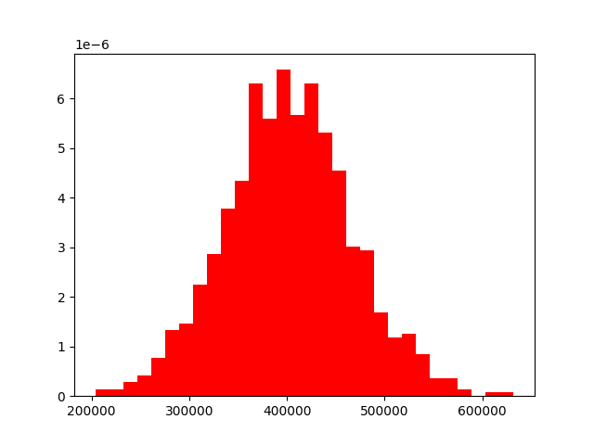

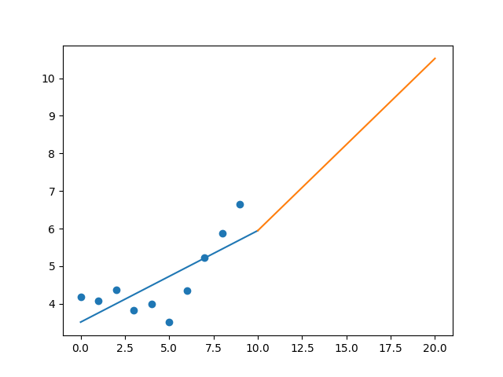

R-Value ROE: 0.159

R-Value EPS: 0.739

CAGR EPS: 0.047

PE Min: 13.848

PE Max: 22.315

Projected AGR Min: 1.773

Projected AGR Max: 6.747

# TICKER: RJF

Something wrong happened

# TICKER: RTX

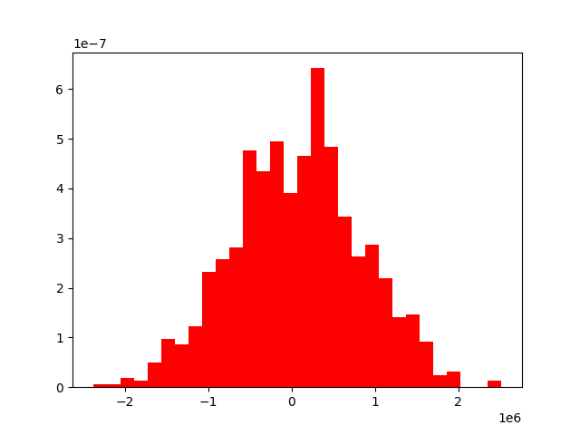

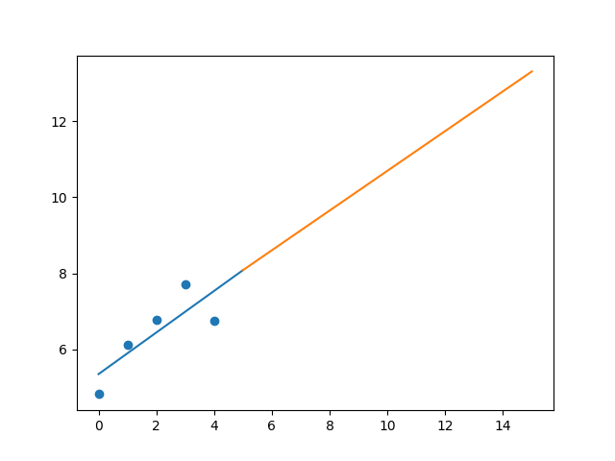

R-Value ROE: 0.89

R-Value EPS: 0.809

CAGR EPS: 0.07

PE Min: 8.448

PE Max: 327.801

Projected AGR Min: 5.493

Projected AGR Max: 52.094

# TICKER: O

Something wrong happened

# TICKER: REG

Something wrong happened

# TICKER: REGN

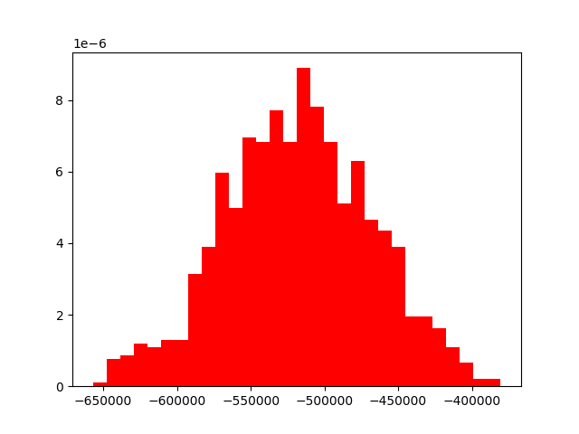

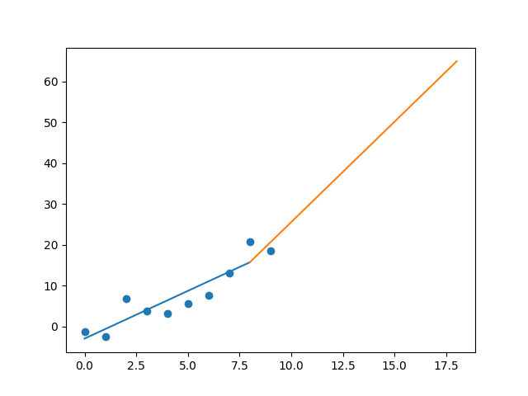

R-Value ROE: 0.428

R-Value EPS: 0.914

CAGR EPS: 0.134

PE Min: 15.237

PE Max: 98.535

Projected AGR Min: 5.766

Projected AGR Max: 27.471

# TICKER: RF

Something wrong happened

# TICKER: RSG

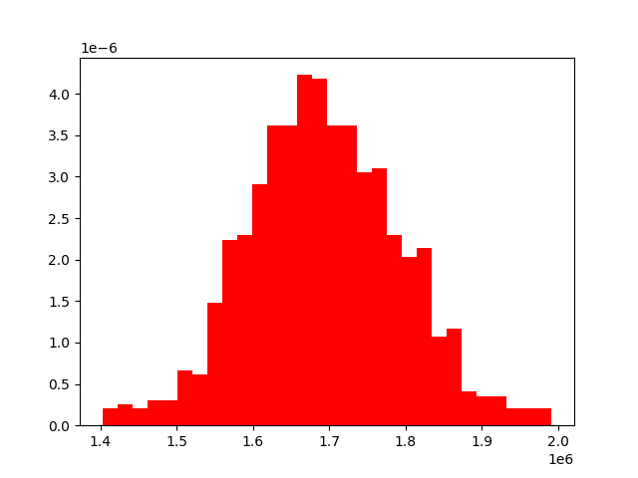

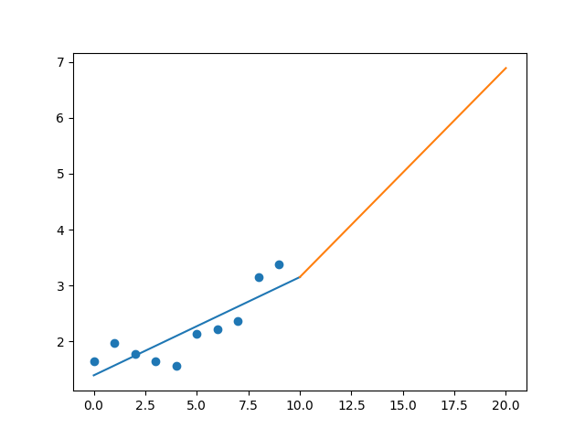

R-Value ROE: 0.808

R-Value EPS: 0.848

CAGR EPS: 0.074

PE Min: 20.608

PE Max: 33.473

Projected AGR Min: 3.332

Projected AGR Max: 8.468

# TICKER: RMD

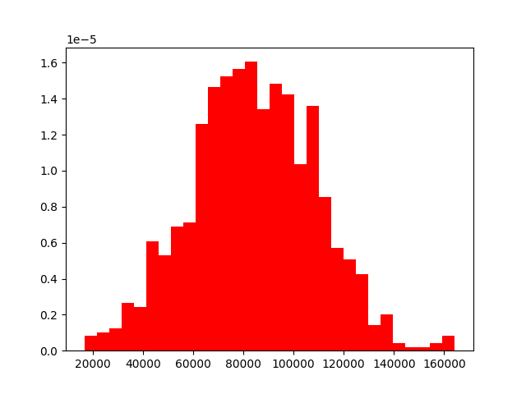

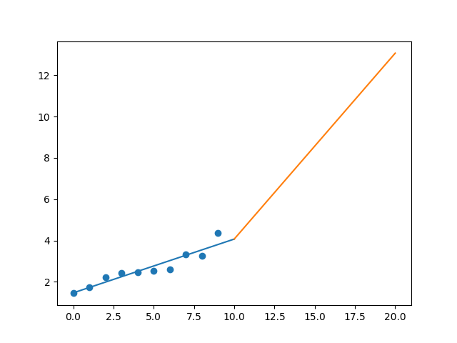

R-Value ROE: 0.554

R-Value EPS: 0.94

CAGR EPS: 0.116

PE Min: 21.375

PE Max: 49.415

Projected AGR Min: 2.667

Projected AGR Max: 11.641

# TICKER: RHI

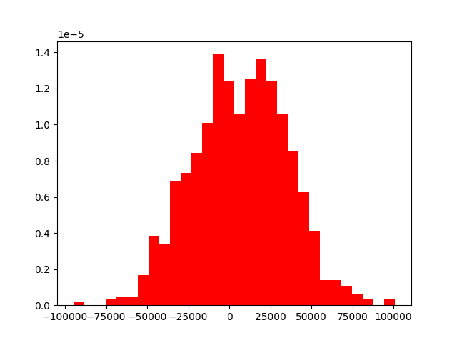

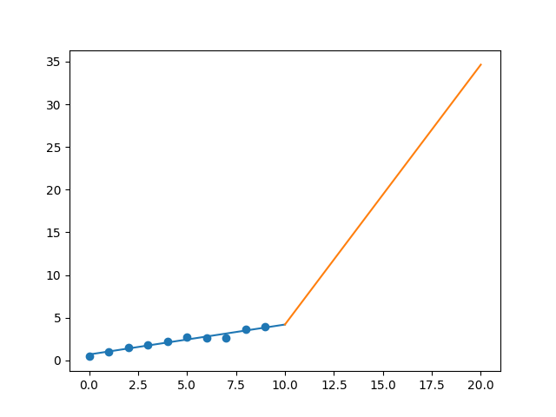

R-Value ROE: 0.861

R-Value EPS: 0.979

CAGR EPS: 0.244

PE Min: 10.031

PE Max: 20.969

Projected AGR Min: 18.694

Projected AGR Max: 27.777

# TICKER: ROL

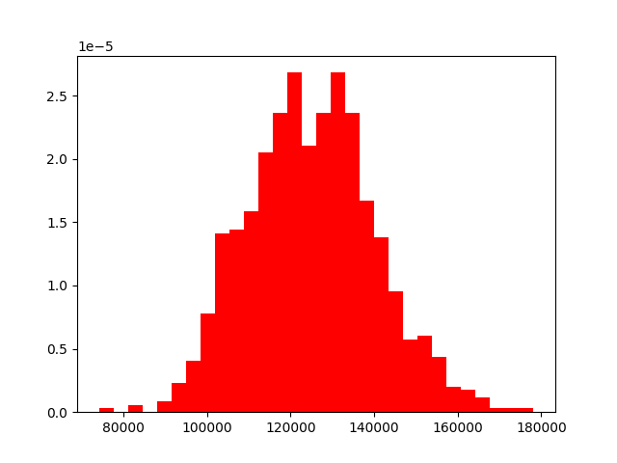

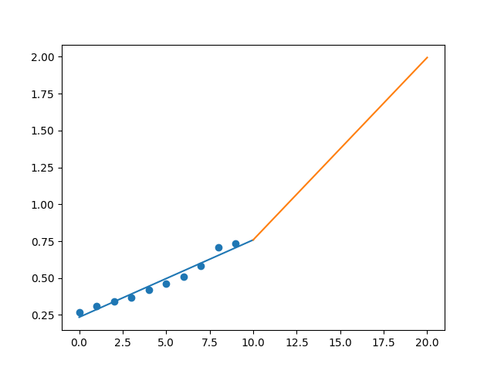

R-Value ROE: 0.452

R-Value EPS: 0.978

CAGR EPS: 0.105

PE Min: 36.875

PE Max: 71.564

Projected AGR Min: 2.216

Projected AGR Max: 9.223

# TICKER: ROP

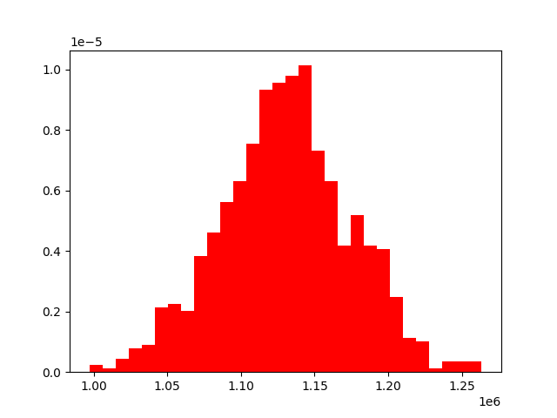

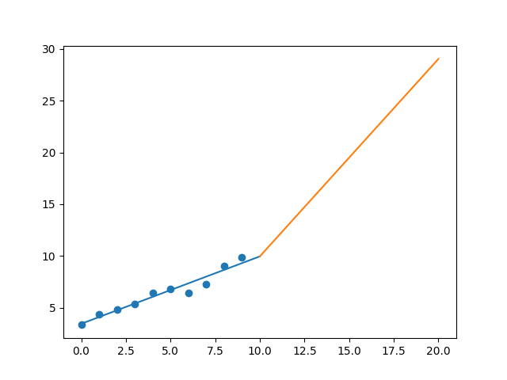

R-Value ROE: 0.495

R-Value EPS: 0.972

CAGR EPS: 0.114

PE Min: 20.0

PE Max: 35.993

Projected AGR Min: 3.804

Projected AGR Max: 10.087