Monte-Carlo Discounted Cash Flow Model and Buffett Analysis

# TICKER: ABBV

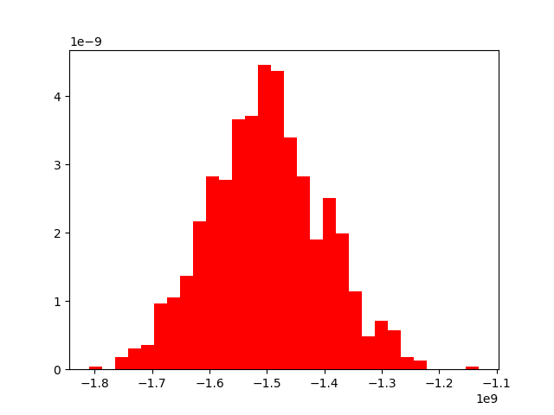

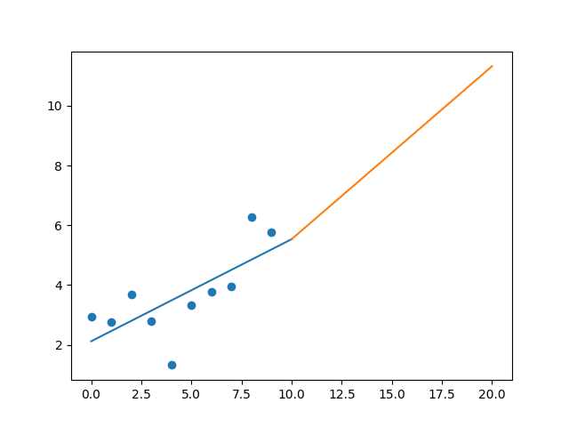

R-Value ROE: 0.407

R-Value EPS: 0.711

CAGR EPS: 0.07

PE Min: 13.856

PE Max: 33.903

Projected AGR Min: 6.396

Projected AGR Max: 16.355

# TICKER: ACHC

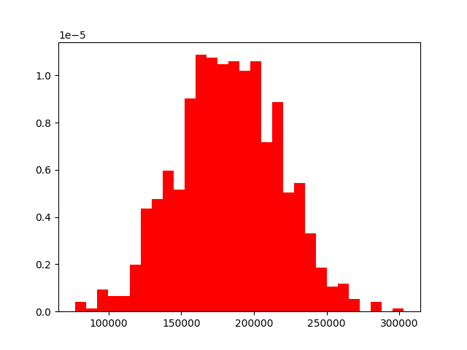

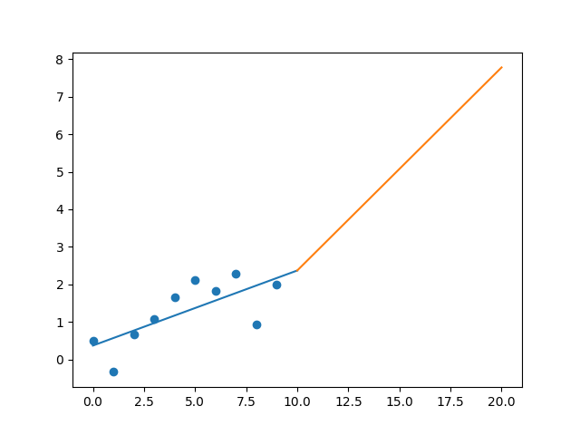

R-Value ROE: 0.005

R-Value EPS: 0.719

CAGR EPS: 0.146

PE Min: 14.285

PE Max: 587.224

Projected AGR Min: 12.278

Projected AGR Max: 62.812

# TICKER: AMGN

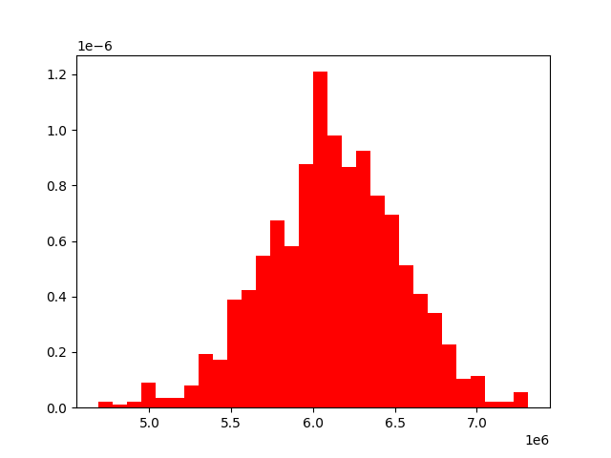

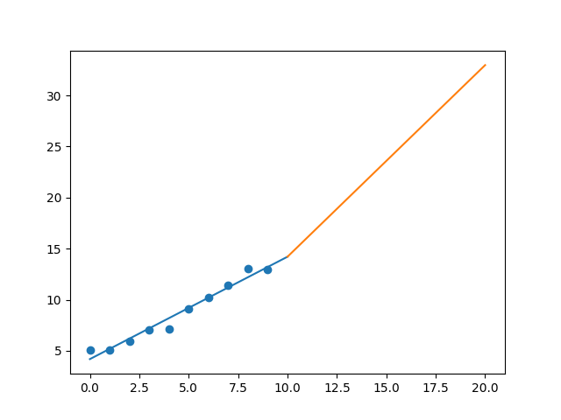

R-Value ROE: 0.649

R-Value EPS: 0.984

CAGR EPS: 0.098

PE Min: 14.251

PE Max: 19.27

Projected AGR Min: 8.154

Projected AGR Max: 11.467

# TICKER: AMN

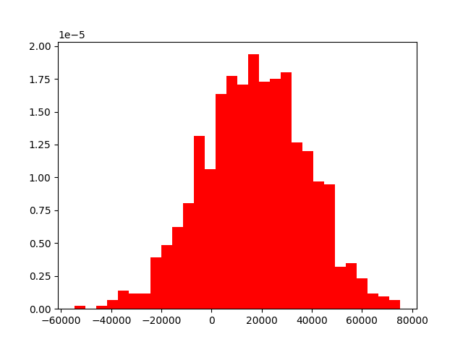

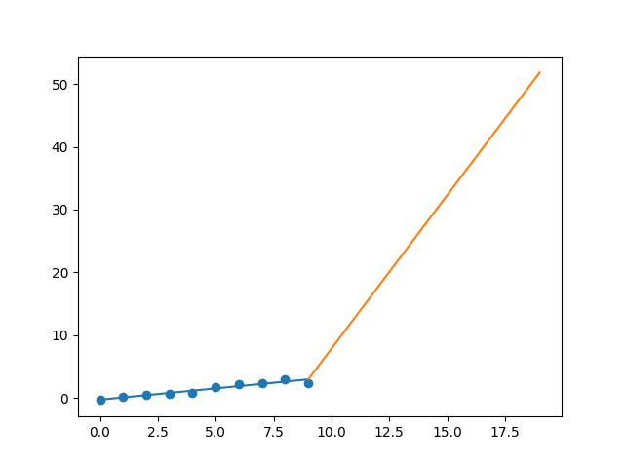

R-Value ROE: 0.784

R-Value EPS: 0.967

CAGR EPS: 0.36

PE Min: 15.755

PE Max: 29.608

Projected AGR Min: 28.75

Projected AGR Max: 37.135

# TICKER: CNC

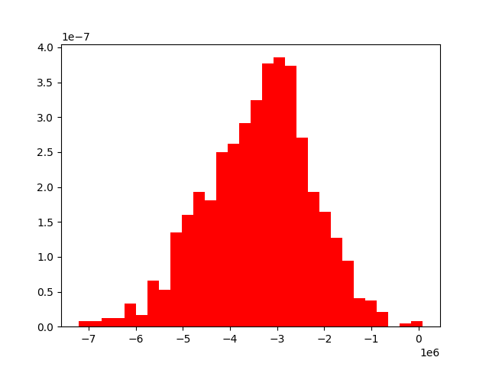

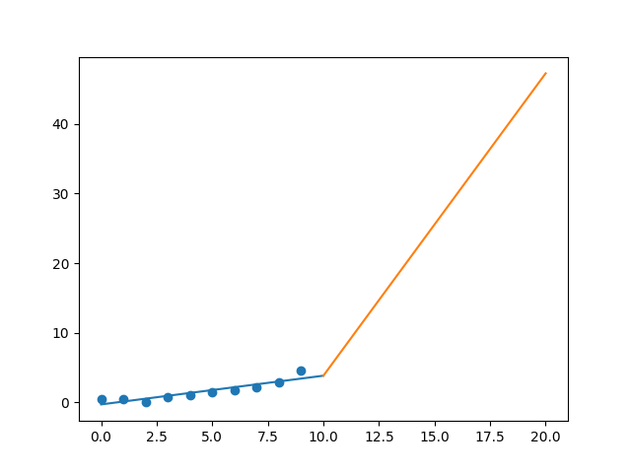

R-Value ROE: 0.043

R-Value EPS: 0.909

CAGR EPS: 0.262

PE Min: 13.423

PE Max: 35.316

Projected AGR Min: 26.908

Projected AGR Max: 39.798

# TICKER: ENDP

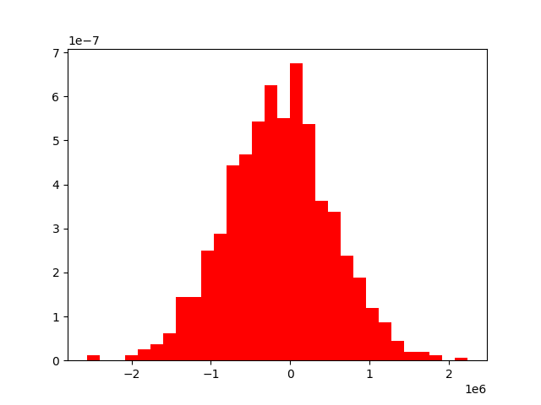

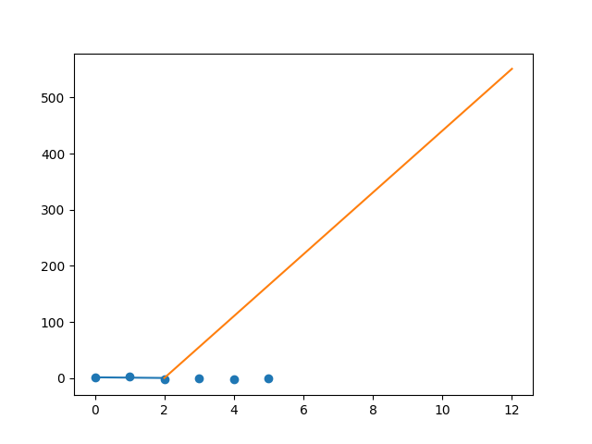

R-Value ROE: 0.203

R-Value EPS: 0.51

CAGR EPS: 0.665

PE Min: 8.157

PE Max: 8.157

Projected AGR Min: 99.177

Projected AGR Max: 99.177

# TICKER: GILD

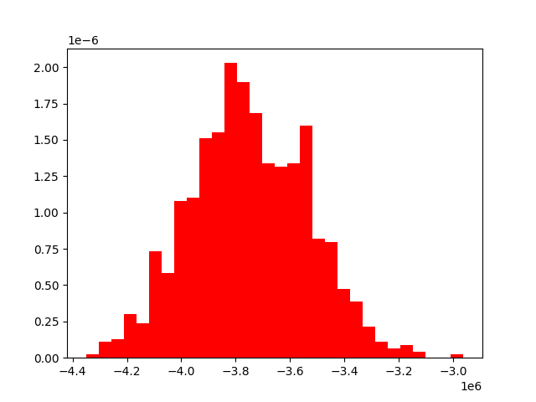

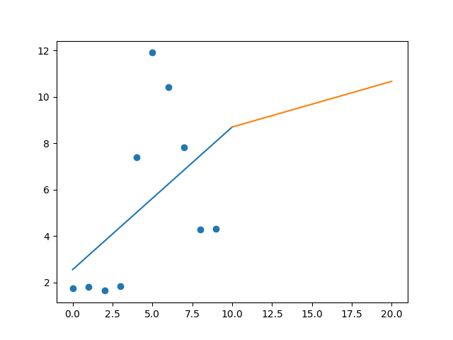

R-Value ROE: 0.147

R-Value EPS: 0.484

CAGR EPS: 0.095

PE Min: 7.179

PE Max: 30.106

Projected AGR Min: 2.806

Projected AGR Max: 18.652

# TICKER: GMED

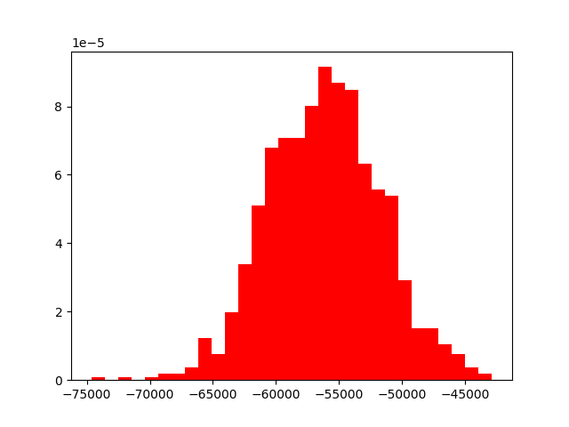

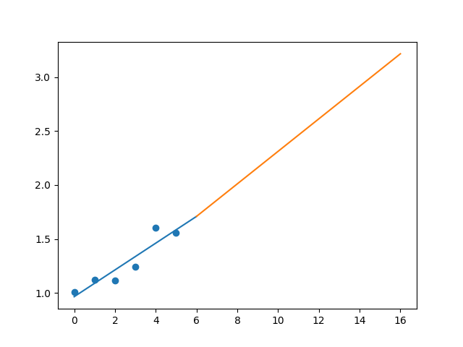

R-Value ROE: 0.822

R-Value EPS: 0.928

CAGR EPS: 0.075

PE Min: 18.483

PE Max: 55.616

Projected AGR Min: 1.555

Projected AGR Max: 13.382

# TICKER: ILMN

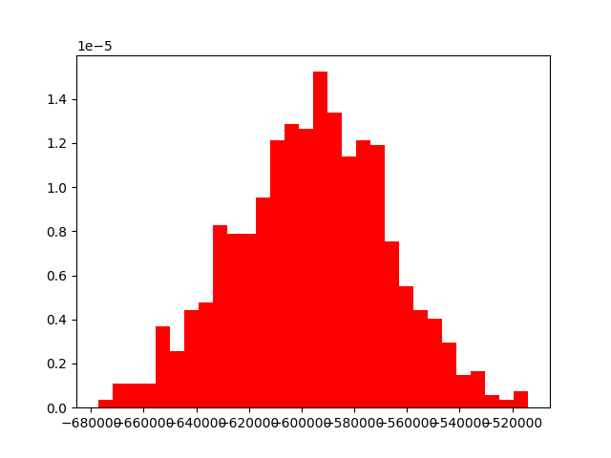

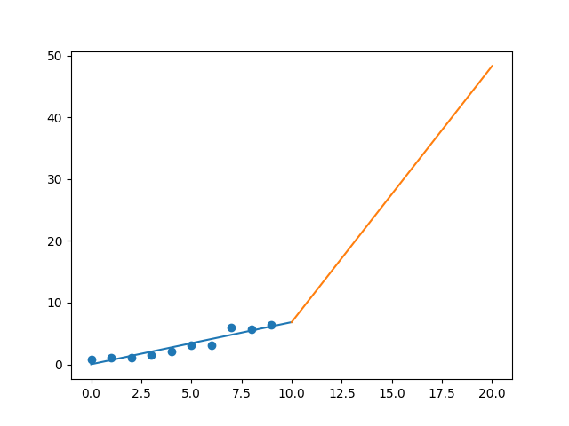

R-Value ROE: 0.778

R-Value EPS: 0.946

CAGR EPS: 0.224

PE Min: 34.003

PE Max: 77.079

Projected AGR Min: 18.873

Projected AGR Max: 29.011

# TICKER: JNJ

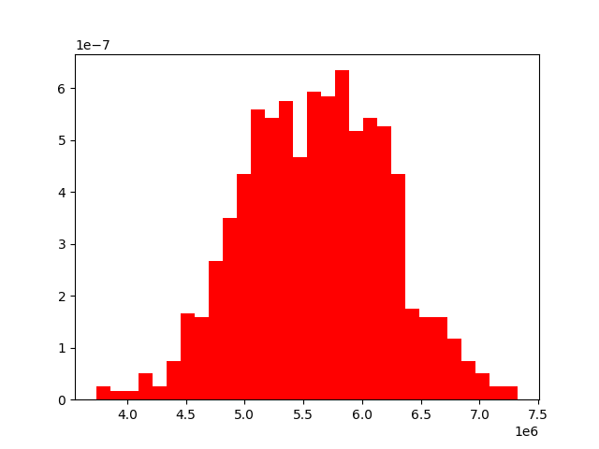

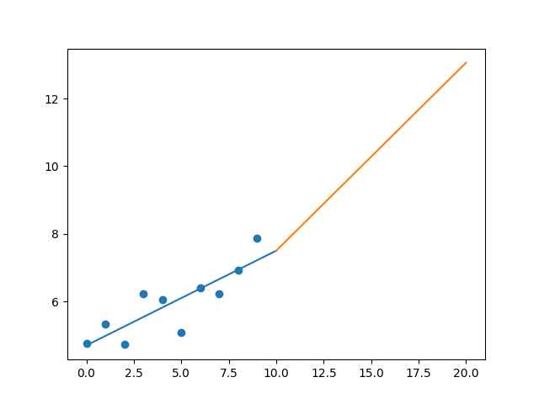

R-Value ROE: 0.045

R-Value EPS: 0.846

CAGR EPS: 0.052

PE Min: 18.748

PE Max: 26.725

Projected AGR Min: 6.078

Projected AGR Max: 9.906

# TICKER: MRK

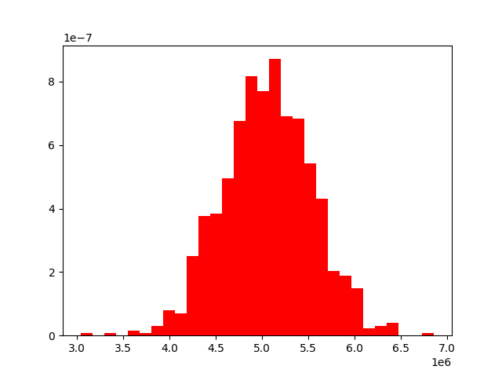

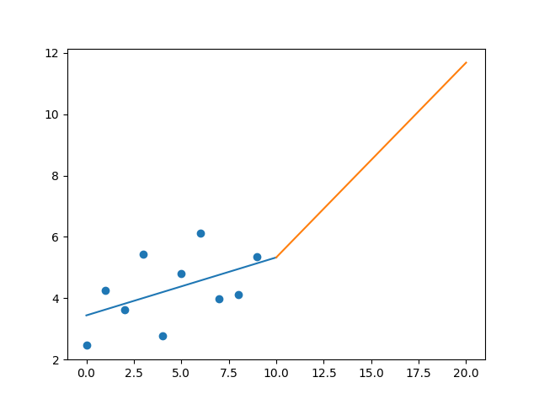

R-Value ROE: 0.639

R-Value EPS: 0.49

CAGR EPS: 0.081

PE Min: 13.158

PE Max: 62.074

Projected AGR Min: 7.562

Projected AGR Max: 25.611

# TICKER: PBH

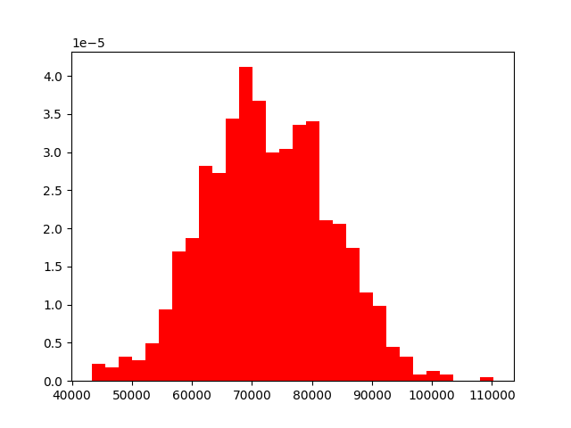

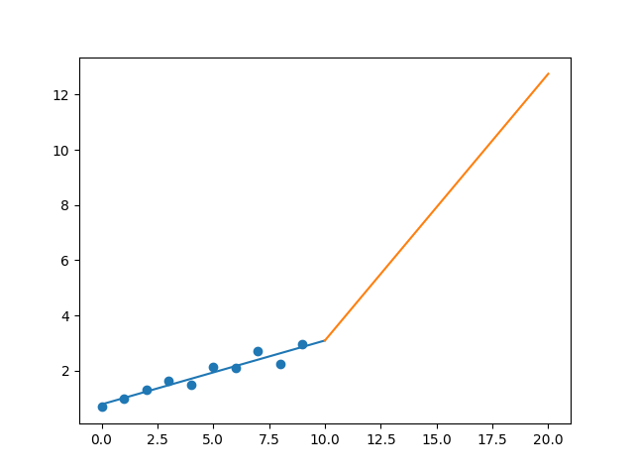

R-Value ROE: 0.029

R-Value EPS: 0.96

CAGR EPS: 0.158

PE Min: 12.556

PE Max: 43.225

Projected AGR Min: 17.149

Projected AGR Max: 32.564

# TICKER: REGN

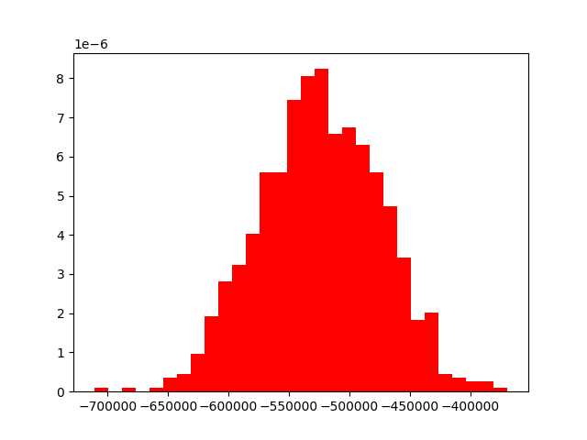

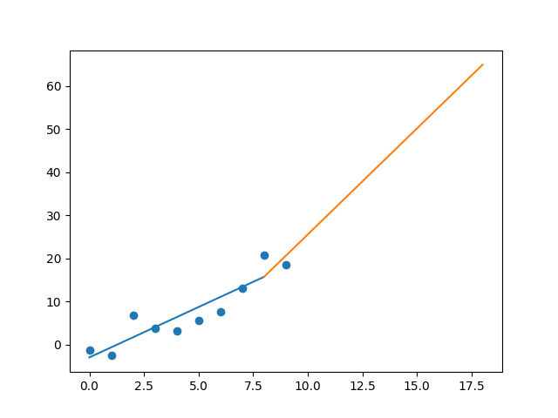

R-Value ROE: 0.428

R-Value EPS: 0.914

CAGR EPS: 0.134

PE Min: 15.237

PE Max: 98.535

Projected AGR Min: 6.272

Projected AGR Max: 28.081

# TICKER: TVTY

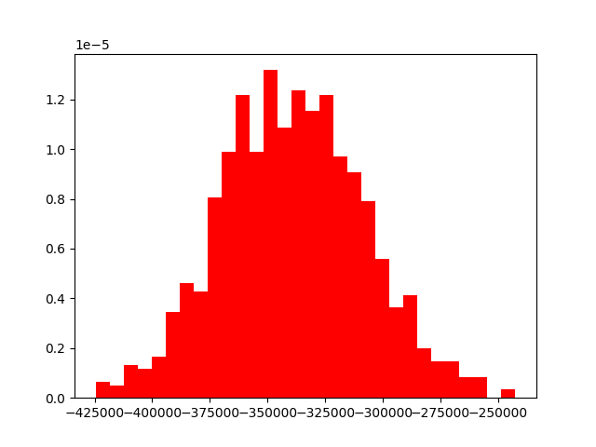

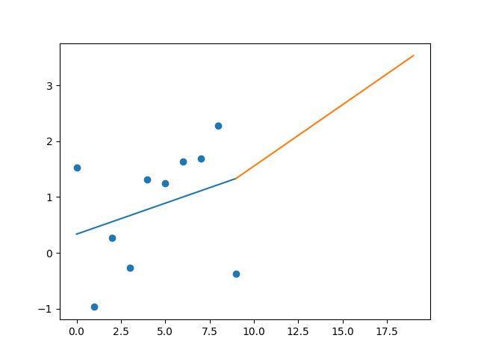

R-Value ROE: 0.277

R-Value EPS: 0.31

CAGR EPS: 0.045

PE Min: 6.83

PE Max: 32.528

Projected AGR Min: 6.076

Projected AGR Max: 23.993

# TICKER: UNH

Something wrong happened