Monte-Carlo Discounted Cash Flow Models

# TICKER: CASY

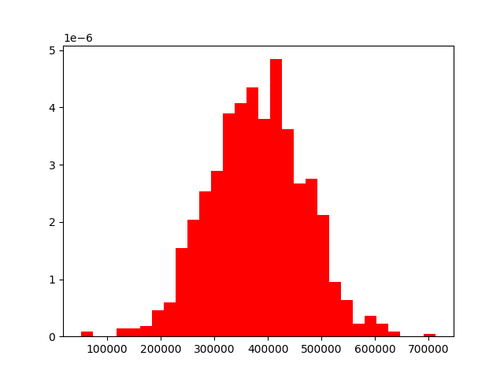

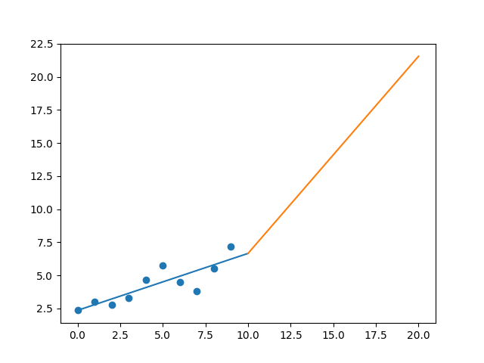

R-Value ROE: 0.472

R-Value EPS: 0.85

CAGR EPS: 0.116

PE Min: 18.871

PE Max: 28.9

Projected AGR Min: 9.305

Projected AGR Max: 14.064

# TICKER: KO

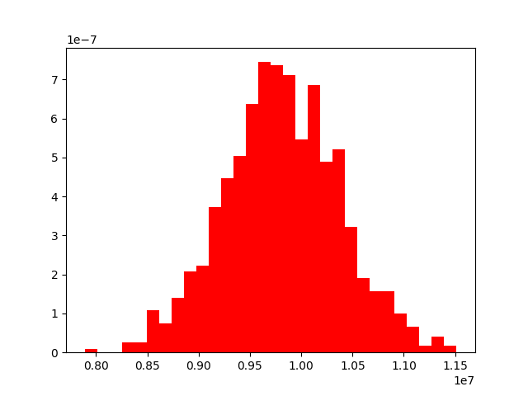

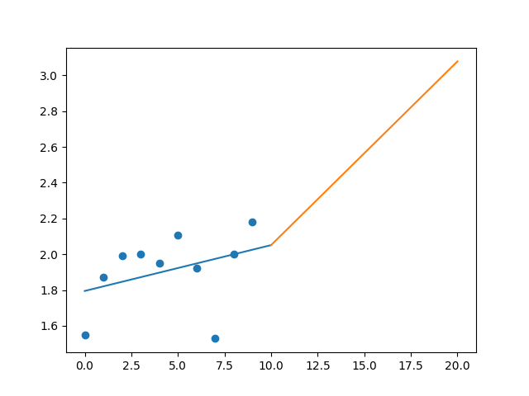

R-Value ROE: 0.117

R-Value EPS: 0.362

CAGR EPS: 0.035

PE Min: 18.455

PE Max: 46.923

Projected AGR Min: 1.714

Projected AGR Max: 11.663

# TICKER: CVS

Something wrong happened

# TICKER: GIS

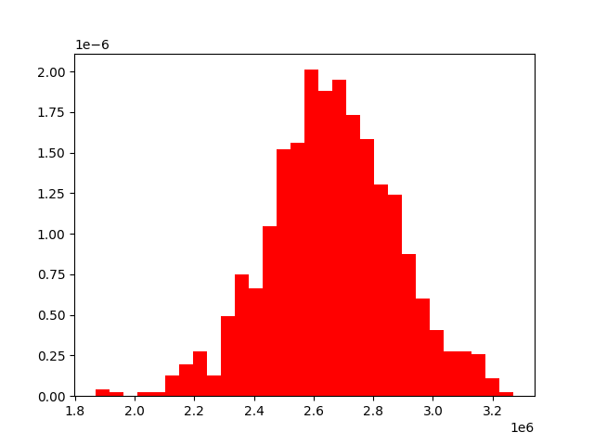

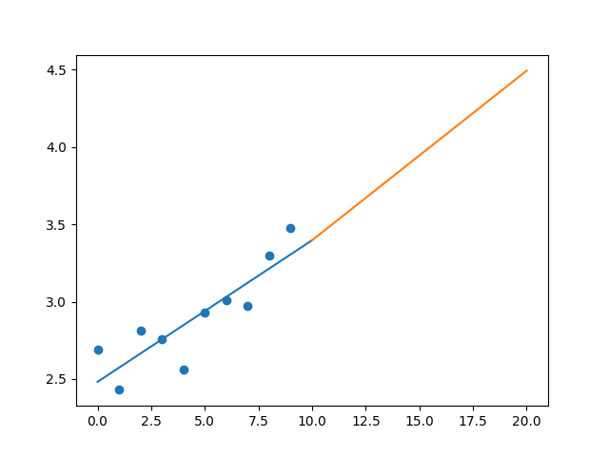

R-Value ROE: 0.256

R-Value EPS: 0.868

CAGR EPS: 0.026

PE Min: 15.217

PE Max: 25.788

Projected AGR Min: 1.473

Projected AGR Max: 6.969

# TICKER: JJSF

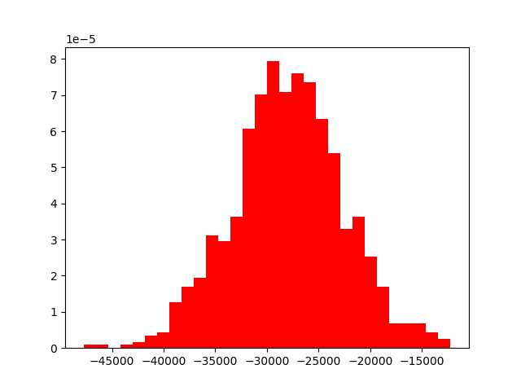

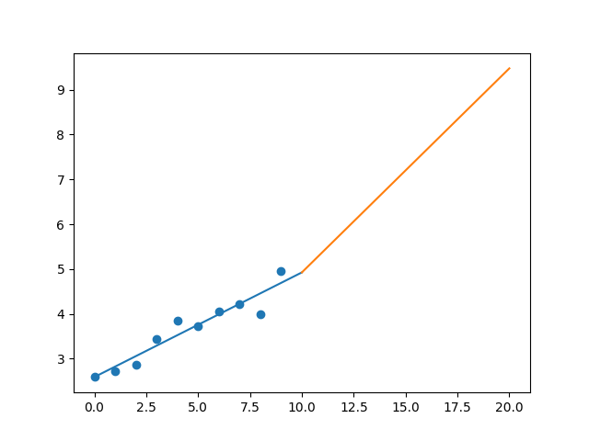

R-Value ROE: 0.18

R-Value EPS: 0.951

CAGR EPS: 0.067

PE Min: 26.826

PE Max: 59.94

Projected AGR Min: 6.394

Projected AGR Max: 15.301

# TICKER: MKC

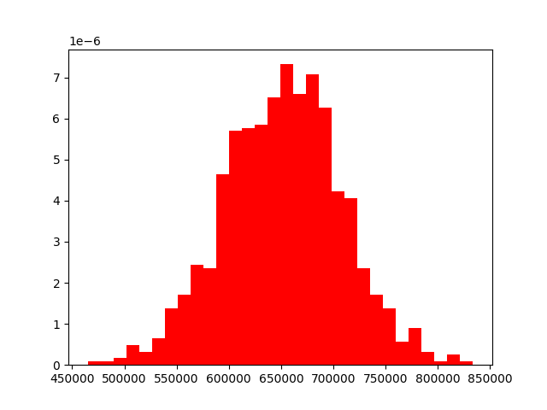

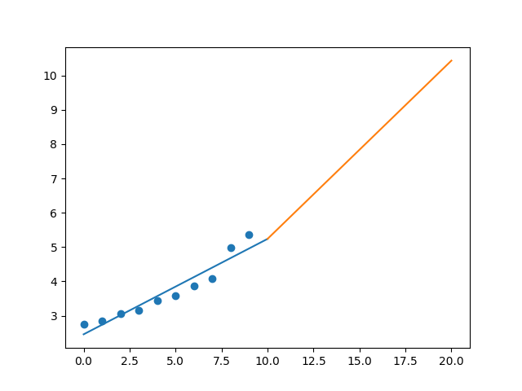

R-Value ROE: 0.023

R-Value EPS: 0.955

CAGR EPS: 0.069

PE Min: 24.695

PE Max: 36.477

Projected AGR Min: 3.629

Projected AGR Max: 7.752

# TICKER: MNST

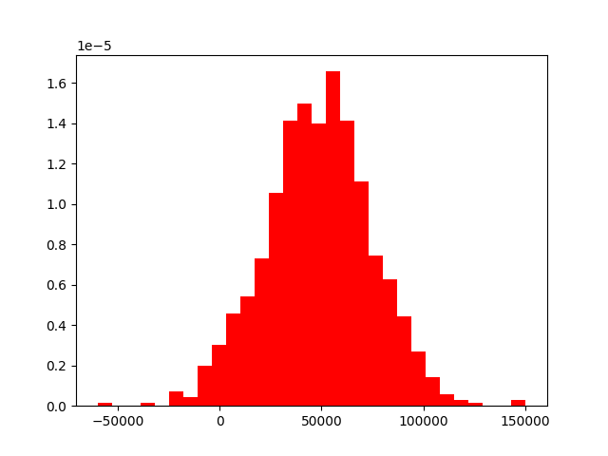

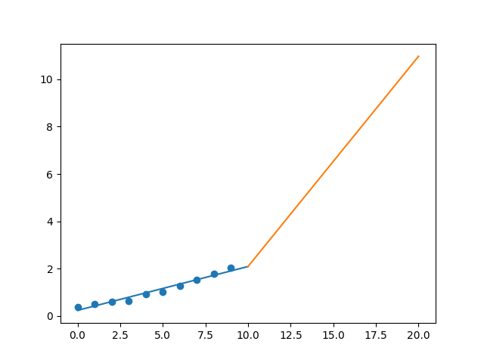

R-Value ROE: 0.376

R-Value EPS: 0.982

CAGR EPS: 0.183

PE Min: 27.238

PE Max: 53.195

Projected AGR Min: 14.594

Projected AGR Max: 22.527

# TICKER: FIZZ

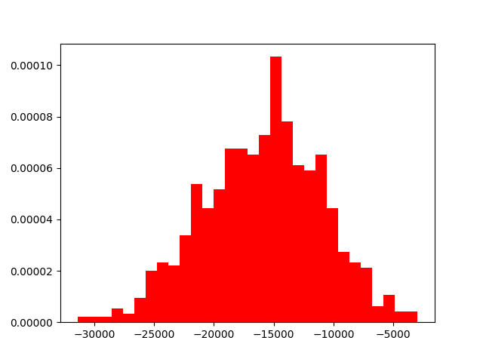

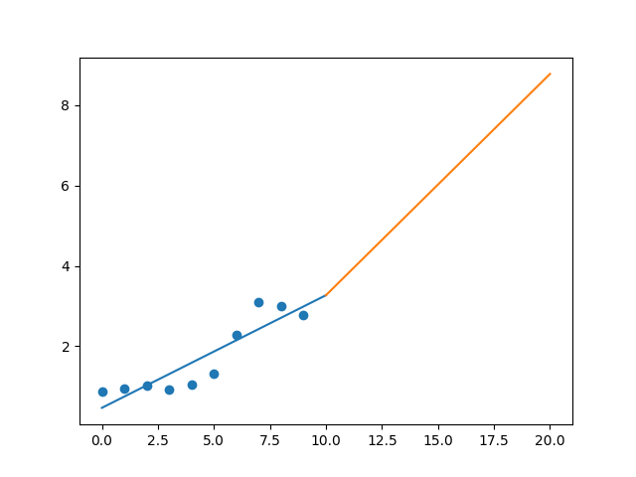

R-Value ROE: 0.422

R-Value EPS: 0.896

CAGR EPS: 0.122

PE Min: 15.792

PE Max: 40.017

Projected AGR Min: 5.845

Projected AGR Max: 16.159

# TICKER: SFM

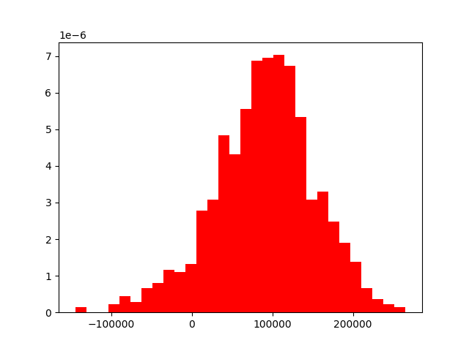

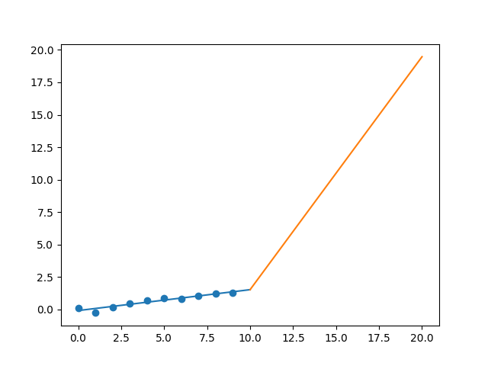

R-Value ROE: 0.916

R-Value EPS: 0.953

CAGR EPS: 0.316

PE Min: 11.462

PE Max: 32.121

Projected AGR Min: 27.96

Projected AGR Max: 41.849

# TICKER: HSY

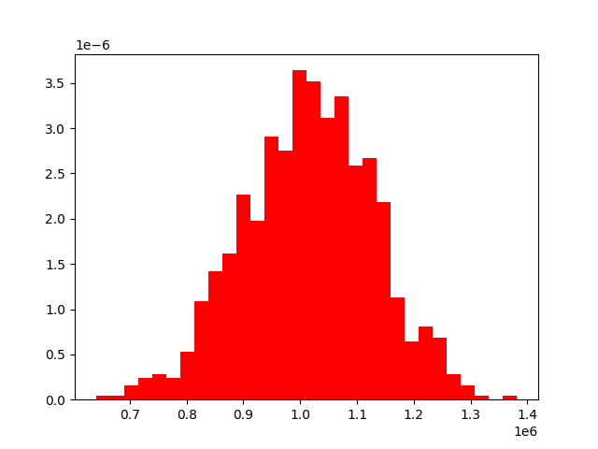

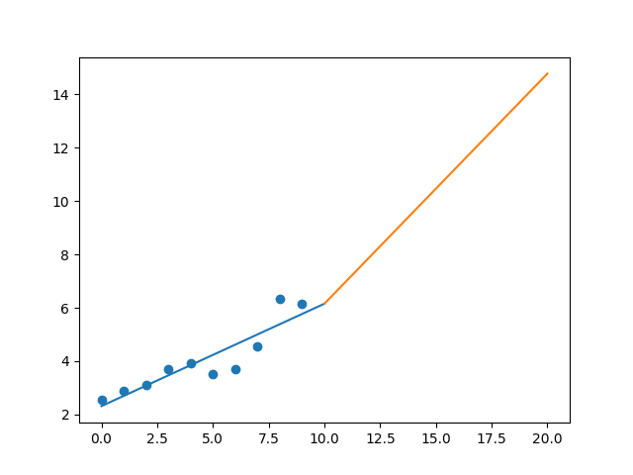

R-Value ROE: 0.472

R-Value EPS: 0.904

CAGR EPS: 0.092

PE Min: 19.343

PE Max: 41.855

Projected AGR Min: 7.654

Projected AGR Max: 16.293

# TICKER: TR

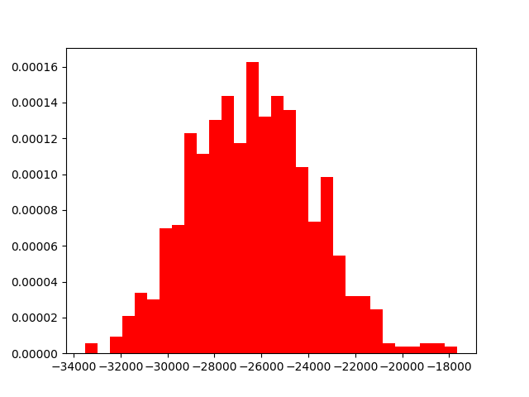

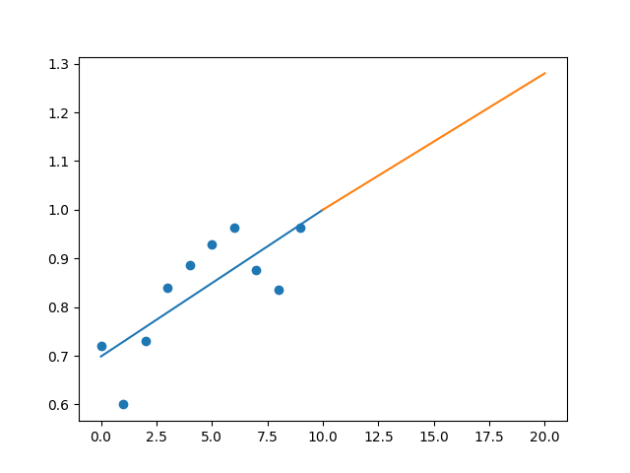

R-Value ROE: 0.428

R-Value EPS: 0.774

CAGR EPS: 0.029

PE Min: 29.327

PE Max: 42.602

Projected AGR Min: 2.359

Projected AGR Max: 6.254

# TICKER: TSN

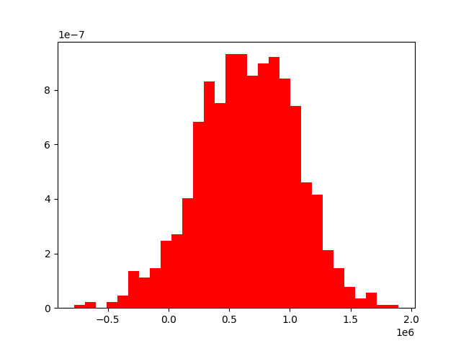

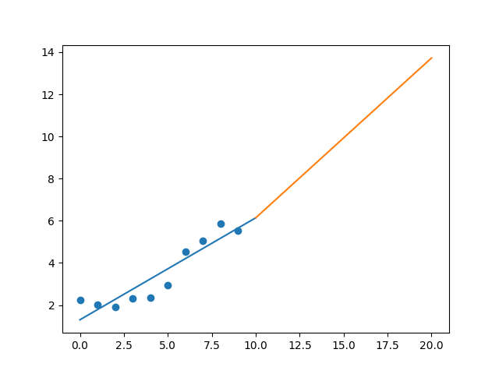

R-Value ROE: 0.532

R-Value EPS: 0.923

CAGR EPS: 0.095

PE Min: 9.852

PE Max: 18.356

Projected AGR Min: 9.043

Projected AGR Max: 16.044

# TICKER: WDFC

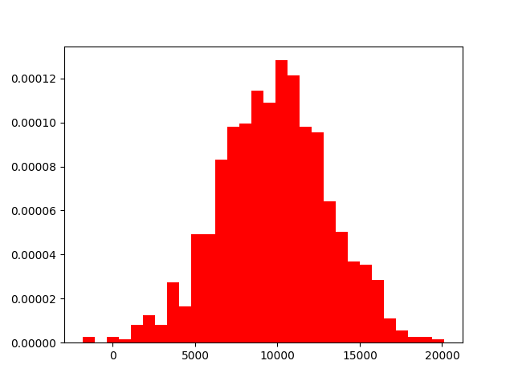

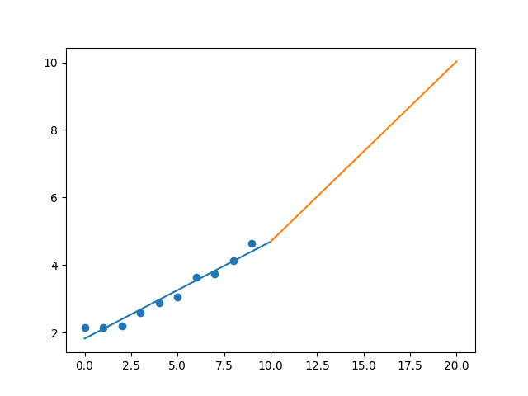

R-Value ROE: 0.957

R-Value EPS: 0.979

CAGR EPS: 0.08

PE Min: 28.569

PE Max: 46.401

Projected AGR Min: 1.539

Projected AGR Max: 6.585