Monte-Carlo Discounted Cash Flow Model and Buffett Analysis

# TICKER: ADBE

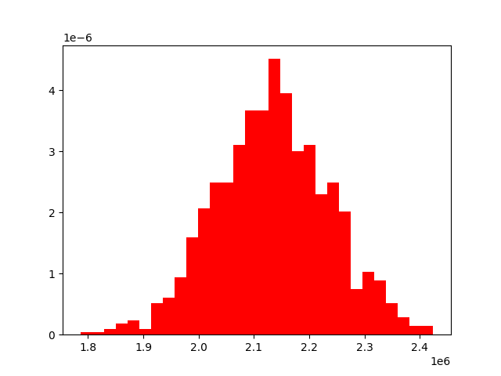

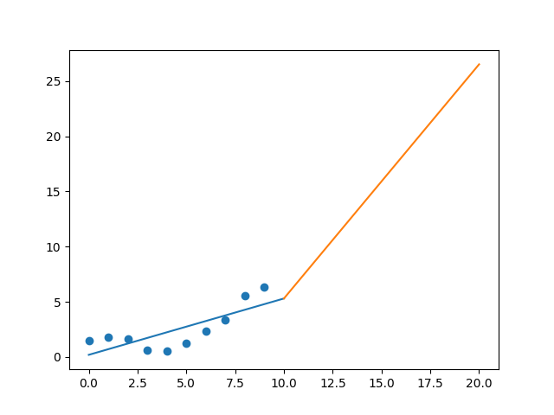

R-Value ROE: 0.561

R-Value EPS: 0.772

CAGR EPS: 0.154

PE Min: 42.978

PE Max: 74.156

Projected AGR Min: 9.819

Projected AGR Max: 15.975

# TICKER: BABA

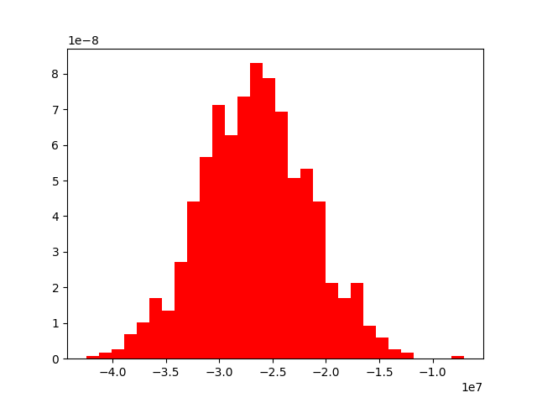

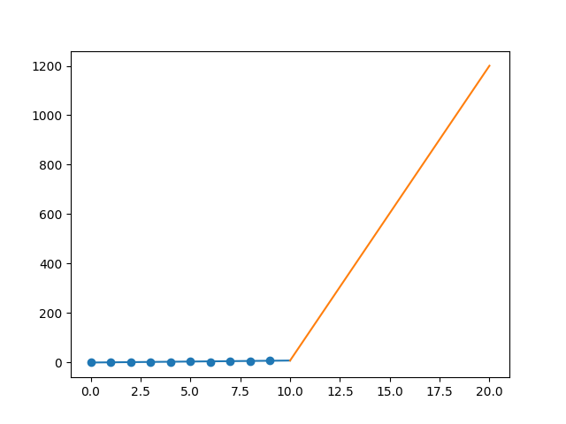

R-Value ROE: 0.479

R-Value EPS: 0.913

CAGR EPS: 0.641

PE Min: 15.488

PE Max: 55.361

Projected AGR Min: 50.82

Projected AGR Max: 71.308

# TICKER: GOOGL

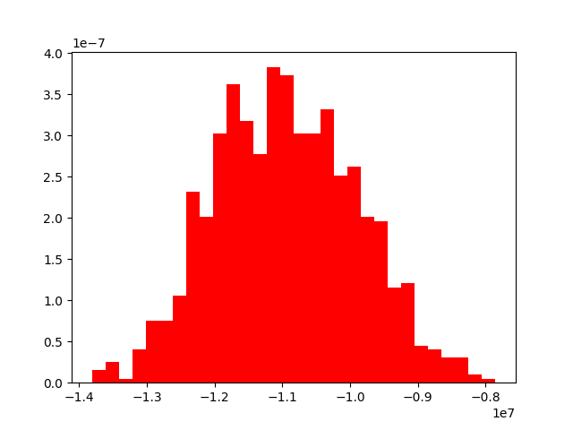

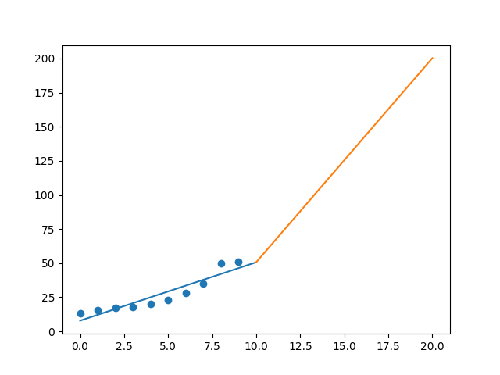

R-Value ROE: 0.277

R-Value EPS: 0.93

CAGR EPS: 0.146

PE Min: 21.859

PE Max: 34.085

Projected AGR Min: 10.449

Projected AGR Max: 15.466

# TICKER: ANET

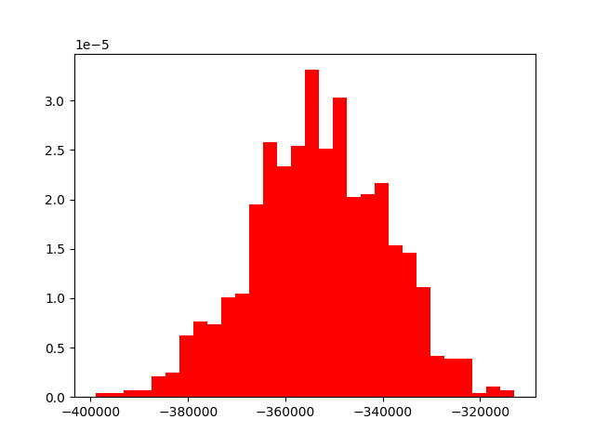

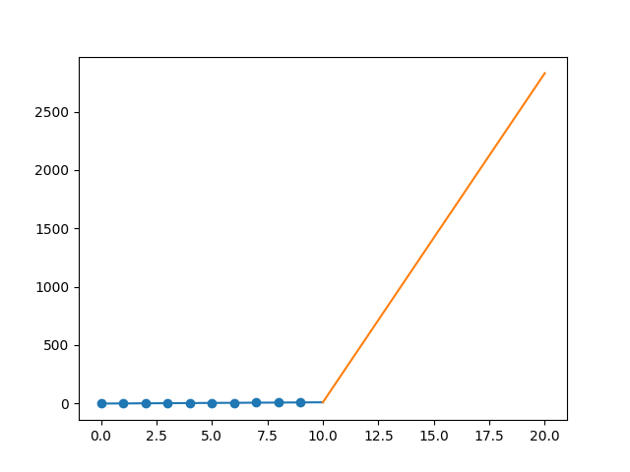

R-Value ROE: 0.417

R-Value EPS: 0.897

CAGR EPS: 0.748

PE Min: 19.126

PE Max: 74.058

Projected AGR Min: 74.277

Projected AGR Max: 99.543

# TICKER: BIDU

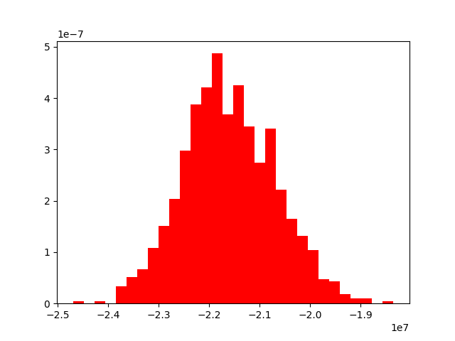

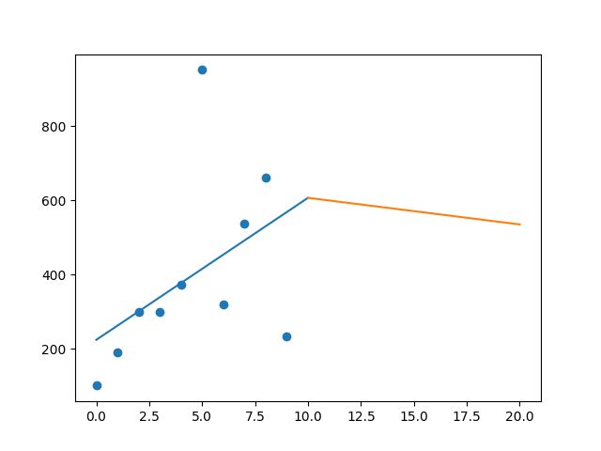

R-Value ROE: 0.868

R-Value EPS: 0.456

CAGR EPS: 0.087

PE Min: 12.089

PE Max: 157.071

Projected AGR Min: 47.455

Projected AGR Max: 90.559

# TICKER: CTSH

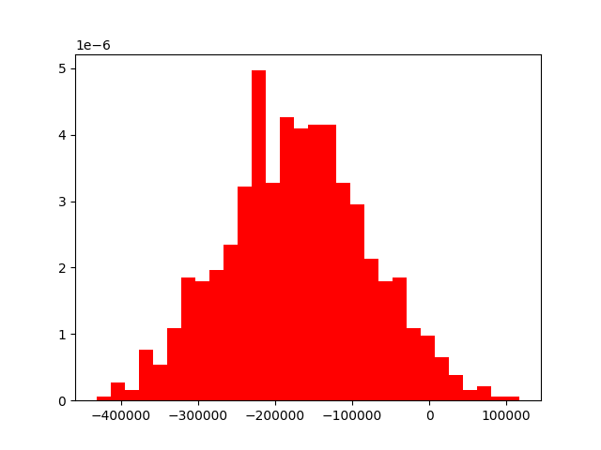

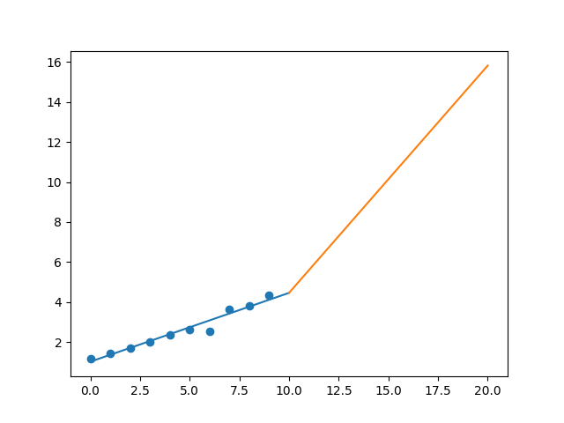

R-Value ROE: 0.767

R-Value EPS: 0.978

CAGR EPS: 0.138

PE Min: 14.551

PE Max: 24.568

Projected AGR Min: 12.437

Projected AGR Max: 18.483

# TICKER: DXC

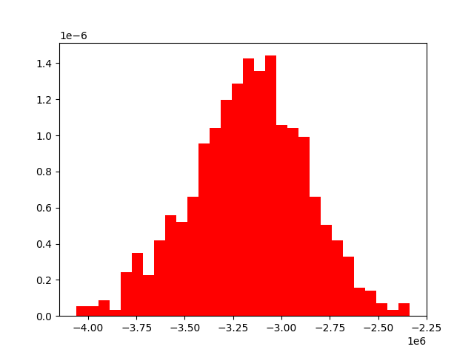

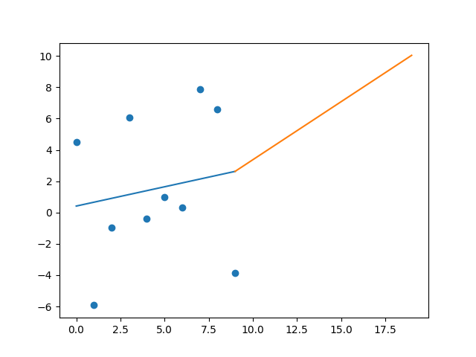

R-Value ROE: 0.037

R-Value EPS: 0.162

CAGR EPS: 0.043

PE Min: 10.273

PE Max: 442.309

Projected AGR Min: 18.798

Projected AGR Max: 73.067

# TICKER: FB

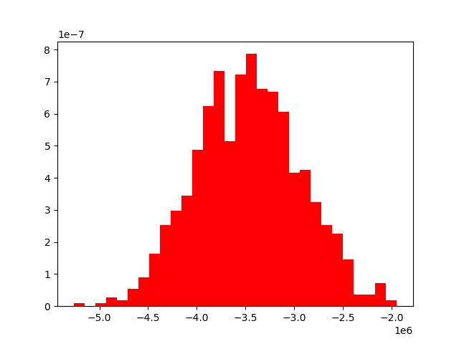

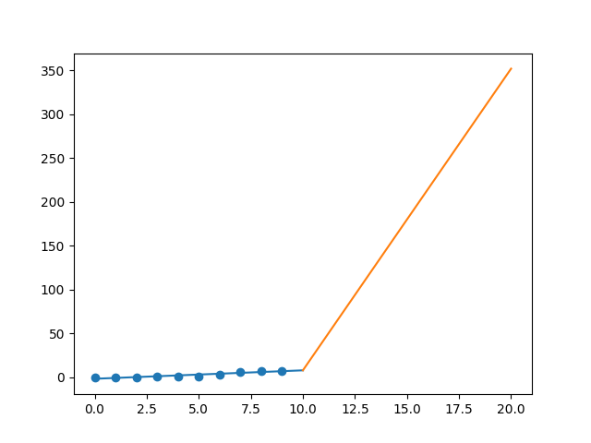

R-Value ROE: 0.168

R-Value EPS: 0.921

CAGR EPS: 0.465

PE Min: 17.293

PE Max: 90.314

Projected AGR Min: 36.862

Projected AGR Max: 61.461

# TICKER: GRPN

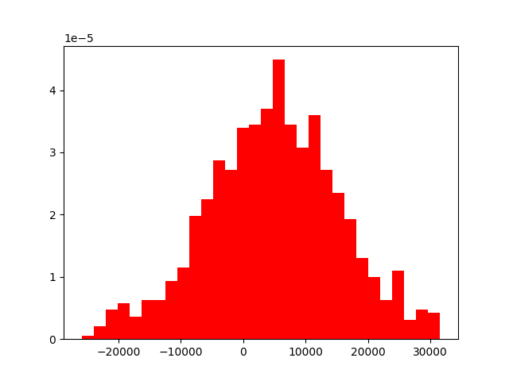

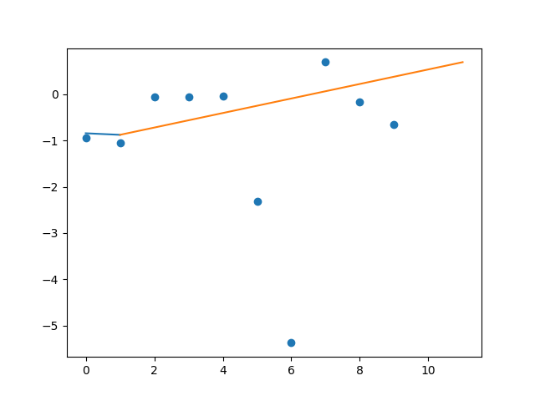

R-Value ROE: 0.525

R-Value EPS: 0.059

CAGR EPS: 0.0

PE Min: 77.767

PE Max: 385.901

Projected AGR Min: 10.771

Projected AGR Max: 30.015

# TICKER: MANH

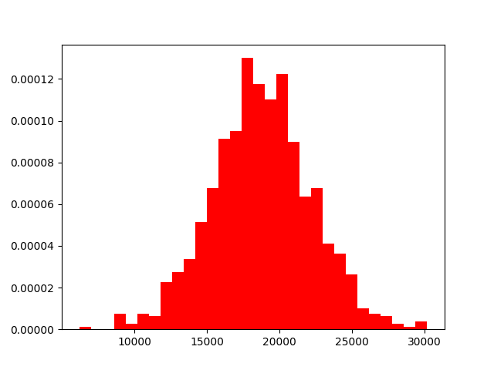

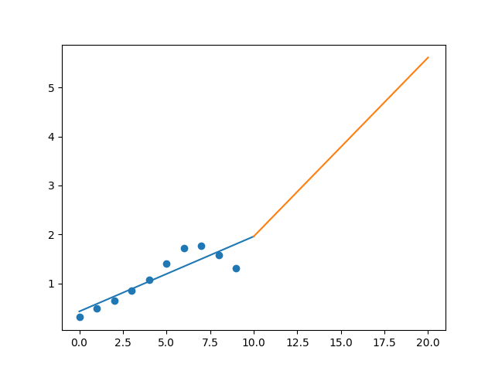

R-Value ROE: 0.921

R-Value EPS: 0.884

CAGR EPS: 0.156

PE Min: 23.825

PE Max: 73.757

Projected AGR Min: 4.546

Projected AGR Max: 17.054

# TICKER: MSFT

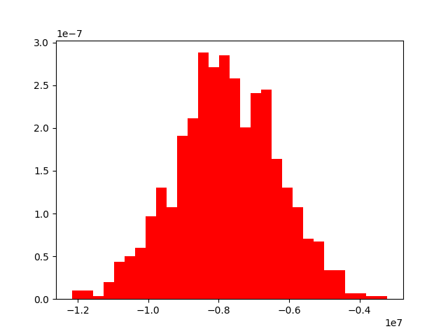

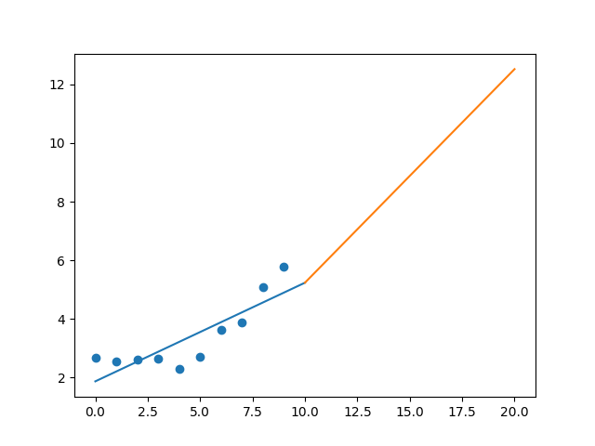

R-Value ROE: 0.112

R-Value EPS: 0.846

CAGR EPS: 0.08

PE Min: 19.945

PE Max: 42.361

Projected AGR Min: 2.101

Projected AGR Max: 10.089

# TICKER: NTES

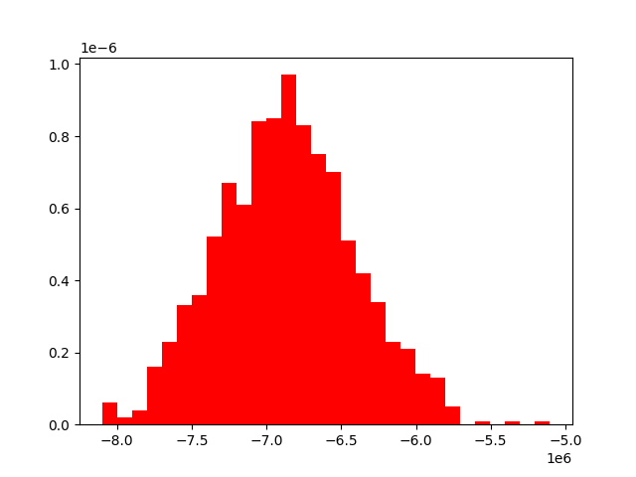

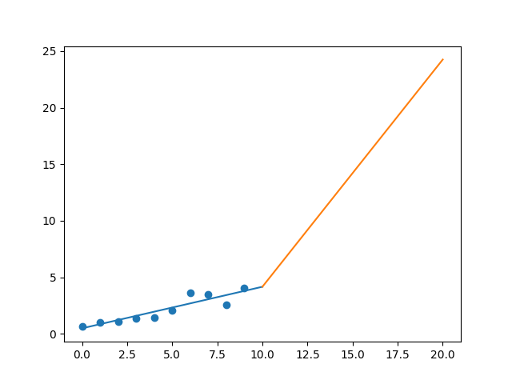

R-Value ROE: 0.185

R-Value EPS: 0.91

CAGR EPS: 0.195

PE Min: 10.949

PE Max: 29.079

Projected AGR Min: 11.799

Projected AGR Max: 23.27

# TICKER: ORCL

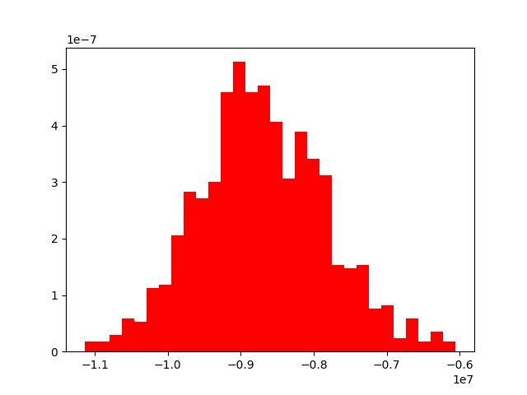

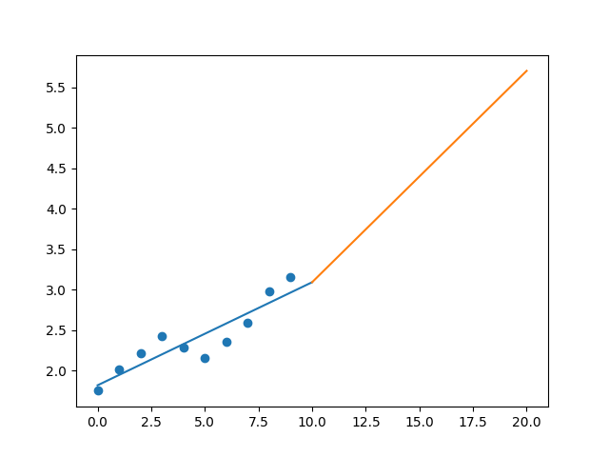

R-Value ROE: 0.544

R-Value EPS: 0.907

CAGR EPS: 0.061

PE Min: 15.57

PE Max: 22.089

Projected AGR Min: 4.669

Projected AGR Max: 8.394

# TICKER: TWTR

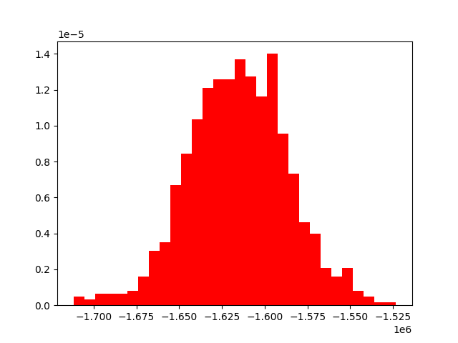

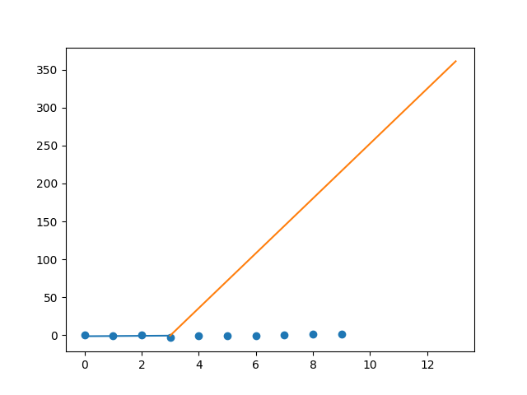

R-Value ROE: 0.882

R-Value EPS: 0.541

CAGR EPS: 0.693

PE Min: 11.567

PE Max: 73.888

Projected AGR Min: 58.655

Projected AGR Max: 90.981