Monte-Carlo Discounted Cash Flow Model and Buffett Analysis

# TICKER: AEP

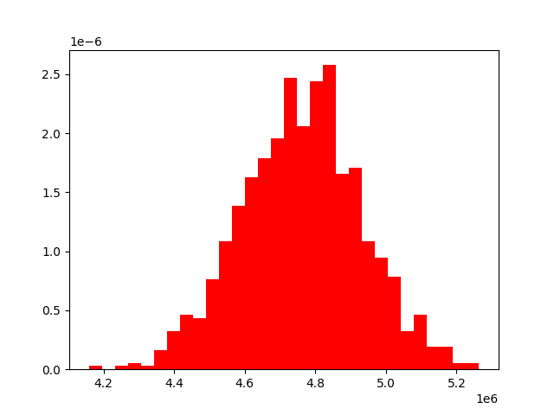

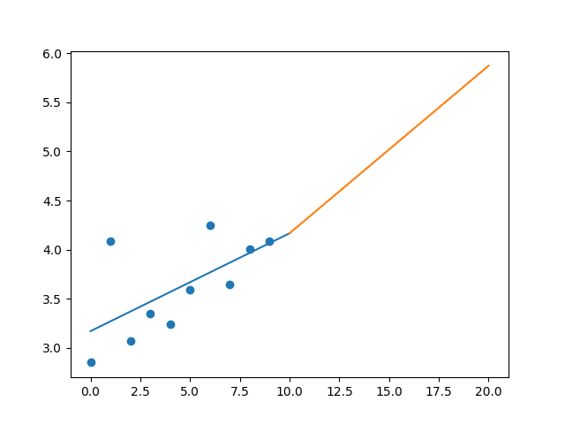

R-Value ROE: 0.136

R-Value EPS: 0.626

CAGR EPS: 0.037

PE Min: 16.208

PE Max: 71.093

Projected AGR Min: 0.545

Projected AGR Max: 16.566

# TICKER: AWK

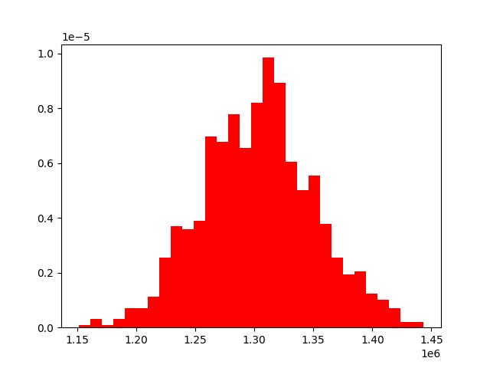

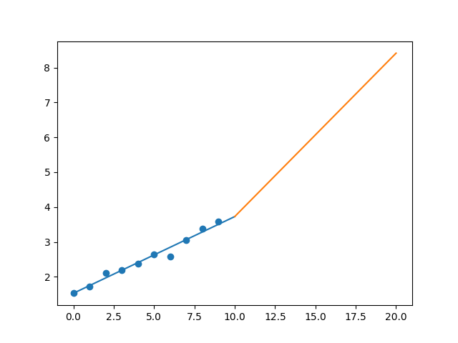

R-Value ROE: 0.856

R-Value EPS: 0.987

CAGR EPS: 0.089

PE Min: 21.089

PE Max: 36.501

Projected AGR Min: 1.675

Projected AGR Max: 7.409

# TICKER: D

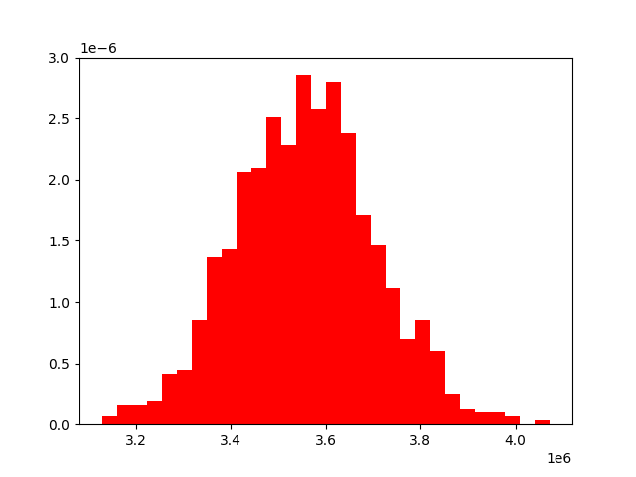

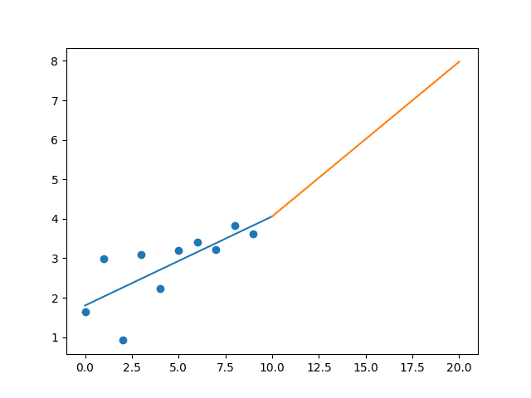

R-Value ROE: 0.278

R-Value EPS: 0.736

CAGR EPS: 0.082

PE Min: 18.787

PE Max: 125.376

Projected AGR Min: 6.483

Projected AGR Max: 28.741

# TICKER: MSEX

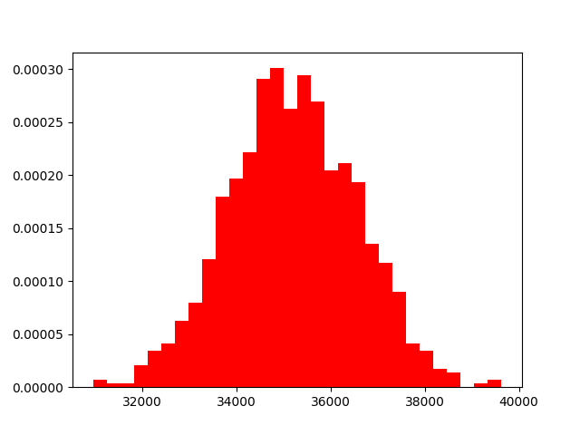

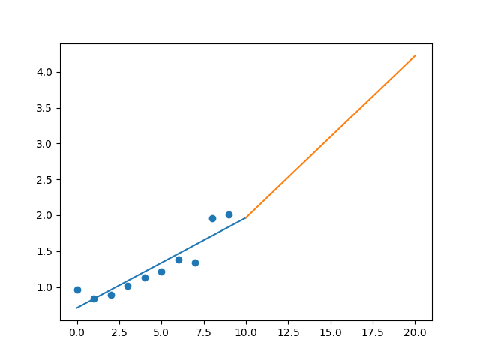

R-Value ROE: 0.854

R-Value EPS: 0.916

CAGR EPS: 0.077

PE Min: 20.346

PE Max: 33.034

Projected AGR Min: 2.844

Projected AGR Max: 7.951

# TICKER: NFG

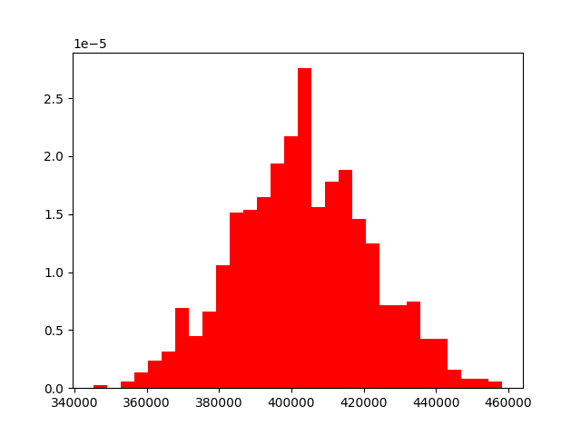

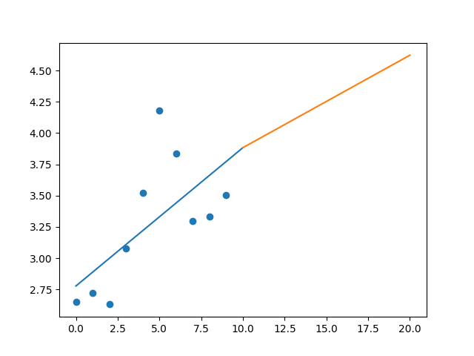

R-Value ROE: 0.051

R-Value EPS: 0.648

CAGR EPS: 0.028

PE Min: 13.379

PE Max: 53.546

Projected AGR Min: 4.597

Projected AGR Max: 20.157

# TICKER: YORW

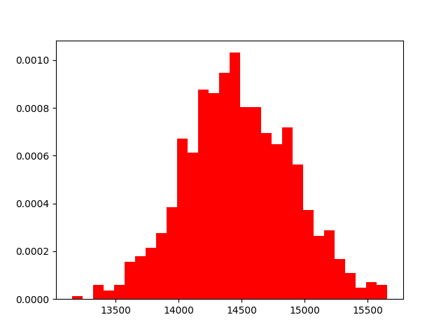

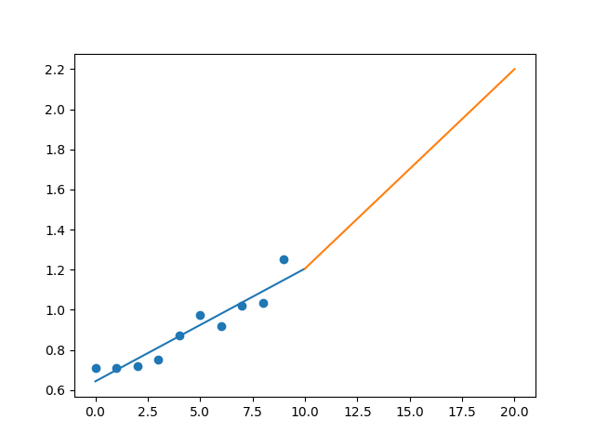

R-Value ROE: 0.664

R-Value EPS: 0.947

CAGR EPS: 0.058

PE Min: 21.542

PE Max: 41.607

Projected AGR Min: 1.18

Projected AGR Max: 8.064

# TICKER: VZ

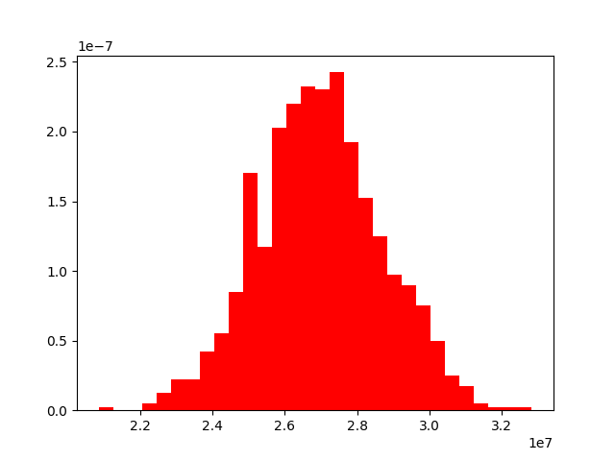

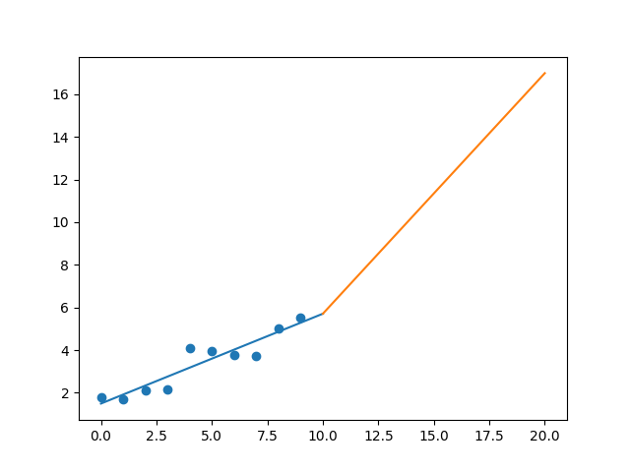

R-Value ROE: 0.45

R-Value EPS: 0.934

CAGR EPS: 0.119

PE Min: 10.58

PE Max: 16.614

Projected AGR Min: 12.209

Projected AGR Max: 17.389