4SSPP111 – Statistics for Political Science

Mock Exam
This is a practice exam covering the same skills as the final exam. It is designed to help you prepare by working through questions in the same format you will encounter in the real exam.
Instructions:
- Attempt this mock exam under timed conditions: 2 hours.
- You may use one sheet of A4 paper with handwritten notes on both sides.
- Calculators (Casio Fx83 or Fx85) are permitted.
- Answer all questions.
- Total marks: 100.

PART ONE – DESCRIPTIVE ANALYSIS (25 points)
Below is a histogram of student satisfaction scores by course, using data from the 2025 National Student Survey (NSS). Each observation is a university course. The variable measures the percentage of students on each course who agreed with the statement “Overall, I am satisfied with the quality of the course.”
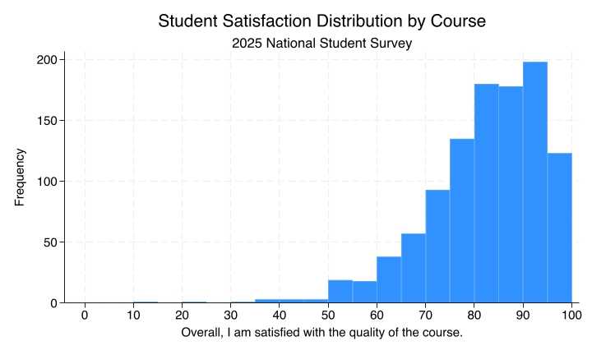
Question 1 (5 points)
What type of variable is the student satisfaction score: nominal, ordinal, interval, or ratio? Why?
Question 2 (5 points)
Approximately how many courses have satisfaction scores between 85% and 95%?
Question 3 (5 points)
Is this distribution symmetric, left-skewed, or right-skewed?
Question 4 (5 points)
Would you expect the mean satisfaction score to be greater than, less than, or approximately equal to the median? Explain your reasoning in terms of the shape of the distribution.
Question 5 (5 points)
A researcher states: “Large student-to-staff ratios decrease student satisfaction.” Is this a descriptive claim or a causal claim? Explain.

PART TWO – ESTIMATION, SAMPLING, AND UNCERTAINTY (25 points)
A local councillor wants to know whether residents in her ward support building a new cycle lane on the high street. She sets up a stall at the entrance to the local leisure centre on Saturday mornings for four consecutive weeks and asks people entering the centre to complete a short questionnaire about the proposal. People who see the stall can choose whether or not to participate.
Question 6 (5 points)
What is the population of interest in this study?
Question 7 (10 points)
Is the sample obtained through this procedure a probability sample or a non-probability sample? Please justify your answer. In your justification, be sure to demonstrate that you understand the difference between probability and non-probability sampling.
Question 8 (10 points)
Would you expect this sampling procedure to result in a statistically biased or unbiased estimate of residents’ support for the cycle lane? If you expect the estimate to be biased, would it likely overestimate or underestimate support? Please justify your answer.

PART THREE – REGRESSION ANALYSIS (50 points)
The three regression models in Table 1 use regional-level data from England and Wales. The variables are the following:
Dependent Variable:
- Leave Vote Share (%): the percentage of voters in each region who voted to leave the European Union in the 2016 Brexit referendum.
Independent Variables:
- Higher Education (%): the percentage of the region’s population with a higher education qualification. Source: Census data.
- Immigrant Share (%): the percentage of the region’s population born outside the UK. Source: Census data.
The regression table reports three models. Models 1 and 2 are bivariate regression models, each including a single independent variable. Model 3 is a multivariate regression model that includes both independent variables simultaneously.
Table 1: Models 1 and 2 are bivariate regression models, whereas Model 3 is a multivariate model.
============================= Independent variables: | Dependent variable: Leave Vote Share (%) =========================== Model 1 | ============== Model 2 | =============== Model 3
Higher Education (%) | -1.130^(***) |  | -1.143^(***)|
 | (0.147) |  | (0.148)
Immigrant Share (%) |  | -0.414^(***)| 0.085 |
 |  | (0.066) | (0.112)
Constant (Intercept) | 83.918^(***) | 56.807^(***)| 83.493^(***)
 | (3.995) | (1.110) | (4.040)
Observations | 139 | 167 | 139
R² | 0.301 | 0.193 | 0.304
Note: | *p<0.1; **p<0.05; ***p<0.01| |  | p<0.01| | |
Question 9 (5 points)
According to Model 1, for each one percentage point increase in the share of residents with higher education, what is the associated variation in the Leave vote share?
Question 10 (5 points)
According to Model 2, if there existed a region where none of the residents were born outside the UK, what would be this region’s predicted Leave vote share?
Question 11 (10 points)
Imagine a region where 30% of residents have higher education and 10% were born outside the UK. Using estimates from Model 3, what would be the predicted Leave vote share for this region? Please show your calculations.
Question 12 (15 points)
According to Model 3, which of the two independent variables has a greater chance of having no real effect on the dependent variable? How can you tell from the table?
Question 13 (15 points)
Suppose that a researcher reads the regressions in Table 1 and concludes: “These regressions prove that higher education has a causal effect on Brexit voting.”
Can you think of a potential confounding variable, not included in the regressions in Table 1, that would raise concerns about the validity of this causal claim? Please justify your answer. In your justification, be sure to demonstrate that you understand the concept of confounding variables by explaining how the potential confounding variable meets the definition.

