Battle of Neighborhoods—Exploring Filming Locations

1. Introduction

A lot of films and commercial ads are filmed in New York City. There might be various elements that could affect a director's choice of filming scenes. Since we have our access to the Foursquare API, we can try to explore what's around the filming scenes and hopefully, observe some frequently appearing venue categories that make a neighborhood attractive.

My research is useful for the following groups of people: first, it could be a valuable reference for other directors when they look for a suitable filming locations; second, many countries try to develop their movie industry, but then there should be many suitable locations like those of Hollywood and New York City. The stakeholders may wonder how to make a city popular as a film shooting spot and will get an idea from this research.

2. Data

This research project use Filming Locations data (NYC Open Data, 2018). This xml dataset includes list of filming locations mentioned in the book Scenes from the City. It contains the name of the films, boroughs, neighborhoods, and the coordinate of the exact location. I noticed that most of the filming scenes are located in Manhattan, so I extracted the latitude and longitude data of the filming locations in 20 neighborhoods in Manhattan.

3. Methodology

Using the coordinate data and Foursquare API, I obtained the venue category information around 16 neighborhoods in Manhattan (venue information around 4 neighborhoods are not available). Using ‘explore’ endpoints, I restricted the number of retrieved information to 10 recommended venues for each filming location. Counting the number of times a venue category appears in each neighborhood, I obtained the top 10 popular venue categories near the 16 neighborhoods.

Table 1. Neighborhoods with 10 most common venues

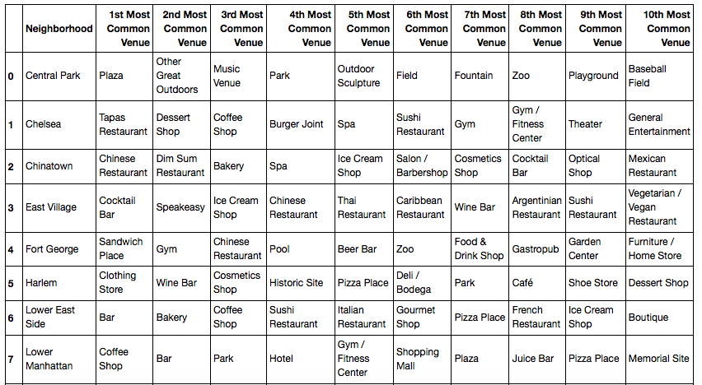

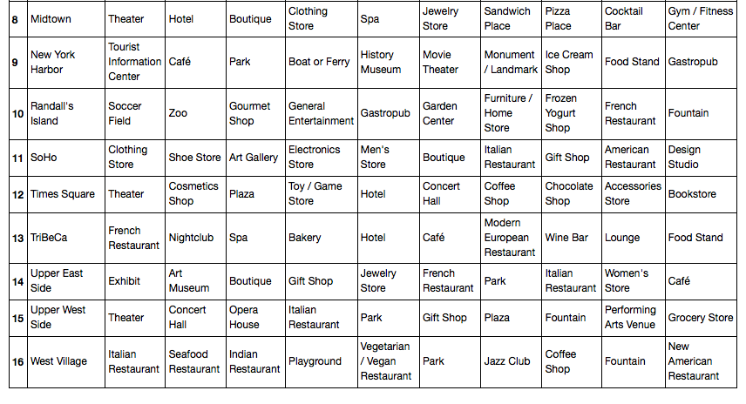

In order to know which neighborhoods possess similar venue categories, I then applied the KMeans clustering method, setting the number of clusters to 5.

4. Results

In the first cluster, we have Chelsea, East Village, Harlem, Lower East Side, Lower Manhattan, Midtown, New York Harbor, SoHo, Times Square, TriBeCa, Upper East Side, Upper West Side, and West Village. Those neighborhoods that are in the first cluster are downtown areas/plazas with many restaurants and shops. We can also see some art galleries, museums, concert halls and theaters.

The second cluster only includes Fort George which seems to be a residential area with many sandwich places, gyms and pools.

The third cluster includes an interesting neighborhood, Randall’s Island, where soccer field is the 1st most common venue. We can say that "general entertainment" is the key word that can characterize this neighborhood.

The fourth cluster includes Chinatown only, where we can find lots of Chinese restaurants obviously.

The fifth cluster includes Central Park only where one can perform many different outdoor activities.

5. Discussion

There are some key observations that one can take away from this research. First, we can see that Mitdtown, Lower Manhattan, and Upper West Side are the top 3 popular film shooting sites in Manhattan. They are all in the first cluster which can be called 'downtown areas'. This means that film directors tend to favor busy commercial districts. Second, unique neighborhoods such as Central Park, Chinatown, Fort George, and Randall's Island are also popular among film directors. They are characterized by 'the great outdoors', 'Chinese', 'residential area' and 'general entertainment', respectively. Each neighborhood can provide unique and high-quality settings which can be used according to the needs of directors.

We can conclude that it is better for a neighborhood to be either a downtown area or possess unique venues in order to become a popular filming scene.

6. Conclusion

In this research project, I utilized the Manhattan's film scenes location data and Foursquare API to analyze the popular venue categories near the neighborhoods that we've seen in films and ads. Based on the venue types, I divided the 16 neighborhoods into 5 clusters using KMeans clustering method. The result shows that downtown areas are the most popular neighborhoods while other unique neighborhoods are also selected as movie shooting sites.