World Weather Measurement

# Purpose of the dashboard

This dashboard displays the data provided by Prac1, that simulates real weather measurement systems in cities all over the world. The purpose of this dashboard is to display the different attributes in order to get a quick overview of the provided data.

Therefore, it is possible to select a desired city and to display its attributes and to highlight some of the most common attributes, like for example temperature, humidity, clouds etc.

In addition, the provided data contains the geo information of the cities. This geo information is displayed on a map to show all the available cities at this moment.

Furthermore, an own widget has been implemented in order to graphically illustrate the cloud data. Consequently, if there are no clouds in a certain city a sun appears, otherwise big or small clouds appear, depending on the value of the clouds attribute regarding the selected city.

To enable an easier access an index.html file is created with this dashboard embedded on it.

# Description of selected widgets and operators

In order to realise the described functionality, the widgets NGSI browser, Spy Wiring, Panel, Map Viewer and the own widget Cloud Display, as well as the operators Panel Filter, NGSI source and NGSI Entity to PoI are used.

## Widgets

### NGSI browser

The NGSI Browser widget allows to browser Orion Context Broker servers, which is done using the queryContext. In the dashboard, it is possible to select the different cities and to browse the defined Context Broker server in order to get the demanded data.

### Spy Wiring

As soon as a city is selected in the NGSI browser, all the attributes of this city are displayed in the widget Spy Wiring. Furthermore, it is possible to manage events, for example to record, pause or delete them. Consequently, it is useful for debugging the wiring.

### Panel

In this dashboard, there are 5 panel widgets renamed to more suitable names. These panels display certain attributes as text messages, as soon as a city is selected in the NGSI browser.

### Cloud Display

Finally, the widget Cloud Display has been implemented to graphically illustrate the clouds attributes. As it is wired to the NGSI browser, it is updated as soon as a city is selected in the NGSI browser.

In the following screenshot, the functionality of the mentioned widgets can be seen with the example of Madrid.

### 

Image 1: Dashboard including NGSI browser, Spy Wiring, Panels, Cloud Display

### Map Viewer

The last widget, that is contained in this dashboard, is the Map Viewer. It provides a basic and simple map viewer using the Google Maps API. The available cities are highlighted with a green sign mapped by the geo information, as can be seen in the following screenshot. If the user is interested in the current attributes of a certain city, it is possible to view them with a single click on the respective green sign.

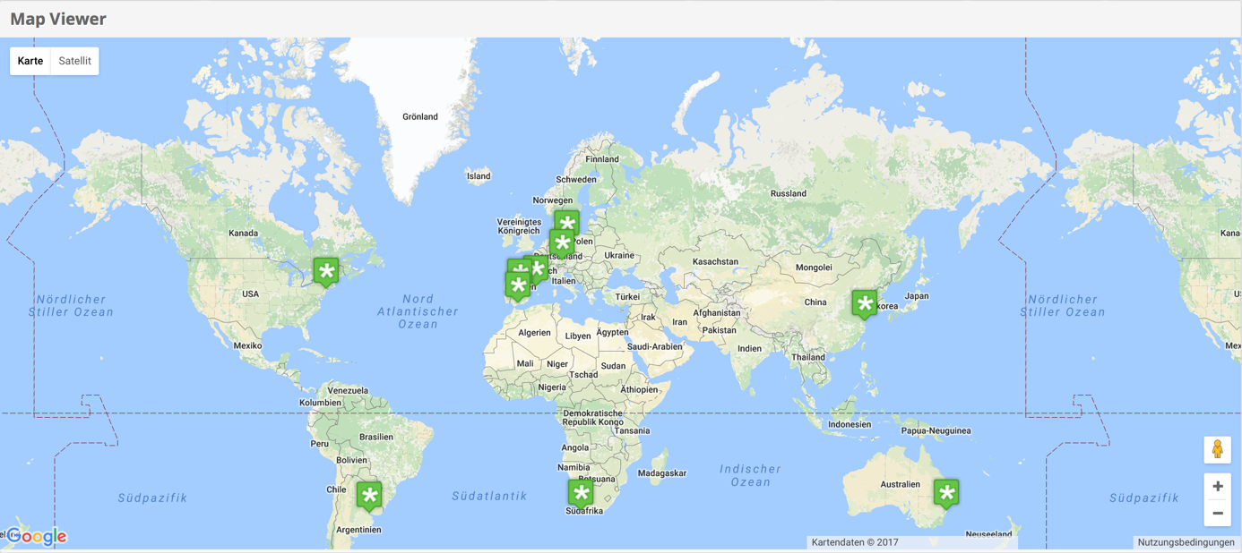

Image 2: Dashboard including Map Viewer

## Operators

### Panel Filter

In the panel widget only one special information should be displayed. Therefore, it is required to filter the desired information. This is done by the operator Panel Filter. The following image shows the connection between the NGSI browser, Spy Wiring, Cloud Display, Panel Filters and the Panels.

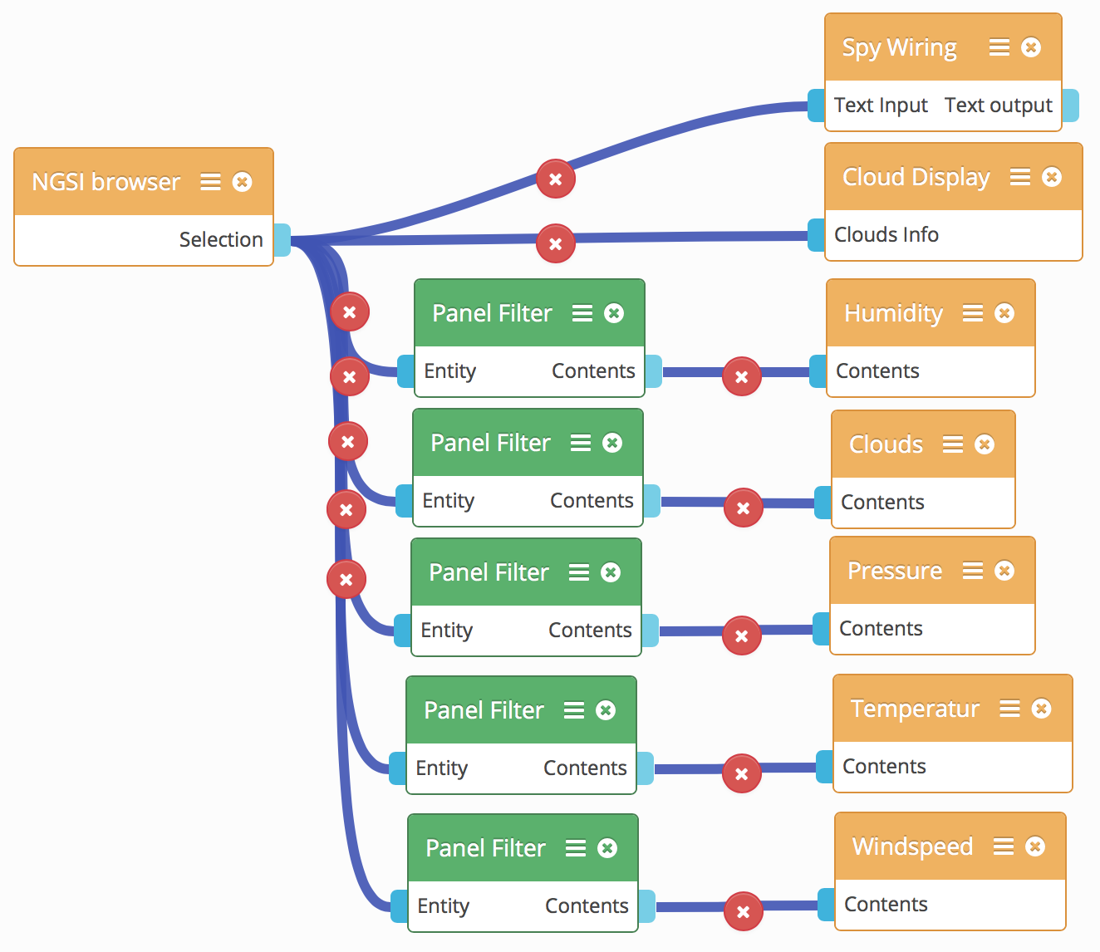

Image 3: Wiring including NGSI browser, Panel Filters, Spy Wiring, Cloud Display, Panels

### NGSI source

The operator NGSI source helps to use the desired Orion Context Broker server as source of data. This is done by creating a subscription to obtain real time notifications about changes on the entities of interest. So, every time an entity is updated, the NGSI source automatically receives the new data and so it is possible to get information about all cities at the same time.

### NGSI Entity to PoI

The operator NGSI Entity to PoI transforms NGSI entities, so in this use case the different city entities, to Points of Interest. This extracts the geo information of the cities, that can finally be displayed on the widget Map Viewer. The following image shows the wiring of the NGSI source, NGSI Entity to PoI and Map Viewer.

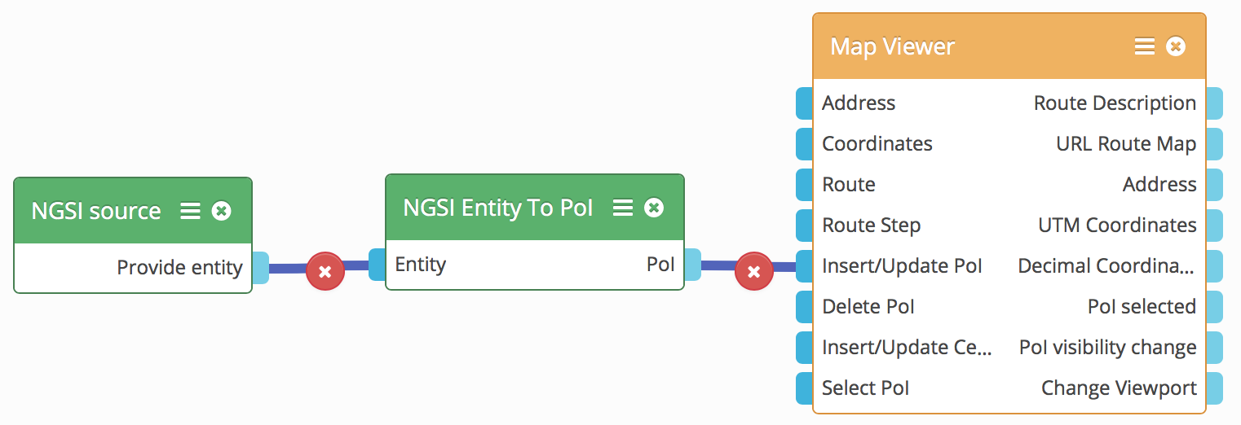

Image 4: Wiring including NGSI source, NGSI Entity To PoI, Map Viewer