Case Study Report
Design and Creative Technologies
Torrens University, Australia

Student: Luis Guilherme de Barros Andrade Faria - A00187785
Subject Code: ISY 503
Subject Name: Intelligent Systems
Assessment No.: 1
Title of Assessment: Case Study Report
Lecturer: Dr. Nandini Sidnal
Date: Mar 2026

Copyright © 2026 by Luis G B A Faria

Permission is hereby granted to make and distribute verbatim copies of this document provided the copyright notice and this permission notice are preserved on all copies.

Table of Contents
1. Introduction 3
1.1. Case Study Overview 3
1.2. Problem Significance 4
1.3. Report Structure 4
2. Background 4
2.1. Intelligent Systems Overview 4
2.2. Machine Learning Models 5
2.3. Methods and Techniques 5
2.4. Related Work 6
3. Method 7
3.1. Research Methodology 7
3.2. Data Sources 7
3.3. Ethical Considerations 8
3.4. Implementation Process 9
4. Results 9
4.1. Performance Metrics 9
4.2. Key Findings 10
4.3. Visual Analysis 11
5. Discussion 11
5.1. Relevance and Significance 11
5.2. Technical Obstacles 12
5.3. Comparison with State-of-the-Art 12
6. Recommendations 13
6.1. Technical Improvements 13
6.2. Ethical and Practical Recommendations 13
7. Conclusion 14
8. Appendices 15
8.1. Appendix A – Glossary of Terms 15
8.2. Appendix B – DHITA vs Transformer Architecture Comparison 16
8.3. Appendix C – Exploratory Pipeline Notebook Skeleton 17
8.4. Appendix D – Lasso Regularization Concept Diagram 18
8.5. Appendix E – User Journey Sequence Diagram 19
9. References 22

Application of Intelligent System in Natural Language Processing (NLP)

Introduction

Case Study Overview
Digital health interventions (DHIs), including smartphone apps, online coaching platforms, and web-based therapy programs, generate large volumes of unstructured text through participant journals, coach-user messages, and logs. Extracting clinically meaningful insights from this text manually is time-intensive and does not scale to the thousands of users these platforms serve.
Funk et al. (2020) addressed this gap by proposing the Digital Health Intervention Text Analytics (DHITA) framework: a reusable two-step natural language processing (NLP) pipeline designed to automate feature extraction from DHI text and apply those features to supervised machine learning models for clinical outcome prediction. The framework was validated on data from two randomized controlled trials (RCTs) targeting eating disorders among college-age women.

Problem Significance
In 2019, an estimated 970 million people lived with a mental disorder (World Health Organization, 2022), yet specialist care access remains severely constrained. DHIs offer a scalable route to evidence-based support, but their clinical value depends on monitoring user progress at scale, a task manual review cannot sustain. Intelligent NLP systems can bridge this gap by transforming unstructured language into actionable clinical signals.

Report Structure
This report examines the DHITA framework as a case study in applying intelligent systems to high-stakes health data. Section 2 provides technical background on the system's architecture, ML models, and feature engineering methods. Section 3 describes the research methodology, data sources, and ethical considerations. Section 4 presents quantitative results, Section 5 discusses limitations, and Section 6 offers recommendations for improvement.

Background

Intelligent Systems Overview
DHITA is a supervised ML system for text analytics operating as a two-step pipeline:
- Feature engineering: transforming raw DHI text into numerical representations;
- Predictive modeling: applying those features to trained classifiers and regressors.

Machine Learning Models
Two predictive models are deployed. Model A: a Random Forest classifier (Breiman, 2001) with 200 decision trees that predicts session-level symptom severity from post-session text entries. Random Forest is well-suited to this task because it handles high-dimensional, mixed-type feature sets without requiring feature scaling and reduces overfitting through ensemble aggregation. Model B: a Logistic Regression classifier that predicts long-term clinical outcomes (eating disorder remission) at six-month follow-up. Logistic Regression was chosen for interpretability, which is critical in clinical contexts where prediction rationale must be auditable.
Feature selection is performed using the Least Absolute Shrinkage and Selection Operator (LASSO) with 50-fold cross-validation (Tibshirani, 1996). LASSO imposes L1 regularization that drives irrelevant feature coefficients to zero, selecting a compact interpretable subset from the 220 available features, necessary given the limited sample size.

Methods and Techniques
The feature engineering layer produces 220 features per user across seven categories (Table 1). Each group captures a distinct linguistic or behavioral dimension, ensuring non-redundant representations.
Table 1 – DHITA Feature Engineering Strategies
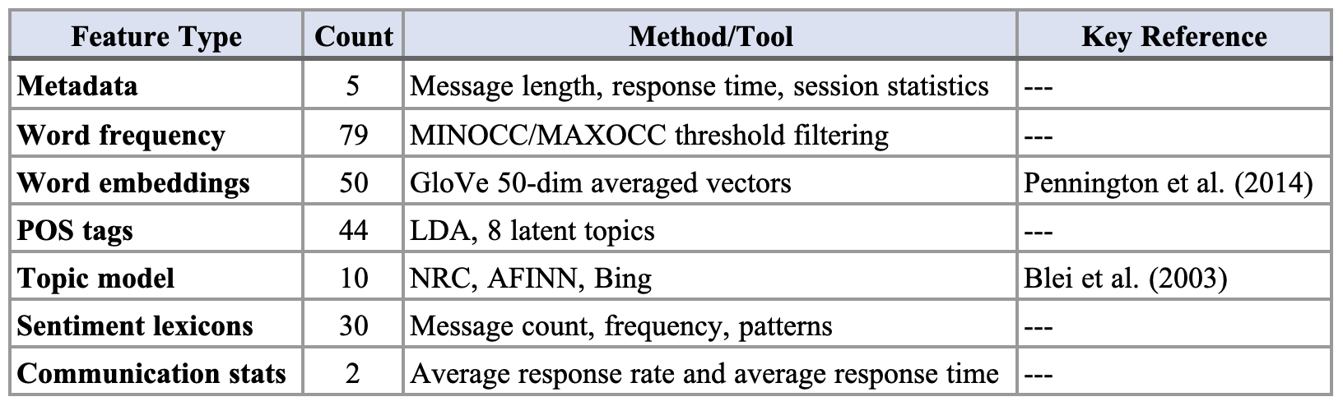
Area Under the ROC Curve (AUC) serves as the primary evaluation metric, selected for robustness to class imbalance.
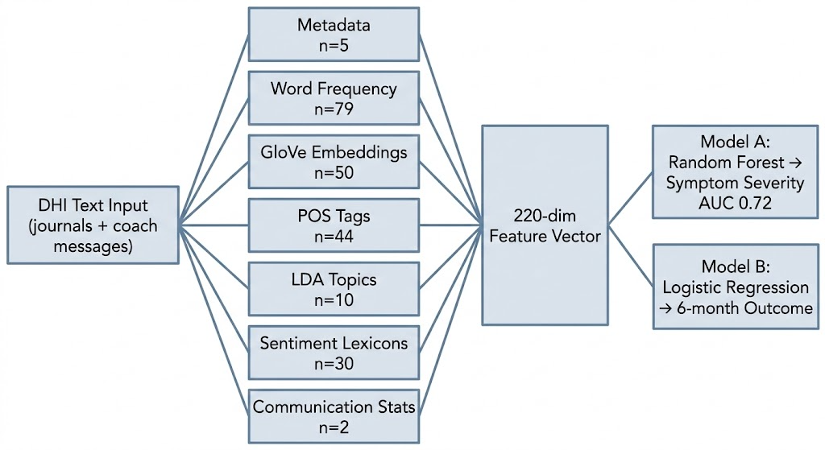
Figure 1 – DHITA two-set pipeline architecture.

Related Work
Prior health NLP work (Calvo et al., 2017) focused on clinical notes and social media (Sarker, 2021); DHIs present a distinct type: longitudinal coach-participant dialogues within structured therapeutic contexts. Earlier DHI studies used isolated sentiment scores or word counts. DHITA is the first framework to systematically combine all major NLP feature classes in a single replicable pipeline.

Method

Research Methodology
The study employed a retrospective observational design, re-analyzing text data from two previously conducted RCTs: the Self-Monitoring of Body, Eating, and Dieting (SBED) program and the Healthy Body Image (HBI) program, both targeting eating disorders in college-age women. This cross-sectional approach allowed evaluation of DHITA's predictive validity against established clinical measures without new data collection.

Data Sources
The dataset comprised 37,228 intervention text snippets from SBED participant journals and 4,285 coach-user messages from the HBI program, contributed by 372 users in total. Of these, 100 users with complete six-month follow-up assessments using the Eating Disorder Examination Questionnaire (EDE-Q) were used for outcome prediction. The study population was homogeneous: predominantly college-age females with subclinical eating disorders - a deliberate clinical design choice that simultaneously limits external validity.
Text preprocessing followed standard NLP practices: tokenization, stemming (Porter stemmer), and vocabulary filtering via MINOCC/MAXOCC thresholds to remove rare and overly common tokens. GloVe vectors were averaged across tokens per document. Model evaluation used a within-user protocol for Model A (training and testing on the same user's temporal data) and a cross-user protocol for Model B (evaluation across 100 users). LASSO with 50-fold cross-validation was applied for feature selection prior to final model fitting.

Ethical Considerations
Four interdependent ethical dimensions arise from DHITA’s design and data (Table 2). Ethical deployment demands updated consent protocols, mandatory human-in-the-loop review, and population-diverse replication before any clinical use.

Table 2 – Ethical Considerations
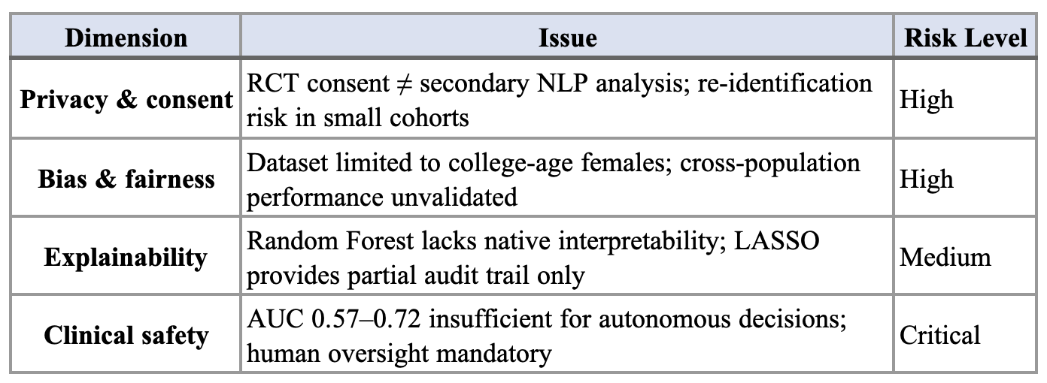

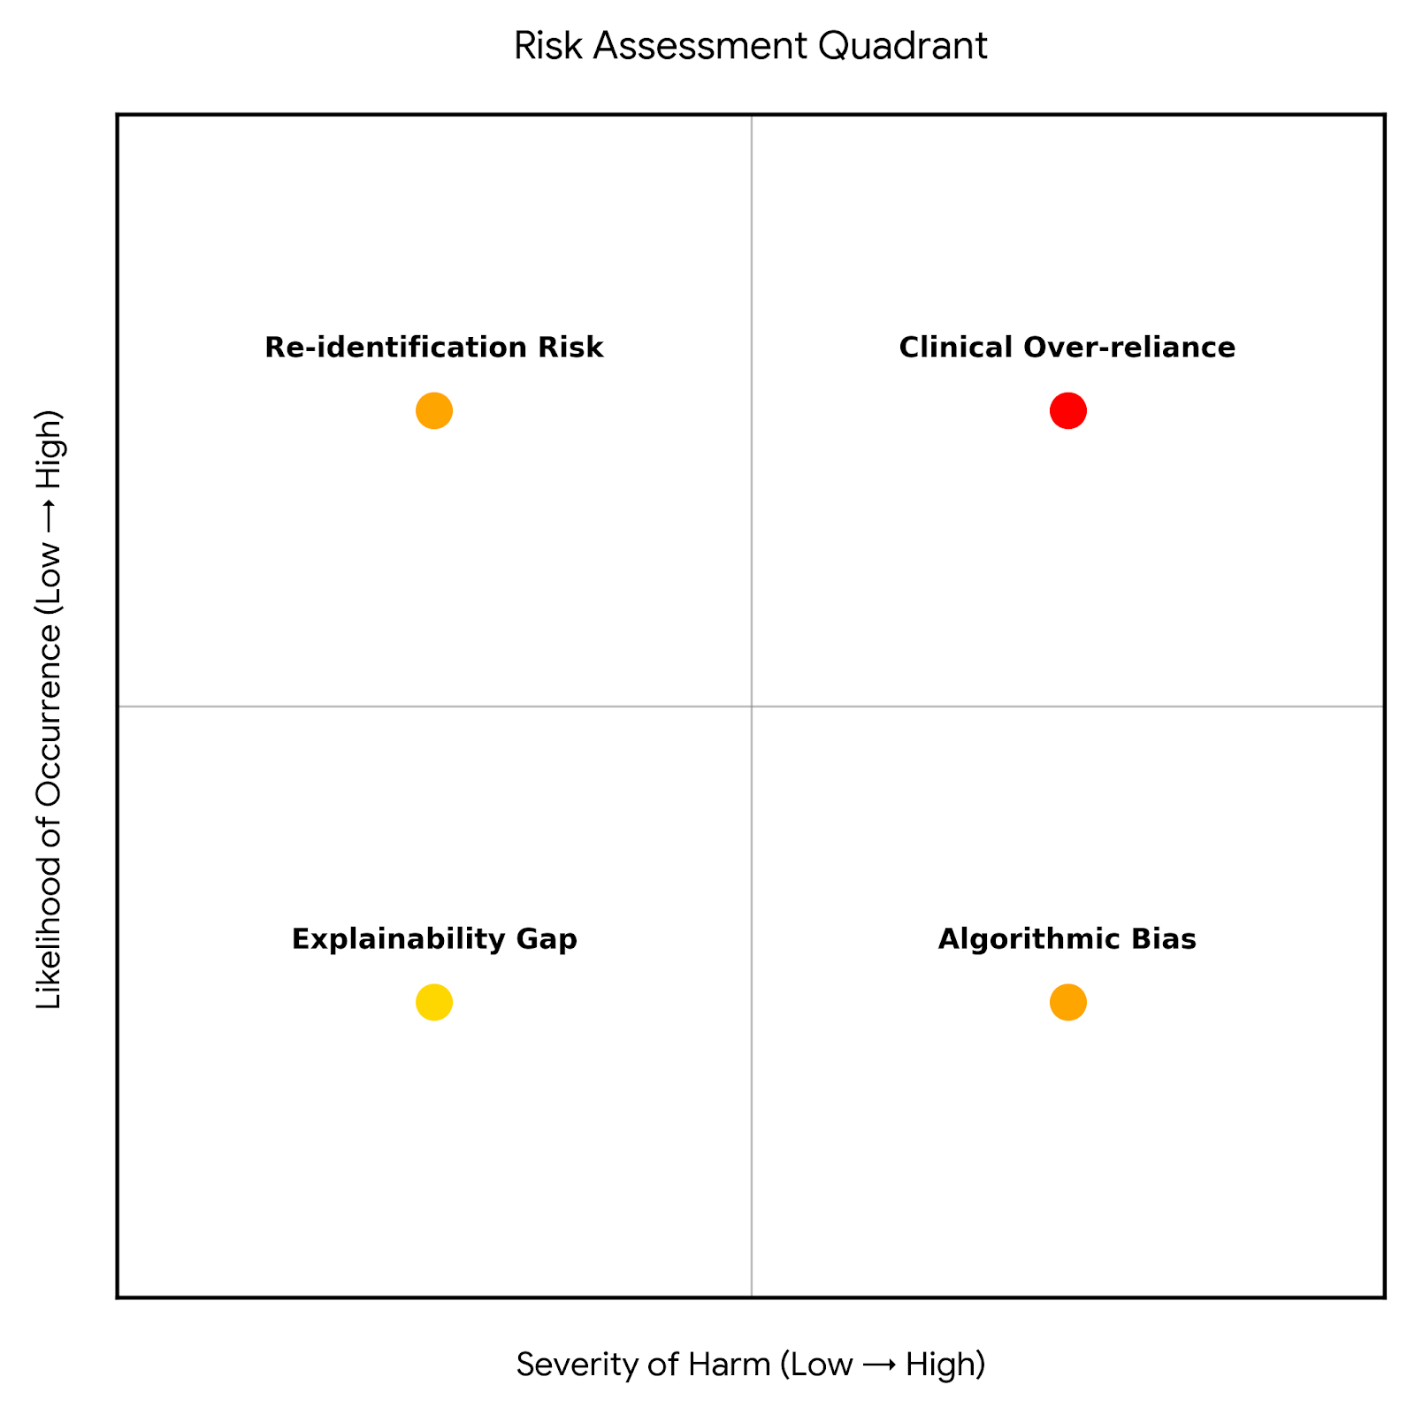
Figure 2 – Ethical risk quadrant

Implementation Process
The pipeline was implemented using an R package called Digital Health Interventions Text Analytics (DHITA), with Apache OpenNLP providing POS tagging. No deep learning frameworks were required; computational demands were modest and hardware constraints are not reported as a limiting factor.

Results

Performance Metrics
Both models outperformed the random baseline (AUC 0.50).
Table 3 – DHITA Predictive Model Performance
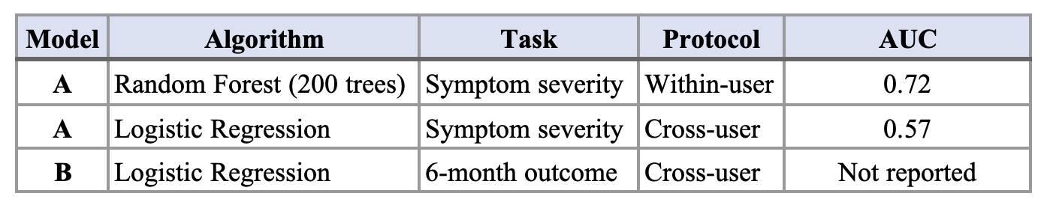

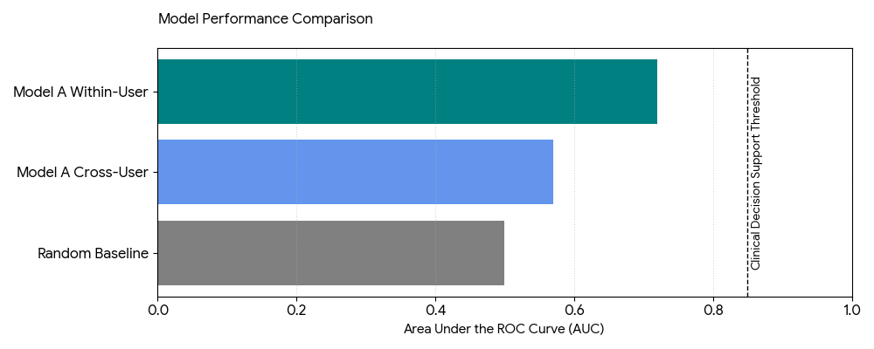
Figure 3 – Model AUC comparison bar chart.

Key Findings
The most discriminative features for outcome prediction centered on thematic and behavioral signals: body-image and diet-related language, references to program content ("help," "program" terms), and temporal engagement metrics such as message response rate and response time. This suggests that linguistic engagement with program content predicts treatment trajectory, not just emotional tone.
Both LR and RF were evaluated under both protocols. RF achieved the highest within-user AUC (0.72) but overfitted when applied across users; LR, being a simpler and less variance-prone model, generalised better and yielded the best cross-user result (AUC 0.57). Among the LASSO-selected features at λ≈0.15, the ten retained predictors included response rate, four specific content words (body, help, program, lct), three POS tag types, possessive endings, and baseline symptom level — confirming that behavioural engagement signals and baseline severity are the most transferable predictors across users.
Feature group counts are detailed in Table 1 (Background); correlation analysis confirmed low inter-feature overlap across all seven groups.

Visual Analysis
The original paper reports ROC curves for both models, with Model A's within-user curve showing the most pronounced departure from the diagonal. Feature importance rankings derived from LASSO coefficients are documented in the paper, with the body/diet/program lexical cluster and response time metrics appearing as the highest-weighted predictors.

Discussion

Relevance and Significance
DHITA demonstrates that NLP-derived features from digital health text carry predictive signal for clinical outcomes. The framework's modular design is a genuine contribution: by standardizing the feature engineering and modeling pipeline, it provides a replicable scaffold for DHI researchers, reducing the barrier to applying NLP in new health domains. The AUC of 0.72 confirms that linguistic signals in DHI text carry clinically informative content.

Technical Obstacles
Technical Obstacles: The within-user/cross-user performance gap - from AUC 0.72 to 0.57 - is the study's most critical finding. It reveals that the model learns idiosyncratic patterns specific to individuals rather than generalizable population-level signals, fundamentally limiting scalability to new users.
Methodological Limitations: The dataset is drawn exclusively from college-age females with eating disorders enrolled in structured RCTs. This narrow population restricts external validity and raises equity concerns: the model may perform poorly on demographically distinct groups. The 100-user outcome prediction sample is small, increasing variance in cross-user evaluation. Beyond accuracy, the framework's narrow training population means its deployment would primarily benefit users demographically similar to the RCT cohort, reinforcing existing health inequity.
Constraints Reported in Article: The authors explicitly acknowledge the preliminary status of the results, the absence of deep learning methods, and the need for validation across additional conditions and populations.

Comparison with State-of-the-Art
The study predates the broad adoption of transformer-based NLP. Since 2020, BERT and its clinical variants (Devlin et al., 2019) - notably BioBERT (Lee et al., 2020) and MentalBERT (Ji et al., 2022) - have substantially advanced clinical text mining. Averaged GloVe embeddings cannot capture contextual meaning; replacing them with transformer representations would likely yield measurable AUC improvements and is the most actionable technical upgrade available today.

Recommendations

Technical Improvements
Replacing GloVe embeddings with contextual representations from transformer models, such as MentalBERT (Ji et al., 2022) or BioBERT (Lee et al., 2020), would capture semantic nuance that averaged static vectors cannot represent, likely pushing AUC toward the ≥0.85 threshold required for clinical decision support. Expanding the corpus to diverse populations (age groups, genders, comorbid conditions) would directly address the generalizability gap.

Ethical and Practical Recommendations
Any clinical deployment must incorporate mandatory human-in-the-loop review; no triage decision should rely solely on algorithmic output. SHAP or LIME explainability tools would enable clinicians to audit predictions. Consent frameworks must be updated to explicitly cover secondary NLP analysis. Integrating passive sensing signals - app usage frequency, session timing, response latency - alongside text features could improve predictive power without requiring additional sensitive disclosures. Future work could explore federated learning (Rieke et al., 2020) to enable multi-site training while preserving participant privacy. Longer term, accurate predictions could trigger automated coaching nudges, providing timely support without requiring constant clinician availability.

Conclusion
Funk et al.'s DHITA framework represents a meaningful step toward scalable clinical insight extraction from digital health text. By combining seven NLP feature engineering strategies with interpretable ML models and LASSO feature selection, the framework achieves an AUC of 0.72 for within-user symptom severity prediction - a promising proof-of-concept for NLP in mental health. However, the cross-user performance drop to AUC 0.57, the narrow study population, and the absence of contextual deep learning methods limit immediate clinical translation. The field has since advanced considerably; replicating DHITA with transformer-based embeddings and diverse, multicondition datasets represents the most productive path forward. Any deployment must prioritize human oversight to ensure predictive models complement rather than replace clinical judgment.

Appendices

Appendix A – Glossary of Terms
Table 4 – Term and Definition support table.
Term | Definition
AUC | Area Under the Receiver Operating Characteristic Curve; a performance metric for classification models measuring the ability to distinguish between classes. Values range from 0.5 (random) to 1.0 (perfect).
DHITA | Digital Health Intervention Text Analytics; the two-step NLP framework proposed by Funk et al. (2020) for automated feature extraction and predictive modeling from DHI text data.
DHI | Digital Health Intervention; technology-based programs (apps, online platforms, web therapy) designed to support health outcomes at scale.
Federated Learning | A distributed machine learning approach where models are trained across multiple decentralised data sources without sharing raw data, preserving participant privacy.
GloVe | Global Vectors for Word Representation; a method for generating static word embeddings by analysing word co-occurrence statistics across a large corpus.
LDA | Latent Dirichlet Allocation; a generative probabilistic model for topic modeling that represents each document as a mixture of latent topics.
LASSO | Least Absolute Shrinkage and Selection Operator; a regression method applying L1 regularisation that drives irrelevant feature coefficients to zero, performing feature selection and regularisation simultaneously.
LIME | Local Interpretable Model-agnostic Explanations; a technique that explains individual predictions of any classifier by approximating it locally with an interpretable model.
Logistic Regression | A statistical model that predicts the probability of a binary outcome using a logistic (sigmoid) function applied to a linear combination of input features.
NLP | Natural Language Processing; a subfield of AI concerned with enabling computers to analyse, understand, and generate human language.
POS Tagging | Part-of-Speech Tagging; the process of labelling each word in a text with its grammatical category (noun, verb, adjective, etc.), used as a feature in NLP pipelines.
Random Forest | An ensemble learning method that constructs many decision trees on random data subsets and outputs the majority vote across trees, reducing overfitting through aggregation.
RCT | Randomised Controlled Trial; an experimental study design where participants are randomly assigned to intervention or control conditions to establish causal evidence.
ROC | Receiver Operating Characteristic curve; a plot of true positive rate against false positive rate at varying classification thresholds, used to evaluate binary classifier performance.
SHAP | SHapley Additive exPlanations; a game-theory-based method for explaining individual model predictions by attributing a contribution value to each input feature.
Transformer | A deep learning architecture using self-attention mechanisms to process sequential data in parallel, enabling rich contextual understanding in NLP tasks (e.g., BERT, BioBERT, MentalBERT).
Sentiment Lexicon | A curated list of words associated with specific emotions or sentiment polarities, used for sentiment analysis.

Appendix B – DHITA vs Transformer Architecture Comparison
The table below contrasts the classical DHITA pipeline (Funk et al., 2020) with a transformer-based upgrade as recommended in §6.1. The key distinction is in word representation: DHITA uses averaged static GloVe vectors that collapse all token contexts into a single fixed vector, losing positional and contextual information. Transformer models process the full token sequence and produce context-sensitive embeddings, enabling the model to distinguish, for example, "not eating" from "eating" - critical nuance in eating disorder text. 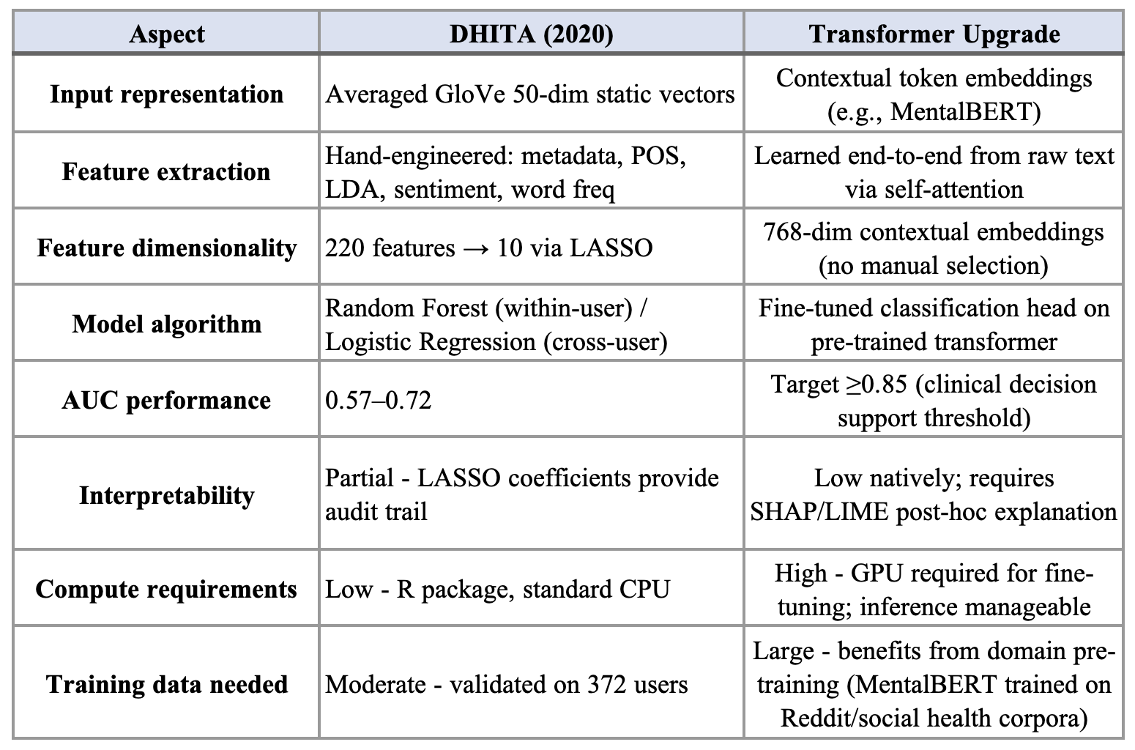
Figure 4 – DHITA classical pipeline vs. transformer + upgrade (side-by-side).

Appendix C – Exploratory Pipeline Notebook Skeleton
This skeleton outlines a post-submission implementation exercise replicating and extending DHITA. Steps 1–3 reproduce the classical pipeline; Steps 4–6 introduce the transformer branch for comparison. Both branches converge at Step 6 for a side-by-side AUC evaluation.
- Step 1: Load & Inspect Data
- Step 2: Preprocessing (tokenise, stem, MINOCC/MAXOCC filter)
- Step 3: Classical Feature Engineering (metadata, word freq, GloVe avg, POS, LDA, sentiment)
- Step 4: Transformer Features (HuggingFace MentalBERT embeddings, no averaging)
- Step 5: Model Training (RF, LR, fine-tuned transformer)
- Step 6: Evaluation (ROC/AUC comparison, LASSO feature selection)
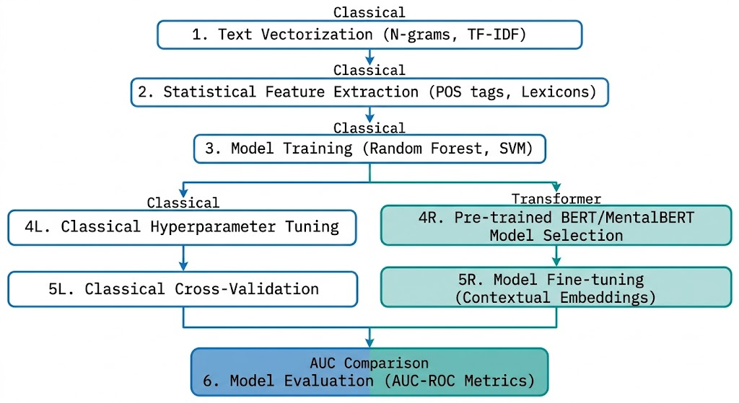
Figure 5 – Six-step pipeline flow diagram (classical + transformer branches).

Appendix D – Lasso Regularization Concept Diagram
LASSO (Least Absolute Shrinkage and Selection Operator) extends standard linear regression by adding an L1 penalty term - the sum of the absolute values of all coefficients - to the loss function. As the regularisation constant λ increases, this penalty grows, forcing the model to shrink less important feature coefficients progressively toward zero. Unlike L2 regularisation (Ridge), which shrinks all coefficients proportionally, L1 produces exact zeros: irrelevant features are eliminated entirely, performing feature selection and regularisation simultaneously.
In the DHITA case study, 220 candidate features were evaluated across a range of λ values using 50-fold cross-validation. The mean squared error (MSE) reached its minimum at λ≈0.15, at which point only 10 features retained non-zero coefficients (Figure D). These 10 features - response rate, four content words, three POS tag types, possessive endings, and baseline symptom level - represent the most generalisable predictors of eating disorder symptom severity across users.
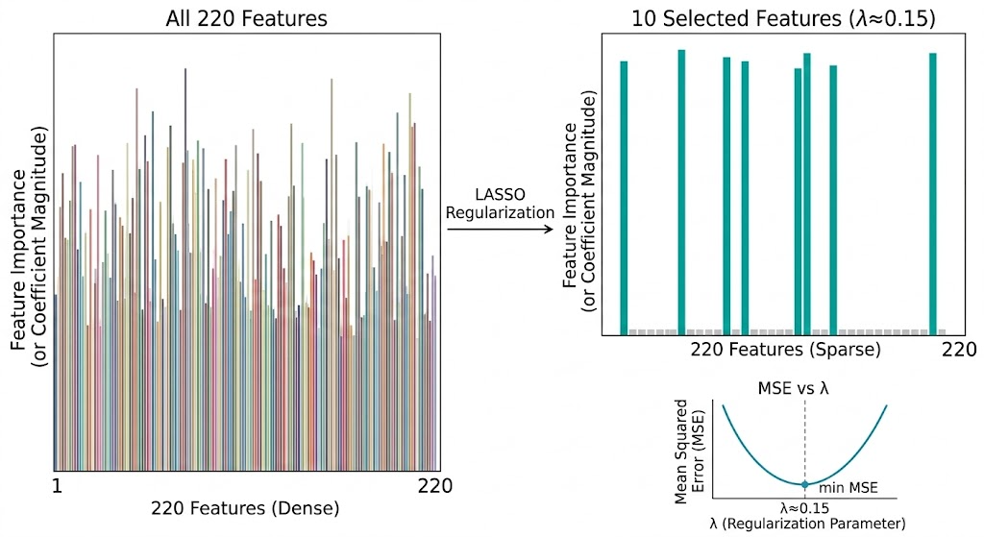
Figure 6 – Before/after feature selection via LASSO.

Appendix E – User Journey Sequence Diagram
The diagram below illustrates how a single user's interaction with a DHI platform triggers the DHITA system across two time horizons. In the short term, each diary entry is forwarded to DHITA, which extracts 220 features and applies Model A to predict near-term symptom severity - alerting the coach for a personalised response. Over the six-month intervention, user messages are continuously aggregated and fed into Model B, which predicts long-term therapeutic outcome and delivers a summary report to the coach at follow-up. The diagram makes explicit that DHITA operates passively in the background: the user interacts only with the DHI platform, while all ML inference is invisible to them.
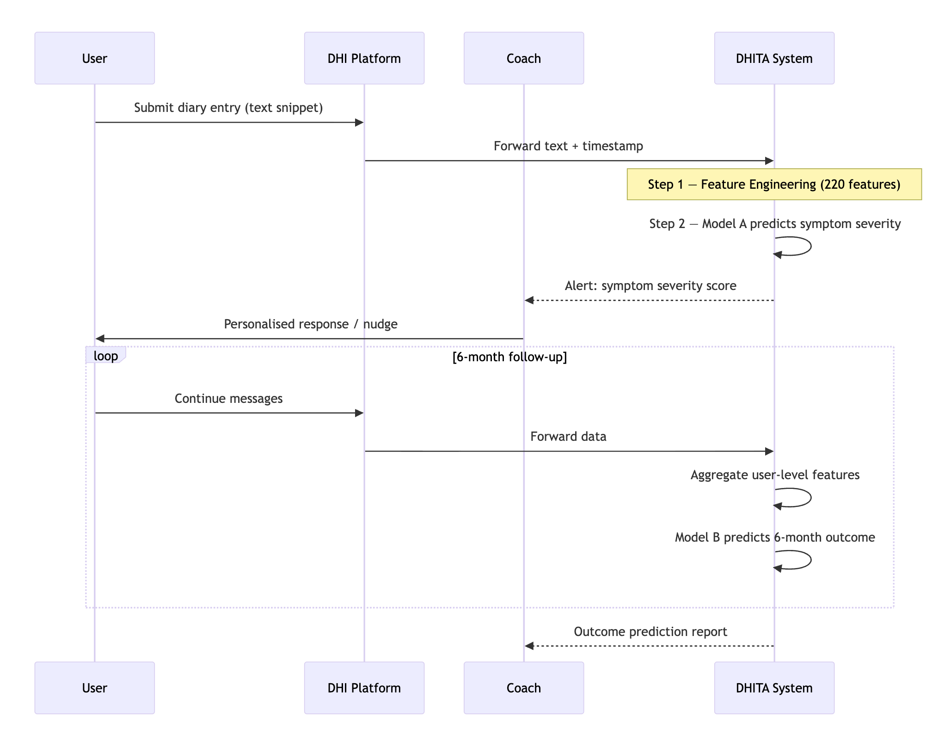
Figure 7 – Sequence diagram of User Journey throughout the application.

End of Appendix Section

Statement of Acknowledgment
I acknowledge that I have used the following AI tool(s) in the creation of this report:
  - OpenAI ChatGPT (GPT-5)
  - Anthropic Claude Sonnet 4.6
Both have been used to assist with outlining, refining structure, improving clarity of academic language, and supporting APA 7th referencing conventions.
Prompt examples:
1. "I'm writing a 1,500-word case study report on Funk et al. (2020) - a framework for applying NLP in digital health interventions. Here is the assessment rubric [pasted]. Help me write a 200–250 word Introduction section that covers the problem significance and outlines the report structure. Do not add content I haven't asked for."
2. "Here is a numbered list of seven DHITA feature engineering categories with counts and methods. Convert this into a clean markdown table with four columns: Feature Type, Count, Method/Tool, Key Reference. Preserve all existing data exactly."
3. "My §3.3 ethics section is one dense 90-word paragraph. Rewrite it as a one-sentence framing statement followed by a four-row table. Rows: Privacy & consent, Bias & fairness, Explainability, Clinical safety - each with an Issue column and a Risk Level (High / Medium / Critical). Keep total word count similar to the original."
I confirm that the use of the AI tool has been in accordance with the Torrens University Australia Academic Integrity Policy and TUA, Think and MDS’s Position Paper on the Use of AI. I confirm that the final output is authored by me and represents my own critical thinking, analysis, and synthesis of sources. I take full responsibility for the final content of this report.

References
Blei, D. M., Ng, A. Y., & Jordan, M. I. (2003). Latent Dirichlet allocation. Journal of Machine Learning Research, 3, 993–1022. https://www.jmlr.org/papers/v3/blei03a.html
Breiman, L. (2001). Random forests. Machine Learning, 45(1), 5–32. https://doi.org/10.1023/A:1010933404324
Calvo, R. A., Milne, D. N., Hussain, M. S., & Christensen, H. (2017). Natural language processing in mental health applications using non-clinical texts. Natural Language Engineering, 23(5), 649–685. https://doi.org/10.1017/S1351324916000383
Devlin, J., Chang, M.-W., Lee, K., & Toutanova, K. (2019). BERT: Pre-training of deep bidirectional transformers for language understanding. Proceedings of NAACL-HLT 2019, 4171–4186. https://doi.org/10.18653/v1/N19-1423
Funk, B., Sadeh-Sharvit, S., Fitzsimmons-Craft, E. E., Trockel, M. T., Monterubio, G. E., Goel, N. J., Balantekin, K. N., Eichen, D. M., Flatt, R. E., Firebaugh, M. L., Jacobi, C., Graham, A. K., Hoogendoorn, M., Wilfley, D. E., & Taylor, C. B. (2020). A framework for applying natural language processing in digital health interventions. Journal of Medical Internet Research, 22(2), e13855. https://doi.org/10.2196/13855
Ji, S., Zhang, T., Ansari, L., Fu, J., Tiwari, P., & Cambria, E. (2022). MentalBERT: Publicly available pretrained language models for mental healthcare. In N. Calzolari, F. Béchet, P. Blache, K. Choukri, C. Cieri, T. Declerck, S. Goggi, H. Isahara, B. Maegaard, J. Mariani, H. Mazo, J. Odijk, & S. Piperidis (Eds.), Proceedings of the Thirteenth Language Resources and Evaluation Conference (pp. 7184–7190). European Language Resources Association. https://aclanthology.org/2022.lrec-1.778
Lee, J., Yoon, W., Kim, S., Kim, D., Kim, S., So, C. H., & Kang, J. (2020). BioBERT: A pre-trained biomedical language representation model for biomedical text mining. Bioinformatics, 36(4), 1234–1240. https://doi.org/10.1093/bioinformatics/btz682
Pennington, J., Socher, R., & Manning, C. D. (2014). GloVe: Global vectors for word representation. Proceedings of the 2014 Conference on Empirical Methods in Natural Language Processing (EMNLP), 1532–1543. https://doi.org/10.3115/v1/D14-1162
Rieke, N., Hancox, J., Li, W., Milletarì, F., Roth, H. R., Albarqouni, S., Bakas, S., Galtier, M. N., Landman, B. A., Maier-Hein, K., Ourselin, S., Sheller, M., Summers, R. M., Trask, A., Xu, D., Baust, M., & Cardoso, M. J. (2020). The future of digital health with federated learning. npj Digital Medicine, 3(1), 119. https://doi.org/10.1038/s41746-020-00323-1
Sarker I. H. (2021). Machine Learning: Algorithms, Real-World Applications and Research Directions. SN computer science, 2(3), 160. https://doi.org/10.1007/s42979-021-00592-x
Tibshirani, R. (1996). Regression shrinkage and selection via the lasso. Journal of the Royal Statistical Society: Series B (Methodological), 58(1), 267–288. https://doi.org/10.1111/j.2517-6161.1996.tb02080.x
World Health Organization. (2022). World mental health report: Transforming mental health for all. WHO Press. https://www.who.int/publications/i/item/9789240049338

