Case Study Report
Design and Creative Technologies
Torrens University, Australia

Student: Luis Guilherme de Barros Andrade Faria - A00187785
Subject Code: BDA 601
Subject Name: Big Data and Analytics
Assessment No.: 1
Title of Assessment: Design Data Pipeline
Lecturer: Dr. Chen Zhan
Date: June 2026

Copyright © 2026 by Luis G B A Faria

Permission is hereby granted to make and distribute verbatim copies of this document provided the copyright notice and this permission notice are preserved on all copies.

Table of Contents
1. Executive Summary 3
2. Data strategy and the V’s for Big Retail 3
3. Potential data sources 5
4. Data integration challenges and resolution strategy 6
5. Data lake design: storage, retrieval, security 8
5.1. Architecture 8
5.2. Lake zones 9
5.3. Retrieval 9
5.4. Security and privacy 10
6. Assumptions, limitations, and conclusion 10
7. Appendices 12
7.1. Appendix A – Glossary of Terms 12
7.2. Appendix B – Integration workflow 13
7.3. Appendix C – Curated datasets and business value 14
7.4. Appendix D – The six V’s mapped to Big Retail 14
7.5. Appendix E – Data-source inventory 15
7.6 Appendix F – Storage and retrieval stack 17
7.7 Appendix G – Integration challenge register 17
7.8 Appendix H – Lakehouse zones 19
8. References 21

Executive Summary
Big Retail, an Adelaide online retailer with more than 100,000 monthly website visitors, has lost sales and conversion despite holding a cost advantage (Torrens University Australia, 2024). The root cause is structural rather than commercial: a static website serves identical content to every visitor, while customer, sales, and marketing data sit in separate departmental databases that cannot be combined to personalize the experience. This report designs the data pipeline that must precede any analytics work. It identifies the internal and external data sources aligned to Big Retail's data-driven goals (targeted campaigns, a recommender system, and product association), articulates the integration challenges that must be resolved before storage, and specifies a governed lakehouse-style data lake on AWS – with open-source equivalents – that stores structured, semi-structured, and unstructured data and serves it efficiently to both managers and data scientists. Key technical terms used throughout are defined in Appendix A.

Data strategy and the V’s for Big Retail
A data-driven strategy must start from the business problem, not the technology: data projects fail when tools are chosen before the organization is clear on why the work matters (Marr, 2021). For Big Retail the “why” is conversion recovery through personalization. Evaluating the five canonical V's - plus Valence, the connectivity V that unlocks Big Retail's value - shows which characteristics drive the design rather than treating them as a checklist (Rutherford, 2017).
- Volume – moderate but sufficient: 100,000+ monthly visitors plus transactions, emails, and catalogue data give enough behavioral signal for pattern detection. Volume justifies object storage and distributed (Spark) processing but is not the binding constraint.
- Velocity – selectively important: only clickstream and cart events are continuous; sales, CRM, and catalogue data are batch. The design therefore needs streaming and batch ingestion, not streaming everywhere.
- Variety – the defining challenge: relational transactions, JSON clickstream, API feeds, and free-text reviews must coexist, which is precisely what a data lake (not a warehouse) is built to hold.
- Veracity – the costliest risk: duplicate customers across sales and marketing systems, guest-checkout gaps, and bot traffic threaten every downstream model, so data quality is treated as a first-class pipeline stage.
- Valence – the value unlock: the recommender and product-association use cases depend on connecting customers to sessions, orders, products, and campaigns. Raising valence through identity resolution is where most analytical value is created.
- Value – the anchor: every source and component below is justified only by its contribution to campaigns, recommendations, association rules, or conversion reporting.
In short, Variety, Veracity, and Valence – not raw Volume – dominate Big Retail’s design. Appendix D maps each V to its design response.
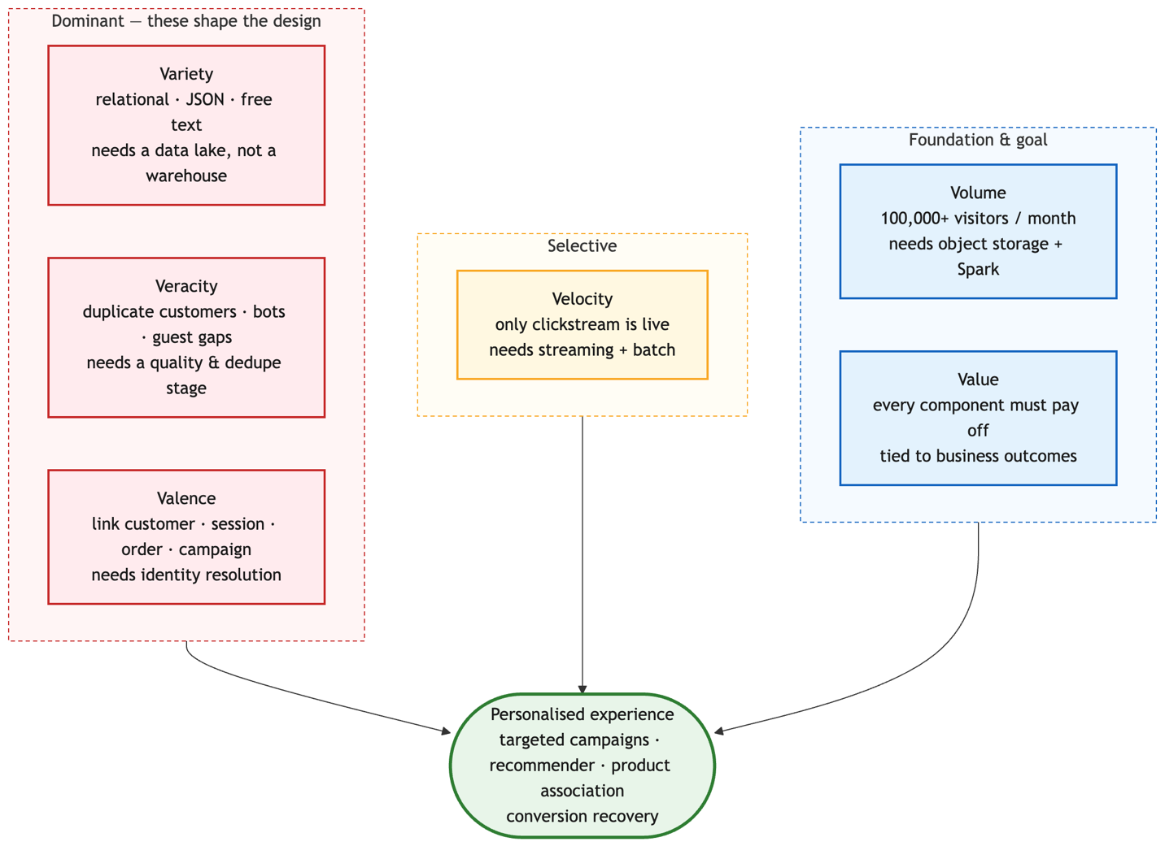
Figure 1 – The six V’s of Big Retail, ranked by how strongly each drives the design (full mapping in appendix D, table D1).

Potential data sources
The intended analytics cannot run on transactions alone; recommenders and targeted campaigns need behavioral, descriptive, and contextual data, and product association needs reliable order-line data linked to categories and campaign timing. The full inventory (Appendix E, Table E1) spans internal and external sources and all three structure types, with fields and formats taken as reasonable assumptions for an online retailer of this size.
These sources fall into four characteristic groups. Transactional and account data (sales DB, customer accounts) are highly structured, low-velocity, and high-veracity when controlled, but PII-sensitive and prone to duplication across the sales and marketing teams – they anchor revenue analysis and segmentation. Behavioral data (clickstream, search, cart events) is the highest-velocity and highest-volume source; it arrives as semi-structured JSON, carries bot noise, and is the raw signal for funnel analysis and the recommender, yet it depends on the IT team being able to emit or export events. Descriptive data (product catalogue, promotions) is a mix of structured attributes and semi-structured media that changes frequently and must be treated as slowly changing dimension, so recommendations stay stock aware. Contextual and unstructured data (reviews, complaint text, weather, demographics, competitor signals) adds the variety that lifts personalization beyond transactions but brings the weakest veracity and the clearest legal constraints, so it is enriched cautiously.
Together, these cover structured (transactions, accounts, catalogue), semi-structured (clickstream, CRM events, weather/API payloads), and unstructured (review text, complaint notes, competitor/social signals) data – the full spread the recommender, campaign, and association use cases require, and the spread a warehouse alone could not hold.

Data integration challenges and resolution strategy
The hard problem is not storage; it is joining fragmented customer, product, campaign, and event data without fabricating false identities or exposing personal information. Integration is therefore treated as a governed stage, not a one-off load – the data-preparation work that, more than the modelling itself, determines the quality and credibility of every downstream result (EMC Education Services, 2015). Schema alignment and duplicate resolution – the two challenges the rubric names explicitly – head the list.
The two challenges the rubric names deserve fuller treatment. Schema alignment fails silently rather than loudly: the sales DB may call a key cust_id while marketing calls it customer_ref and the catalogue keys products by an internal item_code that the promotions feed does not share. Resolving this means agreeing canonical entities (customer, product, order, campaign, event), publishing them in a versioned schema registry, and validating each incoming feed against a data contract so a renamed or retyped field is rejected at ingestion rather than corrupting a join downstream. Duplicate customers are the costlier problem because the case explicitly allows the same person to exist in both the sales and marketing databases and to move between guest checkout, a new account and an existing login. Resolution is staged: a deterministic pass matches on hashed email or account ID first, and only unmatched records fall through a cautious fuzzy pass on name, address, and phone, every match carrying a confidence score a full source lineage so a merge can be audited or reversed.
Beyond those two, two resolutions carry real trade-offs worth stating. Identity matching must favor precision over recall: aggressive fuzzy matching merges distinct customers, corrupting both recommendations and privacy boundaries, so low-confidence matches are flagged rather than merged. Batch-vs-streaming is not a free choice either – streaming everything adds cost and operational complexity for data (sales, catalogue) that changes slowly, so streaming is reserved for clickstream where latency genuinely matters. The end-to-end flow is shown in Figure 2; Appendix B (Figure B1) expands the integration stage into its step-by-step validation and resolution sequence. Data quality (bot filtering, deduplication, malformed-field handling) and external-feed reliability are handled as further governed steps; the full challenge register, naming each issue with a resolution step and output artefact, is given in Appendix G (Table G1).
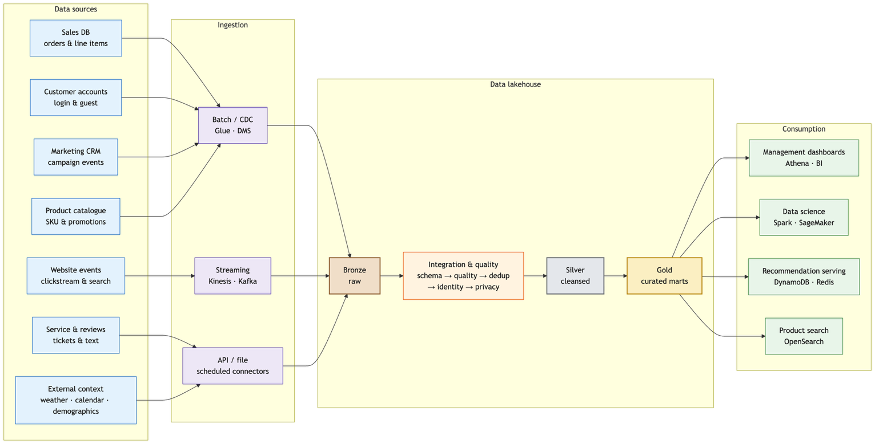
Figure 2– End-to-end Big Retail data pipeline and lakehouse (primary schematic)

Data lake design: storage, retrieval, security

Architecture
The recommended design is a lakehouse on cloud object storage, because a data lake can hold structured and unstructured data at scale and expose it for dashboards, batch processing, and machine learning (Amazon Web Services, n.d.-b). AWS is proposed as the single primary stack - chosen over Azure because Big Retail's team already meets the CCF501 AWS prerequisite - with open-source equivalents (full mapping in Appendix F, Table F1) so the design is portable and not locked in.
The AWS-vs-open-source choice is a genuine trade-off: managed services cut operational burden and speed delivery but add cost and vendor lock-in, whereas the open-source stack lowers licensing cost at the price of in-house operations. Open table formats (Iceberg/Delta) and S3-compatible storage keep migration feasible either way.

Lake zones
Data moves through three governed zones - Bronze (immutable raw data: DB extracts, clickstream JSON, review text), Silver (standardized, deduplicated, privacy-tagged Parquet), and Gold (business-ready marts and features in Iceberg/Delta) - plus a serving tier for low-latency outputs. This medallion layering is what lets the lake hold every structure type while still serving fast queries; Appendix H (Table H1) details each zone's purpose, examples, and format.

Retrieval
Retrieval is split to satisfy both audiences and both rubric retrieval requirements. Efficient search for managers and data scientists uses SQL engines (Athena, Redshift Spectrum, or Trino) over Parquet/Iceberg tables partitioned by date, source, and category (Amazon Web Services, n.d.-a). Low-latency retrieval for the live site is served from precomputed gold outputs pushed into DynamoDB/Redis (e.g. customer_id → top_product_ids) and OpenSearch for product/review search - so the website never queries raw lake files during checkout, while the lake stays the governed source of truth.

Security and privacy
Because accounts, campaign data, and behavioral logs contain personal information, collection and storage follow data-protection best practice aligned to the Australian Privacy Principles (Office of the Australian Information Commissioner, n.d.): minimize to only the fields each use case needs; encrypt in transit and at rest; enforce role-based access (managers see aggregates, scientists see de-identified analytical sets, engineers administer pipelines); hash/mask direct identifiers and separate identity tables from behavior tables; store consent state as first-class fields; and catalogue every dataset with owner, lineage, and retention period for auditability.

Assumptions, limitations, and conclusion
The design rests on assumptions to confirm with Big Retail: that the IT team can export or emit clickstream events; that guests can be linked via hashed email, device/session ID, or later sign-up; that sales and marketing share overlapping (if inconsistent) customer fields; and that external competitor/social data is collected only through lawful APIs or compliant providers. Its limitations are honest ones – identity resolution will never be perfect for guest traffic, external feeds carry variable veracity, and the lakehouse adds operational cost that only pays off once the recommender and campaign use cases are live. Subject to those caveats, the proposed pipeline ingests Big Retail’s fragmented internal and external sources, resolves schema and duplicate-identity challenges before storage, and lands data in a governed lakehouse that stores structured, semi-structured, and unstructured data while serving both analytical and low-latency retrieval. Crucially, every component traces back to business value: targeted campaigns, personalized recommendations, product-association insight, and recovered conversion – Appendix C (figure C1) maps each curated dataset to the business outcome it serves.

Appendices

Appendix A – Glossary of Terms
Table A1 – Term and Definition support table.
Term | Definition
Data lake | A store-all repository that holds raw data of any structure until it is needed, applying structure on read.
Lakehouse | An architecture that adds warehouse-style ACID tables and SQL querying on top of a data lake’s low-cost object storage.
Schema-on-read | Structure is applied when data is queried, not when it is stored (contrast schema-on-write in a warehouse).
Medallion (Bronze / Silver / Gold) | Layered lake zones: raw landing (Bronze), cleansed and standardized (Silver), business-ready marts (Gold).
ELT (land-then-validate) | Load raw data first, then transform and validate it inside the lake (contrast ETL).
CDC (Change Data Capture) | Ingesting only the records that change since the last load, instead of re-copying whole tables.
Identity resolution | Linking records that refer to the same customer across sources, despite inconsistent or missing IDs.
Data fusion | Deciding the authoritative value for a field when matched sources disagree - the third integration step, after schema alignment and record linkage.
Enrichment | Adding context (external data) or derived attributes (e.g. customer lifetime value, product affinity) to make data more analytically useful.
Event-time watermark | A threshold defining how late a streaming event may arrive before its processing window closes.
PII | Personally identifiable information (names, emails, addresses) requiring privacy controls.
OAIC APPs | The Australian Privacy Principles, the national baseline for handling personal information.
Lineage | A record of where a dataset came from and how it was transformed, used for audit and trust
Parquet / Iceberg / Delta | Columnar file and ACID table formats used for efficient analytical storage in the lake

Appendix B – Integration workflow
Figure B1 expands the "Integration & quality" stage of Figure 1 into its step-by-step validation and entity-resolution sequence, including the quarantine path for records that fail validation.
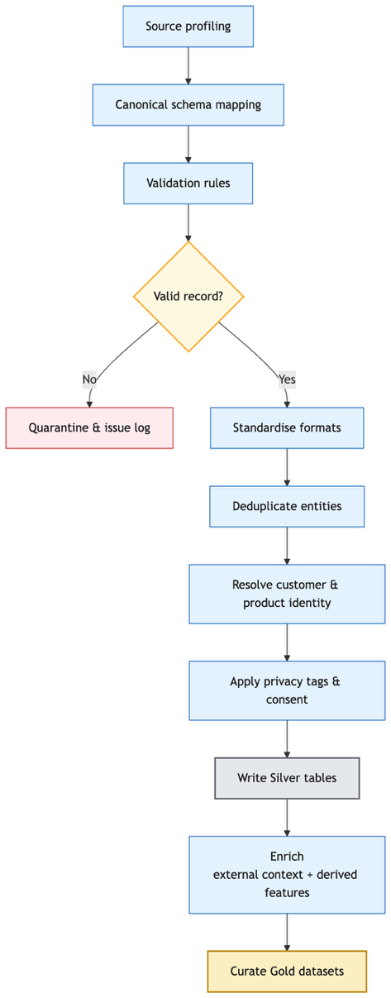
Figure B1 – Integration workflow (source profiling to curated)

Appendix C – Curated datasets and business value
Figure C1 traces how curated (Gold) datasets map to Big Retail's target business outcomes, showing the line of sight from cleansed data to campaigns, recommendations, association rules, and management reporting.
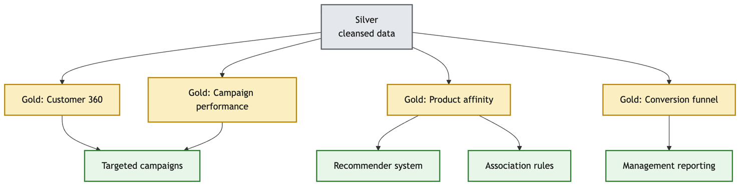
Figure C1 – Curated outputs to business value

Appendix D – The six V’s mapped to Big Retail
This table cross-references the evaluation in §2: each V is mapped to its Big Retail interpretation, the concrete design response, and the severity that drives the design.
Table D1 – Six V’s mapping to Big Retail
V | What it means for Big Retail | Design response | Severity here
Volume | 100,000+ monthly visitors plus transactions, emails, catalogue, and events | S3 object storage and distributed Spark processing | Moderate – not the binding constraint
Velocity | Clickstream and cart events are continuous; sales, CRM, and catalogue are batch | Streaming (Kinesis/Kafka) for events plus batch/CDC for databases | Selective
Variety | Relational, JSON, API, and free-text data must coexist | Lakehouse zones store structured, semi-structured, and unstructured data | Primary
Veracity | Duplicate customers, guest-checkout gaps, and bot traffic | Data-quality rules, deduplication, identity resolution, and quarantine | Primary
Valence | Customers link to sessions, orders, products, and campaigns | Identity graph plus customer and product master tables | Primary (value unlock)
Value | Every component must serve a business outcome | Gold marts and serving features tied to campaigns, recommendations, association and conversion | Anchor

Appendix E – Data-source inventory
The full per-source inventory referenced in §3: internal and external sources across all three structure types, with assumed fields, formats, and the business value each serves.
Table E1 – Big Retail data-source inventory
Source | Int/Ext | Structure | Assumed fields & format | Business value
Sales transaction DB | Internal | Structured | order_id, customer_id, guest_id, sku, qty, price, discount, payment_status, order_ts; relational / csv | Association rules, revenue, conversion
Customer account DB | Internal | Structured | customer_id, name, email, address, postcode, prefs, created_at; relational (PII-sensitive) | Segmentation, personalization, retention
Marketing / email CRM | Internal | Structured + semi | campaign_id, segment, send_ts, open/click/bounce/unsub events; CSV / JSON / API | Targeted campaigns, attribution
Website clickstream & search logs | Internal | Semi-structured | session_id, visitor_id, url, referrer, query, product_view, cart_event, ts, device, geo; JSON events | Funnel analysis, recommender signals
Product catalogue & promotions | Internal | Structured + semi | sku, category, brand, attributes, stock, price, images, promo, margin; relational / CSV | Similarity, offer ranking, stock-aware recs
Customer service, returns & reviews | Internal | Structured + unstructured | ticket_id, reason_code, free-text complaint, return_reason, rating, review_text; DB + text | Pain points, sentiment, product feedback
Location / demographic / calendar | External | Structured | postcode population, income bands, holidays, local events; CSV / API | Contextual campaign segmentation
Weather | External | Structured + semi | date, postcode, temperature, rainfall, alerts; API / JSON | Promotion timing, demand modelling
Competitor pricing public signals | External | Semi + unstructured | competitor price, title, availability, public reviews / social mentions; API / lawful scrape | Pricing intelligence, demand signals

Table E2 – Worked example – field types and a sample record (Sales Transaction DB).
Source | Data type | Example value
order_id | Categorical (ID) | ORD-1048772
customer_id | Categorical (ID) | CUST-00913
guest_id | Categorical (nullable ID) | (null)
sku | Categorical (ID) | SKU-3391
qty | Numerical (discrete) | 2
price | Numerical (continuous) | 49.95
discount | Numerical (continuous) | 5.00
payment_status | Categorical | Paid
order_ts | Datetime | 2026-06-14T13:42:08+09:30

Appendix F – Storage and retrieval stack
The full storage and retrieval stack referenced in §5.1, mapping each AWS service to an open-source equivalent so the design stays portable.
Table F1 –Storage and retrieval stack (AWS primary, with open-source equivalents).
Layer | AWS (primary) | Open-source equivalent | Role
Batch ingestion | Glue / DMS | Airbyte, Debezium | Import sales, CRM, catalogue
Streaming ingestion | Kinesis | Apache Kafka | Clickstream, cart, checkout events
Raw storage | Amazon S3 | MinIO / HDFS | Durable object storage, all raw files
Processing | Glue / EMR Spark | Apache Spark | Clean, join, aggregate, feature build
Table format | Iceberg / Delta | Iceberg / Delta | ACID tables, schema evolution, time travel
Catalogue | Glue Data Catalog | Hive Metastore, Open Metadata | Searchable schemas, ownership, lineage
Governance | Lake Formation | Apache Ranger | Fine-grained access, audit
Analytical query | Athena / Redshift Spectrum | Trino / Presto | SQL for dashboards and analysts
Low-latency serving | DynamoDB / OpenSearch | Cassandra / Redis / OpenSearch | Fast recommendation & product lookup

Appendix G – Integration challenge register
The full set of integration challenges referenced in §4: schema alignment and duplicate resolution first (the two the rubric names) - which, with data fusion, form the canonical schema alignment → record linkage → data fusion sequence (Dong & Srivastava, 2015) - then identity, timing, quality, privacy, and external-source issues, each with a resolution step and the artefact it produces.
Table G1 – Integration challenges and resolution steps.
Challenge | Why it appears at Big Retail | Resolution step | Output artefact
Schema alignment | Sales, marketing, web, and catalogue systems use different field names, types and IDs | Define canonical customer / product / order / campaign / event schemas; validate incoming data against data contracts | Versioned schema registry + canonical model
Duplicate customers | Same customer in sales and marketing DBs; guests later create accounts | Deterministic match on hashed email / account ID, then cautious fuzzy match on name/address/phone with confidence scores | Master customer table with source lineage
Conflicting field values (data fusion) | Matched records disagree - two addresses or phones for one customer | Choose the authoritative value by source priority + recency; keep alternates with lineage | Golden customer record
Guest-checkout identity | Guest orders may not map to web session or later accounts | Store privacy-safe guest_id, session ID, hashed email, and linkage timestamps | Identity graph with transparent lineage
Batch vs streaming mismatch | DB/CRM are batch; clickstream is continuous | Batch/CDC for databases, streaming for events; watermark and reconcile late events on event-time | Bronze landing zone + event-time rules
Data quality | Address formats, bot traffic, duplicate events, missing profiles | Validation rules, standardize timestamps to UTC/AEST, dedupe event IDs, filter bots, quarantine bad records | Data-quality scorecard + quarantine table
Privacy & consent | Accounts, campaigns, and logs hold PII | Minimization, encryption, role-based access, consent flags, masking, retention, audit logging (OAIC APPs) | Privacy control matrix
External-source reliability | Weather/competitor/review feeds refresh unevenly | Record source, extraction time, license, reliability score, refresh cadence | External source register

Appendix H – Lakehouse zones
The medallion zones referenced in §5.2, from raw landing to curated marts plus a serving tier, showing how each structure type is stored.
Table H1 – Lakehouse zones (Raw to curated, plus a serving tier)
Zone | Purpose | Examples | Format
Bronze (raw) | Immutable source data for audit/replay | DB extracts, raw clickstream, JSON, review text | CSV, JSON, Avro, text
Silver (cleansed) | Standardized, deduplicated, privacy-tagged | Master customer/product, cleaned orders, standardized events | Partitioned Parquet
Gold (curated) | Business-ready marts and features | Customer 360, product-affinity matrix, campaign performance | Iceberg / Delta
Serving | Fast retrieval for live use | Top-N recommendations, product search index | Key-value / search index

End of Appendix Section

Statement of Acknowledgment
I acknowledge that I have used the following AI tool(s) in the creation of this report:
  - OpenAI ChatGPT (Codex 5.5)
  - Anthropic Claude (Opus 4.8)
Both have been used to assist with understanding big data concepts, evaluating the six V's against the Big Retail case, structuring the data pipeline and data lake design, improving the clarity of academic language, and supporting APA 7th referencing conventions.
Prompt examples:
- "For the Big Retail case, which of the six V's of big data most constrain the pipeline design, and how should each map to a concrete design response?"
- "My data lake validates records after landing them raw in a Bronze zone, while the textbook validates at a Transient Landing zone before Raw - when is each correct, and how do I frame the trade-off critically?"
- "Format this as APA 7th: Marr, Bernard (2021), Data Strategy, 2nd edition, Kogan Page."
I confirm that the use of the AI tool has been in accordance with the Torrens University Australia Academic Integrity Policy and TUA, Think and MDS’s Position Paper on the Use of AI. I confirm that the final output is authored by me and represents my own critical thinking, analysis, and synthesis of sources. I take full responsibility for the final content of this report.

References
Amazon Web Services. (n.d.-a). Amazon Athena documentation. https://docs.aws.amazon.com/athena/
Amazon Web Services. (n.d.-b). What is a data lake? https://aws.amazon.com/what-is/data-lake/
Dong, X. L., & Srivastava, D. (2015). Big data integration. Synthesis Lectures on Data Management, 7(1), 1-198. Morgan & Claypool. https://doi.org/10.2200/S00578ED1V01Y201404DTM040
EMC Education Services. (2015). Data science and big data analytics: Discovering, analyzing, visualizing and presenting data. John Wiley & Sons.
Marr, B. (2021). Data strategy: How to profit from a world of big data, analytics and artificial intelligence (2nd ed.). Kogan Page.
Office of the Australian Information Commissioner. (n.d.). Australian Privacy Principles. https://www.oaic.gov.au/privacy/australian-privacy-principles
Rutherford, A. (2017, February 21). What is big data? [Video]. YouTube. https://www.youtube.com/watch?v=91tncL3gA6I
Torrens University Australia. (2024). BDA601 Assessment 1 brief: Design data pipeline.

