Individual Contribution Report
Design and Creative Technologies
Torrens University, Australia

Student: Luis Guilherme de Barros Andrade Faria – A00187785
Subject Code: ISY 503
Subject Name: Intelligent Systems
Assessment No.: 3
Title of Assessment: Case Study Report
Lecturer: Dr. Nandini Sidnal
Date: May 2026

Copyright © 2026 by Luis G B A Faria

Permission is hereby granted to make and distribute verbatim copies of this document provided the copyright notice and this permission notice are preserved on all copies.

Table of Contents
1. Group Details 3
2. Team Contribution Table 3
3. Individual Report 3
4. Appendices 5
4.1 Appendix A – Github Repository 5
4.2 Appendix B – Live Application 5
3.3 Appendix C – Sample Test Cases Output 7
3.4 Appendix D –Future Work 8
5. References 10

Group Details
Student ID | Name | Email
A00187785 | Luis Guilherme de Barros Andrade Faria | Luis.Faria@Student.Torrens.edu.au
A00106473 | Samiran Shrestha | Samiran.Shrestha@Student.Torrens.edu.au
A00179705 | Victor Javier Dorantes Meneses | Victor.Meneses@Student.Torrens.edu.au
- Source code: https://github.com/lfariabr/review-pulse
- Presentation: ISY503_Faria_L_Assessment_3.pptx
- Live Demo: https://review-pulse.streamlit.app/

Team Contribution Table
Member | Main contribution | %
Luis | Technical architecture, implementation, integration, testing, documentation, release management, and coordination | 50%
Samiran | Problem framing, live demonstration support, and future improvement planning | 25%
Victor | DistilBERT/model experimentation and integration support, dataset analysis, error analysis, ethics presentation | 25%

Individual Report
My primary contribution to ReviewPulse was the full technical implementation and hardening of the ML pipeline - the modular Python package structure, the Streamlit web app, the automated test suite, and the project documentation.
On the data side, I built the pseudo-XML parser (src/data/parser.py), the preprocessing pipeline with negation expansion (src/data/preprocess.py), and the vocabulary and PyTorch DataLoader helpers (src/tokenization/). I then implemented the TF-IDF + Logistic Regression baseline (src/training/baseline.py) and the bidirectional LSTM (Hochreiter & Schmidhuber, 1997) initialised with GloVe 100-dimensional embeddings (src/models/bilstm.py). The BiLSTM training loop (src/training/bilstm.py) uses Adam with gradient clipping, F1-based checkpointing, and Apple MPS device support. I also hardened the final modular architecture: app services in src/app/service.py, inference split across src/inference/, and evaluation split across src/evaluation/. I produced the presentation outline, 10 acceptance test cases with real model outputs, the submission checklist, and this document.
An important ethical consideration is that the Blitzer et al. (2007) dataset uses filename-derived labels rather than human raters. We audited for possible rating/text conflicts and ambiguous boundary cases and found zero ambiguous rows, but the risk remains relevant in broader sentiment classification settings. BiLSTM and DistilBERT confidence values are uncalibrated (high confidence does not imply high accuracy) and both models generalise poorly to out-of-distribution text such as logistics reviews (Bender et al., 2021). Any production deployment requires human oversight and periodic label audits.
I estimate my contribution at 50% as the primary technical implementer and final refactor lead. Victor contributed 25% covering DistilBERT/model experimentation, integration support, dataset analysis, error analysis, and ethics. Samiran contributed 25% through supported problem framing, live demonstration support, and future improvement planning, including review-classification challenges such as negation, sarcasm, review length, and domain differences.

Appendices

4.1 Appendix A – Github Repository
https://github.com/lfariabr/review-pulse

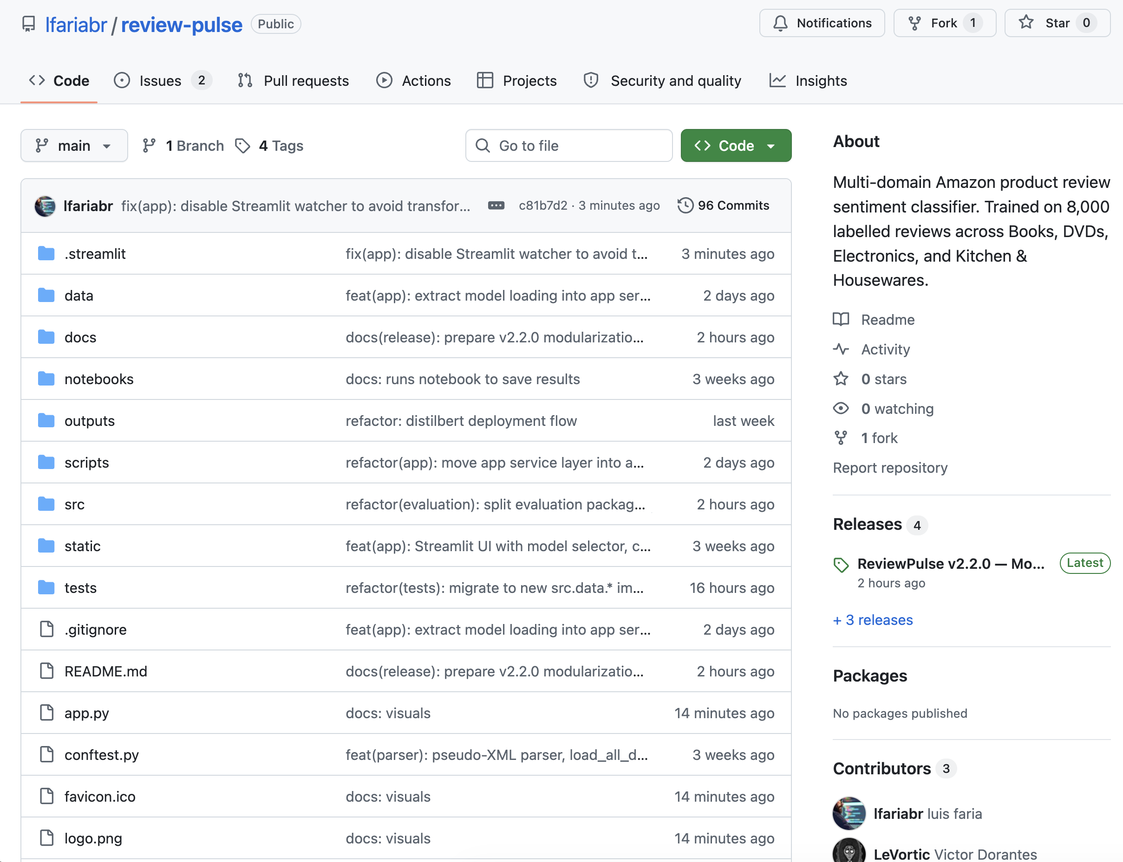
Fig A1. Github repository main page.

4.2 Appendix B – Live Application
https://review-pulse.streamlit.app/
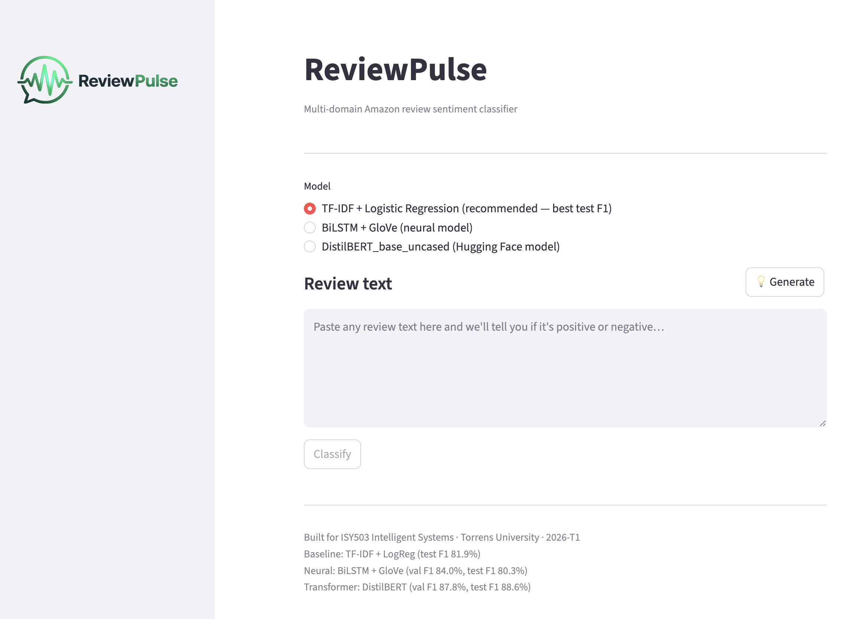
Figure A2.1. ReviewPulse app homepage with model selector.
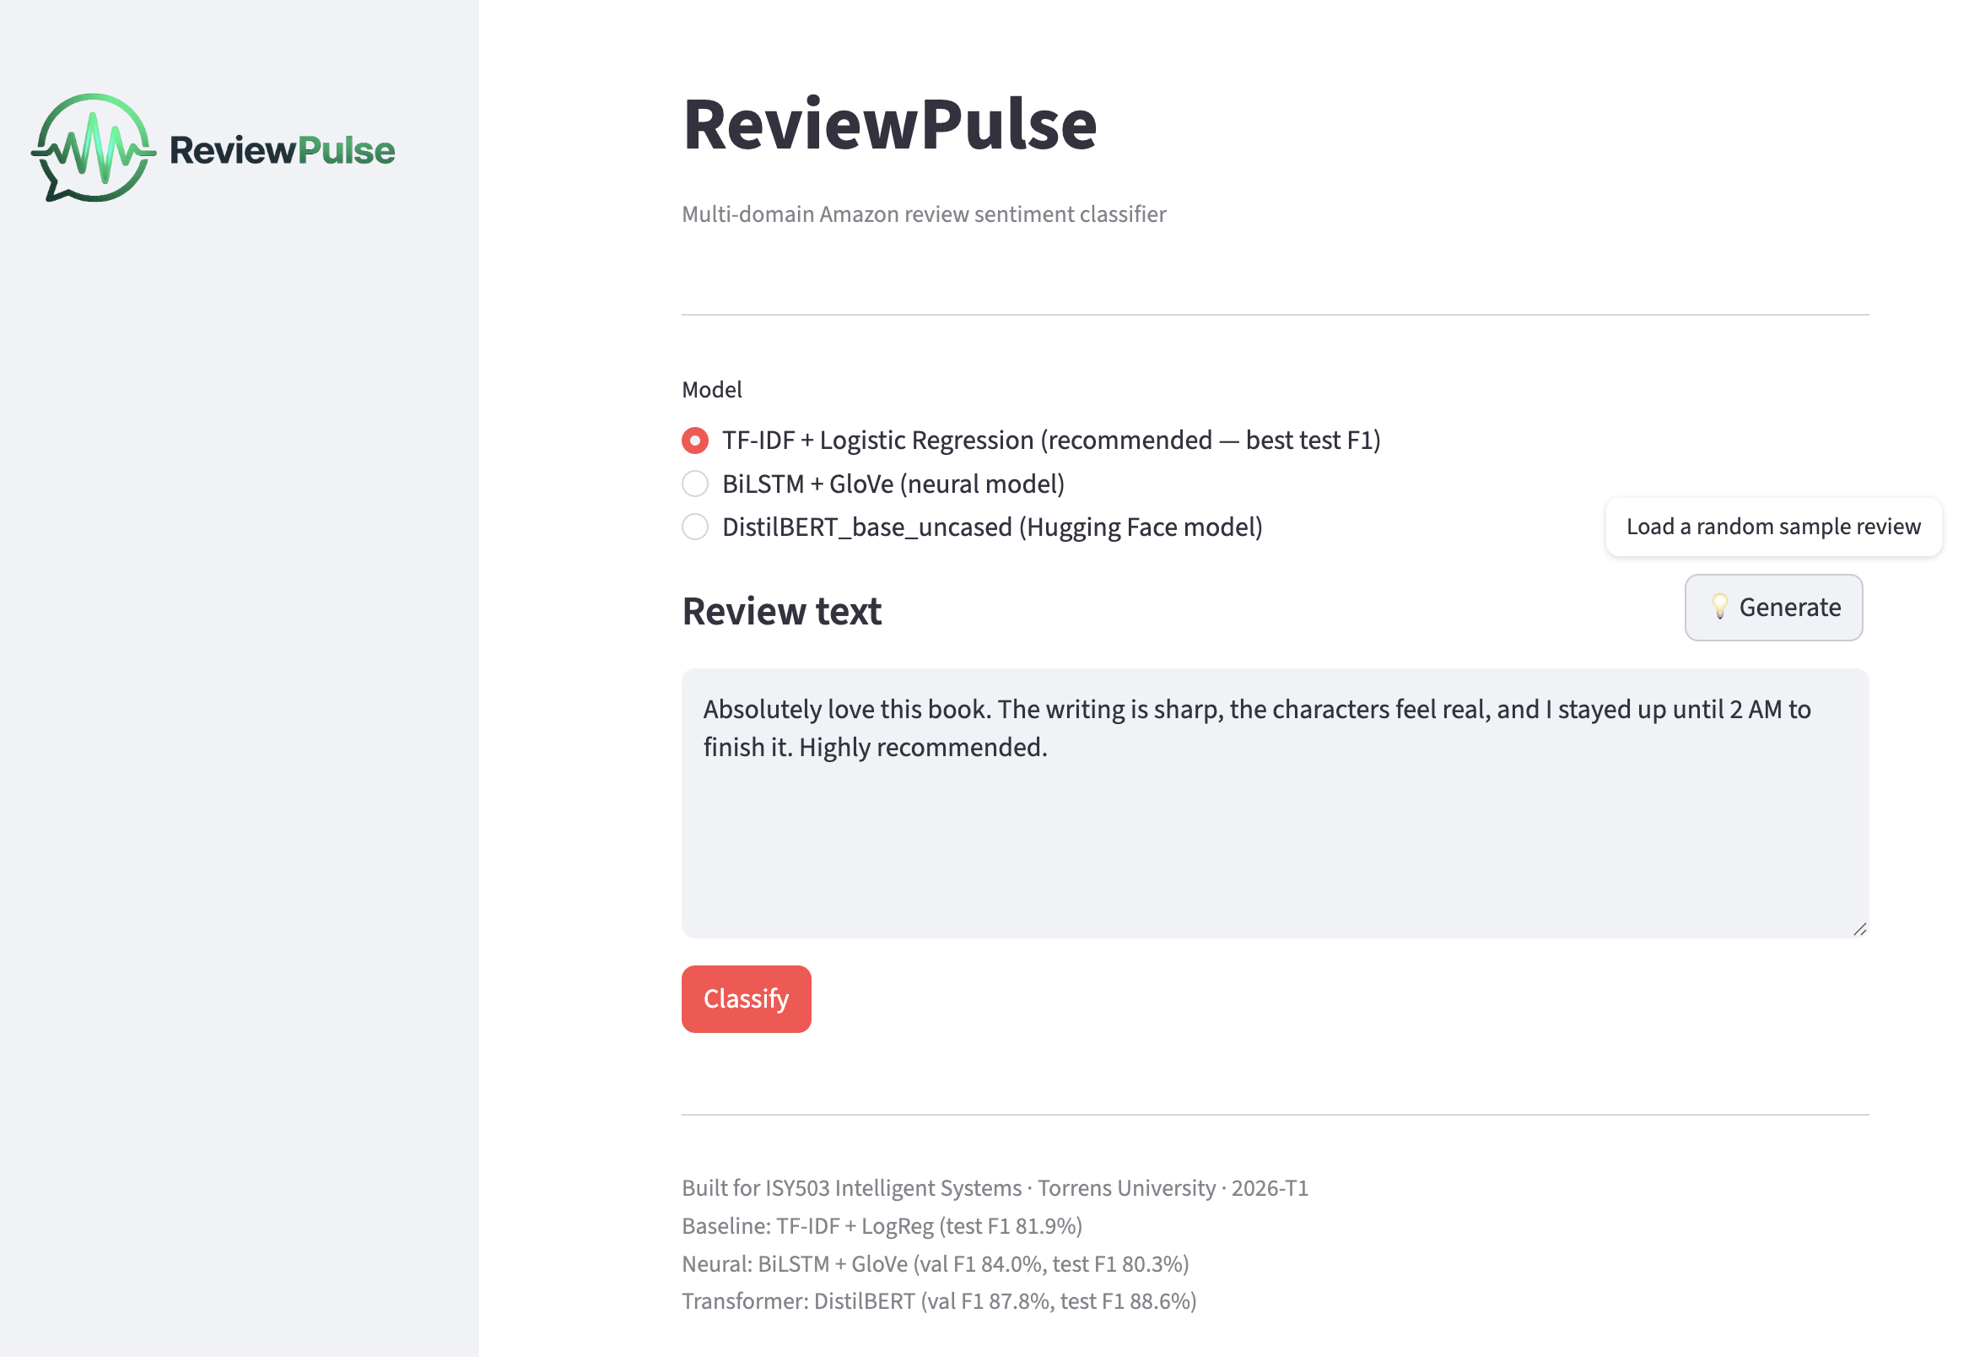
Figure A2.2. ReviewPulse app with random sample review generated and ready to classify.
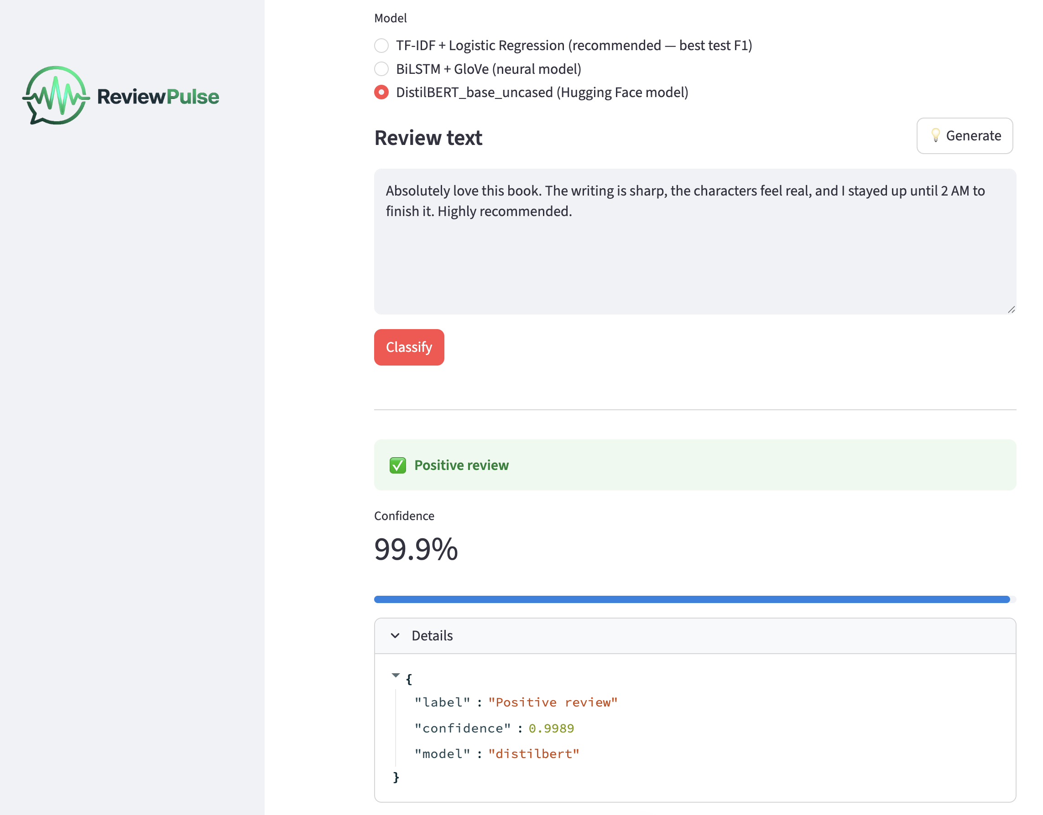
Figure A2.3. ReviewPulse app with input review text classified.

3.3 Appendix C – Sample Test Cases Output

Ten acceptance test cases run against the baseline and BiLSTM checkpoints (baseline checkpoint outputs/baseline.joblib, BiLSTM checkpoint outputs/bilstm.pt epoch 9). DistilBERT is integrated into the app as the third selectable model using outputs/distilbert.pt.
Case | Input (excerpt) | Baseline | BiLSTM
Clear positive | This blender is absolutely incredible… | Positive 73.8% | Positive 97.9%
Clear negative | Broke after two days… | Negative 95.9% | Negative 99.6%
Negation trap | This is not bad at all… | Negative 66.9% | Negative 74.6%
Sarcasm | Oh great, stopped working after a week… | Negative 52.5% | Negative 64.6%
Domain-shifted (books) | One of the best thrillers I have read… | Positive 69.4% | Positive 86.2%

Table A3. Sample Test Cases Output.
Full results: https://github.com/lfariabr/review-pulse/blob/main/docs/assessment-files/demo-test-cases.md.

3.4 Appendix D – Future Work

Priority | Extension | Rationale
Shipped | DistilBERT | Victor implemented Hugging Face distilbert-base-uncased; test F1 88.6%, live in app
High | RoBERTa | Larger pretrained transformer; expect to push F1 beyond 90%
High | Confidence calibration (Platt scaling) | BiLSTM logits are uncalibrated; 98% confidence ≠ 98% accuracy
Medium | Additional training domains | Current model is trained on 4 product categories only; broader domains would validate generalisation
Medium | LIME / attention visualisalion | Makes predictions auditable - necessary for any production or high-stakes deployment
Low | FastAPI backend | Decouple inference from Streamlit for easier integration with external systems

Table A4. Future Work possibilities and opportunities.

End of Appendix Section

Statement of Acknowledgment
I acknowledge that I have used the following AI tool(s) in the creation of this report:
  - OpenAI ChatGPT (GPT–5.4)
  - Anthropic Claude Opus 4.6
Both tools were used to assist with understanding ML concepts, structuring the technical manual, improving clarity of academic language, and supporting APA 7th referencing conventions.
Prompt examples:
- “I built a BiLSTM sentiment classifier with pack_padded_sequence to stop the LSTM processing padding tokens. My training achieves val F1=84.0% at epoch 9, but test F1 drops to 80.3% while the TF-IDF baseline reaches 81.9% on the same held-out set. Can you help me understand why the neural model didn't generalise better despite the stronger validation score?"
- "I need to compare two approaches for sentiment analysis – TF-IDF + Logistic Regression vs BiLSTM with GloVe – in an academic report where the simpler model wins on the held-out test set. How do I frame this honestly without undermining the neural architecture requirement of the assessment rubric?"
- "Format this as APA 7th: Bender, Emily M., Timnit Gebru, Angelina McMillan-Major, and Shmargaret Shmitchell, 2021, article titled On the Dangers of Stochastic Parrots: Can Language Models Be Too Big?, conference ACM FAccT 2021, pages 610 to 623."
I confirm that the use of these tools has been in accordance with the Torrens University Australia Academic Integrity Policy and TUA, Think and MDS’s Position Paper on the Use of AI. I confirm that the final output is authored by me and represents my own critical thinking, analysis, and synthesis of sources. I take full responsibility for the final content of this report.

References
Bender, E. M., Gebru, T., McMillan-Major, A., & Shmitchell, S. (2021). On the dangers of stochastic parrots: Can language models be too big? In Proceedings of the 2021 ACM FAccT Conference (pp. 610–623). https://doi.org/10.1145/3442188.3445922
Blitzer, J., Dredze, M., & Pereira, F. (2007). Biographies, Bollywood, Boom-boxes and Blenders: Domain adaptation for sentiment classification. In Proceedings of the 45th Annual Meeting of the ACL (pp. 440–447). ACL. https://aclanthology.org/P07-1056/
Hochreiter, S., & Schmidhuber, J. (1997). Long short-term memory. Neural Computation, 9 (8), 1735–1780. https://doi.org/10.1162/neco.1997.9.8.1735

