Technology Report and Presentation
Design and Creative Technologies
Torrens University, Australia

Student: Luis Guilherme de Barros Andrade Faria - A00187785
Subject Code: CCF 501
Subject Name: Cloud Computing Fundamentals
Assessment No.: 1
Title of Assessment: Technology Report and Presentation
Lecturer: Dr. Dyvia Leekha
Date: Mar 2026

Copyright © 2026 by Luis G B A Faria

Permission is hereby granted to make and distribute verbatim copies of this document provided the copyright notice and this permission notice are preserved on all copies.

Table of Contents
1. Executive Summary 3
2. Benefits of Cloud Computing vs. Traditional IT Infrastructure 3
2.1. Cost Efficiency and Pay-as-you-grow Model 4
2.2. Rapid Scalability for Business Growth 4
2.3. Reduced IT Management Overhead 5
3. Challenges of Cloud Migration and Mitigation Strategies 5
4. Recommended Cloud Models for ABC Enterprise 6
5. Recommended Cost Model 7
6. Cloud Provider Recommendation: AWS 8
7. Conclusion 9
8. Appendices 10
8.1. Appendix A – Cloud vs Traditional IT Comparison Table 10
8.2. Appendix B – High-Level Architecture Diagram 10
8.3. Appendix C – Cost Model Breakdown Example 11
8.4. Appendix D – Shared Responsibility Model Diagram 11
8.5. Appendix E – NIST Five Essential Characteristics Mapped to ABC 11
8.6. Appendix F – Cloud Resources Provisioned (What we are hiring) 12
8.7. Appendix G – Glossary of Terms 13
9. References 14

Cloud Computing for ABC Enterprise: Key Contributions to Business Automation

Executive Summary
Cloud computing has become a core business utility - email, storage, and smart devices all run on someone else's infrastructure, delivered on demand (Nishimura, 2022). For ABC Enterprise from our case study, this model translated directly into results: start-up IT costs dropped by ~80% and the platform absorbed a 10x customer surge within a month, without a matching increase in headcount (Eliaçık, 2022; McHaney, 2021). This report outlines three key benefits of cloud adoption, the main challenges to manage, and a practical recommendation for service model, deployment model, cost model, and cloud provider. Where ABC needs a provider beyond "XYZ", AWS is recommended for its maturity, global reach, and automation-ready managed services (Amazon Web Services, n.d.).

Benefits of Cloud Computing vs. Traditional IT Infrastructure
Traditional IT means owning servers, cooling, and the staff to keep it running (McHaney, 2021). For a high-growth start-up like ABC, that model is a strategic handicap. Cloud flips it: instead of buying capacity, ABC rents capability, aligned to the NIST characteristics of on-demand self-service, measured service, rapid elasticity, and resource pooling (Mell & Grance, 2011).

Cost Efficiency and Pay-as-you-grow Model
Cloud shifts spend from CAPEX to OPEX - no upfront servers, no idle hardware costs (Eliaçık, 2022). ABC's ~80% reduction in start-up IT costs is the "measured service" characteristic in action: pay for compute-hours, storage GB-months, and data transfer actually consumed (Mell & Grance, 2011). As McHaney (2021) notes, operational overhead - personnel, training, upgrades, and security - often exceeds hardware cost over time, making pay-as-you-go a structural advantage. Beyond the bill, standard tasks like backups, patching, and scaling can be codified and automated, reducing human toil across the delivery pipeline (Carpenter, 2020).
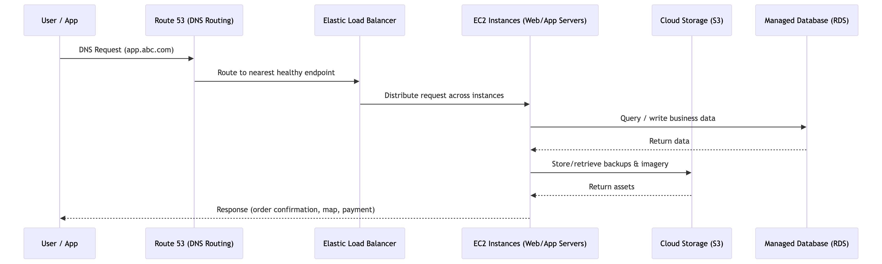
Figure 1 – ABC Enterprise cloud traffic flow - from user request through Route 53, load balancing, compute, storage, and database layers

Rapid Scalability for Business Growth
A 10x customer surge in a single month exposes the core weakness of on-premises infrastructure: procurement lead times mean hardware arrives after the opportunity has passed (McHaney, 2021). Cloud's rapid elasticity lets ABC scale compute up during campaigns or city launches and scale down when demand normalizes - automatically, not reactively (Mell & Grance, 2011). Eliaçık (2022) highlights that this scalability protects against outages from traffic spikes - critical for an app handling delivery, taxi bookings, and payments.

Reduced IT Management Overhead
In on-premises environments, more customers mean more infrastructure and more staff to maintain it (McHaney, 2021). Cloud breaks that linear relationship. Through resource pooling, providers consolidate physical resources across tenants — Manvi and Shyam (2021) describe this as partitioning and isolation that allows multiple workloads to share hardware. ABC gains automated maintenance and resilient architectures that would be expensive to replicate in-house (Naved et al., 2022).

Challenges of Cloud Migration and Mitigation Strategies
Cloud adoption is not risk-free. Three challenges are most relevant for ABC (Eliaçık, 2022):
- Security and Privacy: ABC handles payments and customer PII. Security is the top concern for cloud adopters - 90% of security professionals cite it as a challenge, alongside governance (71%) and compliance (68%) (Manvi & Shyam, 2021). Mitigation: least privilege IAM, mandatory MFA, encryption at rest/in transit, and continuous alerting - the shared responsibility model clarifies the provider/customer division (Shore, 2020).
- Cost Volatility: Pay-as-you-go can spiral without guardrails - overprovisioned instances and excessive egress generate surprise bills (Bittok, 2022). Mitigation: FinOps habits from day one: budget alerts, resource tagging, rightsizing, and reserved pricing for stable workloads.
- Vendor lock-in and Skills gap: Deeper managed-service adoption makes provider migration expensive (Eliaçık, 2022). Mitigation: prioritize portability (containers, standard databases) and invest in targeted upskilling (McHaney, 2021).

Recommended Cloud Models for ABC Enterprise
Cloud service models sit on a control-versus-responsibility spectrum (IBM, n.d.-a; Linthicum, 2021; McHaney, 2021). IaaS provides full compute flexibility; PaaS abstracts infrastructure so the team can focus on development; SaaS offers limited customisation - less suited to a start-up that must differentiate its platform.
Deployment models vary in elasticity and cost. Community cloud does not apply to ABC's consumer use case. Private cloud sacrifices elasticity; hybrid introduces complexity that exceeds ABC's current maturity (Manvi & Shyam, 2021). Public cloud is the most strategically aligned option: IBM (n.d.-b) reports IaaS workloads experience 60% fewer security incidents than traditional data centers (see Table 1).
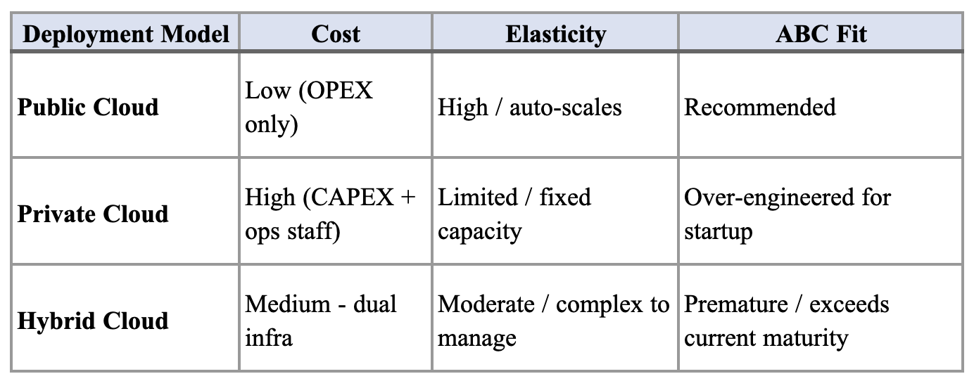
Table 1 – Deployment model trade-offs for ABC Enterprise
Recommendation: A blended IaaS/PaaS approach - IaaS for compute flexibility, PaaS for managed databases and serverless functions - preserves rapid elasticity and measured service (Mell & Grance, 2011). A Virtual Private Cloud (VPC) can address future network isolation needs (IBM, n.d.-c).

Recommended Cost Model
Cloud providers offer three levers:
- Pay-as-you-go (maximum flexibility, highest unit price),
- Reserved/committed pricing (discounts for baseline commitments),
- Spot/preemptible (deep discounts for interruption-tolerant workloads) (Bittok, 2022; Amazon Web Services, n.d.-b).
Recommendation: A hybrid cost model - reserved capacity for stable customer-facing tiers (web/app, databases), pay-as-you-go autoscaling for demand spikes, and spot instances for background jobs and analytics pipelines. TCO modelling should include not just cloud fees but also migration cost, security tooling, and engineering effort (Bittok, 2022). As Bittok (2022) notes, cloud adoption is rarely about the cheapest bill - it's about better ROI: less downtime, faster launches, and automation that avoids linear headcount growth.

Cloud Provider Recommendation: AWS
Azure suits Microsoft-aligned enterprises; GCP leads in analytics. AWS best fits ABC: Route 53 already anchors the described architecture, and AWS offers the broadest automation-ready managed-service catalogue (Nishimura, 2022; Amazon Web Services, n.d.-a) (see Table 2).
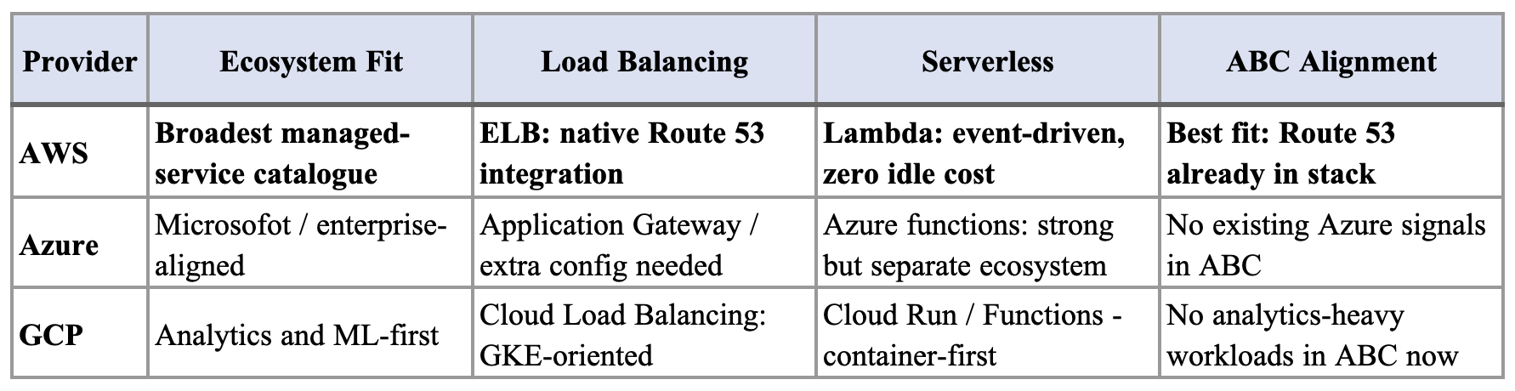
Table 2 – Cloud provider comparison for ABC Enterprise.
- Elastic Load Balancing: Automates traffic routing and health-checks across EC2 instances - critical for ABC's latency-sensitive services. Integrates natively with Route 53 and Auto Scaling (Amazon Web Services, n.d.-a).
- Auto Scaling: Provisions or terminates EC2 instances on demand signals, directly implementing NIST's rapid elasticity (Mell & Grance, 2011). The 10x surge required no manual intervention - capacity becomes policy-driven, not operator-driven (Amazon Web Services, n.d.-a).
- AWS Lambda: Event-driven compute for ABC's workflow automation: order placed → delivery assigned; payment confirmed → restaurant notified. Scales to zero when idle, charging only per invocation (Amazon Web Services, n.d.-a).

Conclusion
Cloud computing is the right strategic move for ABC: measured service, rapid elasticity, and resource pooling (Mell & Grance, 2011) translate directly into automation outcomes - scaling without procurement delays, zero headcount growth, faster time-to-market. Recommended stack: public cloud, blended IaaS/PaaS, hybrid cost model, AWS. Managed well, ABC's infrastructure stops being a bottleneck and becomes a competitive advantage (Eliaçık, 2022).

Appendices

Appendix A – Cloud vs Traditional IT Comparison Table
Dimension | Traditional IT | Cloud (ABC Case)
Cost model | CAPEX heavy | OPEX elasticity
Scaling | Hardware procurement | Auto Scaling
Deployment speed | Weeks/months | Minutes
Automation | Manual ops | Policy-driven
Table 3 – Cloud vs Traditional IT Comparison.

Appendix B – High-Level Architecture Diagram
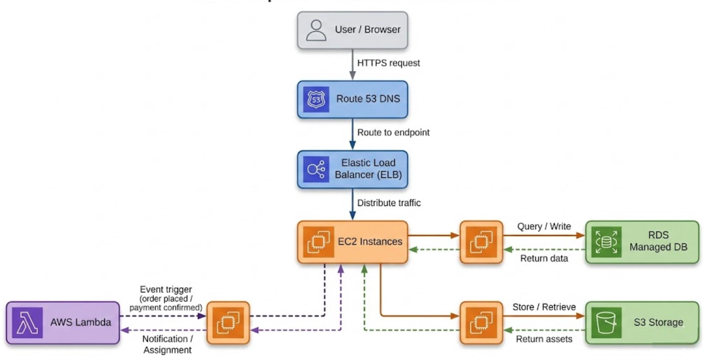
Figure 2 – ABC Enterprise high level cloud architecture on AWS.

Appendix C – Cost Model Breakdown Example
Cost Category | On-Premises | Cloud
Hardware | High upfront | None
Maintenance | Internal team | Managed
Scaling | Hardware purchase | Auto scaling
Downtime cost | High | Reduced
Table 4 – Cost Model Breakdown.

Appendix D – Shared Responsibility Model Diagram
Cloud Provider secures | ABC secures
Physical infra | IAM
Networking | Applications
Hypervisor | Data governance
Table 5 – Shared Responsibility Model.

Appendix E – NIST Five Essential Characteristics Mapped to ABC
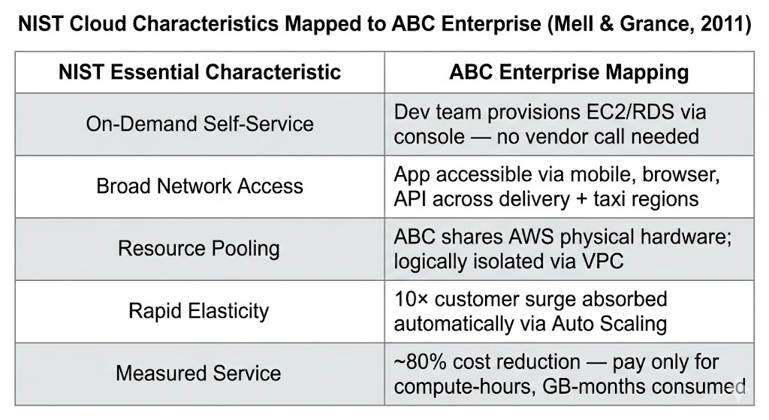
Table 6 – NIST essential cloud characteristics mapped to ABC Enterprise (Mell & Grance, 2011).

Appendix F – Cloud Resources Provisioned (What we are hiring)
AWS Service | Role | Baseline Config | Auto-Scale Ceiling
EC2 (web/app tier) | Serve API requests for all three verticals (Food, Taxi, Payments) | 2x t3.medium (2vCPU, 4GB RAM) | 20x c5.xlarge (4vCPU, 8GB RAM)
Auto Scaling | Scale EC2 fleet up/down on demand signals | Policy-driven (CloudWatch triggers) | Absorbed 10x surge with zero manual intervention
Elastic Load Balancer (ELB) | Distribute inbound traffic across EC2 fleet | Always-on (hourly-charge) | Scales transparently – no manual config
RDS (PostgreSQL) | Structured data: orders, rides, payments, users | Db.r5.large (2vCPU, 16GB) - Multi-AZ | Read replicas added on demand
S3 | Receipt storage, media assets, backups | Pay-per-GB – no provisioned minimum | Unlimited (object storage)
AWS Lambda | Event-driven workflows: order assignment, payment notifications, driver dispatch | 128MB / 3s timeout per function | 1,000 concurrent executions (default limit, raisable)
Route 53 | DNS routing and health checks | Always-on (per-query billing) | Globally redundant by default
VPC | Network isolation – multi-tenant segmentation per vertical | Single VPC with subnet per workload tier | Peering and private endpoints as needed
CloudFront | CDN – low-latency delivery of static assets to distributed users | Global edge network (always-on) | Scales to any volume; invalidation on deploy
CloudWatch | Monitoring, alerting, autoscale triggers | Always-on (free tier + paid metrics) | Retains 15 months of metrics
Cost Explorer | FinOps – cost tracking, rightsizing, usage analysis | Always-on (no provisioning needed) | Validates ~80% cost reduction claim
AWS WAF + Shield Standard | Security layer – DdoS mitigation, traffic filtering | Included (Shield Standard free) | Shield Advanced available for high-volume attacks
Table 7 – AWS services provisioned for ABC Enterprise — baseline configuration and scaling ceiling.

Appendix G – Glossary of Terms
Term | Meaning
CAPEX | Capital Expenditure
OPEX | Operational Expenditure
IAM | Identity and Access Management
TCO | Total Cost of Ownership
SOA | Service-Oriented Architecture
PaaS | Platform as a Service
IaaS | Infrastructure as a Service
SaaS | Software as a Service
VPC | Virtual Private Cloud
ELB | Elastic Load Balancer
EC2 | Elastic Compute Cloud
RDS | Relational Database Service
Route 53 | AWS DNS Service
Auto Scaling | AWS service for automatic scaling of compute resources
Shared Responsibility | Cloud security model defining provider vs customer security obligations
Measured Service | Resource usage is monitored and billed accordingly
Rapid Elasticity | Allows resources to scale up/down automatically based on demand
Table 8 – Glossary of Terms
End of Appendix Section

References
Amazon Web Services. (n.d.-a). AWS Well-Architected Framework. https://aws.amazon.com/architecture/well-architected/
Amazon Web Services. (n.d.-b). AWS Pricing. https://aws.amazon.com/pricing/
Bittok, T. (2022, January 22). Cloud total cost of ownership. LinkedIn Pulse. https://www.linkedin.com/pulse/cloud-total-cost-ownership-theophilus-bittok-/
Carpenter, T. (2020, May 27). AWS Certified Solutions Architect – Associate (SAA-C02) Cert Prep 1: Cloud services overview. LinkedIn Learning. https://www.linkedin.com/learning/aws-certified-solutions-architect-associate-saa-c02-cert-prep-1-cloud-services-overview/benefits-of-cloud-computing
Eliaçık, E. (2022). Pros and cons of cloud computing. Dataconomy. https://dataconomy.com/2022/05/pros-and-cons-of-cloud-computing-2022/
IBM. (n.d.-a). SaaS, PaaS, IaaS explained. IBM Cloud. https://www.ibm.com/think/topics/iaas-paas-saas
IBM. (n.d.-b). What is a public cloud? IBM. https://www.ibm.com/think/topics/public-cloud
IBM. (n.d.-c). What is private cloud? IBM. https://www.ibm.com/think/topics/private-cloud
Linthicum, D. (2021, May 25). Learning cloud computing: Core concepts. LinkedIn Learning. https://www.linkedin.com/learning/learning-cloud-computing-core-concepts-13710481/
Manvi, S., & Shyam, G. K. (2021). Cloud computing: Concepts and technologies (Chapter 4). CRC Press. https://learning-oreilly-com.torrens.idm.oclc.org/library/view/cloud-computing/9781000338058/
McHaney, R. (2021). Cloud technologies: An overview of cloud computing technologies for managers. Wiley. https://ieeexplore-ieee-org.torrens.idm.oclc.org/servlet/opac?bknumber=9820907
Mell, P., & Grance, T. (2011). The NIST definition of cloud computing (Special Publication 800-145). National Institute of Standards and Technology. https://doi.org/10.6028/NIST.SP.800-145
Naved, M., Sanchez, D. T., Dela Cruz, A. P., Jr., Peconcillo, L. B., Jr., Peteros, E. D., & Tenerife, J. J. L. (2022). Identifying the role of cloud computing technology in management of educational institutions. Materials Today: Proceedings, 51(8), 2309–2312. https://doi.org/10.1016/j.matpr.2021.11.414
Nishimura, H. (2022, August 30). Introduction to AWS for non-engineers: 1 cloud concepts. LinkedIn Learning. https://www.linkedin.com/learning/introduction-to-aws-for-non-engineers-1-cloud-concepts-2/
Shore, J. (2020). Cybersecurity with cloud computing: Service models. LinkedIn Learning. https://www.linkedin.com/learning/cybersecurity-with-cloud-computing-2/

