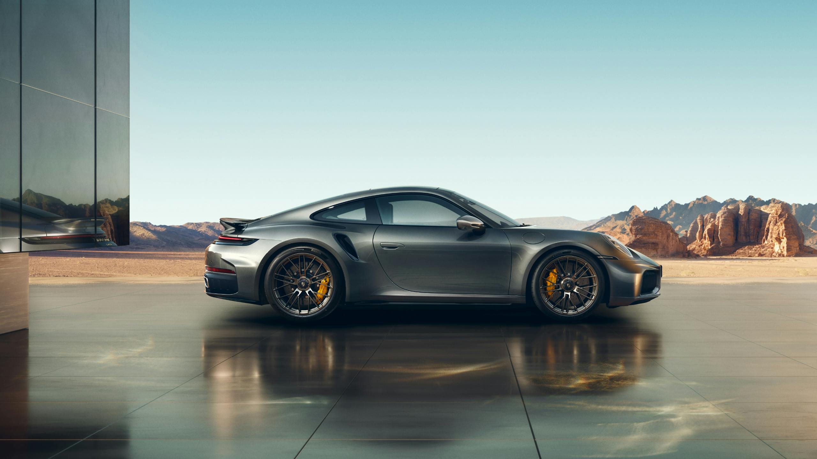

Redesigning the Porsche 911 Turbo S for Efficiency under HCD Lens
(Module 10 – Learning Activity: Understanding What to Redesign)

1. Why the Porsche 911 Turbo S Is So Inefficient
The 2025 Porsche 911 Turbo S ranks among the least fuel-efficient mini compact vehicles with a combined fuel economy of 16 MPG (EPA, 2025). Its inefficiency stems from:
- High-output 3.7-L twin-turbo six-cylinder engine optimized for extreme performance, not efficiency.
- Aerodynamic profile tuned for downforce, increasing drag at mid-high speeds.
- Wide rear tires for grip, generating rolling resistance.
- High-performance calibration that prioritizes acceleration, responsiveness, and top speed over fuel economy.
The vehicle was designed for enthusiasts seeking track-level performance, not environmental efficiency, which makes it an ideal case for redesign exploration.

2. Attributes That Could Be Improved
To make the 911 Turbo S more efficient, several redesign opportunities exist:
# | Attribute | Description
1 | Powertrain optimization | - Replace the current engine calibration with a dual-mode ECU map → “Performance mode” + “Eco cruising” mode  - Transition toward plug-in hybridization like the Mercedes AMG GT63 S E-Performance
2 | Aerodynamic Drag | - Adjustable active aero that reduces drag in city driving, not only at high speeds.  - Lower rolling resistance tire compounds for non-track use.
3 | Lightweight materials | - Increased use of carbon fiber for non-structural components → lower weight → lower fuel consumption.
4 | Mild Regenerative braking | - Even a small hybrid motor could recapture waste energy.

3. What the Most Efficient Vehicles Have That the Porsche 911 Turbo S Doesn’t
When comparing to the Best-in-Class 2025 vehicles (Tesla Model 3 LR RWD, Lucid Air Pure, BMW i4), several differences stand out:
Efficient Vehicles Have | Porsche 911 lacks
Fully electric drivetrain | Pure internal combustion
Regenerative braking | None
Aerodynamics optimized for drag reduction | Aerodynamics optimized for downforce
Energy-efficient tire & wheel configs | Wide, high-resistance performance tires
Weight-optimized EV platforms | Heavy reinforcement for performance

4. How to Increase Efficiency: Hypothetical Redesign Proposal for the Porsche 911 Turbo S e-Hybrid
A conceptual redesign could include:
- Plug-in Hybrid System (PHEV)
  - Add a small electric motor powering the front axle → torque vectoring + zero-emission city driving.
  - Pure EV range: 30–40 km for urban low-speed zones.
- Eco-Adaptive Driving Mode
  - System automatically prioritizes efficiency below 70 km/h.
  - Real-time predictive energy management using GPS + traffic data.
- Variable Aerodynamics 2.0
  - Rear wing + air vents close at low speed to reduce drag.
  - “Eco Aero” profile configurable by user.
- Lightweight Reengineering
  - Replace steel panels with aluminum/magnesium mix.
  - Reduce unsprung weight for better efficiency.
- Low-Resistance Street Tire Set
  - Offer two tire kits: performance (track), eco (street commuting).
Projected Impact: These changes could raise combined MPG from 16 MPG → 25–28 MPG, reducing emissions while maintaining Porsche’s performance DNA.

5. Connection to Human-Centered Design
Every change aligns with the needs, limitations, and values of diverse users:
- User Goals: Many Porsche owners drive mostly in cities → Eco mode + EV driving support real user habits.
- Cognitive Load Reduction: Eco-adaptive system manages efficiency automatically, reducing the mental effort of toggling modes.
- Accessibility & Usability: Hybrid driving is quieter, smoother, less fatiguing — beneficial for older drivers or long-distance commuters.
- Sustainability as a Human Value: Consumers increasingly expect premium products to be ethically and environmentally responsible.
- Familiarity: The redesign preserves Porsche’s user experience (controls, behavior) while improving efficiency.
This way we improve without alienating the user.

6. Impact on Usability
Enhanced | Maintained
Quieter EV operation | Porsche “feel”
Lower running cost | Performance mode unchanged
Reduced heat and vibration | No complex settings
Smoother acceleration in city traffic | -
The redesign adds value without breaking user expectations.

