Start with the basic layout already created. Show the user what has been created and the search bar which doesn’t return any results and the moment, then show them the database that has already been created along with the backend **schema** and the boilerplate code, etc.

Before we begin properly, mention the fact that we will be proceeding through the tutorial with the **composition API**, although users can easily adapt it to work with the **options API** if they so want to.

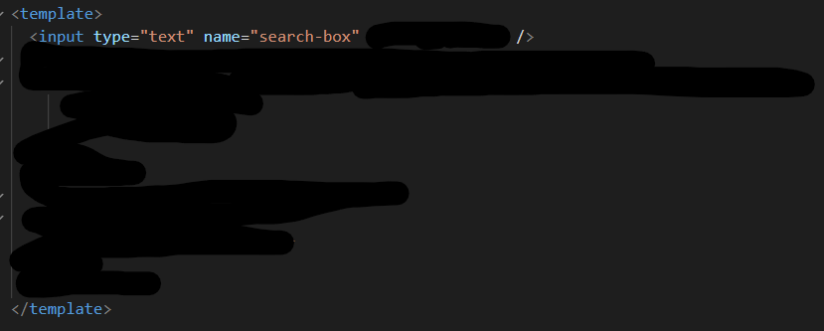



*This is written in the* ***setup*** *method. Obviously, because we are working with the* ***composition API****.*

*In the line below,* log *search* so that the user can see what is going on.



But not before **installing** *axios*.



The original console log should now be removed and just log **res** *in the line below*.

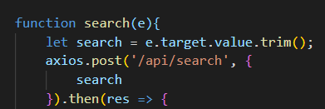

Just send back *req.body.search in the callback below*.



Show the user how things are not working. Explain that it is because our backend server is hosted on PORT 3000 whereas our Vue frontend is hosted on PORT 8080 by default. Therefore, we would need to include *http-colon-double-forward-slash-localhost-colon-3000* before the endpoint begins in order for this to work.

*In the root directory*. Explain that we will use this file to **proxy** all endpoints requesting the *api* endpoint to *localhost* on PORT 3000, so that we can easily communicate with our backend this way.



After this, show them that things are now working because we can see the response being logged from *axios*’s promise callback.

