Analisis de resultados Rubus glaucus

Luis Fernando Delgado Muñoz

25/1/2022

Mora_pn <- read_excel("Data/DATOS CRUDOS MORA.xlsx", sheet = "Produccion", na = ".")  
  
Mora_pn <- Mora_pn %>% pivot_longer(c(`San Antonio`, Brazos, Castilla), names_to = "Genotipo", values_to = "Produccion")  
  
Mora_pn$Month <-factor(Mora_pn$Month,   
 levels = c("enero", "febrero", "marzo", "abril", "mayo", "junio", "julio",  
 "agosto", "septiembre", "octubre", "noviembre", "diciembre"))

Mora_pn_mean <- Mora_pn %>% group_by(Month, Genotipo) %>% summarize(mean = mean(Produccion, na.rm = T))

Mora_pn_cum <- read_excel("Data/DATOS CRUDOS MORA.xlsx", sheet = "Produccion_cum", na = ".")  
  
Mora_pn_cum <- Mora_pn_cum %>% pivot_longer(c(`San Antonio`, Brazos, Castilla), names_to = "Genotipo", values_to = "Produccion") %>% group_by(Month, Year, Genotipo) %>% summarize(acum = sum(Produccion , na.rm = T))  
  
Mora_pn_cum$Month <-factor(Mora_pn_cum$Month,   
 levels = c("enero", "febrero", "marzo", "abril", "mayo", "junio", "julio",  
 "agosto", "septiembre", "octubre", "noviembre", "diciembre"))

Mora_pn %>% dplyr::filter(Year == 2020) %>% ggplot(aes(x = Month, y = Produccion, fill = Month)) +  
 geom_boxplot() +  
 theme(axis.text.x = element_text(hjust = 1 , angle = 45)) +  
 labs(title = "Producción 2020") +  
 facet_grid(~Genotipo)

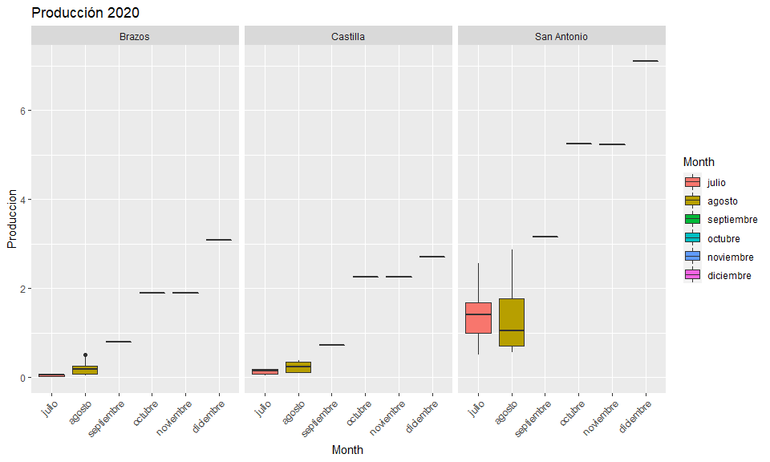

Mora_pn %>% dplyr::filter(Year == 2021) %>% ggplot(aes(x = Month, y = Produccion, fill = Month)) +  
 geom_boxplot() +  
 theme(axis.text.x = element_text(hjust = 1 , angle = 45)) +  
 labs(title = "Producción 2021") +  
 facet_grid(~Genotipo)

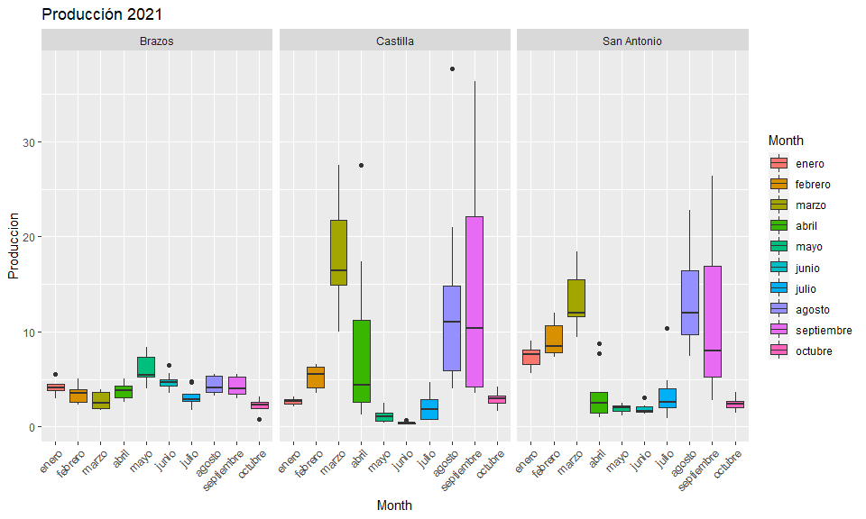

Mora_pn_cum %>% dplyr::filter(Year == 2020) %>% ggplot(aes(x = Month, y = acum)) +  
 geom_bar(stat = "identity", position = "dodge", aes(fill = Genotipo), col = "black") +  
 theme(axis.text.x = element_text(hjust = 1 , angle = 45)) +  
 labs(title = "Producción 2020", y = "Producción total")

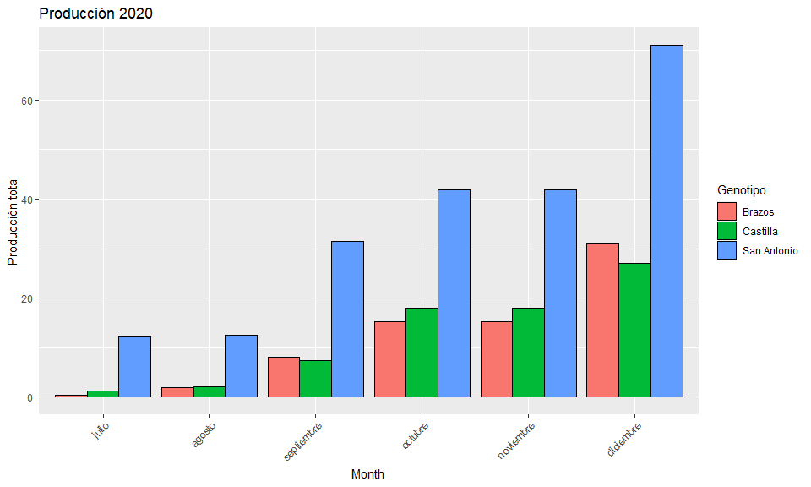

Mora_pn_cum %>% dplyr::filter(Year == 2021) %>% ggplot(aes(x = Month, y = acum)) +  
 geom_bar(stat = "identity", position = "dodge", aes(fill = Genotipo), col = "black") +  
 theme(axis.text.x = element_text(hjust = 1 , angle = 45)) +  
 labs(title = "Producción 2021", y = "Producción total")

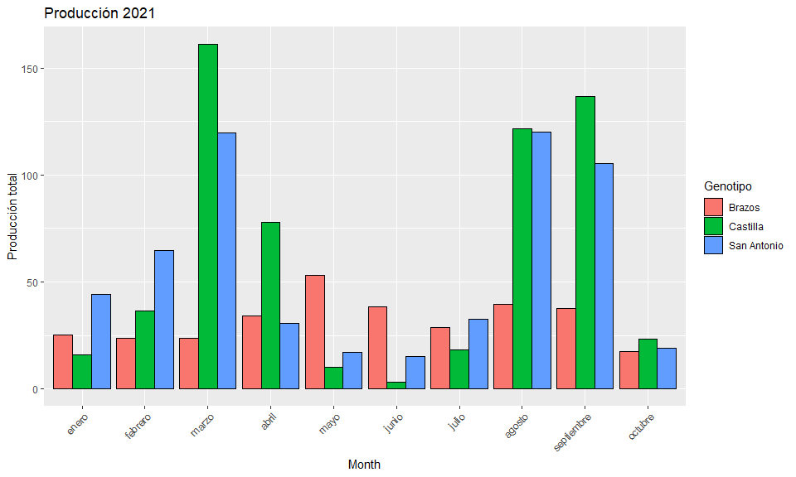

# Analisis de varianza año 2020

mod.mora_2020 <- lm(Produccion ~ Genotipo, data = Mora_pn[Mora_pn$Year == "2020", ])  
# ANOVA para mostrar  
ao_mora <- anova(mod.mora_2020)  
ao_mora

## Analysis of Variance Table  
##   
## Response: Produccion  
## Df Sum Sq Mean Sq F value Pr(>F)   
## Genotipo 2 36.826 18.4128 12.701 2.321e-05 ***  
## Residuals 63 91.334 1.4497   
## ---  
## Signif. codes: 0 '***' 0.001 '**' 0.01 '*' 0.05 '.' 0.1 ' ' 1

# Mean comparisons by Finca  
mean_comparisons_mora_2020 <- mod.mora_2020 %>%   
 emmeans(pairwise ~ "Genotipo", adjust="tukey") %>%   
 pluck("emmeans") %>%   
 cld(details=TRUE, Letters=letters) # add letter display  
  
mean_comparisons_mora_2020$emmeans # adjusted variety means

## Genotipo emmean SE df lower.CL upper.CL .group  
## Brazos 0.453 0.257 63 -0.05997 0.966 a   
## Castilla 0.507 0.257 63 -0.00582 1.020 a   
## San Antonio 2.064 0.257 63 1.55097 2.577 b   
##   
## Confidence level used: 0.95   
## P value adjustment: tukey method for comparing a family of 3 estimates   
## significance level used: alpha = 0.05   
## NOTE: Compact letter displays can be misleading  
## because they show NON-findings rather than findings.  
## Consider using 'pairs()', 'pwpp()', or 'pwpm()' instead.

# plotting Results for Tto para mostrar  
ggplot() +  
 # #black dots representing the raw data  
 # geom_point(  
 # data = Mora_pn[Mora_pn$Year == "2020", ],  
 # aes(y = Produccion, x = reorder(Genotipo, Produccion))  
 # ) +  
 #red dots representing the adjusted means  
 geom_point(  
 data = mean_comparisons_mora_2020$emmeans,  
 aes(y = emmean, x = Genotipo),  
 color = "#333b69",  
 position = position_nudge(x = 0.1)  
 ) +  
 # red error bars representing the confidence limits of the adjusted means  
 geom_errorbar(  
 data = mean_comparisons_mora_2020$emmeans,  
 aes(ymin = lower.CL, ymax = upper.CL, x = Genotipo),  
 color = "#333b69",  
 width = 0.1,  
 position = position_nudge(x = 0.1)  
 ) +  
 # red letters   
 geom_text(  
 data = mean_comparisons_mora_2020$emmeans,  
 aes(y = emmean, x = Genotipo, label = .group),  
 color = "#333b69",  
 position = position_nudge(x = 0.23)  
 ) +   
 #ylim(0, NA) + # force y-axis to start at 0  
 ylab("Producción (kg/planta muestreada)") + # label y-axis  
 xlab("Genotipos") + # label x-axis  
 labs(title = "Agrupamiento de Tukey | Producción 2020",caption = "Blue dots and error bars represent adjusted mean with 95% confidence limits per treatment  
 Means followed by a common letter are not significantly different according to the Tukey-test") +  
 theme_bw() # clearer plot format

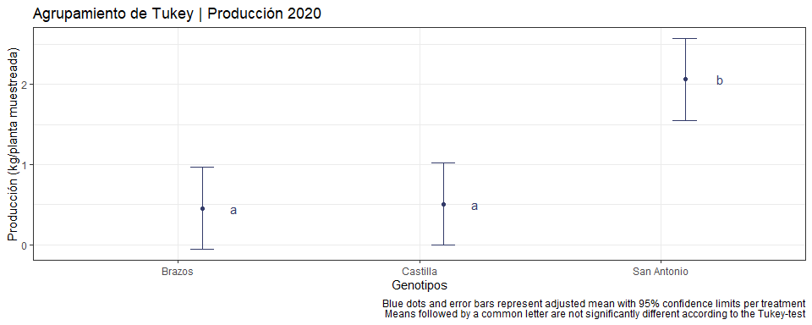

mod.mora_2021 <- lm(Produccion ~ Genotipo, data = Mora_pn[Mora_pn$Year == "2021", ])  
# ANOVA para mostrar  
ao_mora_ <- anova(mod.mora_2021)  
ao_mora_

## Analysis of Variance Table  
##   
## Response: Produccion  
## Df Sum Sq Mean Sq F value Pr(>F)   
## Genotipo 2 571.2 285.59 7.6772 0.0005831 ***  
## Residuals 246 9151.3 37.20   
## ---  
## Signif. codes: 0 '***' 0.001 '**' 0.01 '*' 0.05 '.' 0.1 ' ' 1

# Mean comparisons by Finca  
mean_comparisons_mora_2021 <- mod.mora_2021 %>%   
 emmeans(pairwise ~ "Genotipo", adjust="tukey") %>%   
 pluck("emmeans") %>%   
 cld(details=TRUE, Letters=letters) # add letter display  
  
mean_comparisons_mora_2021$emmeans # adjusted variety means

## Genotipo emmean SE df lower.CL upper.CL .group  
## Brazos 3.88 0.669 246 2.56 5.20 a   
## San Antonio 6.85 0.669 246 5.53 8.17 b   
## Castilla 7.29 0.669 246 5.97 8.61 b   
##   
## Confidence level used: 0.95   
## P value adjustment: tukey method for comparing a family of 3 estimates   
## significance level used: alpha = 0.05   
## NOTE: Compact letter displays can be misleading  
## because they show NON-findings rather than findings.  
## Consider using 'pairs()', 'pwpp()', or 'pwpm()' instead.

# plotting Results for Tto para mostrar  
ggplot() +  
 # #black dots representing the raw data  
 # geom_point(  
 # data = Mora_pn[Mora_pn$Year == "2020", ],  
 # aes(y = Produccion, x = reorder(Genotipo, Produccion))  
 # ) +  
 #red dots representing the adjusted means  
 geom_point(  
 data = mean_comparisons_mora_2021$emmeans,  
 aes(y = emmean, x = reorder(Genotipo, emmean)),  
 color = "#333b69",  
 position = position_nudge(x = 0.1)  
 ) +  
 # red error bars representing the confidence limits of the adjusted means  
 geom_errorbar(  
 data = mean_comparisons_mora_2021$emmeans,  
 aes(ymin = lower.CL, ymax = upper.CL, x = Genotipo),  
 color = "#333b69",  
 width = 0.1,  
 position = position_nudge(x = 0.1)  
 ) +  
 # red letters   
 geom_text(  
 data = mean_comparisons_mora_2021$emmeans,  
 aes(y = emmean, x = Genotipo, label = .group),  
 color = "#333b69",  
 position = position_nudge(x = 0.23)  
 ) +   
 #ylim(0, NA) + # force y-axis to start at 0  
 ylab("Producción (kg/planta muestreada)") + # label y-axis  
 xlab("Genotipos") + # label x-axis  
 labs(title = "Agrupamiento de Tukey | Producción 2021",caption = "Blue dots and error bars represent adjusted mean with 95% confidence limits per treatment  
 Means followed by a common letter are not significantly different according to the Tukey-test") +  
 theme_bw() # clearer plot format

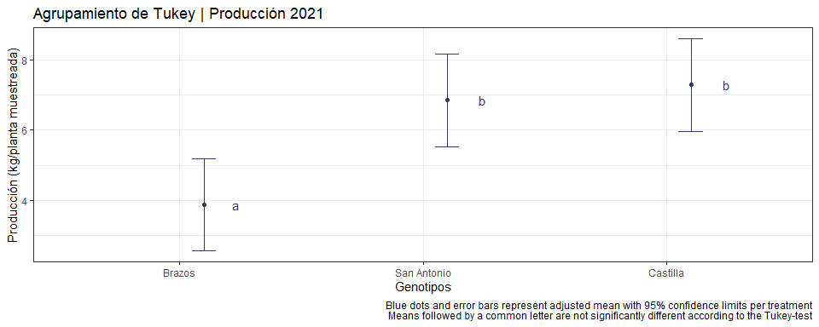

mod.mora_2021_I <- lm(Produccion ~ Genotipo*Month, data = Mora_pn[Mora_pn$Year == "2021", ])  
# ANOVA para mostrar  
ao_mora_I <- anova(mod.mora_2021_I)  
ao_mora_I

## Analysis of Variance Table  
##   
## Response: Produccion  
## Df Sum Sq Mean Sq F value Pr(>F)   
## Genotipo 2 571.2 285.59 15.4694 5.198e-07 ***  
## Month 9 2946.9 327.43 17.7356 < 2.2e-16 ***  
## Genotipo:Month 18 2161.2 120.07 6.5036 7.625e-13 ***  
## Residuals 219 4043.1 18.46   
## ---  
## Signif. codes: 0 '***' 0.001 '**' 0.01 '*' 0.05 '.' 0.1 ' ' 1

# Mean comparisons by Finca  
mean_comparisons_mora_2021_I <- mod.mora_2021_I %>%   
 emmeans(pairwise ~ "Genotipo*Month", adjust="tukey") %>%   
 pluck("emmeans") %>%   
 cld(details=TRUE, Letters=letters) # add letter display  
  
mean_comparisons_mora_2021_I$emmeans # adjusted variety means

## Genotipo Month emmean SE df lower.CL upper.CL .group   
## Castilla junio 0.412 1.52 219 -2.5815 3.41 a   
## Castilla mayo 1.122 1.43 219 -1.7005 3.94 ab   
## San Antonio junio 1.875 1.52 219 -1.1190 4.87 ab   
## San Antonio mayo 1.900 1.43 219 -0.9227 4.72 ab   
## Castilla julio 2.022 1.43 219 -0.8005 4.84 ab   
## Brazos octubre 2.200 1.52 219 -0.7940 5.19 ab   
## San Antonio octubre 2.388 1.52 219 -0.6065 5.38 ab   
## Brazos marzo 2.633 1.43 219 -0.1894 5.46 ab   
## Castilla enero 2.650 1.75 219 -0.8071 6.11 ab   
## Castilla octubre 2.913 1.52 219 -0.0815 5.91 ab   
## Brazos julio 3.200 1.43 219 0.3773 6.02 ab   
## San Antonio abril 3.389 1.43 219 0.5661 6.21 ab   
## Brazos febrero 3.400 1.62 219 0.1993 6.60 ab   
## San Antonio julio 3.611 1.43 219 0.7884 6.43 ab   
## Brazos abril 3.800 1.43 219 0.9773 6.62 ab   
## Brazos enero 4.183 1.75 219 0.7262 7.64 abc   
## Brazos septiembre 4.189 1.43 219 1.3661 7.01 abc   
## Brazos agosto 4.378 1.43 219 1.5550 7.20 abc   
## Brazos junio 4.787 1.52 219 1.7935 7.78 abc   
## Castilla febrero 5.200 1.62 219 1.9993 8.40 abcd   
## Brazos mayo 5.922 1.43 219 3.0995 8.74 abcde   
## San Antonio enero 7.383 1.75 219 3.9262 10.84 abcdef   
## Castilla abril 8.667 1.43 219 5.8439 11.49 bcdef   
## San Antonio febrero 9.257 1.62 219 6.0565 12.46 bcdef   
## San Antonio septiembre 11.700 1.43 219 8.8773 14.52 cdefg  
## San Antonio marzo 13.289 1.43 219 10.4661 16.11 defg  
## San Antonio agosto 13.367 1.43 219 10.5439 16.19 defg  
## Castilla agosto 13.522 1.43 219 10.6995 16.34 efg  
## Castilla septiembre 15.200 1.43 219 12.3773 18.02 fg  
## Castilla marzo 17.911 1.43 219 15.0884 20.73 g  
##   
## Confidence level used: 0.95   
## P value adjustment: tukey method for comparing a family of 30 estimates   
## significance level used: alpha = 0.05   
## NOTE: Compact letter displays can be misleading  
## because they show NON-findings rather than findings.  
## Consider using 'pairs()', 'pwpp()', or 'pwpm()' instead.

# plotting Results for Tto para mostrar  
ggplot() +  
 # #black dots representing the raw data  
 # geom_point(  
 # data = Mora_pn[Mora_pn$Year == "2020", ],  
 # aes(y = Produccion, x = reorder(Genotipo, Produccion))  
 # ) +  
 #red dots representing the adjusted means  
 geom_point(  
 data = mean_comparisons_mora_2021_I$emmeans %>% filter(Genotipo == "Castilla"),  
 aes(y = emmean, x = Month),  
 color = "#333b69",  
 position = position_nudge(x = 0.1)  
 ) +  
 # red error bars representing the confidence limits of the adjusted means  
 geom_errorbar(  
 data = mean_comparisons_mora_2021_I$emmeans %>% filter(Genotipo == "Castilla"),  
 aes(ymin = lower.CL, ymax = upper.CL, x = Month),  
 color = "#333b69",  
 width = 0.1,  
 position = position_nudge(x = 0.1)  
 ) +  
 # red letters   
 geom_text(  
 data = mean_comparisons_mora_2021_I$emmeans %>% filter(Genotipo == "Castilla"),  
 aes(y = emmean, x = Month, label = .group),  
 color = "#333b69",  
 position = position_nudge(x = 0.32)  
 ) +   
 #ylim(0, NA) + # force y-axis to start at 0  
 ylab("Producción (kg/planta muestreada)") + # label y-axis  
 xlab("Genotipos") + # label x-axis  
 labs(title = "Agrupamiento de Tukey | Producción 2021 | Castilla",caption = "Blue dots and error bars represent adjusted mean with 95% confidence limits per treatment  
 Means followed by a common letter are not significantly different according to the Tukey-test") +  
 theme_bw() # clearer plot format

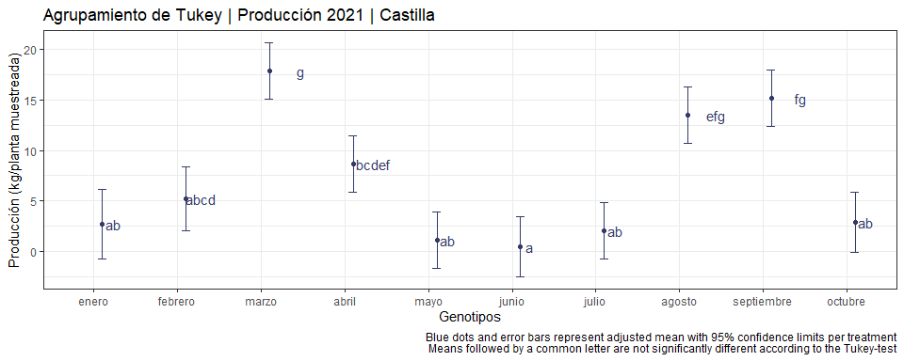

# plotting Results for Tto para mostrar  
ggplot() +  
 # #black dots representing the raw data  
 # geom_point(  
 # data = Mora_pn[Mora_pn$Year == "2020", ],  
 # aes(y = Produccion, x = reorder(Genotipo, Produccion))  
 # ) +  
 #red dots representing the adjusted means  
 geom_point(  
 data = mean_comparisons_mora_2021_I$emmeans %>% filter(Genotipo == "San Antonio"),  
 aes(y = emmean, x = Month),  
 color = "#333b69",  
 position = position_nudge(x = 0.1)  
 ) +  
 # red error bars representing the confidence limits of the adjusted means  
 geom_errorbar(  
 data = mean_comparisons_mora_2021_I$emmeans %>% filter(Genotipo == "San Antonio"),  
 aes(ymin = lower.CL, ymax = upper.CL, x = Month),  
 color = "#333b69",  
 width = 0.1,  
 position = position_nudge(x = 0.1)  
 ) +  
 # red letters   
 geom_text(  
 data = mean_comparisons_mora_2021_I$emmeans %>% filter(Genotipo == "San Antonio"),  
 aes(y = emmean, x = Month, label = .group),  
 color = "#333b69",  
 position = position_nudge(x = 0.32)  
 ) +   
 #ylim(0, NA) + # force y-axis to start at 0  
 ylab("Producción (kg/planta muestreada)") + # label y-axis  
 xlab("Genotipos") + # label x-axis  
 labs(title = "Agrupamiento de Tukey | Producción 2021 | San Antonio",caption = "Blue dots and error bars represent adjusted mean with 95% confidence limits per treatment  
 Means followed by a common letter are not significantly different according to the Tukey-test") +  
 theme_bw() # clearer plot format

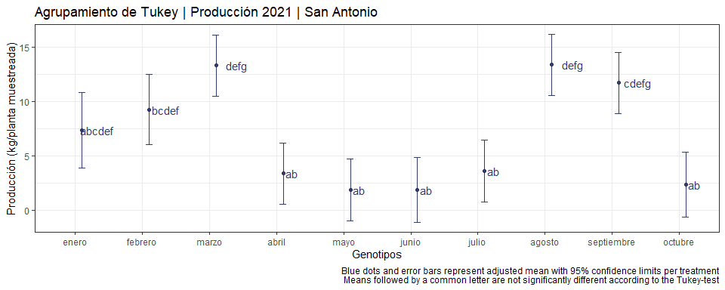

# plotting Results for Tto para mostrar  
ggplot() +  
 # #black dots representing the raw data  
 # geom_point(  
 # data = Mora_pn[Mora_pn$Year == "2020", ],  
 # aes(y = Produccion, x = reorder(Genotipo, Produccion))  
 # ) +  
 #red dots representing the adjusted means  
 geom_point(  
 data = mean_comparisons_mora_2021_I$emmeans %>% filter(Genotipo == "Brazos"),  
 aes(y = emmean, x = Month),  
 color = "#333b69",  
 position = position_nudge(x = 0.1)  
 ) +  
 # red error bars representing the confidence limits of the adjusted means  
 geom_errorbar(  
 data = mean_comparisons_mora_2021_I$emmeans %>% filter(Genotipo == "Brazos"),  
 aes(ymin = lower.CL, ymax = upper.CL, x = Month),  
 color = "#333b69",  
 width = 0.1,  
 position = position_nudge(x = 0.1)  
 ) +  
 # red letters   
 geom_text(  
 data = mean_comparisons_mora_2021_I$emmeans %>% filter(Genotipo == "Brazos"),  
 aes(y = emmean, x = Month, label = .group),  
 color = "#333b69",  
 position = position_nudge(x = 0.4)  
 ) +   
 #ylim(0, NA) + # force y-axis to start at 0  
 ylab("Producción (kg/planta muestreada)") + # label y-axis  
 xlab("Genotipos") + # label x-axis  
 labs(title = "Agrupamiento de Tukey | Producción 2021 | Brazos",caption = "Blue dots and error bars represent adjusted mean with 95% confidence limits per treatment  
 Means followed by a common letter are not significantly different according to the Tukey-test") +  
 theme_bw() # clearer plot format

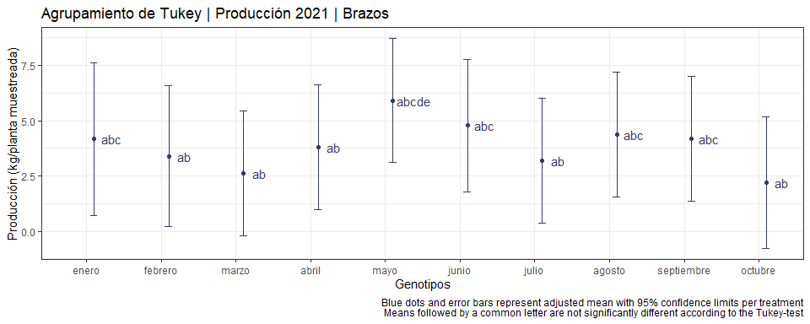

Se identificaron los costos mensuales desde octubre 2019 hasta octubre 2021. Se hizo un analisis del primer año ().

Llevar a cabo un analisis en funcion de las temperaturas e incidencias de enfermedades y plagas.

LLevar a cabo un analisis desde Junio 2020 hasta octubre 2021 (datos)

HAcer un analisis acumulado por la etapa productiva de los 3 cultivos.

Mora_clima <- read_excel("Data/DATOS CRUDOS MORA.xlsx",   
 sheet = "Clima", na = ".")  
  
Mora_clima$Month <-factor(Mora_clima$Month,   
 levels = c("enero", "febrero", "marzo", "abril", "mayo", "junio", "julio",  
 "agosto", "septiembre", "octubre", "noviembre", "diciembre"))  
  
Mora_clima %>%   
 ggplot() +  
 geom_point(aes(x = Dias, y = Temp_min), col = "red") +  
 geom_point(aes(x = Dias, y = Temp_max), col = "blue") +  
 geom_point(aes(x = Dias, y = Temp_amb), col = "black") +  
 labs(y = "Temperatura", x = "Dias") +  
 theme_bw() +  
 facet_wrap(~Macrotunel)

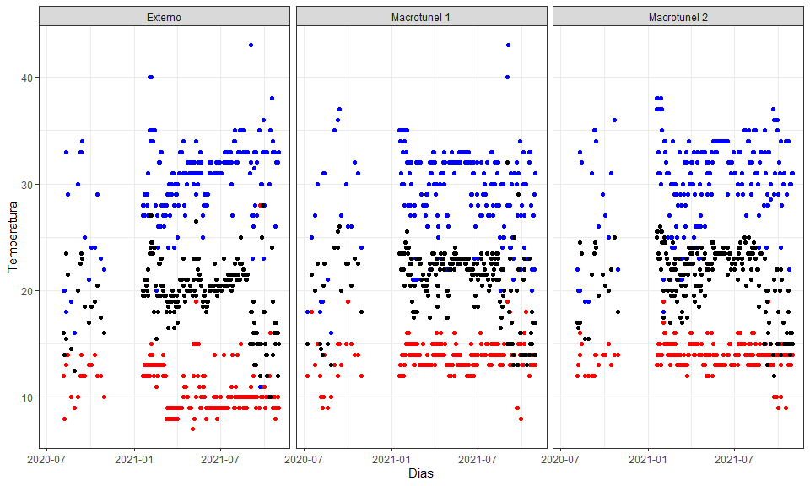

Mora_clima_mean <- Mora_clima %>% dplyr::group_by(Macrotunel, Month, Year) %>% dplyr::summarise(Temp_mínima = mean(Temp_min, na.rm = T),  
 Temp_máxima = mean(Temp_max, na.rm = T),  
 Temp_ambiental = mean(Temp_amb, na.rm = T))  
Mora_clima_mean <- Mora_clima_mean %>% pivot_longer(c(Temp_mínima, Temp_ambiental, Temp_máxima), names_to = "Rangos", values_to = "Temperaturas")

# año 2020  
Mora_clima_mean %>% dplyr::filter(Year == 2020) %>%   
 ggplot() +  
 geom_point(aes(x = Month, y = Temperaturas , col = Rangos, shape = Rangos)) +  
 geom_line(aes(group = Rangos, x = Month, y = Temperaturas, col = Rangos)) +  
   
 #geom_point(aes(x = Month, y = Temp_máxima), col = "blue") +  
 #geom_point(aes(x = Dias, y = Temp_amb), col = "black") +  
 labs(y = "Temperatura (ºC)", x = "Mes", title = "Variación de la temperatura año 2020") +  
 theme_bw() +  
 theme(axis.text.x = element_text(angle = 45, hjust = 1)) +  
 facet_wrap(~Macrotunel)

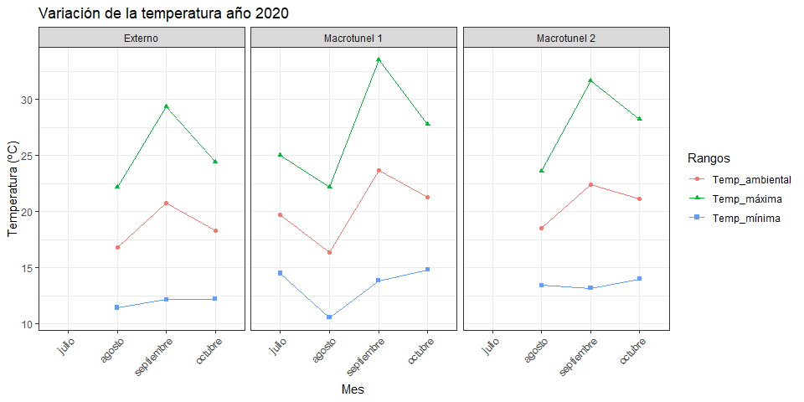 En noviembre y diciembre no hubo profesional técnico encargado del cultivo

# año 2021  
Mora_clima_mean %>% dplyr::filter(Year == 2021) %>%   
 ggplot() +  
 geom_point(aes(x = Month, y = Temperaturas , col = Rangos, shape = Rangos)) +  
 geom_line(aes(group = Rangos, x = Month, y = Temperaturas, col = Rangos)) +  
 labs(y = "Temperatura (ºC)", x = "Mes", title = "Variación de la temperatura año 2021") +  
 theme_bw() +  
 theme(axis.text.x = element_text(angle = 45, hjust = 1)) +  
 facet_wrap(~Macrotunel)

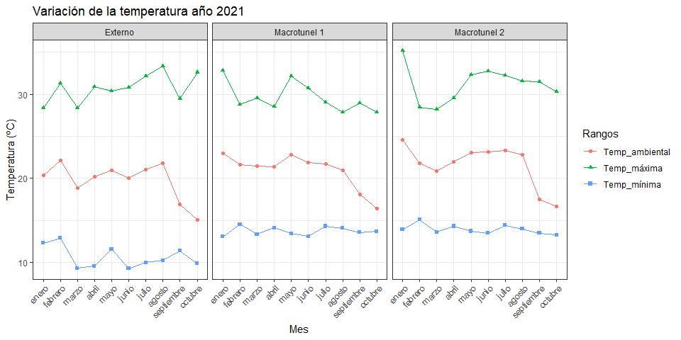

Mora_pn_cum %>% dplyr::filter(Year == 2021, Genotipo == "San Antonio") %>% ggplot(aes(x = Month)) +  
 geom_col(aes(y = acum, fill = Month), col = "black", show.legend = F) +  
 geom_point(data = Mora_clima_mean %>% dplyr::filter(Year == 2021, Rangos == "Temp_máxima", Macrotunel == "Macrotunel 1"), aes(y = Temperaturas*5), col = "black") +  
 geom_point(data = Mora_clima_mean %>% dplyr::filter(Year == 2021, Rangos == "Temp_mínima", Macrotunel == "Macrotunel 1"), aes(y = Temperaturas*5), col = "black") +  
  
 #geom_line(data = Mora_clima_mean, aes(group = Rangos)) +  
 scale_y_continuous(sec.axis = sec_axis(~./5, name = "Temperatura")) +  
 theme(axis.text.x = element_text(hjust = 1 , angle = 45)) +  
 theme_bw() +  
 labs(title = "Producción 2021 | San Atonio", y = "Producción total")

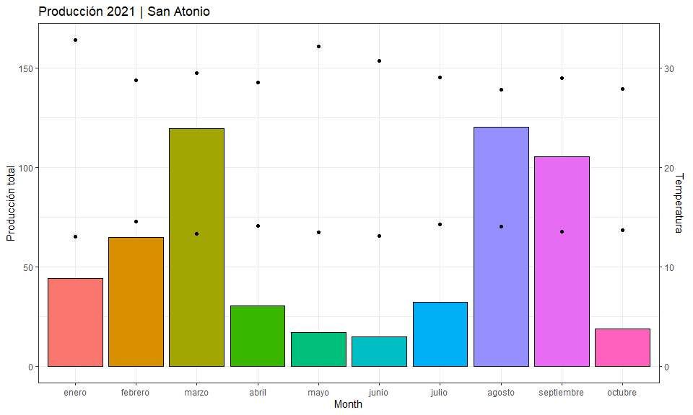

Mora_pn_cum %>% dplyr::filter(Year == 2021, Genotipo == "Brazos") %>% ggplot(aes(x = Month)) +  
 geom_col(aes(y = acum, fill = Month), col = "black", show.legend = F) +  
 geom_point(data = Mora_clima_mean %>% dplyr::filter(Year == 2021, Rangos == "Temp_máxima", Macrotunel == "Macrotunel 2"), aes(y = Temperaturas*3), col = "black") +  
 geom_point(data = Mora_clima_mean %>% dplyr::filter(Year == 2021, Rangos == "Temp_mínima", Macrotunel == "Macrotunel 2"), aes(y = Temperaturas*3), col = "black") +  
  
 #geom_line(data = Mora_clima_mean, aes(group = Rangos)) +  
 scale_y_continuous(sec.axis = sec_axis(~./3, name = "Temperatura")) +  
 theme(axis.text.x = element_text(hjust = 1 , angle = 45)) +  
 theme_bw() +  
 labs(title = "Producción 2021 | Brazos", y = "Producción total")

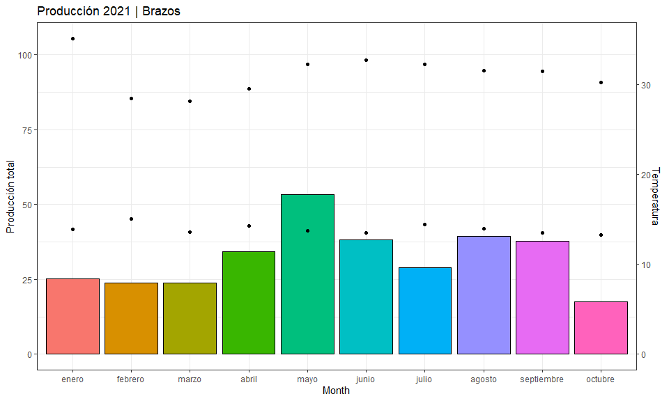

Mora_pn_cum %>% dplyr::filter(Year == 2021, Genotipo == "Castilla") %>% ggplot(aes(x = Month)) +  
 geom_col(aes(y = acum, fill = Month), col = "black", show.legend = F) +  
 geom_point(data = Mora_clima_mean %>% dplyr::filter(Year == 2021, Rangos == "Temp_máxima", Macrotunel == "Macrotunel 2"), aes(y = Temperaturas*5), col = "black") +  
 geom_point(data = Mora_clima_mean %>% dplyr::filter(Year == 2021, Rangos == "Temp_mínima", Macrotunel == "Macrotunel 2"), aes(y = Temperaturas*5), col = "black") +  
  
 #geom_line(data = Mora_clima_mean, aes(group = Rangos)) +  
 scale_y_continuous(sec.axis = sec_axis(~./5, name = "Temperatura")) +  
 theme(axis.text.x = element_text(hjust = 1 , angle = 45)) +  
 theme_bw() +  
 labs(title = "Producción 2021 | Castilla", y = "Producción total")

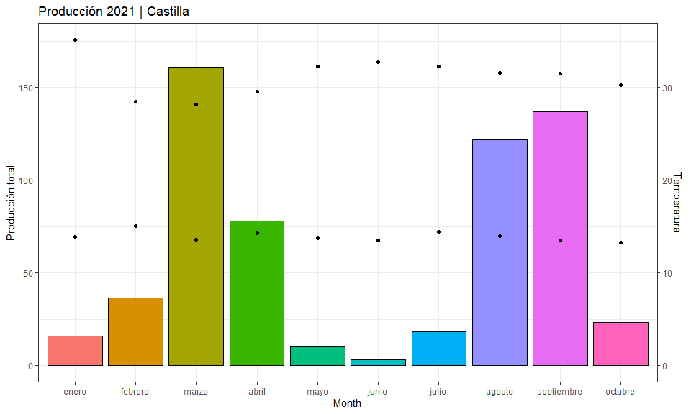

# Producción estandarizada

# base de datos de pn estandarizada  
  
Pn_standarizada <- read.csv("Data/pn_acum.csv", sep = ";", header = T, na.strings = ".")

# Castilla sin espinas

Pn_standarizada %>% dplyr::filter(Year == 2021, Genotipo == "Castilla") %>% ggplot(aes(x = Month)) +  
 geom_col(aes(y = Pn_estandarizada, fill = Month), col = "black", show.legend = F) +  
 geom_line(data = Mora_clima_mean %>% dplyr::filter(Year == 2021, Macrotunel == "Macrotunel 2", !Rangos == "Temp_ambiental"), aes(y = Temperaturas*5, group = Rangos, col = Rangos)) +  
 geom_point(data = Mora_clima_mean %>% dplyr::filter(Year == 2021, Macrotunel == "Macrotunel 2", !Rangos == "Temp_ambiental"), aes(y = Temperaturas*5, fill = Rangos), shape = 21, size = 3, show.legend = F) +  
 #geom_point(data = Mora_clima_mean %>% dplyr::filter(Year == 2021, Rangos == "Temp_mínima", Macrotunel == "Macrotunel 2"), aes(y = Temperaturas*5), col = "black") +  
  
 #geom_line(data = Mora_clima_mean, aes(group = Rangos)) +  
 scale_y_continuous(sec.axis = sec_axis(~./5, name = "Temperatura (ºC)")) +  
 theme(axis.text.x = element_text(hjust = 1 , angle = 45)) +  
 theme_bw() +  
 labs(title = "Producción estandarizada 2021 | Castilla", y = "Producción total (kg/53 plantas)")

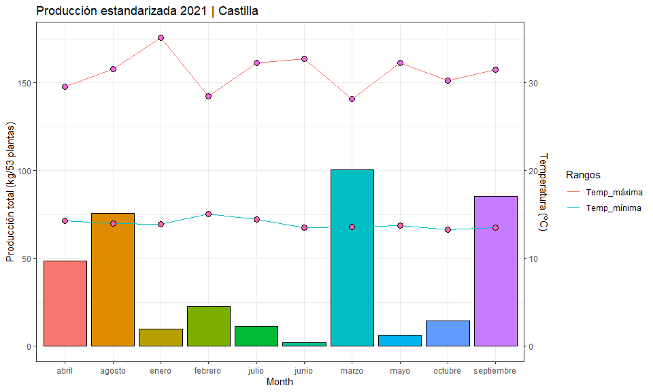

# Brazos

Pn_standarizada %>% dplyr::filter(Year == 2021, Genotipo == "Brazos") %>% ggplot(aes(x = Month)) +  
 geom_col(aes(y = Pn_estandarizada, fill = Month), col = "black", show.legend = F) +  
 geom_line(data = Mora_clima_mean %>% dplyr::filter(Year == 2021, Macrotunel == "Macrotunel 2", !Rangos == "Temp_ambiental"), aes(y = Temperaturas*5, group = Rangos, col = Rangos)) +  
 geom_point(data = Mora_clima_mean %>% dplyr::filter(Year == 2021, Macrotunel == "Macrotunel 2", !Rangos == "Temp_ambiental"), aes(y = Temperaturas*5, fill = Rangos), shape = 21, size = 3, show.legend = F) +  
 #geom_line(data = Mora_clima_mean, aes(group = Rangos)) +  
 scale_y_continuous(sec.axis = sec_axis(~./5, name = "Temperatura (ºC)")) +  
 theme(axis.text.x = element_text(hjust = 1 , angle = 45)) +  
 theme_bw() +  
 labs(title = "Producción estandarizada 2021 | Brazos", y = "Producción total (kg/53 plantas)")

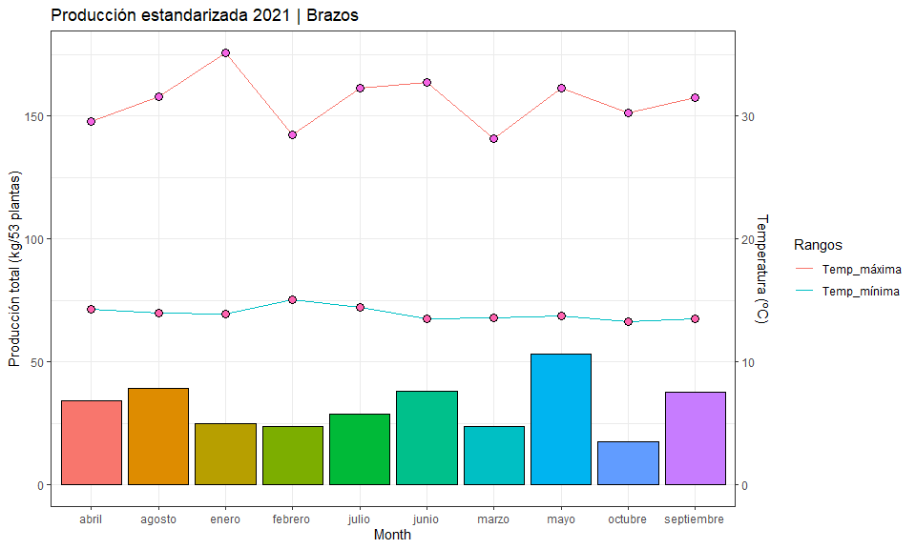

# San Antonio

Pn_standarizada %>% dplyr::filter(Year == 2021, Genotipo == "San Antonio") %>% ggplot(aes(x = Month)) +  
 geom_col(aes(y = Pn_estandarizada, fill = Month), col = "black", show.legend = F) +  
 geom_line(data = Mora_clima_mean %>% dplyr::filter(Year == 2021, Macrotunel == "Macrotunel 2", !Rangos == "Temp_ambiental"), aes(y = Temperaturas*5, group = Rangos, col = Rangos)) +  
 geom_point(data = Mora_clima_mean %>% dplyr::filter(Year == 2021, Macrotunel == "Macrotunel 2", !Rangos == "Temp_ambiental"), aes(y = Temperaturas*5, fill = Rangos), shape = 21, size = 3, show.legend = F) +  
 #geom_line(data = Mora_clima_mean, aes(group = Rangos)) +  
 scale_y_continuous(sec.axis = sec_axis(~./5, name = "Temperatura (ºC)")) +  
 theme(axis.text.x = element_text(hjust = 1 , angle = 45)) +  
 theme_bw() +  
 labs(title = "Producción estandarizada 2021 | San Antonio", y = "Producción total (kg/53 plantas)")

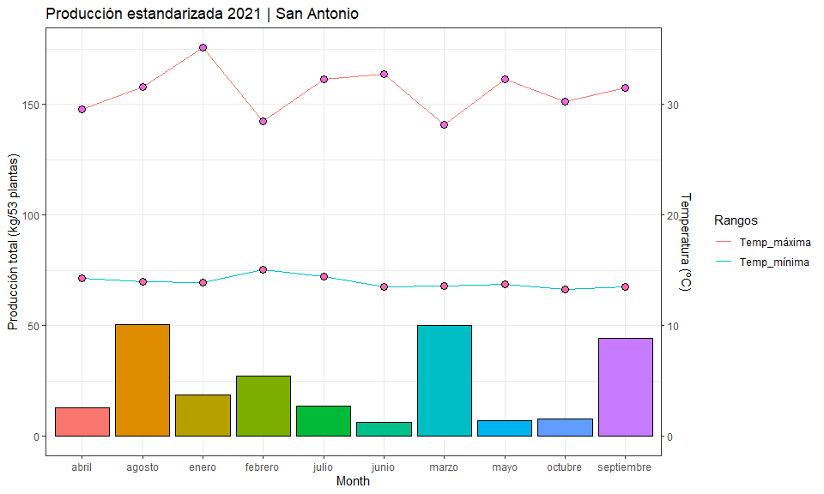

# Calidad_mora <- read_excel("Data/DATOS CRUDOS MORA.xlsx",   
# sheet = "Solidos")  
#   
# Calidad_mora <- Calidad_mora %>% dplyr::select(c(FECHA, MUESTRA, Genotipo, `BRIXº` ))