Demanda de tomate

Luis Fernando Delgado Muñoz

22/3/2022

# Carga de datos

|  |  |  |  |  |  |  |  |
| --- | --- | --- | --- | --- | --- | --- | --- |
| Semana | Lunes | Martes | Miercoles | Jueves | Viernes | Sabado | Domingo |
| 1 | 10.90 | 10.58 | 11.78 | 10.71 | 12.35 | 12.95 | 7.24 |
| 2 | 8.60 | 11.97 | 12.63 | 10.84 | 14.90 | 11.89 | 8.83 |
| 3 | 7.91 | 8.73 | 9.12 | 13.23 | 12.52 | 13.94 | 9.48 |
| 4 | 9.50 | 9.34 | 9.79 | 10.38 | 14.17 | 14.05 | 6.05 |
| 5 | 9.15 | 10.91 | 11.77 | 11.03 | 13.02 | 12.35 | 8.00 |
| 6 | 8.21 | 7.81 | 10.15 | 10.56 | 13.83 | 12.63 | 8.93 |
| 7 | 7.62 | 9.00 | 12.13 | 11.42 | 13.46 | 13.03 | 5.65 |
| 8 | 9.80 | 9.98 | 11.99 | 12.00 | 13.39 | 14.24 | 5.86 |
| 9 | 10.00 | 8.55 | 10.89 | 10.08 | 13.12 | 12.72 | 7.58 |
| 10 | 9.67 | 8.58 | 13.13 | 12.16 | 14.07 | 11.93 | 7.99 |
| 11 | 10.37 | 9.72 | 11.76 | 10.76 | 12.70 | 12.38 | 6.06 |
| 12 | 8.57 | 11.30 | 8.87 | 11.94 | 13.38 | 12.51 | 6.58 |
| 13 | 9.15 | 10.54 | 10.67 | 10.09 | 12.44 | 14.82 | 5.88 |
| 14 | 9.31 | 10.61 | 10.39 | 10.92 | 13.44 | 12.37 | 6.23 |
| 15 | 9.76 | 10.48 | 10.50 | 13.45 | 12.95 | 13.25 | 8.34 |
| 16 | 10.42 | 8.53 | 12.96 | 9.04 | 12.32 | 13.20 | 5.79 |
| 17 | 9.66 | 8.68 | 11.59 | 10.63 | 13.29 | 14.43 | 4.38 |
| 18 | 12.59 | 8.88 | 11.66 | 11.01 | 12.78 | 13.91 | 6.10 |
| 19 | 10.72 | 11.10 | 10.33 | 12.77 | 12.44 | 13.88 | 5.33 |
| 20 | 12.30 | 8.71 | 11.22 | 13.68 | 13.19 | 13.12 | 3.94 |
| 21 | 8.42 | 9.27 | 10.69 | 10.63 | 13.20 | 11.71 | 8.39 |
| 22 | 9.21 | 10.31 | 11.23 | 10.21 | 13.07 | 12.61 | 6.67 |
| 23 | 10.73 | 10.42 | 12.19 | 11.40 | 11.84 | 13.30 | 9.74 |
| 24 | 9.70 | 9.82 | 10.14 | 10.51 | 13.40 | 13.33 | 8.47 |
| 25 | 10.35 | 12.19 | 10.65 | 11.33 | 12.11 | 11.61 | 5.94 |
| 26 | 7.79 | 9.49 | 12.70 | 9.21 | 12.80 | 14.15 | 6.17 |
| 27 | 10.01 | 9.75 | 12.61 | 11.61 | 12.88 | 13.81 | 5.81 |
| 28 | 10.30 | 10.93 | 12.61 | 11.42 | 13.85 | 13.19 | 4.39 |
| 29 | 8.35 | 11.89 | 10.58 | 10.69 | 12.62 | 13.02 | 6.15 |
| 30 | 9.27 | 9.65 | 9.65 | 11.17 | 14.03 | 12.76 | 7.84 |

# Tidy data

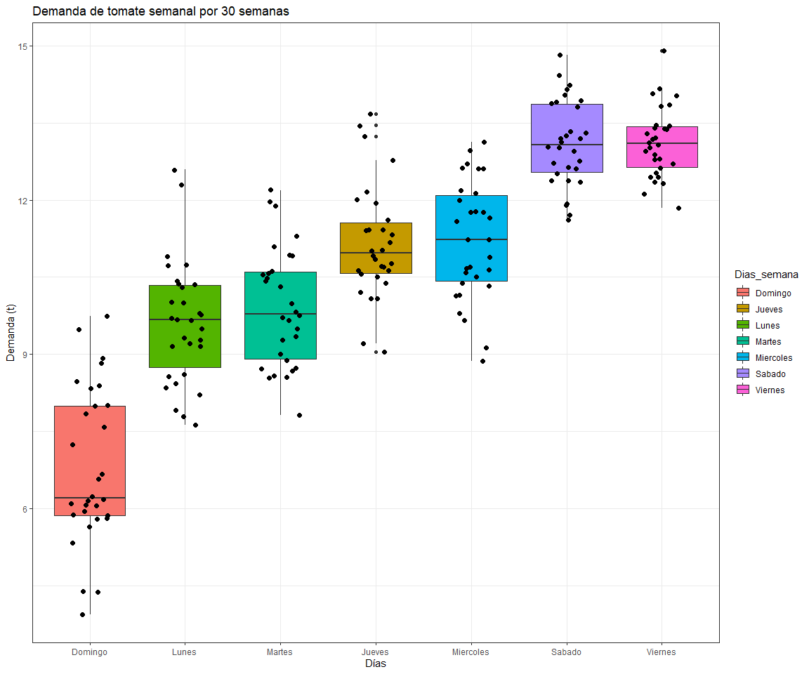

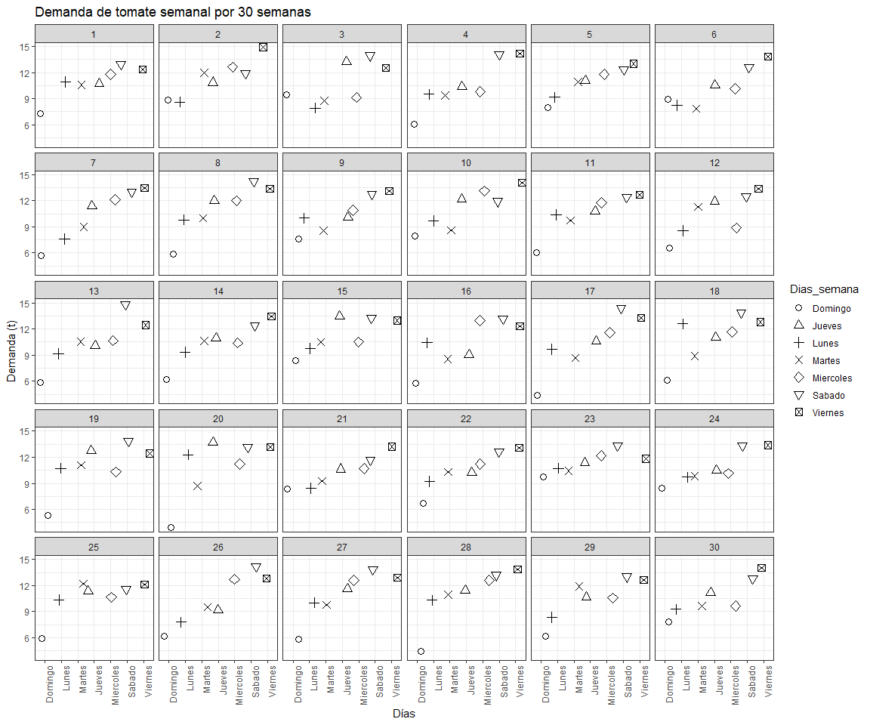

|  |  |  |
| --- | --- | --- |
| Semana | mean | sd |
| 1 | 10.93000 | 1.853249 |
| 2 | 11.38000 | 2.201651 |
| 3 | 10.70429 | 2.444742 |
| 4 | 10.46857 | 2.849886 |
| 5 | 10.89000 | 1.772127 |
| 6 | 10.30286 | 2.251849 |
| 7 | 10.33000 | 2.958896 |
| 8 | 11.03714 | 2.801194 |
| 9 | 10.42000 | 2.027124 |
| 10 | 11.07571 | 2.338717 |
| 11 | 10.53571 | 2.249429 |
| 12 | 10.45000 | 2.475843 |
| 13 | 10.51286 | 2.762558 |
| 14 | 10.46714 | 2.308771 |
| 15 | 11.24714 | 1.982151 |
| 16 | 10.32286 | 2.727555 |
| 17 | 10.38000 | 3.311737 |
| 18 | 10.99000 | 2.680299 |
| 19 | 10.93857 | 2.773706 |
| 20 | 10.88000 | 3.492807 |
| 21 | 10.33000 | 1.774646 |
| 22 | 10.47286 | 2.161710 |
| 23 | 11.37429 | 1.196381 |
| 24 | 10.76714 | 1.882921 |
| 25 | 10.59714 | 2.165708 |
| 26 | 10.33000 | 2.944696 |
| 27 | 10.92571 | 2.702923 |
| 28 | 10.95571 | 3.158596 |
| 29 | 10.47143 | 2.461662 |
| 30 | 10.62429 | 2.158038 |

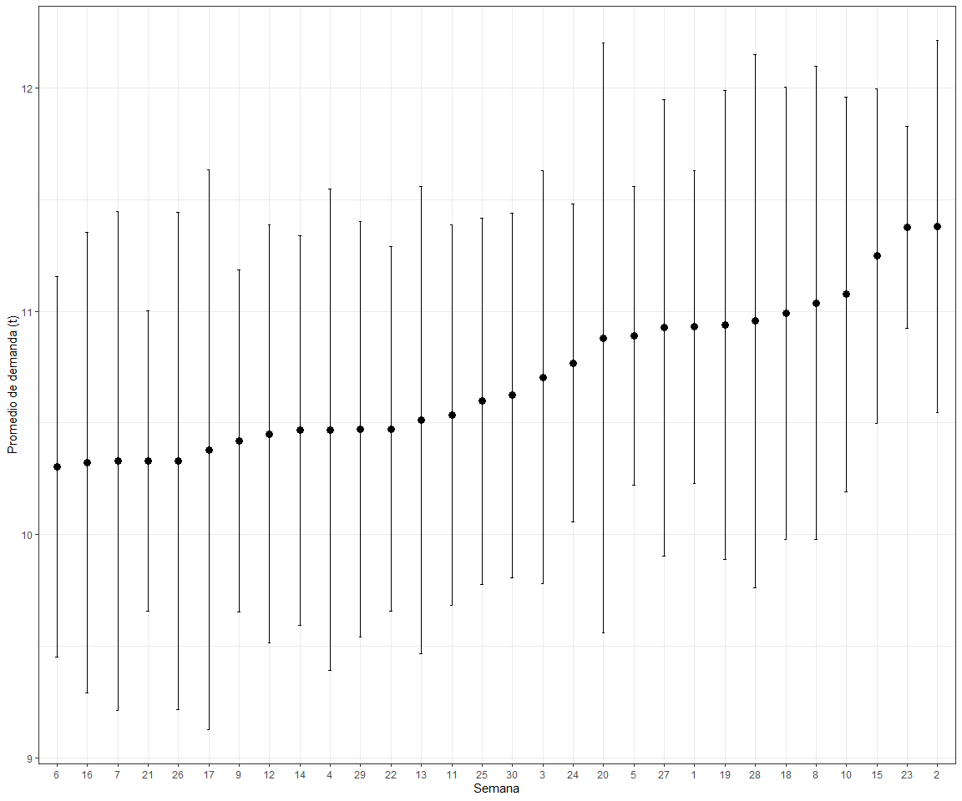

Cual fue la semana con mayor demanda y cual fue la semana con menor variación