**A step-by-step technique to model wave propagation in viscoelastic media**L. F. DaSilva1, W. J. Mansur2, and M. A. B. Botelho3

1 LAMEMO - Modeling and Computational Geophysics Laboratory/ UFRJ.

email: lfgeoﬁsica@gmail.com; tel:55 21 3938-7393, Cel: 55 21 980568704. <https://orcid.org/0000-0001-6097-7073>

2 LAMEMO - Modeling and Computational Geophysics Laboratory/ UFRJ.

[1]email: [webe@coc.ufrj.br](mailto:webe@coc.ufrj.br); tel:55 21 3938-7393.

<https://orcid.org/0000-0001-6033-9653>

3Geoscience Institute - CPGG-UFBA. email: mabarsottelli@gmail.com; tel: 55 71 32838598. <https://orcid.org/0000-0002-2705-4151>

Abstract

A technique for modeling wave propagation in viscoelastic media was developed. One way to describe and incorporate the attenuation of seismic waves is found in the theory of linear viscoelasticity. In this article, the Boltzmann superposition principle is used as a technique for modeling and inserting the attenuation of the medium in the wave propagation in viscoelastic media. This method directly applies the convolutional relationship between stress and strain in each step of the implemented algorithm. This article describes the implementation of the Direct Insertion Method - DIM and takes you to step by step on how to implement it. This method was compared to the usual memory variables and the results are obtained through synthetic seismograms and seismic traces, comparing DIM - Direct Insertion Method with that of the memory variables (MV - Memory Variables): the results are the same as those found in the existing theory. The effect of the seismic wave attenuation is of great importance for more realistic seismic modeling. Over time, theories were developed to implement mitigation in the time domain. We developed an implementation that directly uses the Boltzmann superposition principle. It is easier to implement and can be applied in several areas of scientific knowledge, where the phenomenon of attenuation is important. We researched the development of the viscoelastic modeling theory and then analyzed the modeling with memory variables and then tested the technique (DIM) of making seismic modeling using the viscoelastic models. This article shows that the results are satisfactory and are in line with the theory.

Luiz Fernando da Silva: Conception of the idea of ​​adding relaxation to the medium as a priori information, elaboration of the algorithm and test, writing, and revision of the manuscript.

Webe João Mansur: analysis and interpretation of the data;final approval of the version to be published.

Marco Antonio B. Botelho: assistance in writing and revising the manuscript.

**1. Introduction**

The theory and application of seismic modeling are very relevant to the process of seismic interpretation and also in the development of inversion algorithms. The characteristics of the real materials of the layers that form the planet Earth are of anisotropy and anelasticity in general. As an example of the exploration geophysics, we can mention the propagation of seismic waves in a hydrocarbon reservoir and the high seismic attenuation (quality factor Q with small value) caused by the presence of accumulation of pressurized free gas (Carcione J. M., 1990; Carcione et al. 2003; Dvorkin and Mavko 2006). It is known that the attenuation effects alter the amplitude and phase aspects of the recorded seismic wave. The quality factor Q is a parameter that measures how much the medium will attenuate the seismic wave. Its parameterization is based on rheological models and each of these presents unique aspects in the frequency domain (example: high pass, low pass) (Liu et al., 1976; Kjartansson, 1979; Blanch et al. 1995; Moczo and Kristek, 2005; Moczo et al., 2007; Vasheghani F. L. R. Lines, 2009; Carcione J. M., 2014). The scientific community for decades has been concerned with the problem of incorporating the phenomenon of attenuation in the time domain because all laboratory research showed a strong dependence in the frequency domain and the phenomenon of seismic wave propagation carries all frequency content. The path found was that of behavior in the time domain given by the stress-strain relationship described by the mathematical expression of the convolution (Riemann – Stieltjes integral, known as hereditary integral in the viscoelastic linear theory). The theory of memory variables removes the convolution integral calculation and adds an auxiliary differential equation (memory variables) that describes the viscoelastic behavior of the medium (Day and Minster, 1984; Emmerich and Korn, 1987; Carcione et al., 1988; Fabien et al. 2017; Kristek and Moczo, 2003). The viscoelastic module was approximated by rational function and its coefficients obtained by the method of Padé (Day and Minster, 1984); the use of generalized viscoelastic models - application of the GMB to obtain greater accuracy compared to the results of Padé's approach (Emmerich and Khorn, 1987); an approximation of the constant Q using a standard linear solid - GSLS and also the equivalence between GSLS and GMB (Liu et. al 1976; Carcione J. M., 1993; Moczo and Kristek, 2005; Guo and McMechan, 2017). To this day, more accurate modeling is researched and always guided by previous research and its attempts to model the effect of intrinsic attenuation. One example: wave propagation with a generalized Zener model and memory variables (Carcione et al., 1988; Zienkiewicz, O. C. and Taylor, R. L., 1989). In this example given above, the constitutive relationship is described through the relaxation spectrum of the medium and this results in a set of first-order differential equations that are solved and discretized by a numerical method (Carcione J. M., 1993; Robertsson et al. 1994; Zhu et al. 2013; Zhu T. 2015). Viscoelastic behavior has interrelated descriptions:

- Boltzmann's principle given by an integral equation often referred to as the integral representation of linear viscoelasticity;

- The differential representation that describes the behavior of models consisting of springs (Hookeanas) and a viscous part (Newtonian) by dampers (T. Alfrey and P. Doty, 1945; Christensen, RM, 1982);

-Laboratory tests whose mechanical tests of fluency, stress relaxation, and dynamic load are performed for mechanical characterization of the material.

The incident and scattered wavefield have an intrinsic attenuation (viscoelastic) due to internal friction during the passage of the elastic wave and part of that energy is converted into heat. It can be described through the resistivity and viscosities of the crystalline networks represented by models of atomic oscillators. Thus, the friction of the cracking movement and the fluid flow between the interstitial spaces of the grains also contribute to the attenuation phenomenon (O'Connell and Budiansky, 1977; Picotti et al. 2010 and 2012). Finally, laboratory tests to investigate the microscope mechanisms of this attenuation (Jackson 1993, 2007, 2010).

The article is organized as follows: first, we review the mechanics of continuous media and viscoelastic theory. The results of the approach (DIM) and its validation are presented.

**2. The Mechanics of Continous Media**

In the mechanics of continuous media, constitutive equations provide the relationships between stress and strain of the material. While the solid finds its deformations in the linear elastic regime, the constitutive equation receives the specific name of Hooke's Law. Where cijkl is a fourth-order tensor that characterizes the material, and δij is the delta of Kronecker, and λ and µ do not vary with the direction chosen for the axis Cartesian. Therefore the tensor cijkl depends on only two constants, λ, and µ, denominated Lame’s constants:

σij = cijklεkl cijkl = λδijδkl + µ(δikδjl + δilδjk); (1)

σxx = λθ +2µεxx;

σyy= λθ +2µεyy;

σzz = λθ +2µεzz. (2)

The shear modulus µ = G and λ are related to the Young modulus E and Poisson ratio ν by the expression:

µ =G= and λ = . (4)

where εkk = εxx + εyy + εzz = θ is the ﬁrst invariant of the strain tensor, which provides solid body volumetric variation.

θ =.

The bidimensional equation 2D (P-wave) of momentum conservation can be expressed as:

(5)

where ρ is the density, u displacement, and denote the stress components.

3. Viscoelastic Theory

The mechanical response of a material body, subjected to stresses variations, is non-instantaneous and depends on time and characterizes its viscoelastic behavior. (Carcione J. M., 2014). That means the response of the medium to stress is not indefinite and occurs with a delay due to the viscous behavior of the material: the material has memory. To formulate the viscoelastic behavior are used springs and dashpots as the components of viscoelasticity. Responses of these components to stress are given in equations 6 and 7 for elastic and viscous materials, respectively:

σij= cijklεkl (6) and

σij= ψijkl∗ (7), where ψijkl is relaxation-tensor.

In the Maxwell model, one spring and one dashpot are connected in series. In the Kelvin-Voigt model, one spring and one dashpot are connected in parallel and the Burger model and the sum of the two models and display more realistic responses regarding the medium.

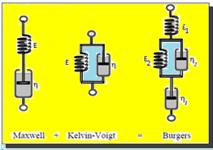

Figure 1: Maxwell, Kelvin-Voight and Burger Models

The mechanism of evanescent memory (memory variables: Day and Minster, 1984; Emmerich and Korn, 1987) can be described by the equations below, where stresses are related in time with the strains and vice versa.

σ(t) = ψ ∗ (8)

ε(t) = χ ∗

where ψ is the relaxation function and χ is the ﬂuency function.

From theory we can write:

σ(t) = M(t)∗ε(t) (10)

and in the frequency domain σ(w) = M(ω)ε(ω). Where = M(t) is the complex modulus and its Fourier transform is:3. 1 Memory Variable

Be ψ (t) = f(t)H(t) where H(t) is Heaviside step function

then σ(t) = ψ(t) ∗

σ(t) = ψ(t) ∗

Where e =and the e time derivative is

. (11)

This last equation results in the equations of memory variables of the viscoelastic models (Carcione et al., 1988). Each viscoelastic model has a specific M(t)/M(ω), which describes the model behavior in time/frequency, respectively. The usual modeling process goes toward the discretization of the convolution integral. The quality factor is defined:

Q(ω)= . (12)

3.2 The Boltzmann Superposition Principle

The Boltzmann superposition principle says that the effects of the mechanical history of linear materials are linearly additive. That is, a linear superposition of stresses leads to a corresponding linear superposition of deformations and vice versa. The mathematical formulation of this principle is the constitutive relationship between stress and strain given by a convolution integral and can be applied to any linear behavior of the material (8), (9) and (10). The equations below briefly describe what was said earlier. Let it be an arbitrary linear superposition of strains and stresses given by:

ε(t)= and and an arbitrary constant independent of time.

From the convolution relation given in (10) and the distributive property of the operator, we have:

(13)

It is seen that the response to the incremental load is independent of that due to other incremental loads. The individual sum of the responses, through a series of incremental loads, corresponds to the complete load history.

σ(t) = (14)

The differential equations Maxwell model has presented in appendix A **(**Cerjan et. al, 1985; Findley et al., 1989). The numerical method of the anelastic equation and the equation of motion are in appendix B (Levander, A. R., 1988).

4. Materials and Methods

We used the theory of the mechanics of continuous media and a numerical simulation algorithm with finite difference method -FDM to simulate the propagation of waves (Virieux, J. (1986). The Maxwell model (P wave) was used to test the implementation of the algorithm and the validation of the method to incorporate attenuation through viscoelastic models. The method was compared with that of the memory variables in a two-layer geological model. The results are compatible with the theory of memory variables. The method developed is as follows: First, we solve the differential equation for the adopted viscoelastic model to find we add this value in each time step of the algorithm of the motion equation (elastic case). In the case of memory variable theory, as described previously, its numerical implementation for the Maxwell model is in appendix B. The algorithm (DIM, Da Silva, L. F. (2013)): Calculates the stress with the addition of a priori information which is the time behavior and the data is recorded. We use differential equation discretized of the viscoelastic model (time information) plus the stress information in space (Hooke’s Law). The proposed method directly applies the Boltzmann superposition principle in the algorithm. All previous time information is added at each time step and thus follows the Boltzmann superposition principle. In this way, information is recorded in the space-time domain. The phenomenon of relaxation is intrinsically linked to attenuation, and it manifested in the results. The results presented confirm what was expected. The attenuation phenomenon can be incorporated using this methodology and it can be easier applied to any viscoelastic model that has the stress as a function of time (relaxation of the medium).

**5. Results**

The results are presented by seismic traces, time snapshots, and seismograms. The validation of the method used employed the same parameters of the medium and the acquisition geometry. The DIM validation results are compatible with the existing theory.

5.1 Preliminary results

As preliminary results we show some images generated by the algorithm used to test the Maxwell model, implemented through the theory of memory variables (Appendix B). This is a classic algorithm for the implementation of viscoelastic models in seismic modeling. To demonstrate the functionality of the modeling algorithm developed in this article, we present a snapshot and a seismogram. The two-layer geologic model was discretized using a square mesh with DX=5m and DZ = 5 m and Two- layers geologic model. As an example of a more complex viscoelastic model (Burger Model), we present a seismogram of an anticlinal trap: elastic and viscoelastic cases (Carcione J. M., 1993; DaSilva L. F., 2013). This result with the DIM application (figures 10 and 11).

**5.2 Methodology Validation**

The Maxwell model is used to validate the methodology described here. A two-layer geological model, 500m deep and 500 m wide, was discretized with grid spacing o 5m in both vertical and horizontal directions. The wave propagation velocity of the compressional wave are 3000m/s and 2300m/s for the upper and lower layers respectively. Young’s modulus, shear modulus, and Poisson coefficient are shown in figure 2. The shot position is at point (250m,230m) and geophones are placed along the line z=170m. The results for trace at x=250m and the seismogram shown in figure 3 to 5 show close results for DIM methodology and memory variables. The three cases analyzed considered frequency of 10 20 and 30 HZ, and a constant the Q factor equal to 10. In figure 6 an anticlinal trap geologic model is employed using the burger viscoelastic model. Results for the elastic case are also displayed so that one can see the representative change between simple elastic and viscoelastic analyses.

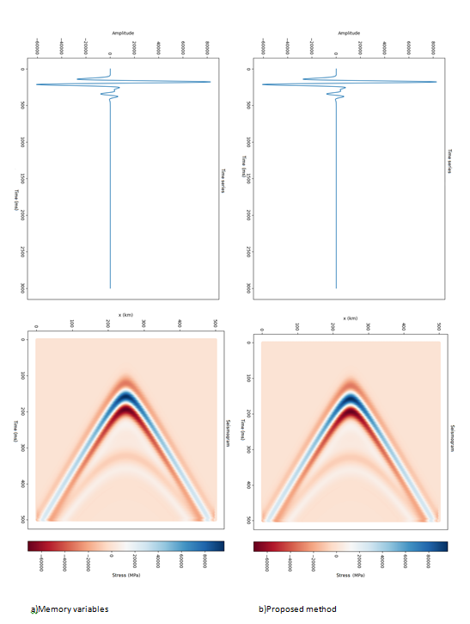

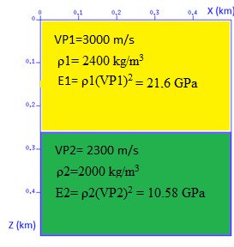

Figure 2: Sesimic Traces at x=250 m and Seismograms at the time t= 0.5 s, source frequency 10 Hz and quality factor Q=30. a) memory variables and b) DIM method.

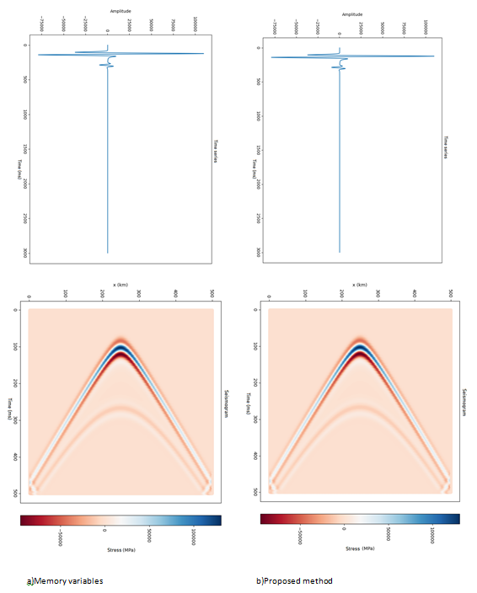

Figure 3: Seismic Traces at x=250 m and Seismograms at the time t= 0.5 s, source frequency 20 Hz and quality factor Q=30. a) memory variables and b) DIM method.

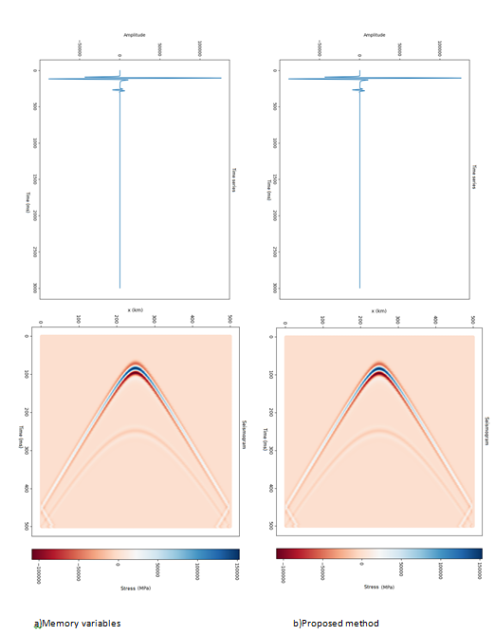

Figure 4: Seismic Traces in x=250 m and Seismograms at the time t= 0.5 s, source frequency 30 Hz and quality factor Q=10. a) memory variables and b) DIM method.

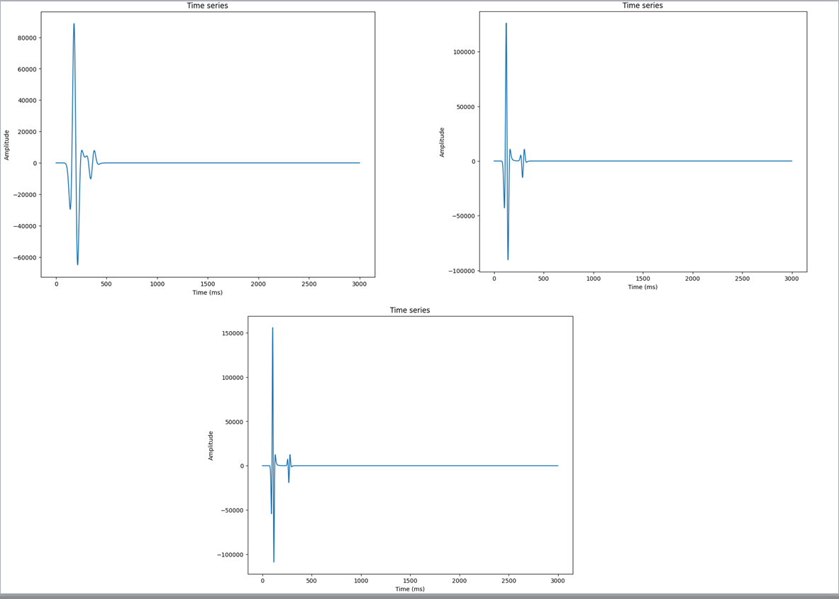

Figure 5: Seismic Traces in x=250 m (elastic case) at the time t= 0.5 s, source frequency 10, 20 and 30 Hz.

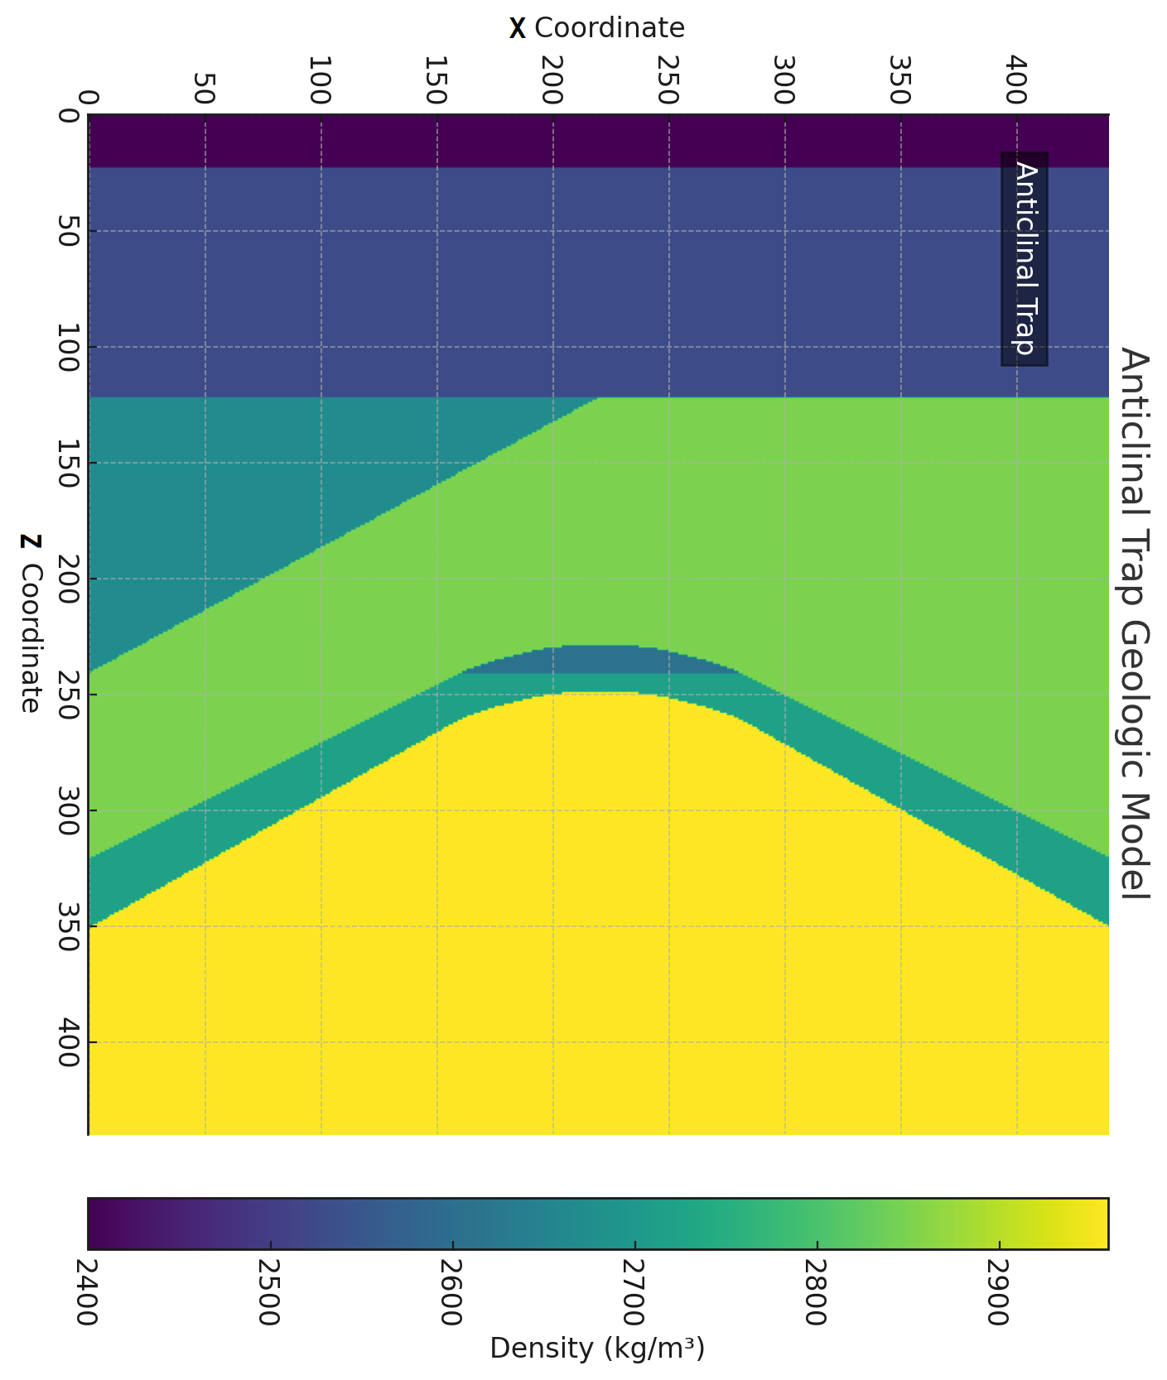

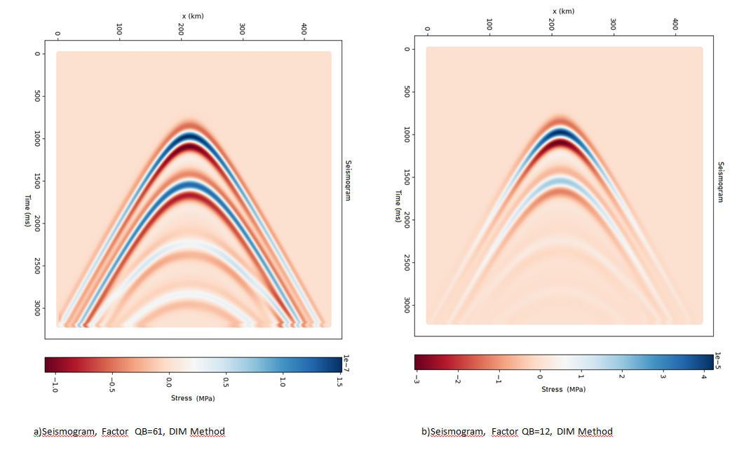

Figure 6 – Burger model with DIM method and anticlinal trap geologic model (P and S wave, source frequency 20 Hz, Seismograms at the time t= 3.2 s, Burger Model quality factor QB=61 and QB=12 ).

Acrescentando as Figuras , depois vou redigir um novo texto….Preciso incluir outras informações sobre a atenuação etc.......

Vou apresentar mais resultados com o DIM...1D, Zenner e Zenner Generalizado.....

Neste exemplo mostramos o método DIM aplicado numa modelagem 1D e Seus resultados etc......

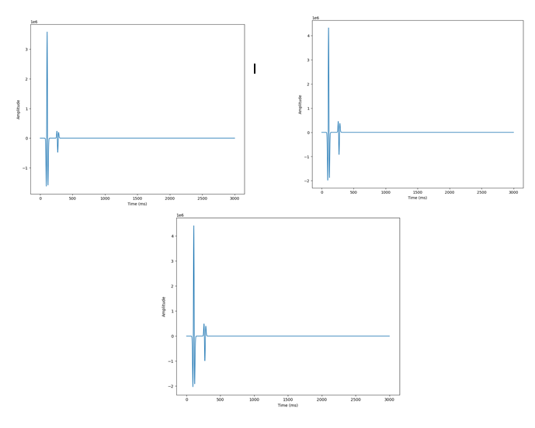Figura 7: Modelagem 1D, frequência de pico 30 Hz e Q=30, 300 e 3000 Respectivamente..

Agora acrescento as figuras de Zenner....Só pra dar uma olhada....Tenho que refazer o texto...acresentar mais informações e já fiz meu GITHUB e já me cadastrei no Zenodo para compartilhar os softwares? Fiz Zenner e Zenner Generalizado no Marmousi..... ..

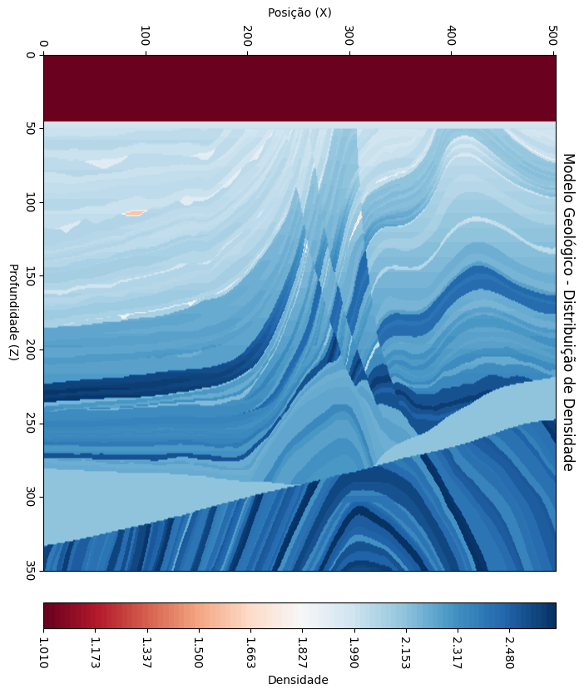

Figura 8: Modelo geologico Marmousi

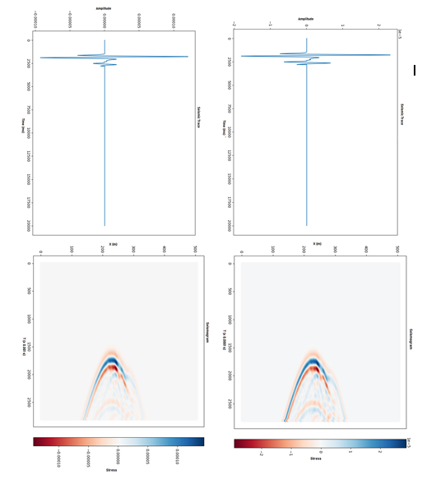

Figura 9 : DIM aplicado ao modelo de Zenner, Frequencia pico 30 Hz e Q=30 e 2000(elástico) respectivamente .

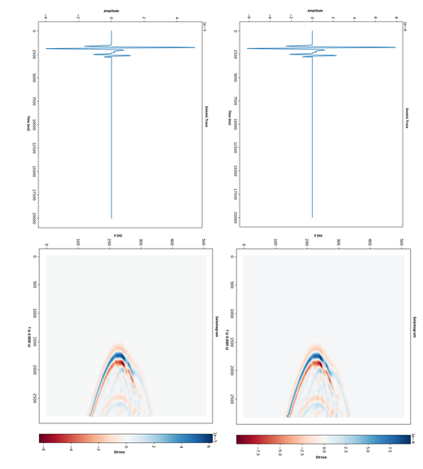

Figura 10 : DIM aplicado ao modelo generalizado de Zenner , Frequencia de Pico 30 HZ e Q=30 e Q=300 respetivamente.

6. Conclusions

The incorporation of the attenuation of the medium in the propagation of waves is one of the main objectives of seismic and seismology. The method (DIM) is robust and its results show that it can be applied in many areas of knowledge where intrinsic attenuation is an important phenomenon. The method is easily implemented in complex viscoelastic models, such as the Burger model and can be applied to complex geological models with anisotropy. Its results are the same as those obtained by the existing theory of memory variables. The method presents itself as a powerful tool in seismology and seismic oil prospecting. The attenuation phenomena are easily controlled by the algorithm and this is of great interest to the scientific community. Another viscoelastic model will be implemented and the application in seismic inversion.

Acknowledgements

All the work was supported and partly financed by the Coordination for the Improvement of Higher Education Personnel - Brazil (CAPES) - Financial Code 001, CNPq (306.933 / 2014-4, 423.794 / 2016-7), Faperj: (E- 26 / 203.021 / 2017, E-26 / 010.001818 / 2015; E-26 / 010.101236 / 2018 and Petrobras (CENPES - 21066), LAMEMO-UFRJ, UFBA.

Computer Code Availability

In this article, the execution of the programs in FORTRAN language used the open-source software GNU (GNU General Public License) Fortran (Ubuntu 5.4.0-6ubuntu1 ~ 16.04.11) 5.4.0 20160609 Copyright (C) 2015 Free Software Foundation, Inc. Additional information about the codes and how to execute them are described below:

**Name of codes:** MaxwellDIMSoftware (94.24 kB) and MaxwellMemoryVariableSoftware (94.83 kB)

Developer: Luiz Fernando da Silva

Year first available: 2013

Contact address: Tel: +55 21 980568704 , e-mail: [lfgeofisica@gmail.com](mailto:lfgeofisica@gmail.com)

Software required: *Linux: Ubuntu*

program language: FORTRAN

Hardware required:

Processor (CPU): Intel Core i5 (sixth generation or newer) or equivalent;

Memory: 8 GB RAM; Storage: 500 GB internal storage drive;

Monitor/Display: 14" LCD monitor, resolution of 1600 x 900 or better;

Network Adapter: 802.11ac 2.4/5 GHz wireless adapter;

Other: Internal or external Webcam, lock, carrying case, external hard drive for backups

The data contained in the article and corroborate the conclusions of this study and its respective codes are available openly in the [figshare repository] at <https://figshare.com/articles/Appendix_AeB_pdf/11763192>

and <https://figshare.com/articles/MaxwellMemoryVariableandDIMSoftware/12124113>.

**References**

Blanch, J. O., J. O. A. Robertsson, and W. W. Symes, 1995, Modeling of a constant Q: Methodology and algorithm for an efficient and optimally inexpensive viscoelastic technique: Geophysics, 60, 176–184, doi: 10 .1190/1.1443744.

Carcione, J. M., D. Kosloff, and R. Kosloff, 1988, Viscoacoustic wave propagation simulation in the earth, 53, 769-777, Geophysics, doi:10.1190/1.1442512.

Carcione, J. M., D. Kosloff, and R. Kosloff, 1988, Wave propagation simulation in a linear viscoacoustic medium, Geophysical Journal International, 93, 393–401, doi: 10.1111/j.1365-246X.1988.tb02010.x.

Carcione, J. M., D. Kosloff, and R. Kosloff, 1988, Wave propagation simulation in a linear viscoelastic medium, Geophysical Journal International, 95, 597-611, doi:10.1111/j.1365-246X.1988.tb06706.x.

Carcione, J. M., 1990, Wave propagation in anisotropic linear viscoelastic media: theory and simulated wavefields, Geophysical Journal International, 101, 739-750, doi: 10.1111/j.1365-246X.1990.tb05580.x.

Carcione, J. M., 1993, Seismic modeling in viscoelastic media, Geophysics, 58, 110-120, doi:10.1190/1.1443340.

Carcione, J. M., K. Helbig, and H. B. Helle, 2003, Effects of pressure and saturating fluid on wave velocity and attenuation of anisotropic rocks, International Journal of Rock Mechanics and Mining Sciences, 40, no. 3, 389–403. doi:10.1016/S1365-1609(03)00016-9.

Carcione, J. M., 2014, Wavefields in real media, wave propagation in anisotropic, anelastic, porous and electromagnetic media: Elsevier Science.

Cerjan, C., D. Kosloff, R. Kosloff, and M. Reshef, 1985, A nonreflecting boundary condition for discrete acoustic and elastic wave equations: Geophysics, 50, 705-708. [doi:10.1190/1.1441945](https://doi.org/10.1190/1.1441945).

Christensen, R. M., 1982, Theory of viscoelasticity — An introduction: Academic Press, Inc.

DaSilva, L. F. (2013). Modelagem da Propagação de Ondas Sísmicas em Meios Viscoelásticos Descritos pelo Modelo de Burger (Tese de Doutorado, Salvador, Bahia - Brasil: Universidade Federal da Bahia). Acessível em : <http://www.pggeofisica.ufba.br/publicacoes/detalhe/300>.

Day, S. M., and J. B. Minster, 1984, Numerical simulation of attenuated wavefields using a Pade approximant method: Geophysical Journal of the Royal Astronomical Society, 78, 105–118, doi: 10.1111/j.1365- 246X.1984.tb06474.x.

Dvorkin, J. P., and G. Mavko, 2006, Modeling attenuation in reservoir and nonreservior rock, The Leading Edge, 25, 194–197. doi: 10.1190/1.2172312.

Emmerich, H., and M. Korn, 1987, Incorporation of attenuation into time‐ domain computations of seismic wave fields: Geophysics, 52, 1252– 1264, doi: 10.1190/1.1442386.

Fabien-Ouellet G., Erwan Gloaguen, Bernard Giroux, 2017, [Time-domain seismic modeling in *viscoelastic* media for full-waveform inversion on heterogeneous computing platforms with OpenCL](https://www.sciencedirect.com/science/article/pii/S0098300416307816), [Computers & Geosciences](https://www.sciencedirect.com/science/journal/00983004), 100, 142-155.

Findley, W.N., Lai, J. S., Onaran, K. (1989) Creep and Relaxation of Nonlinear Viscoelastic Materials with an Introduction to Linear Viscoelasticity. New York. Dover.

Guo, P., and G. A. McMechan, 2017, Evaluation of three first-order isotropic viscoelastic formulations based on the generalized standard linear solid: Journal of Seismic Exploration, Volume 26, Number 3, doi:10.1190/GEO2017-0235.1.

Jackson, I., 1993. Progress in the experimental study of seismic attenuation. Ann. Rev. Earth Planet Sci. 21: 375-406.

Jackson, I., 2007. Properties of rocks and minerals physical origin of anelasticity and attenuation in rocks. In: Schubert, G. (Ed.), Treatise on Geophysics, 2, Elsevier, 493-525.

Jackson I and Faul UH, 2010. Grainsize-sensitive viscoelastic relaxation in olivine: Towards a robust laboratory-based model for seismological application. Physics of the Earth and Planetary Interiors 183: 151–163. doi:10.1016/j. pepi.2010.09.005.

Kjartansson, E., 1979, Constant-Q wave propagation and attenuation, Journal of Geophysical Research, 84, B9, 4737-4748, doi: 10.1020/JB084iB09p04737.

Kristek, J., and P. Moczo, 2003, Seismic-wave propagation in viscoelastic media with material discontinuities, A 3D fourth-order staggered-grid finite-difference modeling: Bulletin of the Seismological Society of America, 93, 2273-2280, doi: 10.1785/0120030023.

Levander, A. R., 1988, Fourth-order finite-difference P-SV seismograms : Geophysics, 53, 1425–1436, doi:10.1190/1.1442422.

Liu, H.-P., D. L. Anderson, and H. Kanamori, 1976, Velocity dispersion due to anelasticity; implications for seismology and mantle composition,Geophysical Journal International, 47, 41–58, doi: 10.1111/j.1365-246X.1976.tb01261.x.

Moczo, P.,and J. Kristek, 2005, On the rheological models used for time-domain methods of seismic wave propagation, Geophysical Research Letters, 32, L01306,

doi:10.1029/2004GL021598.

Moczo, P., J. Kristek, M. Galis, P. Pazak, and M. Balazovjech, 2007, The finite-difference and finite-element modeling of seismic wave propagation and earthquake motion : Acta Phys. Slovaca, 57(2), 177–406.

O’Connell, R. J., and Budiansky, B., 1977, Viscoelastic properties of fluid-saturated cracked solids: J. Geophys. Res., 82, 5719-5736. doi: 10.1029/JB082i036p05719.

Picotti S., José M. Carcione, J. Germán Rubino, Juan E. Santos, Fabio Cavallini, 2010

1. [A viscoelastic representation of wave attenuation in porous media](https://www.sciencedirect.com/science/article/pii/S0098300409002647), [Computers & Geosciences](https://www.sciencedirect.com/science/journal/00983004), 36, 44-53.

Picotti S., José M. Carcione, Juan E. Santos, 2012, [Oscillatory numerical experiments in finely layered anisotropic viscoelastic media](https://www.sciencedirect.com/science/article/pii/S0098300412000829), [Computers & Geosciences](https://www.sciencedirect.com/science/journal/00983004), 43, 83-89.

Robertsson, J. O. A., J. O. Blanch, and W. W. Symes, 1994, Viscoelastic Finite-difference modeling, Geophysics, 59, 1444–1456, doi: 10.1190/1.1443701.

T. Alfrey, P. Doty, 1945, The Methods of Specifying the Properties of Viscoelastic Materials, Journal of Applied Physics, 16, 700, doi:10.1063/1.1707524.

Vasheghani F., and L. R. Lines, 2009, Viscosity and Q in heavy-oil reservoir characterization: The Leading Edge, 28, 856-860.

Virieux, J., 1986, P-SV wave propagation in heterogeneous media: velocity-stress finite-difference method: Geophysics, 51, 889–901, doi:10.1190/1.1442147**.**

Zienkiewicz, O. C. Taylor, R. L. (1989) The Finite Element Method. 4 th. ed. London, McGraw-Hill.

Zhu, T., J. M. Carcione, and J. M. Harris, 2013, Approximating constant-Q seismic propagation in the time domain, Geophysical Prospecting, 61, no. 5, 931–940, doi:10.1111/1365-2478.12044.

Zhu, T., 2015, Viscoelastic time-reversal imaging: Geophysics, 80, no. 2, A45–A50, doi:10.1190/geo2014-0327.1.

1. Luiz Fernando da Silva: Conception of the idea of ​​adding relaxation to the medium as a priori information, elaboration of the algorithm and test, writing and revision of the manuscript.

   Webe João Mansur: analysis and interpretation of the data;final approval of the version to be published.

   Marco Antonio B. Botelho: assistance in writing and revising the manuscript.