Lot 2
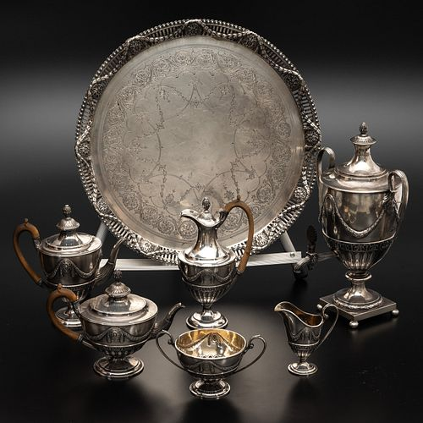 | Reserve price:  Estimation:
Lot 3
Reserve price:
Estimation:
Lot 4
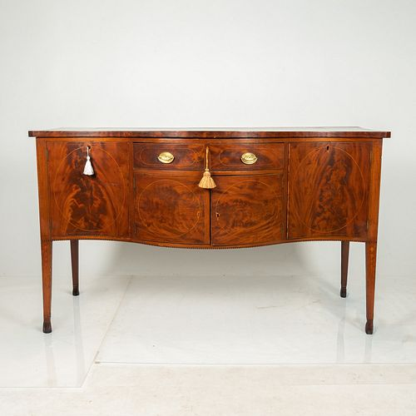 | Reserve price:  Estimation:
Lot 5
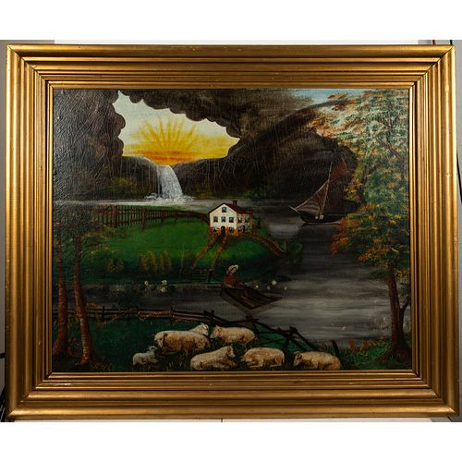 | Reserve price:  Estimation:
Lot 6
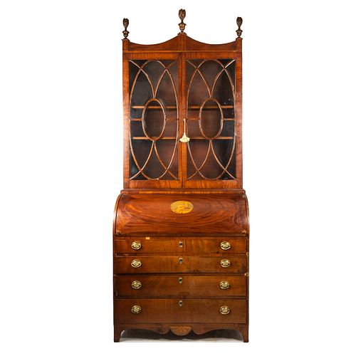 | Reserve price:  Estimation:
Lot 7
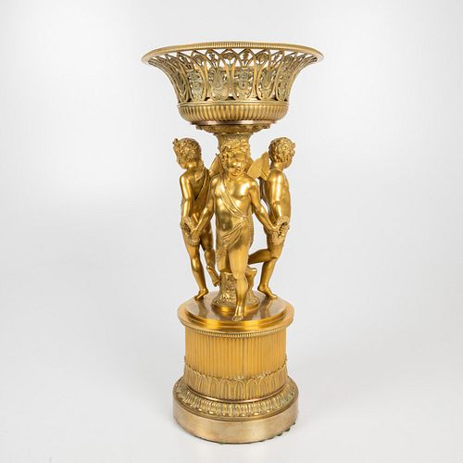 | Reserve price:  Estimation:
Lot 8
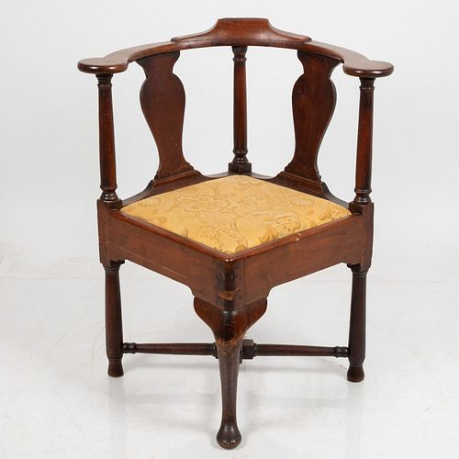 | Reserve price:  Estimation:
Lot 9
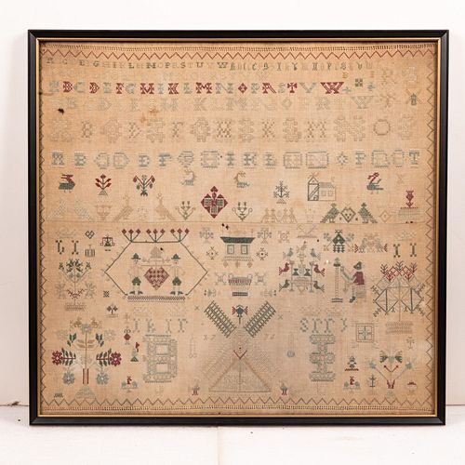 | Reserve price:  Estimation:
Lot 10
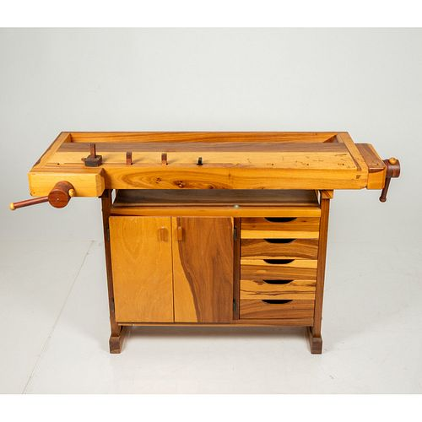 | Reserve price:  Estimation:
Lot 11
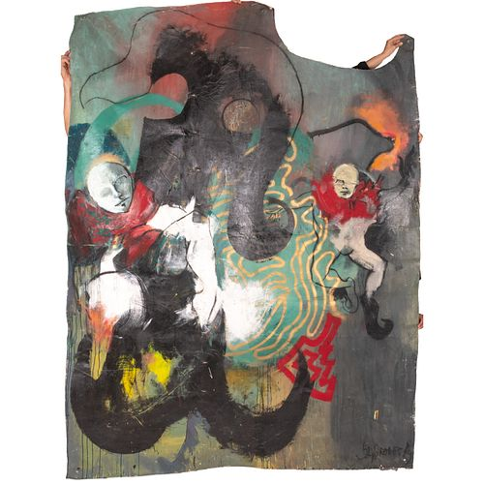 | Reserve price:  Estimation:
Lot 12
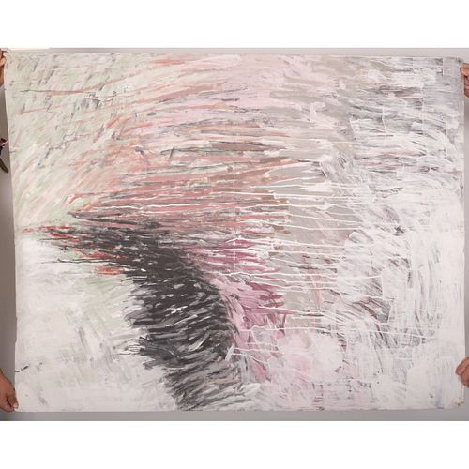 | Reserve price:  Estimation:
Lot 13
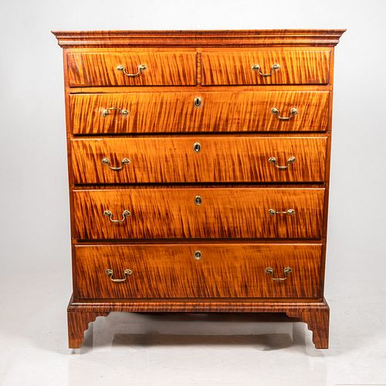 | Reserve price:  Estimation:
Lot 14
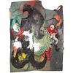 | Reserve price:  Estimation:
Lot 15
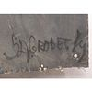 | Reserve price:  Estimation:
Lot 16
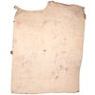 | Reserve price:  Estimation:
Lot 17
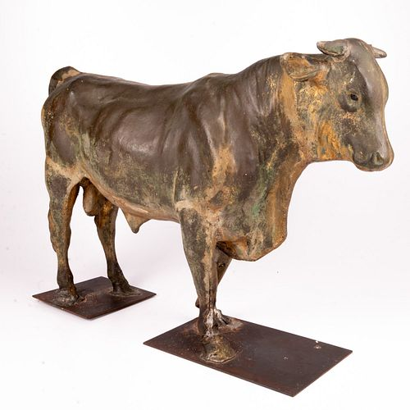 | Reserve price:  Estimation:

