# Milestone 2 - Test Plan

Team 10 - Soulless

### **Instructions to Start the Game:**

1. In the project folder, run:
   * cmake .
   * make
2. After building, run ./soulless
3. Ensure that your machine's audio is on.

### **Game Mechanics and Controls:**

#### Player Movement:

* **Movement Keys**: Player can move in 8 directions (N, S, E, W, NW, NE, SW, SE) using W, A, S, D.
  + Holding two keys, such as WA, moves diagonally (e.g., NW).
  + Movement is independent of mouse position.

#### Shooting Mechanics:

* **Mouse Direction**: Shooting direction is based on mouse position, allowing for 8 directions.
* **Shooting Action**: Left-click to shoot; cooldown prevents rapid firing.
* **Projectile**: See Spell Mechanics below.
* **Enemy Interaction**: Damaging spells reduce enemy health on impact; enemies disappear only when their health reaches 0.
* **Audio Cue**: Ensure sound effects for fireball, lightning, water, and enemy hits trigger at appropriate times.

#### Health Mechanics and Invincibility:

* **Damage and Cooldowns**: Player takes damage upon contact with enemies or their projectiles, indicated by an impact sound.
  + **Damage Lock**: Player is invincible for a short time after taking damage.
  + **Visual Indicator**: Player flashes red when damaged, and then becomes slightly transparent to indicate the damage lock.
* **Health Bar**: Health bar is shown above player and corresponds to their current health
* **Health Recovery**:
  + Player: Regain 10 HP by walking over a campfire (if health is not full)
  + Farmer (enemy type): When in fleeing mode they will regenerate health until it reaches 30HP.
* **Enemy Health Display**: Enemy health percentage is displayed above each enemy.

#### Additional Controls:

* **FPS Toggle**: Press Shift + F to toggle FPS display in the top-right corner.
* **Game Over Shortcut**: Press "J" to force game over.
* **Debug Mode:** Press “K” to enter debug mode, visualizing bounding boxes and collisions
* **Tutorial mode**: Explained later in the document

#### Spell Mechanics:

* **Spell Types**:
  + **Fire Barrier**: Shoots in a straight line, damaging the first enemy hit and nearby enemies within its hitbox.
  + **Lightning Barrier**: Hits a large area from above, damaging multiple enemies. (large radius).
  + **Water Barrier**: Blocks the next enemy projectile or lasts 1 second.
  + **AOE Spells**: Both fire and lightning can damage multiple enemies within their range.
* **Spell Queue**: Spell queue holds up to 8 spells, adding a random spell when one is used
  + **Spell Display**: Current spell shown at the bottom of the screen.

#### Camera and Visuals:

* **Fixed Camera**: Camera follows the player as they move, stops at world boundaries.
* **Collision Visualization**: In debug mode, collision boxes are shown for entities with motion.
  + **Mesh Collisions**: Player collides with entities only when the bounding box collides with the player’s mesh.
  + **Map Boundaries**: Ensure the player remains within map boundaries.

#### Animation:

* **Player Animations**: Includes idle, walking and spell-casting animations. Animations align with the 8 directions in the game.
* **Spell Animations:** Water and lightning spells are animated during their cast
* **Other Animations:** Campfire burning

### **Game Start, Tutorial, and Pausing:**

* **Tutorial Screen**: Game begins with a tutorial showing controls. Press space or mouse click to exit the tutorial or pause screen.
  + **Pause / Resume**: Press shift + T to pause or open the tutorial during gameplay. Game loop should also pause/resume.

### **Enemy Behaviour:**

* **Enemy Spawning**:
  + **Farmers**: Spawn from the start.
  + **Archers**: Spawn after 1 minute.
  + **Knights**: Spawn after 2 minutes.
* **Enemy AI**:
  + **Low Health Retreat**: Only villagers/farmers retreat when health is ≤ 30%, with a slower speed as they are wounded until their health reaches 30% or just above it.
  + **Move closer to enemy**: If the player is outside of their range they will move closer to the player.
  + **Attack and Range**: Enemies approach and attack if within range. Ranged enemies stop upon reaching their attack range and will not move closer to the player.

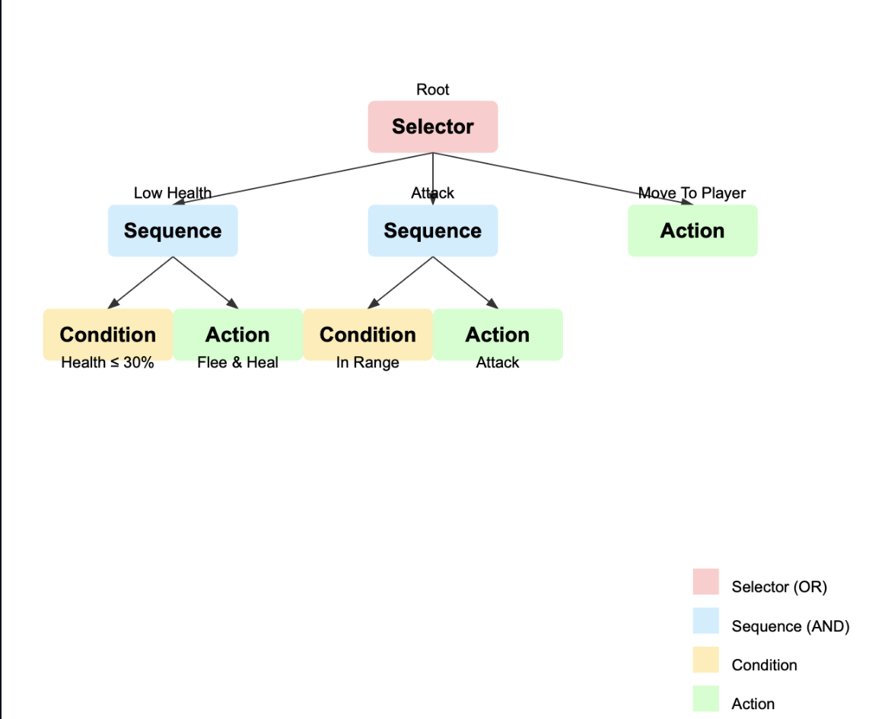

### **Death and Loss Condition:**

* **Player Death**:
  + **Background Music Change**: Changes upon death and reverts after the reset.
  + **Rotation**: Player rotates 180 degrees on death.
  + **Disable Input**: Player cannot move, cast spells, or take damage after death.
  + **Defeat Announcement**: Mage announces defeat with a unique audio cue.
  + **Game Reset**: After ~6 seconds, game resets with the player in the center, and all enemies and projectiles removed.

### **Audio Testing:**

#### Background Music:

* **Start**: Background music plays at the beginning.
* **Death**: Music changes on player death and resets after respawn.

#### Sound Effects:

Verify sound effects for:

* Fireball, Lightning, Water spells
* Enemy hit
* Player damage
* Player death announcement

### **Debug and Testing:**

#### Debug Controls:

* **Visualise Collisions**: "K" to show debug collision boxes.
* **Force Game Over**: "J" to immediately trigger game over.