## Organization and legal structures of business entities

- many determinants on a company: stakeholders, society, state, legal restrictions, climate, etc.

- Sizes:

* Medium (Staff < 250; turnover <= 250 M€; total <= 43 M€)
* Small (<50; <= 10; <= 10)
* Micro (<10; <= 2; <= 2)

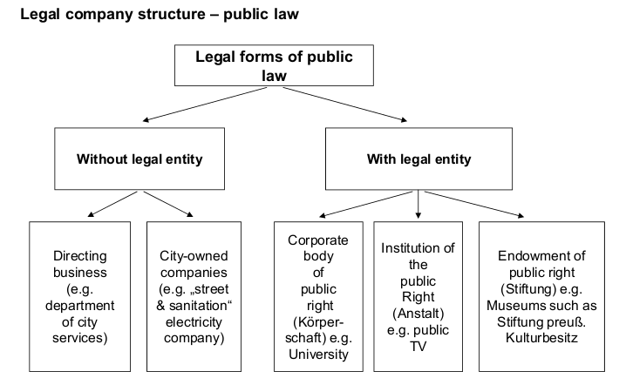

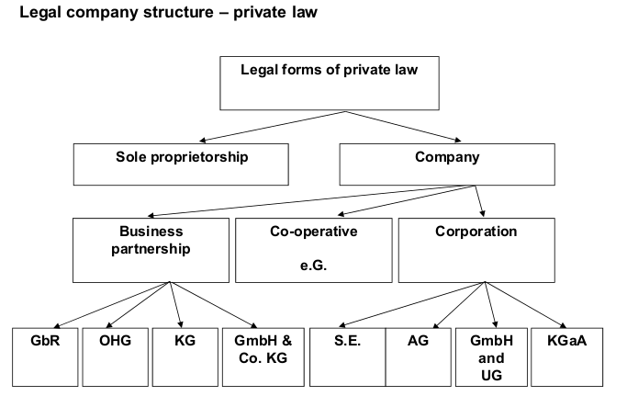

- forms of cooperation:

|  |  |  |  |  |
| --- | --- | --- | --- | --- |
| Form | Min. Partners | Min. Share Capital | Limited liability to | Formalities |
| GmbH (limited liability company) | 1 | 25 T€ | Share Capital | Moderate |
| UG ( Entrepreneurial Company) | 1 | 1 € | Share Capital | low-moderate |
| AG (stock cooperation) | 1 | 50 T€ | Stock Capital | moderate-high |
| KGaA | 2 (1 general, 1 limited) | 50 T€ | General: personal unlimited limited: share | moderate-high |
| GbR – Civil Partnership | 2 | - | Personal (unlimited) | low |
| oHG – Commercial Partnership | 2 | - | Personal (unlimited) | low-moderate |
| KG – Limited Partnership | 2 (1 general, 1 limited) | - | General: personal unlimited limited: share | low-moderate |
| GmbH & Co. KG | 2 (1 general (GmbH), 1 limited (KG partners)) | Not required, but GmbH demands 25 T€ | General: personal unlimited limited: share | moderate-high |

- Organizational company structures are necessary for

* allocating work in the most meaningful way (to fulfill objectives and thus vision and mission)
* control internal affairs (hierarchy)
* can be one-, two- or three-dimensional
* leadership span: # of directly related employess
* leadership hierarchy: # of management levels within company

|  |  |  |
| --- | --- | --- |
| One-Dimensional | * Top-Bottom * classic (management pyramid) * sub-units are e.g. functional (CEO--CFO-CTO-...) or divisional (TOP--FINANCE-PROD-...) organized * + clear decision-making, easy control, specialization * - hinders innovation, bureaucratic, hierarchical thinking | * Product-Division * Divisional or Functional |
| Two-Dimensional | * Each position could have several superior positions * but still clear hierarchical communication process * + short decision and reporting lines * - several managers per staff | * Multi-line or Matrix |
| Three-Dimensional | * Third dim mostly regional   (dim 1 = product; dim 2 = function; dim 3 = region) | * Tensor |
| Swarm | * Like Tensor, but every department is connected to each other * + adaptation, (open) innovation, re-combination of existing resources * - overload possible |  |

## Strategic Management II

- SWOT critical analysis tool:

* Strengths (internal to company):
  + Advantages, Capabilities
  + Resources and Assets (e.g. IT infrastructure)
  + Marketing, Knowledge, Experience
* Weaknesses (internal):
  + Financial, lack of competitive strength
  + Vulnerabilities
  + dependencies, e.g. suppliers or processes
* Opportunities (external to company; competitors):
  + Market Developments, USP, new technologies, unfulfilled customer need
  + Business and Product development
* Threats (external):
  + Environmental effects, market effects, obstacles

- Product Market Matrix

|  |  |  |
| --- | --- | --- |
|  | Existing Product | New Product |
| Existing Markets | Market Penetration (increase market share) | Product Development (growth through new or improved products) |
| New Markets | Market Development (new target groups) | Diversification (very risky) |

- Market Entry & Exit Barriers

Entry:

* Structural (e.g. market leaders try to push competitors out of the market)
* Behavioral

Exit:

* Specialized Assets (e.g. Mining Tools → they cannot be easily transferred)
* Fixed Costs (e.g. compulsory continuation of operations, supplying)
* Strategic Inter-relations (e.g. still continuing a certain product)
* Emotional Barriers ()
* Regulations by law ()

- Product Life Cycle:

* Start-Up: low sales, poor quality, high costs, high margins, intense marketing, gain market shares
* Growth Established: high growth rates, increasing sales/profits, marketing focus
* Maturity/Saturated: peak sales, low costs, stable numbers, top quality
* Decline: everything declines and decreases