**Background**

* If you plot temperature measured in a place, it will look like a normal curve. Climate change has been forcing this curve to move to the right and increasing the variance, thus, extreme events will be much more frequent. Some species are more susceptible to temperature change. For example, in Brazil, 1oC change in coffee plantations areas can reduce production to almost zero. This behavior is not only related to temperature, but all extreme events, such as flooding, drought, etc... If your study prevents plantations from extreme weather conditions, it will have huge impact least developed areas.

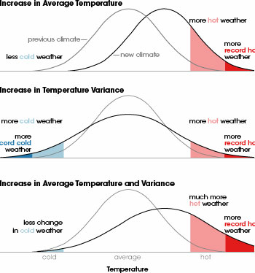

* Like as humans, plants also “feel” climate stress. If you travel from a place where the temperature is below zero to +40oC, you will probably get sick. This climate stress depends on frequency and intensity and may reduce production and it can be calculated/forecasted to estimate use of chemicals/ defensives depending on the plant’s health. You may also know how the neighboring farms are healthy. Thus, reducing use of chemicals may save lots of money and reduce perverse impact on environment.
* Some of the biggest agricultural problem is the higher land costs. Controlling climate conditions may create new plantation areas within cheaper regions. It would also reduce insurance costs, that would protect manly familiar farmers. Producing more in less area may also reduce deforestation pressure.
* Familiar agriculture doesn’t have managerial capacity to create good monitoring plans and estimate revenues and planning crop. My main interest here is related to the traceability of production. If a big company buys raw material from small producers, how do they know if that material was really produced there? If you know how much a farmer may produce and compare how much they sold, you can guarantee there were no external source of material. But nowadays it is almost impossible to track production from small farmers.
* 3.1.6 Naturaleza de los datos agrometeorológicos: Declividad, velocidad de percolación, pH, O2, fertilización y precio del aceite (no és meteo pero agro), edad, altura, DAP (diámetro altura pecho), salud de la plantación (climate stress) y cuantidad de residuos después de extracción. Humidad en la superficie o en la profundidad de la raíz.
* Fire control