**Luis Filipe Kopp**

“Systematic” Literature Review on Practical uses of Blockchain

## Abstract

Blockchain is a technology that decentralizes information and may impact many human activities. This review aimed to identify real applications of the blockchain technology, focusing on areas such as Finance, Supply Chain and Citizenship. The material from Springer Digital library were analyzed and 113 papers and conference materials obtained. Although blockchain was used in late 2008 with Bitcoin, most of the academic literature focused on its framework and security issues and only from 2017 on real world applications have been discussed – manly in China, USA and Germany.

# Introduction

Blockchain is a potentially disruptive technology that was introduced by Satoshi Nakamoto [2008][1] applying it on a cryptocurrency. This technology has been tested during the last years to evaluate its scalability and transaction cost compared to the *status quo*. Its main goal is to be a framework to be accessible to anyone and keep record of every transaction in a decentralized way. There is no central entity that controls any transaction, but every node must decide whether the transaction is trustworthy and once consensus is reached, every transaction is immutable.

There are some blockchain-based platforms, such as Ethereum, that may run applications exactly as programmed and agreed by parties, working as contracts, that would be executed if some conditions are met. Although the integration of such contracts with real-world is still on early stages of development and there are many security and vulnerability concerns due to this integration, it may have significant impact on industries and governments.

We propose perform a Systematic Literature Review (SLR) to identify real and hypothetical use cases of blockchain and smart contracts in the literature to demonstrate how these technologies may (or not) increase transparency, sustainability, and the traceability on governments and industries’ supply chain.

**Main hypothesis:** The use of Blockchain technology and smart contracts may increase traceability, sustainability, and transparency.

# “Systematic” Literature Review

One of the main goals of SLR is to evaluate all available research material in a topic area and identify gaps in the literature for further study. A SLR involves a step-by-step approach to allow unbiased investigation and reproducibility of the findings. This study followed instructions on how to perform a SLR based on the methodological framework proposed by Kitchenham et al. [2007], Kitchenham et al. [2009], and some adaptations present on Farias et al. [2016] was also used.

## Research Question

Blockchain technology was first used in 2001 with the implementation of the Bitcoin cryptocurrency, and its main characteristic is its decentralized nature. Even though many academics focused on studying this technology, only few real-world applications besides cryptocurrencies are being proposed, since most of the problems can also be solved using traditional and centralized databases (no consensus is actually needed).

In this paper, we propose to investigate real-world applications of the blockchain technology in the academic literature, focusing on transparency, sustainability, and traceability through smart-contracts. The smart-contracts are immutable scripts that may run on the blockchain once certain pre-established conditions are met, without interference of the parties involved.

Cryptocurrencies functionality resides totally on the blockchain and no information from the outside is needed. But the interaction of the blockchain and smart-contracts with external data is needed to make it more useful. In this context, internet-of-things may play an important rule, even though bringing more complexity to the security concerns – How to guarantee that information provided to the blockchain is legit?

**Research Question:** Which existing/ongoing/potential applications can benefit from the use of blockchain?

## Search Process

An initial stage of the search process involved the consultation of our main keywords in the Google Trend[2] tool, so it would be possible to examine the most appropriate timeframe for the analysis as initial guess. The topic “Smart contract” had no appearance and it was replaced by “Smart City” only as a scale for comparison. The Figure 1 present information on “blockchain”, “smart city”, and “internet of things” from May 2013 to May 2018. So, although the blockchain was started back in 2008 with the Bitcoin, this review process starting in 2012 seems to be appropriate due its minimal relevance at that time. The downtrend of “blockchain” search queries since December 2017 is notable and it will be further analyzed in this review process.

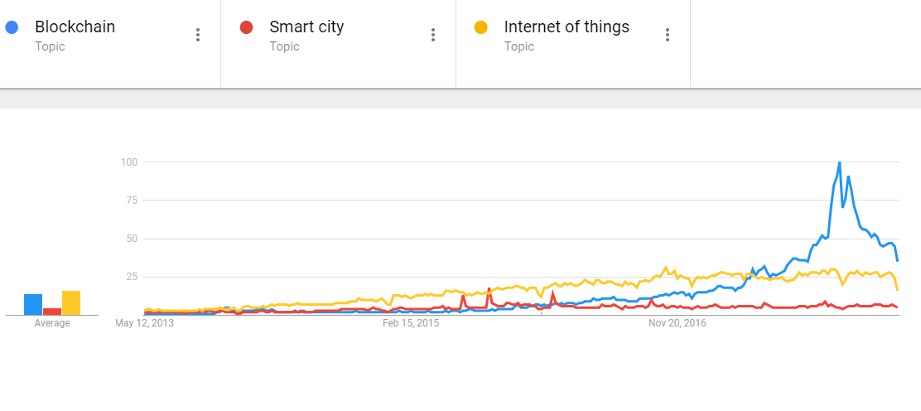

Figure 1 - Google Trends: relative appearance of selected terms on web search.

During this second stage, we visited SpringerLink (<http://link.springer.com>) digital library to identify all English articles and conference papers available on the platform since 2012. This platform was selected because of its amount of academic papers available and fitness to the topic area. The search queries were performed according to the search terms presented in the table 1 below. For each combination of the search terms presented above, we executed manual search[3] on the web, exported the results on a .CSV file and consolidated all files into one single spreadsheet, which resulted in 1,737 unique items available for further scrutiny.

|  |  |  |  |  |
| --- | --- | --- | --- | --- |
| Blockchain  **OR**  Smart Contract  **OR**  Internet of Things | **AND** | Transparency  **OR**  Traceability  **OR**  Sustainability | **AND** | Case  **OR**  Real World  **OR**  Application |

Table 1 - Search terms used in SLR

A script in Python was developed by the authors to obtain the Abstract from 1,628 papers and conference material. The existing difference from the 1,737 items is due to obtained items from Springer Digital Library that are interviews with authors, or other materials that do not present an abstract. After that, the information was organized in the Excel file and all abstracts that did not contained words related to blockchain (blockchain, Bitcoin, Ethereum, and smart contract) were removed, thus leading to only **113 papers and conference materials** since 2012. We are looking in the literature for uses of the blockchain beyond cryptocurrencies and which of them may be applicable to the Internet-of-things. Although, an assessment on the excluded material indicated that most of them were solely related to technical aspects of “Internet of Things”, which was one of our most important search term, but the material was not related to our research question. The search engine from Springer Digital Library may also have been less restrictive considering our search query.

## Quality Assessment

The quality of the publications considered in this study was not taken into consideration. We considered that all publications available by Springer Digital Library have quality standards above the cut-level threshold. The searching procedure was carried out twice, with 24 hours difference, to guarantee that the procedure taken would lead to the same results and improving the reproducibility of this review.

As quality assessment procedure, we also analyzed all keywords provided by the authors to possibly identify a missing search term not identified in prior steps. This procedure guaranteed that the search terms used was appropriated to answer the research question.

# Method & Analysis

All the **113 papers and conference materials** obtained from previous steps of this review were analyzed. Each abstract was read by one researcher, and classified into two categories: (green) Perfect fit to research question and (red) not fitted, resulting in 53 documents as perfect fit to research question and the remaining 60 documents not fitted.

The abstracts were also classified in a main topic idea, which is related the objective of the material. The 38 identified topics were grouped by affinity and similarity to each other, and consolidated into 7 main topics (Framework, security, finance, citizenship, supply chain, conceptual paper, and review) and 3 areas (Framework, Case, and Academic). For those cases where the author was not sure about the classification during the first step, they were reassessed after main topic were defined and explained. The area and main topics obtained are detailed in Table 2 below:

Table 2 - Main topics and areas identified in the Abstracts

|  |  |  |  |  |
| --- | --- | --- | --- | --- |
| **Area** | **Main Topic** | **Explanation** | **Green** | **Red** |
| Framework | Framework | Focused on blockchain’s framework and suggestion for improvements related to privacy or efficiency (time or storage), and blockchain regulation. Hardware related discussion. | 10 | 27 |
| Security | The author studied security aspects, invasion test or data archiving or data loss. | 1 | 13 |
| Cases | Finance | Several possible applications of digital currencies, market conditions, money laundering, crowdfunding. | 12 | 4 |
| Citizenship | Cases on citizen participation on public decisions, elections, environmental friendly initiatives, e-government, education, arts, healthcare, and sharing economy. | 12 | 7 |
| Supply Chain | Use of blockchain to track products, shipments or data custody. Industrial applications. | 8 | 0 |
| Academic | Conceptual Paper | The author presented new concepts and definition of vocabulary. | 2 | 6 |
| Review | Assessment of the current literature related to blockchain, or case studies. | 8 | 3 |
|  |  | **Total** | **53** | **60** |
|  |  | **Grand Total** | **113** | |

Once classified into areas and main topics, and divided into two groups (fitted and not fitted to the research question), we analyzed how those groups varied along the years. Results are presented in Figure 2 and Figure 3 below.

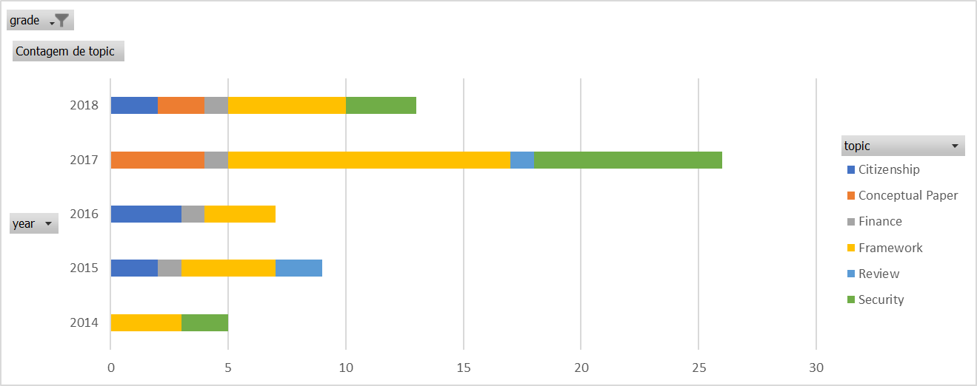

Figure 2 – Documents analyzed which were not fitted to the research question (practical applications)

It can be clearly noted that in 2017 the publication rate was much higher compared to the 3 previous years. Most of publications not related to practical applications are related to the framework, followed by security concerns. During the first quarter of 2018, the number of publication was half of the number from 2017. It can be expected then, that the potential for 2018 is to continue the increase rate of publications.

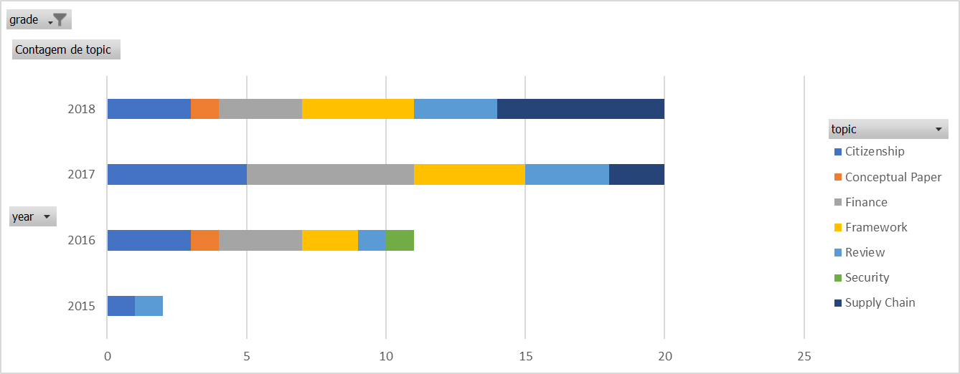

Figure 3 - Documents analyzed which were not fitted to the research question (practical applications)

In 2017, the number of documents discussing practical applications of the blockchain technology almost doubled compared to 2016. During the first quarter of 2018, the number of documents reached the total published in 2017. Showing an exponential increasing in blockchain-related publications. The downtrend presented in Figure 1 could not be confirmed due to the long cycle to a document be published. Finance topic have high participation since 2016 and Supply chain has been increasing its rate since 2017. Supply Chain in 2018 has already reached 30% of the number of publications.

It worth mention the number of Literature Review of practical applications of blockchain, around 15% of the publications, compared to 5% for those cases not related to practical applications. This finding may indicate that authors are looking forward to understand applications from the experience of other authors, since finding cases that blockchain is the best technological solution is not clear.

We also identified Journals and Conferences that had more than 1 publication during the period of this analysis (2012-1Q2018). The “Financial Cryptography and Data Security” published 9 documents with no focus on practical applications and “Financial Cryptography and Data Security” and “Business & Information Systems Engineering” published 5 documents each, related to practical application of blockchain.

Table 3 - Journals and conferences publishing on blockchain, but not focused on practical applications

|  |  |
| --- | --- |
| **Journal/ Conference** | **Number of documents** |
| Financial Cryptography and Data Security | 9 |
| Wireless Personal Communications | 4 |
| Cluster Computing | 2 |
| Computer Security - ESORICS | 2 |
| Data Privacy Management, Cryptocurrencies and Blockchain Technology | 2 |
| International Journal of Precision Engineering and Manufacturing-Green Technology | 2 |

Table 4 - Journals and conferences publishing on blockchain, focused on practical applications

|  |  |
| --- | --- |
| **Journal/ Conference** | **Number of documents** |
| Financial Cryptography and Data Security | 5 |
| Business & Information Systems Engineering | 5 |
| Financial Innovation | 4 |
| Security, Privacy, and Anonymity in Computation, Communication, and Storage | 2 |
| Security with Intelligent Computing and Big-data Services | 2 |
| Computer Science - Research and Development | 2 |
| Advances in Computer Science and Ubiquitous Computing | 2 |

The authorship analysis indicated six main authors based on the number of publications. The number of citations was not analyzed due to the short period, when this topic became available in academic research. Their publications are presented in Table 5 below:

Table 5 - Authors with more than one publication related to practical application of blockchain in Springer Digital Library

|  |  |
| --- | --- |
| **Author** | **Publications** |
| Benedikt Notheisen | Trading Real-World Assets on Blockchain (2017)  Trading Stocks on Blocks - Engineering Decentralized Markets (2017)  A blockchain-based smart grid: towards sustainable local energy markets (2018) |
| Christof Weinhardt | Trading Stocks on Blocks - Engineering Decentralized Markets (2017)  A blockchain-based smart grid: towards sustainable local energy markets (2018) |
| Jiaqi Yan | Overview of business innovations and research opportunities in blockchain and introduction to the special issue (2016)  Blockchain-based sharing services: What blockchain technology can contribute to smart cities (2016) |
| Joseph Bonneau | EthIKS: Using Ethereum to Audit a CONIKS Key Transparency Log (2016)  Escrow Protocols for Cryptocurrencies: How to Buy Physical Goods Using Bitcoin (2017) |
| Marten Risius | A Blockchain-Based Approach Towards Overcoming Financial Fraud in Public Sector Services (2017)  A Blockchain Research Framework (2017) |
| Omri Ross | Automated Execution of Financial Contracts on Blockchains (2017)  KYC Optimization Using Distributed Ledger Technology (2017) |

The geographical analysis indicated that from 32 documents with practical applications on Supply Chain, Citizenship, or Finance, three countries (USA, China, and Germany) represented 43.7% of the documents. Germany produced 2 documents in Supply Chain and Finance and one in Citizenship. China produced three from five in Citizenship. USA produced at similar levels between the three groups. Considering all this, 17 from 32 documents are from European institutions, being 9 in Finance and 5 in Citizenship.

|  |  |  |  |  |
| --- | --- | --- | --- | --- |
| **Countries** | **Citizenship** | **Finance** | **Supply Chain** | **Total** |
| **AMERICA** | **2** | **2** | **3** | **7** |
| Canada | 1 | 1 |  | 2 |
| USA | 1 | 1 | 2 | 4 |
| Colombia |  |  | 1 | 1 |
| **ASIA** | **5** | **1** | **2** | **8** |
| China | 3 | 1 | 1 | 5 |
| India | 1 |  | 1 | 2 |
| Bangladesh | 1 |  |  | 1 |
| **EUROPE** | **5** | **9** | **3** | **17** |
| Switzerland | 1 | 1 |  | 2 |
| Romania | 1 |  |  | 1 |
| UK | 1 |  |  | 1 |
| Norway | 1 |  |  | 1 |
| Germany | 1 | 2 | 2 | 5 |
| Finland |  | 1 |  | 1 |
| Austria |  | 1 |  | 1 |
| Australia |  | 1 |  | 1 |
| Denmark |  | 2 | 1 | 3 |
| Spain |  | 1 |  | 1 |
| **Total** | **12** | **12** | **8** | **32** |

# Conclusion and Discussions

This review of the literature selected 163 documents, which reveals the growing interest on the theme of blockchain technology with the publication of 14 documents in 2014 to about 100 already in 2017. We have found that the concept of the Blockchain technology is still in an early stage, supported by Morisse [2015, p. 16].

There are many possible applications for the blockchain technology that can make use of decentralized applications, but these applications are not straight through due to the paradigm change from central organization. Some of the current applications could still be using old-fashioned technologies. This explain why real applications accelerated only in 2017, considering that Bitcoin is around since late 2008.

The papers and conference material focused on the areas such as Finance and Citizenship, with about 22.5% each, and Supply chain with 15%. This analysis supports that blockchain technology can be applied to other fields, such as e-government, for transparency, and elections and supply chain for traceability. The sustainability perspective that was expected to be relevant was identified only indirectly in material that studied smart cities, focusing on energy market and environmental data storage. Some papers highlighted the negative environmental impact due to the high energy consumption to run a blockchain, compared to business-as-usual model.

# Limitations and Future Research

This review study comprehended only from publications available at Springer Digital Library. Therefore, it remains open whether including more journals and conferences from other digital libraries. For further studies, other libraries such as IEEE Xplore, ACM Digital Library, ScienceDirect, and Google Scholar should be used.

From 113 studies, only 3 were literature reviews excluded from our analysis since they are secondary sources. Other 8 reviews were considered because they were focused on a limited aspect of blockchain use.

# References

Barbara Kitchenham and Stuart Charters. 2007. Guidelines for performing Systematic Literature Reviews in Software Engineering. EBSE 2007-001. Keele University and Durham University Joint Report.

Barbara Kitchenham, O. Pearl Brereton, David Budgen, Mark Turner, John Bailey, and Stephen Linkman. 2009. Systematic literature reviews in software engineering—A systematic literature review. Information and Software Technology 51, 1 (2009), 7–15. DOI:http://dx.doi.org/10.1016/j.infsof.2008.09.009

Claudio M. de Farias, Wei Li, Flavia C. Delicato, Luci Pirmez, Albert Y. Zomaya, Paulo F. Pires, and José N. de Souza. 2016. A systematic review of shared sensor networks. ACM Computing Surveys 48, 4, Article 51 (February 2016), 50 pages. DOI:http://dx.doi.org/10.1145/2851510

Marcel Morisse. 2015. "Cryptocurrencies and Bitcoin: Charting the Research Landscape," Twenty-first Americas Conference on Information Systems (AMCIS), A. Dennis and S. Paul (eds.), Puerto Rico, pp. 1-16.

Satoshi Nakamoto, “Bitcoin: A peer-to-peer electronic cash system,” 2008. [Online]. Available: https://bitcoin.org/bitcoin.pdf

1. Available at <https://bitcoin.org/bitcoin.pdf>
2. The Google Trend information was obtained from <https://trends.google.com/trends/explore?date=today%205-y&q=%2Fm%2F0138n0j1,Smart%20contracts,%2Fm%2F02vnd10>
3. Using “(Blockchain OR "Smart Contract" OR "Internet of Things") AND(Transparency OR Traceability OR Sustainability) AND(Case OR "Real World" OR Application)” criteria