Assignment 1 Dataset from web
2026-06-01
data <- read.csv("cc_institution_grads.csv")

Dataset Source:

Kaggle - Boost Student Success with College Completion Data

https://www.kaggle.com/datasets/thedevastator/boost-student-success-with-college-completion-da

Quantitative Variable
summary(data$grad_150_rate)
## Min. 1st Qu. Median Mean 3rd Qu. Max. NA's
## 0.0 14.0 35.7 39.3 60.0 100.0 607233

Qualitative Variable: Gender
table(data$gender, data$race)
##
## A Ai B H W X
## B 72339 72339 72339 72339 72339 72339
## F 72339 72339 72339 72339 72339 72339
## M 72339 72339 72339 72339 72339 72339

Variable Transformation
I transformed the quantitative variable grad_150_rate into a categorical variable called completion_level. Institutions with a graduation rate of 50% or higher were classified as “High Completion” and those below 50% were classified as “Low Completion”.
data$completion_level <- ifelse(data$grad_150_rate >= 50,
"High Completion",
"Low Completion")
table(data$completion_level)
##
## High Completion Low Completion
## 259623 435246

Histogram
hist(data$grad_150_rate,
main = "Distribution of 150% Graduation Rates",
xlab = "Graduation Rate")
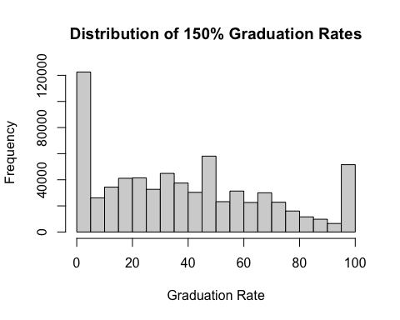

Scatterplot
plot(data$grad_100_rate,
data$grad_150_rate,
main = "100% vs 150% Graduation Rate",
xlab = "100% Graduation Rate",
ylab = "150% Graduation Rate")
