log4z
目录
log4z 1
intro 1
update logs 1
Structure chart 2
logger's configure 2
the log file's path and the log file's name 3
Quick User Manual 3
demo 4

intro
- Log4z is an open source C++ lightweight log library. It provides in a C++ application log and trace debug function. Using log4z can be very easy and convenient to debug log or track for conveying information to the screen, the log file
- log4z的优点
- The advantages of log4z
- A very wide range of MIT open source license can unrestricted use in personal, educational and commercial cases
- log4z very lightweight. Using C++ and API system write only a header file and a CPP source files, very simple and easy to use
- suitable for cross platform (windows or Linux, 32 or 64bit) multithreading logging output occasions
- to provide a complete log priority control, and the procedure can be adjusted in any position.
- through a configuration file or call interface increased with the configuration of different log recorder.
- screen output according to priority to different log color display, file output information and neat enough, logging interface fast and convenient.
- excellent performance, a small memory footprint
- Interface clear and simple, a skilled programmer just visit the log4z.h interface can grasp the log system.

update logs
/*
* UPDATES
*
* VERSION 0.1.0 <DATE: 2010.10.4>
* create the first project.
* It support put log to screen and files,
* support log level, support one day one log file.
* support multiple thread, multiple operating system.
*
* VERSION .... <DATE: ...>
* ...
*
* VERSION 0.9.0 <DATE: 2012.12.24>
* support config files.
* support color text in screen.
* support multiple logger.
*
* VERSION 1.0.0 <DATE: 2012.12.29>
* support comments in the config file.
* add a advanced demo in the ./project
* fix some details.
*/

Structure chart
LOG4Z manager
logger 1
logger 1
logger 1
logger 1
logger 1 files
logger 1 files
logger 1 files
logger 1 files

logger's configure
virtual bool AddLogger(int nLoggerID, std::string path="", std::string preName ="", int nLevel = LOG_DEBUG, bool display = true) = 0;

the logger's param
nLoggerID logger ID .
if 0 that is main logger.

path log file in the path.

preName log file's prefix name.

nLevel filter level: if log's level < the filter level, it's will discard.
diffrent level show diffrent color on the screen.

display if true that will display on the screen, else only put to the log file.

the log file's path and the log file's name
- examples
log
└── 2012_12
├── AddLogger_2012_12_23.log
├── AddLogger_2012_12_24.log
├── main_2012_12_23.log
└── main_2012_12_24.log
log: the logger configure path.
2012_12: one month one directory
file name format: prefix_dateformat.log; one day only one file.

- log content format
xxxx-xx-xx xx:xx::xx LOG_LEVEL note source file (function) : source line
2012-12-24 00:05:51 LOG_ALARM log alarm(main.cpp )(main):20

Quick User Manual
- include log4z.h
- using namespace
using namespace zsummer::log4z;
- add a logger. if skip that only one main logger.
ILog4zManager::GetInstance()->AddLogger(1,"", "AddLogger", LOG_DEBUG);
- start log4z.
ILog4zManager::GetInstance()->Start();
- fast log record micro: LOGD LOGI LOGE ... It's record to main logger, and the level is LOG DEBUG, LOG INFO ... example:
LOGD("this is a LOG_DEBUG level's log, " << " ^_^ " );
- stop and close. Log4z will auto stop and close at the process dea.
//ILog4zManager::GetInstance()->Stop()

demo
- demo code
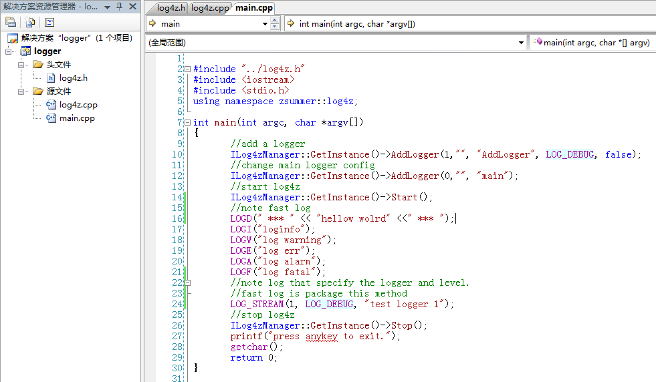
- compile
in VS join the .h and .cpp
in linux, need append -lpthread.
g++ -lpthread -o test main.cpp ../log4z.cpp

- run
windows:
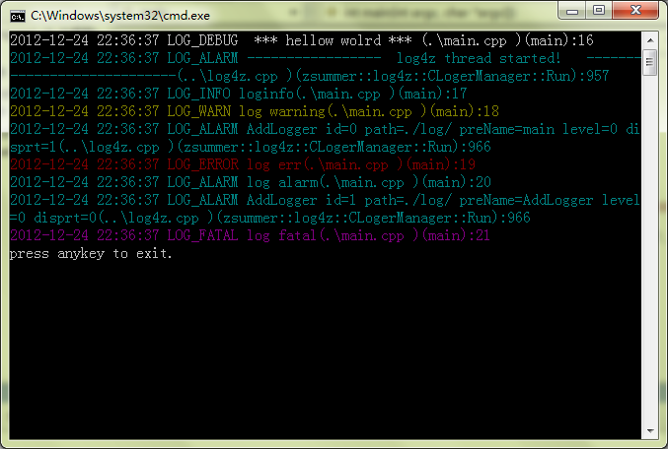
linux
