ENGR 4399 ST: Cyber-Physical and IoT Systems
Project 1 Report
Automatic Plant Watering System with Weather-Aware Dashboard (Smart Greenhouse, Stage 1)
Course | ENGR 4399 ST: Cyber-Physical and IoT Systems
Instructor | Dr. Okan Caglayan
Semester/Term | Fall 2026
Assignment # / Title | Project 1 - Automatic Plant Watering System (real ESP32 hardware)
Due Date / Presentation | 10/20/2026
Student Name(s) | Oliveira, Luis; [TO FILL partner full name]
Group Members | Luis Oliveira; [TO FILL partner]
Wokwi Project URL | [TO FILL - Wokwi simulation prototype URL, if used]
Microcontroller Board/Model | ESP32 development board (30-pin, USB-C)
Components Used | Keyestudio resistive soil moisture sensor; Keyestudio water level sensor; Elegoo 1-channel 5 V relay module (active-HIGH); small DC submersible pump with tube; 0.96" I2C OLED (SSD1306, 0x3C); active buzzer; Elegoo MB102 breadboard power module and 9 V battery (optional); breadboard, jumper wires, cup of water, plant/soil

Abstract
This project builds an automatic plant watering system on a real ESP32 as stage 1 of a Smart Greenhouse. A resistive soil moisture sensor and a water level sensor feed a four-state machine (IDLE, WATERING, SOAKING, FAULT) that switches a submersible pump through a relay, using hysteresis (start below a threshold, stop above a higher one), a pump run limit, a soak delay and a latching fault. Beyond the original idea, the ESP32 reads a live weather forecast over Wi-Fi so that it skips watering when rain is likely, judges whether the temperature is healthy for the selected plant and sounds a buzzer if it is not, and applies one of three per-plant profiles. The ESP32 also serves a web dashboard with simulation buttons (rain, tank low, soil too dry, temperature too high or too low) so every protective behavior can be demonstrated on demand. A tank-level interlock, a response check and a fault latch protect the pump and the plant. The tests validate that the hardware, the control logic and the safety interlocks behave as designed on the real board.

1. Introduction

1.1 Problem and motivation
Houseplants and small gardens fail for two opposite reasons: too little water when nobody is around, and too much water when the pot is already wet. An automatic watering system must therefore do more than "turn the pump on when the soil is dry." It must avoid damaging its own pump (running dry), avoid flooding the plant, notice when something is broken, and use context such as incoming rain and unhealthy temperatures. These are classic cyber-physical concerns: sensing, decision, actuation and safe failure.

1.2 Inspiration and credit
The basic concept (soil moisture sensor, relay and small pump in a glass of water watering a potted plant) is inspired by the Instagram video "Automatic Plant Watering System" by eazytronic3795. We rebuilt the idea on an ESP32 with different hardware and added the features listed below. The original video is credited here and in Appendix B.

1.3 What we added to the original idea
- Water-tank level interlock: the pump is blocked, and stops, when the tank is low.
- Hysteresis control (start 30% / stop 60% for the baseline, per-plant values in the final system), an 8 s pump run limit and a 30 s soak delay.
- Response check after each soak and a FAULT latch after three failed cycles; the pump stays disabled until a physical reset (EN).
- Calibrated, averaged analog readings and a BOOT-button manual pump test limited to 5 s.
- OLED status screen (soil %, state, tank status, alerts).
- Weather forecast integration: a rain chance of 60% or more in the next three hours blocks automatic watering.
- Temperature judgement per plant profile with an active buzzer alert.
- Three per-plant profiles (water need and healthy temperature range).
- A web dashboard served by the ESP32 with five simulation buttons for demonstration and testing.

1.4 Place in the Smart Greenhouse roadmap
This is stage 1. Stage 2 (later) adds a grow light, richer plant profiles stored on the device, and a forecast-driven greenhouse controller. The weather skip logic and the profile mechanism described here are first steps in that direction.

2. System Design

2.1 Architecture
Figure 1 shows the system. Two analog sensors report the soil moisture and the tank level to the ESP32. The ESP32 combines them with the weather forecast and the selected plant profile, decides whether the pump may run and drives a relay that switches the pump supply. The OLED, the buzzer and the web dashboard report the state to the user.
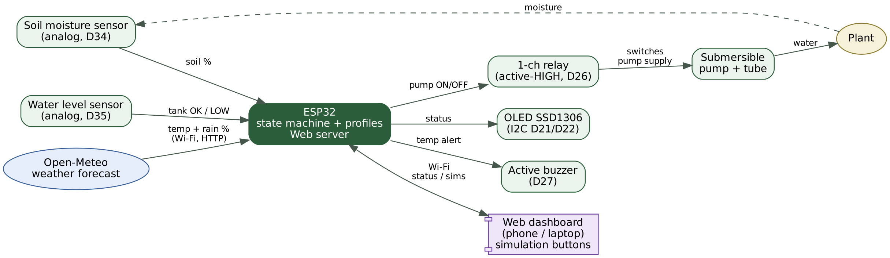
Figure 1. System block diagram: sensors, ESP32, actuator chain, user interfaces and weather service.

2.2 Circuit description and wiring
Both Keyestudio sensors are 3-pin analog modules (S = signal, V = power, G = ground) powered from 3V3. Signals go to ADC1 pins (D34 and D35), which are input-only and unaffected by Wi-Fi. The relay module is powered from VIN (5 V) and its input is driven from D26. The pump has its own supply routed through the relay contacts (COM and NO), so the ESP32 only drives the relay input and the pump current never flows through the ESP32. The OLED uses the default I2C pins. The buzzer is on D27.
Table 1. Pin function mapping and wiring
ESP32 pin / terminal | Component | Function / signal | Notes
D34 | Soil sensor S | Analog input (ADC1) | V to 3V3, G to GND. Reads about 0 in air, about 1500 in water
D35 | Water level sensor S | Analog input (ADC1) | V to 3V3, G to GND. LOW below raw 300 (hysteresis +150)
D26 | Relay header S | Digital output | Active-HIGH (measured). Relay header + to VIN (5 V), - to GND
Relay screws | COM / NO | Pump switch | COM to pump supply (+); NO to pump red wire; pump black wire to supply (-)
D21 (SDA), D22 (SCL) | OLED SSD1306 | I2C bus, address 0x3C | VCC to 3V3, GND to GND
D27 | Active buzzer | Digital output | Alert beeps; other lead to GND
D0 (BOOT button) | On-board button | Manual pump test | INPUT_PULLUP, runs pump while held, max 5 s
3V3 / VIN / GND | Power | Rails | 3V3: sensors and OLED; VIN (5 V): relay module; common GND for all ESP32-side parts

[INSERT PHOTO - Figure 2: full hardware setup (ESP32, sensors, relay, pump, tank, plant)]
Figure 2. Assembled hardware. [TO FILL: replace with your photo]

2.3 Control software
The firmware (Arduino C++, Appendix A) samples both sensors every 500 ms with 16- and 8-sample averaging (a simple low-pass filter) and runs the state machine in Figure 3. Soil percentage is a linear map of the raw ADC value between the calibration points (raw 0 = 0%, raw 1500 = 100%). Because this probe reads low when dry, the opposite of YL-69 style probes, the mapping uses the calibrated dry and wet raw values rather than assuming a direction.
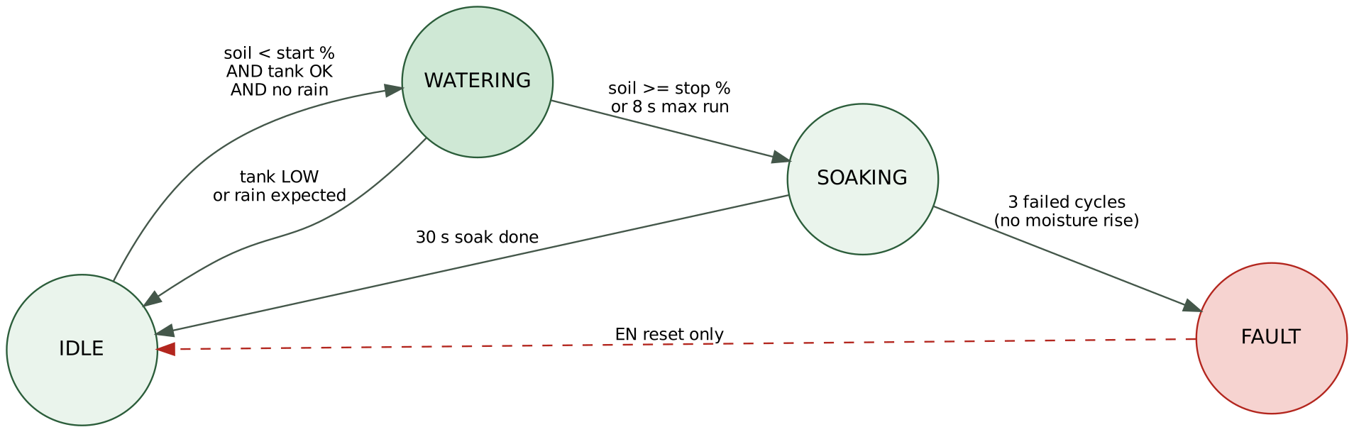
Figure 3. Pump state machine with its transition conditions.
Table 2. Control parameters
Parameter | Value | Purpose
Start / stop moisture | Per profile (baseline 30% / 60%) | Hysteresis stops the pump chattering around one threshold
Pump run limit | 8 s | Protects against empty tank, kinked tube or stuck sensor
Soak time | 30 s (demo); minutes for a real plant | Lets water reach the probe before re-checking
Response check | Soil must rise at least 3% per run | Detects dead pump, blocked tube or misplaced probe
Fault latch | 3 failed cycles, cleared only by EN reset | Prevents endless pumping when something is broken
Manual test | BOOT button, max 5 s, blocked when tank low | Priming and bench test
Rain skip | Rain chance of 60% or more in next 3 h | Rain will water the plant, so the pump is blocked

2.4 Weather, temperature alert and plant profiles
Every ten minutes (every 30 s after a failed attempt, and never while the pump is running) the ESP32 requests the current temperature and the maximum rain probability of the next three hours from the free Open-Meteo forecast service for the University of the Incarnate Word location. If rain is likely, automatic watering is blocked and a running pump is stopped. The temperature is compared with the healthy range of the selected plant. Outside the range the dashboard shows "TOO HIGH" or "TOO LOW", the OLED shows an alert and the buzzer beeps: two short beeps every two seconds for too hot, one long beep for too cold. A dashboard button silences the buzzer until the status changes.
Table 3. Per-plant profiles (default values, adjustable in the code)
Profile | Water need | Start watering below | Stop at | Healthy temperature
Basil | Thirsty | 40% | 70% | 12 - 32 C
Aloe | Drought-tolerant | 15% | 35% | 10 - 35 C
Fern | Likes moist soil | 50% | 80% | 16 - 27 C
The profile is selected from the dashboard. The values are reasonable starting points, not horticultural prescriptions, and are meant to be tuned to the three real plants. [TO FILL: replace the plant names and values if you use different plants]

2.5 Dashboard and simulations
The ESP32 serves a single-page dashboard over Wi-Fi (also reachable at plantwater.local). It shows temperature with a healthy/unhealthy verdict, rain chance and whether watering is allowed, soil moisture with the start and stop thresholds, state, pump, tank and failed cycles, the three profile buttons and an event log. Five simulation buttons inject a condition on top of the real readings so that each protective behavior can be shown on demand without waiting for real rain or a real empty tank:
Simulation button | What it injects | Expected system response
Rain forecast | Rain chance = 100% | Watering blocked, pump stopped if running; OLED "RAIN - WATERING OFF"
Tank low | Level sensor reads LOW | Pump blocked, no fault counted; OLED "TANK LOW - REFILL"
Soil too dry | Soil reads 10 points below the start threshold | Pump starts (if tank OK and no rain), stops at the 8 s limit
Temp too high | Temperature 8 C above the plant maximum | Dashboard and OLED alert; two short beeps every 2 s
Temp too low | Temperature 8 C below the plant minimum | Dashboard and OLED alert; one long beep every 2 s

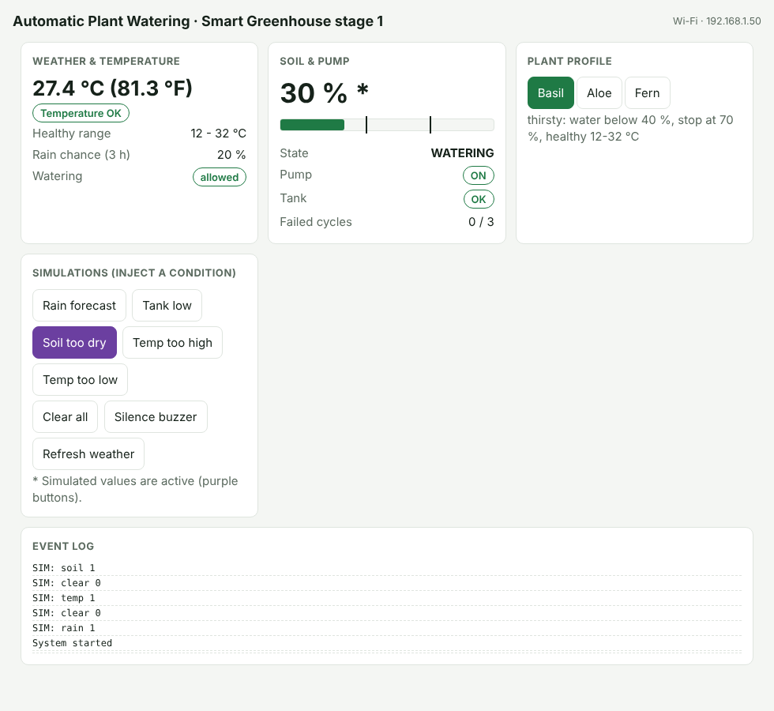 | 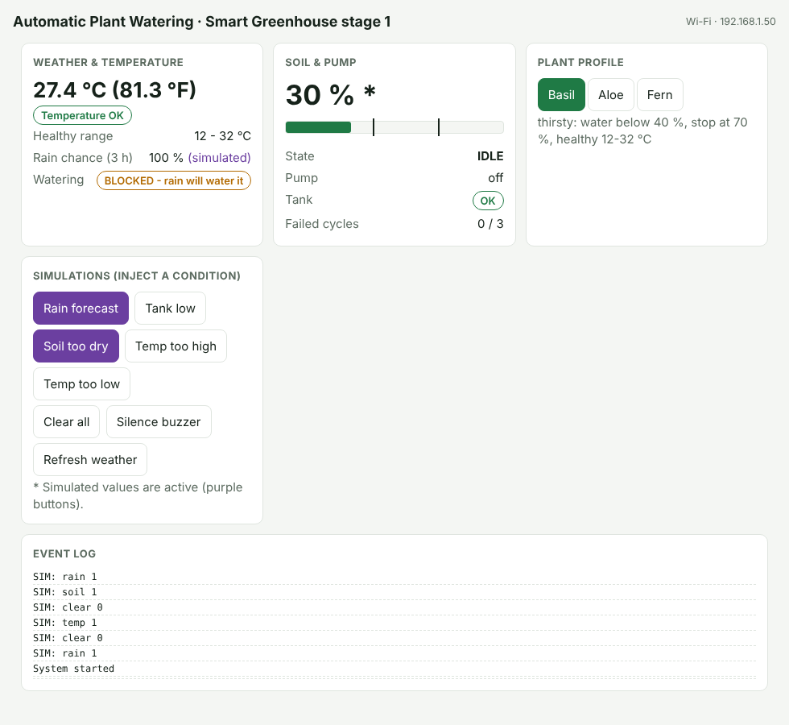
Figure 4. Dashboard layout (UI preview rendered in a desktop browser): normal operation (left) and rain forecast simulation (right). [TO FILL: replace with real screenshots from the ESP32]

3. Setup and Operation
- Install the ESP32 board package and the libraries Adafruit SSD1306 and Adafruit GFX in the Arduino IDE; select "ESP32 Dev Module".
- Wire the circuit as in Table 1 with the pump disconnected. Upload the sketch and open the Serial Monitor at 115200 baud.
- Set WIFI_SSID and WIFI_PASS in the sketch. If the connection fails within 12 s the ESP32 opens its own network "PlantWater" and the dashboard is at 192.168.4.1 (weather is then unavailable and only simulated).
- Calibrate: soil probe in air and in water, level sensor at the lowest acceptable water level; store the numbers in SOIL_RAW_DRY, SOIL_RAW_WET and LEVEL_LOW_RAW.
- Check the relay polarity with the pump disconnected, then connect the pump and hold BOOT to prime the tube.
- Place the probe 2-3 cm deep and the tube end next to it, open the dashboard, select the plant profile and run the tests in Section 4.

4. Test Plan and Results
Tests 1 and 2 were performed on the real board during the build. The remaining rows state the expected behavior designed into the firmware; the observed results and Pass/Fail entries must be completed from the real tests before submission. [TO FILL]
Table 4. Test cases and outcomes
# | Steps / inputs | Expected behavior | Observed behavior | Pass/Fail
1 | Relay test sketch: toggle D26 HIGH/LOW, 3 s each | Relay clicks ON with D26 HIGH; OFF at boot | Relay is ACTIVE-HIGH (first assumed active-low); OFF at boot | Pass
2 | Soil probe in air, then in a glass of water; read raw ADC | Distinct dry and wet values | About 0 in air, about 1500 in water (reads LOW when dry) | Pass
3 | Level sensor dry, then at the minimum safe water level | Dry about 0; rises with depth; LOW threshold 300 | [TO FILL: raw readings] | [TO FILL]
4 | Hold BOOT with water in tank | Pump runs while held, stops after 5 s | [TO FILL] | [TO FILL]
5 | Full cycle: dry soil, pump connected, tank OK | IDLE to WATERING (pump on), SOAKING, IDLE; stops at the profile stop % or 8 s | [TO FILL: serial log, soil % before/after] | [TO FILL]
6 | Real tank low: lift level sensor out of water | OLED TANK LOW; pump blocked; no fault counted | [TO FILL] | [TO FILL]
7 | FAULT: dry soil, tube pinched or pump out of water | After 3 failed cycles state FAULT; pump off until EN reset | [TO FILL] | [TO FILL]
8 | Dashboard: Rain forecast | Watering blocked; running pump stops; event logged | [TO FILL] | [TO FILL]
9 | Dashboard: Tank low | Pump blocked; no fault counted | [TO FILL] | [TO FILL]
10 | Dashboard: Soil too dry (tank OK, no rain) | Pump starts and stops at 8 s limit; no false fault | [TO FILL] | [TO FILL]
11 | Dashboard: Temp too high | TOO HIGH on dashboard and OLED; two short beeps; Silence button mutes | [TO FILL] | [TO FILL]
12 | Dashboard: Temp too low | TOO LOW alert; one long beep | [TO FILL] | [TO FILL]
13 | Switch profile Basil, Aloe, Fern | Thresholds, markers and healthy range change | [TO FILL] | [TO FILL]
14 | Live weather over Wi-Fi | Temperature and rain % match a reference weather source | [TO FILL: values and source compared] | [TO FILL]
15 | Wrong Wi-Fi password at boot | Own network "PlantWater" starts; dashboard at 192.168.4.1 | [TO FILL] | [TO FILL]

[INSERT PHOTOS - Figure 5: OLED in each state (normal, WATERING, TANK LOW, RAIN, TEMP alert, FAULT)]
Figure 5. OLED status screens. [TO FILL]
[INSERT SERIAL MONITOR EXCERPT - calibration readings, one watering cycle, TANK LOW and FAULT events]
Figure 6. Serial Monitor output. [TO FILL]
[INSERT PHOTO / VIDEO STILL - Figure 7: pump starting when the soil is dry]
Figure 7. Pump running during a watering cycle. [TO FILL]

5. Safety and Failure Modes
The relay is forced OFF at the first line of setup(), so the pump cannot run while the board boots. Whenever several conditions apply, the pump is allowed to run only if all of the following hold, in effect giving the interlocks priority over the watering request: no FAULT, tank not low, no rain expected, and the run time under 8 s (the BOOT test is limited to 5 s and also blocked when the tank is low).
Table 5. Failure modes, detection and mitigation
Failure mode | Cause | Detection | Mitigation
Pump runs dry | Empty tank | Level sensor below threshold | Pump blocked and stopped; no fault counted; resumes after refill (with hysteresis)
Pump never stops | Sensor stuck, probe out of soil | Run timer | 8 s maximum run per cycle
Pump or tube failure | Dead pump, kinked tube, probe far from drip point | Soil rise under 3% after a soak | CHECK PUMP message; FAULT after 3 cycles; pump disabled until EN reset
Overwatering | Single threshold chatter; watering before rain | Hysteresis; soak delay; forecast | Start/stop thresholds, soak, rain skip
Wrong temperature for plant | Heat wave or cold night | Temperature vs profile range | Dashboard verdict, OLED alert, buzzer
Wi-Fi or weather service down | Network loss, API error | Fetch failure, no data | System keeps watering by soil logic only; weather shown as unknown; own-network fallback for the dashboard
Relay polarity or boot glitch | Wrong assumption (active-low vs active-high) | Bench relay test before the pump is connected | Polarity constant, relay off first in setup()
Brown-out when pump starts | Pump on the 5 V pin, weak USB port | Unexpected ESP32 reset | Separate pump supply or capacitor; pump supply is isolated by the relay contacts
Water near electronics | Spill or leak | Visual | Tray, drip loop in the tube, tank away from the breadboard
Probe corrosion | Resistive probe powered constantly | Drifting readings over days | Known limitation; capacitive probe or pulsed power in future work
Spoofed or false sensor data | Unauthenticated dashboard, tampered probe | Not detected in this stage | See security note below

Security note
The dashboard is an unauthenticated HTTP page, which is acceptable for a classroom demonstration but not for deployment. Anyone on the same network could press the simulation buttons, which override sensor readings. The simulations are deliberately limited: they can block watering or request a normal, time-limited watering cycle, but they cannot disable the run limit, the tank interlock or the fault latch. A production version would remove the simulation interface, require a login or token, use HTTPS for the weather request and the dashboard, and use signed firmware updates (secure boot, flash encryption and signed OTA), which map to the course outcomes on embedded security and cyber-physical threats such as sensor spoofing and network disruption.

6. Discussion of Engineering Concepts
- Analog sensing: the 12-bit ADC (0-4095) reads the sensor voltage; averaging reduces noise; two-point calibration converts raw counts to percent. ADC1 pins are used because ADC2 conflicts with Wi-Fi.
- Digital output and isolation: a GPIO drives the relay input and the relay contacts isolate the pump supply from the ESP32.
- Finite state machine: four explicit states with guarded transitions make the behavior predictable and testable.
- Hysteresis and soak time: control-theory ideas that prevent oscillation in a slow process (water takes time to spread to the probe).
- I2C: the OLED shares the two-wire bus at address 0x3C.
- Wi-Fi, HTTP and REST: the ESP32 is an HTTP client of the weather service and an HTTP server for the dashboard; a small JSON API provides status and simulation control.
- Real-time behavior: the main loop polls sensors every 500 ms and handles web requests between samples. The blocking weather request is skipped while the pump runs so that the pump limits and interlocks are never delayed by the network.
- Safety engineering: interlocks, run limits, fail-safe default (pump off), latching fault with a physical reset.

7. Troubleshooting and Limitations

Lessons learned
- The relay turned out to be active-HIGH, not active-low as first assumed (many blue relay modules are active-low). A standalone relay test sketch, run with the pump disconnected, found this before anything could run unexpectedly.
- This Keyestudio soil sensor reads LOW when dry and HIGH when wet, the opposite of YL-69 style sensors used in many tutorials. The percentage mapping therefore uses measured dry and wet calibration points instead of assuming a direction.
- Calibration must be done with the real sensor in air and in water; datasheet or tutorial values did not match this module.
- [TO FILL: add any wiring or software problems you hit while connecting the pump, for example brown-out, tube placement, Wi-Fi]

Limitations
- The temperature judged is the forecast outdoor temperature for the location, not a sensor at the plant. A DHT22 or similar sensor at the plant is the logical stage 2 improvement.
- The rain skip uses forecast probability, not measured rain at the pot, and is meaningful mainly for outdoor plants.
- Plant profile values are defaults and need tuning with real plants.
- The resistive soil probe corrodes over time; the 30 s soak is a demo value and a real plant needs minutes.
- The weather request uses plain HTTP and the dashboard has no authentication (see Section 5).
- Campus Wi-Fi may block device-to-device connections; the own-network fallback keeps the dashboard reachable but then weather is simulated only.
- Tests with real watering cycles are limited by tank size and time.

Conclusion
The system turns a simple "pump when dry" idea into a small cyber-physical system with sensing, forecast awareness, per-plant decisions, actuation and layered safety. The hardware and calibration work on the real board, and the control logic includes a tank interlock, run limit, response check and latching fault. The dashboard simulations make each protective behavior demonstrable on demand. [TO FILL: one sentence summarizing whether all tests passed.] The most important takeaway is that verifying assumptions on the real hardware (relay polarity, sensor direction) mattered more than the code itself. The next improvement is a temperature and humidity sensor at the plant plus a grow light, which leads into stage 2 of the Smart Greenhouse.

Appendix A - Arduino Code Listing
RealHardware_Dashboard.ino (the embedded dashboard web page is abbreviated below; the full file is in the project folder).
/*
* ENGR 4399 - Project 1: Automatic Plant Watering System - REAL ESP32 + WEB DASHBOARD
* (stage 1 of the Smart Greenhouse)
*
* Inspired by the Instagram video "Automatic Plant Watering System" by eazytronic3795.
*
* Added on top of the tested RealHardware.ino:
* - Wi-Fi weather forecast (Open-Meteo, no API key): rain chance blocks automatic watering
* - temperature judgement per plant profile + active buzzer alert
* - 3 per-plant profiles (start/stop moisture, healthy temperature range)
* - web dashboard served by the ESP32 itself, with SIMULATION buttons:
* rain forecast, tank low, soil too dry, temperature too high / too low
* - if the Wi-Fi does not connect the ESP32 opens its own network "PlantWater"
*
* Wiring (same as the tested build, plus the buzzer)
* Soil sensor S -> D34 V -> 3V3 G -> GND
* Level sensor S -> D35 V -> 3V3 G -> GND
* Relay header S -> D26 + -> VIN (5 V) - -> GND (ACTIVE-HIGH module)
* Relay screws COM -> pump supply (+), NO -> pump red wire, pump black -> supply (-)
* OLED SSD1306 SDA -> D21 SCL -> D22 VCC -> 3V3 GND -> GND (0x3C)
* Active buzzer signal / (+) -> D27 (-) / G -> GND
*
* Board: "ESP32 Dev Module". Libraries: "Adafruit SSD1306", "Adafruit GFX Library".
* WiFi, WebServer, ESPmDNS and HTTPClient come with the ESP32 core.
*/
#include <Arduino.h>
#include <Wire.h>
#include <WiFi.h>
#include <WebServer.h>
#include <ESPmDNS.h>
#include <HTTPClient.h>
#include <Adafruit_GFX.h>
#include <Adafruit_SSD1306.h>

// ============================ Options (edit these) =========================
static const char* WIFI_SSID = ""; // your phone hotspot / campus Wi-Fi name ("" = go straight to own network)
static const char* WIFI_PASS = "";
static const char* AP_SSID = "PlantWater"; // own network if the Wi-Fi fails
static const char* AP_PASS = "plant1234"; // at least 8 characters
static const uint32_t WIFI_TIMEOUT_MS = 12000;

// Weather location (default: University of the Incarnate Word, San Antonio TX)
static const char* LATITUDE = "29.47";
static const char* LONGITUDE = "-98.47";
static const int RAIN_SKIP_PCT = 60; // rain chance (next 3 h) at/above this blocks automatic watering

static const uint8_t OLED_ADDR = 0x3C;
static const bool RELAY_ACTIVE_LOW = false; // measured: this relay is ACTIVE-HIGH
static const bool RELAY_FLOAT_WHEN_OFF = false;
static const bool BUZZER_ACTIVE_LOW = false;

// Soil calibration (this Keyestudio probe reads LOW when dry, HIGH when wet)
static const int SOIL_RAW_DRY = 0;
static const int SOIL_RAW_WET = 1500;
// Water-level sensor
static const int LEVEL_LOW_RAW = 300;
static const int LEVEL_HYST_RAW = 150;

// Control
static const uint32_t MAX_RUN_MS = 8000;
static const uint32_t SOAK_MS = 30000;
static const float MIN_RISE_PCT = 3.0f;
static const int MAX_FAILED_CYCLES = 3;
static const uint32_t PRIME_MAX_MS = 5000;
static const uint32_t SAMPLE_MS = 500;
static const uint32_t LOG_MS = 2000;

// ============================== Plant profiles =============================
struct Profile { const char* name; const char* need; float dry; float wet; float tMin; float tMax; };
static const Profile PROFILES[3] = {
// name water need start stop min C max C
{ "Basil", "thirsty", 40.0f, 70.0f, 12.0f, 32.0f },
{ "Aloe", "drought-tolerant", 15.0f, 35.0f, 10.0f, 35.0f },
{ "Fern", "likes moist soil", 50.0f, 80.0f, 16.0f, 27.0f },
};
static uint8_t profileIdx = 0;

// ================================== Pins ===================================
static const int PIN_SOIL = 34;
static const int PIN_LEVEL = 35;
static const int PIN_RELAY = 26;
static const int PIN_BUZZER = 27;
static const int PIN_PRIME = 0; // BOOT button
static const int PIN_SDA = 21;
static const int PIN_SCL = 22;

static Adafruit_SSD1306 oled(128, 64, &Wire, -1);
static bool oledOk = false;
static WebServer server(80);

// ================================== State ==================================
enum State : uint8_t { IDLE, WATERING, SOAKING, FAULT };
static const char* STATE_NAME[] = {"IDLE", "WATERING", "SOAKING", "FAULT"};

static State state = IDLE;
static uint32_t stateSince = 0;
static float soilAtStart = 0;
static bool evalPending = false;
static bool noResponse = false;
static int failedCycles = 0;
static int cycles = 0;
static bool primeOn = false;

static bool realTankLow = false;
static bool tankLow = false; // real OR simulated
static float soilReal = 0, soilShown = 0;
static int soilRaw = 0, levelRaw = 0;

// Simulation switches (set from the dashboard)
static bool simRain = false, simTank = false, simSoil = false;
static uint8_t simTemp = 0; // 0 off, 1 too high, 2 too low

// Weather
static float weatherTemp = NAN;
static int weatherRain = -1; // max rain probability next 3 h, -1 unknown
static uint32_t weatherOkAt = 0, nextWeatherAt = 0;
static bool weatherEver = false;
static bool apMode = false;
static String ipText = "-";

// Alerts
static uint8_t lastTempStatus = 0;
static bool muted = false;
static bool buzzing = false;

// Event log shown on the dashboard
static char events[8][80];
static uint8_t evHead = 0, evCount = 0;
static void logEvent(const char* msg) {
strncpy(events[evHead], msg, 79); events[evHead][79] = 0;
evHead = (evHead + 1) % 8; if (evCount < 8) evCount++;
Serial.printf("[EVENT] %s\n", msg);
}

// ================================ Helpers ==================================
static void relayWrite(bool on) {
if (RELAY_FLOAT_WHEN_OFF && RELAY_ACTIVE_LOW) {
pinMode(PIN_RELAY, OUTPUT_OPEN_DRAIN);
digitalWrite(PIN_RELAY, on ? LOW : HIGH);
return;
}
pinMode(PIN_RELAY, OUTPUT);
bool level = RELAY_ACTIVE_LOW ? !on : on;
digitalWrite(PIN_RELAY, level ? HIGH : LOW);
}

static void buzzerWrite(bool on) {
digitalWrite(PIN_BUZZER, (on != BUZZER_ACTIVE_LOW) ? HIGH : LOW);
}

static int readAveraged(int adcPin, int samples) {
long acc = 0;
for (int i = 0; i < samples; i++) { acc += analogRead(adcPin); delayMicroseconds(200); }
return (int)(acc / samples);
}

static float soilPercentFromRaw(int raw) {
float pct = 100.0f * (raw - SOIL_RAW_DRY) / (float)(SOIL_RAW_WET - SOIL_RAW_DRY);
return constrain(pct, 0.0f, 100.0f);
}

static float curDry() { return PROFILES[profileIdx].dry; }
static float curWet() { return PROFILES[profileIdx].wet; }
static float curTMin() { return PROFILES[profileIdx].tMin; }
static float curTMax() { return PROFILES[profileIdx].tMax; }

static float effectiveTemp() {
if (simTemp == 1) return curTMax() + 8.0f;
if (simTemp == 2) return curTMin() - 8.0f;
return weatherTemp;
}
static int effectiveRain() { return simRain ? 100 : weatherRain; }
static bool rainBlock() { int r = effectiveRain(); return r >= RAIN_SKIP_PCT; }

// 0 unknown, 1 OK, 2 too high, 3 too low
static uint8_t tempStatus() {
float t = effectiveTemp();
if (isnan(t)) return 0;
if (t > curTMax()) return 2;
if (t < curTMin()) return 3;
return 1;
}

static void setState(uint8_t s, const char* why) {
char b[80];
snprintf(b, sizeof b, "%s -> %s: %s", STATE_NAME[state], STATE_NAME[s], why);
logEvent(b);
state = (State)s;
stateSince = millis();
}

// ================================ Weather ==================================
static void fetchWeather() {
if (WiFi.status() != WL_CONNECTED) return;
String url = String("http://api.open-meteo.com/v1/forecast?latitude=") + LATITUDE + "&longitude=" + LONGITUDE +
"&current=temperature_2m&hourly=precipitation_probability&forecast_hours=3&timezone=auto";
HTTPClient http;
http.setTimeout(4000);
http.begin(url);
int code = http.GET();
bool ok = false;
if (code == 200) {
String body = http.getString();
int c = body.indexOf("\"current\":{");
if (c >= 0) {
int t = body.indexOf("\"temperature_2m\":", c);
if (t >= 0) { weatherTemp = body.substring(t + 17).toFloat(); ok = true; }
}
int h = body.indexOf("\"hourly\":{");
if (h >= 0) {
int p = body.indexOf("\"precipitation_probability\":[", h);
if (p >= 0) {
int i = p + 29, best = -1;
while (i < (int)body.length() && body[i] != ']') {
if (isDigit(body[i])) { int v = body.substring(i).toInt(); if (v > best) best = v; while (isDigit(body[i])) i++; }
else i++;
}
if (best >= 0) weatherRain = best;
}
}
}
http.end();
if (ok) {
weatherEver = true; weatherOkAt = millis(); nextWeatherAt = millis() + 600000UL;
Serial.printf("[WEATHER] %.1f C, rain chance next 3 h: %d %%\n", weatherTemp, weatherRain);
logEvent("Weather updated");
} else {
nextWeatherAt = millis() + 30000UL;
Serial.printf("[WEATHER] fetch failed (HTTP %d)\n", code);
}
}

// ================================ Dashboard ================================
static const char PAGE[] PROGMEM = R"HTML(... single-page dashboard HTML, CSS and JavaScript omitted from this listing ...)HTML";

static void sendStatus() {
float t = effectiveTemp();
String j; j.reserve(1800);
j += "{\"soil\":" + String(soilShown, 1);
j += ",\"state\":\"" + String(STATE_NAME[state]) + "\"";
j += ",\"pump\":" + String((state == WATERING && !tankLow && !rainBlock()) || primeOn ? "true" : "false");
j += ",\"tank\":" + String(tankLow ? "true" : "false");
j += ",\"rain\":" + String(effectiveRain());
j += ",\"rainblock\":" + String(rainBlock() ? "true" : "false");
j += ",\"temp\":" + (isnan(t) ? String("null") : String(t, 1));
j += ",\"tstatus\":" + String(tempStatus());
j += ",\"profile\":" + String(profileIdx);
j += ",\"failed\":" + String(failedCycles);
j += ",\"muted\":" + String(muted ? "true" : "false");
j += ",\"buzzing\":" + String(buzzing ? "true" : "false");
j += ",\"net\":\"" + String(apMode ? "own network PlantWater" : "Wi-Fi") + "\",\"ip\":\"" + ipText + "\"";
j += ",\"sim\":{\"rain\":" + String(simRain ? "true" : "false") + ",\"tank\":" + String(simTank ? "true" : "false") +
",\"soil\":" + String(simSoil ? "true" : "false") + ",\"temp\":" + String(simTemp) + "}";
j += ",\"profiles\":[";
for (int i = 0; i < 3; i++) {
if (i) j += ",";
j += "{\"name\":\"" + String(PROFILES[i].name) + "\",\"need\":\"" + PROFILES[i].need + "\",\"dry\":" + String(PROFILES[i].dry, 0) +
",\"wet\":" + String(PROFILES[i].wet, 0) + ",\"tmin\":" + String(PROFILES[i].tMin, 0) + ",\"tmax\":" + String(PROFILES[i].tMax, 0) + "}";
}
j += "],\"events\":[";
for (int k = 0; k < evCount; k++) { // newest first
int idx = (evHead - 1 - k + 16) % 8;
if (k) j += ",";
j += "\""; j += events[idx]; j += "\"";
}
j += "]}";
server.send(200, "application/json", j);
}

static void handleSim() {
String n = server.arg("name");
int v = server.arg("val").toInt();
if (n == "clear") { simRain = simTank = simSoil = false; simTemp = 0; logEvent("SIM: all simulations cleared"); }
else if (n == "rain") { simRain = v; logEvent(v ? "SIM: heavy rain forecast injected" : "SIM: rain forecast cleared"); }
else if (n == "tank") { simTank = v; logEvent(v ? "SIM: tank LOW injected" : "SIM: tank low cleared"); }
else if (n == "soil") { simSoil = v; logEvent(v ? "SIM: soil too dry injected" : "SIM: soil dry cleared"); }
else if (n == "temp") { simTemp = (v == 1 || v == 2) ? v : 0;
logEvent(simTemp == 1 ? "SIM: temperature TOO HIGH injected" : simTemp == 2 ? "SIM: temperature TOO LOW injected" : "SIM: temperature cleared"); }
server.send(200, "text/plain", "ok");
}

static void startNetwork() {
WiFi.mode(WIFI_STA);
if (strlen(WIFI_SSID) > 0) {
WiFi.begin(WIFI_SSID, WIFI_PASS);
Serial.printf("Connecting to Wi-Fi \"%s\"", WIFI_SSID);
uint32_t t0 = millis();
while (WiFi.status() != WL_CONNECTED && millis() - t0 < WIFI_TIMEOUT_MS) { delay(300); Serial.print("."); }
Serial.println();
}
if (WiFi.status() == WL_CONNECTED) {
ipText = WiFi.localIP().toString();
apMode = false;
} else {
WiFi.disconnect(); WiFi.mode(WIFI_AP);
WiFi.softAP(AP_SSID, AP_PASS);
ipText = WiFi.softAPIP().toString();
apMode = true;
Serial.println("Wi-Fi unavailable: own network started (weather will be simulated only)");
}
if (MDNS.begin("plantwater")) Serial.println("Also reachable at http://plantwater.local");
server.on("/", []() { server.send_P(200, "text/html", PAGE); });
server.on("/api/status", sendStatus);
server.on("/api/sim", handleSim);
server.on("/api/profile", []() {
int id = server.arg("id").toInt();
if (id >= 0 && id < 3) { profileIdx = id; char b[80]; snprintf(b, sizeof b, "Profile changed to %s", PROFILES[id].name); logEvent(b); }
server.send(200, "text/plain", "ok");
});
server.on("/api/mute", []() { muted = true; logEvent("Buzzer silenced from dashboard"); server.send(200, "text/plain", "ok"); });
server.on("/api/weather", []() { nextWeatherAt = 0; server.send(200, "text/plain", "ok"); });
server.begin();
Serial.printf("Dashboard: http://%s\n", ipText.c_str());
}

// ============================ Display & buttons ============================
static void updatePrime(uint32_t now) {
static uint32_t start = 0;
static bool held = false;
if (digitalRead(PIN_PRIME) == LOW) {
if (!held) {
held = true; start = now;
Serial.println(tankLow ? "[PRIME] refused: tank is low" : "[PRIME] manual pump (max 5 s per press)");
}
primeOn = !tankLow && (now - start < PRIME_MAX_MS);
} else { held = false; primeOn = false; }
}

static void drawScreen(uint32_t now) {
if (!oledOk) return;
oled.clearDisplay();
oled.setTextColor(SSD1306_WHITE);
oled.setTextSize(1);
oled.setCursor(0, 0); oled.print(PROFILES[profileIdx].name);
float t = effectiveTemp();
oled.setCursor(84, 0);
if (isnan(t)) oled.print("--C"); else oled.printf("%.0fC", t);
oled.setTextSize(2);
oled.setCursor(0, 11); oled.printf("Soil %.0f%%", soilShown);
oled.drawRect(0, 30, 128, 9, SSD1306_WHITE);
oled.fillRect(1, 31, (int)(126.0f * soilShown / 100.0f), 7, SSD1306_WHITE);
oled.drawFastVLine((int)(1 + 126.0f * curDry() / 100.0f), 40, 3, SSD1306_WHITE);
oled.drawFastVLine((int)(1 + 126.0f * curWet() / 100.0f), 40, 3, SSD1306_WHITE);
oled.setTextSize(1);
oled.setCursor(0, 45);
bool pumpOn = (state == WATERING && !tankLow && !rainBlock()) || primeOn;
oled.printf("%s Pump:%s", STATE_NAME[state], pumpOn ? "ON" : "off");
oled.setCursor(0, 56);
uint8_t ts = tempStatus();
if (state == FAULT) oled.print("FAULT - press EN");
else if (tankLow) oled.print("TANK LOW - REFILL");
else if (rainBlock()) oled.print("RAIN - WATERING OFF");
else if (ts == 2) oled.print("TEMP TOO HIGH!");
else if (ts == 3) oled.print("TEMP TOO LOW!");
else if (noResponse) oled.print("CHECK PUMP / TUBE");
else if (state == SOAKING) oled.printf("Tank OK soak %lus", (unsigned long)((SOAK_MS - (now - stateSince)) / 1000));
else oled.print("Tank OK");
oled.display();
}

// ============================ Sampling & control ===========================
static void sampleAndControl(uint32_t now) {
static uint32_t lastLog = 0;
static bool lastTankLow = false, lastRainBlock = false;

soilRaw = readAveraged(PIN_SOIL, 16);
levelRaw = readAveraged(PIN_LEVEL, 8);
soilReal = soilPercentFromRaw(soilRaw);
soilShown = simSoil ? max(0.0f, curDry() - 10.0f) : soilReal; // "soil too dry" simulation

if (levelRaw < LEVEL_LOW_RAW) realTankLow = true;
else if (levelRaw > LEVEL_LOW_RAW + LEVEL_HYST_RAW) realTankLow = false;
tankLow = realTankLow || simTank;
if (tankLow != lastTankLow) {
logEvent(tankLow ? "TANK LOW - pump blocked, refill" : "Tank OK again");
lastTankLow = tankLow;
}
bool rb = rainBlock();
if (rb != lastRainBlock) {
logEvent(rb ? "Rain expected - automatic watering blocked" : "No rain expected - watering allowed");
lastRainBlock = rb;
}

switch (state) {
case IDLE:
if (soilShown < curDry() && !tankLow && !rb) { soilAtStart = soilShown; setState(WATERING, "soil dry"); }
break;

case WATERING:
if (tankLow) {
evalPending = false; setState(IDLE, "tank low - pump stopped");
} else if (rb) {
evalPending = false; setState(IDLE, "rain expected - pump stopped");
} else if (soilShown >= curWet()) {
failedCycles = 0; noResponse = false; evalPending = false; cycles++;
setState(SOAKING, "target moisture reached");
} else if (now - stateSince >= MAX_RUN_MS) {
evalPending = !simSoil; // a simulated reading cannot prove or disprove the pump
cycles++;
setState(SOAKING, "max run time reached");
}
break;

case SOAKING:
if (now - stateSince >= SOAK_MS) {
if (evalPending) {
evalPending = false;
if (soilShown - soilAtStart < MIN_RISE_PCT) {
failedCycles++; noResponse = true;
char b[80]; snprintf(b, sizeof b, "Soil did not respond (%d/%d): check pump, tube, probe", failedCycles, MAX_FAILED_CYCLES);
logEvent(b);
} else { failedCycles = 0; noResponse = false; }
}
if (failedCycles >= MAX_FAILED_CYCLES) setState(FAULT, "too many failed cycles - press EN after fixing");
else setState(IDLE, "soak finished");
}
break;

case FAULT:
break;
}

drawScreen(now);

if (now - lastLog >= LOG_MS) {
lastLog = now;
Serial.printf("[SOIL] %.0f%% (raw %d) tank=%s (raw %d) state=%s pump=%s rain=%d%% temp=%.1f profile=%s sim[r%d t%d s%d T%d]\n",
soilShown, soilRaw, tankLow ? "LOW" : "ok", levelRaw, STATE_NAME[state],
((state == WATERING && !tankLow && !rb) || primeOn) ? "ON" : "off",
effectiveRain(), effectiveTemp(), PROFILES[profileIdx].name, simRain, simTank, simSoil, simTemp);
}
}

static void updateAlert(uint32_t now) {
uint8_t ts = tempStatus();
if (ts != lastTempStatus) {
muted = false;
if (ts == 2) logEvent("ALERT: temperature too high for this plant");
else if (ts == 3) logEvent("ALERT: temperature too low for this plant");
else if (lastTempStatus >= 2) logEvent("Temperature back in the healthy range");
lastTempStatus = ts;
}
bool want = false;
if ((ts == 2 || ts == 3) && !muted) {
uint32_t ph = now % 2000;
if (ts == 2) want = (ph < 150) || (ph >= 300 && ph < 450); // two short beeps = too hot
else want = (ph < 700); // one long beep = too cold
}
buzzing = (ts == 2 || ts == 3) && !muted;
buzzerWrite(want);
}

void setup() {
relayWrite(false); // pump OFF first
pinMode(PIN_BUZZER, OUTPUT); buzzerWrite(false);
pinMode(PIN_PRIME, INPUT_PULLUP);
Serial.begin(115200);
analogReadResolution(12);
Wire.begin(PIN_SDA, PIN_SCL);
oledOk = oled.begin(SSD1306_SWITCHCAPVCC, OLED_ADDR);
if (!oledOk) Serial.println("OLED not found - continuing without it");
Serial.println("\n=== Automatic Plant Watering + Dashboard - ENGR 4399 Project 1 ===");
if (oledOk) {
oled.clearDisplay(); oled.setTextColor(SSD1306_WHITE); oled.setTextSize(1);
oled.setCursor(0, 0); oled.print("Starting Wi-Fi..."); oled.display();
}
startNetwork();
logEvent("System started");
if (oledOk) {
oled.clearDisplay(); oled.setCursor(0, 0); oled.print("Dashboard:");
oled.setCursor(0, 14); oled.print(ipText); oled.setCursor(0, 30);
oled.print(apMode ? "Wi-Fi: PlantWater" : "plantwater.local"); oled.display();
delay(2500);
}
nextWeatherAt = millis() + 1000;
}

void loop() {
static uint32_t lastSample = 0;
static int lastRelay = -1;
uint32_t now = millis();

server.handleClient();
updatePrime(now);
if (now - lastSample >= SAMPLE_MS) { lastSample = now; sampleAndControl(now); }

// Weather is fetched only while the pump is off (the fetch can block for a few seconds)
bool pumpBusy = (state == WATERING) || primeOn;
if (!pumpBusy && !apMode && (int32_t)(now - nextWeatherAt) >= 0) fetchWeather();

updateAlert(now);

int wantOn = ((state == WATERING && !tankLow && !rainBlock()) || primeOn) ? 1 : 0;
if (wantOn != lastRelay) { relayWrite(wantOn); lastRelay = wantOn; }
}

Appendix B - References
- eazytronic3795, "Automatic Plant Watering System," Instagram video (inspiration for the project concept). [TO FILL: paste the video link]
- Open-Meteo, Free Weather Forecast API documentation, https://open-meteo.com/en/docs (weather data licensed CC BY 4.0).
- Espressif Systems, Arduino-ESP32 core documentation (WiFi, WebServer, HTTPClient, ESPmDNS), https://docs.espressif.com/projects/arduino-esp32/
- Espressif Systems, ESP-IDF Programming Guide, Release v5.3.2 (2024).
- Adafruit, Adafruit SSD1306 and Adafruit GFX libraries, https://github.com/adafruit
- Keyestudio, KS0487 37-in-1 Sensor Kit v3.0 documentation (soil moisture and water level sensors).
- Elegoo, ESP32 development board and relay module getting-started documentation, https://wiki.elegoo.com/en/oshw-getting-started-&-kits
- E. White, Making Embedded Systems, 2nd ed., O'Reilly, 2024.
- W. Dunn, Introduction to Instrumentation, Sensors, and Process Control, Artech House, 2005.
- Wokwi simulator, https://wokwi.com/ ; Fritzing, https://fritzing.org/
- AI assistance disclosure: report drafting and firmware development assistance by Claude (Anthropic); all hardware construction, measurements and test results are the team's own. [TO FILL: keep or adjust per course policy]

