Introduction to Quarto

Lifeng Ren

2023-09-13

# Overview

* Today, I am going to go over a software called Quarto that is developed by the same team that developed R Markdown. As you can guess for now, they are very similar with slight difference.
* In this session, I am hoping to go over:
  + What is Quarto, and why we should use it
  + How to use Quarto to generate:
    - HTML documents
    - Reveal.js slides
    - Quarto website with GitHub Pages

## What is Quarto

* Quarto is an open-source scientific and technical publishing system to create dynamic content with Python, R, Stata, Julia with engines Jupyter, Knitr, and Observable.
* Just like R Markdown, Quarto uses PanDoc to convert Markdown to LaTex, HTML, PDF, Word, etc.
* In short: One document (.qmd), multiple languages, multiple outputs.

## Why Quarto?

* To keep your code and document in one place and make it reproducible. Most importantly, to make it open-sourced and shareable.
* What if I am already using R Markdown, do I need to switch?
  + Based on your needs. There are many discussions on this, and I am providing some blogs and articles that you can read to make your own decision.
    - [With Quarto Coming, is R Markdown Going Away? No.](https://yihui.org/en/2022/04/quarto-r-markdown/)
    - [Notes on Changing from Rmarkdown/Bookdown to Quarto](https://www.njtierney.com/post/2022/04/11/rmd-to-qmd/)

## Install Quarto

To play with Quarto, you should firstly download Quarto from [here](https://quarto.org/docs/get-started/), install it, and choose your favorite IDE to write Quarto documents. I am using VS Code with Quarto extension installed to show the demo today.

* If you are using R Studio, once you installed Quarto, you do not need any extra steps. Just restart your R Studio and you are good to go.
* In the VS Code IDE, you need to install Quarto extension in the Extensions marketplace.
* 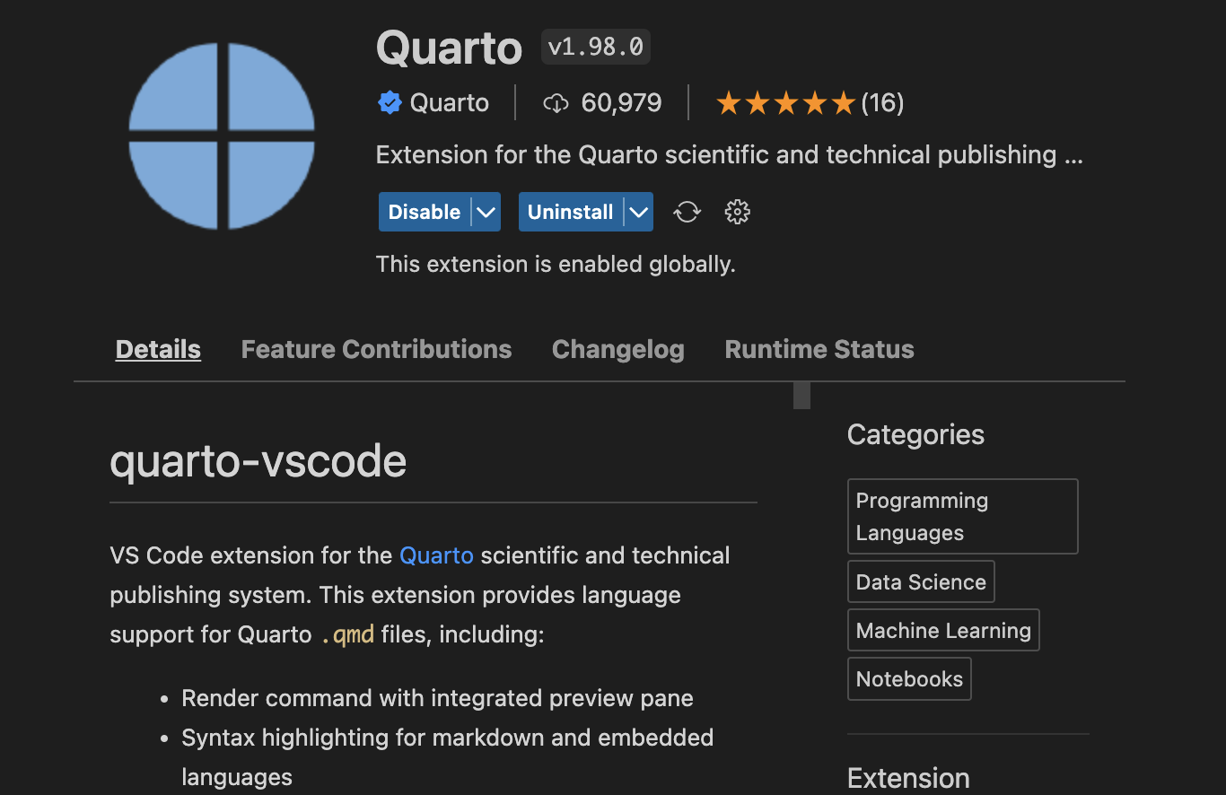

# Generate your first Quarto document

As I mentioned above, Quarto can support many output formats. Today, I am going to show you how to generate HTML documents, Reveal.js slides, and Quarto website with GitHub Pages. For a full list of reference, please visit this page: <https://quarto.org/docs/guide/>.

## Quarto Notebook (HTML)

* Quarto provides a Notebook Editor and a Visual Editor mode to write the document. (DEMO)
* 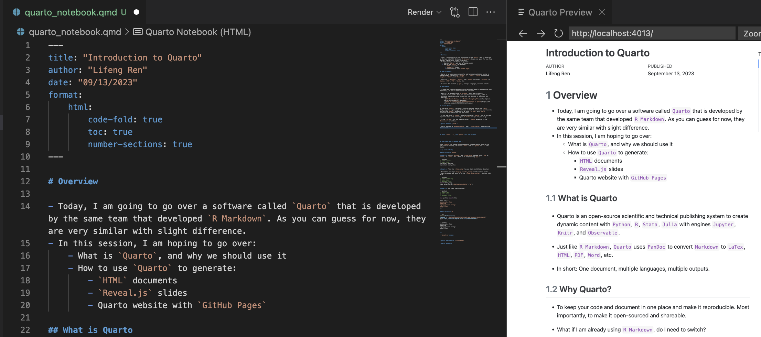 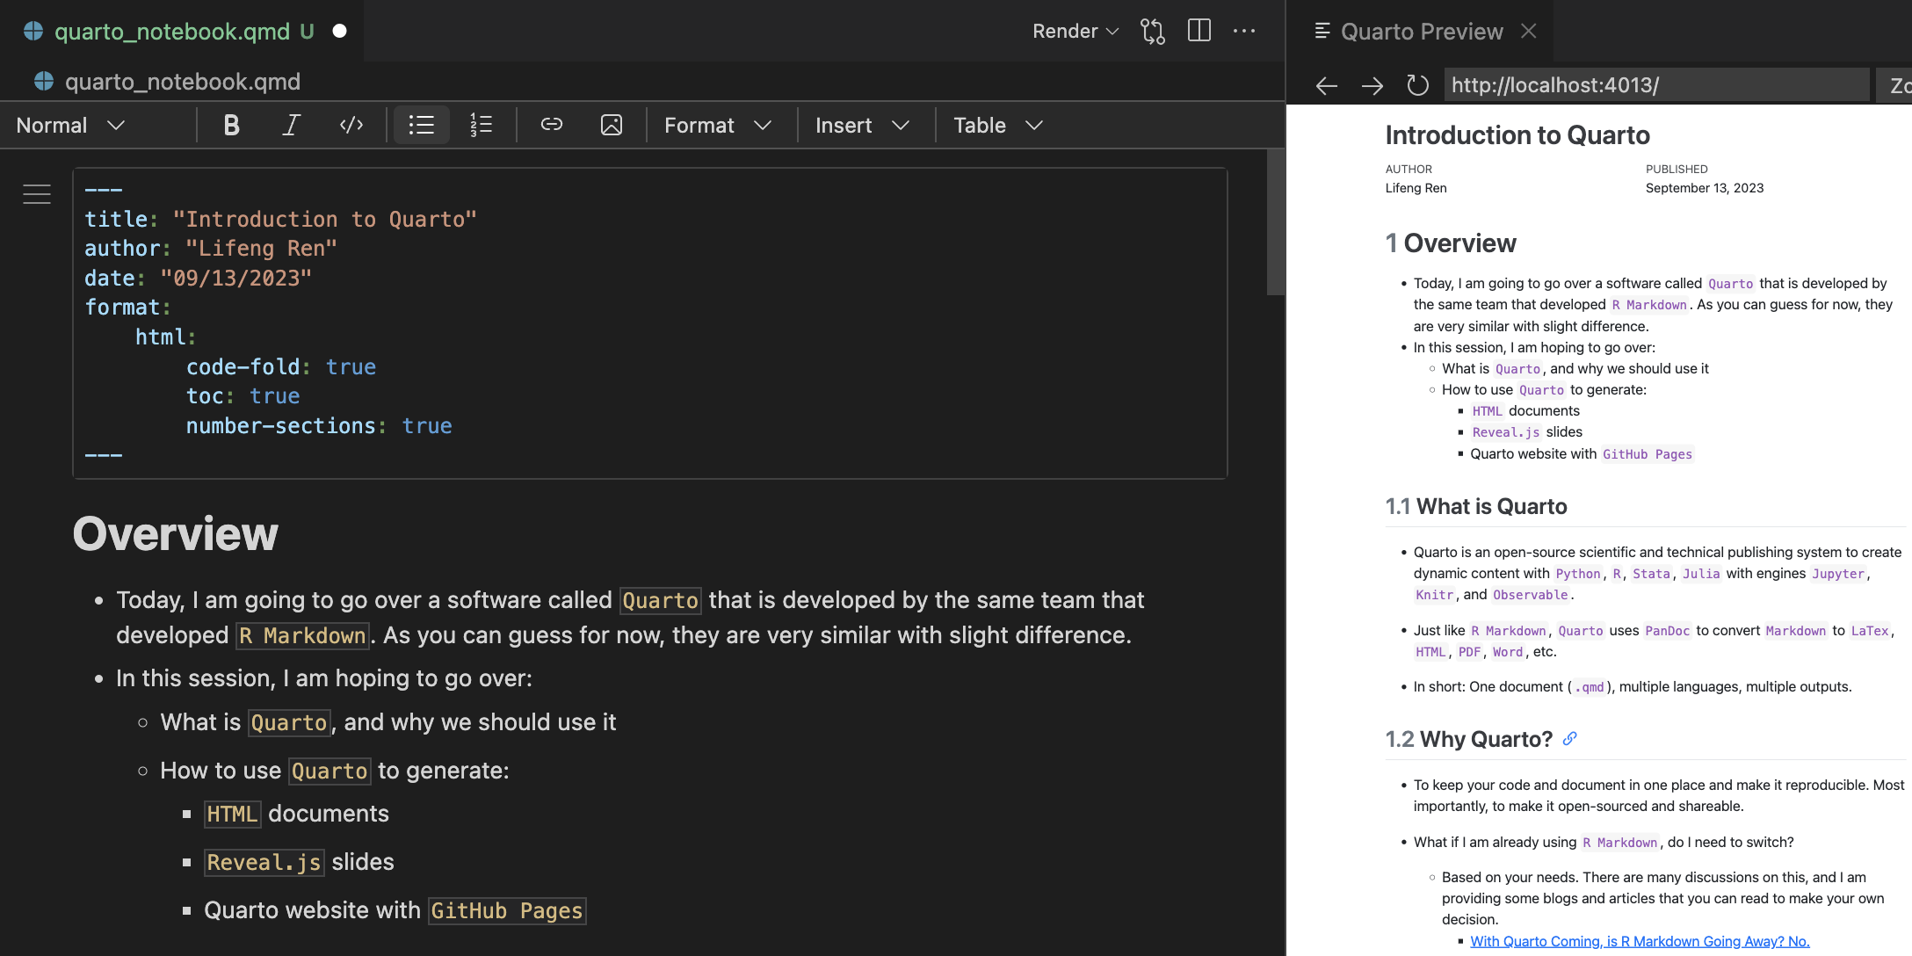
* It has sim

## Weave Stata, R, and Python into one Document

## Run Stata Code in Python and R

Since Quarto can choose the corresponding language engine based on the code chunk’s language, we can run Stata code in Python and R code chunks.

### Run Stata in Python

**Step 1:** Install pystata, and stata_setup package using pip or conda, or mamba, etc. (Here is an example using pip)

pip install pystata  
pip install stata_setup

**Step 2:** Point the stata_setup to your Stata installation directory

* Open Stata, and type display c(sysdir_stata) in the command window.
* Copy the output and paste it in the stata_setup.config() function like below.

import stata_setup  
stata_setup.config('/Applications/Stata/', 'mp')

___ ____ ____ ____ ____ ®  
 /__ / ____/ / ____/ 17.0  
___/ / /___/ / /___/ MP—Parallel Edition  
  
 Statistics and Data Science Copyright 1985-2021 StataCorp LLC  
 StataCorp  
 4905 Lakeway Drive  
 College Station, Texas 77845 USA  
 800-STATA-PC https://www.stata.com  
 979-696-4600 stata@stata.com  
  
Stata license: Single-user 8-core , expiring 1 Jan 2025  
Serial number: 501709301094  
 Licensed to: Lifeng Ren  
 APEC  
  
Notes:  
 1. Unicode is supported; see help unicode_advice.  
 2. More than 2 billion observations are allowed; see help obs_advice.  
 3. Maximum number of variables is set to 5,000; see help set_maxvar.

**Step 3:** Run Stata code in Python

from pystata import stata  
  
stata.run('''  
sysuse auto, clear  
summarize  
reg mpg price i.foreign  
ereturn list  
''')

.   
. sysuse auto, clear  
(1978 automobile data)  
  
. summarize  
  
 Variable | Obs Mean Std. dev. Min Max  
-------------+---------------------------------------------------------  
 make | 0  
 price | 74 6165.257 2949.496 3291 15906  
 mpg | 74 21.2973 5.785503 12 41  
 rep78 | 69 3.405797 .9899323 1 5  
 headroom | 74 2.993243 .8459948 1.5 5  
-------------+---------------------------------------------------------  
 trunk | 74 13.75676 4.277404 5 23  
 weight | 74 3019.459 777.1936 1760 4840  
 length | 74 187.9324 22.26634 142 233  
 turn | 74 39.64865 4.399354 31 51  
displacement | 74 197.2973 91.83722 79 425  
-------------+---------------------------------------------------------  
 gear_ratio | 74 3.014865 .4562871 2.19 3.89  
 foreign | 74 .2972973 .4601885 0 1  
  
. reg mpg price i.foreign  
  
 Source | SS df MS Number of obs = 74  
-------------+---------------------------------- F(2, 71) = 23.01  
 Model | 960.866305 2 480.433152 Prob > F = 0.0000  
 Residual | 1482.59315 71 20.8815937 R-squared = 0.3932  
-------------+---------------------------------- Adj R-squared = 0.3761  
 Total | 2443.45946 73 33.4720474 Root MSE = 4.5696  
  
------------------------------------------------------------------------------  
 mpg | Coefficient Std. err. t P>|t| [95% conf. interval]  
-------------+----------------------------------------------------------------  
 price | -.000959 .0001815 -5.28 0.000 -.001321 -.000597  
 |  
 foreign |  
 Foreign | 5.245271 1.163592 4.51 0.000 2.925135 7.565407  
 _cons | 25.65058 1.271581 20.17 0.000 23.11512 28.18605  
------------------------------------------------------------------------------  
  
. ereturn list  
  
scalars:  
 e(N) = 74  
 e(df_m) = 2  
 e(df_r) = 71  
 e(F) = 23.00749448574634  
 e(r2) = .3932401256962295  
 e(rmse) = 4.569638248831391  
 e(mss) = 960.8663049714787  
 e(rss) = 1482.593154487981  
 e(r2_a) = .3761482982510528  
 e(ll) = -215.9083177127538  
 e(ll_0) = -234.3943376482347  
 e(rank) = 3  
  
macros:  
 e(cmdline) : "regress mpg price i.foreign"  
 e(title) : "Linear regression"  
 e(marginsok) : "XB default"  
 e(vce) : "ols"  
 e(depvar) : "mpg"  
 e(cmd) : "regress"  
 e(properties) : "b V"  
 e(predict) : "regres_p"  
 e(model) : "ols"  
 e(estat_cmd) : "regress_estat"  
  
matrices:  
 e(b) : 1 x 4  
 e(V) : 4 x 4  
 e(beta) : 1 x 3  
  
functions:  
 e(sample)   
  
.

### Run Stata in R

library(Statamarkdown)

Stata found at /Applications/Stata/StataMP.app/Contents/MacOS/StataMP

The 'stata' engine is ready to use.

stataexe <- "/Applications/Stata/StataMP.app/Contents/MacOS/StataMP"  
knitr::opts_chunk$set(engine.path=list(stata=stataexe))

sysuse auto, clear  
summarize  
reg mpg price i.foreign  
ereturn list

(1978 automobile data)  
  
 Variable | Obs Mean Std. dev. Min Max  
-------------+---------------------------------------------------------  
 make | 0  
 price | 74 6165.257 2949.496 3291 15906  
 mpg | 74 21.2973 5.785503 12 41  
 rep78 | 69 3.405797 .9899323 1 5  
 headroom | 74 2.993243 .8459948 1.5 5  
-------------+---------------------------------------------------------  
 trunk | 74 13.75676 4.277404 5 23  
 weight | 74 3019.459 777.1936 1760 4840  
 length | 74 187.9324 22.26634 142 233  
 turn | 74 39.64865 4.399354 31 51  
displacement | 74 197.2973 91.83722 79 425  
-------------+---------------------------------------------------------  
 gear_ratio | 74 3.014865 .4562871 2.19 3.89  
 foreign | 74 .2972973 .4601885 0 1  
  
 Source | SS df MS Number of obs = 74  
-------------+---------------------------------- F(2, 71) = 23.01  
 Model | 960.866305 2 480.433152 Prob > F = 0.0000  
 Residual | 1482.59315 71 20.8815937 R-squared = 0.3932  
-------------+---------------------------------- Adj R-squared = 0.3761  
 Total | 2443.45946 73 33.4720474 Root MSE = 4.5696  
  
------------------------------------------------------------------------------  
 mpg | Coefficient Std. err. t P>|t| [95% conf. interval]  
-------------+----------------------------------------------------------------  
 price | -.000959 .0001815 -5.28 0.000 -.001321 -.000597  
 |  
 foreign |  
 Foreign | 5.245271 1.163592 4.51 0.000 2.925135 7.565407  
 _cons | 25.65058 1.271581 20.17 0.000 23.11512 28.18605  
------------------------------------------------------------------------------  
  
  
scalars:  
 e(N) = 74  
 e(df_m) = 2  
 e(df_r) = 71  
 e(F) = 23.00749448574634  
 e(r2) = .3932401256962295  
 e(rmse) = 4.569638248831391  
 e(mss) = 960.8663049714787  
 e(rss) = 1482.593154487981  
 e(r2_a) = .3761482982510528  
 e(ll) = -215.9083177127538  
 e(ll_0) = -234.3943376482347  
 e(rank) = 3  
  
macros:  
 e(cmdline) : "regress mpg price i.foreign"  
 e(title) : "Linear regression"  
 e(marginsok) : "XB default"  
 e(vce) : "ols"  
 e(depvar) : "mpg"  
 e(cmd) : "regress"  
 e(properties) : "b V"  
 e(predict) : "regres_p"  
 e(model) : "ols"  
 e(estat_cmd) : "regress_estat"  
  
matrices:  
 e(b) : 1 x 4  
 e(V) : 4 x 4  
 e(beta) : 1 x 3  
  
functions:  
 e(sample)

# Reveal.js slides

# Quarto website with GitHub Pages

# Useful Resources