EDLD 640 Capstone Agreement

Lea Frank

I am currently enrolled in *EDLD 640: Educational Data Science Capstone*, the final course needed for an *Educational Data Science Specialization* offered through the College of Education. This letter is to communicate an agreement between myself, the Brain & Memory Lab, and Dr. Anderson (the instructor of EDLD 640). A brief description of the planned capstone project in partnership with the Brain & Memory Lab is provided below.

In functional MRI pattern analyses, we are sometimes faced with classification problems where the training set contains unequal class sizes. For example, if we are trying to predict activity for remembered v. forgotten pictures, we may find that there are more remembered than forgotten trials. Unequal observations between the classes may bias the classifier to predict the more frequently observed class. In other words, if trained on more “remembered” trials, the classifier may be more likely to predict trials in the untrained set as “remembered.”

For this project, I will create a shiny dashboard testing the robustness of different machine learning classification algorithm (e.g., support vector machine, artificial neural networks) against unequal class sizes. The data will be taken from a previously conducted functional MRI project where participants studied pictures of animals and tools. The classifiers will be trained to predict the type of trial (animal v. tool) from patterns of brain activity. The class sizes in the training set will be adjusted to different ratios (e.g., 1:1, 1:2, 1:3, 1:4). The performance of the classifiers will then be tested on a withheld sample. The shiny dashboard will allow me to test different features of the algorithms (e.g., ratio of class sizes) to see how performance is affected. If available, classification algorithms will be taken from multiple sources (e.g., SVM in `e1071` or `caret`) to see if this also impacts robustness against unequal class sizes.

*Signatures*

*Jan 17, 2021*

_____________________ _____________

[your name] Date

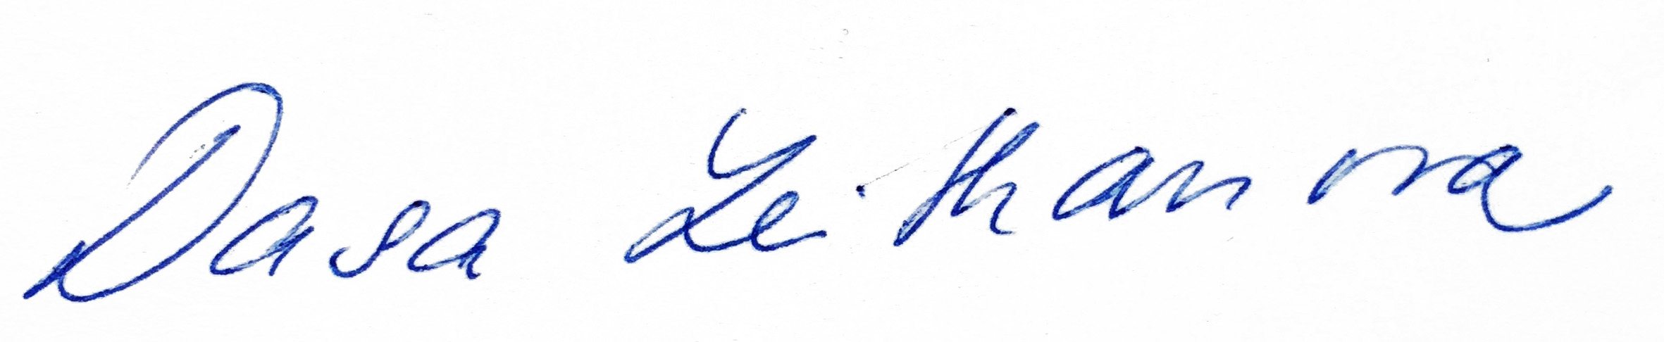

_____________________ _____Jan 15, 2022____

Dasa Zeithamova, Principle Investigator, University of Oregon Date

_____________________ _____________

Daniel Anderson Dat