**Blood-Bank-Management-System**



**Student: Luis Rodriguez**

**Group 1068**

**Series G, 2nd Year**

**Romania**

**Bucharest, 2022**



### 1. Description of the chosen theme:

Blood bank is a place where blood bag that is collected from blood donation events is stored in one place. The term “blood bank” refers to a division of a hospital laboratory where the storage of blood product occurs and where proper testing is performed to reduce the risk of transfusion related events.

Blood Bank Management System is a web-based system that can assists the information of blood bag during its handling in the blood bank. With this system, the user of this system can key in the result of blood test that has been conducted to each of the blood bag received by the blood bank. The result of test will indicate whether the blood bag can be delivered to patient or not.

The process of managing the blood bag that is received from the blood donation events needs a proper and systematic management. The blood bag must be handled with care and treated thoroughly as it is related to someone’s life. The development of Web-based Blood Bank Management System is proposed to provide a management functional to the blood bank in order to handle the blood bag.

Consisting data of different blood groups along with the medical history by bringing donors and recipients of blood on a single platform and suggesting nearest blood transfusion center according to the location of user, all the data is located in Romania.

Our database is composed from 9 Tables: (1) HOSPITAL,(2)INVENTORY,(3)PATIENT,(4)TRANS,

(5)REQUEST_TYPE,(6)USER_TYPE,(7)USER_CREDS,(8)PATIENT_TYPE, (9)BILLING

1.**HOSPITAL**: is a table that store Hospitals name,Adress and phone numbers

2.**INVENTORY:**is a table that store H_ID ,PT_BTYPE,TOTAL_BLOOD_UNIT,INVENTORY_ID.

3.**PATIENT:** is a table that store

PT_ID,USER_ID,PT_FIRST_NAME,PT_LAST_NAME,PT_ADRESS,PT_TYPE_ID,PT_GENDER,PT_AGE,PT_BTYP E,PT_STD,PATIENT_PHONE,PT_WEIGHT.

4.**TRANS:**is a table that store

TRANS_ID,PT_ID,T_DATE,REQUEST_TYPE_ID,PT_BTYPE,BLOOD_UNIT,H_ID,INVENTORY_ID.

5.**REQUEST_TYPE:**is a table that store REQUEST_TYPE_ID and REQUEST_TYPE_NAME.

6.**USER_TYPE:**is a table that store USER_TYPE_ID and USER_TYPE_NAME.

7**.USER_CREDS:**is a table that store USER_ID,PASSWORD,USERNAME,USER_TYPE_ID.

8.**PATIENT_TYPE:**is a table that store PT_TYPE_ID and PT_TYPE_NAME.

9.**BILLING:**is a table that store BILL_ID,PT_ID,AMOUNT,TRANS_ID,T_DATE

## 2. Conceptual scheme for modeling the chosen theme:

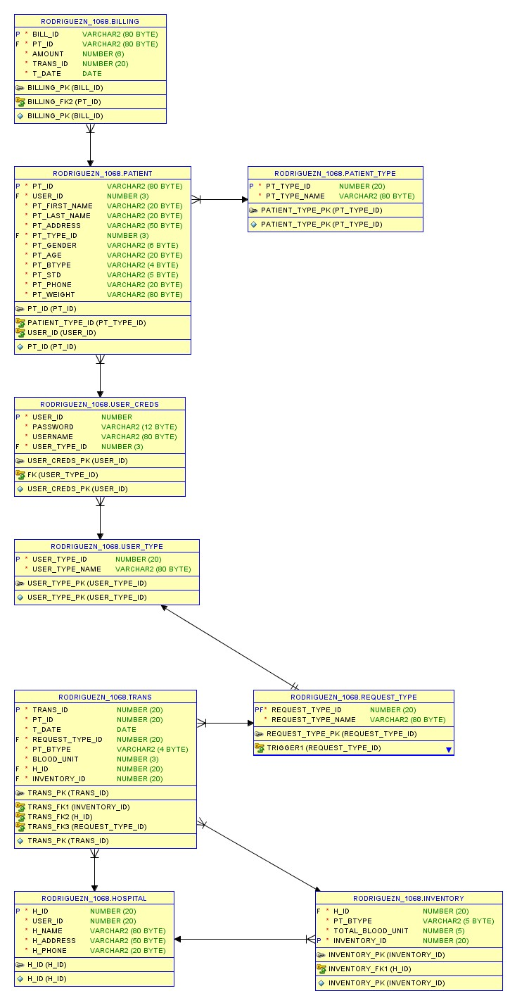

The attributes have the following constraints:

1. **Table HOSPITAL:**

H_ID NOT NULL ,

USER_ID NOT NULL ,

H_NAME NOT NULL ,

H_ADDRESS NOT NULL ,

H_PHONE NOT NULL ,

CONSTRAINT H_ID PRIMARY KEY (H_ID)

1. **Table INVENTORY:**

H_ID NOT NULL , PT_BTYPE NOT NULL ,

TOTAL_BLOOD_UNIT NOT NULL ,

INVENTORY_ID NOT NULL ,

CONSTRAINT INVENTORY_PK PRIMARY KEY (INVENTORY_ID),

CONSTRAINT INVENTORY_FK1 FOREIGN KEY (H_ID),

REFERENCES HOSPITAL (H_ID)

1. **Table PATIENT:**

PT_ID NOT NULL , USER_ID NOT NULL ,

PT_FIRST_NAME NOT NULL ,

PT_LAST_NAME ,

PT_ADDRESS NOT NULL ,

PT_TYPE_ID NOT NULL ,

PT_GENDER NOT NULL ,

PT_AGE NOT NULL ,

PT_BTYPE NOT NULL , PT_STD NOT NULL ,

PT_PHONE NOT NULL ,

CONSTRAINT PT_ID PRIMARY KEY (PT_ID),

CONSTRAINT USER_ID FOREIGN KEY (USER_ID)

REFERENCES USER_CREDS (USER_ID) ,

CONSTRAINT PATIENT_TYPE_ID FOREIGN KEY (PT_TYPE_ID)

REFERENCES PATIENT_TYPE (PT_TYPE_ID)

4. **Table TRANS:**

TRANS_ID NOT NULL , PT_ID NOT NULL ,

T_DATE DATE NOT NULL ,

REQUEST_TYPE_ID NOT NULL ,

PT_BTYPE NOT NULL ,

BLOOD_UNIT NOT NULL ,

H_ID NOT NULL ,

INVENTORY_ID NOT NULL ,

CONSTRAINT TRANS_PK PRIMARY KEY (TRANS_ID),

CONSTRAINT TRANS_FK1 FOREIGN KEY (INVENTORY_ID)

REFERENCES INVENTORY (INVENTORY_ID) ,

CONSTRAINT TRANS_FK2 FOREIGN KEY (H_ID)

REFERENCES HOSPITAL (H_ID) ,

1. **Table REQUEST_TYPE:**

REQUEST_TYPE_ID NOT NULL,

REQUEST_TYPE_NAME NOT NULL ,

CONSTRAINT REQUEST_TYPE_PK

PRIMARY KEY ("REQUEST_TYPE_ID")

1. **Table USER_TYPE:**

USER_TYPE_ID NOT NULL ENABLE, USER_TYPE_NAME NOT NULL ENABLE,

CONSTRAINT USER_TYPE_PK PRIMARY KEY ("USER_TYPE_ID")

1. **Table USER_CREDS:**

USER_ID NOT NULL , PASSWORD NOT NULL ,

USERNAME NOT NULL ,

USER_TYPE_ID NOT NULL ,

CONSTRAINT USER_CREDS_PK PRIMARY KEY (USER_ID),

CONSTRAINT FK FOREIGN KEY (USER_TYPE_ID)

REFERENCES USER_TYPE (USER_TYPE_ID)

1. **PATIENT_TYPE:**

PT_TYPE_ID NOT NULL ENABLE, PT_TYPE_NAME NOT NULL ENABLE,

CONSTRAINT PATIENT_TYPE_PK PRIMARY KEY ("PT_TYPE_ID")

1. **BILLING:**

BILL_ID NOT NULL ENABLE, PT_ID NOT NULL ,

AMOUNT NOT NULL,

TRANS_ID NOT NULL ,

T_DATE" DATE NOT NULL ,

CONSTRAINT BILLING_PK PRIMARY KEY ("BILL_ID")

## Constructing the database: tables and constraints:

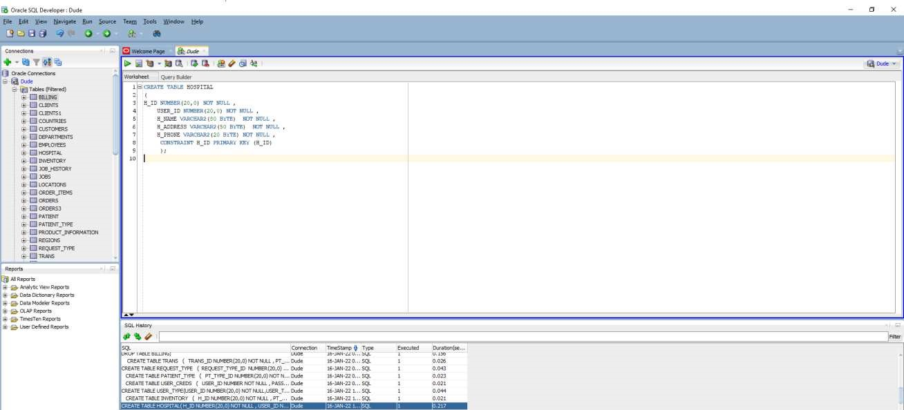

**CREATE TABLE HOSPITAL**

**(**

**H_ID NUMBER(20,0) NOT NULL ,**

**USER_ID NUMBER(20,0) NOT NULL ,**

**H_NAME VARCHAR2(80 BYTE) NOT NULL ,**

**H_ADDRESS VARCHAR2(50 BYTE) NOT NULL ,**

**H_PHONE VARCHAR2(20 BYTE) NOT NULL ,**

**CONSTRAINT H_ID PRIMARY KEY (H_ID)**

**);**

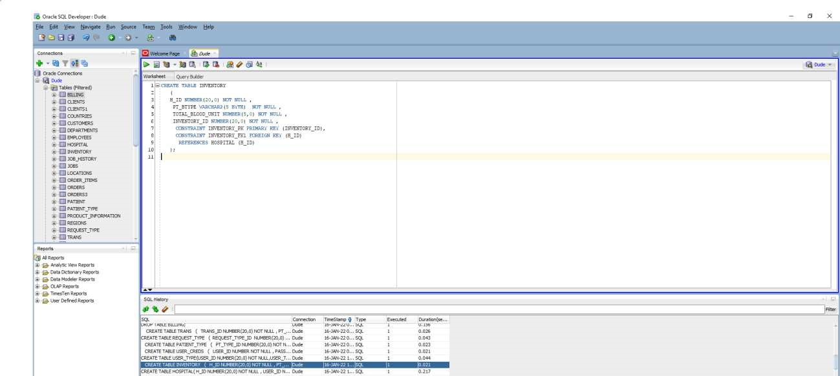

**CREATE TABLE INVENTORY**

**(**

**H_ID NUMBER(20,0) NOT NULL ,**

**PT_BTYPE VARCHAR2(5 BYTE) NOT NULL ,**

**TOTAL_BLOOD_UNIT NUMBER(5,0) NOT NULL ,**

**INVENTORY_ID NUMBER(20,0) NOT NULL ,**

**CONSTRAINT INVENTORY_PK PRIMARY KEY (INVENTORY_ID),**

**CONSTRAINT INVENTORY_FK1 FOREIGN KEY (H_ID)**

**REFERENCES HOSPITAL (H_ID)**

**);**

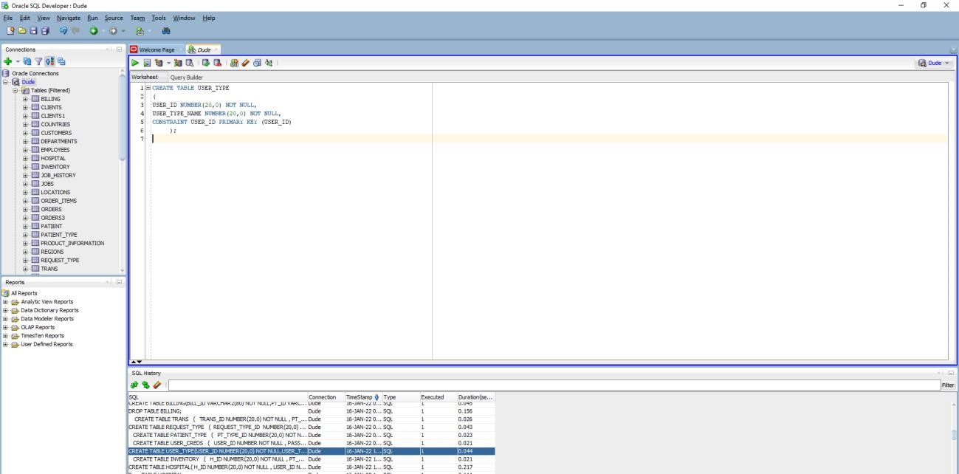

**CREATE TABLE USER_TYPE**

**(**

**USER_ID NUMBER(20,0) NOT NULL,**

**USER_TYPE_NAME NUMBER(20,0) NOT NULL,**

**CONSTRAINT USER_ID PRIMARY KEY (USER_ID)**

**);**

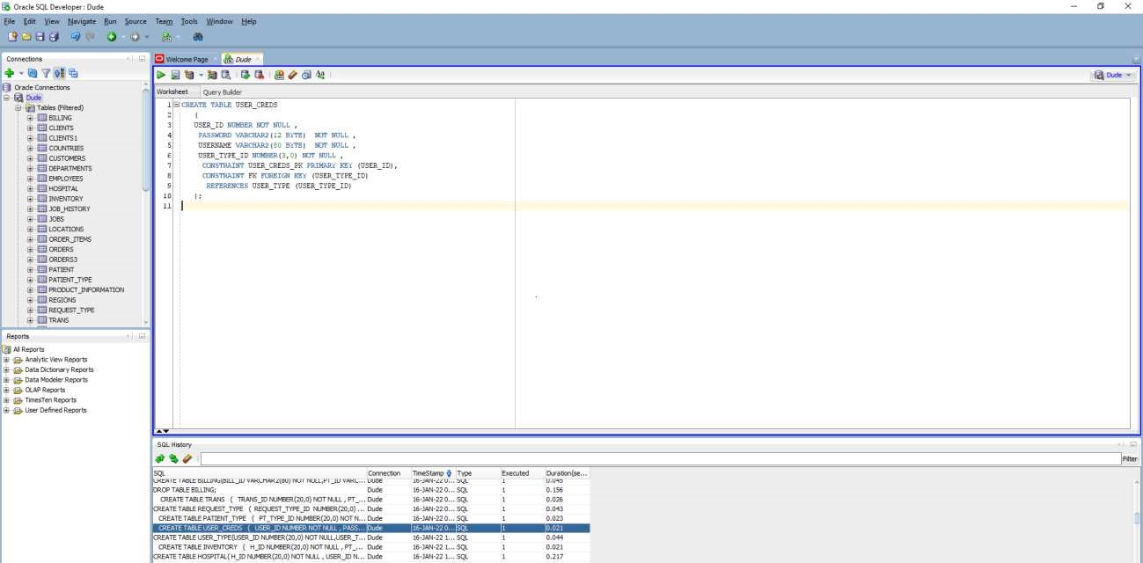

**CREATE TABLE USER_CREDS**

**(**

**USER_ID NUMBER NOT NULL ,**

**PASSWORD VARCHAR2(12 BYTE) NOT NULL ,**

**USERNAME VARCHAR2(80 BYTE) NOT NULL ,**

**USER_TYPE_ID NUMBER(3,0) NOT NULL ,**

**CONSTRAINT USER_CREDS_PK PRIMARY KEY (USER_ID),**

**CONSTRAINT FK FOREIGN KEY (USER_TYPE_ID) REFERENCES USER_TYPE (USER_TYPE_ID)**

**);**

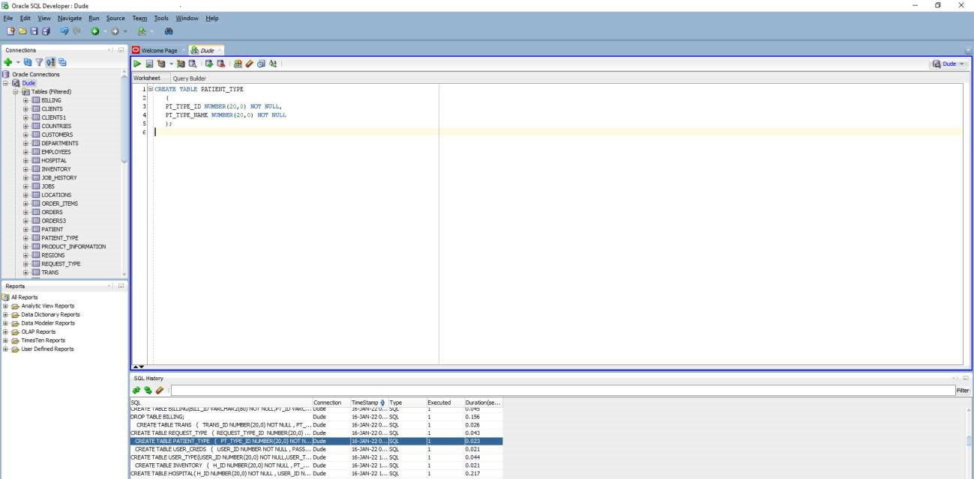

**CREATE TABLE PATIENT_TYPE**

**(**

**PT_TYPE_ID NUMBER(20,0) NOT NULL,**

**PT_TYPE_NAME NUMBER(20,0) NOT NULL**

**);**

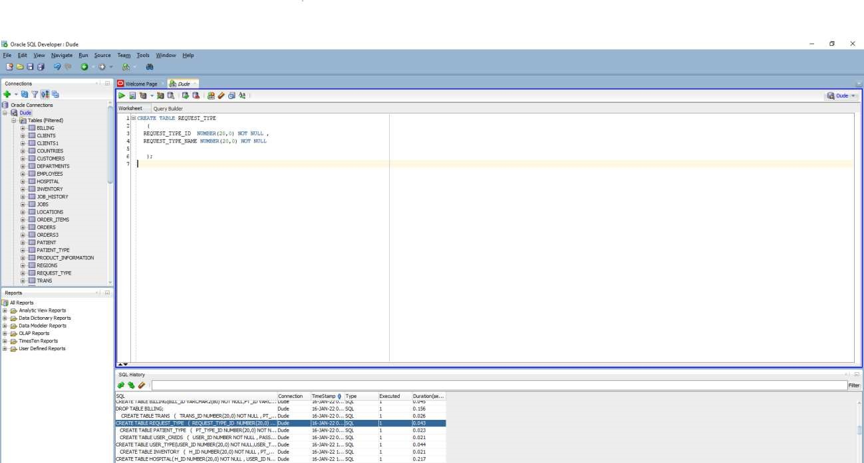

**CREATE TABLE REQUEST_TYPE**

**(**

**REQUEST_TYPE_ID NUMBER(20,0) NOT NULL ,**

**REQUEST_TYPE_NAME NUMBER(20,0) NOT NULL**

**);**

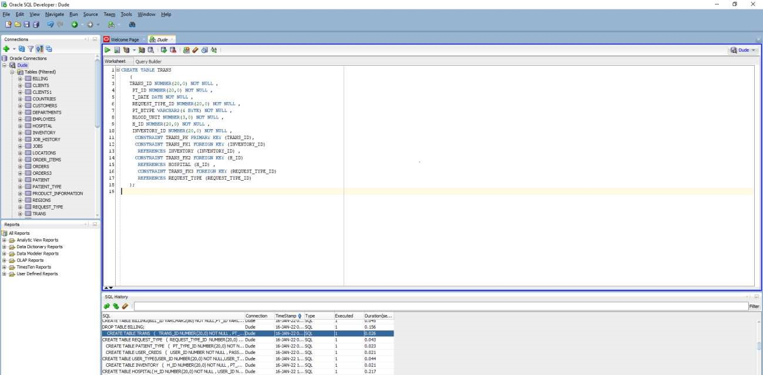

**CREATE TABLE TRANS**

**(**

**TRANS_ID NUMBER(20,0) NOT NULL ,**

**PT_ID NUMBER(20,0) NOT NULL ,**

**T_DATE DATE NOT NULL ,**

**REQUEST_TYPE_ID NUMBER(20,0) NOT NULL ,**

**PT_BTYPE VARCHAR2(4 BYTE) NOT NULL ,**

**BLOOD_UNIT NUMBER(3,0) NOT NULL ,**

**H_ID NUMBER(20,0) NOT NULL ,**

**INVENTORY_ID NUMBER(20,0) NOT NULL ,**

**CONSTRAINT TRANS_PK PRIMARY KEY (TRANS_ID),**

**CONSTRAINT TRANS_FK1 FOREIGN KEY (INVENTORY_ID)**

**REFERENCES INVENTORY (INVENTORY_ID) ,**

**CONSTRAINT TRANS_FK2 FOREIGN KEY (H_ID)**

**REFERENCES HOSPITAL (H_ID) ,**

**CONSTRAINT TRANS_FK3 FOREIGN KEY (REQUEST_TYPE_ID)**

**REFERENCES REQUEST_TYPE (REQUEST_TYPE_ID)**

**);**

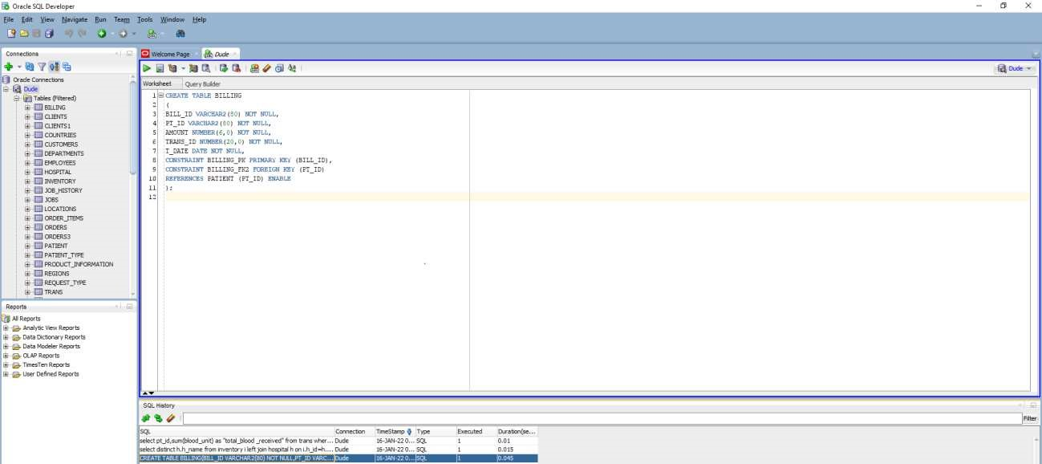

**CREATE TABLE BILLING**

**(**

**BILL_ID VARCHAR2(80) NOT NULL,**

**PT_ID VARCHAR2(80) NOT NULL,**

**AMOUNT NUMBER(6,0) NOT NULL,**

**TRANS_ID NUMBER(20,0) NOT NULL,**

**T_DATE DATE NOT NULL,**

**CONSTRAINT BILLING_PK PRIMARY KEY (BILL_ID),**

**CONSTRAINT BILLING_FK2 FOREIGN KEY (PT_ID)**

**REFERENCES PATIENT (PT_ID) ENABLE**

**);**

# DML statements:

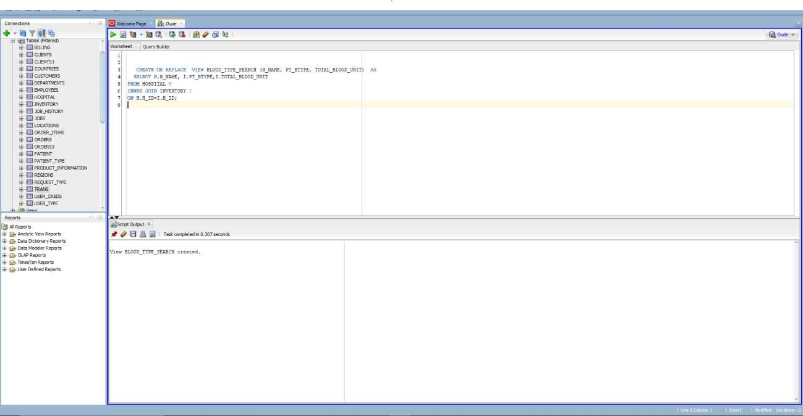

Blood type search by location

**CREATE OR REPLACE VIEW BLOOD_TYPE_SEARCH (H_NAME, PT_BTYPE, TOTAL_BLOOD_UNIT) AS**

**SELECT H.H_NAME, I.PT_BTYPE,I.TOTAL_BLOOD_UNIT**

**FROM HOSPITAL H**

**INNER JOIN INVENTORY I**

**ON H.H_ID=I.H_ID;**

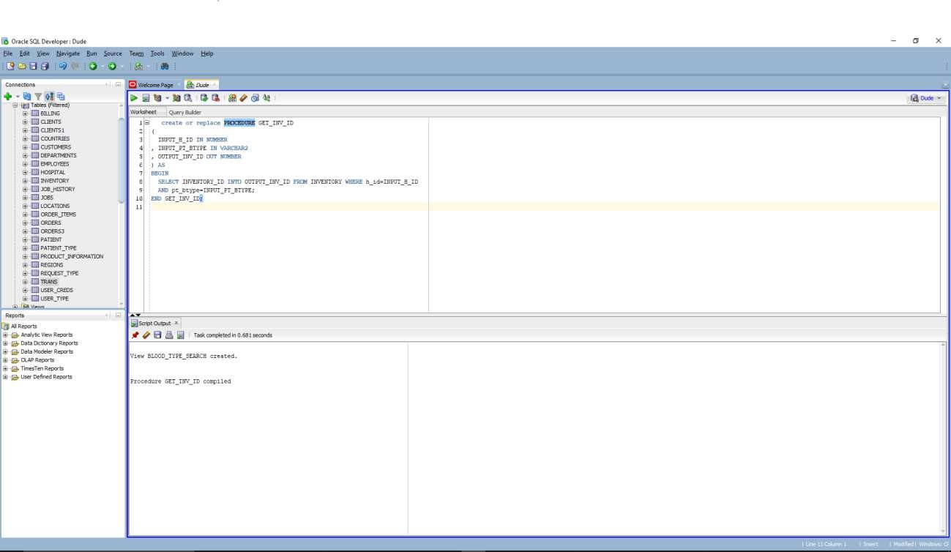

Stored Procedure ( Determining the inventory_ID for coresponding H_id and PT_btype) create or replace PROCEDURE GET_INV_ID

(

INPUT_H_ID IN NUMBER

, INPUT_PT_BTYPE IN VARCHAR2

, OUTPUT_INV_ID OUT NUMBER

) AS

BEGIN

SELECT INVENTORY_ID INTO OUTPUT_INV_ID FROM INVENTORY WHERE h_id=INPUT_H_ID

AND pt_btype=INPUT_PT_BTYPE;

END GET_INV_ID;

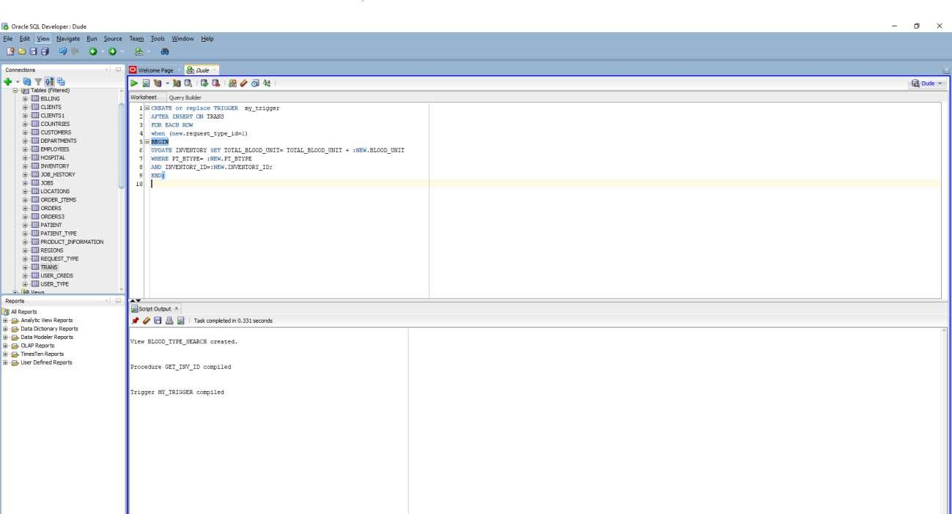

CREATE or replace TRIGGER my_trigger

AFTER INSERT ON TRANS FOR EACH ROW when (new.request_type_id=1)

BEGIN

UPDATE INVENTORY SET TOTAL_BLOOD_UNIT= TOTAL_BLOOD_UNIT + :NEW.BLOOD_UNIT

WHERE PT_BTYPE= :NEW.PT_BTYPE

AND INVENTORY_ID=:NEW.INVENTORY_ID;

END;

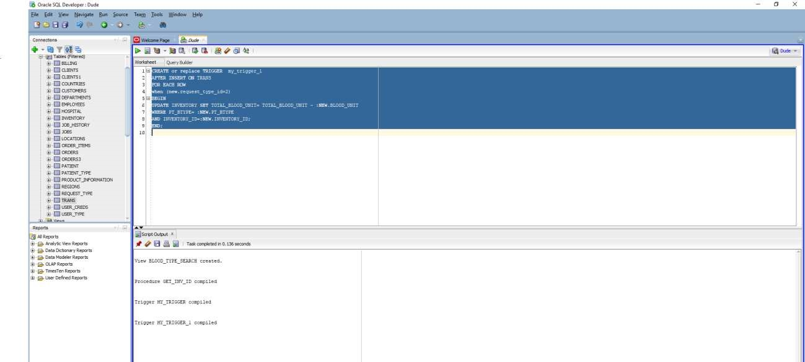

**CREATE or replace TRIGGER my_trigger_1**

**AFTER INSERT ON TRANS**

**FOR EACH ROW when (new.request_type_id=2)**

**BEGIN**

**UPDATE INVENTORY SET TOTAL_BLOOD_UNIT= TOTAL_BLOOD_UNIT - :NEW.BLOOD_UNIT**

**WHERE PT_BTYPE= :NEW.PT_BTYPE**

**AND INVENTORY_ID=:NEW.INVENTORY_ID;**

**END;**

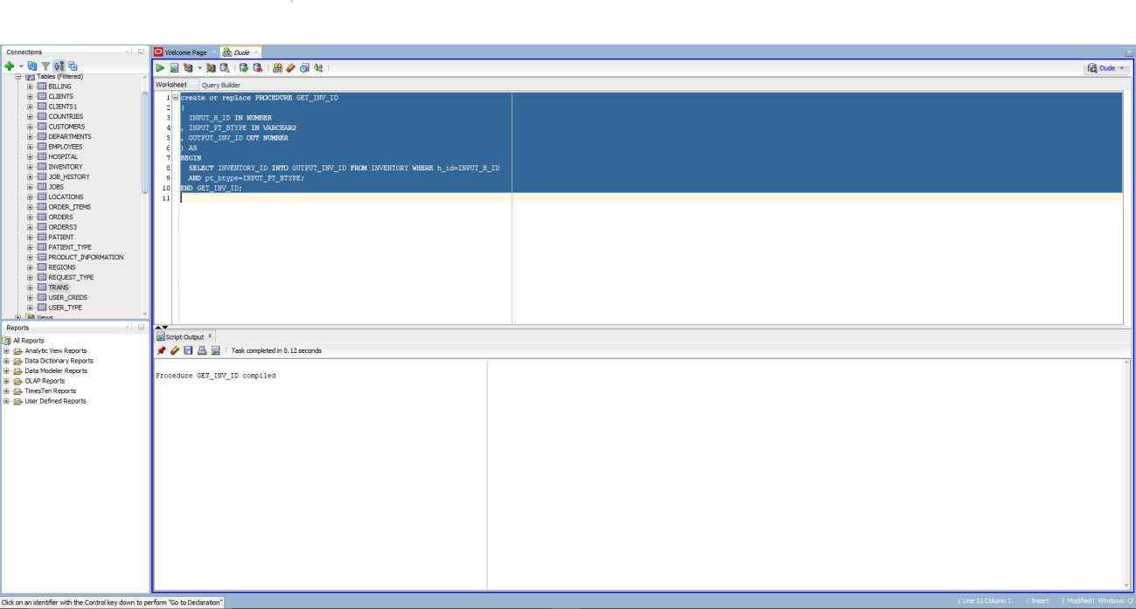

create or replace PROCEDURE GET_INV_ID

(

INPUT_H_ID IN NUMBER

, INPUT_PT_BTYPE IN VARCHAR2

, OUTPUT_INV_ID OUT NUMBER

) AS

BEGIN

SELECT INVENTORY_ID INTO OUTPUT_INV_ID FROM INVENTORY WHERE h_id=INPUT_H_ID

AND pt_btype=INPUT_PT_BTYPE;

END GET_INV_ID;

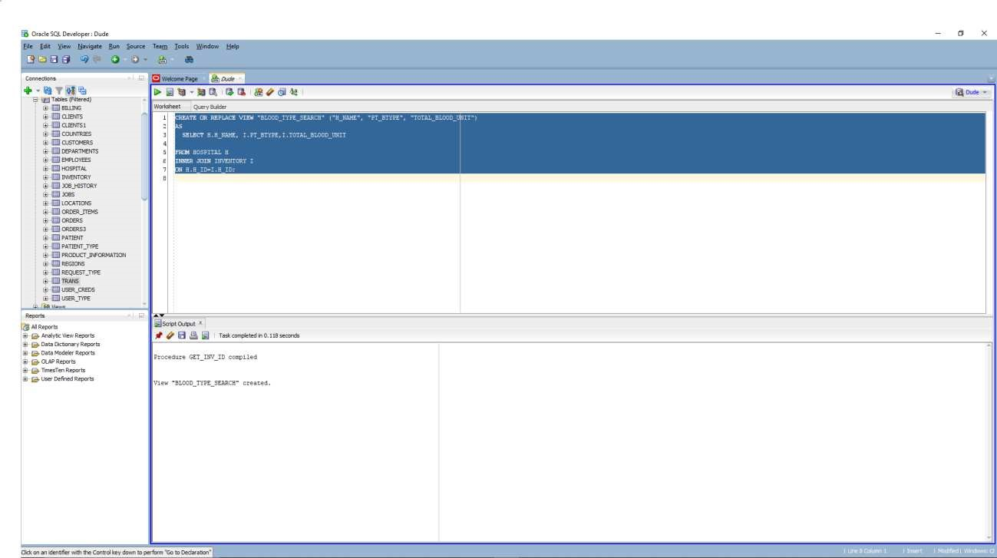

**CREATE OR REPLACE VIEW "BLOOD_TYPE_SEARCH" ("H_NAME", "PT_BTYPE", "TOTAL_BLOOD_UNIT")**

**AS**

**SELECT H.H_NAME, I.PT_BTYPE,I.TOTAL_BLOOD_UNIT**

**FROM HOSPITAL H**

**INNER JOIN INVENTORY I**

**ON H.H_ID=I.H_ID;**

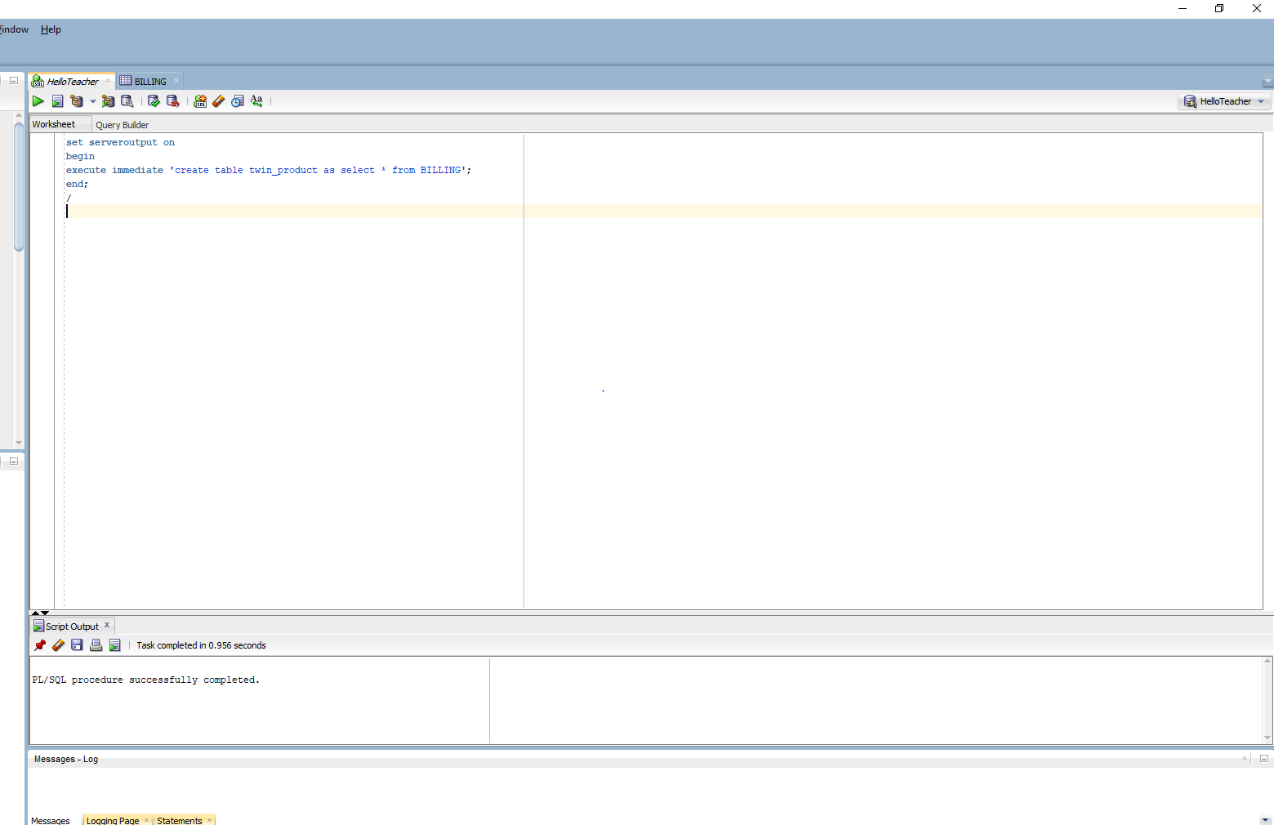

set serveroutput on

begin

execute immediate 'create table twin_product as select * from BILLING';

end;

/

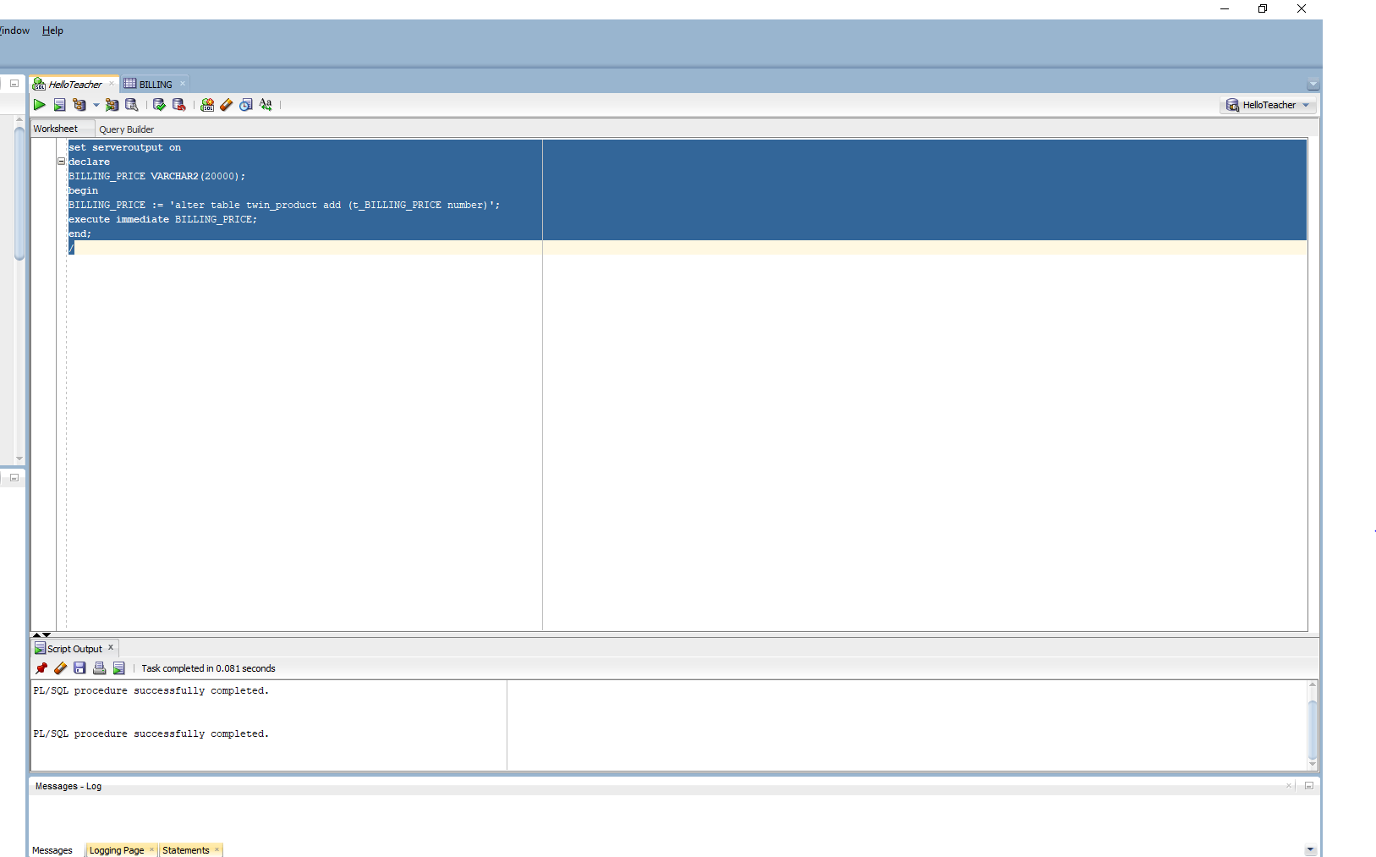

set serveroutput on

declare

BILLING_PRICE VARCHAR2(20000);

begin

BILLING_PRICE := 'alter table twin_product add (t_BILLING_PRICE number)';

execute immediate BILLING_PRICE;

end;

/

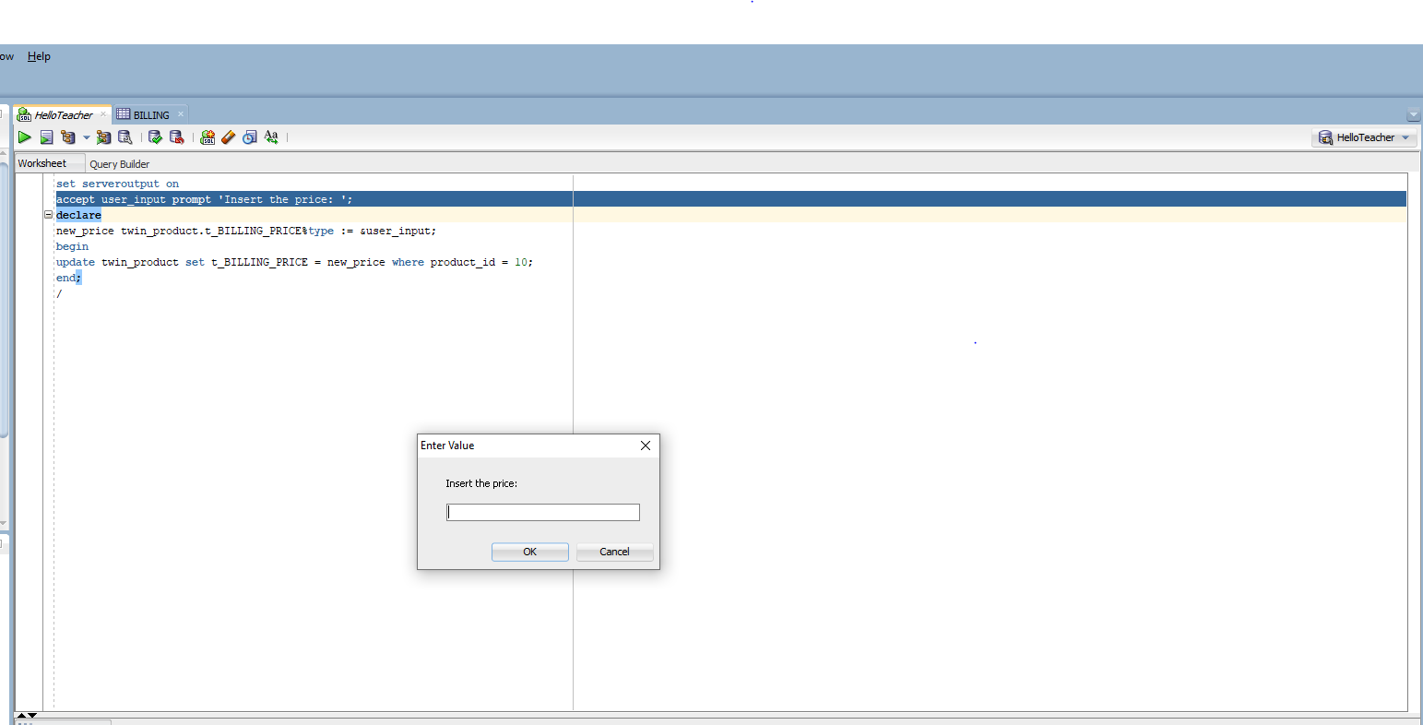

set serveroutput on

accept user_input prompt 'Insert the price: ';

declare

new_price twin_product.t_BILLING_PRICE%type := &user_input;

begin

update twin_product set t_BILLING_PRICE = new_price where product_id = 10;

end;

/

# Examples of varied queries:

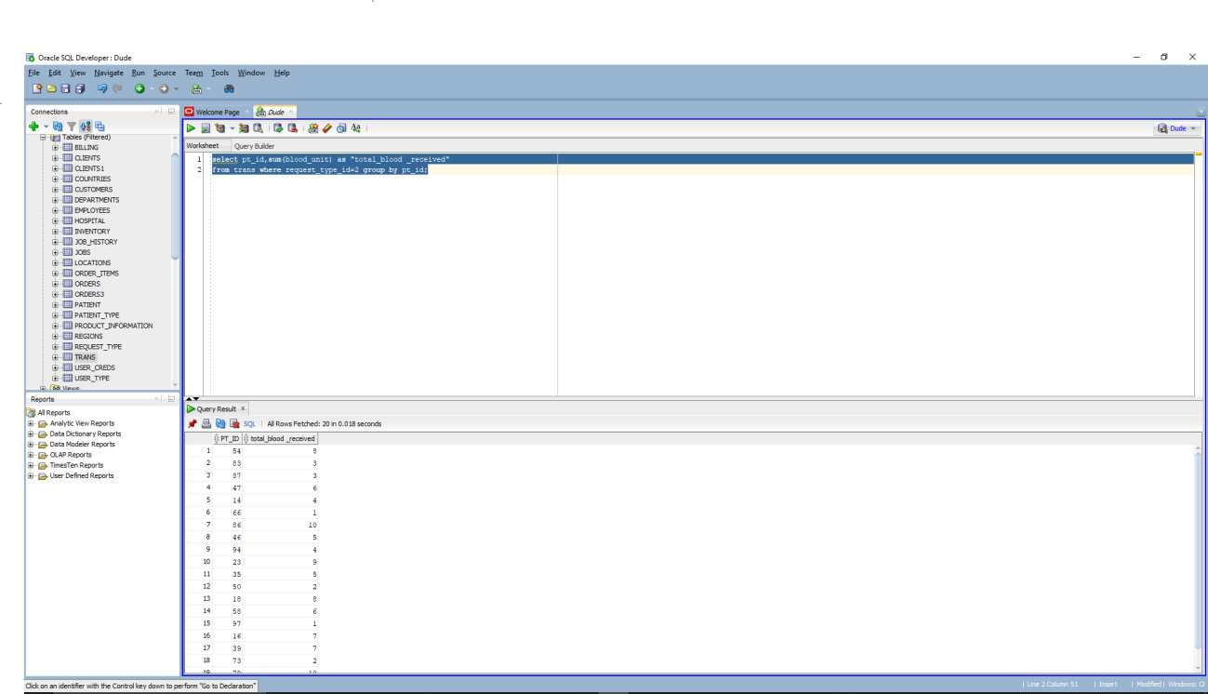

list of total blood units received by a patient

**select pt_id,sum(blood_unit) as "total_blood _received" from trans where request_type_id=2 group by pt_id;**

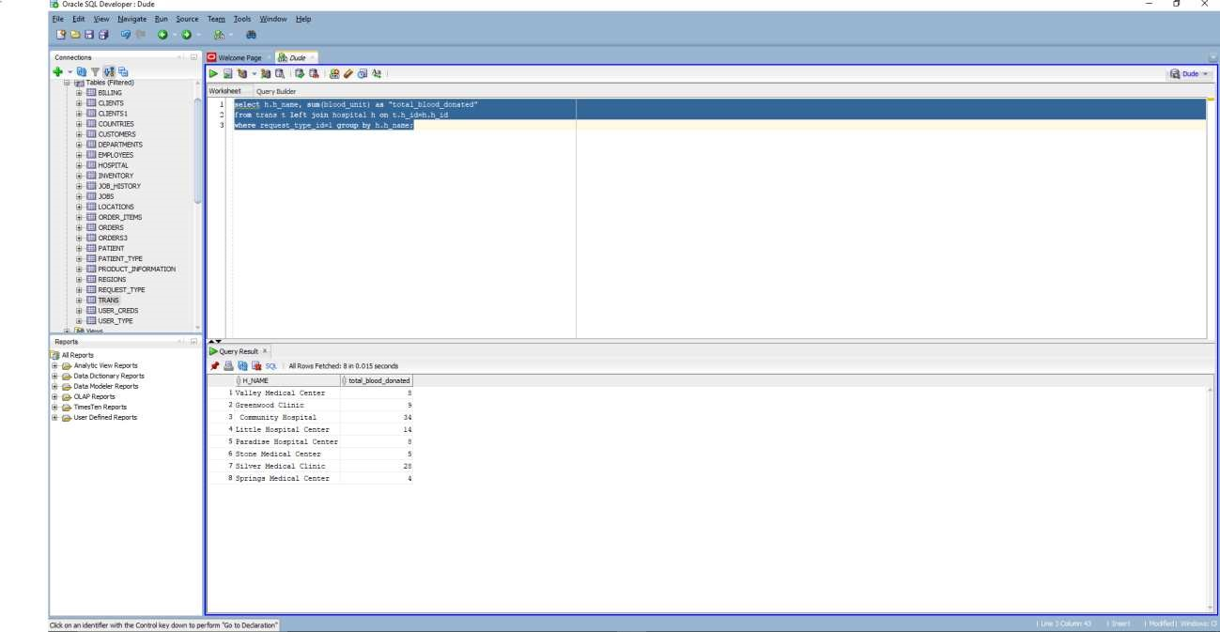

list of patients donating or receiving blood from respective hospitals **select h.h_name, sum(blood_unit) as "total_blood_donated" from trans t left join hospital h on t.h_id=h.h_id**

**where request_type_id=1 group by h.h_name;**

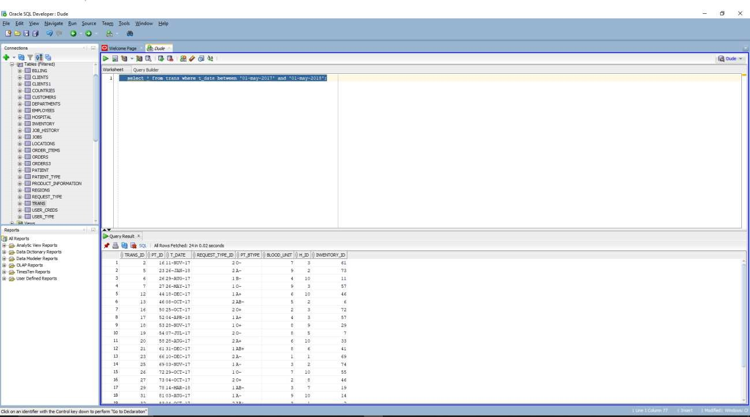

transactions between 2 dates

**select * from trans where t_date between '01-may-2017' and '01-may-2018';**

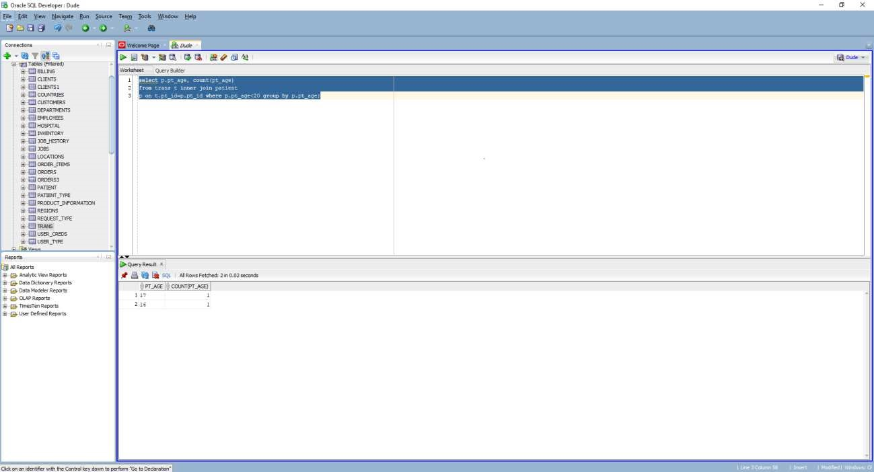

total transactions done by population with age <20; **select p.pt_age, count(pt_age) from trans t inner join patient p on t.pt_id=p.pt_id where p.pt_age<20 group by p.pt_age;**

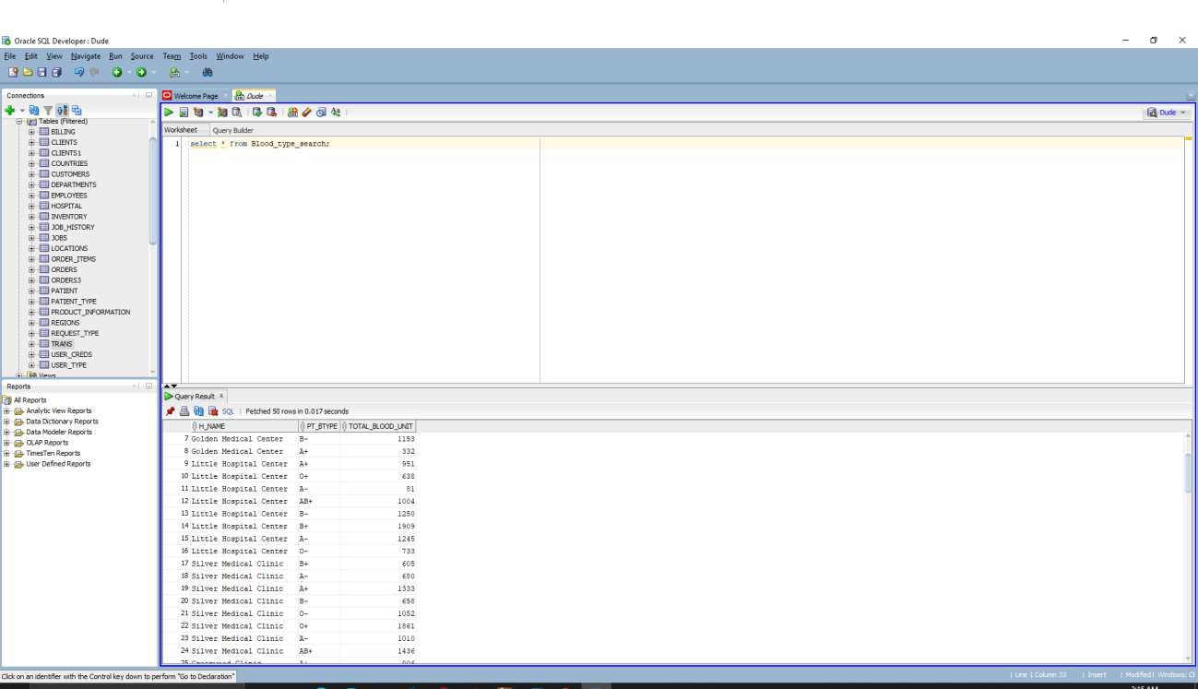

**select * from Blood_type_search;**

**THANKS!**