Investigation of NH3-DME-Air Combustion

Logan Freeman

4/17/25

## Question 1

This study will investigate the combustion of an ammonia -air mixture. The stochiometric reaction is given by:

$$NH_{3}+\frac{3}{4}\left(O_{2}+3.76N_{2}\right)→ 1.5H_{2}O+\left(0.5+3*\frac{3.76}{4}\right)N_{2}$$

The kinetic model is the San Diego model. This detailed chemical mechanism has been developed over 25+ years. Detailed Nitrogen models were added in 2003. [1]

Some comparisons are made against experimental results obtained by Takizawa et al. [2]. Takizawa et al. obtained results by the SV (Spherical Vessel) method, the SP (Schlieren Photography) method, closed vessels in microgravity and earth gravity, and a vertical tube. In this report, the SV and SP results are considered. Spherical flame propagation is used and the SV method measures changes in pressure, while the SP method optically measures the flame velocity.

## Question 2 & 3

The laminar flame speed is studied with Cantera. The flame speed at default conditions of T=300K, P=1atm, and equivalence ratio of 1 is 6.74cm/s. This agrees well with the SV and SP experimental results [2].

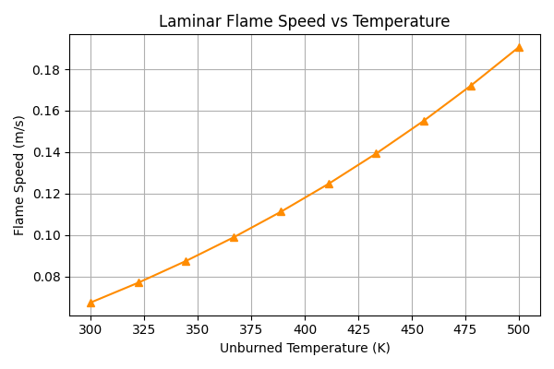

**Figure 1: Temperature dependence of laminar flame speed**

The dependence of the laminar flame speed on temperature is positive and superlinear. This result is expected, since for a higher unburned gas temperature there is more energy, which translates to a higher flame velocity. Specifically, less energy is required to ignite the gas, so more energy is available to accelerate the flow.

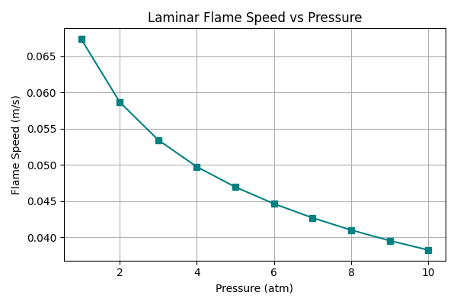

**Figure 2: Pressure dependence of laminar flame speed**

The dependence of the laminar flame speed on pressure is negative. These results are at a constant temperature of 300K, so the density is higher. The inverse exponential pressure dependence was also observed by Zhang et al. for CH4 flames [3]. The suggested mechanism of the pressure dependence is that increased pressure has a stabilizing effect on the combustion.

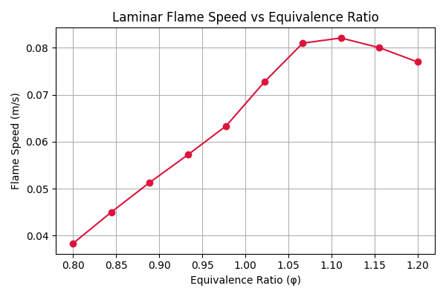

**Figure 3: Equivalence ratio dependence of laminar flame speed**

**Figure 4: Equivalence ratio dependence of laminar flame speed [2]**

The trends observed from the computed equivalence ratio results agree with the experimental results. The values are slightly higher from the computational results, compared to the experimental results. The highest flame speed is observed at an equivalence ratio greater than one, which agrees with the peak of adiabatic flame temperature, which also occurs at an equivalence ratio greater than one. A higher adiabatic flame temperature corresponds with more energy released, and therefore a higher flame speed. This is the suggested mechanism to explain the equivalence ratio dependence.

## Question 4

At conditions of P=1atm, T=300K, and an equivalence ratio of one, the temperature distribution, heat release rate Q, and molar concentrations of selected species were calculated:

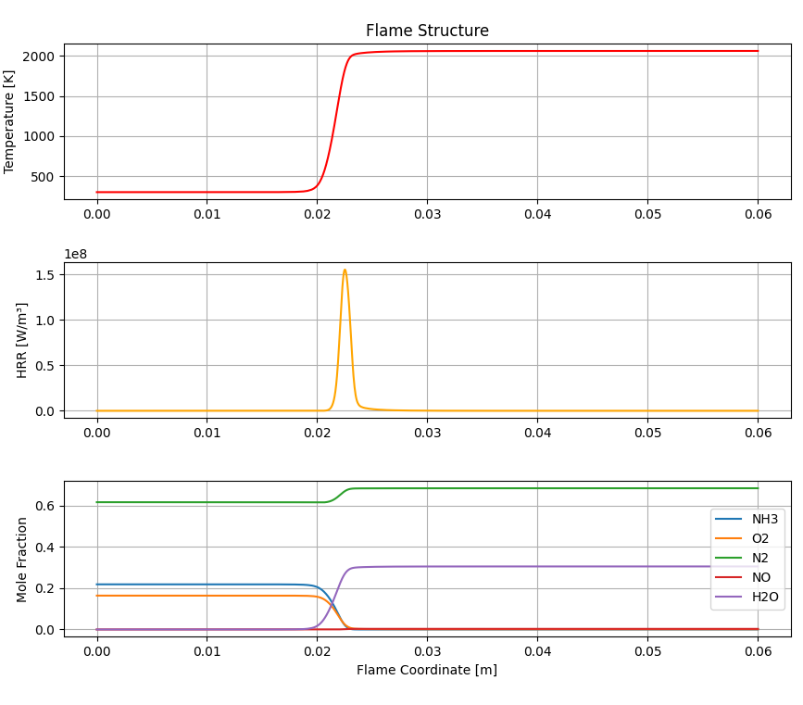

**Figure 5: Combined plot of temperature, heat release rate, and mole fractions**

Using the equation $δ=\frac{2α}{S_{L}}$, evaluated at the flame midpoint x=0.0215m, results in a calculated flame thickness of 6.3mm. When evaluating the thickness based on the temperature distribution, the thickness appears to be approximately 3mm. The disparity in thickness is due to different methods used to calculate the thicknesses.

## Question 5

**Figure 6: Sensitivities of reactions for NH3-Air combustion**

The sensitivities of ammonia-air combustion are obtained with Cantera, by application of the adjoint method. These results indicate that Hydrogen-involving reactions dominate the sensitivity. The reactions with the highest positive sensitivity contribute to the creation of radicals, or chain branching. The reactions with the highest negative sensitivity consume radicals. Rate coefficients for the reactions with highest sensitivities should be studied carefully to ensure accurate flame speeds.

AI Disclosure: AI was used for plotting & debugging

Citations

[1] Chemical Mechanism: Combustion Research Group at UC San Diego. <https://web.eng.ucsd.edu/mae/groups/combustion/mechanism.html>

[2] Takizawa, Kenji, et al. "Burning velocity measurements of nitrogen-containing compounds." *Journal of hazardous materials* 155.1-2 (2008): 144-152.

[3] Zhang, Xiaolei, et al. "Effect of CH4, pressure, and initial temperature on the laminar flame speed of an NH3–air mixture." ACS omega 6.18 (2021): 11857-11868.