* Due Date is **July 4th,2017.**
* Points possible **20 out of 20** for “MyWeb” links submitted on Blackboard (ONLY).
* Late submission of a homework assignment is subjected to a 20% per late day penalty
* This assignment should be done individually.

**The folder structure of this assignment looks like Figure 1**

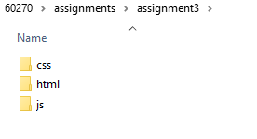

60334 > assignments > assignment3

Figure 1: assignment3 structure

All CSS files must be stored and accessed from the css folder; all JavaScript files must be stored and accessed from js folder.

Follow the folder structure please, with the same exact names, All small letters. uwinid is your uwin username, the one before @ in your uwin email,

1. Follow the instruction in lecture 5 – Introduction to MySQL slides, to create **uwinid_pbl** database, **uwinid_pbl** user, with “**mypassword**” as a password, then create **classics** table, and do all the changes on the tables as per the slides (All inserts, alters, updates, deletes).
2. Create login.php page as lecture 7: Accessing MySQl using PHP slides to html folder.
3. Download **sqltest.php** file from 334 Blackboard site 🡪 resources menu and upload it to **html** folder.
4. In **css** folder, create **table.css** file then copy into it all CSS rules from 334 Blackboard site 🡪 labs 🡪 lab1: Design Exercise🡪Table design.docx🡪 point (f)
5. Change **sqltest.php** to print the classics rows as html table with the header as seen in **Figure2**, point your file to the external **table.css** file. Add a checkbox for each row to be selected for deletion. The red-highlighted checkbox is check/uncheck all checkboxes that call a JavaScript function with **check_all()** name . Delete buttons will redirect you back to **sqltest.php** where all selected (checked rows) will be deleted.
6. **check_all()** function must be implemented in **checkboxes.js** file, **checkboxes.js** must be stored and access from **js** folder.
7. As usual in the previous assignments, please submit **sqltest.php** link from your domain on myweb, **failure to submit the correct link will lead to marks deduction this time!**

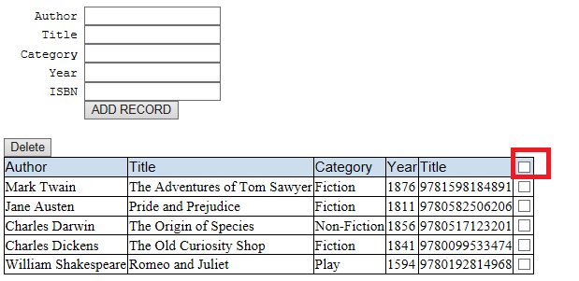

Figure : the assignment has to look like this figure