MidtermStats

Lucas Forrest

11/10/2021

## Library Packages

library(readxl)  
library(vioplot)

## Warning: package 'vioplot' was built under R version 4.1.1

## Loading required package: sm

## Warning: package 'sm' was built under R version 4.1.1

## Package 'sm', version 2.2-5.7: type help(sm) for summary information

## Loading required package: zoo

##   
## Attaching package: 'zoo'

## The following objects are masked from 'package:base':  
##   
## as.Date, as.Date.numeric

library(tidyverse)

## -- Attaching packages --------------------------------------- tidyverse 1.3.1 --

## v ggplot2 3.3.3 v purrr 0.3.4  
## v tibble 3.1.2 v dplyr 1.0.6  
## v tidyr 1.1.3 v stringr 1.4.0  
## v readr 1.4.0 v forcats 0.5.1

## -- Conflicts ------------------------------------------ tidyverse_conflicts() --  
## x dplyr::filter() masks stats::filter()  
## x dplyr::lag() masks stats::lag()

## Import Data

gradedata <- read_excel("C:/Users/Lucas/OneDrive - Forrest/Work/UWT Lecturer/AU21 TBUS 301C/AU21 Midterm Grades.xlsx", sheet = "Grades")  
  
surveydata <- read_excel("C:/Users/Lucas/OneDrive - Forrest/Work/UWT Lecturer/AU21 TBUS 301C/AU21 Midterm Grades.xlsx",   
 sheet = "Survey")

## Survey

summary(surveydata$Hours)

## Min. 1st Qu. Median Mean 3rd Qu. Max. NA's   
## 2.000 3.712 4.500 5.500 6.000 30.000 1

boxplot(surveydata$Hours, col = "darkgoldenrod1", xlab = "Hours", horizontal = TRUE, main = "Time to Finish Midterm")

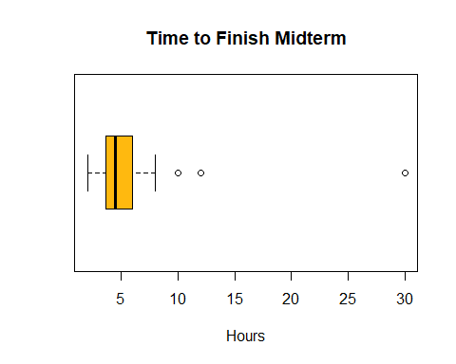

barplot(table(surveydata$EasiestQ), main = "Easiest Question")

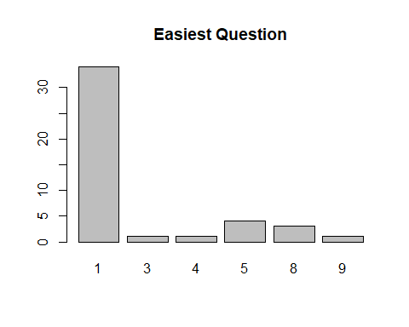

barplot(table(surveydata$HardestQ), main = "Hardest Question")

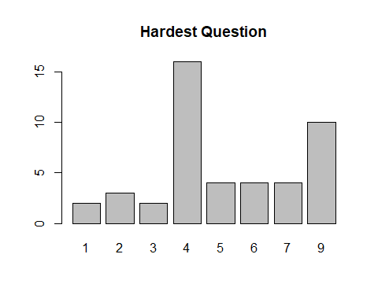

## Question 1

qcol1 <- c('P1', 'C1', 'T1')  
  
vioplot(gradedata[, qcol1], col = c("skyblue3", "coral1", "darkgoldenrod1"), xlab = "Points", horizontal = TRUE)

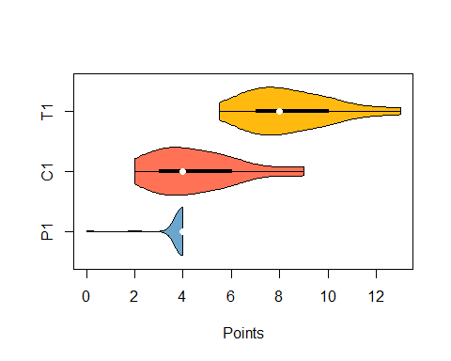

## Question 2

qcol2 <- c('P2', 'C2', 'T2')  
  
vioplot(gradedata[, qcol2], col = c("skyblue3", "coral1", "darkgoldenrod1"), xlab = "Points", horizontal = TRUE)

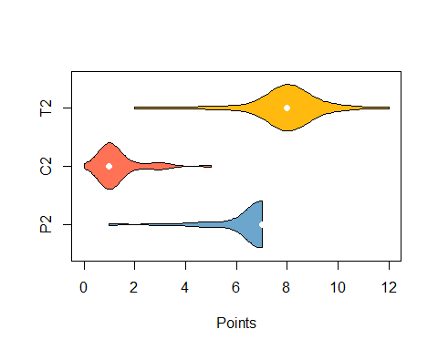

## Question 3

qcol3 <- c('P3', 'C3', 'T3')  
  
vioplot(gradedata[, qcol3], col = c("skyblue3", "coral1", "darkgoldenrod1"), xlab = "Points", horizontal = TRUE)

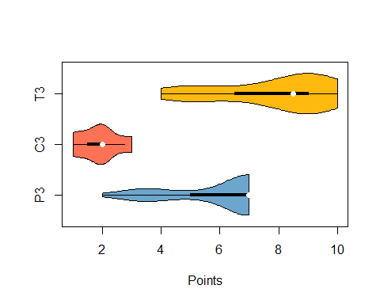

## Question 4

qcol4 <- c('P4', 'C4', 'T4')  
  
vioplot(gradedata[, qcol4], col = c("skyblue3", "coral1", "darkgoldenrod1"), xlab = "Points", horizontal = TRUE)

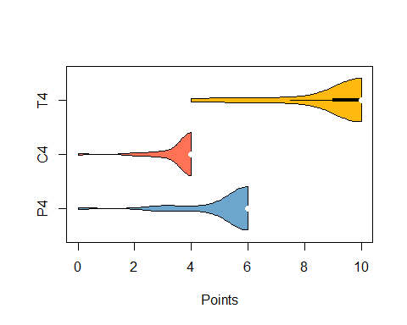

## Question 5

qcol5 <- c('P5', 'C5', 'T5')  
  
vioplot(gradedata[, qcol5], col = c("skyblue3", "coral1", "darkgoldenrod1"), xlab = "Points", horizontal = TRUE)

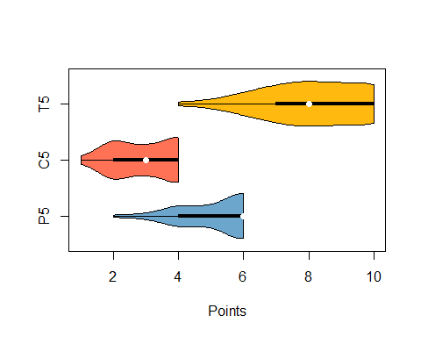

## Question 6

qcol6 <- c('P6', 'C6', 'T6')  
  
vioplot(gradedata[, qcol6], col = c("skyblue3", "coral1", "darkgoldenrod1"), xlab = "Points", horizontal = TRUE)

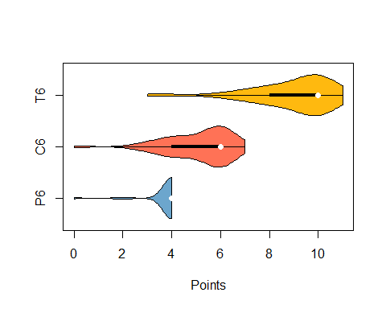

## Question 7

qcol7 <- c('P7', 'C7', 'T7')  
  
vioplot(gradedata[, qcol7], col = c("skyblue3", "coral1", "darkgoldenrod1"), xlab = "Points", horizontal = TRUE)

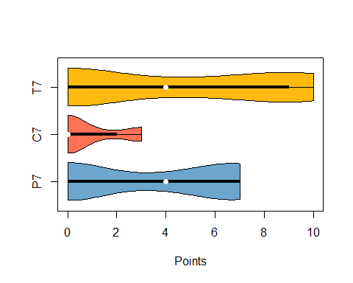

## Question 8

qcol8 <- c('P8', 'C8', 'T8')  
  
vioplot(gradedata[, qcol8], col = c("skyblue3", "coral1", "darkgoldenrod1"), xlab = "Points", horizontal = TRUE)

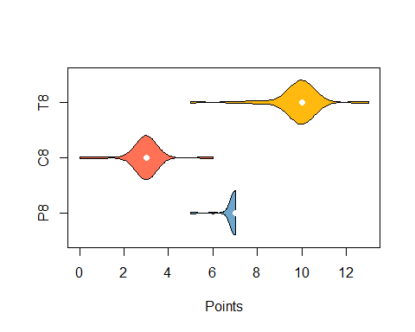

## Question 9

qcol9 <- c('P9', 'C9', 'T9')  
  
vioplot(gradedata[, qcol9], col = c("skyblue3", "coral1", "darkgoldenrod1"), xlab = "Points", horizontal = TRUE)

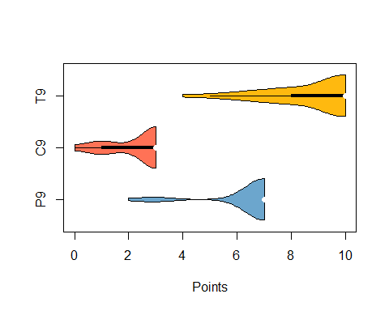

## Adjustments

# To record point information  
ppoints <- 57 # Raw practical points  
cpoints <- 33 # Raw conceptual points  
appoints <- 50 # Removes Q4p points  
acpoints <- 30 # Removes Q4c points  
  
# To remove question 4 values  
gradedata$APRS <- gradedata$PRS - gradedata$`4a` - gradedata$`4b`  
gradedata$ACRS <- gradedata$CRS - gradedata$`4c`  
gradedata$TAS <- gradedata$APRS + gradedata$ACRS  
  
# To add extra points, add back carry forward errors  
  
gradedata$FPS <- gradedata$APRS + gradedata$PDPA  
gradedata$FCS <- gradedata$ACRS + gradedata$CDPA  
gradedata$FTS <- gradedata$FPS + gradedata$FCS + gradedata$EA  
  
# To reweigh practical/conceptual  
gradedata$TRP <- (gradedata$PRS / ppoints) * 0.70 + (gradedata$CRS / cpoints) * 0.30  
  
gradedata$TAP <- (gradedata$APRS / appoints) * 0.70 + (gradedata$ACRS / acpoints) * 0.30  
  
gradedata$TFP <- ((gradedata$FPS / appoints) * 0.70 + (gradedata$FCS / acpoints) * 0.30) + gradedata$EA / (appoints + acpoints)

## Scores

vioplot(gradedata[, c("TRS", "TAS", "FTS")], col = c("skyblue3", "coral1", "darkgoldenrod1"), xlab = "Percent", horizontal = TRUE)

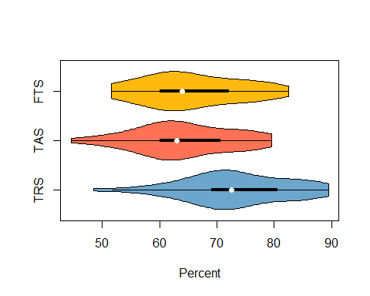

vioplot(gradedata[, c("TRP", "TAP", "TFP")], col = c("skyblue3", "coral1", "darkgoldenrod1"), xlab = "Percent", horizontal = TRUE)

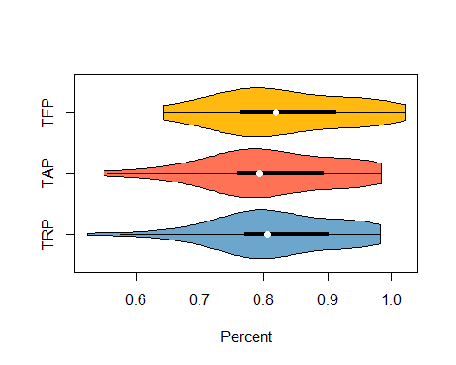

## Summary

summary(gradedata$TFP)

## Min. 1st Qu. Median Mean 3rd Qu. Max.   
## 0.6430 0.7630 0.8180 0.8283 0.9130 1.0205

## Output

output <- data.frame(gradedata$Student, gradedata$FTS, gradedata$TFP)  
View(output)