Finance 580, Homework 4
Due October 4, 2016

- Using excel, find the value of a European call option with using a 3 period binomial tree.

S= 50
X= 50
T= 1 year
Daily variance of continuously compounded returns =0.0040
Rf = 10% per annum, annually compounded. Show all work.
S | 50 | h | 0.785422478 | r | 0.03228
X | 50 | l | -0.43990847
T | 1 | T' | 1/3 | T'' | 0.57735
VAR(daily) | 0.004 | std. annual returns | 1.003992032
Rf | 0.1
Stock price tree |  |  |  |  | Call option price tree
 |  |  | 284.5725458 |  |  |  |  | 234.5725
 |  | 159.3866713 |  |  |  |  | 110.9502
 | 89.27112 |  | 89.27112392 |  |  | 50.14732 |  | 39.27112
50 |  | 50 |  |  | 21.97886 |  | 14.66013
 | 28.00458 |  | 28.00457629 |  |  | 5.472709 |  | 0
 |  | 15.68512586 |  |  |  |  | 0
 |  |  | 8.785106073 |  |  |  |  | 0
The value is 21.97886

- We have one-year maturity European call and a put options both with exercise prices of $66 on ABC stock, which does not pay dividends. Call price is $2, while the put price is $12, r=10%, T=1 year. What is the fair value of the stock price?
X = 66 C = 2 P = 12 r = 10% T = 1 year
S = C+PV(X)-P=2+66/1.1-12=$50

- You are given the following information. S=50, X=50, simple annual risk-free interest rate is 5%, standard deviation of monthly stock returns is 10%. What is the value of a one-year European call option using the Black-Scholes model?
Current Stock Price | $50.0
Exercise Price | $50
Time to Maturity (years) | 1
Simple Risk-free rate (% per year) | 5
Volatility (% per year) | 34.64101615
Call Value | 7.968046443
The value is 7.968.

- We have one-year maturity European call and a put option both with exercise prices of $66 on ABC stock (priced at $50 ) which does not pay dividends. The put price is $12, r=10%, T=1 year. The stock price is $50. What is the fair value of the call price?
C = P+S-PV(X)=12+50-66/(1+0.1)=$2

- S = $55, C (X=$60) =$10.35, P(X=$60) =$4.94, T=2 years . All options are European and the stock does not pay a dividend. What is the fair value of the risk-free interest rate? Explain.
X = 60 C = 10.35 P = 4.94 T = 2 year S = 55
PV(X) = S+P-C= $49.59=60/(1+r)² Then we get r=10%

- You are given the following information. S=50, X=50, simple annual risk-free interest rate is 5%, standard deviation of monthly stock returns is 10%. What is the value of a one-year European call option using the three-period Binomial model?
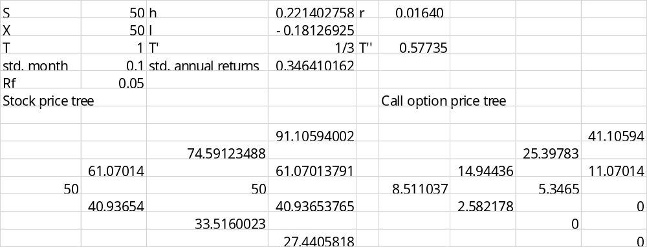
So the value is 8.511

- You are given the following information. S=50, X=50, simple annual risk-free interest rate is 5%, standard deviation of monthly stock returns is 10%. Explain what you would do at each node (how many shares purchased and how much borrowed and owed) to synthetically construct and value one year European call option using a three-period Binomial model?
 |  |  | Sell all shares | for
 |  |  | 1 | 91.10594002
 |  |  | Payoff
 |  |  | 50
 |  | Buy shares | Net
 |  | 0.184614871 | 41.10594002
 | Buy shares | Borrow more | Sell all shares | for
 | 0.201377561 | 13.77065123 | 1 | 61.07013791
 | Borrow more | Total debt | Payoff
Buy shares | 12.29815541 | 49.19340734 | 50
0.614007568 | Total debt | Sell shares | Net
Borrow | 34.8513214 | 0.265551131 | 11.07013791
22.18934163 | Sell shares | Pay off | Sell all shares | for
New cost | 0.289662684 | 13.27755657 | 0.549833997 | 22.50830013
8.511036758 | Pay off | Total debt | Payoff
 | 11.85778736 | 22.14519954 | 22.50830013
 | Total debt | Sell shares | Net
 | 10.69537864 | 0.324344884 | 0
 |  | Pay off | Sell all shares | for
 |  | 10.87074389 | 0 | 0
 |  | Total debt | Payoff
 |  | 0 | 0
 |  |  | Net
 |  |  | 0

- You are given the following information. S=50, X=50, simple annual risk-free interest rate is 5%, standard deviation of monthly stock returns is 10%. What is the price of a one-year exotic option that pays
max(0, X - S ^{0. 5} )?
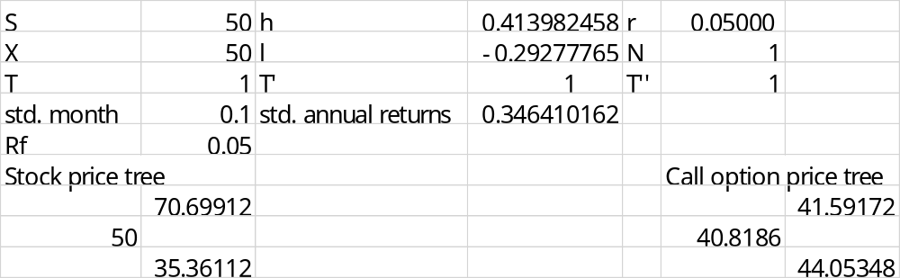
So the price is 40.8186.
- You are given the following information. S=50, X=50, simple annual risk-free interest rate is 5%, standard deviation of monthly stock returns is 10%. What is the price of a one-year European put option using the Binomial model.
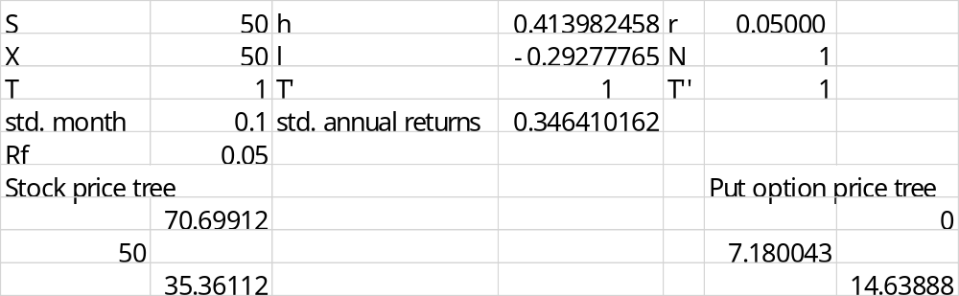
The price using binomial model is $7.18.
- You are given the following information. S=50, X=50, simple annual risk-free interest rate is 5%, standard deviation of monthly stock returns is 10%. What is the price of a one-year European put option using the Binomial model. How about Black-Scholes model?
The price using binomial model is $7.18
BS model:
Current Stock Price | $50.0
Exercise Price | $50
Time to Maturity (years) | 1
Simple Risk-free rate (% per year) | 5
Volatility (% per year) | 34.64101615
Put Value | 5.587094062
The price use BS model is $5.587.

- How would you construct a bear spread from put options? When would you be interested in buying a bear spread? Explain.

Buy a put with X= X₂ and sell a put with X= X₁ < X₂. When you are expecting the decrease of the stock price, you would buy a bear spread.

- S= $50, X=$66, C=$2, P=$12, r=10%, T=1year. All options are American. Is there an arbitrage opportunity here? Explain.
Yes. P=12<X-S=16, so there is an arbitrage opportunity. You can exploit it as below.
long the put | -$12
long the stock | -$50
Borrow $66 at risk-free rate | +$66
Profit | +$4

- S= $50, X=$66, C=$2, P=$12, r=10%, T=1 year. All options are European. Is there an arbitrage opportunity here? Explain.

No. P+S = 62 = C+PV(X)=62

- You are given the following information. S=50, X=50, simple annual risk-free interest rate is 5%, standard deviation of monthly stock returns is 10%. What is the hedge ratio of a one-year European call option using the Black-Scholes model?
Current Stock Price | $50.0
Exercise Price | $50
Time to Maturity (years) | 1
Simple Risk-free rate (% per year) | 5
Volatility (% per year) | 34.64101615
Call Value | 7.968046443
Put Value | 5.587094062
Call Delta | 0.6232585
The hedge ratio is 0.623.

- You are given the following information. S=50, X=50, simple annual risk-free interest rate is 5%, standard deviation of monthly stock returns is 10%. What is the hedge ratio of a one-year European put option using the Black-Scholes model?
Current Stock Price | $50.0
Exercise Price | $50
Time to Maturity (years) | 1
Simple Risk-free rate (% per year) | 5
Volatility (% per year) | 34.64101615
Put Delta | -0.38
The hedge ratio is -0.38.

- S = $50, C (X=$60) =$2, P(X=$60) =$12, r=10%, T=1 year. All options are European. Is there an arbitrage opportunity here? Explain.
P=12>C-S+PV(X)=6.54 So there is an arbitrage opportunity, you can exploit it as below.
Write the put | +$12
Buy the call | -$2
Short the stock | +$50
Lend $60 with risk-free rate 10% | -$54.55
Profit | +$5.45

- S = $50, C (X=$40) =$2, r=10%, T=1 year. The call is European. Is there an arbitrage opportunity here? Explain.
C=2<S-PV(X)= 13.64 So there is an arbitrage opportunity, you can exploit it as below.
Buy the call | -$2
Short the stock | +$50
Lend $40 with risk-free rate 10% | -$36.36
Profit | +11.64

- Explain the terms portfolio insurance, hedge ratio, and delta.
Portfolio insurance: Portfolio insurance refers to buying or creating a put option to eliminate potential losses on a portfolio that you already own. You have limited downside risk, with unlimited upside potential during the life of the put option. You can long index and long put option on the same index in S&P index to get portfolio insurance, then you participate in the up-market and you have limited downside risk.
Delta is also called hedge ratio: It says how many shares of the underlying stock you have to hold in the portfolio of stock and risk-free bonds that replicates the payoff of a single call option.
For the Black-Scholes model,
1.The delta of an option (D = N(d₁)) tells you how many shares of the underlying asset you need (for each call option) to create a synthetic call option.
2. An option's delta tells us how much its value will change per unit change in the price of the underlying stock.
3. A call option's delta must lie between 0 and 1, and will give us a good idea about the probability that the option will end up in the money.
4. 1/delta units of call option has the same price sensitivity as one share of stock.
- S = $50, C (X=$60) =$14, C(X=$65) =$10, r=10%, T=2 years. All options are European and the stock does not pay a dividend. Which option is relatively more expensive? Explain. (Hint: Compute implied volatility).
Current Stock Price | $50.0
Exercise Price | $60
Time to Maturity (years) | 2
Simple Risk-free rate (% per year) | 10
Volatility (% per year) | 50.12601725
Call Value | 13.99999681

Current Stock Price | $50.0
Exercise Price | $65
Time to Maturity (years) | 2
Simple Risk-free rate (% per year) | 10
Volatility (% per year) | 40.79002342
Call Value | 10.00003115
So the call option with X=$60 is relatively more expensive.
- S = $55; P (X=$60) =$10; P(X=$65) =$14.5; r=10%; T=2 years. All options are European and the stock does not pay a dividend. Which option is relatively more expensive? (Hint: Compute implied volatility). Explain.
Current Stock Price | $55.0
Exercise Price | $60
Time to Maturity (years) | 2
Simple Risk-free rate (% per year) | 10
Volatility (% per year) | 43.13311962
Put Value | 9.999153075

Current Stock Price | $55.0
Exercise Price | $65
Time to Maturity (years) | 2
Simple Risk-free rate (% per year) | 10
Volatility (% per year) | 50.38748131
Put Value | 14.49998235
So the put option with X=$65 is relatively more expensive.

- S = $55, C (X=$60) =$10.35, T=2 years and volatility is 25%. The option is European and the stock does not pay a dividend. What is the fair value of the risk-free interest rate? Explain.
Current Stock Price | $55.0
Exercise Price | $60
Time to Maturity (years) | 2
Simple Risk-free rate (% per year) | 9.992957459
Volatility (% per year) | 25
Call Value | 10.34999837

So the risk-free interest rate is 10%.
For all questions above: C=call price, P=put price, S=stock price, X=exercise price, r=risk-free rate, T=maturity.

