Question 1

For a new way to clean, try Sureshot, new from Chiffon, Incoporated. Sureshot’s unique design and patented nozzle delivers the cleaning agent into areas other cleaners can’t. Unlike other cleaning agents that either spray or stream their product, Sureshot offers a quick “shot” of cleaning agent that applies directly where it is aimed. Try Sureshot today and witness for yourself why people are calling it “the best thing to happen to cleaning since bleach.”

Question 2

In the traffic news, the stalled car on Berman Road has been cleared, and traffic seems to be flowing smoothly now in both directions. Meanwhile, Lincoln Expressway is still moving very slowly in all lanes. If you’re taking Lincoln home, expect a long wait. Those who are heading to Fremont should take Matterson Road, where traffic is moving quickly. This is Sandy Mills with your traffic. I’ll see you again in 30 minutes.

Question 3

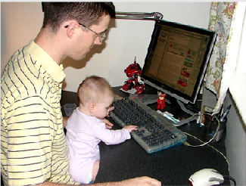

Question 4 through 6

Imagine that a British marketing firm is doing research in your company. You have agreed to participate in a telephone interview about listening to music.

What do you use to listen to music?

When do you usually listen to music?

What kinds of music do you listen to?

Question 10

Hello, Ms. Springs, this is Robert from Pacific Airlines. We received your message about the discomfort you experienced while flying to Beijing. I would like to sincerely apologize for this inconvenience you experienced and assure you that this is not a regular occurrence. As compensation, I would like to offer you a free class upgrade on your next international flight with us. If you will not be going abroad anytime soon, you can choose two free air tickets to anywhere in the U.S. during the off-peak season. I hope we will be able to restore the faith in us that you might have lost because of the matter. Thank you for your understanding and we hope to be doing business with you again in the future.

Question 11

Some companies would rather keep employees who have been working for the company for a long time than hire new employees. Other companies like to have younger employees with fresh ideas. Which do you think is better and why? Use specific reasons and examples to support your opinion.

Example:

I think it is better to hire people with fresh ideas than to keep employees for being loyal. Although loyalty is a good quality, keeping a business up-to-date and successful should be an employer’s main concern. There is no point in keeping an employee who is good at a particular job but can no longer improve the company. Businesses thrive from improving, and the only way to do this is by having fresh ideas and a broad outlook. Companies who keep older employees not only restrain themselves, but they keep these employees from gaining new experiences by keeping them at a job in which they can no longer improve. So, I think it’s best if a company hires people who bring fresh ideas.

Test 2

Question 1

If you’re looking for a new taste, try Freshly’s Herbal Teas. Freshly’s Herbal Teas are all natural and organically grown, so you know what you’re drinking. With more than fifteen flavors including original blends such as Tiger Tea, Roseberry, and Garden Herb, you’ll never be bored of the taste. So, put down your coffee and try Freshly’s Herbal Teas today.

Question 2

Hello, I’m Jerry Williams, with The Business Report. Anatol Communications was acquired today by Baker Industries. Anatol, enjoying success with its mini-microphone technologies, will add innovation to the tradition-based Baker Industries, along leader in international sales of electronic equipment. With the acquisition of Anatol, Baker Industries obtains a fast-rising company on its way to becoming a market leader. For more on this news, here’s Ray Lee reporting live from Baker headquarters.

Question 3

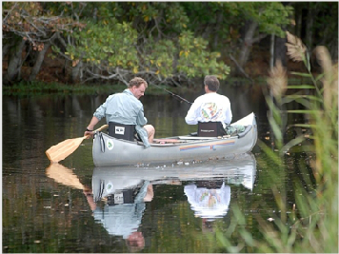

Question 7 through 9

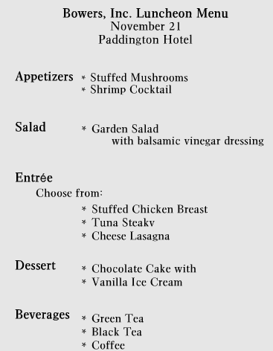

What type of appetizers will be served?

What will be served after the main course?

We have a few employees are vegetarian, will there be a problem to have vegetarian choices for then?

Question 4 through 6

Imagine that a British marketing firm is doing research in your company. You have agreed to participate in a telephone interview about reading books.

How often do you read books?

Where do you usually read?

What kind of books do you like to read?

Question 10

Hello, Mrs. Sawyer. This is Peter from Little Italy returning your call. Regarding tonight, I will be able to reserve a table for 10 people, but I don’t have any room at 7:30. If you’re willing to come at six, I can give you our private room. However, if that’s too early, we’ll have a table at 8:45 for you in the main dining room. It might be a little noisy, but this is the only space we have available. Please let me know which time you prefer. Oh, and congratulate your husband for me. I’ll see you tonight! Have a nice day.

Question 11

With constant advances in technology, it is increasingly easier to communicate without meeting in person. While some people prefer to meet their clients or friends, others prefer to communicate through e-mail, faxes, and telephones. Which do you think is better and why? Use specific reasons and examples to support your opinion.

Example:

For me, face-to-face communication is better especially when the purpose of the meeting is important. E-mails and telephone calls are helpful for setting up appointments, but the actual important communication is usually done face-to-face. Not only is this more professional, it is better for business because meeting face-to-face enables people to communicate on different levels. For instance, if I were to discuss something with a client by e-mail, I wouldn’t get the same feeling or information that I would if I were to meet the client in person. Facial expressions, gestures, and mood are all lost through technology. So, I think it is better to communicate by meeting in person.

Test 3

Question 1

It’s going to be another hot day today! Early this morning we experienced temperatures of 97F, but that will climb to 105F by the late afternoon. There’s not a cloud in the sky, and radar reports suggest this weather will continue throughout the next few days, so don’t expect rain anytime soon! It’s the weekend, so this might be an ideal time to head down to the beach. Don’t forget the sun block!

Question 2

As we enter the central hall, you’ll see the life-size bronze statue of James Polk. This statue was completed in 1910 and installed in 1912. It has been declared a public monument and is now a very widely recognized symbol of the academy. The hall itself has undergone a number of renovations over the years, but at the time of construction the original interiors were considered very modern. We’ll now move outside to the assembly hall.

Question 3

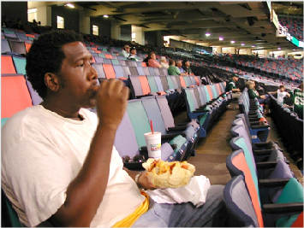

Question 4 through 6

Imagine that a Irish marketing firm is doing research in your company. You have agreed to participate in a telephone interview about online shopping.

How often do you shop online?

What kind of products do you buy through online shopping?

What are the advantages of the online shopping?

Question 7 through 9

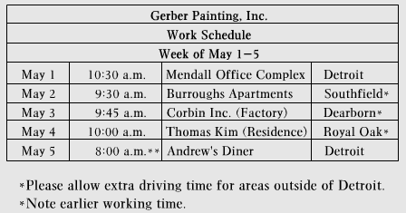

What will we be painting on May first?

I heard we’re going to be working early on one day, can you tell me about that?

Do you know if all the jobs next week are going to be in Detroit?

Question 10

Hi Matt, it’s Sarah. I’m sorry that Jenny got sick and I hope she’s O.K. I didn’t realize that it would be that busy at work today. I thought the rain would keep everyone indoors, but I guess it didn’t. Well, I’d go into work today if I could, but I promised my sister that I would babysit my nephew today. She went out of town with a friend and since I had the day off. I offered to help her. But, I’ll definitely be able to help you tomorrow. If you want, I can even go in early and do all the work you guys didn’t get to finish. I could use the money anyway. Well, let e know what time you’d like me to go in. I’ll be at home. Bye.

Question 11

These days more people are becoming involved in celebrity lifestyles and purchasing more high-end goods, even though they may not be able to afford them. Do you think it is important to live a luxurious lifestyle? Use specific reasons and examples to support your opinion.

Example:

I don’t think it is good to spend more money than you can afford in order to fit into a certain lifestyle. Celebrities earn more money than the average person so they can afford to eat at fancy restaurants and drive nice cars. Furthermore, many celebrities don’t have to pay for their high-end brands they wear; companies usually give their products to stars for endorsements. So, purchasing high-end goods will not give you a celebrity lifestyle. I don’t think it is good idea for regular people to try to live such a luxurious lifestyle they cannot afford. Everybody likes nice things, but living above your limits is not always a wise choice. After all, these are just material possessions and don’t always make a person happy.

Test 4

Question 1

To make sure that your white clothes stay white, it’s best to take a few simple steps. First, separate all of your white clothes. Second, use bleach to remove tough stains and give your clothes a very fresh scent. Also, make sure you use hot water to wash your whites. The high temperature works very well with all sorts of detergent.

Question 2

Are you looking to get in shape? Flex Master Gym is offering a summer special for all new members. Sign up before August 1st and get thirty percent off your new membership. Flex Master has all the latest equipment as well as the best trainers who will help you feel your best. For more information or to find a location nearest you, visit flexmaster.com.

Question 3



Question 4 through 6

Imagine that a British marketing firm is doing research in your company. You have agreed to participate in a telephone interview about dining at restaurants.

How often do you eat out at a restaurant?

What are some advantages of eating out?

Describe one of the most memorable meals of your life?

Question 7 through 9

I will be a little late because of my work. If I go to the training session at 2p.m., what am I going to miss?

I heard that there will be a special speech. Is that about economic issues?

After the special speech, what is next on the agenda?

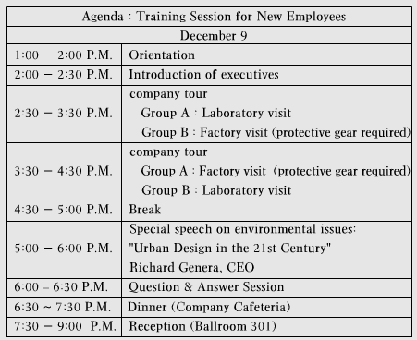

Question 10

Let me begin by apologizing for all of the inconveniences with your order. I understand that you placed an order for dishes with our company three weeks ago and have yet to receive the shipment. We have recently had some problems with our computer network, and your order may have been lost in our system. I’m really sorry about that. Please tell me what you ordered again and I will personally ship it to you before your sister’s wedding. I’ll also give you a 10%discount on a future purchase. Does that sound fair?

Question 11

Some people believe that students must wear uniforms in school. Others think that they should be allowed to wear what they want. Which do you think is better and why? Use specific reasons and examples to support your opinion.

Example:

I think students should not be required to wear uniforms in school. First, when students wear what they want, they are happy. Feeling happy helps them feel freer and more creative in school. This kind of mood motivates students to do everything well. They can focus not only on their studies but also get along well with their friends. Second, wearing casual clothing encourages student creativity. When students have freedom of appearance, they can think, feel and express themselves without restrictions. If they have to wear uniforms throughout their whole school days, their ideas might become identical or simple. Therefore, students should be allowed to wear what they want.

Test 5

Question 1

Hi, and welcome back to Dining with Danny. I’m Danny, and today we’re traveling to historic Philadelphia to try out a sandwich the city is famous for-the Philly Cheese Steak. While most people have heard of this sandwich, we thought it would be interesting to talk to some residents to find out who makes it the best. Let’s take a look at these clips and see what we found.

Question 2

Most of us don’t have the time to brush and floss our teeth. To ensure that your teeth and gums stay healthy, use Pro-Rinse, the newest way to fight tooth decay, and keep your breath fresh. A thirty-second rinse with Pro-Rinse is all that you need after a meal to clean and freshen your mouth. You can even take Pro-Rinse to work, and use it after lunch. Don’t have time to brush? Pro-Rinse instead!

Question 3

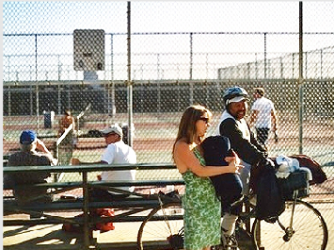

Question 4 through 6

Imagine that a British marketing firm is doing research in your country. You have agreed to participate in a telephone interview about cellular phones.

In what situations do you usually use a cellular phone?

What are some advantages of using a cellular phone?

What is it not appropriate to use a cellular phone?

Question 7 through 9

When does the new software training session start and where will it be held?

Before lunch, will there be any break time?

I heard that we will have practice exercise. What kind of activities will we have?

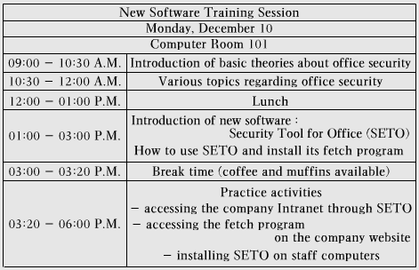

Question 10

I’m really sorry about this situation. I can see that you did make reservations for two suite rooms for today and tomorrow. The receptionist was correct when he told you that we only have one vacant suite room right now. We have made a mistake in booking, and I’ll do my best to make it up to you. If you wish, I can give your client the suite room tonight and offer you a free room with a king size bed. Tomorrow, we’ll have a second suite available, and we will immediately move you to that room. I can even give you a voucher for a free dinner tomorrow. Is there anything else I can do for you?

Question 11

Some people say that physical activities should be a part of every school day. Others think that people must only focus on academic issues during the whole school day. Which do you think is better and why? Use specific reasons and examples to support your opinion.

Example:

I believe that physical activities should be a part of every school day. To begin with, children have a lot of energy. If they just sit and study all day long, they won’t be able to pay attention to the teacher. Let them play outside for a little bit, and when they come back into the classroom they’ll be ready to learn again. In addition, I think schools should teach not only knowledge, but also ways of living a good life. Part of having a good life is being healthy, and that means getting exercise. Some students never exercise after school. If they don’t do it in school, then they never will. So I think exercise should be a part of the school system.