Supporting information

Synthesis and Emissive Properties of Novel 4-(benzo[a]phenazin-5-yl) Derivatives

Daniel Tadeu Gomes Gonzaga,^{1*} Vinicius Nascimento da Rocha,² Acácio Silva de Souza,³ Paulo Cesar Piquini², Vitor Francisco Ferreira,^{3*} Bernardo Almeida Iglesias^{4*}

Characterization of compound 12a
FTIR analysis............................................................................... | 2
¹H NMR spectrum....................................................................... | 3
¹³C NMR spectrum....................................................................... | 4
HRMS-ESI spectrum..................................................................... | 5
DSC analysis................................................................................ | 5
Characterization of compound 12b
FTIR analysis............................................................................... | 6
¹H NMR spectrum....................................................................... | 7
¹³C NMR spectrum....................................................................... | 8
HRMS-ESI spectrum..................................................................... | 9
DSC analysis................................................................................ | 9
Characterization of compound 12c
FTIR analysis............................................................................... | 10
¹H NMR spectrum....................................................................... | 11
¹³C NMR spectrum....................................................................... | 12
HRMS-ESI spectrum..................................................................... | 13
DSC analysis................................................................................ | 13
Characterization of compound 12d
FTIR analysis............................................................................... | 14
¹H NMR spectrum....................................................................... | 15
¹³C NMR spectrum....................................................................... | 16
HRMS-ESI spectrum..................................................................... | 17
DSC analysis................................................................................ | 17
Characterization of compound 12e
FTIR analysis............................................................................... | 18
¹H NMR spectrum....................................................................... | 19
¹³C NMR spectrum....................................................................... | 20
HRMS-ESI spectrum..................................................................... | 21
DSC analysis................................................................................ | 21
Characterization of compound 12f
FTIR analysis............................................................................... | 22
¹H NMR spectrum....................................................................... | 23
¹³C NMR spectrum....................................................................... | 24
HRMS-ESI spectrum..................................................................... | 25
DSC analysis................................................................................ | 25
Photophysical analysis of derivatives 12a-f
Absorption spectra……………………………………………………. | 26
Steady-state fluorescence emission spectra……………………….. | 28
Theoretical absorption spectra od derivatives 12a-f………… | 30
NTO plots……………………………………………………… | 31
Theoretical lifetimes table……………………………………. | 32

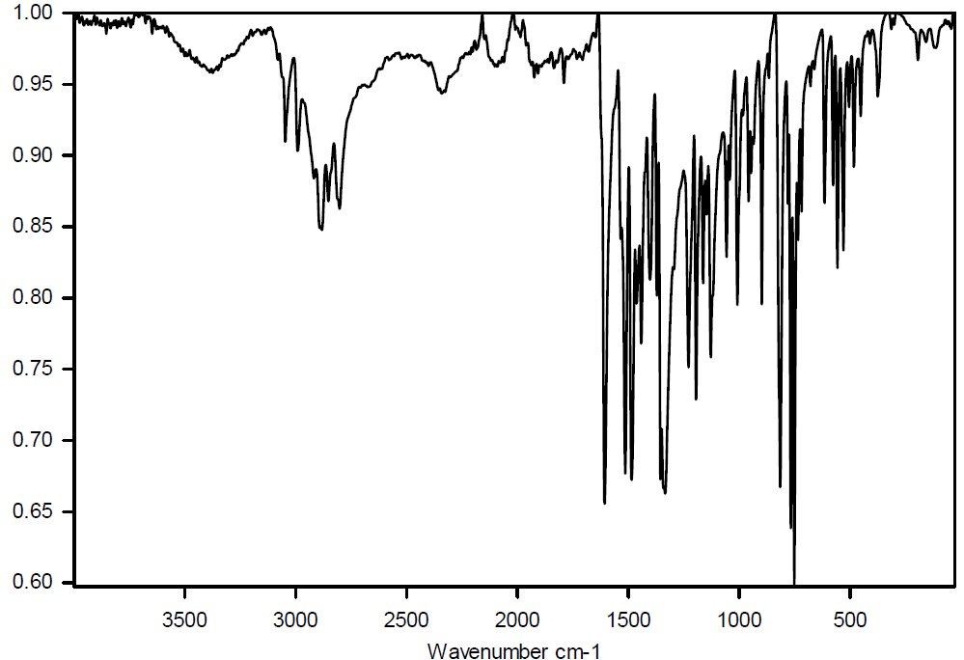
Figure S1. FTIR spectrum of compound 12a.
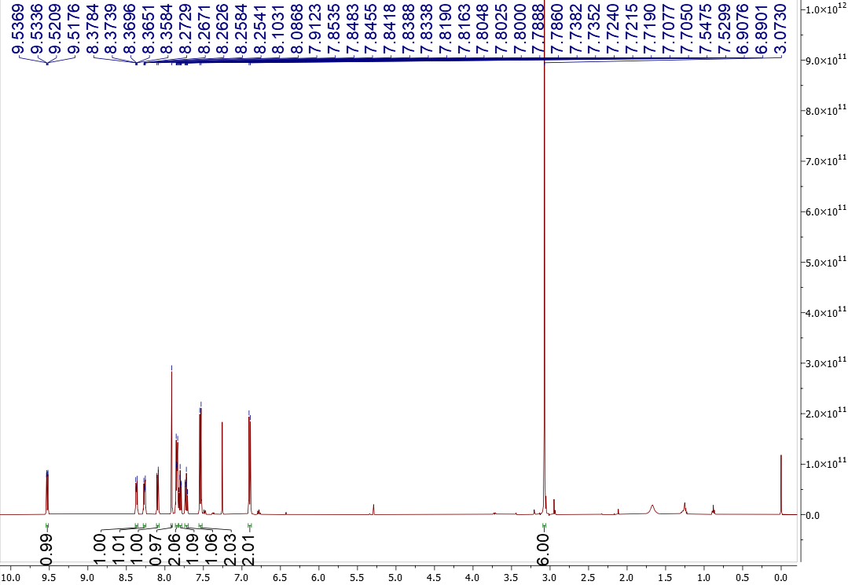
Figure S2. ¹H NMR spectrum in CDCl₃ of compound 12a.

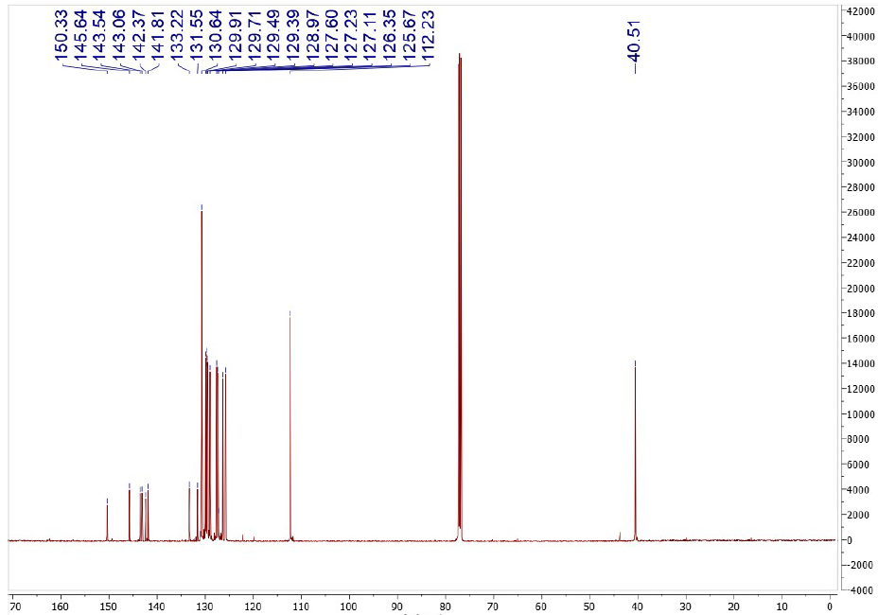
Figure S3. ¹³C NMR spectrum in CDCl₃ of compound 12a.

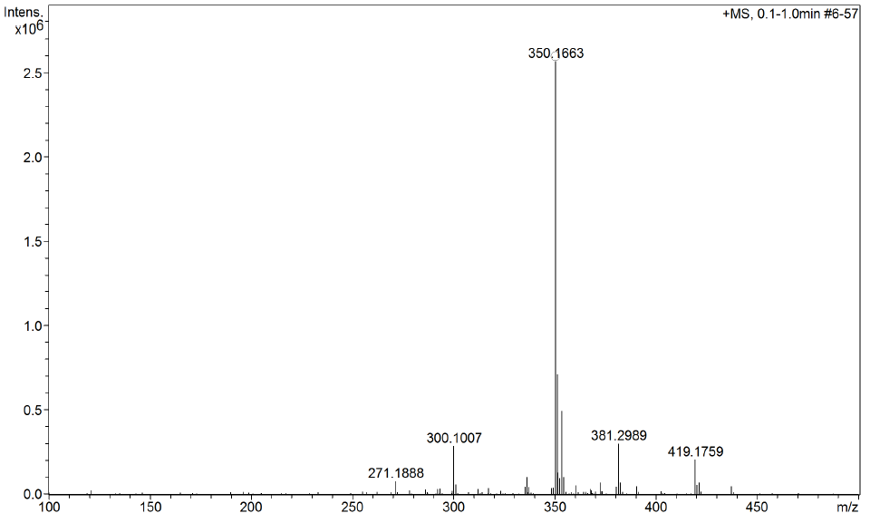
Figure S4. HRMS-ESI spectrum of compound 12a.
Figure S5. DSC analysis of compound 12a.

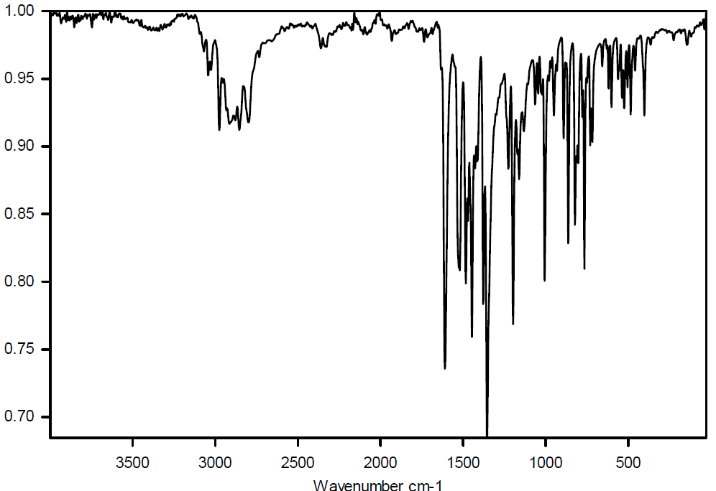
Figure S6. FTIR spectrum of compound 12b.
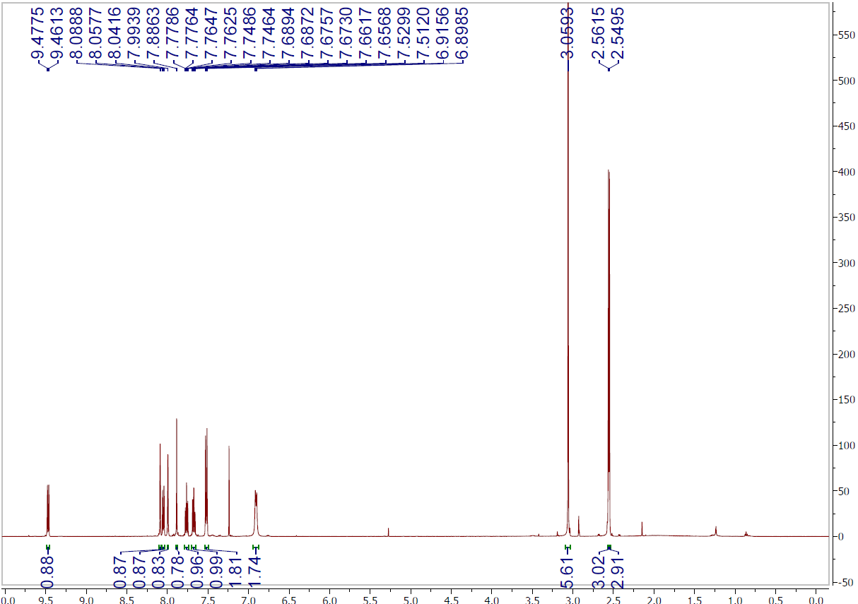
Figure S7. ¹H NMR spectrum in CDCl₃ of compound 12b.

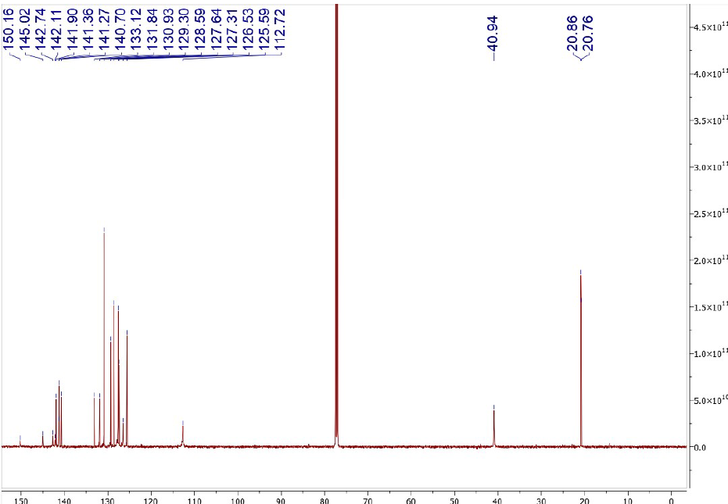
Figure S8. ¹³C NMR spectrum in CDCl₃ of compound 12b.

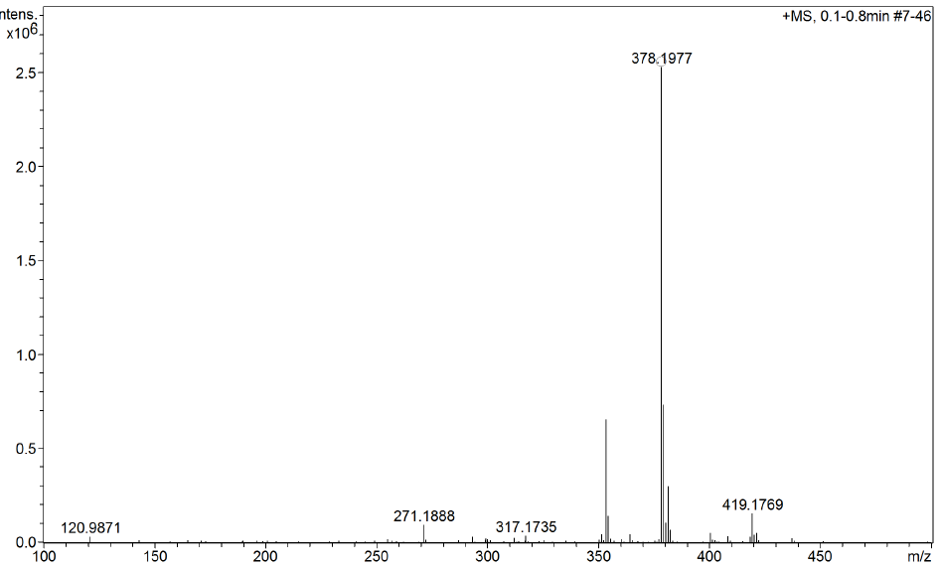
Figure S9. HRMS-ESI spectrum of compound 12b.
Figure S10. DSC analysis of compound 12b.

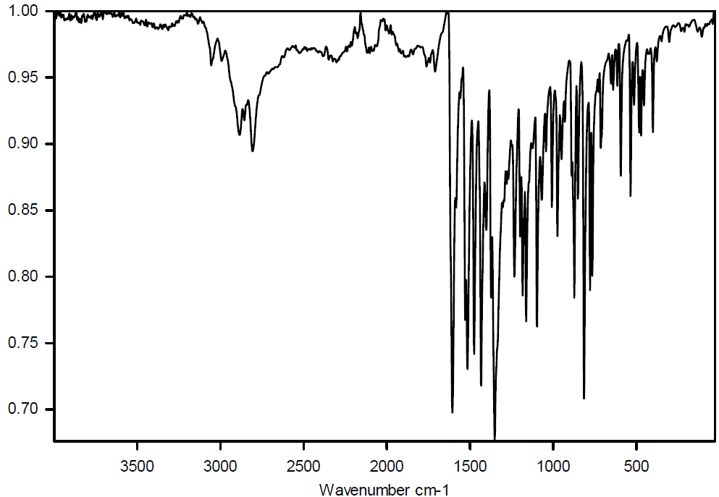
Figure S11. FTIR spectrum of compound 12c.
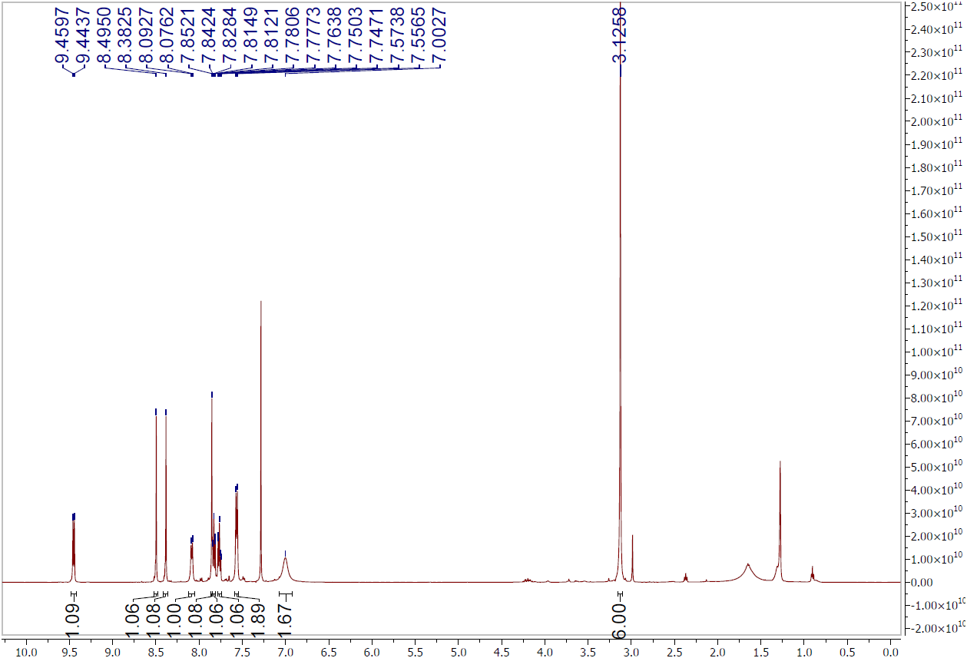
Figure S12. ¹H NMR spectrum in CDCl₃ of compound 12c.

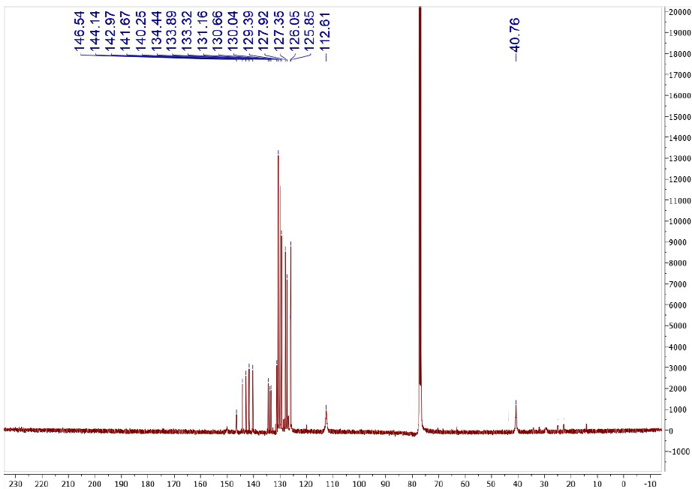
Figure S13. ¹³C NMR spectrum in CDCl₃ of compound 12c.

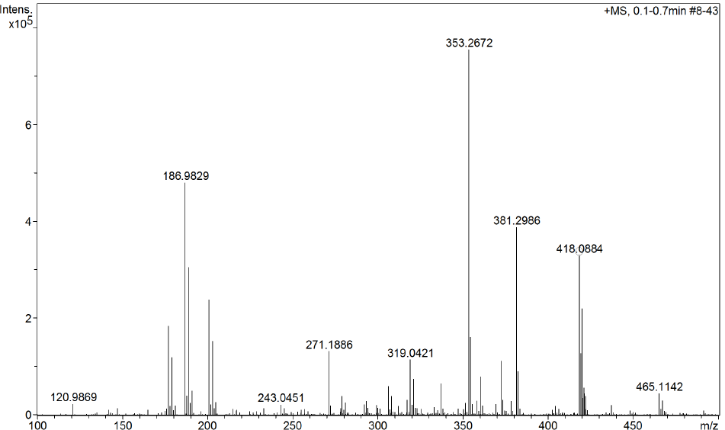
Figure S14. HRMS-ESI spectrum of compound 12c.
Figure S15. DSC analysis of compound 12c.

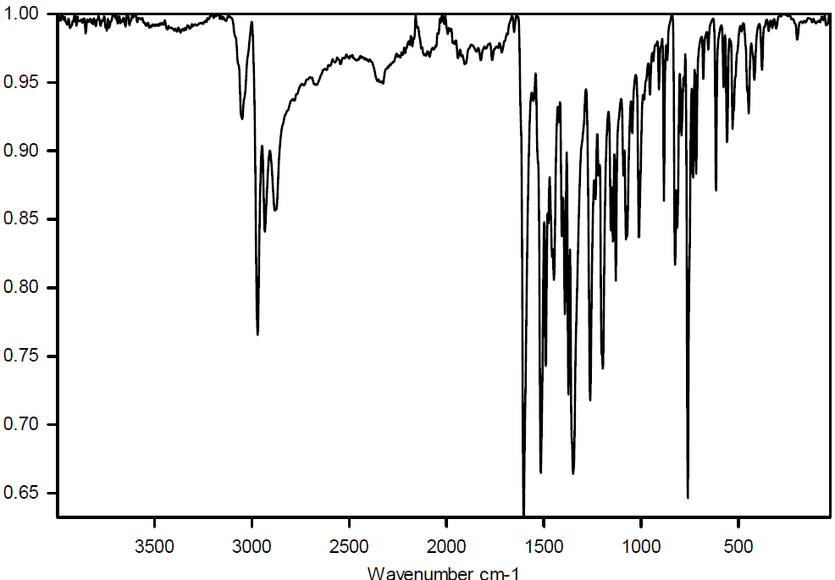
Figure S16. FTIR spectrum of compound 12d.

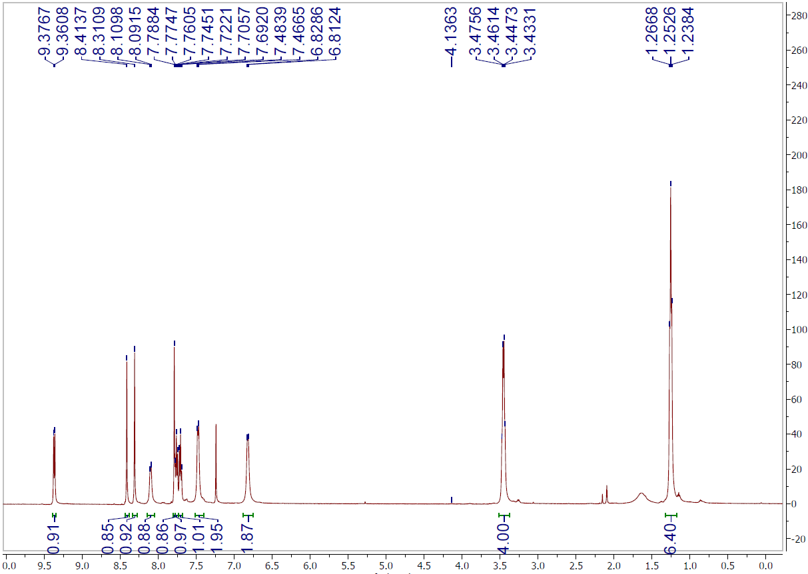
Figure S17. ¹H NMR spectrum in CDCl₃ of compound 12d.

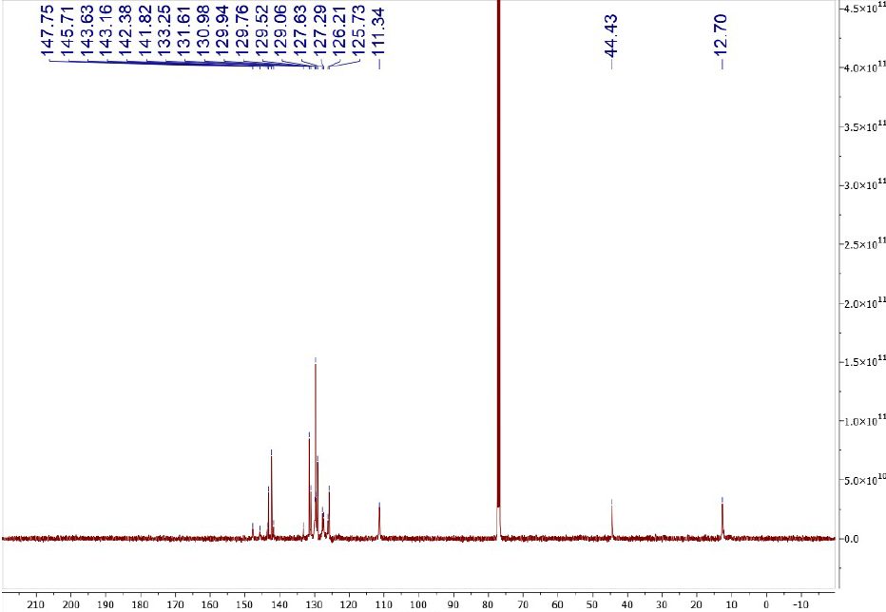
Figure S18. ¹³C NMR spectrum in CDCl₃ of compound 12d.

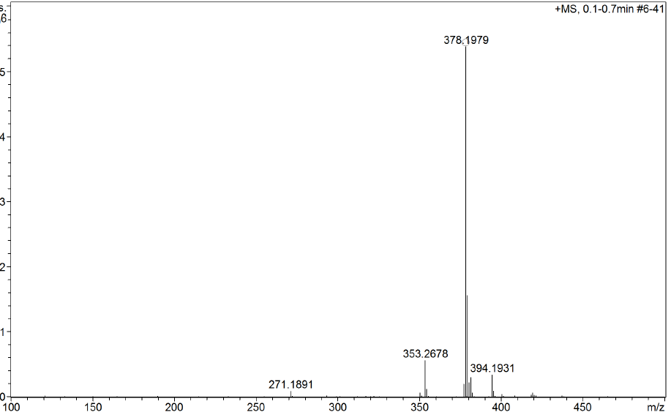
Figure S19. HRMS-ESI spectrum of compound 12d.
Figure S20. DSC analysis of compound 12d.

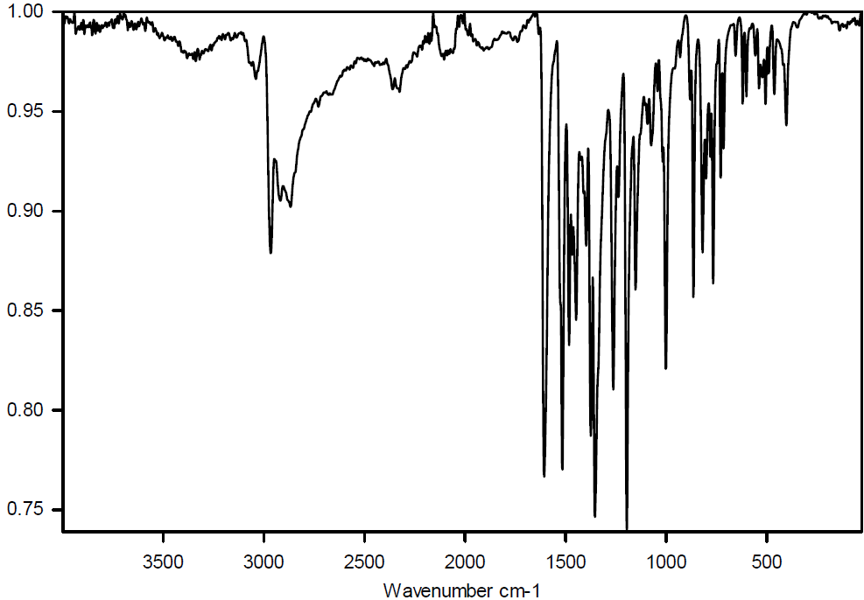
Figure S21. FTIR spectrum of compound 12e.

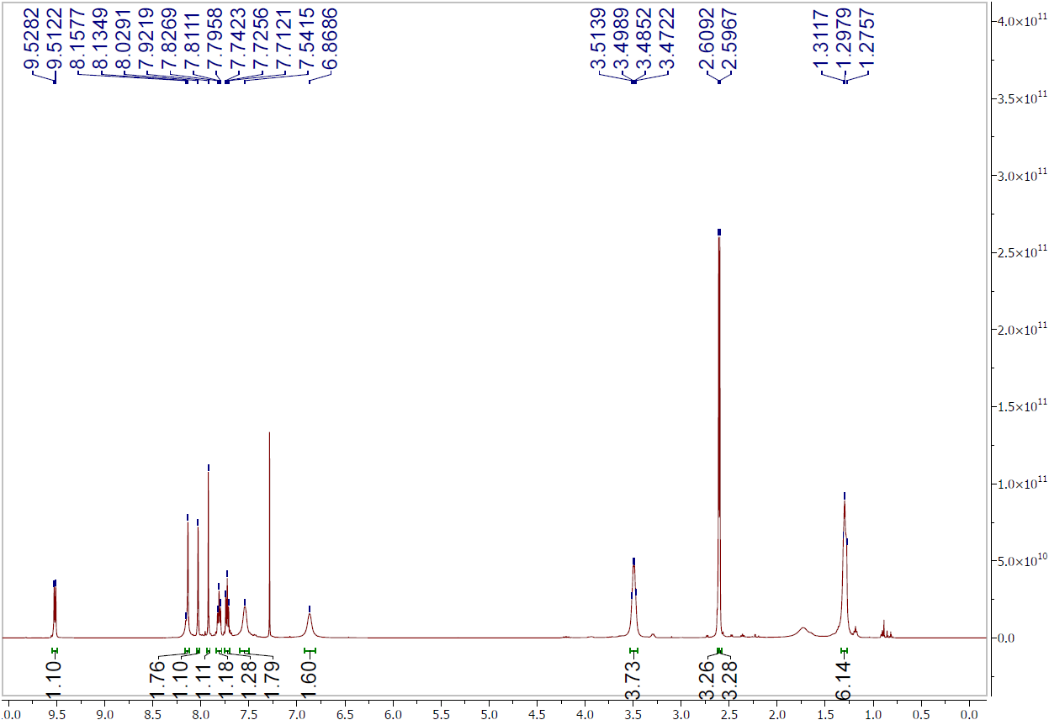
Figure S22. ¹H NMR spectrum in CDCl₃ of compound 12e.

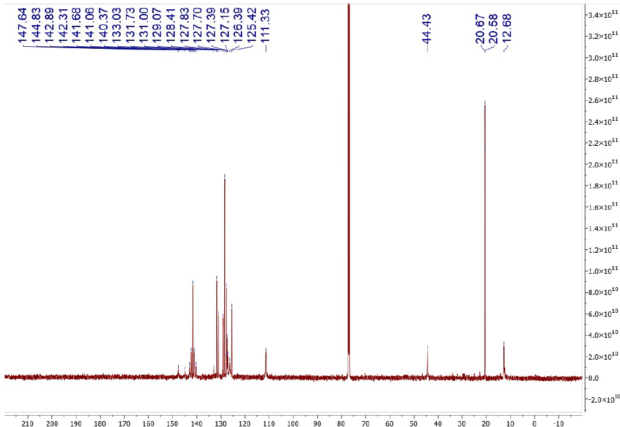
Figure S23. ¹³C NMR spectrum in CDCl₃ of compound 12e.

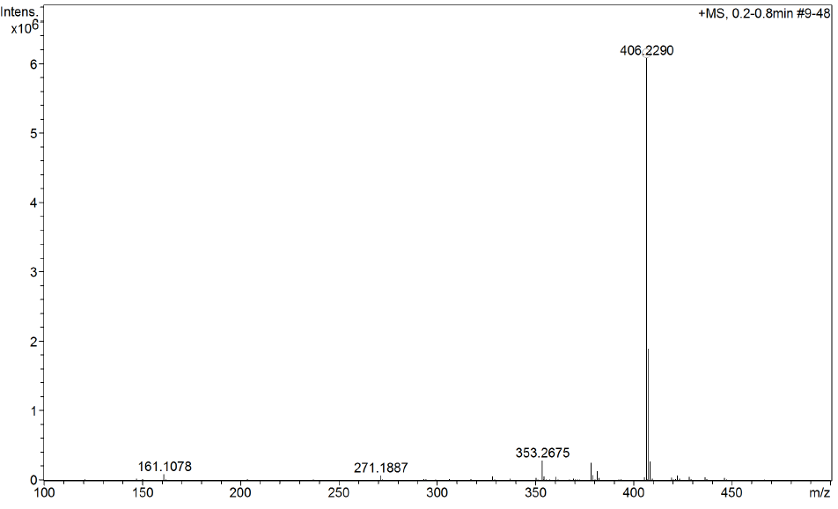
Figure S24. HRMS-ESI spectrum of compound 12e.
Figure S25. DSC analysis of compound 12e.

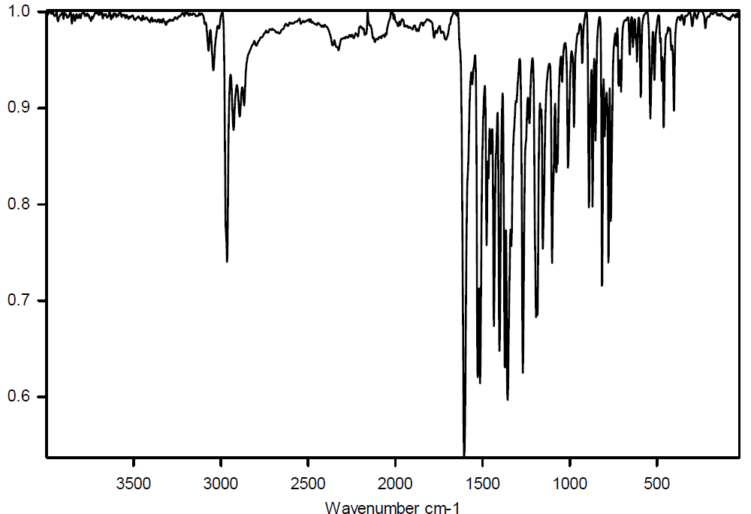
Figure S26. FTIR spectrum of compound 12f.

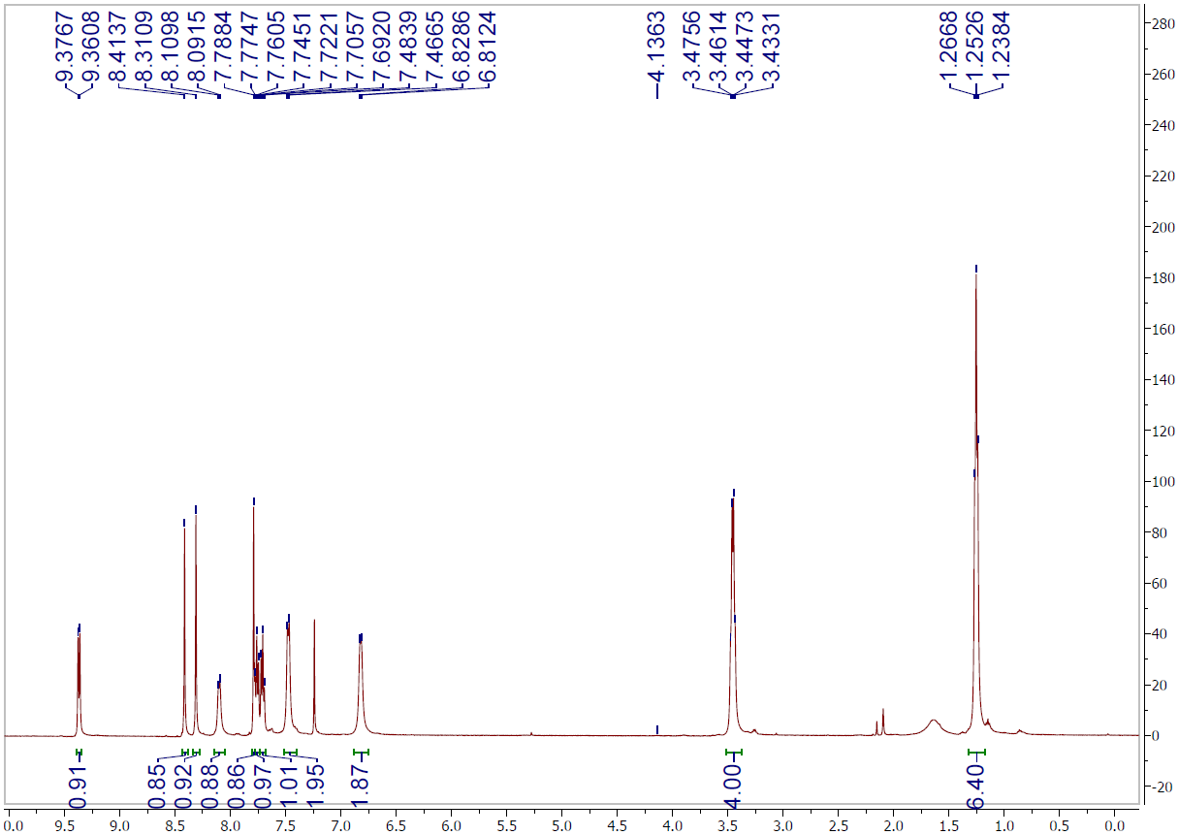
Figure S27. ¹H NMR spectrum in CDCl₃ of compound 12f.

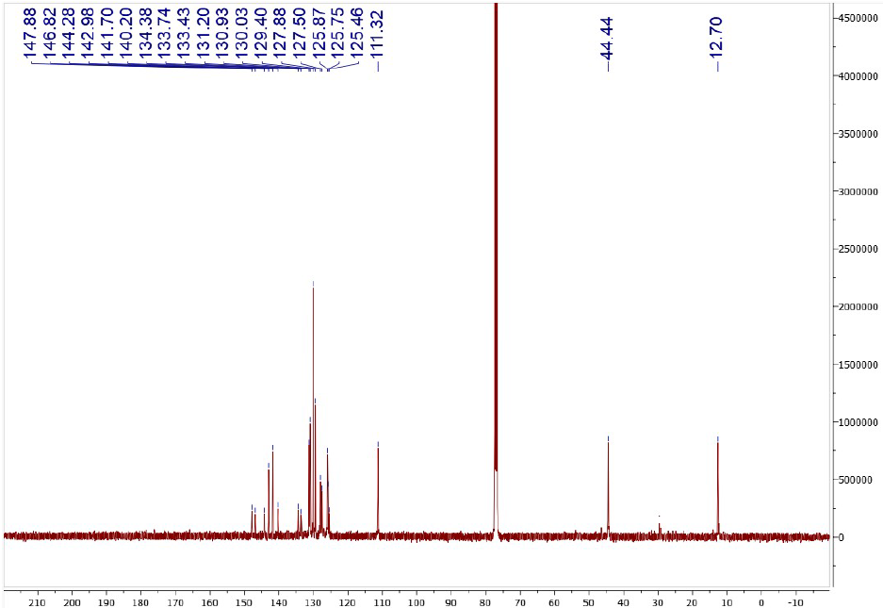
Figure S28. ¹³C NMR spectrum in CDCl₃ of compound 12f.

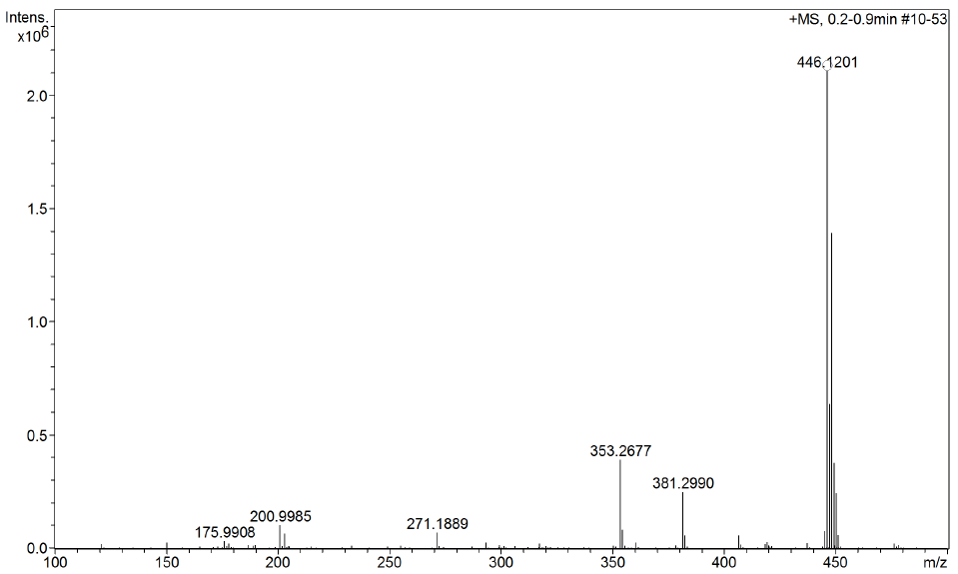
Figure S29. HRMS-ESI spectrum of compound 12f.
Figure S30. DSC analysis of compound 12f.
Figure S31. UV-Vis analysis of compounds 12a-f in CHCl₃.
Figure S32. UV-Vis analysis of compounds 12a-f in ethyl acetate.
Figure S33. UV-Vis analysis of compounds 12a-f in MeOH.
Figure S34. UV-Vis analysis of compounds 12a-f in MeCN.
Figure S35. Steady-state fluorescence emission analysis of compounds 12a-f in CHCl₃.
Figure S36. Steady-state fluorescence emission analysis of compounds 12a-f in ethyl acetate.
Figure S37. Steady-state fluorescence emission analysis of compounds 12a-f in MeOH.
Figure S38. Steady-state fluorescence emission analysis of compounds 12a-f in MeCN.
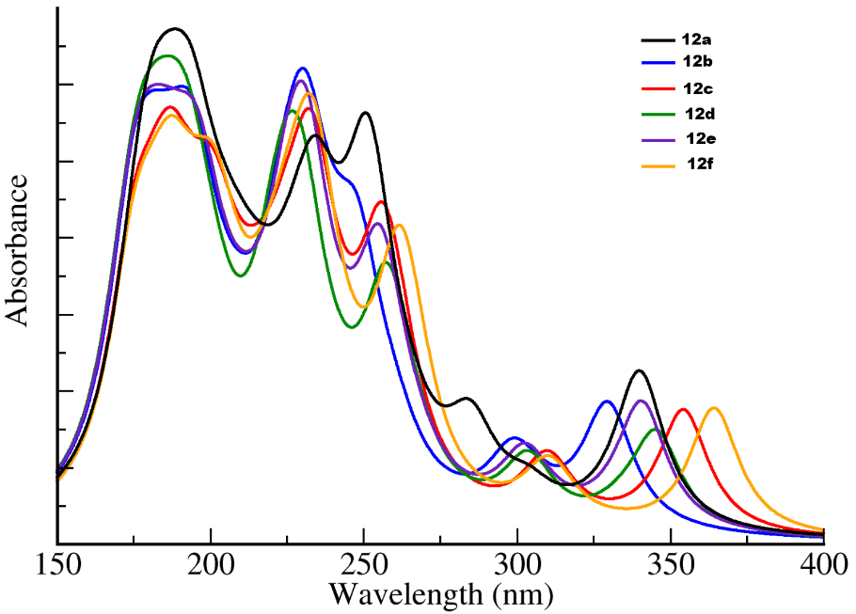
Figure S39. Theoretical UV-Vis spectra of compounds 12a-f in CHCl₃.

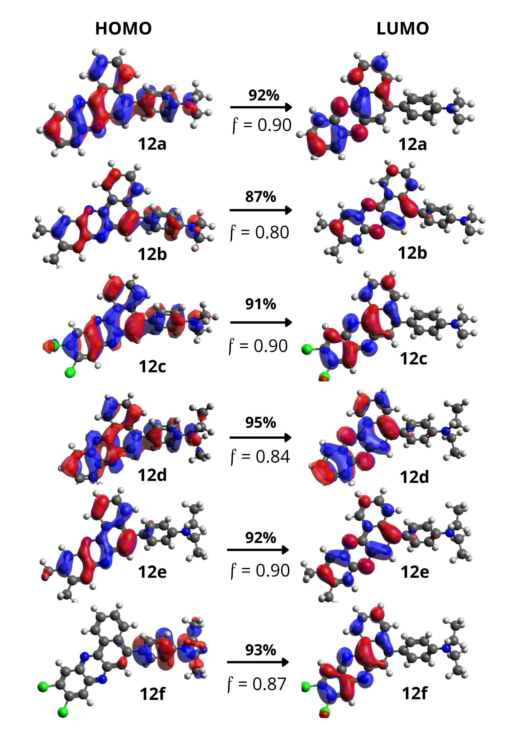

Figure 40. Natural transition orbitals of compounds 12a–f for the S₁ transition using ethyl acetate as solvent.

Table S1. Radiative lifetimes for the five lowest energy electronic transition in ethyl acetate and in chloroform.
Solvent | Molecule | τ_{s1} | τ_{s2} | τ_{s3} | τ_{s4} | τ_{s5}
Ethyl acetate | 12a | 2.91 x 10⁻⁹ s | 5.13 x 10⁻⁸ s | 1.38 x 10⁻⁸ s | 3.46 x 10⁻⁹ s | 8.15 x 10⁻⁹ s
Ethyl acetate | 12b | 2.39 x 10⁻⁹ s | 1.24 x 10⁻⁷ s | 1.43 x 10⁻⁸ s | 3.58 x 10⁻⁹ s | 7.96 x 10⁻⁹ s
Ethyl acetate | 12c | 2.57 x 10⁻⁹ s | 2.66 x 10⁻⁷ s | 1.21 x 10⁻⁸s | 4.44 x 10⁻⁹ s | 3.64 x 10⁻⁹ s
Ethyl acetate | 12d | 2.80 x 10⁻⁹ s | 1.35 x 10⁻⁷ s | 1.51 x 10⁻⁸ s | 3.94 x 10⁻⁹ s | 9.89 x 10⁻⁹ s
Ethyl acetate | 12e | 2.33 x 10⁻⁹ s | 2.04 x 10⁻⁷ s | 1.51 x 10⁻⁸ s | 3.86 x 10⁻⁹ s | 9.70 x 10⁻⁹ s
Ethyl acetate | 12f | 2.61 x 10⁻⁹ s | 2.78 x 10⁻⁷ s | 1.25 x 10⁻⁸ s | 4.90 x 10⁻⁹ s | 5.07 x 10⁻⁹ s
Chloroform | 12a | 2.81 x 10⁻⁹ s | 4.63 x 10⁻⁸ s | 1.32 x 10⁻⁸ s | 3.28 x 10⁻⁹ s | 7.71 x 10⁻⁹ s
Chloroform | 12b | 4.91 x 10⁻⁹ s | 9.08 x 10⁻⁹ s | 2.15 x 10⁻⁸ s | 5.55 x 10⁻⁹ s | 1.56 x 10⁻⁸ s
Chloroform | 12c | 3.73 x 10⁻⁹ s | 2.68 x 10⁻⁷ s | 1.77 x 10⁻⁸ s | 7.35 x 10⁻⁹ s | 6.58 x 10⁻⁹ s
Chloroform | 12d | 4.46 x 10⁻⁹ s | 3.83 x 10⁻⁸ s | 2.41 x 10⁻⁸ s | 6.60 x 10⁻⁹ s | 1.43 x 10⁻⁸ s
Chloroform | 12e | 3.34 x 10⁻⁹ s | 1.12 x 10⁻⁷ s | 2.25 x 10⁻⁸ s | 6.21 x 10⁻⁹ s | 1.41 x 10⁻⁸ s
Chloroform | 12f | 3.82 x 10⁻⁹ s | 3.22 x 10⁻⁷ s | 1.86 x 10⁻⁸ s | 8.03 x 10⁻⁹ s | 8.27 x 10⁻⁹ s

