Supporting Information
High-Efficiency Red TADF OLEDs Based on Phenanthroline-Pyrazine Derivatives with Tailored Donor Substitution
Yuqi Yan ª, Yimeng Li ª, Xiangbin Tian ª, Yaowei Han ª, Yanfang Wang ª, Runyu Gao ª, Bo Zhao ª, Hua Wang ^{a b} *,
ª Key Laboratory of Interface Science and Engineering in Advanced Materials, Ministry of Education, Taiyuan University of Technology, Taiyuan, 030024, China
^{b} College of Textile Engineering, Taiyuan University of Technology, Jin Zhong, 030600, China
* Corresponding authors: wanghua001@tyut.edu.cn (Hua Wang)
Table of contents
- Experimental
- Synthesis
- Supplementary Figures
- Supplementary Tables

I. Experimental

Characterization and measurements.
The ¹H NMR and ¹³C NMR spectra were performed on the Bruker Ascend 400 MHz spectrometer. High-resolution mass spectra were detected with ThermoScientificTM Q-Exactive. UV-Vis optical absorption spectra were measured on a Shimadzu UV-3600 UV-VIS-NIR spectrophotometer. Cyclic voltammetry measurements were carried out under argon atmosphere using the CHI760E voltammetric workstation with a N₂-saturated solution of 0.1 M tetra-n-butyl ammonium hexafluoro phosphate (Bu₄NPF₆) in CH₂Cl₂ as the supporting electrolyte. A platinum disk working electrode, a platinum wire counter electrode, and a silver wire reference electrode were employed, and the ferrocene/ferrocenium redox couple (Fc/Fc⁺) was used as the reference for all measurements with a scanning rate of 50 mV s⁻¹. Thermogravimetric (TGA) measurements were carried out on a METTLER TOLEDO (TGA 1 STARe System) apparatus at a heat ramp of 10 °C min⁻¹ under N₂. DSC curves were recorded on a differential scanning calorimetry in nitrogen (Mettler, STARe, heating ramp: 10 °C min⁻¹). The Photoluminescence (PL) spectra were characterized by an Agilent fluorescence spectrophotometer at room temperature.
Theoretical calculations.
The geometry optimization was performed by DFT method at the B3LYP/6-31(d) level. All the calculations were carried out using Gaussian 09 program package.
Device Fabrication.
Indium tin oxide (ITO) conductive glass was used as the substrate to fabricate OLED devices with an area of 3×3 mm². The ITO substrates were cleaned with detergent powder and deionized water, ultrasonicated in acetone and isopropanol for 10 minutes, and then treated with ultraviolet lamp ozone for 30 minutes. Then, the ITO substrate was loaded into a vacuum chamber with a vacuum degree of less than 5×10⁻⁴ Pa, and according to the designed device structure, the organic functional layers were deposited sequentially according to different thicknesses, the organic layer was deposited at a rate of 1.0 Å s⁻¹, the molybdenum trioxide (MoO₃) and lithium fluoride (LiF) were deposited at a rate of 0.1 Å s⁻¹, and the aluminum (Al) electrode was deposited at a rate of 5.0 Å s⁻¹ to obtain a complete OLED device. Electroluminescence spectra and CIE color coordinates were measured using a PR-655 spectrophotometer; The Keithley-2400 Source Meter and ST-900M Spot Brightness Meter were used to measure the voltage (V), luminance (L), current density (J), current efficiency (CE), and power efficiency (PE) of the device. The external quantum efficiency (EQE) of the device is calculated by the above parameters.

II. Synthesis

5-(4-(9H-carbazol-9-yl)phenyl)pyrazine-2,3-diamine (1)
Compounds 5-bromopyrazine-2,3-diamine (1.00 g, 5.29 mmol), (4-(9H-carbazol-9-yl)phenyl)boronic acid (1.67 g, 5.82 mmol) and bistriphenylphosphine palladium dichloride (0.02 g, 0.0175 mmol) were added to a 100 mL three-mouth bottle in a nitrogen atmosphere, potassium carbonate aqueous solution (2M, 10 mL), toluene (6 mL) and ethanol (3 mL) were added to the reaction system, and heated to reflux reaction under magnetic stirring for 4 hours. After the reaction solution was cooled, 500 mL of water was added to quench the reaction, and the organic phase was extracted with dichloromethane (100 mL), and then filtered and dried with anhydrous MgSO₄. After solvent removal under reduced pressure, the mixture was purified by column chromatography with dichloromethane/n-hexane = 1/1 as the eluent. The resulting product was recrystallized in a toluene/ethanol mixture solvent to obtain brown powder 1 (1.25 g, 67%).¹H NMR (400 MHz, DMSO-d₆) δ 8.25 (s, 2H), 8.14 (d, J = 8.5 Hz, 2H), 7.93 (s, 1H), 7.62 (d, J = 8.5 Hz, 2H), 7.44 (s, 4H), 7.30 (ddd, J = 7.9, 5.4, 2.6 Hz, 2H), 6.15 (d, J = 19.0 Hz, 4H).
5-(4-(diphenylamino)phenyl)pyrazine-2,3-diamine (2)
Compounds 5-bromopyrazine-2,3-diamine (1 g, 5.29 mmol), 4-(diphenylamine)phenylboronic acid (1.68 g, 5.82 mmol) and bistriphenylphosphine palladium dichloride (0.02 g, 0.0175 mmol) were added to a 50 mL three-mouth bottle in a nitrogen atmosphere, potassium carbonate aqueous solution (2M, 10 mL), toluene (6 mL) and ethanol (3 mL) were added to the reaction system, and heated to reflux reaction for 4 hours under magnetic stirring. After the reaction solution was cooled, 500 mL of water was added to quench the reaction, and the organic phase was extracted with dichloromethane (100 mL), and then filtered and dried with anhydrous MgSO4. After solvent removal under reduced pressure, the mixture was purified by column chromatography with dichloromethane/n-hexane = 1/1 as the eluent. The resulting product was recrystallized in a toluene/ethanol mixed solvent to obtain brown powder 2 (1.38 g, 74%).¹H NMR (400 MHz, DMSO-d₆) δ 7.76 (d, J = 8.7 Hz, 2H), 7.72 (s, 1H), 7.30 (t, J = 7.9 Hz, 4H), 7.07 – 6.96 (m, 8H), 6.02 (d, J = 5.8 Hz, 4H).
3,6-bis(4-(9H-carbazol-9-yl)phenyl)phenanthrene-9,10-dione (3)
3,6-Dibromophenanthrene-9,10-dione (1.50 g, 4.10 mmol), (4-(9H-carbazole-9-yl)phenyl)boric acid (2.47 g, 8.61 mmol) and bistriphenylphosphine palladium dichloride (0.02 mg, 0.0175 mmol) were added to a 250 mL three-mouth bottle in a nitrogen atmosphere, and potassium carbonate aqueous solution (2M, 10 mL), toluene (6 mL) and ethanol (3 mL) were added to the reaction system, and heated to reflux under magnetic stirring. Reaction for 6 h. After the reaction solution was cooled, 500 mL of water was added for quenching reaction, and the organic phase was extracted with 100 mL of dichloromethane, and then filtered and dried with anhydrous magnesium sulfate. After solvent removal under reduced pressure, the crude product was purified by column chromatography with dichloromethane/n-hexane = 1/1 as the eluent. The resulting product is recrystallized in a toluene/ethanol mixture to obtain red powder 3 (2.20 g, 78%).¹H NMR (400 MHz, Chloroform-d) δ 8.37 (d, J = 1.7 Hz, 2H), 8.34 (s, 1H), 8.32 (s, 1H), 8.11 (s, 2H), 8.09 (s, 2H), 7.93 – 7.89 (m, 4H), 7.78 (d, J = 1.5 Hz, 1H), 7.76 (d, J = 1.6 Hz, 1H), 7.72 (d, J = 8.5 Hz, 4H), 7.45 (d, J = 8.2 Hz, 4H), 7.39 (d, J = 1.3 Hz, 1H), 7.38 (d, J = 1.2 Hz, 2H), 7.36 (d, J = 1.3 Hz, 1H), 7.27 (d, J = 1.1 Hz, 1H), 7.26 (s, 2H), 7.24 (d, J = 1.1 Hz, 1H).
3,6-bis(4-(diphenylamino)phenyl)phenanthrene-9,10-dione (4)
3,6-Dibromophenanthrene-9,10-dione (1.00 g, 2.73 mmol), triphenylamine 4-borate (1.66 g, 5.74 mmol) and bis-triphenylphosphine palladium dichloride (0.02 g, 0.0175 mmol) were added to a 100 mL three-mouth bottle in a nitrogen atmosphere, and potassium carbonate aqueous solution (2M, 10 mL), toluene (6 mL) and ethanol (3 mL) were added to the reaction system, heated to 105 °C under magnetic stirring, and the reaction was carried out for 6 hours after reflux. After the reaction solution was cooled to room temperature, 500 mL of water was added to the reaction flask for quenching, and the organic phase was extracted with 100 mL of dichloromethane (DCM), and then filtered and dried with anhydrous magnesium sulfate. After solvent removal under reduced pressure, the mixture was purified by column chromatography with DCM/PE = 1/1 as the eluent. The crude product is recrystallized by a toluene/ethanol mixture to produce a purple powder 4（1.65 g，87 %）。¹H NMR (400 MHz, Chloroform-d) δ 8.20 (s, 1H), 8.18 – 8.16 (m, 3H), 7.60 (d, J = 1.6 Hz, 1H), 7.58 (d, J = 1.5 Hz, 1H), 7.53 (d, J = 1.9 Hz, 2H), 7.51 (d, J = 2.0 Hz, 2H), 7.26 (s, 2H), 7.24 (s, 4H), 7.23 (d, J = 1.8 Hz, 2H), 7.12 – 7.09 (m, 12H), 7.05 (d, J = 1.2 Hz, 1H), 7.03 (d, J = 1.4 Hz, 2H), 7.01 (d, J = 1.2 Hz, 1H).
4,4'-(11-(4-(9H-carbazol-9-yl)phenyl)dibenzo[f,h]pyrazino[2,3-b]quinoxaline-3,6-diyl)bis(N,N-diphenylaniline) (CD-2T)
3,6-bis(4-(diphenylamino)phenyl)phenanthrene-9,10-dione 3 (0.50 g, 0.72 mmol) and 5-(4-(9H-carbazol-9-yl)phenyl)pyrazine-2,3-diamine 4 (0.25 g, 0.72 mmol) added into a degassed solution of acetic acid (AcOH) (30 mL). Heat the mixture back and return for 3 hours. After cooling down, the solvent was removed under vacuum and the residue was purified by column chromatography (silica gel) using CH₂Cl₂/CH₃OH = 10/1 as eluent, gave a light brown solid 4,4'-(11-(4-(9H-carbazol-9-yl)phenyl)dibenzo[f,h]pyrazino[2,3-b]quinoxaline-3,6-diyl)bis(N,N-diphenylaniline) CD-2T ( 0.70 g, 96.8 %). ¹H NMR (400 MHz, CDCl₃) δ 9.51 (dd, J = 13.2, 8.4 Hz, 2H), 8.75 (s, 2H), 8.68 (d, J = 8.3 Hz, 2H), 8.17 (d, J = 7.7 Hz, 2H), 7.98 (dt, J = 8.4, 1.8 Hz, 2H), 7.88 (d, J = 8.4 Hz, 2H), 7.71 (d, J = 8.3 Hz, 4H), 7.56 (d, J = 8.2 Hz, 2H), 7.47 (ddd, J = 8.3, 7.1, 1.3 Hz, 2H), 7.37 – 7.28 (m, 11H), 7.23 (d, J = 8.3 Hz, 4H), 7.21 – 7.17 (m, 8H), 7.08 (ddd, J = 8.7, 6.5, 1.3 Hz, 4H).¹³C NMR (101 MHz, Chloroform-d) δ 152.98, 147.16, 147.13, 146.39, 145.67, 145.44, 144.36, 143.30, 142.96, 142.60, 142.47, 139.63, 139.28, 133.02, 132.44, 131.97, 131.81, 128.83, 128.40, 128.01, 127.20, 127.16, 127.12, 127.03, 126.75, 126.65, 126.21, 125.75, 125.65, 125.22, 124.27, 123.79, 122.80, 122.39, 122.30, 119.53, 119.44, 108.85, 76.20, 57.46, 17.42. HRMS: C₇₂H₄₇N₇ calcd: 1009.3893, found: 1010.3966 [M+H]⁺.
4,4',4''-(dibenzo[f,h]pyrazino[2,3-b]quinoxaline-3,6,11-triyl)tris(N,N-diphenylaniline) (TD-2T)
3,6-bis(4-(diphenylamino)phenyl)phenanthrene-9,10-dione 7 (0.50 g, 0.72 mmol) and 5-(4-(diphenylamino)phenyl)pyrazine-2 and 3-diamine 4 (0.25 g, 0.72 mmol) added into a degassed solution of acetic acid (AcOH) (30 mL). Heat the mixture back and return for 3 hours. After cooling down, the solvent was removed under vacuum and the residue was purified by column chromatography (silica gel) using CH₂Cl₂/CH₃OH = 10/1 as eluent, gave a light brown solid 4,4',4''-(dibenzo[f,h]pyrazino[2,3-b]quinoxaline-3,6,11-triyl)tris(N,N-diphenylaniline) TD-2T (0.71 g, 97.2 %). ¹H NMR (400 MHz, Chloroform-d) δ 9.56 (s, 1H), 9.40 (dd, J = 17.1, 8.4 Hz, 2H), 8.66 (t, J = 2.1 Hz, 2H), 8.26 – 8.20 (m, 2H), 7.91 – 7.85 (m, 2H), 7.66 – 7.58 (m, 4H), 7.32 – 7.20 (m, 12H), 7.18 – 7.07 (m, 20H), 7.03 – 6.99 (m, 4H).¹³C NMR (101 MHz, Chloroform-d) δ 147.09, 146.45, 145.62, 142.46, 132.77, 131.65, 128.61, 128.45, 128.38, 127.22, 127.16, 127.02, 126.89, 124.81, 123.74, 123.49, 122.44, 122.31, 120.28, 119.52, 76.20, 74.22, 66.69, 32.05, 24.87, 19.93. HRMS: C₇₂H₄₉N₇ calcd: 1011.4049, found: 1012.4123 [M+H] ⁺.
4-(3,6-bis(4-(9H-carbazol-9-yl)phenyl)dibenzo[f,h]pyrazino[2,3-b]quinoxalin-11-yl)-N,N-diphenylaniline (TD-2C)
3,6-bis(4-(9H-carbazol-9-yl)phenyl)phenanthrene-9,10-dione 7 (0.50 g, 0.72 mmol) and 5-(4-(diphenylamino)phenyl)pyrazine-2,3-diamine 5 (0.25 g, 0.72 mmol) added into a degassed solution of acetic acid (AcOH) (30 mL). Heat the mixture back and return for 3 hours. After cooling down, the solvent was removed under vacuum and the residue was purified by column chromatography (silica gel) using CH₂Cl₂/CH₃OH = 10/1 as eluent, gave a light brown solid 4,4'-(11-(4-(9H-carbazol-9-yl)phenyl)dibenzo[f,h]pyrazino[2,3-b]quinoxaline-3,6-diyl)bis(N,N-diphenylaniline) TD-2C ( 0.70 g, 95.8 %). ¹H NMR (400 MHz, Chloroform-d) δ 9.66 – 9.56 (m, 2H), 8.92 (d, J = 2.7 Hz, 1H), 8.46 – 8.23 (m, 3H), 8.20 – 8.04 (m, 9H), 7.96 (d, J = 8.2 Hz, 1H), 7.80 – 7.75 (m, 4H), 7.57 – 7.40 (m, 9H), 7.33 (dd, J = 16.0, 7.9 Hz, 8H), 7.23 – 7.12 (m, 8H). ¹³C NMR (101 MHz, CDCl₃) δ 178.81, 175.24, 146.74, 145.27, 144.17, 143.01, 139.82, 139.61, 139.51, 139.20, 137.65, 137.18, 136.93, 136.88, 135.11, 132.02, 131.84, 130.42, 129.11, 128.79, 127.97, 127.92, 127.84, 127.54, 127.36, 126.50, 126.44, 126.40, 126.14, 125.22, 125.09, 125.07, 122.83, 122.60, 122.55, 121.52, 119.59, 119.45, 119.41, 119.33, 119.22, 108.84, 108.74, 108.64, 76.19, 19.56. HRMS: C₇₂H₄₅N₇ calcd: 1007.3736, found: 1008.3810 [M+H] ⁺.

Ⅲ. Supplementary Figures
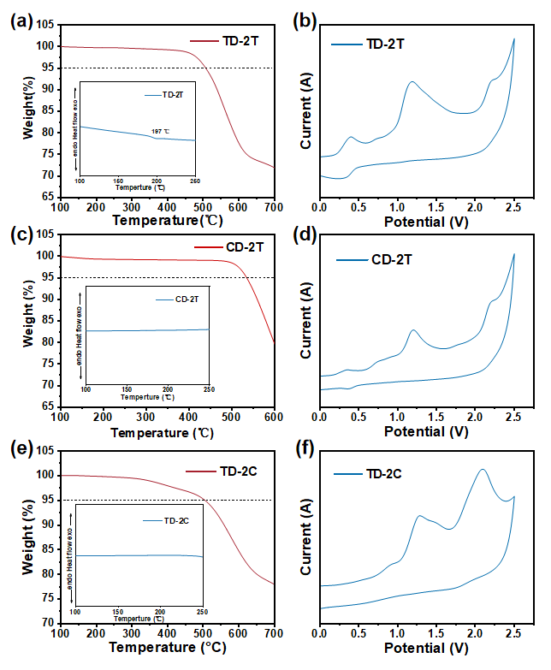
Figure S1. (a) TGA and DSC curves of TD-2T (b) CD-2T (e) TD-2C; (b) Cyclic Voltammetry curves of TD-2T (d) CD-2T (f) TD-2C

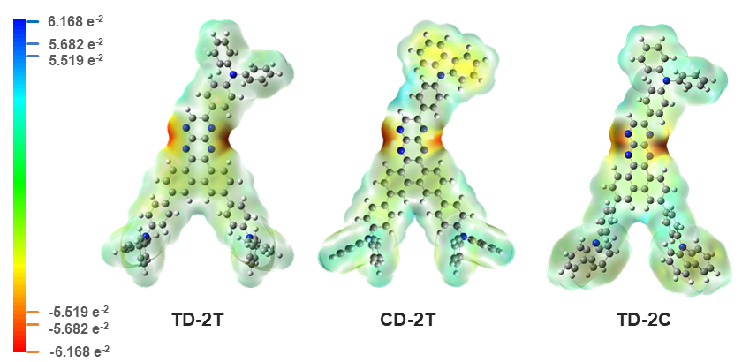
Figure S2. Surface electrostatic potential for TD-2T、CD-2T and TD-2C

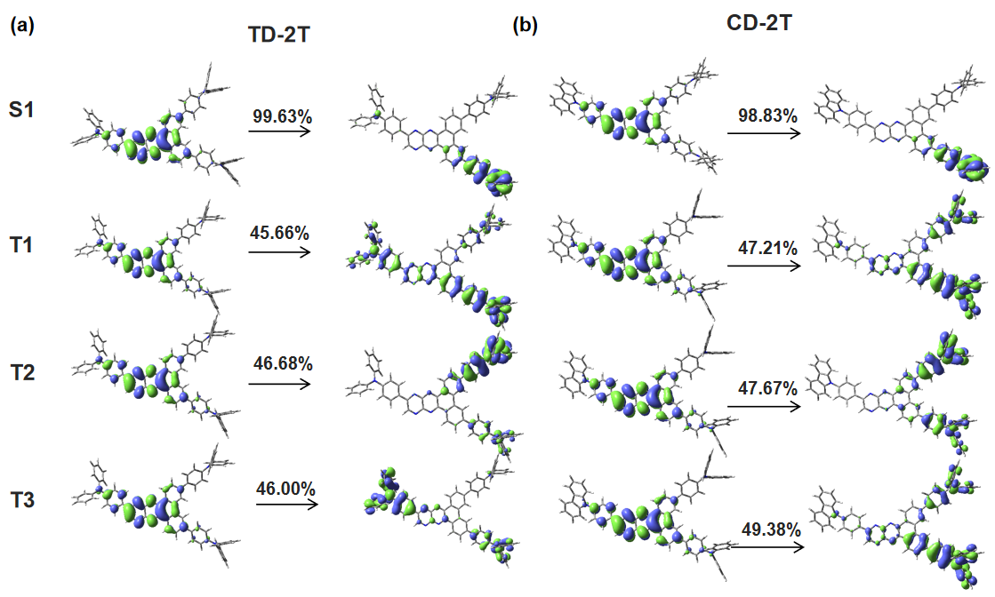
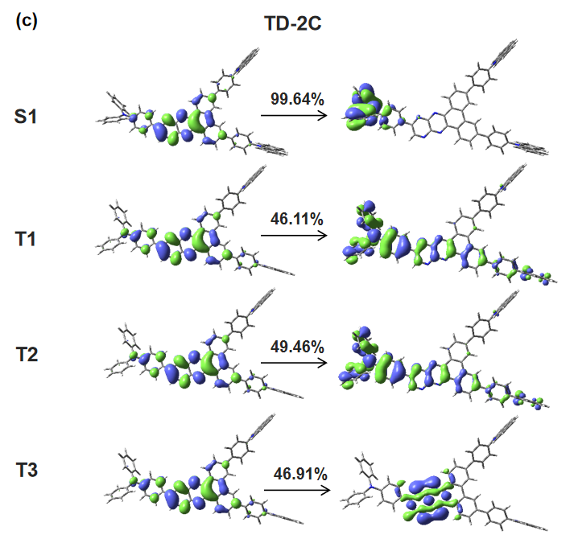
Figure S3. NTO orbital distribution of (a) TD-2T (b) CD-2T and (c) TD-2C
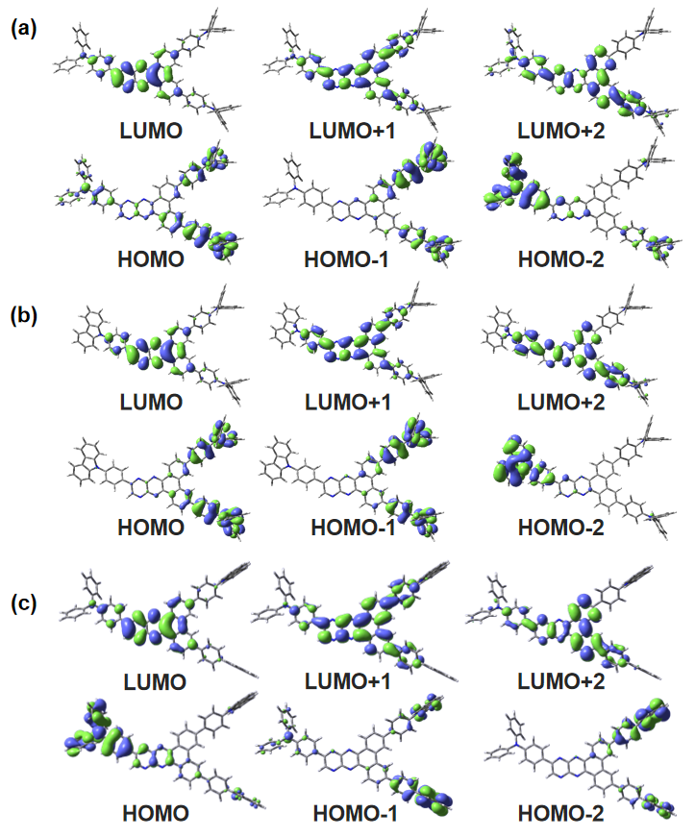
Figure S4. (a) Schematic diagram of the quasi-degenerate and occupying orbit of TD-2T (b) CD-2T (c) TD-2C

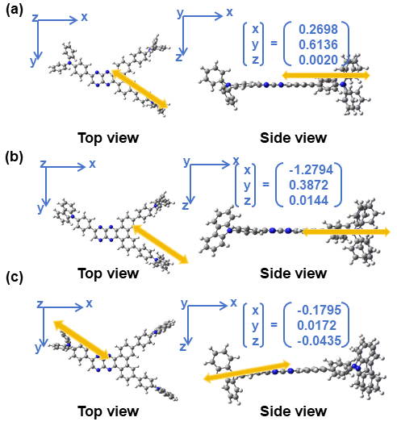
Figure S5. (a) Calculation direction of transition dipole moment of TD-2T (b) CD-2T (c) TD-2C in top and side views
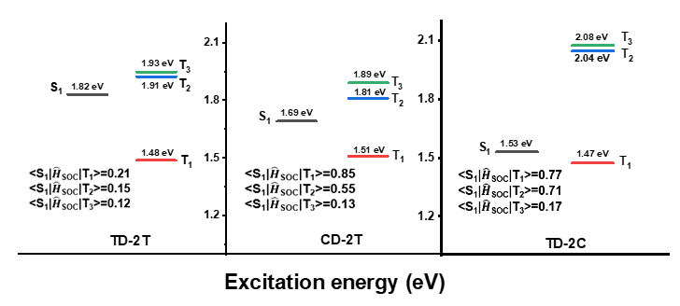
Figure S6. The calculation of ground state and excited state for TD-2T,CD-2T,TD-2C

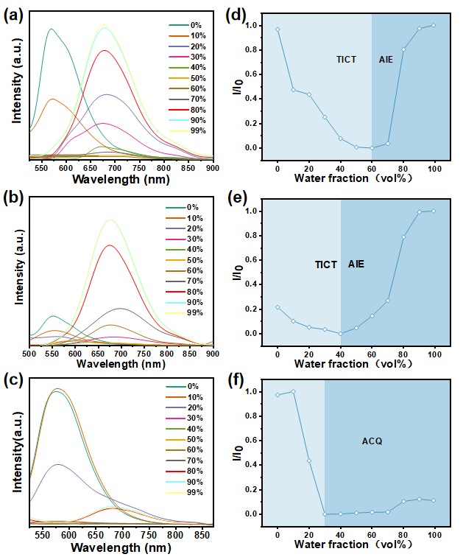
Figure S7. PL curves of (a) TD-2T (b) CD-2T and (c) TD-2C molecules with different water contents in DMSO/H₂O mixed solution; (d) Relationship between different water contents and luminescence intensity of TD-2T (e) CD-2T and (f) TD-2C molecules in DMSO/H₂O mixed solution
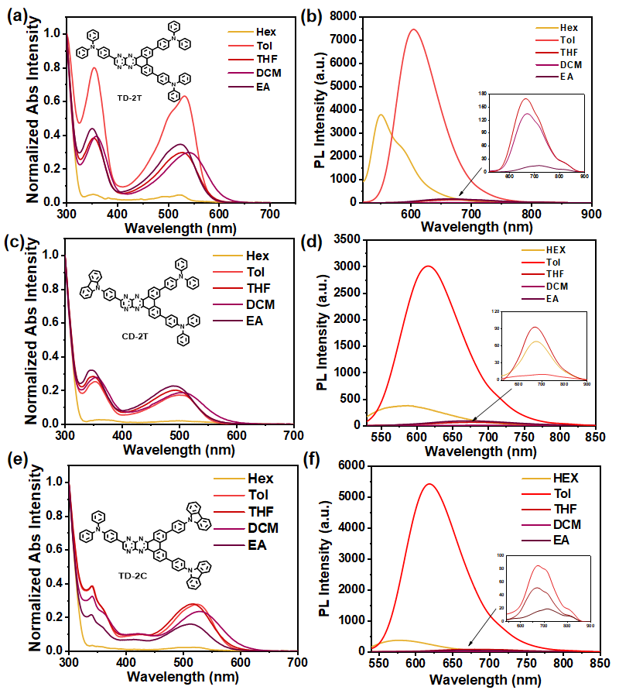
Figure S8. UV-vis absorption curves of (a)TD-2T (c) CD-2T (e) TD-2C molecules in different solvents; PL emission spectra of (b) TD-2T (d) CD-2T (f) TD-2C in different solvents

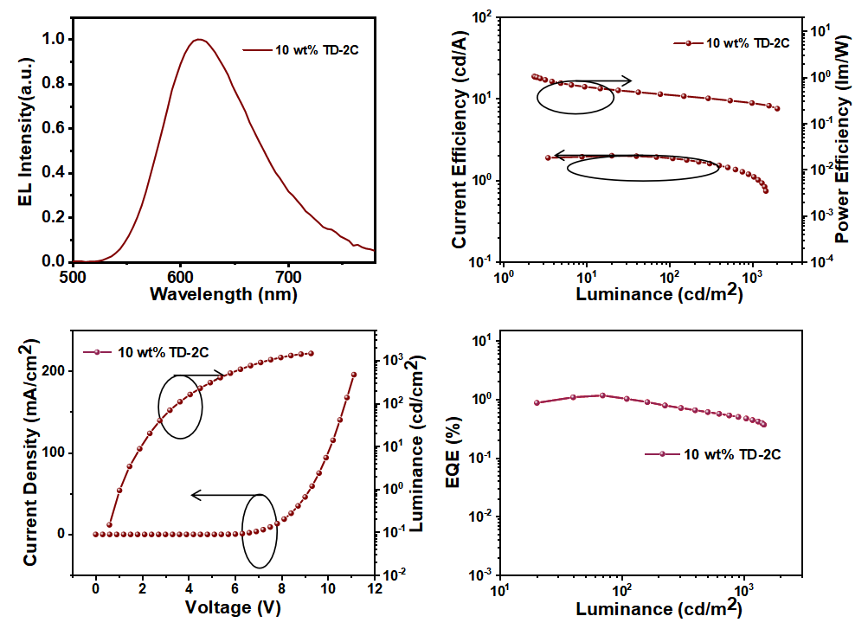
Figure S9. Electroluminescent performances of TD-2C(A3): (a) EL spectra at a driven voltage of 6 V; (b) J-V-L curves; (c)CE-L-PE curves; (d) EQE-L curves

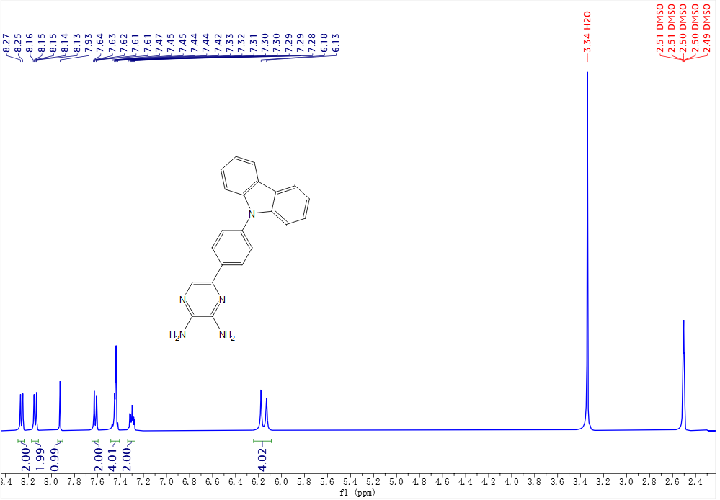
Figure S10. The ¹H NMR spectrum of 1.
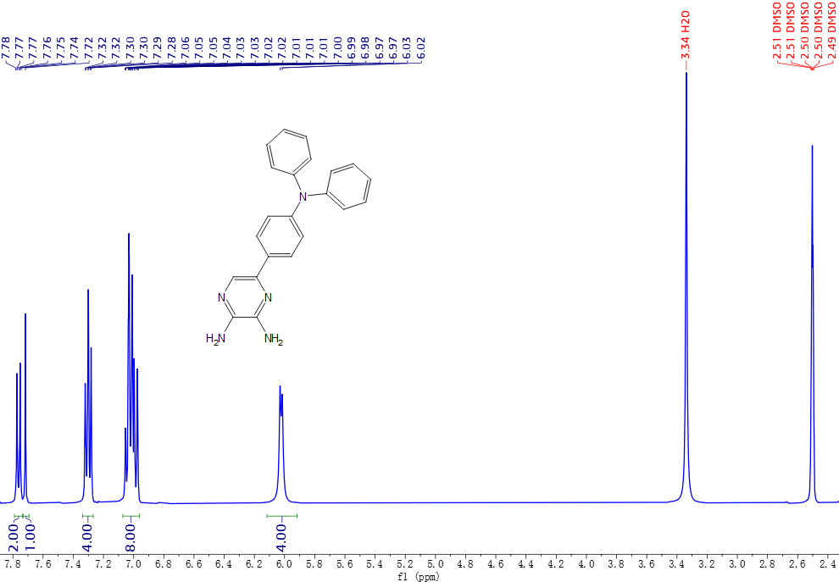
Figure S11. The ¹H NMR spectrum of 2.
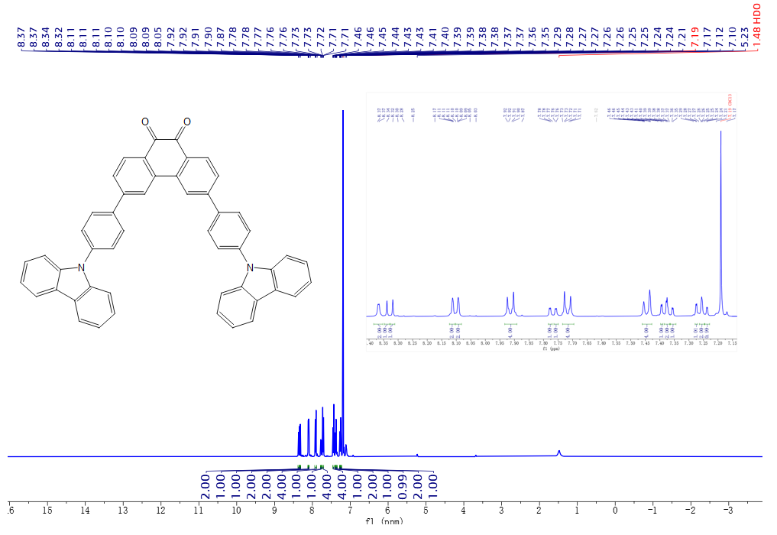
Figure S12. The ¹H NMR spectrum of 3.
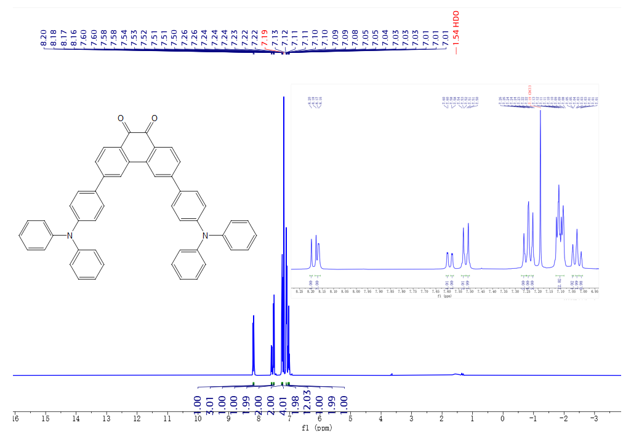
Figure S13. The ¹H NMR spectrum of 4.
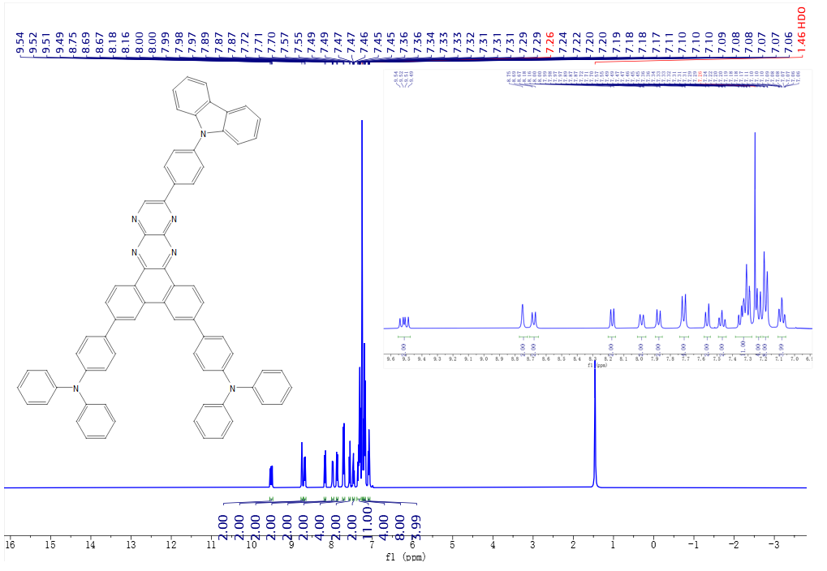
Figure S14. The ¹H NMR spectrum of CD-2T.
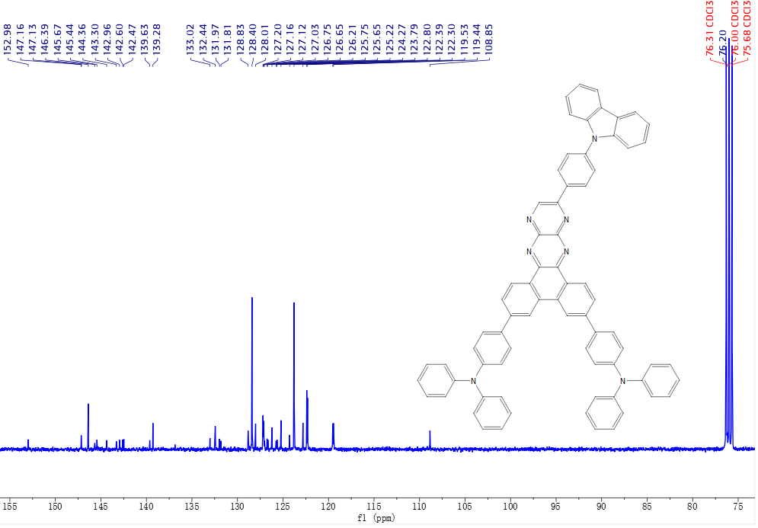
Figure S15. The ¹³C NMR spectrum of CD-2T.
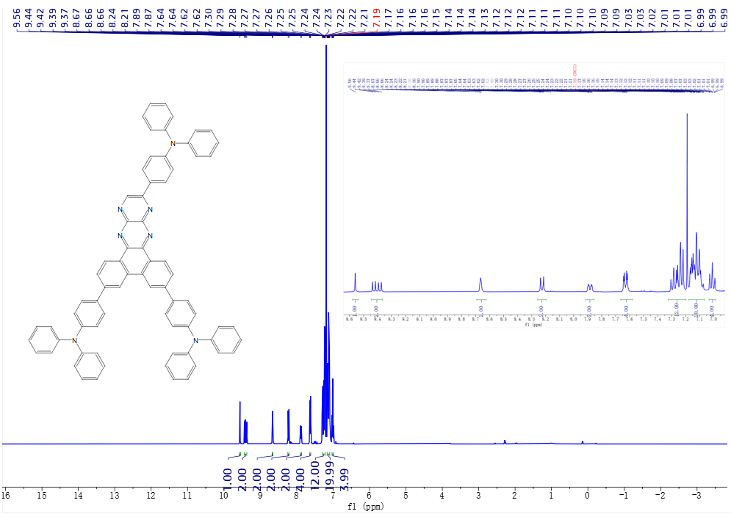
Figure S16. The ¹H NMR spectrum of TD-2T.
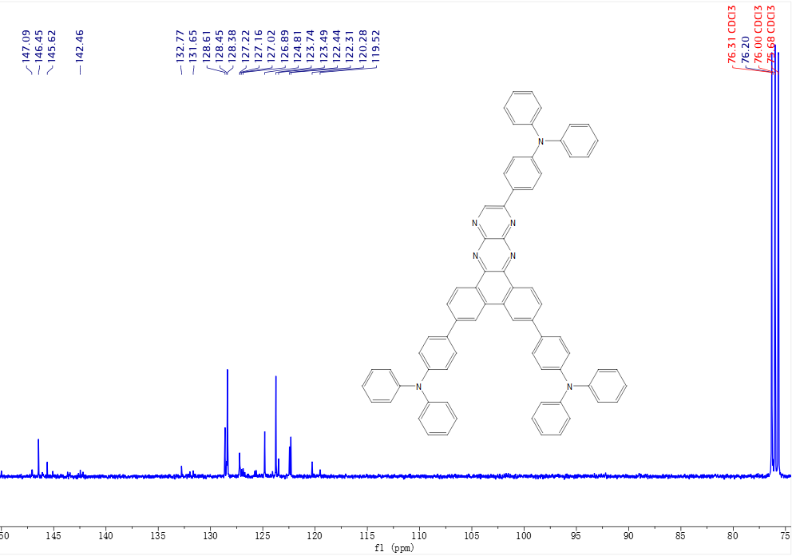
Figure S17. The ¹³C NMR spectrum of TD-2T.
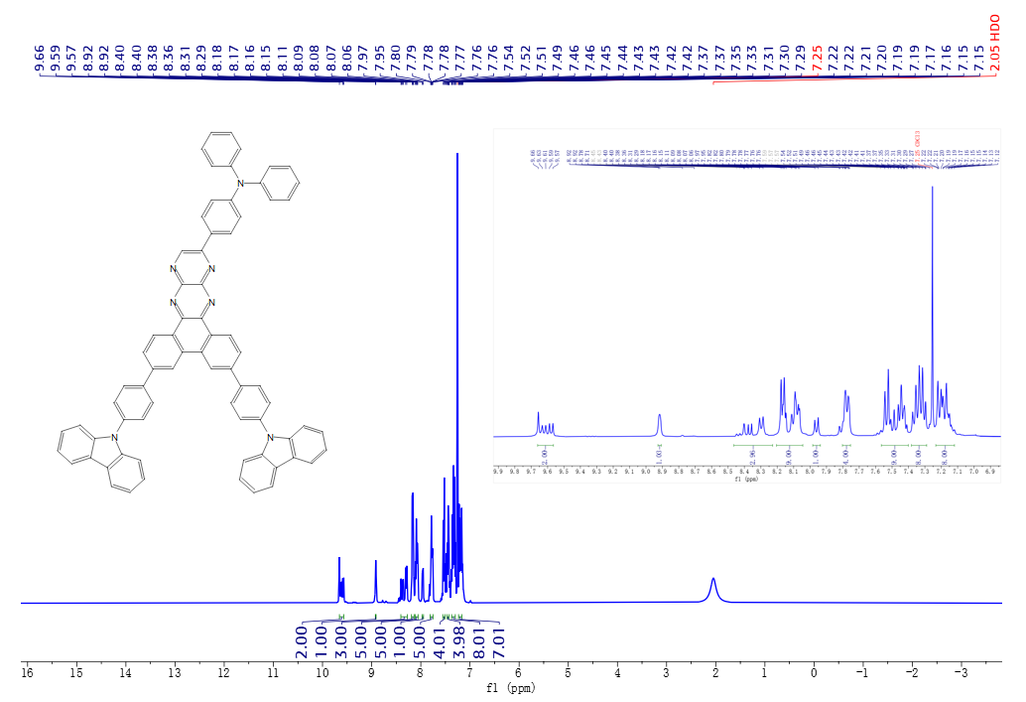
Figure S18. The ¹H NMR spectrum of TD-2C.
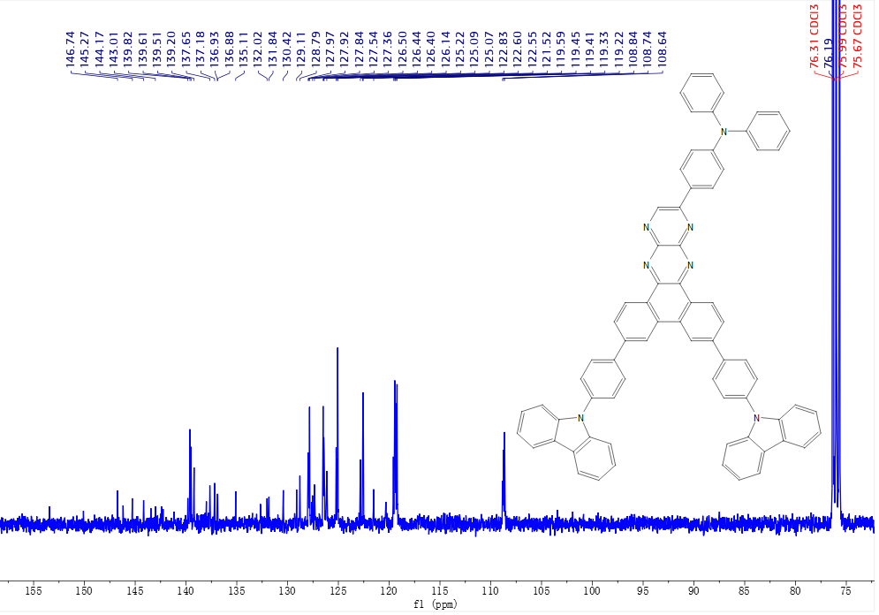
Figure S19. The ¹³C NMR spectrum of TD-2C.
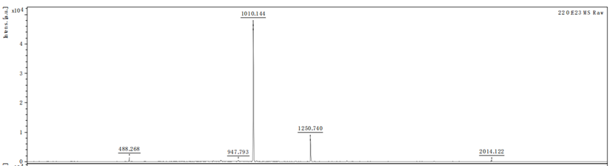
Figure S20. The MS spectrum of CD-2T.
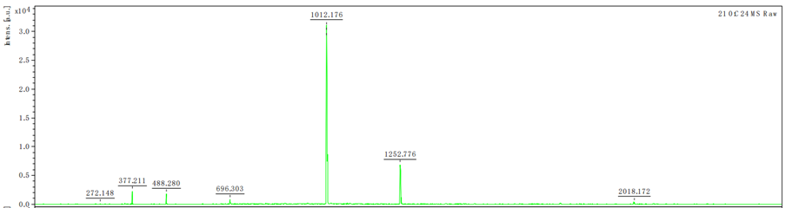
Figure S21. The MS spectrum of TD-2T.
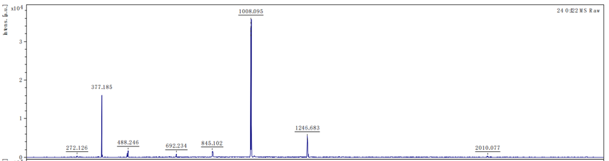
Figure S22. The MS spectrum of TD-2C.

Ⅳ. Supplementary Tables
Table S1. Summary of the simulation data of TD-2T, CD-2T, and TD-2C
 | HOMO  (eV) | LUMO  (eV) | E_{g}  (eV) | S₁  (eV) | T₁  (eV) | ΔE_{ST}  (eV) | f
TD-2T | -4.94 | -2.53 | 2.41 | 1.82 | 1.48 | 0.34 | 0.32
CD-2T | -5.27 | -2.97 | 2.30 | 1.69 | 1.51 | 0.18 | 0.21
TD-2C | -5.19 | -2.71 | 2.48 | 1.53 | 1.47 | 0.06 | 0.80

Table S2. Summary of Electrochemical and Thermal Stability data of four Materials
 | HOMO  (eV) | LUMO  (eV) | E_{g}  (eV) | T_{d}  (℃) | T_{g}  (℃)
TD-2T | -5.15 | -2.96 | 2.19 | 502 | 197
CD-2T | -5.20 | -3.03 | 2.17 | 533 | ——
TD-2C | -5.16 | -3.02 | 2.14 | 506 | ——

Table S3. Photophysical properties of TD-2T,CD-2T and TD-2C in different solvents
Solvent | TD-2T |  | CD-2T |  | TD-2C
Solvent | $$λ_{abs}$$  (nm) | $$λ_{PL}$$  (nm) | $$λ_{abs}$$  (nm) | $$λ_{PL}$$  (nm) | $$λ_{abs}$$  (nm) | $$λ_{PL}$$  (nm)
Hexane | 350/522 | 549 | 345/491 | 505 | 339/512 | 576
Toluene | 352/531 | 603 | 347/503 | 616 | 339/525 | 621
Tetrahydrofuran | 353/533 | 663 | 352/505 | 618 | 340/527 | 671
Dichloromethane | 354/535 | 671 | 355/507 | 626 | 340/528 | 675
Ethyl Acetate | 358/542 | 718 | 360/513 | 658 | 341/528 | 714

Table S4 Electroluminescence performances of device A3
Emitter | λ_{EL}  (nm) | CIE  (x,y) | EQE_{max}  (%) | CE_{max}  (cd/A) | PE_{max}  (lm/W) | L_{max}  (cd/m²) | V_{on}  (V)
A3 | 618 | (0.60,0.38) | 1.64 | 2.01 | 1.00 | 1450 | 5.1

