Supplementary Information

Concentration- and Cucurbit[n]urils-Regulated Molecular Packing Modes for Constructing Continuously Red-Shifted Multi-stimuli Responsive Luminescent System
Junli Yang ª, Dongdong Sun ^{b}, Xingbo Guo ª, Ziwei Hu ª, Qiandie Yang ª, Mengling Lang ª, Le Chen ª, Zhengfen Liu ^{a, *}, and Xianchen Hu ^{a, *}
a: College of Chemical and Materials Engineering, Qujing Normal University, Qujing 655011, China.
b: College of Science, Henan Agricultural University, Zhengzhou 450002, China.
* Corresponding authors.
E-mail addresses: hxc413970239@163.com (X. Hu), zhengfen_liu@163.com (Z. Liu)

Table of Contents
Section A. Characterization of Compound………………………………………………………S2
Section B. Host-guest recognition of CB[n] (n = 7, 8, 10) and G1………………………………S5
Section C. The photophysical properties of G1 and the host-guest inclusion complexes………S9
Section D. DFT calculations…………………………………………………………….……… S13

Section A. Characterization of Compound
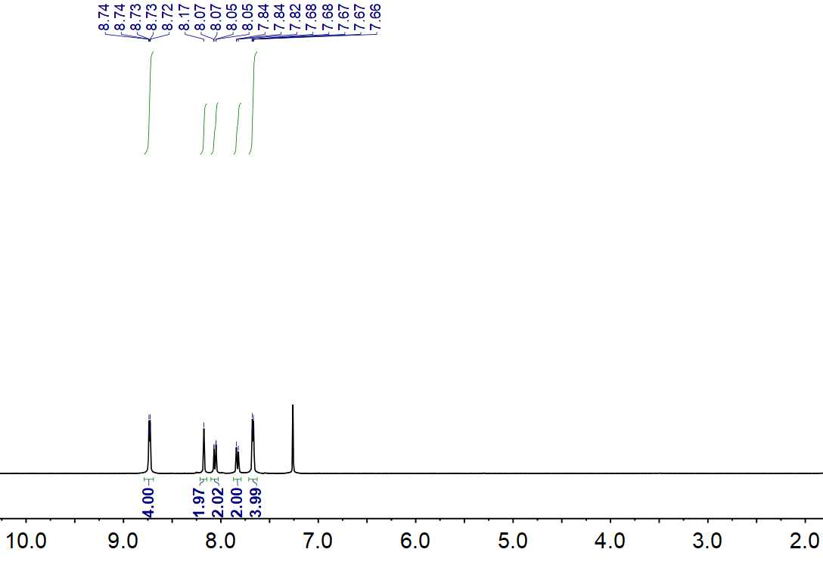
Figure S1. The ¹H NMR spectroscopic spectrum of compound 1-1 (400 MHz, CDCl₃, 298 k).
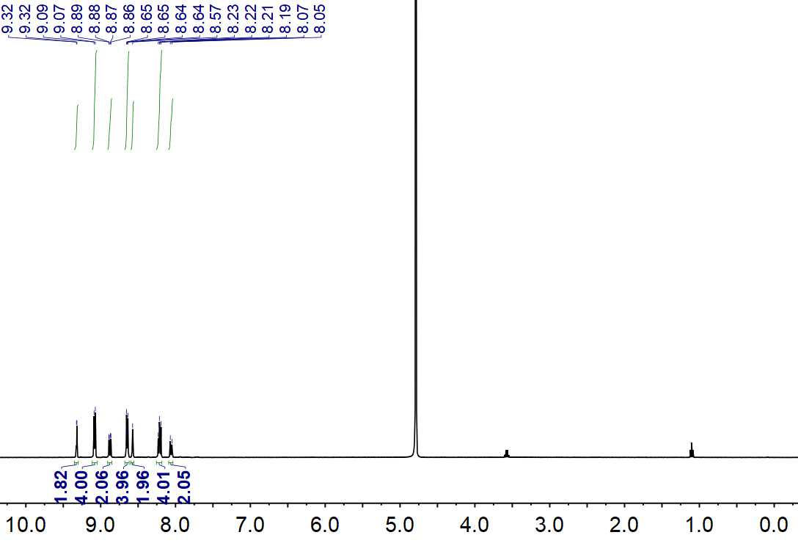
Figure S2. The ¹H NMR spectroscopic spectrum of compound 1-2 (400 MHz, D₂O, 298 k).
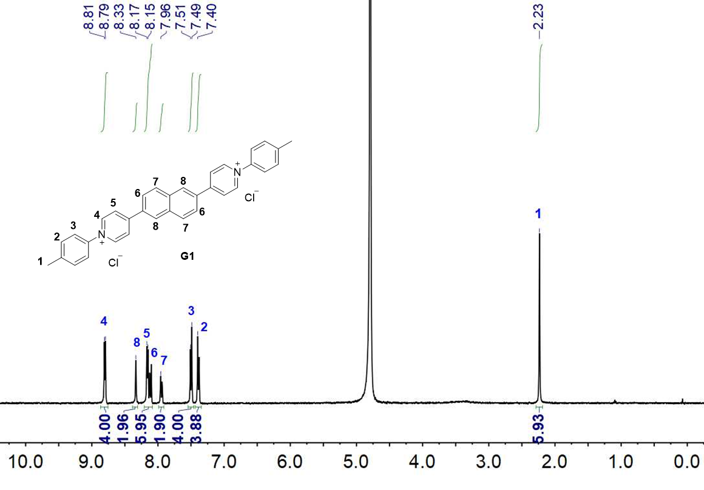
Figure S3. The ¹H NMR spectroscopic spectrum of compound G1 (400 MHz, D₂O, 298 k).
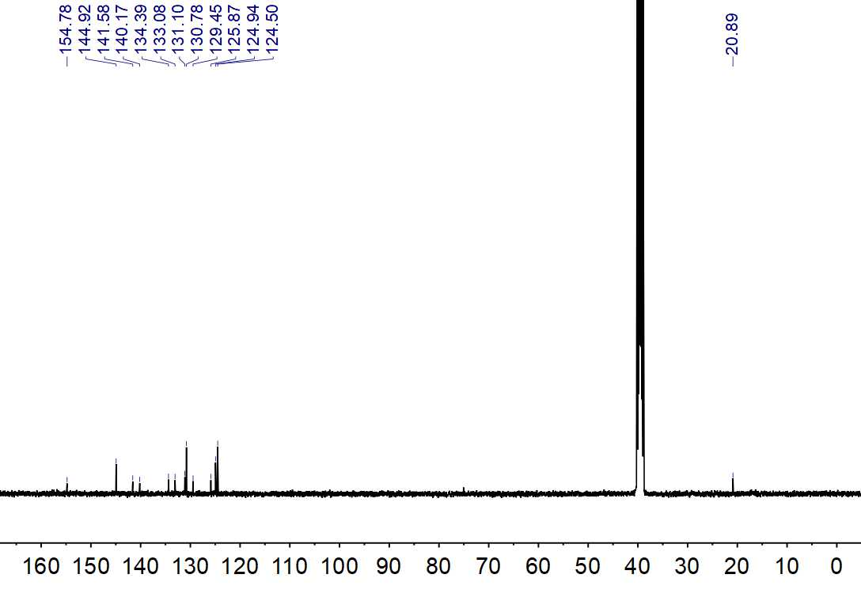
Figure S4. The ¹³C NMR spectroscopic spectrum of compound G1 (400 MHz, DMSO-d₆, 298 k).
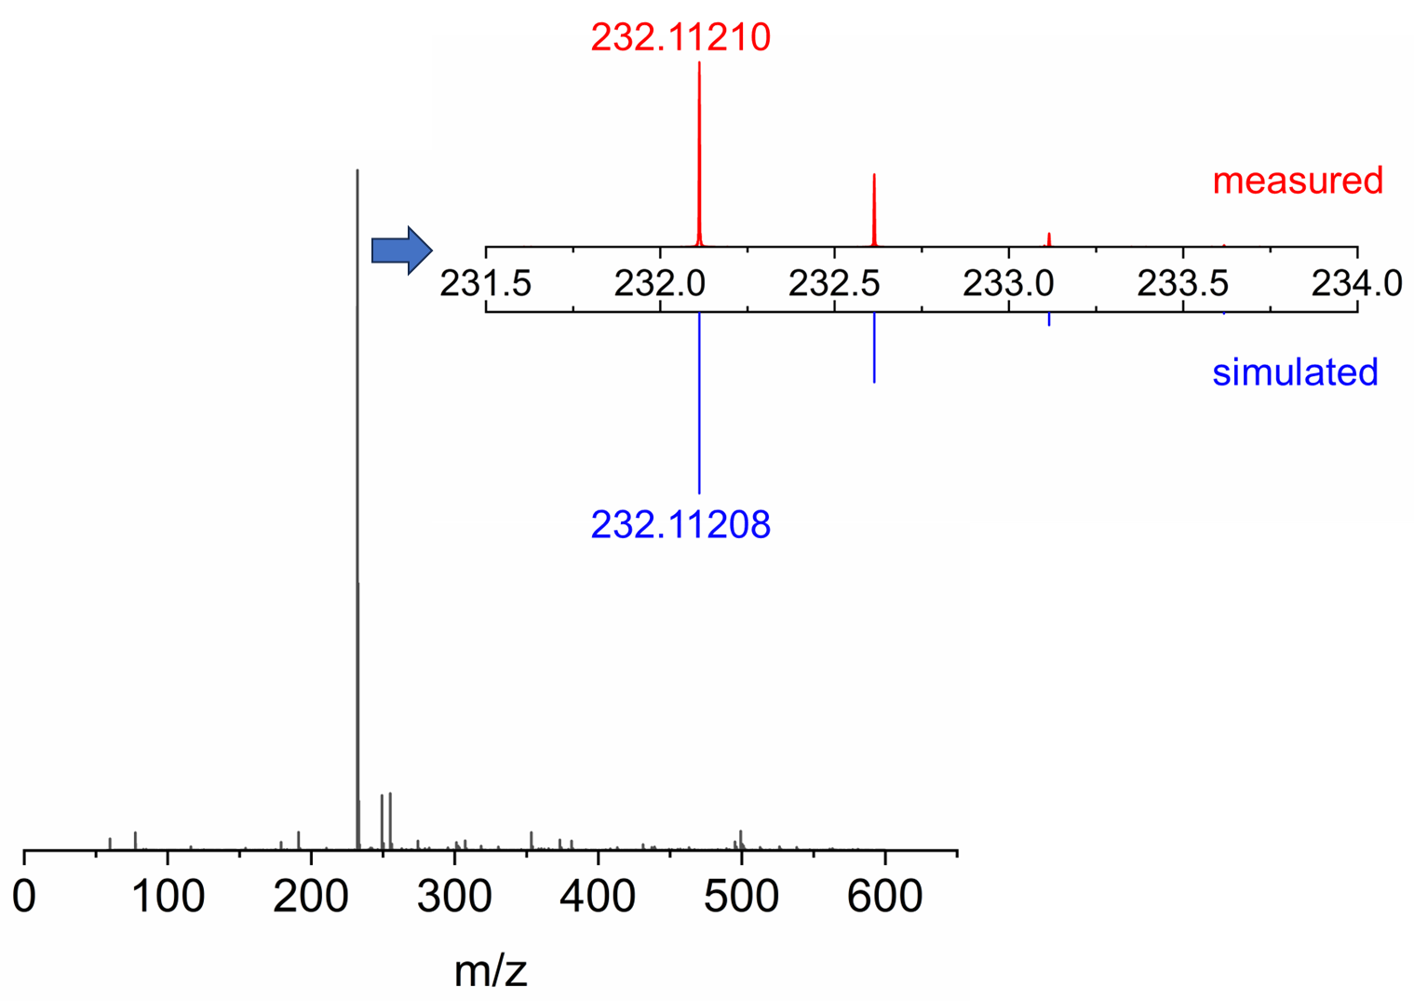
Figure S5. ESI-MS spectrum of G1.

Section B. Host-guest recognition of CB[n] (n = 7, 8, 10) and G1
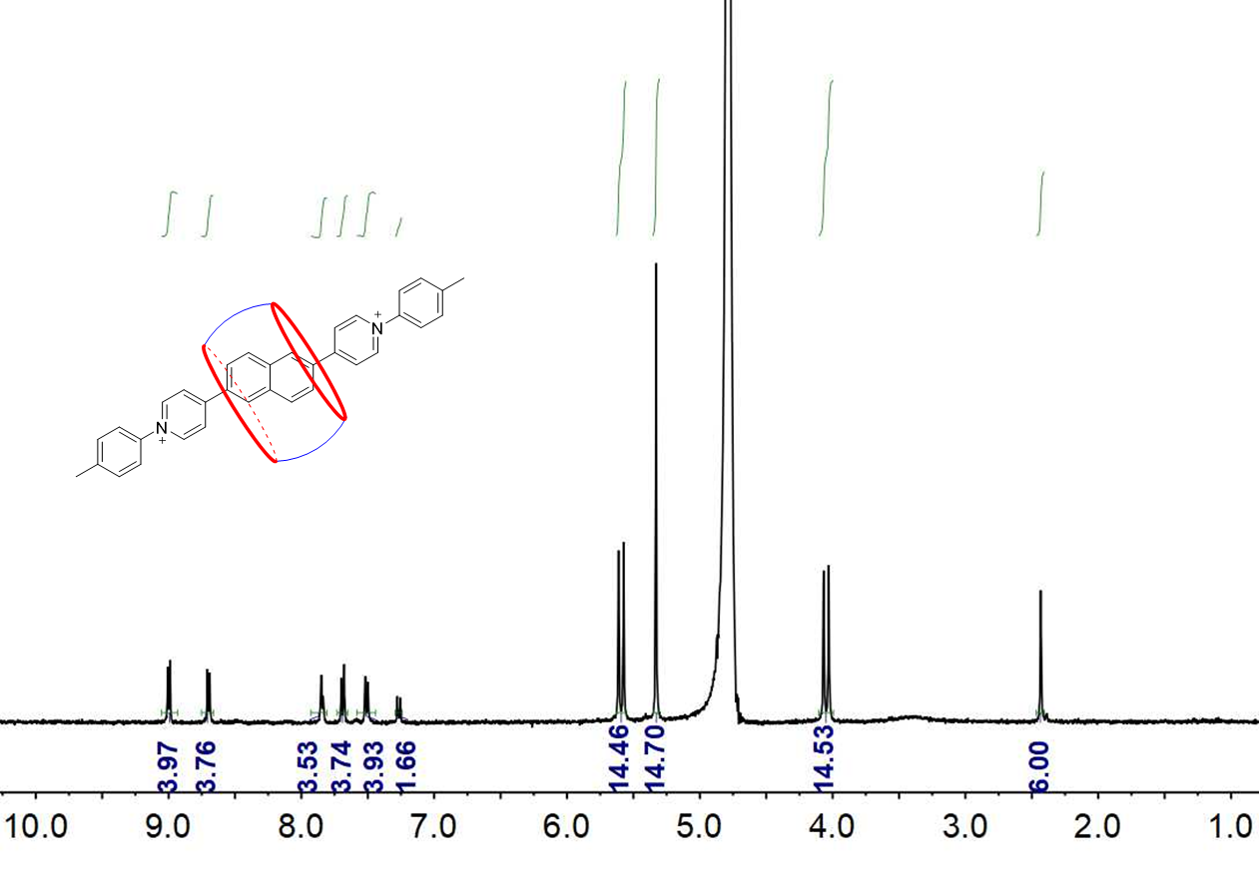
Figure S6. ¹H NMR spectroscopic spectrum of G1 (0.50 mM, 400 MHz, D₂O, 298 K) with 1.00 equiv. of CB[7].
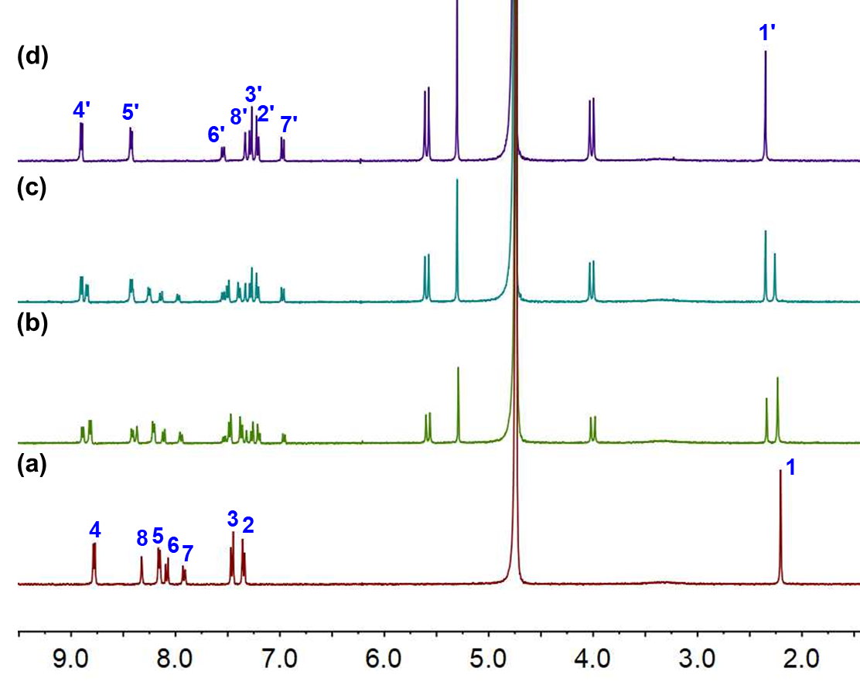
Figure S7. ¹HNMR spectroscopic titration spectra of G1 (0.50 mM, 400 MHz, D₂O, 298 K) with (a) 0.00 equiv., (b) 0.17 equiv., (c) 0.33 equiv., (d) 0.50 equiv. of CB[8]. Characters 1~8 and 1'~8' represent the resonance signals of G1 as free and in CB[8]·G1₂, respectively.
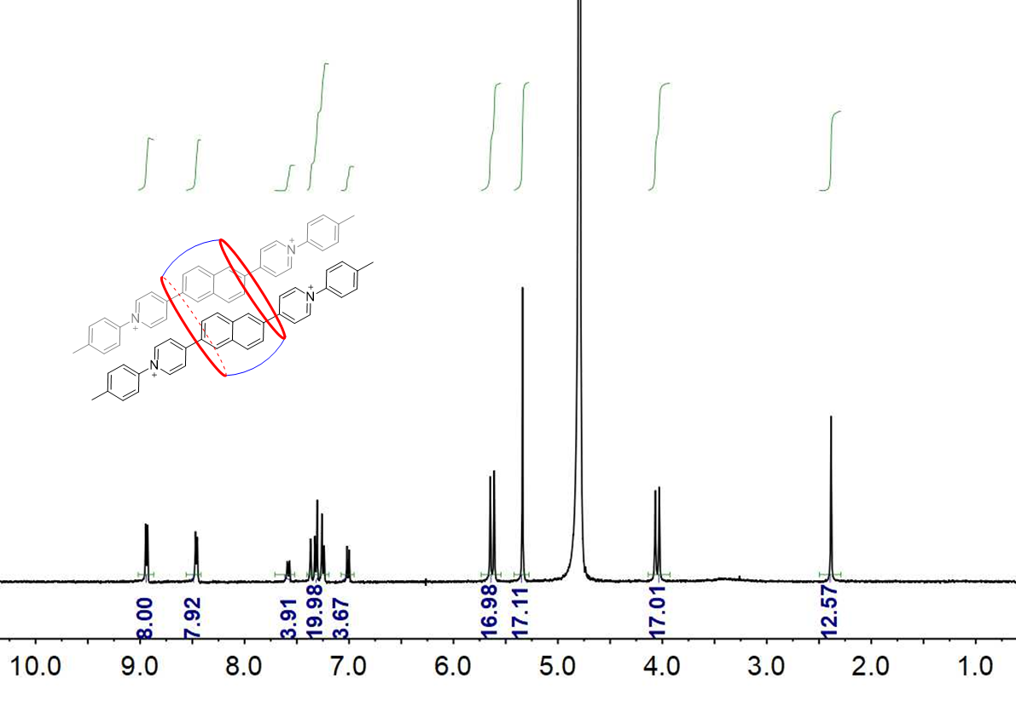
Figure S8. ¹H NMR spectroscopic spectrum of G1 (0.50 mM, 400 MHz, D₂O, 298 K) with 0.50 equiv. of CB[8].
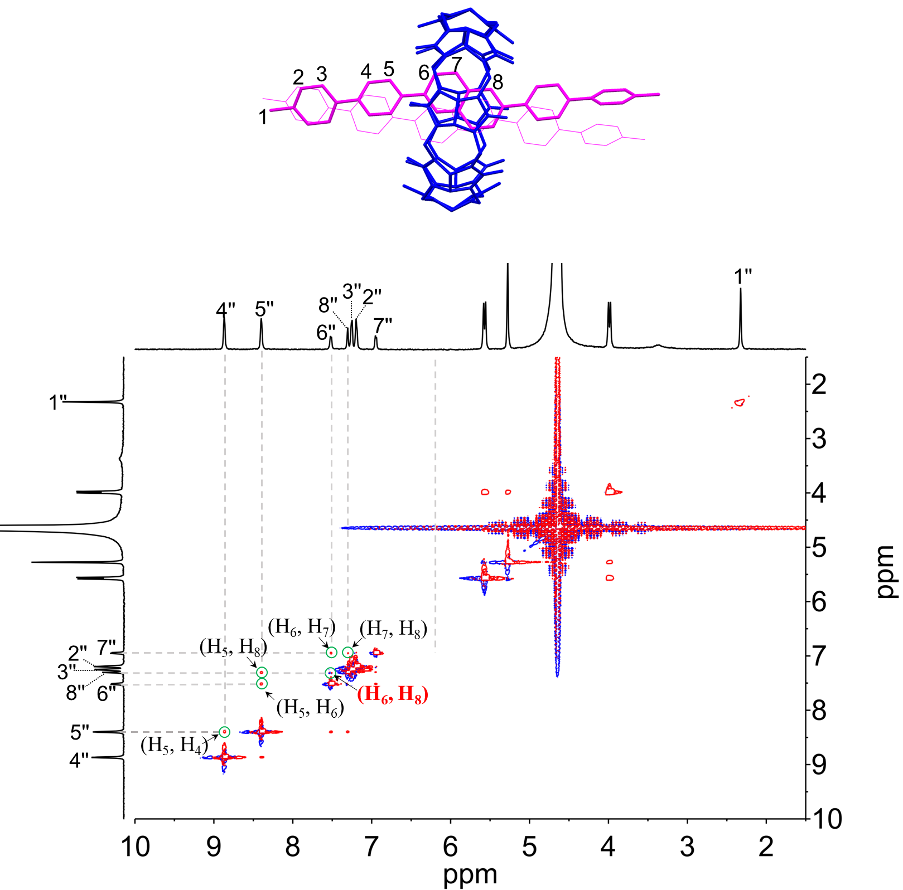
Figure S9. NOESY NMR spectrum recorded (600 MHz, D₂O, 298 K) for compound CB[8]·G1₂ ([G1] = 0.50 mM).
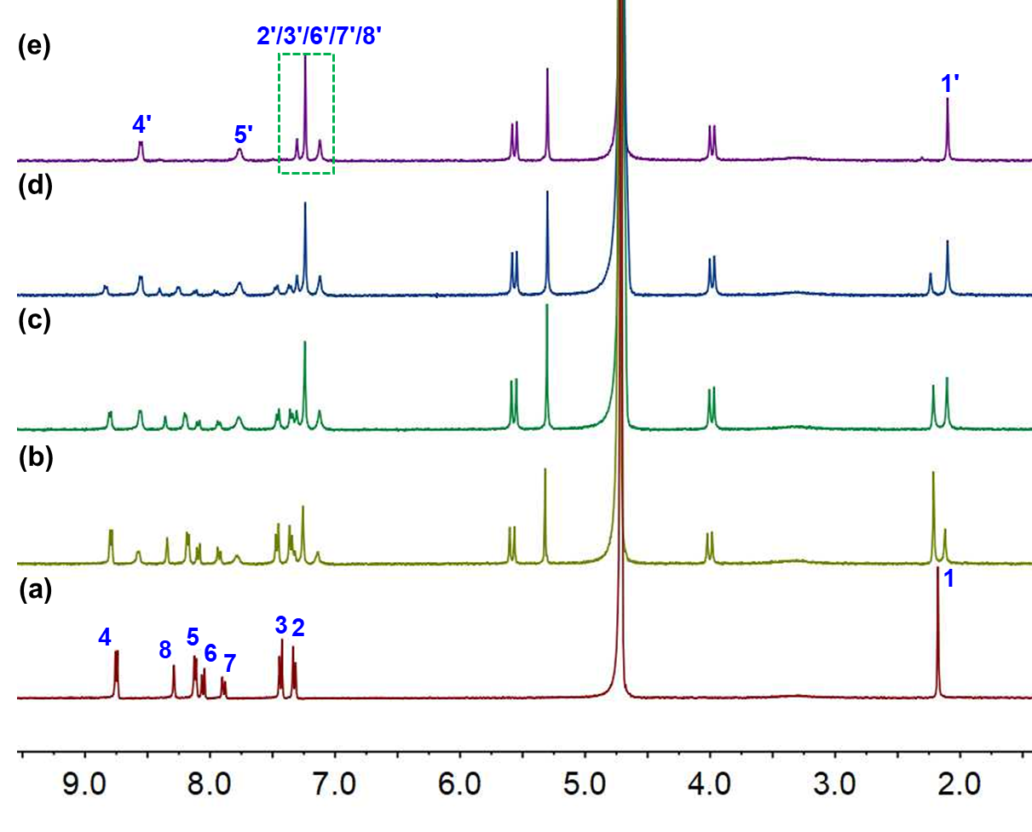
Figure S10. ¹H NMR spectroscopic titration spectra of G1 (0.50 mM, 400 MHz, D₂O, 298 K) with (a) 0.00 equiv., (b) 0.18 equiv., (c) 0.28 equiv., (d) 0.38 equiv., (e) 0.50 equiv. of CB[10]. Characters 1~8 and 1'~8' represent the resonance signals of G1 as free and in CB[10]·G1₂, respectively.
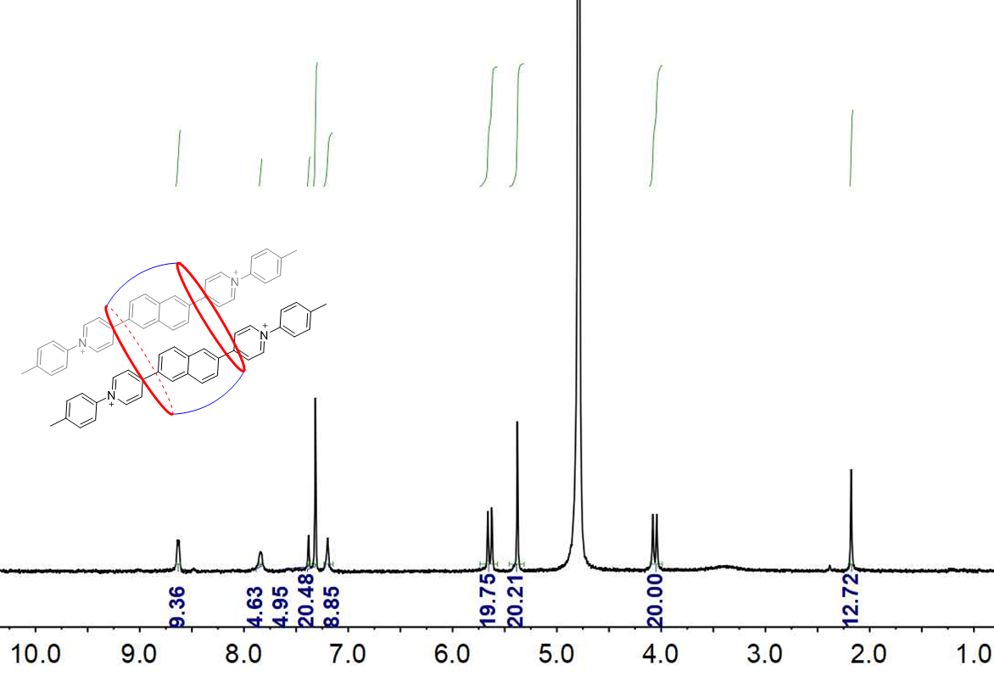
Figure S11. ¹H NMR spectroscopic spectrum of G1 (0.50 mM, 400 MHz, D₂O, 298 K) with 0.50 equiv. of CB[10].
ITC spectra of guest G1 and CB[8]
The instrument used in the isothermal titration calorimetry (Nano ITC) was TA Instruments, with a temperature controlled at 298 K.
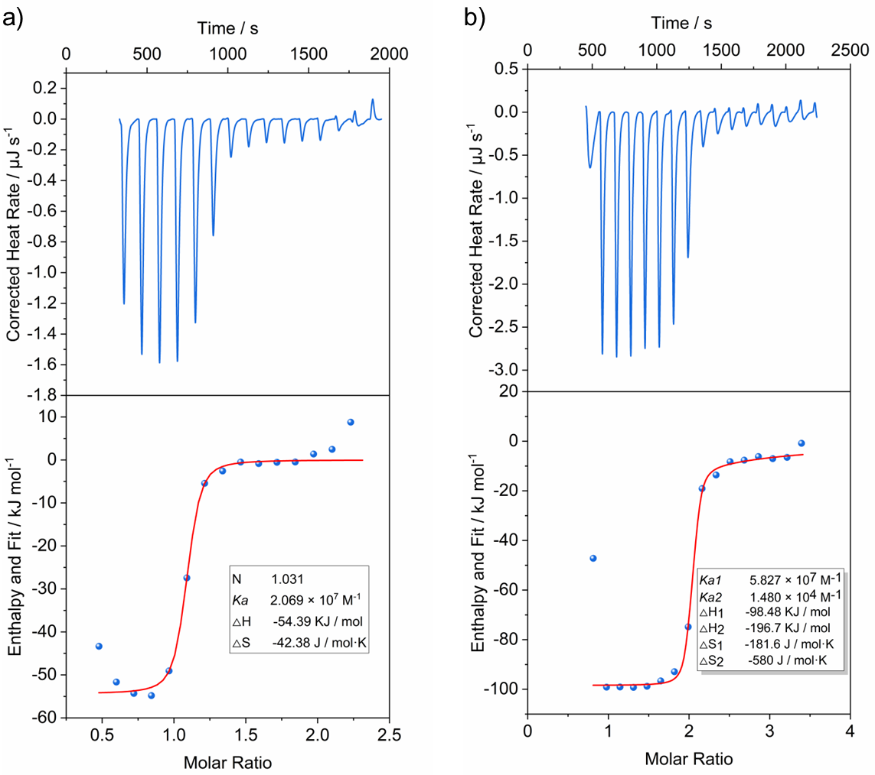
Figure S12. Isothermal titration calorimetry data for (a) compound G1 with CB[7] in H₂O ([G1] (syringe) = 5.0 × 10⁻⁴ M, [CB[7]] (cell) = 5.0×10⁻⁵ M) and (b) compound G1 with CB[8] in H₂O ([G1] (syringe) = 5.0×10⁻⁴ M, [CB[8]] (cell) = 5.0×10⁻⁵ M).

Section C. The photophysical properties of G1 and the host-guest inclusion complexes
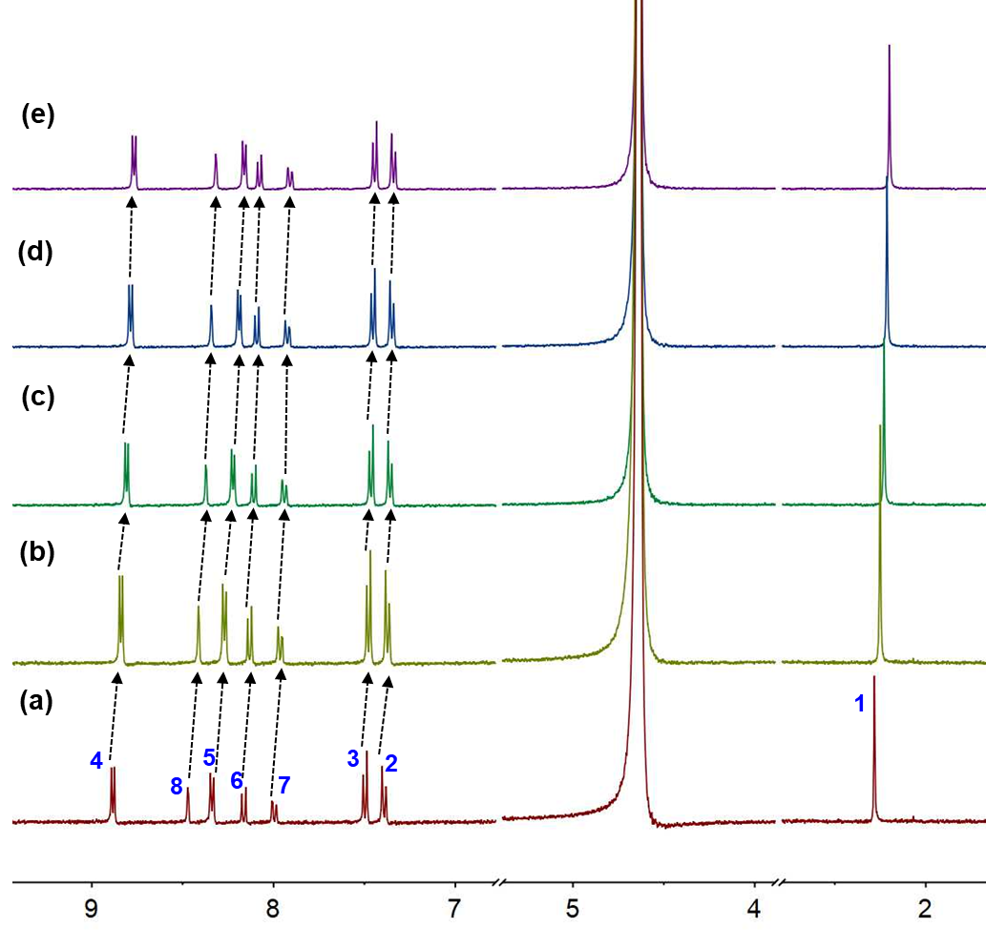
Figure S13. ¹H NMR spectroscopic spectra of compound G1 (400 MHz, D₂O, 298 K) at different concentrations, (a) 0.10 mM, (b) 0.20 mM, (c) 0.30 mM, (d) 0.40 mM, (e) 0.50 mM.
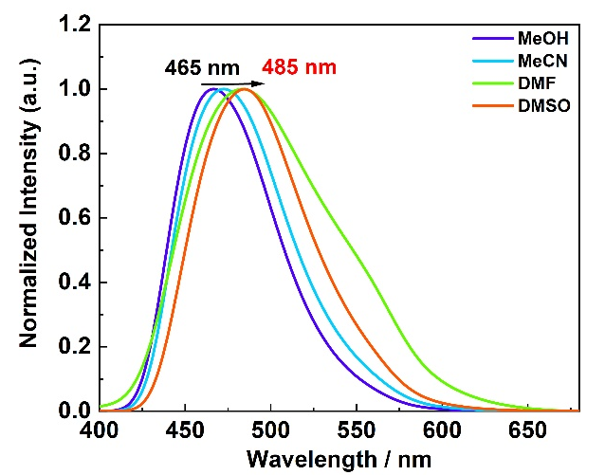
Figure S14. Normalized emission spectra of G1 in different solvents (298 K, λ_{ex} = 350 nm, [G1] = 2.0 × 10⁻⁵ M).
Figure S15. Normalized UV-Vis absorption spectra of free G1 at different concentrations.

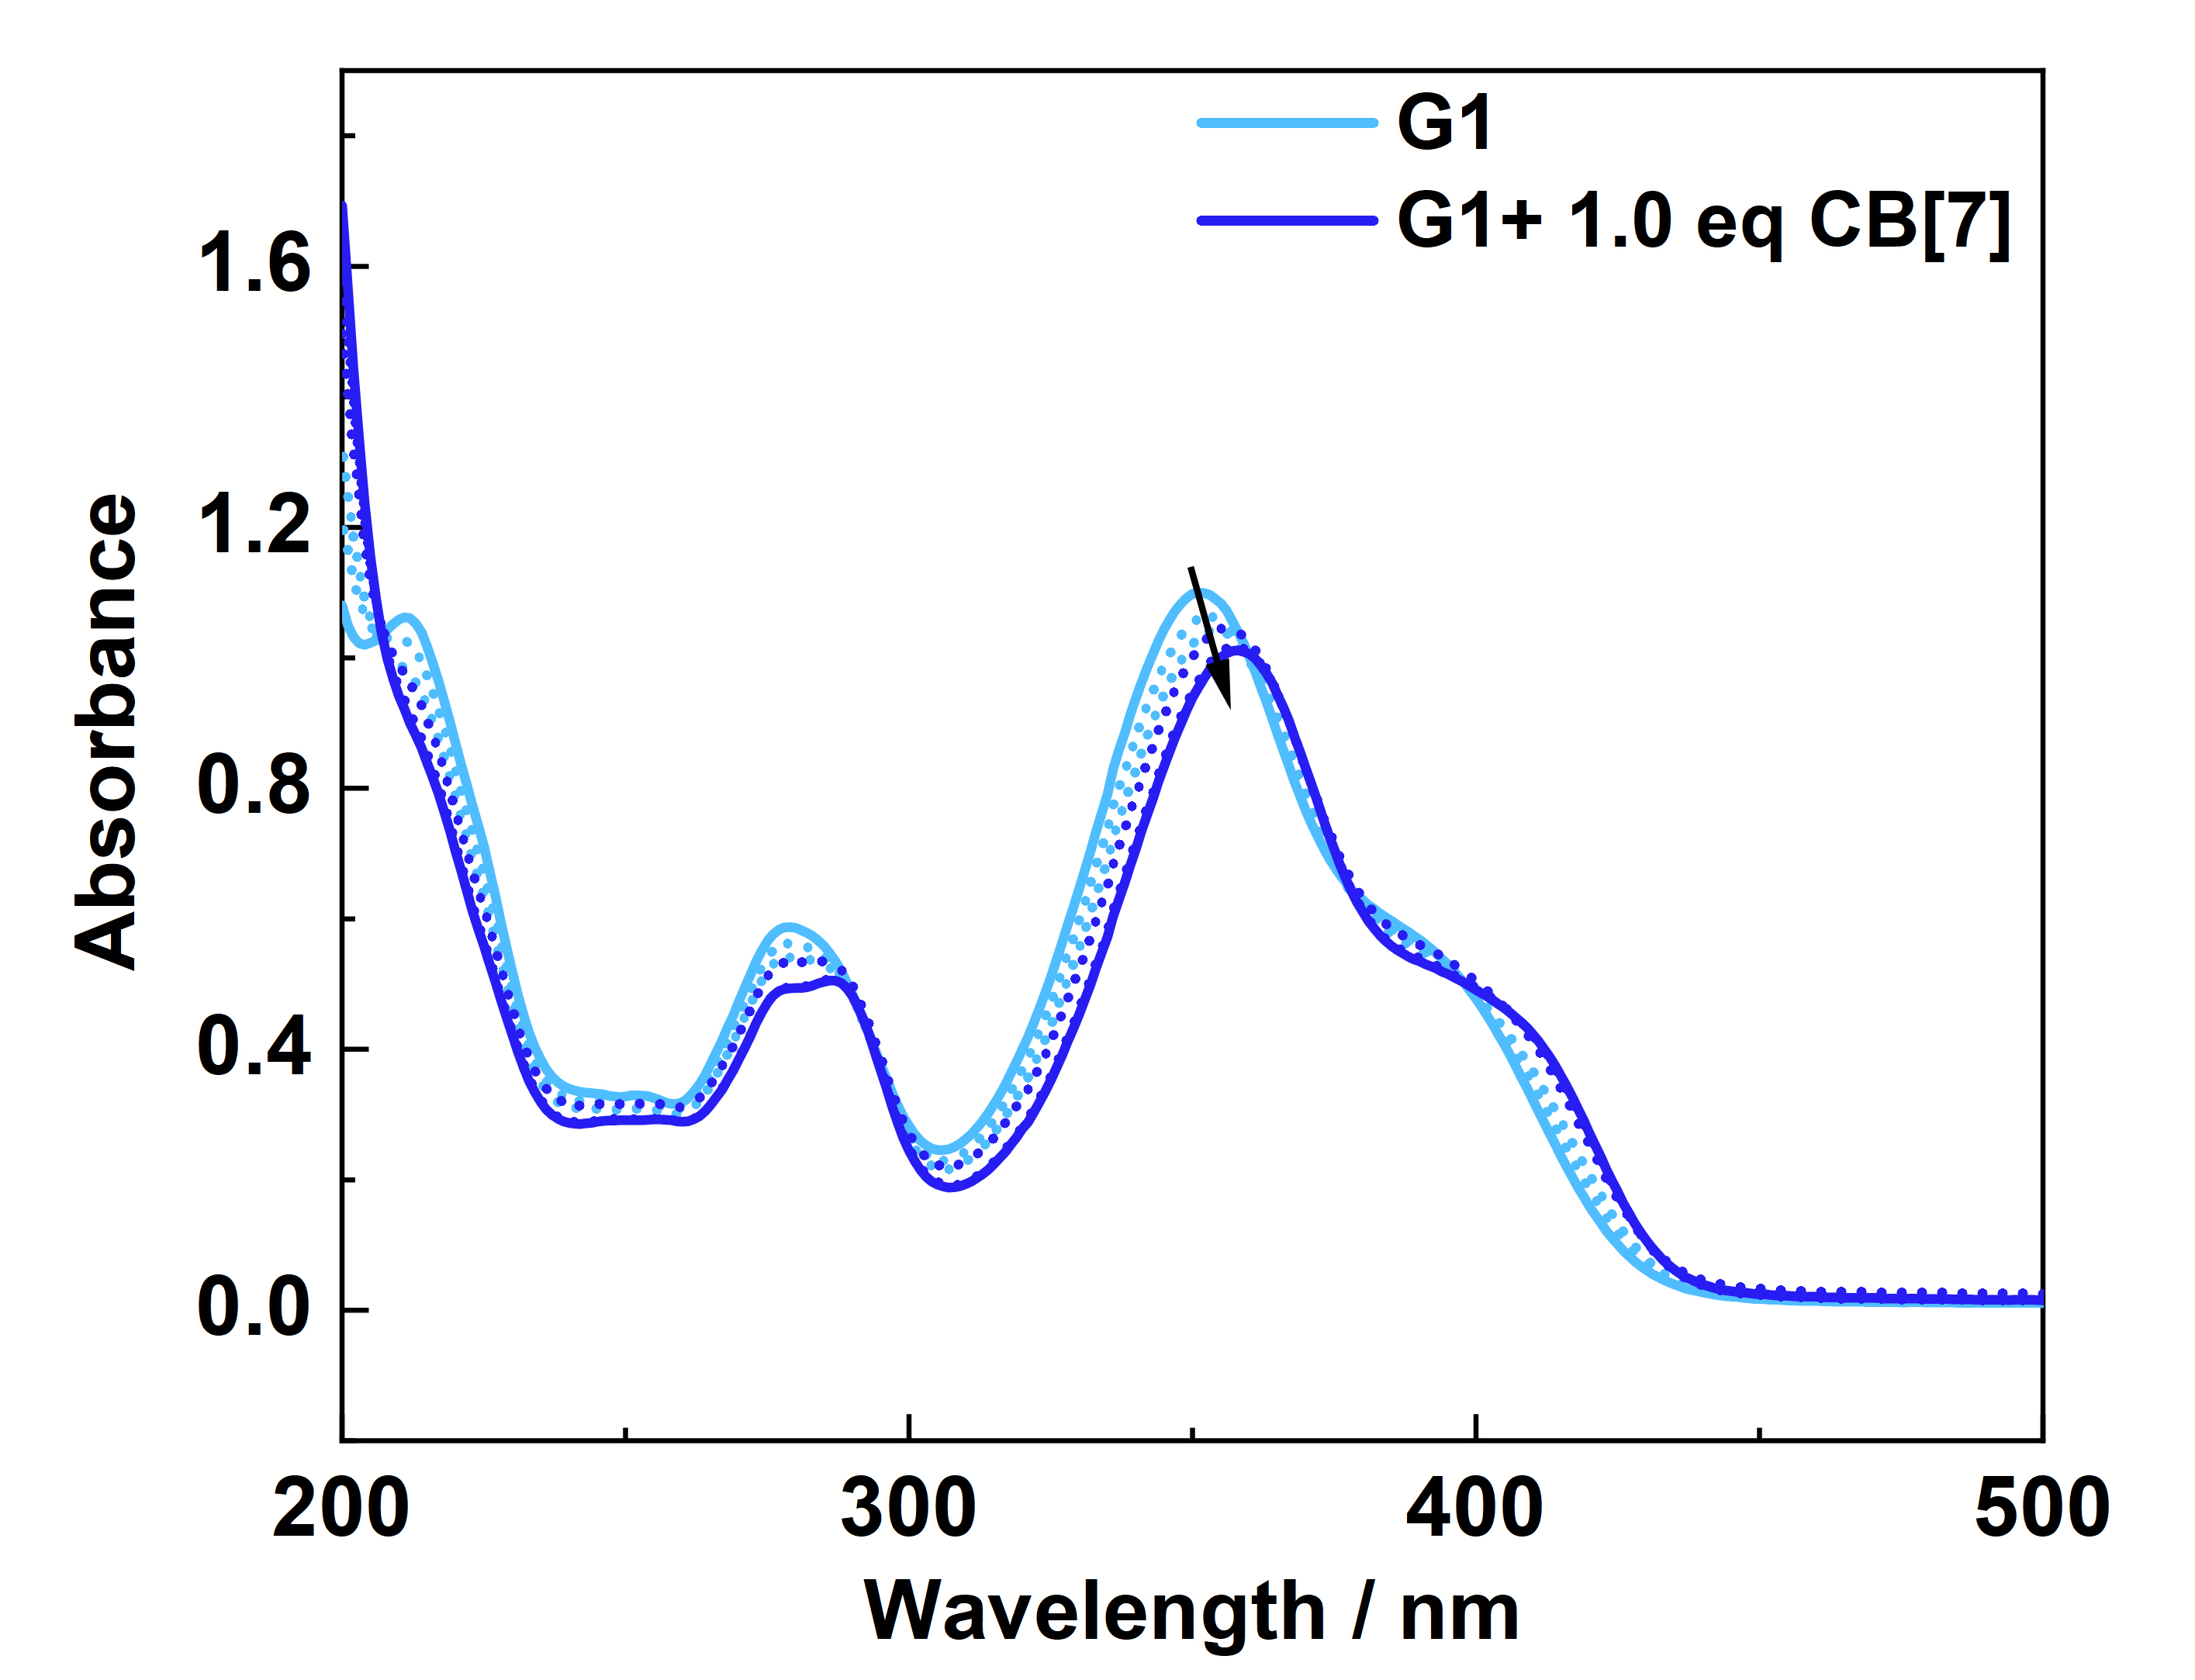
Figure S16. The UV-Vis absorption spectra of G1 (0.02 mM) in the presence of different amount of CB[7] (0.00~1.00 equiv.).

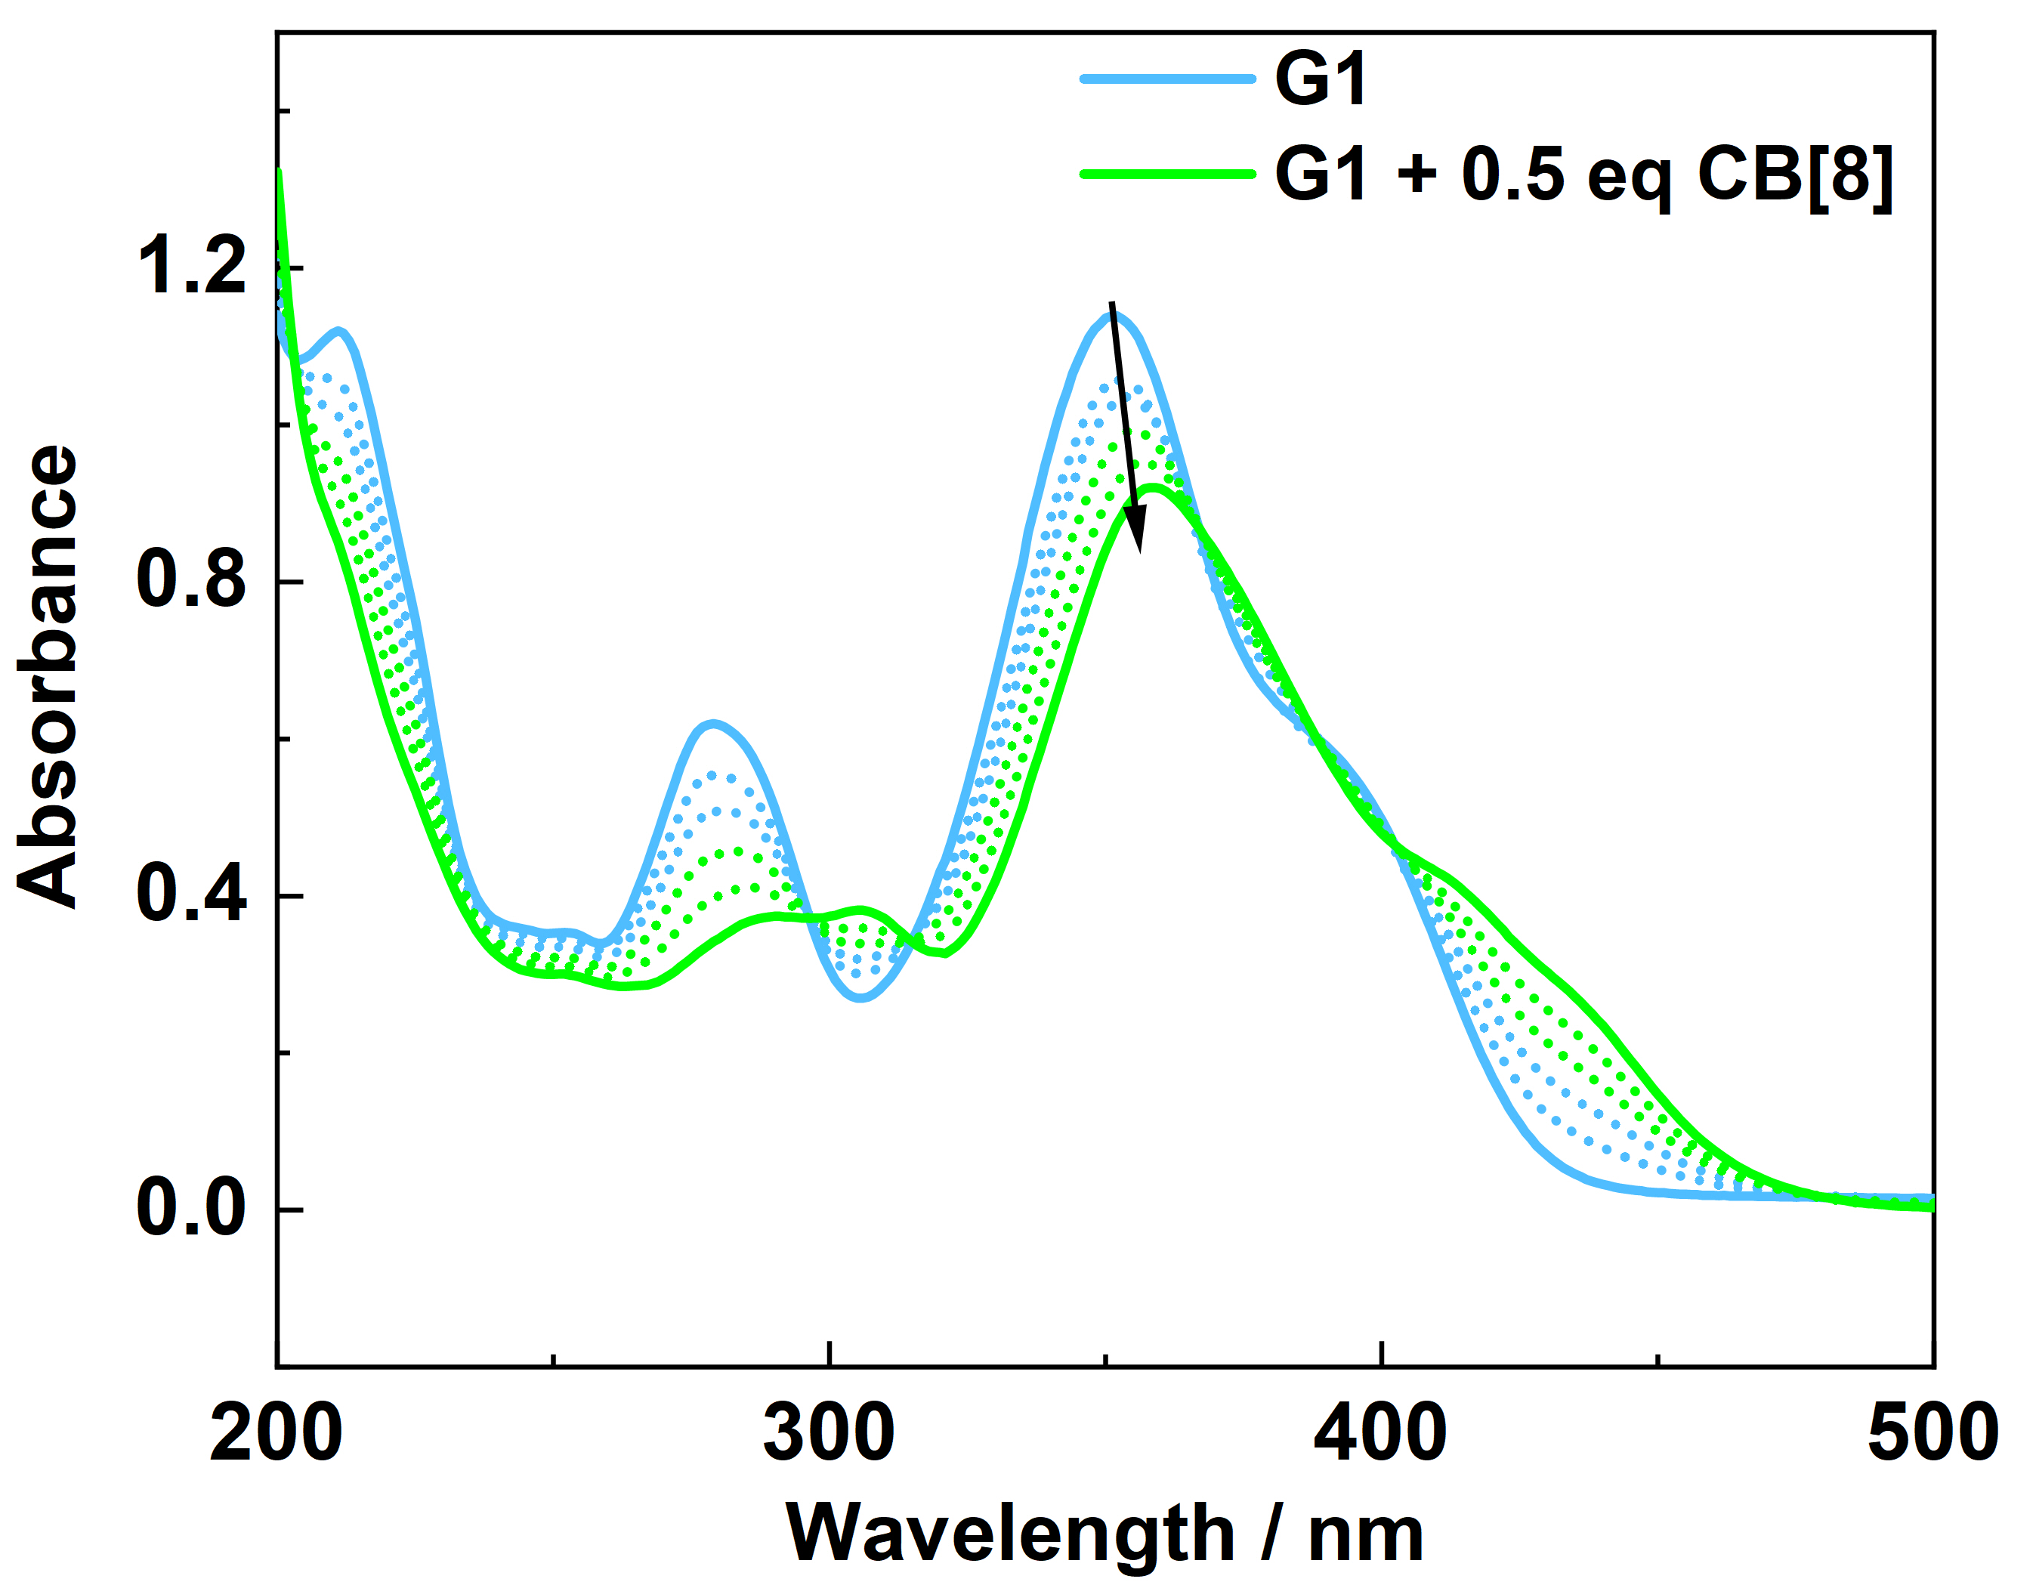
Figure S17. The UV-Vis absorption spectra of G1 (0.02 mM) in the presence of different amount of CB[8] (0.00~0.50 equiv.).
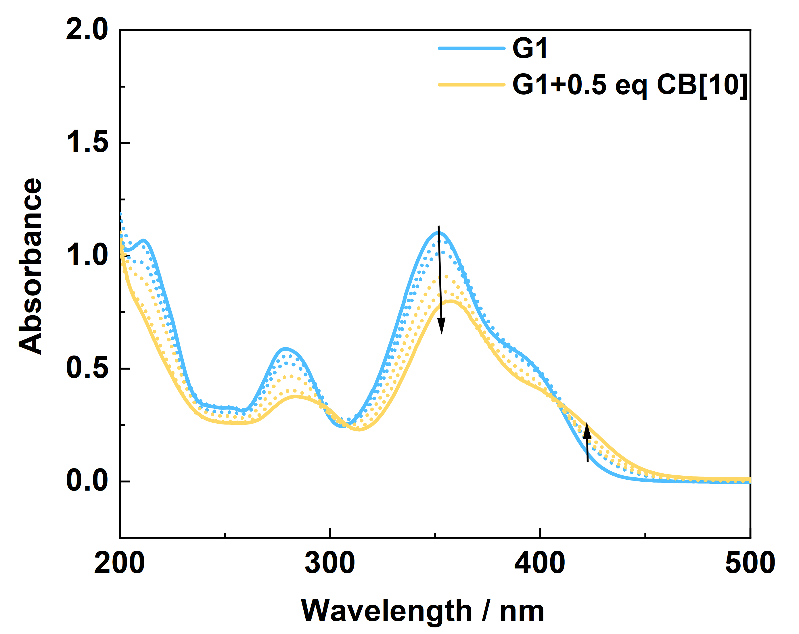
Figure S18. The UV-Vis absorption spectra of G1 (0.02 mM) in the presence of different amount of CB[10] (0.00~0.5 equiv.).

Table S1. Steady-state spectral data of G1, CB[7]·G1, CB[8]·G1₂, CB[10]·G1₂.
Compound | λem (nm) | τ (ns)
G1（0.02 mM） | 464 | 23.15
G1（0.50 mM） | 490 | 13.15
CB[7]·G1（0.50 mM） | 445 | 8.42
CB[8]·G1₂（0.50 mM） | 526 | 30.29
CB[10]·G1₂（0.50 mM） | 546 | 41.18

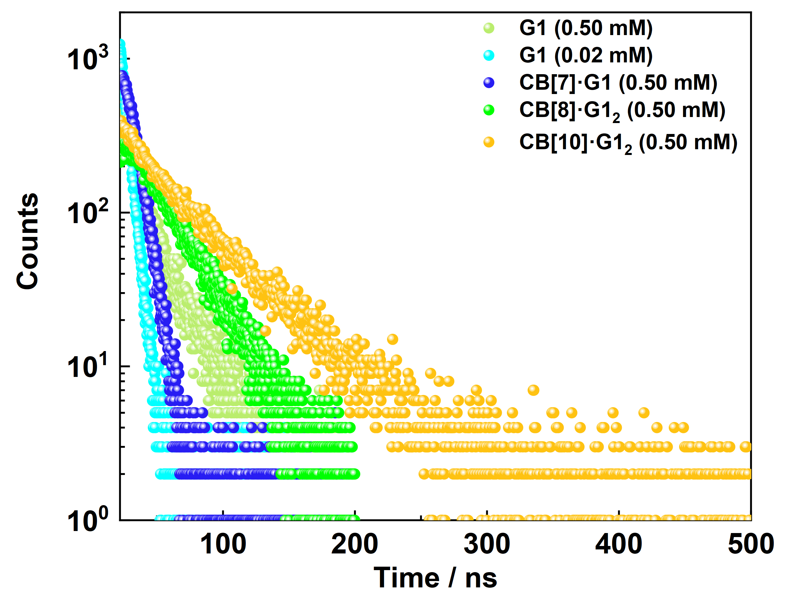
Figure S19. Time-correlated single photon counting decay profiles for G1, CB[7]·G1, CB[8]·G1₂, CB[10]·G1₂.

Section D. DFT calculations
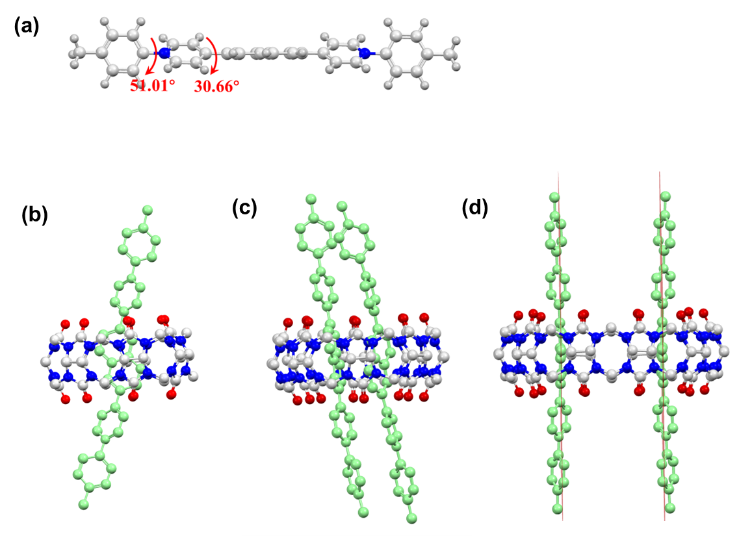
Figure S20. Optimized structures of (a) G1, (b) CB[7]·G1, (c) CB[8]·G1₂, (d) CB[10]·G1₂.
Table S2 Calculation details of the optimized structures.
Compound | Energy / Hartree | Dipole Moment / Debye
G1 | -1421.878539 | 0.098286
Dimer structure of G1 | -2843.807065 | 0.232239
CB[7]·G1 | -5634.715179 | 1.345295
CB[8]·G1₂ | -7658.520430 | 1.026245
CB[10]·G1₂ | -8862.087440 | 0.244448

Cartesian coordinates of optimized monomer (compound G1), ground state
C -0.31160176 0.56553241 0.30399152
C 0.31136680 -0.56796694 -0.30876759
C -0.51015806 -1.57891252 -0.87734151
C -1.87767845 -1.48198328 -0.83044658
C -2.50736414 -0.35547320 -0.22353456
C -1.72239642 0.64642131 0.32789708
C 0.50987357 1.57651678 0.87255859
C 1.87739490 1.47952697 0.82581819
C 2.50706412 0.35292163 0.21909388
C 1.72216513 -0.64894159 -0.33248958
C 3.97475124 0.26274767 0.16928092
C -3.97504392 -0.26546449 -0.17306442
C 4.77975544 1.41553548 0.10569425
C 6.15190216 1.31086844 0.06277461
N 6.75806179 0.09540454 0.06663858
C 6.01210825 -1.03878529 0.12235709
C 4.63858007 -0.97835893 0.18325490
C -4.77998653 -1.41833198 -0.11028816
C -6.15213035 -1.31378984 -0.06632897
N -6.75831881 -0.09836634 -0.06820496
C -6.01244068 1.03591243 -0.12346178
C -4.63897976 0.97562781 -0.18546403
C 8.20096463 0.00789514 0.01172873
C -8.20111407 -0.00989719 -0.01102920
C 8.87391257 -0.78056449 0.94361093
C 10.26220511 -0.86271878 0.87630762
C 10.98605746 -0.16516997 -0.10048713
C 10.27767370 0.61756715 -1.02301101
C 8.88942302 0.70968181 -0.97678114
C -8.87478767 0.77763931 -0.94370759
C -10.26304555 0.85618167 -0.87866244
C -10.98644625 0.15993697 0.09998530
C -10.27822108 -0.62755978 1.01797884
C -8.88930009 -0.71607791 0.97400843
C 12.49098173 -0.23541840 -0.14367430
C -12.48720960 0.27595461 0.17717283
H -0.03926421 -2.43258372 -1.35512534
H -2.48461839 -2.25391001 -1.29036892
H -2.17983134 1.49809392 0.82087653
H 0.03894453 2.43022461 1.35024144
H 2.48437907 2.25143281 1.28572401
H 2.17969796 -1.50063859 -0.82534174
H 4.34210764 2.40496752 0.07853852
H 6.80683188 2.17073421 0.03577112
H 6.55987676 -1.97072848 0.10677182
H 4.08852417 -1.90787553 0.25345561
H -4.34233462 -2.40779506 -0.08452701
H -6.80694163 -2.17375189 -0.04010162
H -6.56029497 1.96779835 -0.10652144
H -4.08907976 1.90527250 -0.25513532
H 8.32713875 -1.30388925 1.72093878
H 10.79096775 -1.47264986 1.60246204
H 10.81717943 1.15342882 -1.79808171
H 8.34923169 1.29336980 -1.71470098
H -8.32842105 1.29692984 -1.72402299
H -10.79266424 1.45957705 -1.60968252
H -10.81826314 -1.17275100 1.78608572
H -8.34963402 -1.30623164 1.70714776
H 12.85733696 -1.18177330 0.26476317
H 12.86481339 -0.12944415 -1.16645251
H 12.93267312 0.57339595 0.45220092
H -12.92707310 0.41191485 -0.81543009
H -12.93230725 -0.61128064 0.63667064
H -12.77682889 1.14257733 0.78496637

Cartesian coordinates of optimized dimer structure of compound G1, ground state
C -2.14840301 1.86063354 -0.44741883
C -1.44586387 1.33814178 0.68408018
C -2.19426461 0.79917759 1.76534099
C -3.56643267 0.80408410 1.74290663
C -4.27491539 1.35191123 0.63307094
C -3.56121799 1.86031297 -0.44290821
C -1.39967246 2.35794062 -1.54805338
C -0.02913562 2.37379479 -1.51398971
C 0.68179675 1.90320676 -0.36946862
C -0.03337096 1.37805255 0.69766563
C 2.14868709 2.00629106 -0.31595923
C -5.74655229 1.37218134 0.63259940
C 2.85223126 2.92505215 -1.11915142
C 4.22347304 3.01236160 -1.05746374
N 4.94301563 2.19978560 -0.23824935
C 4.29467358 1.31195072 0.56224586
C 2.92342203 1.21311836 0.55014163
C -6.48055971 1.45695142 1.83013696
C -7.85714002 1.46141400 1.81126880
N -8.54175118 1.34646775 0.64305897
C -7.86431524 1.26000657 -0.53201833
C -6.48930156 1.29284449 -0.55968533
C 6.38694217 2.26596659 -0.23643957
C -9.98504371 1.28352574 0.64827601
C 7.08604119 2.14486006 0.96420718
C 8.47849027 2.17388232 0.94289834
C 9.18763837 2.34345969 -0.25383214
C 8.45555075 2.47475041 -1.44359192
C 7.06491760 2.42897256 -1.44648121
C -10.70688577 1.96375961 -0.33253234
C -12.09456849 1.85579481 -0.34645287
C -12.77601411 1.08997930 0.60982114
C -12.02309898 0.42997811 1.59053141
C -10.63490539 0.51861742 1.61756005
C 10.69270684 2.39564823 -0.26656651
C -14.27965200 0.99975531 0.59928313
H -1.66468908 0.37501244 2.61249904
H -4.11558438 0.36095056 2.56589963
H -4.07685490 2.29656490 -1.29222354
H -1.92857664 2.72393251 -2.42245052
H 0.51581560 2.73397698 -2.37843073
H 0.47425790 1.01962557 1.58592418
H 2.33592652 3.61298571 -1.77475236
H 4.78527003 3.73671933 -1.62928640
H 4.91449911 0.67658218 1.17723800
H 2.46961747 0.47260367 1.19234739
H -5.98527695 1.56313516 2.78646068
H -8.45207310 1.57671323 2.70606183
H -8.45949291 1.12747896 -1.42345861
H -6.00412783 1.21324475 -1.52315684
H 6.56003901 2.05150550 1.90769963
H 9.02132902 2.07573485 1.87730983
H 8.98042457 2.59134844 -2.38693860
H 6.52266676 2.47891745 -2.38421786
H -10.20099195 2.58611241 -1.06240043
H -12.65636047 2.38544663 -1.10959620
H -12.52626605 -0.17856847 2.33544480
H -10.07134929 -0.02929423 2.36424158
H 11.11253384 1.97967387 0.65212133
H 11.09942273 1.83523350 -1.11358647
H 11.04161028 3.43138179 -0.35995932
H -14.67766579 1.11066846 -0.41349909
H -14.62300766 0.04431660 1.00660767
H -14.71780061 1.79591793 1.21442460
C 1.55161344 -1.80317688 -0.94093699
C 2.11175728 -2.08728227 0.34462225
C 1.23498962 -2.31302440 1.44093059
C -0.12518641 -2.29258490 1.26642343
C -0.69281944 -2.03916522 -0.01730486
C 0.14711928 -1.78718173 -1.09221831
C 2.43010273 -1.55090948 -2.02910683
C 3.79026569 -1.56502343 -1.85347193
C 4.35979873 -1.83604541 -0.57405166
C 3.51624654 -2.10161897 0.49626345
C 5.81569242 -1.75584801 -0.36873888
C -2.15140318 -2.06283021 -0.19736320
C 6.63669716 -1.00689259 -1.23223958
C 7.97975404 -0.85677910 -0.97198312
N 8.54871177 -1.43398886 0.11549989
C 7.79758356 -2.20185875 0.94813168
C 6.45100394 -2.37483649 0.72631715
C -2.98375495 -2.81776458 0.65101150
C -4.34680851 -2.83131085 0.47052867
N -4.92961129 -2.10093265 -0.51787695
C -4.15306997 -1.37036637 -1.36165052
C -2.78489332 -1.34556193 -1.22838673
C 9.94421017 -1.19742211 0.40571459
C -6.36864856 -2.07984147 -0.65161127
C 10.31229719 -0.80941965 1.69345904
C 11.65522294 -0.56126577 1.96280558
C 12.63229624 -0.68566342 0.96488194
C 12.22845208 -1.08270273 -0.31736263
C 10.89143359 -1.34124756 -0.60652617
C -6.94603529 -2.11051431 -1.92177626
C -8.33150599 -2.05259280 -2.03661105
C -9.15665748 -1.98934465 -0.90382888
C -8.54604117 -1.98580460 0.35747047
C -7.16106080 -2.01506035 0.49458513
C 14.07647652 -0.37079011 1.25656879
C -10.65444865 -1.90998948 -1.04536740
H 1.65681532 -2.49957449 2.42354251
H -0.77276649 -2.44572788 2.12201078
H -0.25819141 -1.60782027 -2.08207039
H 2.00928424 -1.34727156 -3.00870919
H 4.43469000 -1.38778419 -2.70626462
H 3.91675942 -2.27410890 1.48928876
H 6.23033137 -0.48584583 -2.08819361
H 8.62553502 -0.24126177 -1.57973219
H 8.32224693 -2.67124092 1.76849140
H 5.90604758 -3.01454841 1.40753045
H -2.57224142 -3.43315555 1.43975875
H -5.00911370 -3.43143122 1.07735603
H -4.67010796 -0.79765088 -2.11720566
H -2.22322017 -0.71676649 -1.90545566
H 9.56170805 -0.67527858 2.46488973
H 11.94488446 -0.25253173 2.96253106
H 12.97061825 -1.20208778 -1.10061987
H 10.59572616 -1.67496921 -1.59543476
H -6.33010615 -2.20334318 -2.80946090
H -8.77928329 -2.07744254 -3.02517776
H -9.16127100 -1.94931345 1.24966633
H -6.71201316 -1.95881480 1.47985736
H 14.32775639 -0.58272722 2.29994975
H 14.74742416 -0.94606995 0.61203833
H 14.28074984 0.69264030 1.07848355
H -11.00983165 -2.57065330 -1.84225654
H -11.15788761 -2.18183486 -0.11455432
H -10.96601233 -0.89057205 -1.30280364

Cartesian coordinates of optimized CB[7]⸱G1, ground state
C 0.31059814 0.66316554 0.18697326
C -0.50110085 -0.48663510 0.45457222
C 0.10934508 -1.64201451 1.01478989
C 1.45915281 -1.67517386 1.26383351
C 2.27104406 -0.53548306 0.98609207
C 1.69128087 0.61331693 0.47077006
C -0.28721251 1.81325091 -0.39031970
C -1.62457057 1.83134560 -0.69001490
C -2.44230376 0.69657371 -0.41817460
C -1.87831438 -0.44078169 0.14126088
C -3.87708021 0.74373468 -0.72851028
C 3.72424792 -0.56979820 1.18770514
C -4.58724332 1.95801797 -0.67320278
C -5.93512756 1.98198410 -0.94608265
N -6.59833768 0.84583836 -1.29137777
C -5.93384785 -0.33797207 -1.36702054
C -4.58948587 -0.41466245 -1.08693640
C 4.45216807 -1.76382150 1.03440182
C 5.82282858 -1.75635092 1.15267072
N 6.49270226 -0.60902214 1.44100884
C 5.81207914 0.55500009 1.61956233
C 4.44320297 0.60050830 1.49937076
C -8.01454232 0.89466921 -1.57236270
C 7.93339605 -0.62409827 1.54822801
C -8.86676164 -0.01330141 -0.94508282
C -10.23054121 0.04087291 -1.22016027
C -10.75637522 0.98939068 -2.10823940
C -9.87386013 1.89224396 -2.71703511
C -8.50588064 1.85050656 -2.46026823
C 8.68106530 0.30995166 0.83257572
C 10.06868118 0.29197665 0.94642951
C 10.72007509 -0.64889225 1.75601173
C 9.93904524 -1.57410979 2.46225731
C 8.54985950 -1.56892265 2.36705395
C -12.23100531 1.02198853 -2.41940570
C 12.22456014 -0.68051930 1.84564151
H -0.51162301 -2.50373999 1.23982830
H 1.89472560 -2.56692932 1.69863599
H 2.30530542 1.47549428 0.23252670
H 0.33261799 2.67853515 -0.59918414
H -2.05051698 2.70632212 -1.16090050
H -2.49540466 -1.30450350 0.35905250
H -4.10189241 2.87350299 -0.35666614
H -6.53666943 2.87732896 -0.87185032
H -6.51972517 -1.19174519 -1.67837419
H -4.10205482 -1.37863468 -1.17023920
H 3.96126472 -2.68246541 0.74081866
H 6.43324613 -2.63402323 0.99033520
H 6.40878232 1.41854274 1.87903517
H 3.94265866 1.54756034 1.66449134
H -8.47491604 -0.73149370 -0.23243680
H -10.89777731 -0.65839802 -0.72518394
H -10.25922177 2.63380778 -3.41043077
H -7.82943627 2.53713522 -2.95831042
H 8.18889923 1.02489342 0.18149040
H 10.65428132 1.01623592 0.38811226
H 10.42194806 -2.30219118 3.10711790
H 7.95374429 -2.27020251 2.94153129
H -12.82489205 0.67155031 -1.56993717
H -12.56051139 2.03191478 -2.68096582
H -12.46141014 0.37027350 -3.27182460
H 12.65312423 0.31574881 1.70153062
H 12.55750042 -1.06542035 2.81414675
H 12.64497707 -1.33397073 1.07060882
N 0.56571228 5.04246135 -1.82277899
C 1.98916446 5.33190127 -1.91272506
H 2.15016753 6.40485561 -2.05879742
N 2.79793840 4.84240770 -0.82104620
C 0.12096405 4.27466838 -2.88766740
O -1.04387053 3.99048769 -3.13176263
C 3.57830201 3.75948446 -1.16742948
O 4.36082205 3.16965482 -0.43375820
N 1.22095178 3.91885239 -3.63770901
C 2.45803009 4.45552084 -3.11792228
H 2.98735787 5.01804147 -3.89408582
N 3.34780290 3.48633024 -2.50154999
C 1.11229760 3.15879853 -4.85847165
H 0.06653264 3.18562560 -5.16366886
H 1.73407791 3.63608099 -5.62461074
C 4.25898529 2.64809758 -3.25067406
H 5.08201048 2.39290976 -2.58344553
H 4.63725713 3.21119685 -4.11149696
N 1.48815750 1.76536894 -4.74013045
C 2.85976080 1.30651825 -4.89765160
H 3.33337309 1.80836473 -5.74845076
N 3.68850031 1.41472395 -3.72275559
C 0.57026855 0.76215005 -5.01276865
O -0.64148329 0.89845669 -5.09891810
C 3.91265703 0.20048959 -3.10496469
O 4.58000979 0.01079177 -2.09759689
N 1.27624944 -0.40745050 -5.21357952
C 2.70239045 -0.23279792 -5.08138217
H 3.22099547 -0.62949197 -5.96095951
N 3.28381436 -0.77324921 -3.86318154
C 0.64932995 -1.62767874 -5.66017569
H 1.22353564 -2.02731553 -6.50354092
H -0.35888380 -1.37338787 -5.98609373
C 3.64643885 -2.16413136 -3.72189244
H 4.39953718 -2.22451904 -2.93624676
H 4.06908402 -2.52481385 -4.66888537
N 0.52669611 -2.65581092 -4.65420167
C 1.59218481 -3.55782667 -4.28337519
H 2.10454623 -3.93315925 -5.17594250
N 2.55386510 -3.02452682 -3.33478601
C -0.69359545 -3.01939013 -4.11921321
O -1.76383685 -2.46266661 -4.31655750
C 2.59455459 -3.75058763 -2.16054920
O 3.39392655 -3.59649015 -1.24548842
N -0.49246516 -4.15584299 -3.35505201
C 0.86149707 -4.66582571 -3.46293913
H 0.86263878 -5.64884881 -3.94596240
N 1.60890509 -4.71213369 -2.22730409
C -1.60437962 -4.95533870 -2.89767718
H -2.51026422 -4.50888683 -3.30720292
H -1.49445440 -5.97943018 -3.27179192
C 1.44479589 -5.72493413 -1.21542907
H 2.35612095 -5.74115859 -0.61813375
H 1.30612903 -6.69362414 -1.70861336
N -1.75880170 -5.00472362 -1.46408543
C -1.02321700 -5.88911094 -0.58825851
H -1.05367199 -6.91544847 -0.96869376
N 0.34503045 -5.49330859 -0.30589306
C -2.71137393 -4.26453068 -0.80155803
O -3.48297643 -3.45976405 -1.31068610
C 0.56396849 -5.26780461 1.03976502
O 1.64521212 -5.04305011 1.56779948
N -2.67359351 -4.62258929 0.53255412
C -1.73650813 -5.70343868 0.78758333
H -2.26976567 -6.59489184 1.13343174
N -0.65134801 -5.38099839 1.68533722
C -3.76151608 -4.29353604 1.42619499
H -4.54638850 -3.82664809 0.83117755
H -4.14033736 -5.21689881 1.88126189
C -0.78206578 -5.27669025 3.11977060
H 0.21925516 -5.36984180 3.53930769
H -1.41370713 -6.09630717 3.47777869
N -3.40111522 -3.35885786 2.46272320
C -2.74506938 -3.74442495 3.69862723
H -3.26862759 -4.58701663 4.16285931
N -1.33213719 -4.02686598 3.58972988
C -3.97041153 -2.10221137 2.53293883
O -4.69170814 -1.58980277 1.68677032
C -0.54639829 -3.04940313 4.17124699
O 0.67180692 -3.06687185 4.27132867
N -3.60604262 -1.54400669 3.73904072
C -2.79218295 -2.43119439 4.54162679
H -3.23557712 -2.55825416 5.53498161
N -1.39181122 -2.06888220 4.65382438
C -4.14268588 -0.28148224 4.19137317
H -4.99516147 -0.04549391 3.55482129
H -4.47245343 -0.39387815 5.23019509
C -0.90949636 -1.03556553 5.53790886
H 0.14648780 -1.23548990 5.71881567
H -1.46344418 -1.08099753 6.48375536
N -3.22759934 0.83186765 4.10803988
C -2.21263568 1.10528714 5.10164998
H -2.63612747 1.03396549 6.10939394
N -1.01506104 0.29796928 5.00027510
C -3.41062617 1.87737448 3.22380497
O -4.26445923 1.94354992 2.35093652
C 0.10411553 1.03967672 4.67367551
O 1.24986742 0.62086434 4.58638661
N -2.48333566 2.85813414 3.53405805
C -1.71783639 2.53577935 4.72456599
H -1.89508288 3.28453655 5.50428478
N -0.30158271 2.34966486 4.51336734
C -2.61658819 4.20697231 3.02770509
H -2.69729367 4.89862794 3.87468014
H -3.53000315 4.24287506 2.43453615
C 0.63440287 3.43228293 4.38115282
H 1.62814619 3.03021463 4.57681331
H 0.39364585 4.20482130 5.12183021
N -1.53536224 4.64039746 2.17471865
C -0.24823942 5.08638108 2.66189726
H -0.37761204 5.81132221 3.47271221
N 0.66644249 4.03434369 3.06701705
C -1.68958557 4.83876188 0.81933047
O -2.70664847 4.62969665 0.16704240
C 1.83325521 4.03812095 2.32676608
O 2.82157782 3.34743043 2.53906456
N -0.50456764 5.35476263 0.33311058
C 0.43385874 5.68134966 1.39192882
H 0.59134025 6.76398731 1.44076733
N 1.70086612 4.99106043 1.33808615
C -0.36276930 5.81921224 -1.02684002
H -1.34340372 5.73906877 -1.49575972
H -0.03994323 6.86697139 -1.02130755
C 2.81144987 5.39538608 0.50869634
H 2.82196668 6.48802534 0.44267810
H 3.72453242 5.04586382 0.98977314

Cartesian coordinates of optimized CB[8]⸱G1₂, ground state
C -0.48255304 1.66322261 -0.70722373
C -1.04806551 1.76168635 0.60260855
C -0.21992754 2.15843653 1.68536563
C 1.11033539 2.41892229 1.49003952
C 1.69058675 2.29676918 0.19318624
C 0.89067246 1.93350584 -0.88270583
C -1.32498303 1.27914254 -1.78553162
C -2.66111673 1.04506028 -1.58635626
C -3.23741548 1.17358989 -0.28712151
C -2.41943348 1.49445366 0.78634632
C -4.68301993 1.03066034 -0.08815655
C 3.12647275 2.53046060 0.00780727
C -5.58359649 1.13818182 -1.16619256
C -6.93764576 1.00289701 -0.96623295
N -7.44779581 0.79271442 0.27711221
C -6.60641600 0.71807793 1.34496589
C -5.24489507 0.81266907 1.18725958
C 4.02113170 2.49492545 1.09637007
C 5.37235042 2.65798642 0.89896731
N 5.88014493 2.86571904 -0.34468849
C 5.03877010 2.94049030 -1.41255366
C 3.68231483 2.77896215 -1.26410808
C -8.86914569 0.61119005 0.45630593
C 7.31033974 2.93849957 -0.54092062
C -9.33066540 -0.38754731 1.31233538
C -10.70103715 -0.58400684 1.44913958
C -11.62320904 0.19438287 0.73874430
C -11.12986419 1.19204153 -0.11376632
C -9.76306682 1.41219258 -0.25515239
C 7.89196576 2.18988414 -1.56518076
C 9.27396141 2.21478037 -1.72205648
C 10.08763139 2.97677946 -0.87304299
C 9.47346468 3.72778863 0.13770337
C 8.09148776 3.71709714 0.31157715
C -13.10578044 -0.02234240 0.89910889
C 11.58332691 2.98995868 -1.05082694
H -0.66426997 2.27871295 2.66652210
H 1.70729167 2.76526085 2.32304335
H 1.31266068 1.82377873 -1.87442030
H -0.89284479 1.16571708 -2.77439142
H -3.26931622 0.74707768 -2.43047238
H -2.82719652 1.60046306 1.78286319
H -5.23426813 1.35237507 -2.16670495
H -7.65213459 1.04130195 -1.77587877
H -7.07341968 0.58854187 2.31093926
H -4.63069468 0.73187765 2.07516834
H 3.68055710 2.29365849 2.10418857
H 6.08929928 2.59163773 1.70450734
H 5.50022520 3.14915604 -2.36758501
H 3.06595370 2.87049597 -2.14872058
H -8.63917060 -1.04029646 1.83066862
H -11.05556362 -1.37758367 2.09942527
H -11.82439832 1.81445382 -0.66978978
H -9.40243739 2.20960125 -0.89553438
H 7.27856329 1.57119141 -2.21048495
H 9.72751881 1.61090257 -2.50185210
H 10.08367674 4.32962330 0.80409167
H 7.63073323 4.31745623 1.08867422
H -13.64271638 0.20212926 -0.02744007
H -13.32721667 -1.05418831 1.18675898
H -13.51159610 0.63257751 1.68053123
H 12.09255434 3.24017068 -0.11588205
H 11.94674701 2.01620905 -1.39171062
H 11.87994277 3.73450500 -1.80028051
C 1.04743170 -1.76231697 0.60294273
C 0.48153565 -1.66472867 -0.70678649
C 1.32367796 -1.28162613 -1.78564238
C 2.65988693 -1.04735650 -1.58708085
C 3.23650252 -1.17466486 -0.28788143
C 2.41885252 -1.49495111 0.78603182
C 0.21954112 -2.15813102 1.68622963
C -1.11088065 -2.41833585 1.49150241
C -1.69150137 -2.29698496 0.19472792
C -0.89179432 -1.93479793 -0.88168388
C -3.12748853 -2.53039609 0.00990136
C 4.68210404 -1.03098273 -0.08923370
C -4.02192108 -2.49315522 1.09858486
C -5.37323652 -2.65601803 0.90170107
N -5.88136146 -2.86526136 -0.34156692
C -5.04024496 -2.94160539 -1.40952146
C -3.68371195 -2.78026808 -1.26158374
C 5.58257386 -1.13913718 -1.16728036
C 6.93661456 -1.00328911 -0.96757194
N 7.44678577 -0.79192297 0.27555714
C 6.60549433 -0.71635746 1.34339308
C 5.24398292 -0.81140588 1.18590369
C -7.31160871 -2.93793901 -0.53736129
C 8.86813157 -0.60990891 0.45452654
C -7.89332347 -2.19039999 -1.56236009
C -9.27535691 -2.21519756 -1.71888758
C -10.08897232 -2.97609422 -0.86882368
C -9.47472412 -3.72603674 0.14265746
C -8.09270545 -3.71539583 0.31621816
C 9.32938866 0.38993341 1.30935287
C 10.69974209 0.58689190 1.44586151
C 11.62204295 -0.19205322 0.73629766
C 11.12892590 -1.19093140 -0.11495890
C 9.76219654 -1.41161412 -0.25599032
C -11.58469378 -2.98927794 -1.04636545
C 13.10459926 0.02529918 0.89605775
H 0.89124895 -1.16914260 -2.77447440
H 3.26772695 -0.75027813 -2.43178159
H 2.82694355 -1.60019329 1.78249806
H 0.66421516 -2.27785523 2.66730858
H -1.70764106 -2.76395944 2.32496813
H -1.31403045 -1.82570823 -1.87335979
H -3.68106121 -2.29055380 2.10602008
H -6.08997652 -2.58829116 1.70730444
H -5.50197360 -3.15131818 -2.36419269
H -3.06759850 -2.87293804 -2.14623533
H 5.23315444 -1.35430579 -2.16754690
H 7.65109026 -1.04226130 -1.77720691
H 7.07256167 -0.58557576 2.30917094
H 4.62990324 -0.72953125 2.07379507
H -7.27993327 -1.57262654 -2.20855747
H -9.72898320 -1.61217691 -2.49930609
H -10.08490533 -4.32699671 0.80986088
H -7.63186551 -4.31496689 1.09387332
H 8.63772346 1.04308180 1.82694856
H 11.05412088 1.38129521 2.09521028
H 11.82362784 -1.81382418 -0.67023807
H 9.40164649 -2.20988161 -0.89534744
H -11.94819764 -2.01541315 -1.38684078
H -11.88139568 -3.73352272 -1.79608696
H -12.09375636 -3.23986491 -0.11143934
H 13.51185905 -0.63264713 1.67417358
H 13.64072906 -0.19480024 -0.03202821
H 13.32544642 1.05611471 1.18777453
O -1.51823575 -5.54241412 2.13703071
O 4.36403079 -3.67923317 1.75238666
O -2.29130596 -2.94715201 4.59028044
O 3.37615730 -0.81649873 4.21037874
O -3.37294257 0.81813808 4.21200689
O 2.29607852 2.94575732 4.58742630
O -4.36188926 3.68009255 1.75572642
O 1.52114086 5.54187568 2.13365344
N 0.58946026 -6.09159887 1.32356253
N 0.41661404 -5.29439615 3.39816054
N 2.95313033 -5.44033408 1.20607959
N 2.70809184 -4.45240010 3.18774029
N -0.11177016 -3.60455962 5.05743994
N -0.75874778 -1.55420071 5.64804562
N 2.14617954 -2.71132708 4.77191803
N 1.54559185 -0.74439560 5.64154008
N -1.53997226 0.74484059 5.64013374
N -2.14262413 2.71257456 4.77387242
N 0.76424519 1.55469446 5.64865153
N 0.11659375 3.60368668 5.05425150
N -2.70440768 4.45335389 3.18929668
N -2.95089333 5.44045727 1.20735068
N -0.41242236 5.29500799 3.39691623
N -0.58720570 6.09191712 1.32243277
C -0.30499591 -5.62140039 2.26620118
C 1.93212056 -6.23708954 1.85232649
H 2.22467160 -7.29269211 1.86268148
C 1.82310117 -5.60085841 3.27313372
H 2.14215407 -6.26725143 4.08198187
C 3.43675419 -4.43479528 2.01342296
C -0.23305454 -4.98291075 4.64684962
H -1.29513987 -5.19148253 4.52223821
H 0.18281236 -5.62031848 5.43506432
C 3.12326831 -3.68794667 4.33616834
H 3.33912131 -4.36704106 5.17080425
H 4.02853822 -3.14961919 4.05634071
C -1.17324105 -2.72518940 5.04123733
C 1.06594747 -3.05285774 5.68433559
H 1.42991893 -3.71818552 6.47394023
C 0.58197866 -1.66584866 6.20007089
H 0.55807097 -1.58277183 7.29155744
C 2.45220856 -1.36067754 4.80427026
C -1.72831771 -0.59715591 6.13191699
H -2.70809453 -0.93807717 5.79878584
H -1.69762736 -0.57338493 7.22858456
C 1.73362432 0.59775268 6.13293111
H 2.71352676 0.93861991 5.80011730
H 1.70251815 0.57419109 7.22956343
C -2.44826521 1.36190216 4.80515432
C -0.57675453 1.66629057 6.19964813
H -0.55367226 1.58289197 7.29113177
C -1.06040854 3.05347525 5.68396004
H -1.42214904 3.71969647 6.47384291
C 1.17827829 2.72448593 5.03939415
C -3.11920087 3.68974892 4.33849808
H -3.33379202 4.36939860 5.17298305
H -4.02513790 3.15200777 4.05970434
C 0.23853773 4.98225058 4.64454079
H -0.17576603 5.61953308 5.43370386
H 1.30062743 5.19007393 4.51868748
C -3.43412805 4.43547304 2.01560964
C -1.81898604 5.60164408 3.27335565
H -2.13707007 6.26835730 4.08232019
C -1.92934115 6.23746034 1.85245525
H -2.22195754 7.29304443 1.86281464
C 0.30806658 5.62147151 2.26413004
C 3.56625017 -5.76358835 -0.05786426
H 3.76317916 -6.84172953 -0.09217638
H 4.50739297 -5.21649956 -0.11074250
C 0.12698043 -6.78644167 0.14518979
H -0.95916232 -6.84473933 0.21234142
H 0.55273584 -7.79646107 0.12816763
O 1.64674732 5.21929778 -1.51061983
O -4.30258949 3.82431847 -2.04137821
O 2.39292553 2.34699871 -4.18019998
O -3.56913774 1.22689507 -4.69506264
O 3.56580191 -1.22818178 -4.69747143
O -2.39601550 -2.34791073 -4.17788387
O 4.30176994 -3.82508600 -2.04451002
O -1.64702561 -5.21930804 -1.50734364
N -0.45070724 6.12803802 -1.09418688
N -0.12200727 5.04185795 -3.00992609
N -2.78383222 5.38041328 -1.21222102
N -2.50958388 4.61183468 -3.29171767
N 0.34334579 3.33974151 -4.66082436
N 0.89012894 1.43978416 -5.69572825
N -2.04808908 2.95538427 -5.01368910
N -1.49531528 0.90749566 -5.70005782
N 1.49113524 -0.90896165 -5.70079708
N 2.04439399 -2.95671665 -5.01439094
N -0.89435002 -1.44127906 -5.69488215
N -0.34676160 -3.34078872 -4.65959458
N 2.50786017 -4.61332472 -3.29306366
N 2.78358898 -5.38068337 -1.21332596
N 0.12035500 -5.04210717 -3.00836349
N 0.45062680 -6.12847443 -1.09295160
C 0.48354524 5.42740755 -1.82675048
C -1.72953832 6.22366569 -1.75421439
H -2.06065281 7.26703902 -1.79688843
C -1.45834345 5.59155960 -3.15067147
H -1.49274343 6.31163061 -3.97590800
C -3.30172626 4.51670461 -2.16371067
C 0.67095250 4.65079137 -4.14530853
H 1.71232831 4.63141049 -3.82596101
H 0.54612108 5.38779075 -4.95013650
C -2.89267607 4.03517870 -4.55762267
H -2.89428116 4.82404087 -5.31852589
H -3.89777769 3.63074139 -4.44234586
C 1.31956086 2.36843273 -4.77453074
C -0.74309019 3.13767820 -5.60765665
H -0.76324910 3.94854434 -6.34317926
C -0.42319492 1.74084457 -6.21789004
H -0.41521972 1.72509015 -7.31261066
C -2.48763600 1.65155668 -5.08469013
C 1.76123642 0.41420540 -6.21431312
H 2.78095837 0.66643708 -5.92473733
H 1.67796256 0.40861528 -7.30746319
C -1.76580650 -0.41578476 -6.21306500
H -2.78531303 -0.66793099 -5.92265729
H -1.68334571 -0.41047078 -7.30627572
C 2.48395664 -1.65290150 -5.08607970
C 0.41867366 -1.74243157 -6.21775198
H 0.41002814 -1.72696651 -7.31247101
C 0.73896326 -3.13908181 -5.60732782
H 0.75850498 -3.95016787 -6.34262558
C -1.32311594 -2.36959782 -4.77305252
C 2.88945793 -4.03659182 -4.55936295
H 2.89010860 -4.82541185 -5.32031007
H 3.89472475 -3.63223960 -4.44522931
C -0.67385489 -4.65157170 -4.14309770
H -0.54998465 -5.38898246 -4.94770315
H -1.71487618 -4.63196750 -3.82261394
C 3.30082052 -4.51754631 -2.16571008
C 1.45633722 -5.59247058 -3.15048672
H 1.48943626 -6.31288016 -3.97548214
C 1.72884754 -6.22418084 -1.75412012
H 2.05999473 -7.26753724 -1.79682427
C -0.48417471 -5.42765203 -1.82460392
C -3.56529349 5.76354814 -0.05604177
H -3.76217161 6.84169736 -0.09032796
H -4.50652522 5.21651168 -0.10786037
C -0.12582672 6.78639754 0.14341409
H 0.96038482 6.84462635 0.20949749
H -0.55152911 7.79643932 0.12652706

Cartesian coordinates of optimized CB[10]⸱G1₂, ground state
C 4.04709954 0.15069740 -0.70703095
C 4.06272768 -0.17117689 0.68848082
C 4.00554428 0.88629587 1.63655355
C 3.97071386 2.19245179 1.22429468
C 4.05460413 2.52330121 -0.15928674
C 4.08089366 1.50564390 -1.10187020
C 3.97513184 -0.90715688 -1.65363077
C 3.95555029 -2.21344371 -1.24055801
C 4.07220778 -2.54374620 0.14072807
C 4.11307167 -1.52576045 1.08261024
C 4.14658755 -3.94849877 0.55969228
C 4.10821725 3.92860791 -0.57932454
C 3.62224956 -4.98768082 -0.23412265
C 3.69207890 -6.29232432 0.19762981
N 4.28216020 -6.60968547 1.38014696
C 4.81647287 -5.63112433 2.15911430
C 4.75720814 -4.31194796 1.77661883
C 3.58984295 4.96076955 0.22708009
C 3.64002045 6.26709955 -0.20177451
N 4.20505712 6.59232866 -1.39444321
C 4.73086019 5.62015835 -2.18733118
C 4.69015153 4.29930157 -1.80788030
C 4.34352578 -7.98759640 1.81092976
C 4.24928534 7.97223158 -1.82098031
C 3.91705762 -8.32033347 3.09603850
C 3.97724414 -9.65045520 3.50279288
C 4.45304928 -10.65250101 2.64567800
C 4.86825408 -10.28546864 1.35824427
C 4.82188784 -8.96000473 0.93399206
C 3.79692166 8.30731921 -3.09659369
C 3.84083342 9.63940932 -3.49895734
C 4.32585927 10.64117910 -2.64672621
C 4.76729311 10.27177359 -1.36872574
C 4.73748763 8.94436225 -0.94912930
C 4.53905346 -12.08524614 3.10617869
C 4.39388743 12.07628970 -3.10279361
H 3.96957886 0.65173224 2.69531793
H 3.91500261 2.98177217 1.95913338
H 4.10959496 1.72685288 -2.16307733
H 3.91659551 -0.67299636 -2.71158146
H 3.88598210 -3.00343112 -1.97336067
H 4.16634688 -1.74592570 2.14312100
H 3.13012099 -4.79527103 -1.18041305
H 3.26666085 -7.11741945 -0.35673738
H 5.30629438 -5.96019400 3.06518156
H 5.23637518 -3.57138192 2.40354777
H 3.11779262 4.75800351 1.18130767
H 3.21878608 7.08719385 0.36310036
H 5.19938676 5.95591698 -3.10217395
H 5.16010545 3.56408788 -2.44820360
H 3.51865692 -7.55798459 3.75726053
H 3.63601813 -9.91433727 4.49932411
H 5.24329147 -11.04488705 0.67876377
H 5.17218467 -8.68472869 -0.05527394
H 3.39130175 7.54502387 -3.75343753
H 3.47943273 9.90494914 -4.48790596
H 5.14987628 11.03095122 -0.69318805
H 5.10793386 8.66755207 0.03233775
H 3.75937475 -12.31512052 3.83854410
H 4.44341685 -12.78005179 2.26656950
H 5.50683023 -12.28010640 3.58559389
H 3.60046553 12.30339252 -3.82111790
H 4.30730047 12.76706112 -2.25888030
H 5.35212542 12.28004782 -3.59743143
C -4.06729576 0.16802408 -0.68476072
C -4.05364476 -0.15418406 0.71068890
C -3.97952416 0.90290850 1.65786042
C -3.95510600 2.20914124 1.24531256
C -4.06850665 2.54023424 -0.13605489
C -4.11268241 1.52296593 -1.07849389
C -4.01222762 -0.88960340 -1.63274442
C -3.98134733 -2.19589871 -1.22049046
C -4.06749480 -2.52666013 0.16293374
C -4.09152303 -1.50891926 1.10541854
C -4.12645397 -3.93158964 0.58329675
C -4.13391480 3.94566694 -0.55376926
C -3.61302762 -4.96638148 -0.22288653
C -3.66825840 -6.27221072 0.20695925
N -4.23359965 -6.59428477 1.40033736
C -4.75491062 -5.61943724 2.19293908
C -4.70903087 -4.29906707 1.81253325
C -3.60199734 4.97881530 0.24261911
C -3.66099427 6.28485160 -0.18596709
N -4.24767978 6.60899775 -1.36853364
C -4.78948365 5.63632715 -2.14980012
C -4.74110023 4.31580950 -1.77014489
C -4.28126439 -7.97370042 1.82810059
C -4.29638219 7.98827274 -1.79659811
C -3.83292875 -8.30839005 3.10510960
C -3.88668123 -9.63910022 3.51108077
C -4.37271233 -10.64050768 2.65916936
C -4.81694098 -10.27047414 1.38218162
C -4.77736179 -8.94450031 0.95906316
C -3.87155539 8.31917071 -3.08261727
C -3.92580507 9.64976600 -3.48885722
C -4.38909448 10.65474726 -2.62849503
C -4.81003965 10.28845193 -1.34258763
C -4.76964630 8.96267253 -0.91892238
C -4.39453953 -12.08283975 3.09666960
C -4.41127638 12.09676236 -3.06698623
H -3.92318314 0.66811908 2.71576591
H -3.88495650 2.99848372 1.97885639
H -4.16426832 1.74405570 -2.13894679
H -3.97432864 -0.65509254 -2.69145623
H -3.92657401 -2.98518758 -1.95536158
H -4.12149550 -1.72985117 2.16661505
H -3.14055410 -4.76605356 -1.17742383
H -3.25094865 -7.09449591 -0.35766493
H -5.22397196 -5.95256094 3.10845590
H -5.17394272 -3.56103499 2.45336181
H -3.11286752 4.77663736 1.18829263
H -3.22962538 7.10557900 0.37030002
H -5.27617226 5.97117337 -3.05541493
H -5.22585220 3.57999240 -2.39838862
H -3.42964062 -7.54605873 3.76334734
H -3.53516685 -9.90328472 4.50394658
H -5.21242102 -11.02746029 0.71157095
H -5.15301656 -8.66625220 -0.02001149
H -3.48566536 7.55394284 -3.74792578
H -3.59263335 9.91097070 -4.48881380
H -5.18785141 11.04831898 -0.66509015
H -5.12747278 8.68752676 0.06767823
H -4.51986671 -12.16858107 4.18013576
H -5.20321042 -12.63456593 2.60821915
H -3.45236844 -12.58092472 2.83467148
H -4.56062684 12.18229835 -4.14742298
H -5.20493462 12.65432621 -2.56088079
H -3.46005776 12.58875215 -2.82709438
N -1.21335149 3.35912174 5.04301634
C -1.64712283 2.67451063 6.25890699
H -1.38009885 3.26199428 7.14460058
N -1.18575516 1.31482629 6.38805143
C -2.30757410 3.82152511 4.31555813
O -2.26082025 4.56461063 3.34298870
C -2.19697501 0.39082311 6.19752873
O -2.09588124 -0.82160084 6.31262081
N -3.45730666 3.32047220 4.89548691
C -3.17992632 2.52111276 6.06278475
H -3.76869933 2.87316941 6.91740616
N -3.35048141 1.09013452 5.87789085
C -4.76752146 3.87781881 4.64158790
H -5.17650670 4.24329368 5.59244338
H -4.65235538 4.71185863 3.94990373
C -4.64194157 0.45733706 6.02978996
H -5.12606926 0.82315598 6.94544531
H -4.46591064 -0.61455328 6.11284460
N -5.69621250 2.95116731 4.03647570
C -6.33496929 1.87042860 4.76796510
H -6.68586445 2.21944560 5.74543588
N -5.53271414 0.67429382 4.91702329
C -6.40202679 3.30254285 2.89876368
O -6.17271666 4.26636170 2.18054709
C -6.01398397 -0.38248870 4.16611966
O -5.55270318 -1.51859119 4.15018931
N -7.41776722 2.38561001 2.73726601
C -7.48399307 1.42329818 3.81315286
H -8.47555503 1.43548075 4.27789749
N -7.11207158 0.06320157 3.46186614
C -8.42835628 2.53260001 1.71673868
H -9.41784783 2.48985120 2.18417318
H -8.27832797 3.51044346 1.25996584
C -8.03569639 -0.86739682 2.85432546
H -7.69610647 -1.87485051 3.09261115
H -9.03307421 -0.70280427 3.28256987
N -8.37309012 1.54825142 0.66448837
C -8.94122376 0.22568291 0.75445596
H -9.93425889 0.26379657 1.21480361
N -8.10805794 -0.76488921 1.41812401
C -7.87720034 1.82790395 -0.59313808
O -7.35585597 2.87527461 -0.94934465
C -7.87281748 -1.87030636 0.61770676
O -7.34880193 -2.91794879 0.96908817
N -8.12098272 0.72313914 -1.39141463
C -8.94810200 -0.26727327 -0.72015707
H -9.94531599 -0.30516304 -1.17134236
N -8.37940500 -1.58988157 -0.63555536
C -8.05990381 0.82489093 -2.82815278
H -7.72437210 1.83295494 -3.06962491
H -9.06023953 0.65801611 -3.24845513
C -8.44346630 -2.57330819 -1.68822115
H -9.43617414 -2.52921737 -2.14846971
H -8.29114496 -3.55162378 -1.23319988
N -7.13881175 -0.10396501 -3.44197392
C -7.51090708 -1.46458680 -3.79167691
H -8.50381066 -1.47791934 -4.25343838
N -7.44036283 -2.42706616 -2.71619347
C -6.04626018 0.34430689 -4.15368587
O -5.58638663 1.48084866 -4.13976564
C -6.41829819 -3.33698699 -2.87597501
O -6.18153937 -4.29734927 -2.15545480
N -5.56901559 -0.71126209 -4.90882100
C -6.36402408 -1.91040872 -4.74968323
H -6.71746929 -2.26712761 -5.72344423
N -5.71533644 -2.98333542 -4.01480698
C -4.68461970 -0.49423460 -6.02648393
H -4.51533360 0.57825722 -6.11565310
H -5.17094946 -0.86739154 -6.93796840
C -4.78396483 -3.90758263 -4.61985687
H -5.19481493 -4.27975842 -5.56729672
H -4.66109001 -4.73770691 -3.92480293
N -3.38851946 -1.11849214 -5.87756969
C -3.21038586 -2.54971853 -6.05503024
H -3.80039450 -2.91032037 -6.90519582
N -3.47846464 -3.34381290 -4.88228379
C -2.24124178 -0.41456715 -6.20944807
O -2.14827635 0.79753026 -6.33454108
C -2.32351909 -3.83093234 -4.30115495
O -2.26832310 -4.56489098 -3.32223074
N -1.22607767 -1.33389699 -6.40038898
C -1.67760427 -2.69512185 -6.25592370
H -1.41016591 -3.28986015 -7.13660556
N -1.23450612 -3.36501557 -5.03487931
C 0.02085306 0.97104731 7.09726092
H 0.02473424 -0.10861692 7.24147479
H 0.02028661 1.47322495 8.07467680
C 0.00634849 4.14894534 5.03734022
H 0.00646732 4.81386794 5.91481319
H 0.00263579 4.75212533 4.13076646
N 1.20964631 -3.35735539 -5.03950485
C 1.64426477 -2.68415218 -6.26167178
H 1.37811081 -3.28015952 -7.14189225
N 1.18279848 -1.32598370 -6.40382948
C 2.30366206 -3.81399972 -4.30785130
O 2.25616500 -4.54563605 -3.32671336
C 2.19219329 -0.39973493 -6.21523606
O 2.09018236 0.81189310 -6.33792146
N 3.45393193 -3.32048563 -4.89319584
C 3.17669486 -2.52837088 -6.06525997
H 3.76650122 -2.88449300 -6.91743760
N 3.34516285 -1.09603895 -5.88782875
C 4.76301721 -3.87913616 -4.63682525
H 5.17091105 -4.24935714 -5.58631408
H 4.64672240 -4.71015949 -3.94171742
C 4.63649387 -0.46271730 -6.03719104
H 5.12363186 -0.82947330 -6.95089562
H 4.45988862 0.60891629 -6.12240032
N 5.69342638 -2.95179035 -4.03567308
C 6.32925655 -1.87183850 -4.77083527
H 6.67963211 -2.22248568 -5.74791375
N 5.52438606 -0.67779974 -4.92166015
C 6.40371174 -3.30194959 -2.90047054
O 6.17817783 -4.26569313 -2.18075618
C 6.00169944 0.38013113 -4.16974524
O 5.53640118 1.51462773 -4.15270393
N 7.41929284 -2.38395163 -2.74357514
C 7.47862192 -1.42046100 -3.81858644
H 8.46905646 -1.42781462 -4.28584671
N 7.10133039 -0.06218800 -3.46537978
C 8.43028994 -2.52526105 -1.72285873
H 9.41964285 -2.47901639 -2.19027093
H 8.28429571 -3.50313835 -1.26483443
C 8.02402814 0.87246023 -2.86225611
H 7.68073101 1.87849669 -3.10121417
H 9.02054981 0.70990270 -3.29331755
N 8.37044249 -1.53951943 -0.67199073
C 8.93662330 -0.21609514 -0.76347591
H 9.92896500 -0.25312222 -1.22545173
N 8.10110979 0.77258783 -1.42642572
C 7.88280872 -1.82183585 0.58827769
O 7.36693059 -2.87132238 0.94621550
C 7.86272803 1.87697186 -0.62607609
O 7.33505132 2.92288056 -0.97706238
N 8.12493224 -0.71581719 1.38530384
C 8.94535155 0.27787837 0.71089448
H 9.94365179 0.32056562 1.15928761
N 8.37072766 1.59799162 0.62697205
C 8.06816512 -0.81628003 2.82231121
H 7.73759073 -1.82555422 3.06563678
H 9.06889983 -0.64487975 3.23967087
C 8.43348983 2.58219834 1.67890844
H 9.42724247 2.54178663 2.13730583
H 8.27679113 3.55969683 1.22367021
N 7.14507880 0.10904966 3.43828315
C 7.51034594 1.47189404 3.78547617
H 8.50393523 1.49125513 4.24551460
N 7.43281798 2.43266415 2.70873367
C 6.05246865 -0.34240990 4.14741288
O 5.59643878 -1.48058282 4.13275329
C 6.41008282 3.34122450 2.87204124
O 6.16946423 4.30124227 2.15233027
N 5.56913826 0.71205709 4.90039456
C 6.36254609 1.91314284 4.74488250
H 6.71547726 2.26718441 5.71978597
N 5.71221551 2.98710627 4.01363788
C 4.68519862 0.49104046 6.01790221
H 4.51757938 -0.58194004 6.10443465
H 5.17096566 0.86274345 6.93028078
C 4.77892639 3.90786774 4.62048229
H 5.18863663 4.27787239 5.56925563
H 4.65496140 4.73970753 3.92768832
N 3.38835718 1.11369174 5.87084353
C 3.20713669 2.54378660 6.05141082
H 3.79642541 2.90366773 6.90237383
N 3.47397252 3.34112345 4.88030463
C 2.24091443 0.40620598 6.19329838
O 2.14962901 -0.80663981 6.31255948
C 2.31849874 3.83349528 4.30428546
O 2.26263165 4.57310837 3.32952695
N 1.22318221 1.32291167 6.38487933
C 1.67388622 2.68590912 6.25272800
H 1.40560903 3.27253071 7.13859220
N 1.23042005 3.36595752 5.03782465
C -0.02375122 -0.98796441 -7.11552743
H -0.02753584 0.09051882 -7.26845272
H -0.02349007 -1.49799051 -8.08879969
C -0.00992220 -4.14744480 -5.02792473
H -0.00937250 -4.81911937 -5.90027627
H -0.00636990 -4.74359304 -4.11671589

