Supporting information
for

Structural and computational investigation of the novel isoxazole derivative: Investigation of interactions by X-ray crystallography, DFT, molecular docking

Neetha S.¹, Kavitha C. V.², Vinay Kumar D. C.¹, Mamatha G. R.³, Manjunath C. R.⁴, Lohith T. N.^{1,*}, Sagar K. S.⁵,

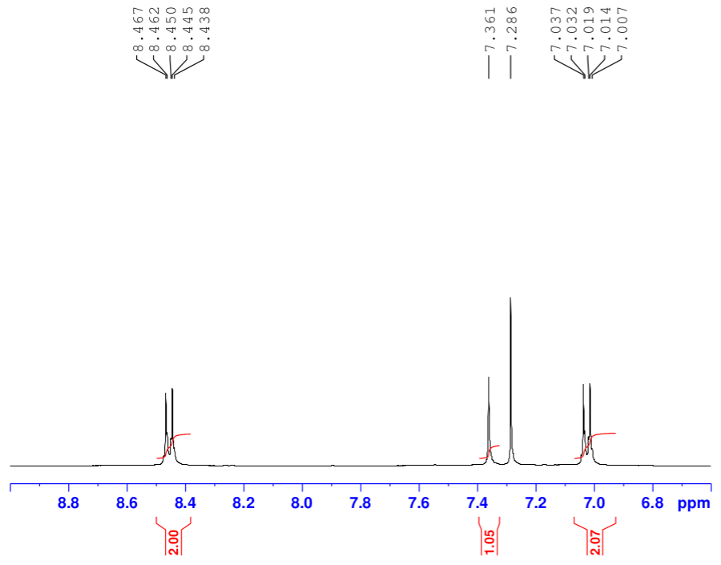
Figure S1: ¹H-NMR spectrum of the compound 1a.
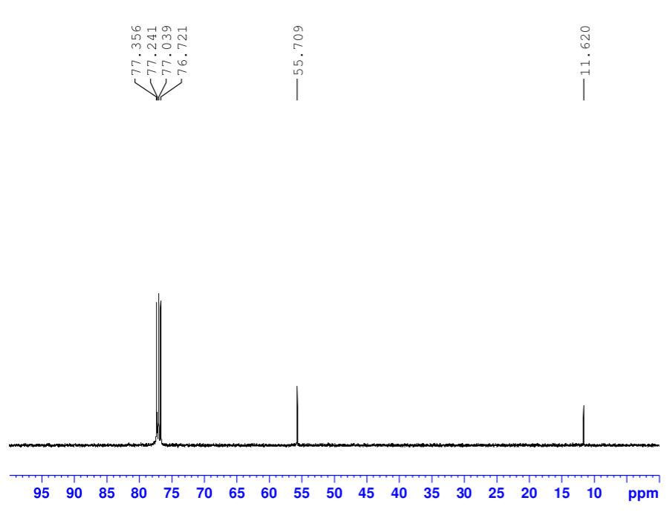

Figure S2: ¹³C-NMR spectrum of the compound 1a.
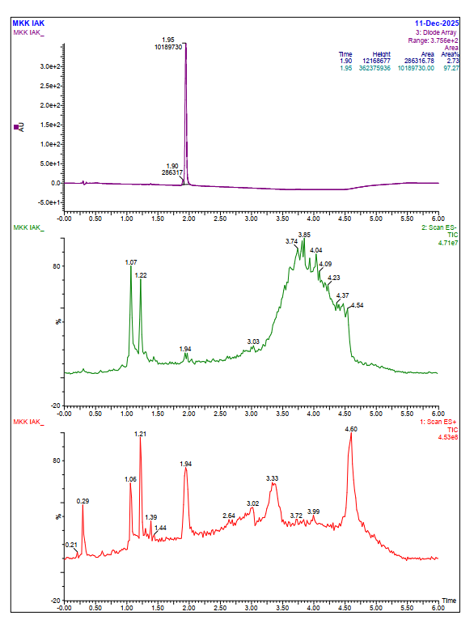
Figure S3: LC spectrum of the compound 1a.
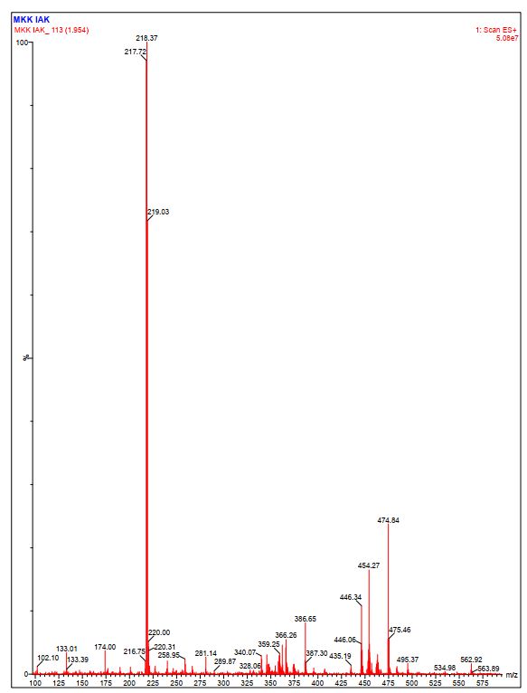
Figure S4: Mass spectrum of the compound 1a.

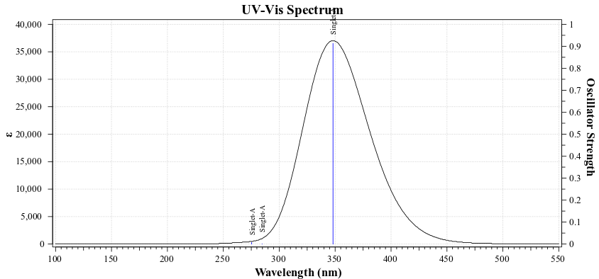
Figure S5: The UV-vis spectra of the 1a compound.
Table S1: The comparison of both experimental (XRD) and theoretical (DFT) bond lengths of 1a molecule.
Atom1 | Atom2 | Length_XRD | Length_DFT
O3 | C11 | 1.204(2) | 1.2054
O1 | C2 | 1.359(2) | 1.3513
O1 | C1 | 1.427(3) | 1.4252
O2 | N1 | 1.446(2) | 1.4242
O2 | C11 | 1.372(2) | 1.3742
N1 | C10 | 1.286(3) | 1.2906
C9 | C8 | 1.359(3) | 1.3632
C9 | C10 | 1.448(2) | 1.4538
C9 | C11 | 1.460(3) | 1.4804
C5 | C8 | 1.444(2) | 1.4434
C5 | C6 | 1.399(2) | 1.4166
C5 | C4 | 1.400(3) | 1.4097
C6 | C7 | 1.364(2) | 1.3784
C10 | C12 | 1.483(2) | 1.4945
C7 | C2 | 1.392(3) | 1.4051
C2 | C3 | 1.382(2) | 1.4015
C4 | C3 | 1.382(2) | 1.3862
Table S2: The comparison of both experimental (XRD) and theoretical (DFT) bond angles of 1a molecule.
Atom1 | Atom2 | Atom3 | Angle_XRD | Angle_DFT
C2 | O1 | C1 | 118.2(1) | 119.1
N1 | O2 | C11 | 110.2(1) | 110.52
O2 | N1 | C10 | 106.6(1) | 107.75
C8 | C9 | C10 | 123.9(1) | 124.47
C8 | C9 | C11 | 132.3(1) | 132.3
C10 | C9 | C11 | 103.8(1) | 103.23
C8 | C5 | C6 | 125.3(1) | 125.46
C8 | C5 | C4 | 117.1(1) | 117.03
C6 | C5 | C4 | 117.5(1) | 117.51
C9 | C8 | C5 | 133.4(1) | 134.15
C5 | C6 | C7 | 121.0(1) | 120.65
N1 | C10 | C9 | 113.0(1) | 112.49
N1 | C10 | C12 | 119.8(2) | 119.78
C9 | C10 | C12 | 127.1(1) | 127.73
C6 | C7 | C2 | 120.8(1) | 120.87
O1 | C2 | C7 | 115.7(1) | 115.8
O1 | C2 | C3 | 124.6(1) | 124.64
C7 | C2 | C3 | 119.7(1) | 119.56
O3 | C11 | O2 | 119.1(1) | 120.9
O3 | C11 | C9 | 134.5(2) | 133.08
O2 | C11 | C9 | 106.3(1) | 106.01
C5 | C4 | C3 | 121.8(1) | 122.2
C2 | C3 | C4 | 119.3(1) | 119.21

Table S3: The comparison of both experimental (XRD) and theoretical (DFT) torsion angles of 1a molecule.
Atom1 | Atom2 | Atom3 | Atom4 | Torsion_XRD | Torsion_DFT
C1 | O1 | C2 | C7 | 174.6(2) | -179.95
C1 | O1 | C2 | C3 | -4.8(2) | 0.05
C11 | O2 | N1 | C10 | 0.0(2) | 0.01
N1 | O2 | C11 | O3 | 177.7(1) | 180
N1 | O2 | C11 | C9 | -1.1(2) | -0.01
O2 | N1 | C10 | C9 | 1.1(2) | -0.01
O2 | N1 | C10 | C12 | 180.0(1) | 179.99
C10 | C9 | C8 | C5 | -173.9(2) | -179.99
C11 | C9 | C8 | C5 | 7.4(3) | 0.01
C8 | C9 | C10 | N1 | 179.2(2) | 180
C8 | C9 | C10 | C12 | 0.5(3) | 0
C11 | C9 | C10 | N1 | -1.8(2) | 0
C11 | C9 | C10 | C12 | 179.5(2) | -180
C8 | C9 | C11 | O3 | 2.0(3) | -0.01
C8 | C9 | C11 | O2 | -179.5(2) | -179.99
C10 | C9 | C11 | O3 | -176.8(2) | 180
C10 | C9 | C11 | O2 | 1.6(2) | 0.01
C6 | C5 | C8 | C9 | 5.3(3) | -0.02
C4 | C5 | C8 | C9 | -178.2(2) | 179.99
C8 | C5 | C6 | C7 | 175.7(2) | 180
C4 | C5 | C6 | C7 | -0.7(2) | -0.01
C8 | C5 | C4 | C3 | -176.2(1) | -180
C6 | C5 | C4 | C3 | 0.5(2) | 0.01
C5 | C6 | C7 | C2 | -0.2(2) | 0.01
C6 | C7 | C2 | O1 | -178.2(1) | -179.99
C6 | C7 | C2 | C3 | 1.3(2) | 0
O1 | C2 | C3 | C4 | 178.0(2) | 179.99
C7 | C2 | C3 | C4 | -1.4(2) | 0
C5 | C4 | C3 | C2 | 0.5(2) | -0.01

