EZConfig-Scanning v4

Version: 4.5.54

Table of Contents

1 Overview 3

1.1 Supported Browser 3

1.2 Communication Interfaces Supported 3

1.3 Platform Supported 3

2 Overview of Release 4

2.1.1 Features 4

2.1.2 Compatibility 8

3 Pre-Requisites 10

4 Limitations 14

5 List of Known Issues and Workarounds 15

5.1 Known issues in current release 15

5.2 Known Issues from previous releases 15

# Overview

Honeywell’s EZConfig for Scanning is free software available at <https://partners.honeywellaidc.com> that facilitates fast and easy one-to-one barcode scanner configurations. EZConfig for scanning versions 4.1 and onward have been updated to be browser-based and improved to provide both an intuitive interface and enhanced efficiency.

## Supported Browser

|  |  |
| --- | --- |
| Browser | Chrome Version 30 above (or HTML 5 supported) , Firefox Version 20 above (or HTML 5 supported),  Microsoft Edge 103 and above,  IE10, IE11  IE8 & 9 [“Disconnected Device” mode only] |

## Communication Interfaces Supported

|  |  |
| --- | --- |
| Communication Interfaces | RS232, USB Serial, USB HID Barcode Scanner, USB HID Keyboard, USB HID SurePOS |

## Platform Supported

|  |  |
| --- | --- |
| OS | Win XP with SP3 and above, Win 7 32/64 bit, Win 8 32/64 bit, Win10,Win11 |

# Overview of Release

### Features

**Main features of 4.5.54 release:**

Includes all the features from 4.5.53

Supports Xenon Ultra 1960  
Integrated HWFlash03.dll 1.23.1.50 to improve Firmware update speed for Xenon Ultra1960

**Issues Fixed/New Features:**

|  |  |  |
| --- | --- | --- |
|  | **JIRA ID** | **Issue Description** |
| 1 | ESTLD-43931 | [ESS] [NPI] Development of ESS Tools support for Xenon Ultra Corded scanners |
| 2 | ESTLD-41074 | Firmware Update speed improvement-Implementation |

All the necessary dlls and exe’s owned by Honeywell are signed by Honeywell certificates.

EZConfig-Scanning v4 is a browser-based Scanner configuration tool.

**Main features of 4.5.53 release:**

Includes all the features from 4.5.52

Supports Honeywell 1991iXLR  
Integrated MSEdge browser setting pre-requisite to set it automatically while installation instead of manual setting

**Issues Fixed/New Features:**

|  |  |  |
| --- | --- | --- |
|  | **JIRA ID** | **Issue Description** |
| 1 | ESTLD-36764 | [ESS][NPI]Granit XLR 1991i NPI Development-EZConfig |

All the necessary dlls and exe’s owned by Honeywell are signed by Honeywell certificates.

EZConfig-Scanning v4 is a browser-based Scanner configuration tool.

**Main features of 4.5.52 release:**

Includes all the features from 4.5.51

Supports Honeywell 7990G Presentation scanner

Implemented logic to popup a message when user is trying to upgrade or downgrade the firmware

**Issues Fixed/New Features:**

|  |  |  |
| --- | --- | --- |
|  | **JIRA ID** | **Issue Description** |
| 1 | ESTLD-37182 | [ESS] [NPI 7990g] Development of ESS Tools to support 7990g |

All the necessary dlls and exe’s owned by Honeywell are signed by Honeywell certificates.

EZConfig-Scanning v4 is a browser-based Scanner configuration tool.

**Main features of 4.5.51 release:**

Includes all the features from 4.5.50

Supports Honeywell Granit 1990i and 1991i XLR Area Imaging Scanner,

Supports Microsoft Edge browser

Supports Windows 11 OS

**Issues Fixed/New Features:**

|  |  |  |
| --- | --- | --- |
|  | **JIRA ID** | **Issue Description** |
| 1 | ESTLD-33274 | [PCR 40316] EZConfig Microsoft Edge browser addition-Implementation |
| 2 | [ESTLD-3](https://acsjira.honeywell.com/browse/ESTLD-32110)3677 | Ezconfig support on Windows 11 |
| 3 | ESTLD-35866 | [ESS] [NPI] Granit XLR support for EZConfig and UPOS |

All the necessary dlls and exe’s owned by Honeywell are signed by Honeywell certificates.

EZConfig-Scanning v4 is a browser-based Scanner configuration tool.

**Main features of 4.5.50 release:**

Includes all the features from 4.5.49

Supports *Honeywell 3320g Area Imaging Scanner*

Issues Fixed/New Features:

|  |  |  |
| --- | --- | --- |
|  | **JIRA ID** | **Issue Description** |
| 1 | ESTLD-32111 | [3320g]As a developer,I need to build EZConfig to support 3320g |
| 2 | [ESTLD-32110](https://acsjira.honeywell.com/browse/ESTLD-32110) | [EWR-39628] HH490 codepage setting is lost after the restart - Implementation |

All the necessary dlls and exe’s owned by Honeywell are signed by Honeywell certificates.

EZConfig-Scanning v4 is a browser-based Scanner configuration tool.

**Main features of 4.5.49 release:**

Includes all the features from 4.5.48

Supports Honeywell Ring Scanner 8675iFR Wireless-Area Imaging Scanner , Ring Scanner 8675iSR Wireless-Area Imaging Scanner

Updated HWFlash03 for supporting 8675i scanners to update firmware  
  
 Issues Fixed/New Features:

|  |  |  |
| --- | --- | --- |
|  | **JIRA ID** | **Issue Description** |
| 1 | 1. ESTLD-30295 | [ESS][8675i]EZConfig/SMU not working with Signed firmware, Investigate this issue and explore option to work with Signed firmware |

All the necessary dlls and exe’s owned by Honeywell are signed by Honeywell certificates.

EZConfig-Scanning v4 is a browser-based Scanner configuration tool.

**Main features of 4.5.48 release:**

Includes all the features from 4.5.47

Supports Honeywell OEM Scan Engine Models of N4680g, N6600,Gen8DB  
Fixed punctuation mistakes in the Home page

All the necessary dlls and exe’s owned by Honeywell are signed by Honeywell certificates.

EZConfig-Scanning v4 is a browser-based Scanner configuration tool.

**Main features of 4.5.47 release:**

Includes all the features from 4.5.46

Supports *Honeywell HH760*

PCR-38529 - UPS - 8690i - 256-bit encryption of security keys in menu commands and configuration barcodes

Issues Fixed/New Features:

|  |  |  |
| --- | --- | --- |
|  | **JIRA ID** | **Issue Description** |
| 1 | 1. [ESTLD-2](https://acsjira.honeywell.com/browse/ESTLD-27009)9256 | ESS - EZConfig support for HH760 |
| 2 | 1. PCR-38529 | UPS - 8690i - 256-bit encryption of security keys in menu commands and configuration barcodes |

All the necessary dlls and exe’s owned by Honeywell are signed by Honeywell certificates.

EZConfig-Scanning v4 is a browser-based Scanner configuration tool.

**Main features of 4.5.46 release:**

Includes all the features from 4.5.45

Supports *Honeywell OEM Scan Engine Models of N4680g, N6600*

PCR-39220 - Urgent Update for EZConfig

All the necessary dlls and exe’s owned by Honeywell are signed by Honeywell certificates.

EZConfig-Scanning v4 is a browser-based Scanner configuration tool.

**Main features of 4.5.45 release:**

Includes all the features from 4.5.44

Supports *Honeywell HF521*

All the necessary dlls and exe’s owned by Honeywell are signed by Honeywell certificates.

EZConfig-Scanning v4 is a browser-based Scanner configuration tool.

Issues Fixed:

|  |  |  |
| --- | --- | --- |
|  | **JIRA ID** | **Issue Description** |
| **1** | 1. [ESTLD-27009](https://acsjira.honeywell.com/browse/ESTLD-27009) | EZCS: Opening a configuration file is not working in Connected and Disconnected modes |
| **2** | 1. PCR-38789 | EZConfig Descriptions |
| **3** | 1. EWR-38509 | "Scanning Mode" option is missing for 1472g in EZ Config v4.5.44 |

**Main features of 4.5.44 release:**

Includes all the features from 4.5.43

Supports *Honeywell 1350g*

All the necessary dlls and exe’s owned by Honeywell are signed by Honeywell certificates.

EZConfig-Scanning v4 is a browser-based Scanner configuration tool.

**Main features of 4.5.43 release:**

Includes all the features from 4.5.42

Supports *Honeywell HH490*

Supports *Genesis XP 7680GSR Presentation Scanner.*

Issues Fixed:

|  |  |  |
| --- | --- | --- |
|  | **JIRA ID** | **Issue Description** |
| **1** | 1. [ESTLD-21185](https://acsjira.honeywell.com/browse/ESTLD-21185) | EZCS: Device name is showing as 8680i for 8690i in Disconnected mode |
| **2** | 1. [ESTLD-21187](https://acsjira.honeywell.com/browse/ESTLD-21187) | EZCS: 1450g Device Image is not showing in disconnected mode |
| **3** | 1. [ESTLD-21188](https://acsjira.honeywell.com/browse/ESTLD-21188) | EZCS: Ethernet Spelling incorrect in the Create Ethernet Barcode Field |

All the necessary dlls and exe’s owned by Honeywell are signed by Honeywell certificates.

EZConfig-Scanning v4 is a browser-based Scanner configuration tool.

**Main features of 4.5.42 release:**

Includes all the features from 4.5.41

Supports *Honeywell 8690i Wearable RFID Mini Mobile Computer*

All the necessary dlls and exe’s owned by Honeywell are signed by Honeywell certificates.

EZConfig-Scanning v4 is a browser-based Scanner configuration tool.

**Main features of 4.5.41 release:**

Includes all the features from 4.5.39.

Supports *Honeywell* HF680 device model

Supports *Honeywell* 8680iB device model

Issues Fixed:

|  |  |  |
| --- | --- | --- |
|  | **JIRA ID** | **Issue Description** |
| **1.** | ESTLD-9354 | FW download percentage in EZConfig should always show positive for Seychelles scanners |

All the necessary dlls and exe’s owned by Honeywell are signed by Honeywell certificates.

EZConfig-Scanning v4 is a browser-based Scanner configuration tool.

**Main features of 4.5.39 release:**

Includes all the features from 4.5.38.

Supports configurable settings *IP of the backup server* and *TCP Port of backup server* for 8680i.

Issues Fixed:

|  |  |  |
| --- | --- | --- |
|  | **JIRA ID** | **Issue Description** |
| **1.** | ESTLD-8979 | Offline/Online Configuration Files Incompatibility – 8680i |

All the necessary dlls and exe’s owned by Honeywell are signed by Honeywell certificates.

EZConfig-Scanning v4 is a browser-based Scanner configuration tool.

**Main features of 4.5.38 release:**

Includes all the features from 4.5.37.

Issues Fixed:

|  |  |  |
| --- | --- | --- |
|  | **JIRA ID** | **Issue Description** |
| **1.** | ESTLD-8714 | EZConfig Utility Open Config issue with 1470g VE device model |
| **2.** | ESTLD-3538 | EZCS: In About EZconfig-Honeywell Peripheral Agent version is not in sync with program files-HPA application |

All the necessary dlls and exe’s owned by Honeywell are signed by Honeywell certificates.

EZConfig-Scanning v4 is a browser-based Scanner configuration tool.

**Main features of 4.5.37 release:**

Includes all the features from 4.5.36.

Supporting Granit XP 1990iSR Corded and cordless Area imaging scanner.

Supporting Granit XP 1990iXR Corded and cordless Area imaging scanner.

All the necessary dlls and exe’s owned by Honeywell are signed by Honeywell certificates.

EZConfig-Scanning v4 is a browser-based Scanner configuration tool.

**Main features of 4.5.36 release:**

Includes all the features from 4.5.35.

Supporting Granit XP 1990iSR Area imaging scanner.

All the necessary dlls and exe’s owned by Honeywell are signed by Honeywell certificates.

EZConfig-Scanning v4 is a browser-based Scanner configuration tool.

**Main features of 4.5.35 release:**

Includes all the features from 4.5.34.

Supporting Xenon Power Lite Area-Imaging Scanner-1900-C, 1900h-C and 1902-C.

Device will be detected and displayed as Xenon 1900-C Area-Imaging Scanner.

Device will be detected and displayed as Xenon XP 1900h-C Area-Imaging Scanner.

Device will be detected and displayed as Xenon Charge & Communication Base.

All the necessary dlls and exe’s owned by Honeywell are signed by Honeywell certificates.

EZConfig-Scanning v4 is a browser-based Scanner configuration tool.

**Main features of 4.5.34 release:**

Includes all the features from 4.5.33.

Supporting Voyager XP1470g Area-Imaging Scanner.

Supporting Voyager XP1472g Wireless Area-Imaging Scanner.

Device will be detected and displayed as 14XX Charge & Communication Base.

All the necessary dlls and exe’s owned by Honeywell are signed by Honeywell certificates.

EZConfig-Scanning v4 is a browser-based Scanner configuration tool.

**Main features of 4.5.33 release:**

Includes all the features from 4.5.32,

Supporting Xenon Power Cordless for battery and battery free devices NPI.

All the necessary dlls and exe’s owned by Honeywell are signed by Honeywell certificates.

EZConfig-Scanning v4 is a browser-based Scanner configuration tool.

**Main features of 4.5.32 release:**

Includes all the features from 4.5.31

All the necessary dlls and exe’s owned by Honeywell are signed by Honeywell certificates.

OSS and Security Testing for EZConfig is cleared and approved by security team.

**Main features of 4.5.31 release:**

Support PCR30717_1450g Voyager Upgrade

Xenon Power corded- NPI

Devices will be detected and displayed as Xenon XP 1950h Area-Imaging Scanner

Devices will be detected and displayed as Xenon XP 1950g Area-Imaging Scanner

Updated Flashdlls in EZConfig-Agent

**Main features of 4.5.30 release:**

* ESTLD-3167: Need to support EZConfig v4.5.27 compatibility on different browsers.

**Main features of 4.5.27 release:**

* Optimize WETTIM can’t work issue.
* Support upgrade on-line.
* Fix issue [ESSTL-857](https://acsjira.honeywell.com/browse/ESSTL-857).

**Main features of 4.5.26 release:**

* Fix WETTIM can’t work issue.
* 1932g support. The device will be detected and displayed as ‘Xenon XP CCB’ in UI.
* Keep consistent flash message between EZConfig and Agent.
* 8680i support. The device will be detected and displayed as ‘Seychelles 8680i Wireless Area-Imaging Scanner’ in UI.
* Add TLS configuration support for 8680i.

**Main features of 4.5.25 release:**

* CM5680SR engine support. The device will be detected and displayed as ‘CM5680SR’ in UI.
* CM3680SR engine support. The device will be detected and displayed as ‘CM3680SR’ in UI.
* CM2180MP engine support. The device will be detected and displayed as ‘CM2180MP’ in UI.

**Main features of 4.5.24 release:**

* 1920i Industrial Area-Imaging Scanner support. The device will be detected and displayed as ‘1920i Industrial Area-Imaging Scanner’ in UI.

**Main features of 4.5.23 release:**

* Orbit 7190g Hybrid Scanner support. The device will be detected and displayed as ‘Orbit 7190g Hybrid Scanner’ in UI.

**Main features of 4.5.22 release:**

* Xenon 1902g-BF Battery-Free Wireless Area-Imaging Scanner and Xenon BF Charge & Communication Base support. Both the devices will be detected and displayed as ‘Xenon BF Charge & Communication Base’ in UI.
* The following setting items for the devices above are not added to this version, they are just grouped as reserved commands by default:

BT_ACS, DECFLA, DECFLR, DECFLS, PDCFLA, PDCFLR, PDCFLS

**Main features of 4.5 release:**

* Vuquest 3320g Area-Imaging Scanner device support. Vuquest 3310g and Vuquest 3320g devices, both the devices will be detected and displayed as ‘Vuquest 33xxg (3310g, 3320g)’ in UI.
* Scan Data Window, Serial Data Window - Keep a running list of commands in the 'create programming bar code' and 'command center' entry boxes.
* “Reset to device default” support from the application.
* Dropped the support for EB (Toggle device in and out of auxiliary port mode and send characters out aux port), FF (End Format) rules in Data Formatting.
* Enhanced data capturing and Maintaining common/single EdgeBroker service & installation for Cloud and local versions of EZConfig.
* Clear pending client transactions if any at HPA once client session gets terminated.
* Usability improvements for “Configuration History”.
* IE 11 Support

**Main features of 4.4 release:**

* Prefix/Suffix redesign in alignment with data formatting.
* Application upgrade notification.
* Improved the data display in Serial, Scan Data Window for better readability.
* Discovery performance when working with cordless devices associated with RF Scanners.

**Main features of 4.3 release:**

* Data formatting redesign.
* Auto firmware upgrade for RF Scanners.
* Displaying license and plug-in as part of device discovery.
* Auto-connect post flashing operation.
* Usability improvements for “Configuration History” and “Compare & Clone” features.
* Win 8 support.
* IE10 support.

**Main features of 4.2 release:**

* Port communication via “Serial Data Window”.
* Capture image by providing menu commands from imaging tab.
* Aztec/Data Matrix support for 2D bar code generation.
* Image capture from selected RF Scanner.
* Auto firmware upgrade.
* Force Reader to Boot Mode support.

**Main features of 4.1 release:**

* Improved HF [Page Navigation, Prefix/Suffix, Data Formatting etc].
* Improved search in Disconnected Device mode by segregating the devices in to different categories.
* Progressive discovery and Auto connect to the first discovered device.
* Interfaces supported: RS 232, USB serial, USB HID, USB HID KBD, USB HID Surepos.
* Configuration History with undo capability.
* 1D/2D Barcode generation for Changed/Selected/Clone settings.
* Provides GUI Search, based on Command names/Friendly text.
* Allows Comparison between device default, current or EXM settings, device current values and clones the settings.

### Compatibility

1. **Hand-held general Purpose:** Voyager1400g, 1900, 1200g, 1250g, 1300g, voyager1450g, voyager1450g2dhr, enhancedxenon1900h, Xenon1900Color, Xenon1900h, Xenon1900hColor, 8620 NGW Ring Scanner, YJHH660 Area-Imaging Scanner, Xenon BF Charge & Communication Base,8680i, 8680iB,1932g,Xenon Power 1950g corded, Xenon Power 1950h corded, 14XX Charge & Communication Base, Xenon 1900-C Area-Imaging Scanner, Xenon 1900h-C Area-Imaging Scanner, Xenon 1902-C Area-Imaging Scanner, Voyager XP1470g Area-Imaging Scanner, Voyager XP 1472g Wireless Area-Imaging Scanner , Honeywell HH490, Honeywell HH760 Area-Imaging Scanner,HH762,HH1800,Xenon Ultra 1960
2. **Hands-Free Barcode Scanner:** genesis7580g, Vuquest3310g, 4850dr, solaris7980g, YJHF500 Fixed Scanning Module, Orbit 7190g Hybrid Scanner, Honeywell HF680, Genesis XP 7680GSR Presentation Scanner, Vuquest 3320g Area-Imaging Scanner, Solaris 7990G
3. **Industrial Barcode Scanner:** Granit 1910i, granit1280i, granit1980i, 1920i Industrial Area-Imaging Scanner,Granit XP 1990i XLR, Granit XP 1991i XLR
4. **In-Counter Scanner:** stratos2700.
5. **OEM Scanner:** N5600, N8600, N4300, 7300, n660X, N3600, CM5680SR, CM3680SR, CM2180MP, Honeywell HF521, N4680g, N6660
6. **Wireless Barcode Scanner:** granit1911i, voyager1602g, 1902, Voyager1202g, voyager1202g-bf, granit1981i, Xenon1902Color, Xenon1902h, and Xenon1902hColor, Ring Scanner 8675iFR Wireless-Area Imaging Scanner, Ring Scanner 8675iSR Wireless-Area Imaging Scanner
7. **Base Model for Wireless**: CCB, HAP, CCB00, CCB03, CCB04, CCB05, CCB00bf, AP100 (HAP for 1602), CCB02, XenonBFBase,CCB22

8. **Document Readers:** 4850dr.

[Instruction text]

# Pre-Requisites

It is recommended to ensure that your browser has the below settings prior to work with the EZConfig-Scanning Cloud application.

1. **Chrome Settings:**

* Go to Settings, click on “Show advanced settings….”
* Under “Downloads” option, ensure that “Ask where to save each file before downloading” option is selected.

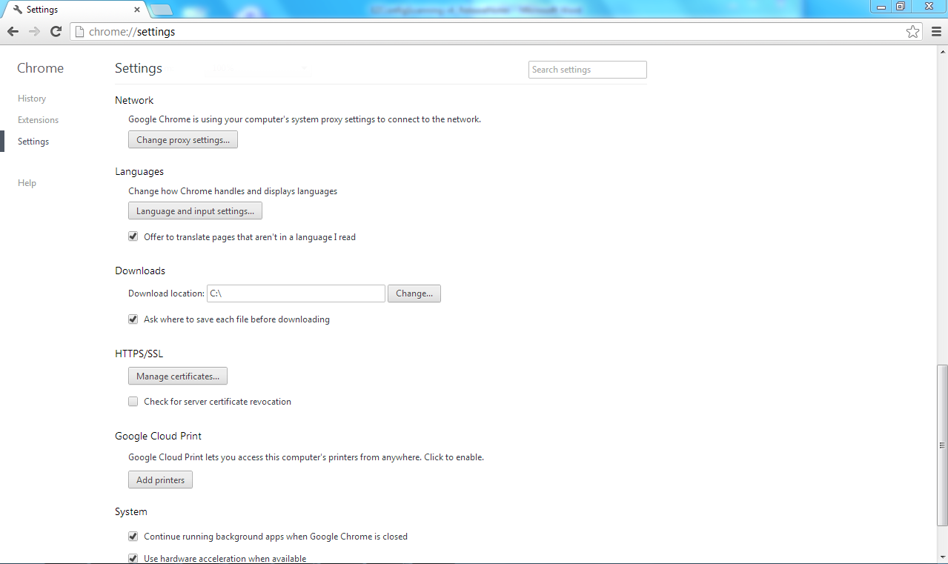

* Always ensure to launch Chrome with the following settings. Ensure to close any other Chrome running instances prior to apply it.

**chrome.exe --allow-file-access-from-files --enable-file-cookies**

ex: C:\Program Files\Google\Chrome\Application>chrome.exe --allow-file-access-from-files --enable-file-cookies

1. **MS Edge Settings:**

* Go to MSEdge browser Settings, click on “System and Performance”. Disable Startup Boost.
* 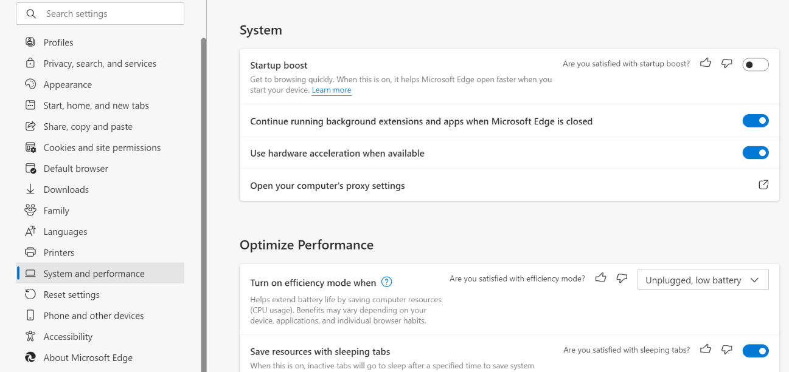Go to Settings, click on “Downloads”
* Under “Downloads” option, ensure that “Ask me what to do with each download” option is selected.

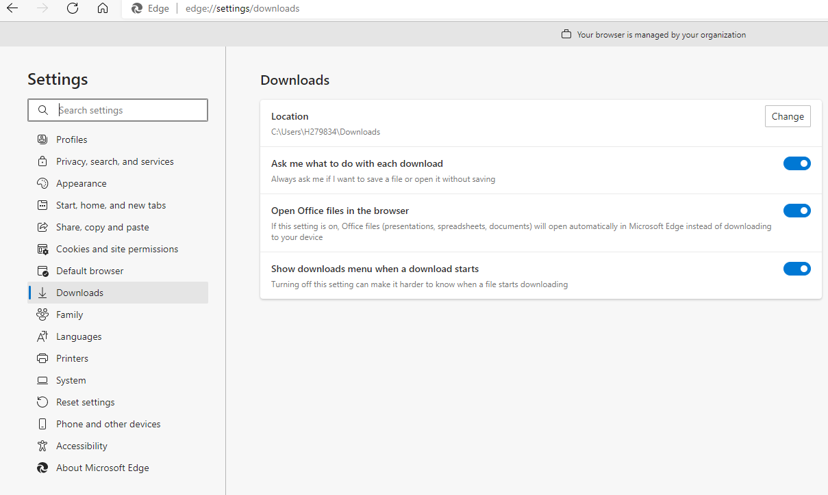

* Always ensure to launch Edge with the following settings. Ensure to close any other Edge running instances prior to apply it.

**msedge.exe --allow-file-access-from-files --enable-file-cookies**

ex: C:\Program Files (x86)\Microsoft\Edge\Application\ > msedge.exe --allow-file-access-from-files --enable-file-cookies "C:\Program Files (x86)\Honeywell\EZConfig-Scanning v4\EZCSHomePageUI.html"

1. **Firefox Settings:**

* Open Firefox, In the url tab, type “about:config”.
* In the configuration settings, search for preference “browser.download.manager.scanWhenDone“ and set the value to false.

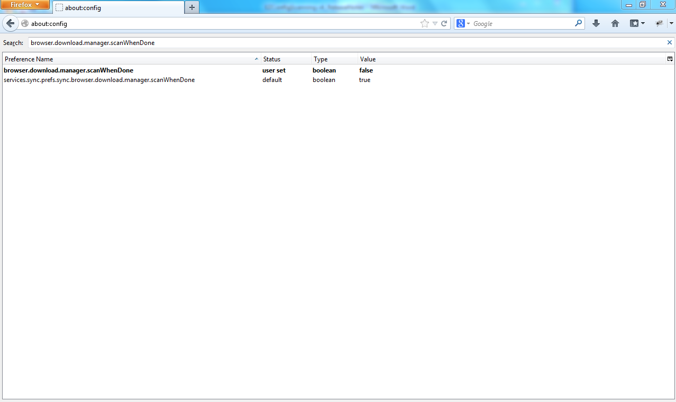

* Press Alt+F , Go to Tools->Options.
* Under General, Go to Downloads, ensure that “Always ask me where to save files” option is selected.

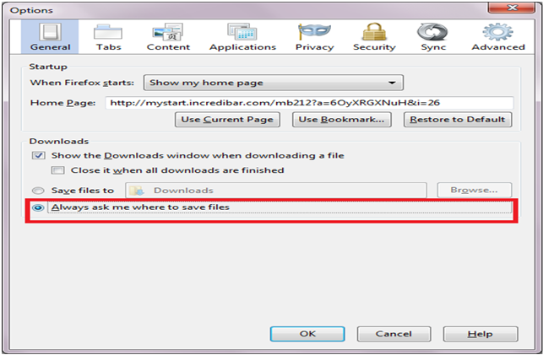

* **Disable the following setting** 
  + - Go to about:config and search for **privacy.file_unique_origin**
    - Change the value from **True** to **false** – this is enabled by default in the latest versions of firefox versions > 67

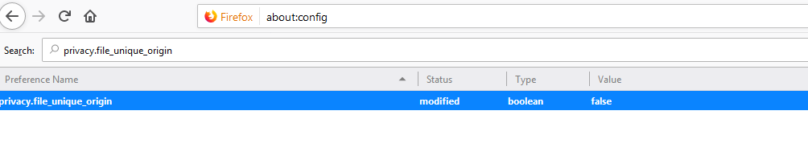

1. **IE Settings**

* Enable the 'Use TLS 1.0' settings. Under Internet Options -> Advanced -> Security -> select "Use TLS 1.0"

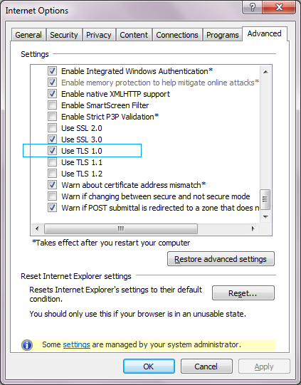

* Enable the EZConfig Add-ons for EZConfig cloud version. Under Manage Add-ons -> Toolbars and Extensions -> select " Enable Communication with Honeywell Scanning and Mobility Devices" and change its status to ‘Enabled’.

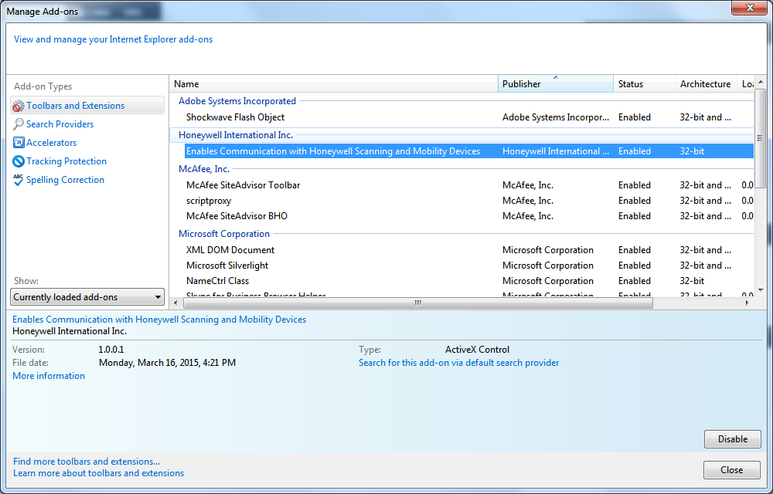

* Allow blocked content for EZConfig local version. The message window as below will be popped up when clicking the desktop shortcut ‘EZConfig-Scanning v4_IE’ to launch EZConfig local version, then click the ‘Allow blocked content’ on the message window.



# Limitations

* **It is required to restart all instances of browsers after installing EZConfig**
* **Opening EZConfig in MSEdge might show an error for the first time as we have integrated the pre-requisite browser setting to be disabled upon installation instead of manually setting the pre-requisite.**
* **Virtual COM support** – The current version of EZConfig only supports Virtual COM ports generated by the HSM USB Serial Driver. Virtual COM ports generated by other drivers (i.e. ports that come up when using RS232 to USB adaptor) are not supported during discovery operation. If you still need to use such ports, Change the value of “SupportVirtualCOM” in the file “EZCSConfig.xml” under installation path to “1” from the default value “0”, power cycle the device and refresh EZConfig application.
  + If the discovery/configure device operation freezes in the middle, the suggested work around is to clear the registry entries under the path “HKEY_LOCAL_MACHINE\HARDWARE\DEVICEMAP\SERIALCOMM\”, power cycle the device and refresh EZConfig application. If the problem (application hang) still persists, reset the “SupportVirtualCOM” in the file “EZCSConfig.xml” under installation path to default value “0” and refresh the application.
* Image Capture supports JPEG, BMP formats for all browsers. TIFF format is supported only in IE. For all others image formats, images are captured with the default JPEG format.
* Force Reader to Boot Mode functionality is supported only for Xenon based devices in RS232 interface at 115200 baud rate and 8N1 data bits.
* **FRLE support** - FRLE (7300) device defaults to PWRMOD2 that causes it to enter sleep mode quickly.  Due to this behavior, EZConfig users may encounter errors while performing operations in “Scan Data Window” and “Serial Data Window”. **The suggested work around** is to set the PWRMOD setting to 0 (zero) prior using “Scan Data Window” and “Serial Data Window”.
* Use a Windows account with Administrator privileges to perform install and uninstall of the EZConfig-Agent.
* For un-installation of EZConfig-Agent, It is recommended to do it from Start menu-> All Programs->Honeywell->EZConfig-Scanning v4-> Uninstall EZConfig- Agent with admin privileges.

If un-installing EZConfig v4 versions from Control Panel->Add/Remove Programs, perform uninstall of “EZConfig-Agent” followed by “EZConfig-Scanning”.

* **Madiera** Support - Flash dll does not support flash operation of two or more BTRS at the same time(when connected with AP100).

# List of Known Issues and Workarounds

## Known issues in current release

|  |  |  |
| --- | --- | --- |
| **S.No** | **JIRA ID** | **Issue Description** |
| **1.** | ESTLD-3558 | EZCS: Intermittently UPDATE ELS option is seen on IEBrowser |
| **2.** | ESTLD-3554 | EZCS: Xenon Power 1950g is going to disconnected mode after firmware upgrade  Work around: Refresh page and connect the scanner |
| **3.** | ESTLD-3544 | EZCS: Force boot functionality is not working |
| **4.** | ESTLD-3543 | EZCS: Data leakage is seen on IBM sure POS after successful flashing.  It was reportable only on win 7 64bit.  Reproducibility: Low |
| **5.** | ESTLD-3541 | EZCS: same device model names are shown for 1450 and voyager power devices. |
| **6.** | ESTLD-3540 | EZCS: Repairing the setup is asking for the MSI details – Only Agent dlls are not restored while EZCS files are restored.  Work around: Reinstalling the setup exe works. |
| **7** | ESTLD-5516 | EZCS: "Settings File is not compatible with connected device"message is seen when tried to open the exm file which is saved through disconnected mode for 1472g device. |
| **8** | ESTLD-5500 | EZCS: Application is not launching in Firefox (68) version. |
| **9** | ESTLD-6207 | EZCS: License Info is showing the details of OCR and digimarc for Xenon XP lite device |
| **10** | [ESTLD-6227](https://acsjira.honeywell.com/browse/ESTLD-6227) | EZCS: Disconnected Mode showing details of OCR and Digimarc ofr Xenon 1902-C device. |
| **11** | [ESTLD-25149](https://acsjira.honeywell.com/browse/ESTLD-25149) | EZCS:Default the HH490 device makes the device stays in the Existing Interface |
| **12** | [ESTLD-25151](https://acsjira.honeywell.com/browse/ESTLD-25151) | EZCS: Image capture is showing Image capture is in Progress for Ever |
| **13** | ESTLD-25163 | EZCS:EZConfig Upgradation is Restarting the Machine for first time and again user need to Upgrade the application to work |
| **14** | [ESTLD-25150](https://acsjira.honeywell.com/browse/ESTLD-25150) | EZCS: Feedback Link is showing blank Page |

## Known Issues from previous releases

|  |  |  |
| --- | --- | --- |
| **S.No** | **JIRA ID** | **Issue Description** |
| 1 | EZCS4-1450 | Most of the Links are not working: FAQ, Feedback & New Features  **Frequency of occurrence:** Constant  **Severity:** Marginal  **Workaround:** None. |
| 2 | EZCS4-1448 | CLOUD: Not Able to Launch application in Connected Mode in Chrome Browser ver. Version 55.0.2883.87 m.  **Frequency of occurrence**: Constant  **Severity**: Major  **Workaround**: None. |
| 3 | EZCS4-1386 | Rf scanner getting de linked with base when performing flash operation with CCB00bf device in USB HID & USB Serial interface.  **Frequency of occurrence**: Constant  **Severity**: Minor  **Workaround**: None. |
| 4 | EZCS4-1365 | 'POSTAL' command's settings list values from 31 to 38 are not shown in the friendly text for the device CCB04.  **Frequency of occurrence**: Constant  **Severity**: Minor  **Workaround**: None. |
| 5 | EZCS4-1364 | Reset to Default operation for 1452 device is displaying message 'Upload operation failed. Lost device connection'.  **Frequency of occurrence**: Rare  **Severity**: Minor  **Workaround**: None. |
| 6 | EZCS4-1363 | Interface change is not happening using save to device operation for 1452 device.  **Frequency of occurrence**: Constant  **Severity**: Minor  **Workaround**: Try changing the interface from ‘Scan Data Window’ using the interface command. |
| 7 | EZCS4-1341 | Security certificate error seen when launching application in Internet Explorer browser.  **Frequency of occurrence**: Occasional  **Severity**: Minor  **Workaround**:  Clear all the cookies and cache in Internet Explorer using menu options Tools->Internet Options->General, click "Delete..." and Un-check the options   * “Preserve Favorites website data”,   check the options   * “Temporary Internet files and website files”, * “Cookies and website data” and “History” boxes,   Click "Delete", when finished, click OK and re launch application to see if issue is resolved. If the problem still persists proceed with the option “Continue to this website” or use Firefox/Chrome browser. |
| 8 | EZCS4-1330 | Observed message "EZCS Configuration has been corrupted, request you to uninstall and install it again" when launching application in Internet Explorer browser.  **Frequency of occurrence**: Occasional  **Severity**: Minor  **Workaround**: Restart machine or use Firefox/Chrome browser. |
| 9 | EZCS4-1297 | Cancel operation not handled as part of EZConfig installation [Install/Repair/Un install].  **Frequency of occurrence**: Frequent  **Severity**: Marginal  **Workaround**: Re launch the setup to perform the required operation. Ex: Instead of cancelling during installation – Re launch setup and perform uninstallation. |
| 10 | EZCS4-1229 | Keyboard layout is not rendered properly while creating/editing prefix/suffix in IE10 browser.  **Frequency of occurrence**: Random  **Severity**: Marginal  **Workaround**: Perform scroll up/down or click on the keyboard layout. |
| 11 | EZCS4-1221 | Tooltip for the drop-down items in configuration settings page is not displayed properly in IE10 browser.  **Frequency of occurrence**: Frequent  **Severity**: Marginal  **Workaround**: Use Firefox/Chrome/IE9 browser. |
| 12 | EZCS4-1144 | Flash operation not working in IE9, when firmware file is located over network drive.  **Frequency of occurrence**: Frequent  **Severity**: Minor  **Workaround**: Use Firefox/Chrome/IE10 browser for flashing operation. |
| 13 | EZCS4-1140 | License, plug-in information not seen consistently for 1900 and CCB/1902.  **Frequency of occurrence**: Occasional  **Severity**: Major  **Workaround**: Upgrade device to latest version of firmware.  Issue not seen with following firmware versions:  Xenon corded: BI000612AAA.moc,  Xenon CCB: BK000169AAA.moc  Xenon Cordless (RF Scanner): BJ000180AAA.moc. |
| 14 | EZCS4-1129 | Flash operation for Stratos 2700 device not working via auto firmware upgrade from IE browser.  **Frequency of occurrence**: Occasional  **Severity**: Minor  **Workaround**: Use Firefox or Chrome browser for flashing operation. |
| 15 | EZCS4-1127 | Observed data leakage when working with CCB/1902 connected in USB KBD interface.  **Frequency of occurrence**: Frequent  **Severity**: Major  **Workaround**: Switch to different interface. |
| 16 | EZCS4-1042 | Application crashing (Browser getting closed) when trying to use 'Print bar code generation' on Chrome browser v29  **Frequency of occurrence**: Regular – Browser limitation.  **Severity**: Minor  **Workaround**: Update chrome to latest version – version above 30. |
| 17 | EZCS4-1007 | Observed data leakage when working with Corded/CCB/1902 connected in USB KBD interface and REMIFC is set to 0  **Frequency of occurrence**: Frequent  **Severity**: Major  **Workaround**: Switch to different interface. |
| 18 | EZCS4-951 | Image capture does not work for CCB with RF scanner in RS-232 interface configured with lower baud rates (9600) and DPS Settings (Ex: 7O2).  **Frequency of occurrence**: Regular – Device limitation.  **Severity**: Major  **Workaround**: None. |
| 19 | EZCS4-947 | Image capture operation is failing for 'cropped' Image type for cordless devices, if the base image cropping parameters (IMGWNL, IMGWNR, IMGWNT and IMGWNB) are not in sync with RF Scanner parameters.  **Frequency of occurrence**: Regular – Device limitation.  **Severity**: Minor  **Workaround**: Change the image cropping parameters values in Sync with RF Scanner before image capture operation. |
| 20 | EZCS4-894 | In connected/disconnected mode when the response for the “Google Analytics” request is delayed, UI rendering is getting delayed/not proper.  **Frequency of occurrence**: Rare – Known issue with the Google Analytics.  **Severity**: Minor  **Workaround**: Make sure the internet connectivity is proper or completely disabled. |
| 21 | EZCS4-836 | When working with cordless devices (CCB/HAP), color supported formats are shown on UI, even when the associated RF scanner doesn't support color.  **Frequency of occurrence**: Regular – Shall be addressed in future releases.  **Severity**: Minor  **Workaround**: None |
| 22 | EZCS4-823 | Publisher name displayed as "Unknown" when trying to uninstall from control panel  **Frequency of occurrence**: Regular – Packaging tool limitation.  **Severity**: Marginal  **Workaround**: None |
| 23 | EZCS4-692 | Multiple instances of application for configuring devices in not supported.  **Frequency of occurrence**: Always - Shall be addressed in future releases.  **Severity**: Minor  **Workaround**: Use one instance at a time. |
| 24 | EZCS4-603 | Disconnect notification not seen when connected to RS232 device and unplugged the power supply/cable.  **Frequency of occurrence**: Always – Shall be addressed in future releases.  **Severity**: Minor  **Workaround**: Refresh the browser. |
| 25 | EZCS4-591 | No barcode data seen in scan window for 7580 scanner with TRMUSB128 interface.  **Frequency of occurrence**: Regular – Device limitation.  **Severity**: Minor  **Workaround**: Need to enable barcode scanning in the device using the command "\X161\X0D1" for reading barcode data and disable using the command "X160\X0D1". |
| 26 | EZCS4-484 | "Google Chrome is unresponsive. Re launch now?" message is seen, when trying to launch the application post installation in the Finish Dialog.  **Frequency of occurrence**: Rare – Known issue with the Chrome browser.  **Severity**: Minor  **Workaround**: Close the browser and re launch it again. |
| 27 | EZCS4-427 | Observed sometimes “EZConfig-Scanning v4” icon for the chrome instance.  **Frequency of occurrence**: Rare – Known issue with the Chrome browser.  **Severity**: Minor  **Workaround**: None |
| 28 | ESSTL-329 | Some setting items for Roscana devices display in the Reserved Commands tab due to firmware issues  **Frequency of occurrence:** Constant  **Severity:** Minor  **Workaround:** None. |
| 29 | ESSTL-354 | Image icon is not enabling in Roscana - CM3680SR scanner  **Frequency of occurrence:** Constant  **Severity:** Minor  **Workaround:** None. |
| 30 | ESSTL-635 | The key-default does not work in confg device.  **Frequency of occurrence:** Constant  **Severity:** Major  **Workaround:** None. |
| 31 | [ESTLD-25163](https://acsjira.honeywell.com/browse/ESTLD-25163) | EZConfig Upgradation is Restarting the Machine for first time and again user need to Upgrade the application to work  **Frequency of occurrence:** Constant  **Severity:** Minor  **Workaround:** Uninstall existing previous version and install 4.5.43 version. |
| 32 | [ESTLD-25151](https://acsjira.honeywell.com/browse/ESTLD-25163) | EZCS: Image capture is showing Image capture is in Progress for Ever  **Frequency of occurrence:** Constant  **Severity:** Minor  **Workaround:** None |