**Foreign Direct Investment (FDI) in various sectors of INDIA**

*A Report submitted in partial fulfilment of the*

*requirements for the award of the degree of*

**BACHELOR OF TECHNOLOGY**

in

**COMPUTER SCIENCE AND ENGINEERING**

**ABSTRACT**

This project attempted to make an analysis of FDI in India and its impact on growth. It also focuses on the determinants and needs of FDI, year-wise analysis, sectoral analysis. One of the economic aspects of globalization is the fact that increasing investments in the form of foreign direct investments. In the recent times due to the global recession most of the countries have not been able to pull investments. India has been able to attract better FDI’s than the developed countries even during the crisis period also. Especially in the recent years the FDI in India has been following a positive growth rate. Since 1991 the government has focused on liberalization of policies to welcome foreign direct investments. These investments have been a key driver for accelerating the economic growth through technology transfer, employment generation, and improved access to managerial expertise, global capital, product markets and distribution network. FDI in India has enabled to achieve a certain degree of financial stability; growth and development to sustain and compete in the global economy.

**INDEX**

|  |  |  |
| --- | --- | --- |
| S. NO. | Table of Contents | Page No. |
| 1. | **Introduction** | **6** |
| 2. | **Motivation of the Work** | **7** |
| 3. | **Objectives** | **8** |
| 4. | **Literature Review** | **9** |
| 5. | **Importing Data** | **10-12** |
| 6. | **Visualizations** | **13-22** |
| 7. | **Dashboards** | **23** |
| 8. | **Conclusion** | **24** |
| 9. | **References** | **25** |

**INTRODUCTION**

A foreign direct investment is an investment in the form of a controlling ownership in a business in one country by an entity based in another country. Apart from being a critical driver of economic growth, Foreign Direct Investment (FDI) has been a major non-debt financial resource for the economic development of India. Foreign companies invest in India to take advantage of relatively lower wages, special investment privileges like tax exemptions, etc. For a country where foreign investment is being made, it also means achieving technical know-how and generating employment.

The Indian Government’s favourable policy regime and robust business environment has ensured that foreign capital keeps flowing into the country. The Government has taken many initiatives in recent years such as relaxing FDI norms across sectors such as defence, PSU oil refineries, telecom, power exchanges, and stock exchanges, among others.

FDI is one of the measures of growing economic globalization. Investment has always been an issue for the developing economies such as India. The world has been globalizing and all the countries are liberalizing their policies for welcoming investment from countries which are abundant in capital resources. The countries which are developed are focusing on new markets where there is availability of abundant labors, scope for products, and high profits are achieved.

Therefore Foreign Direct Investment (FDI) has become a battle ground in the emerging markets. The objective behind allowing FDI is to complement and supplement domestic investment, for achieving a higher level of economic development and providing opportunities for technological upgradation, as well as access to global managerial skills and practices.

**Motivation of the Work**

Foreign direct investment is significant for developing economies and emerging markets where companies need funding and expertise to expand their international sales. Private investment in infrastructure, energy, and water is a critical driver of the economy as helps in increasing jobs and wages. Today, India has become one of the most attractive destinations for foreign direct investments thanks to liberalized norms, easy policies and subsidized rates. Foreign investors are also willing to invest in the country due to lower labour costs, market diversification, subsidies.

Total foreign direct investment (FDI) into India in the first quarter of 2020-21 plunged by 60% from the year-ago period to $6.5 billion, reflecting the impact of the Covid-19 pandemic on the global investment scenario.

In this Tableau Data Science Project I have taken a FDI dataset and analyze it from the perspective that your company wants to see in which sector it will be a beneficial idea to start the work so that your company can collaborate with FDI player and become successful.

Therefore, I thought that we need to study the different sectors of India in which there is foreign direct investment and analyse various trends and forecast for future years also.

**Objectives**

The objective of this project is to familiarize ourselves with different issues associated with foreign direct investment (FDI) and try to correlate the trends with the theoretical knowledge we have acquired. We explain the concept of FDI and its importance in an economy. We also look at the recent trends and why India has become a favored FDI destination in recent past. We analyze FDI in India in its different sectors in greater detail.

The following are the sub-objectives of the project :

* To identify the various determinants of FDI.
* To exhibit the sector-wise, year-wise analysis of FDI’s in India.
* To identify the various trends of FDI.
* To understand the need for FDI in India.

**LITERATURE REVIEW**

In **[1]**, With FDI stocks constituting over 20% of global GDP, FDI has come in lime light in the global economy. From a couple of years, investor confidence has soared in the emerging market countries such as China and India and they have become the most favored destinations for FDI.

In **[2]**, in Indian economy is one of the top emerging markets of the world. Five years ago it was considered as part of the fragile five, but no longer. Since 2014, it has emerged as of the one top foreign destination in the world with a significant rise in FDI. The journey of attracting foreign investments started way back in 1991 with New Economic policy and India has unpreventably scaled new heights in the level of FDI during 2000’s. The paper focuses on secondary data based Sectoral analysis of the inflow of FDI in India from 2000 to 2018. The paper also aims to look at different facets of positive FDI spill overs in the country.

In **[3]**, focuses on the determinants and needs of FDI, year-wise analysis, sectoral analysis and sources of FDI and reasons. One of the economic aspects of globalization is the fact that increasing investments in the form of foreign direct investments. In the recent times due to the global recession most of the countries have not been able to pull investments. India has been able to attract better FDI's than the developed countries even during the crisis period also. Especially in the recent years the FDI in India has been following a positive growth rate. Since 1991 the government has focused on liberalization of policies to welcome foreign direct investments. These investments have been a key driver for accelerating the economic growth through technology transfer, employment generation, and improved access to managerial expertise, global capital, product markets and distribution network. FDI in India has enabled to achieve a certain degree of financial stability; growth and development to sustain and compete in the global economy.

**METHODOLOGY**

**Importing Data-**

**Make the connection and set up the data source**

Start Tableau and under Connect, select Google Sheets. Sign in to Google Sheets using your email or phone, and then select Nextto enter your password. If multiple accounts are listed, select the account that has the Google Sheets data you want to access and enter the password, if you're not already signed in.

Select **Allow** so that Tableau Desktop can access your Google Sheets data.

Select a Google Sheet from the list or use the text box to search for a Google Sheet by name or by URL, and then select **Connect**.

On the data source page, If your Google Sheets file has one table, select the sheet tab to start your analysis.

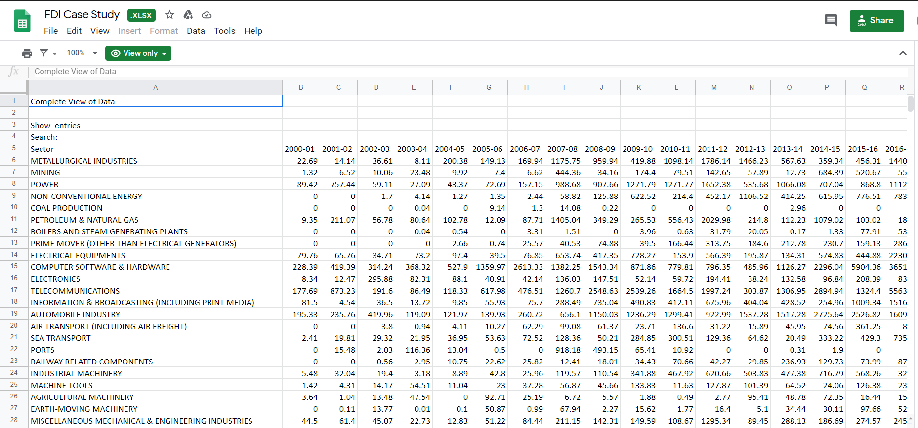

**Unpivoting data from converting wide format to long format-**

An unpivot transformation is one way to transform data from a short/wide to a tall/skinny format. When the data types of source columns differ, the varying data is converted to a common data type so the source data can be part of one single column in the new data set.

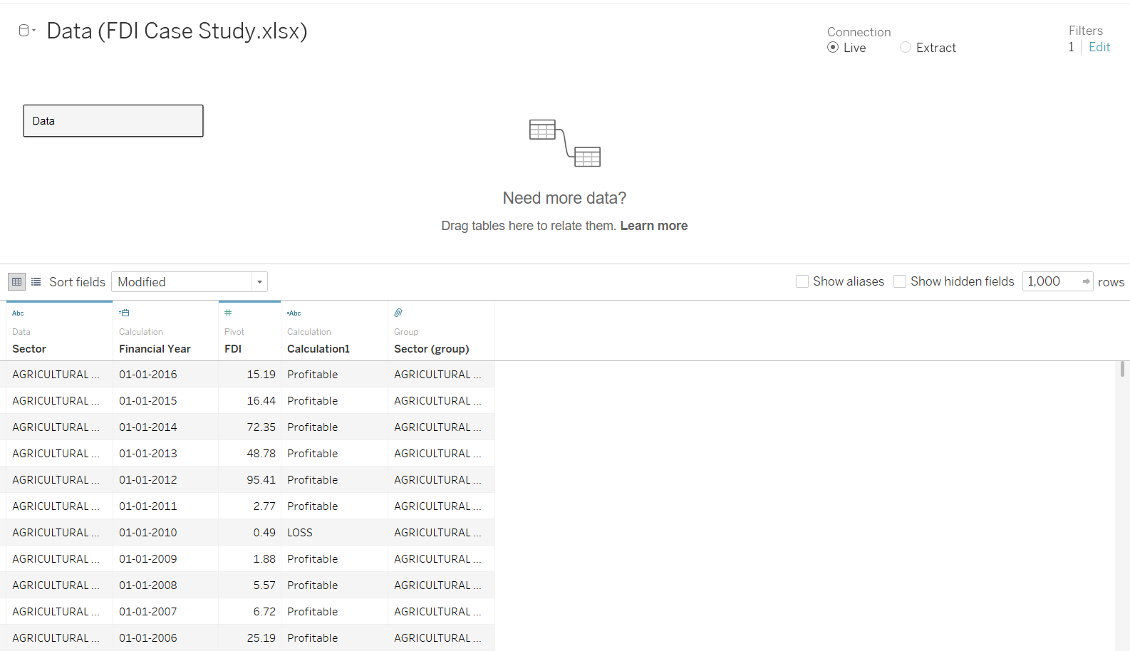

**Visualizations-**

**Highest value for FDI and its sector in latest year**

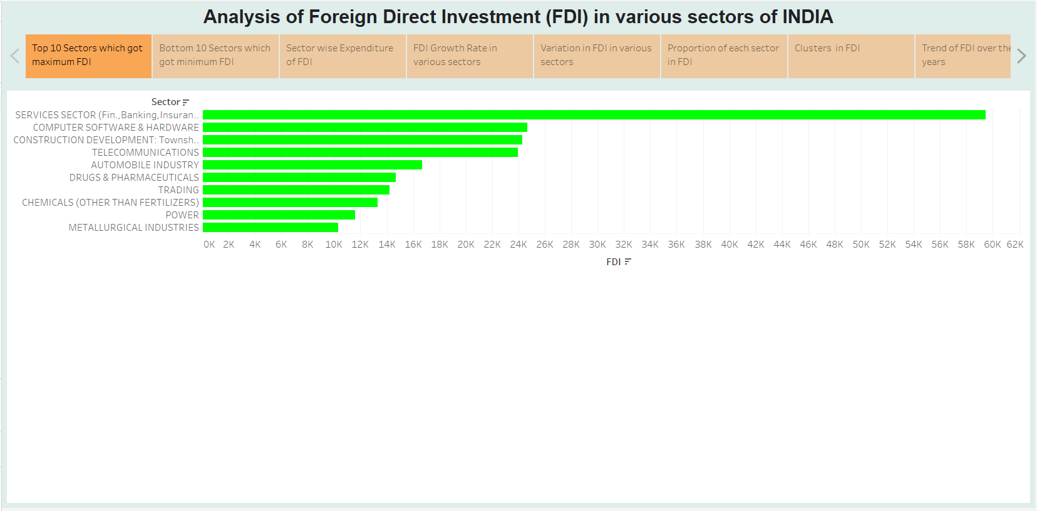

In this, We are looking at the 10 sectors with the highest Foreign direct investment. As can be seen in the image we see largest FDI investment. From this visualization, we get to know that Services sector got the highest FDI in latest year.

**Lowest Value of FDI and its sector in latest year**

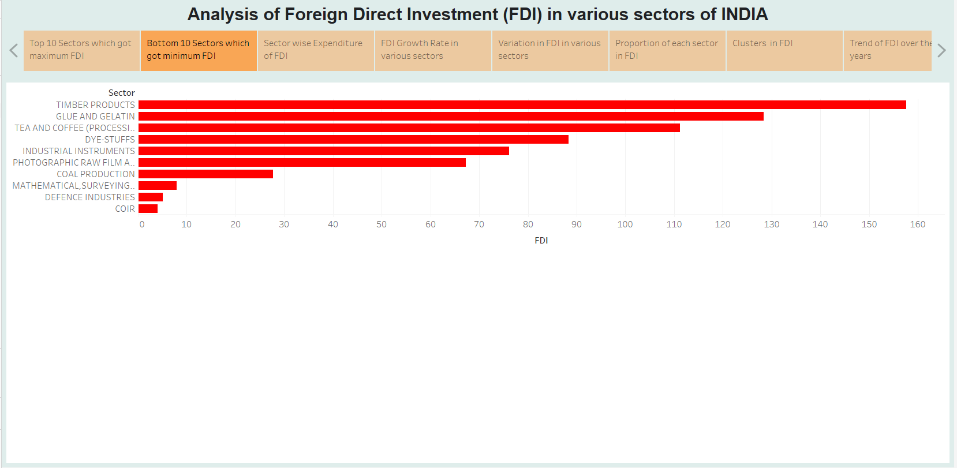

We are looking at 10 sectors that have had the lowest amount of FDI investment. Here we are looking at the cumulative investment across 17 years. The 10 sectors with the lowest investment can be seen in the image.

**Trend of overall foreign direct investment (filter to select any individual sector)**

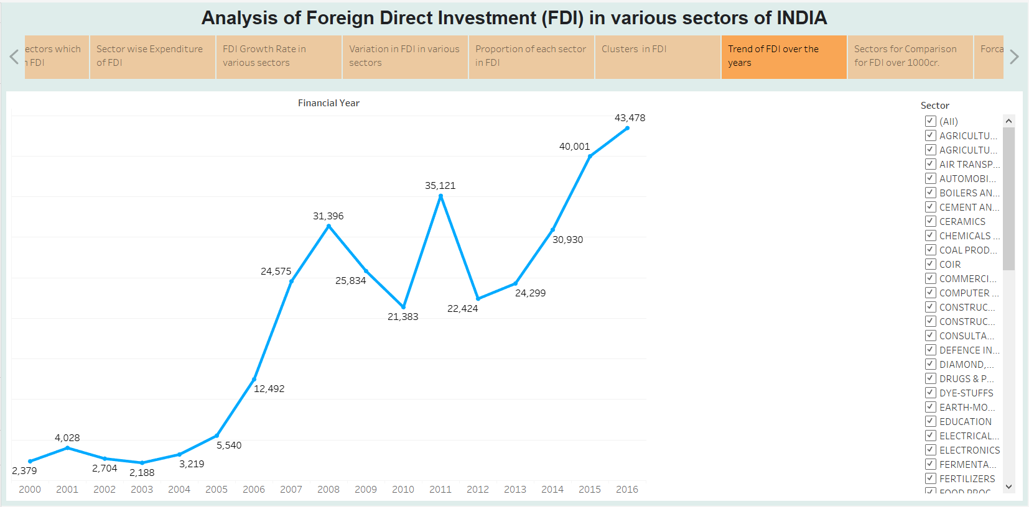

Here we are looking at the trend of FDI across 17 years and how it has increased over time. The graph gives us a good idea about how well the country and all its major sectors are doing.

According to the most recent UNCTAD’s World Investment Report estimated FDI flows were $1.3 trillion in 2018, which is 13% decline compared to the previous year. This is the third consecutive drop in FDI flows. The decline is largely concentrated in the developed part of the world, where FDI inflows dropped by 27% . This is the lowest number since 2004. In the case of developing countries there is slight increase of 2% compared to the last year, while transition economies experienced drop of 28% in FDI inflows.

**Steps:** Dragged Year into column field and selected year as option since Tableau gives an option for date time fields.Then,Dragged FDI into marks and chose sum. Also changed its type to text to be visible on the graph.Add sum FDI in Rows field.Chose sum number of records for colour although it is not required here.Chose path under marks as line.

**Grouping of Sectors for comparison**

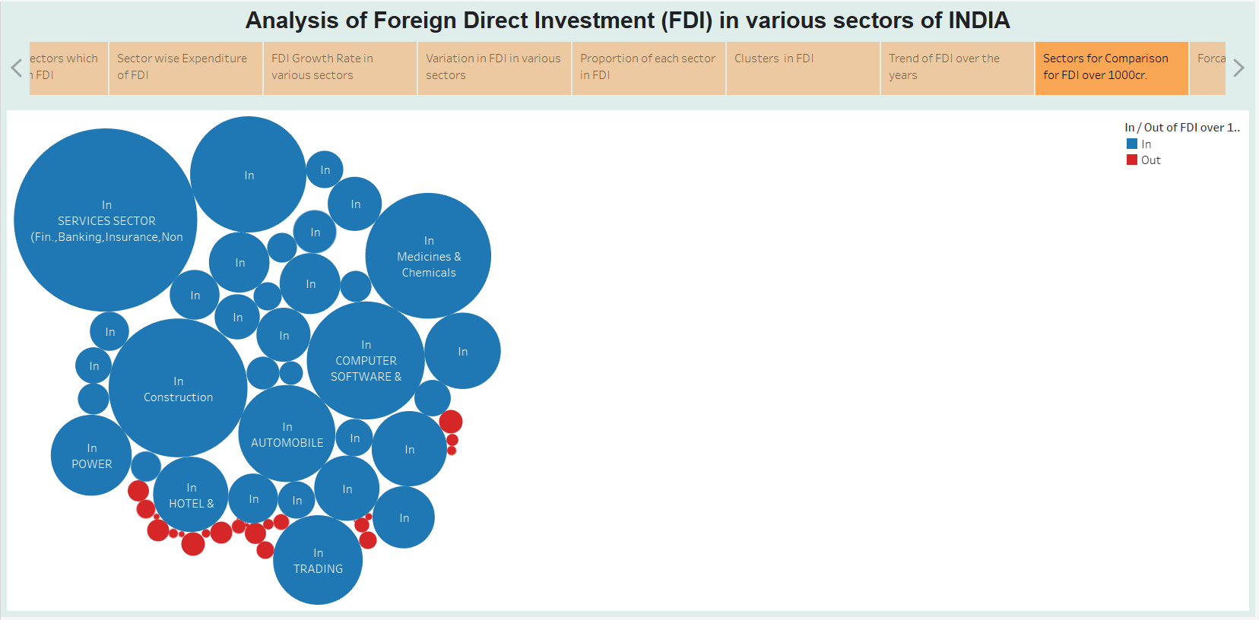

Here we are categorising our sectors into 2 categories. The red’s are the one’s that have not seen enough FDI over 17 years according to our set base line which is 1000. The blue values are sectors that have received FDI above our set baseline. Also, we are using the concept of grouping, which groups the sectors which has some similarities. I have created 3 groups.

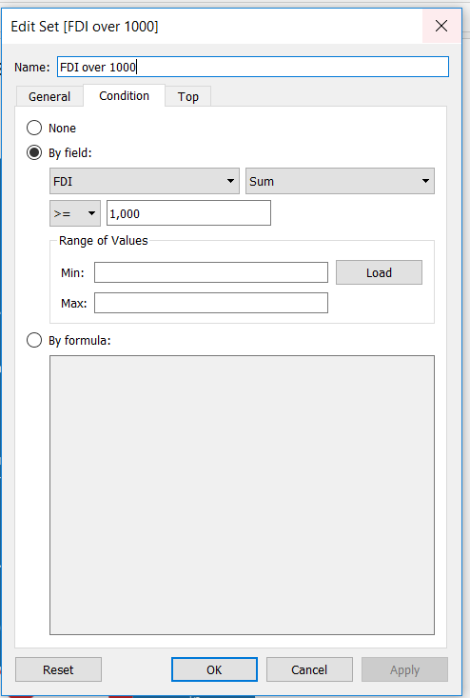**Procedure-**

* Created a calculated field to set the baseline by passing SUM(FDI)<1000.
* Dragged FDI into marks and selected SUM.
* Dragged Sector into rows field.

**Groups-**

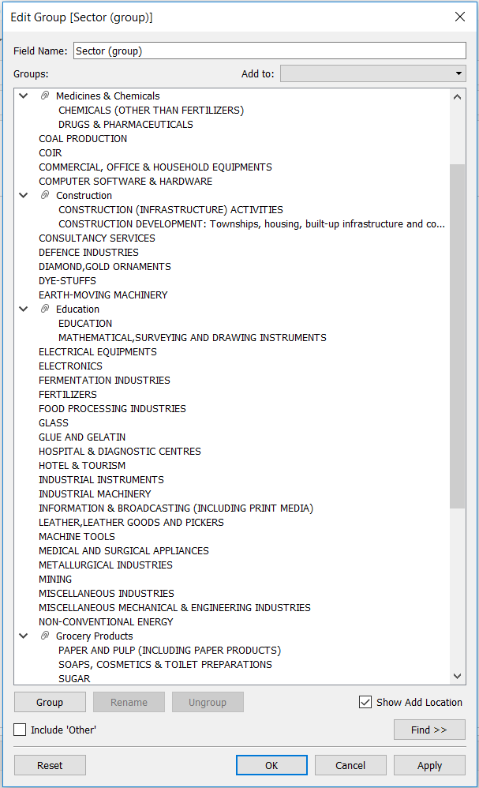We are using the concept of grouping, which groups the sectors which has some similarities. I have created 3 groups.

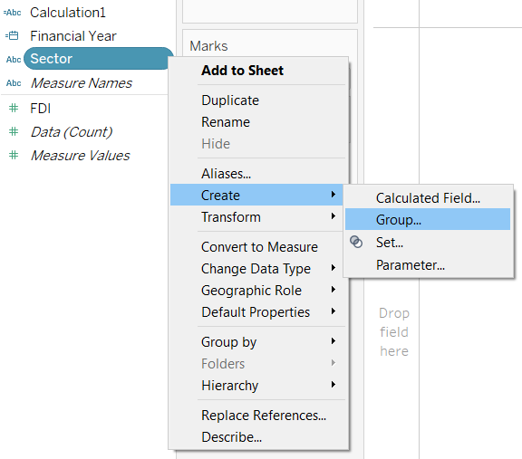

**FDI in top Sectors**

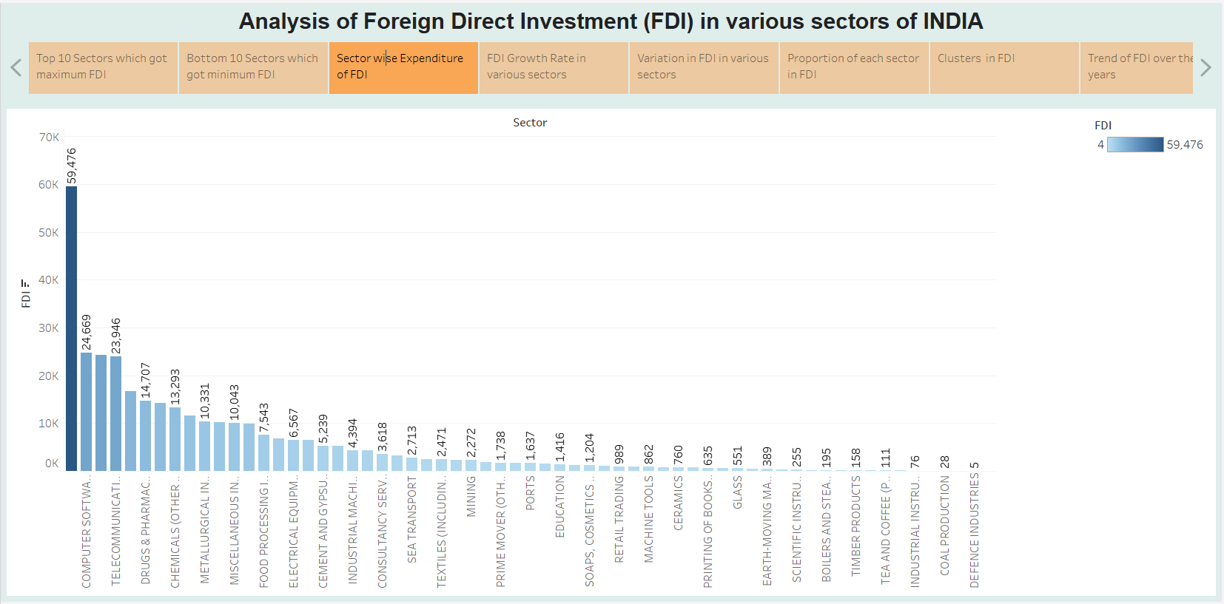

The services sector in India received the highest share in FDIs amounting to over 554 billion Indian rupees in fiscal year 2020. This sector included finance, banking, insurance and other non-financial sectors like research and development, testing, analysis and outsourcing. The computer hardware and software sector came second amounting to almost 324 billion Indian rupees that year.

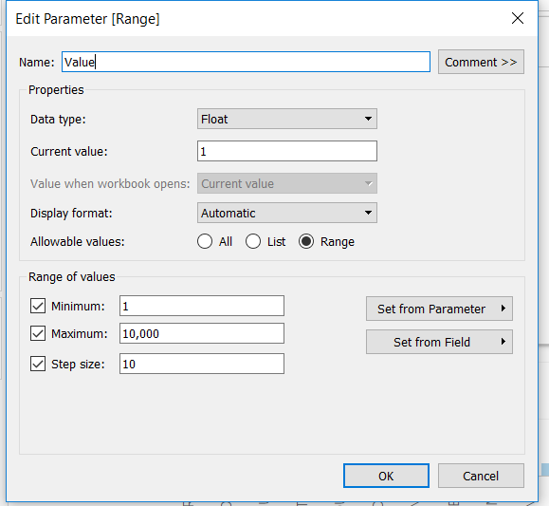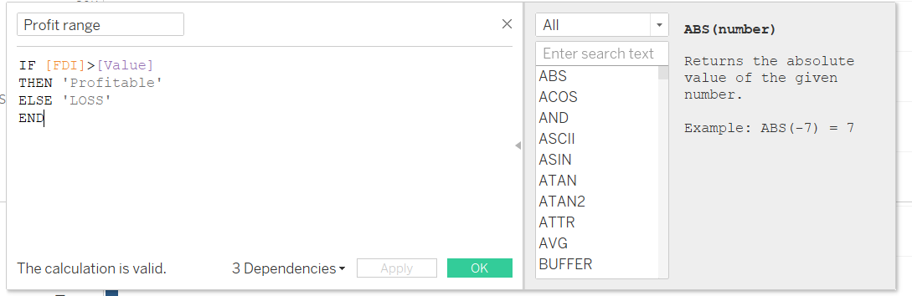Calculation Field and parameter for above visualization-

**Growth rate in FDI in last 5 years**

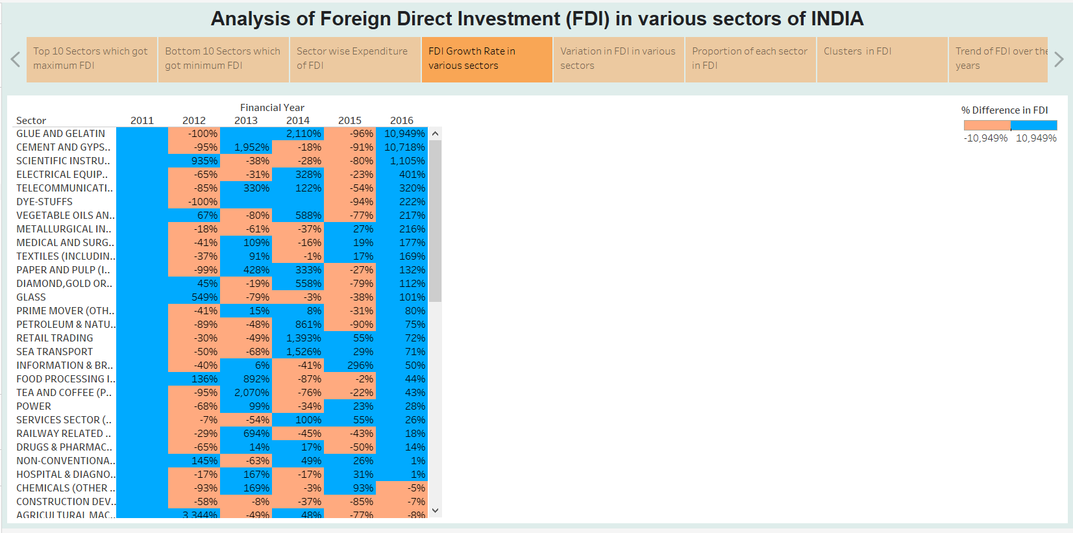

Foreign direct investment (FDI) in India grew by 13% to a record of $ 49.97 billion in the 2019-20 financial year, according to official data.

The country had received FDI of $ 44.36 billion during April-March 2018-19. Sectors which attracted maximum foreign inflows during 2019-20 include services ($ 7.85 billion), computer software and hardware ($ 7.67 billion), telecommunications ($ 4.44 billion), trading ($ 4.57 billion), automobile ($ 2.82 billion), construction ($ 2 billion), and chemicals ($ one billion), the Department for Promotion of Industry and Internal Trade (DPIIT) data showed.

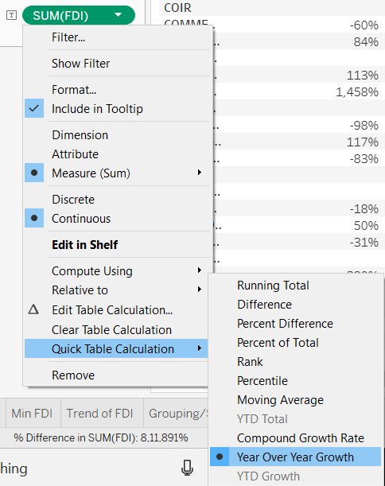Used Quick table calculation for above visualization-

**Which sectors has most variation in FDI**

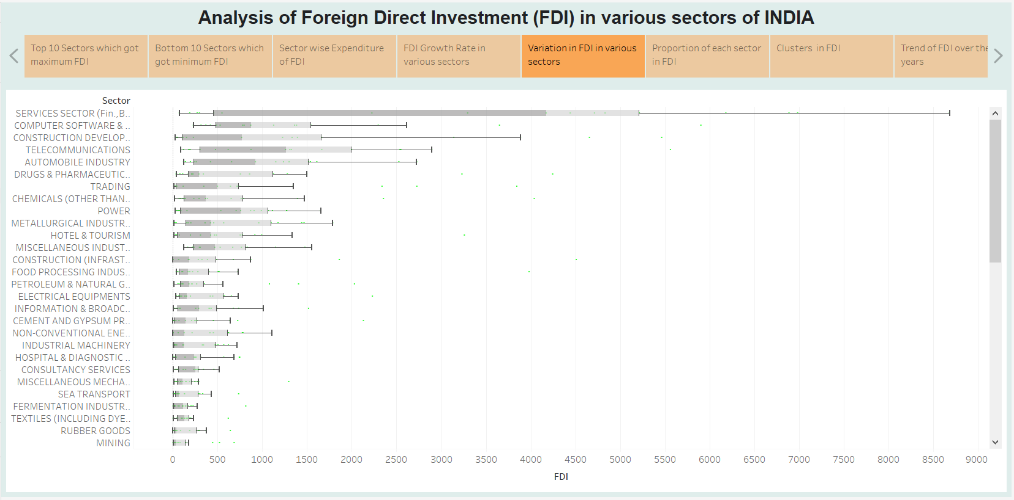

According to analysis of variations, just five sectors account for more than three-fourth of India Inc’s profits amidst a drastic change in the business environment over the past five years that has been impacted by market volatility, digital disruption and mounting debt with Indian banks. Sectors such as IT, automotive, utilities, healthcare and auto-component - contributed three fourths or nearly Rs 27 lakh crore to the bottom-line in 2015 compared to 38% five years ago, according to Kanvic Consulting that analysed India's top 1,000 listed companies and 50 performance variables.

**Proportion of each sector in FDI(year-wise)**

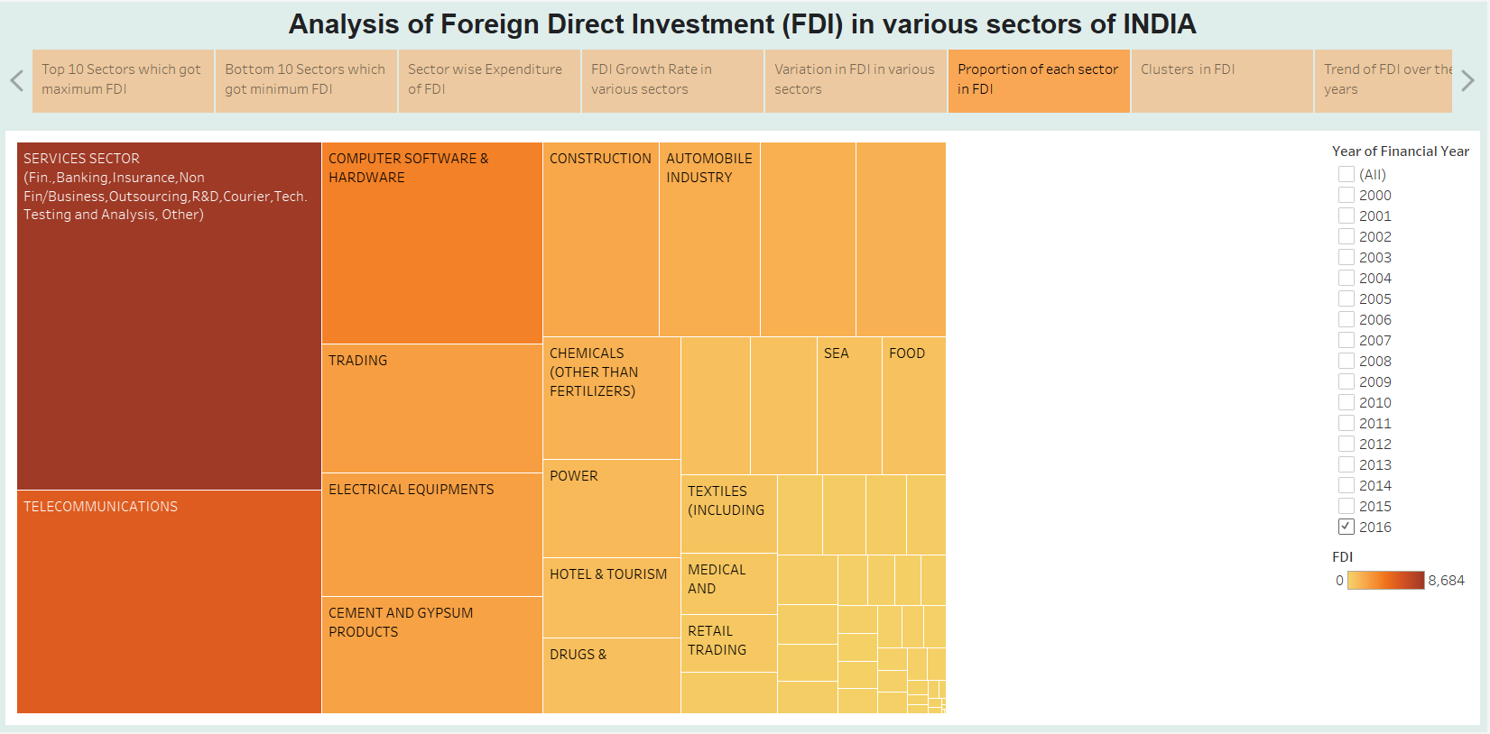

All in all, the business services sector in the country seemed to be faring very well in terms of attention from foreign investors. One possible reason for this could be because almost 56 percent of the registered foreign companies in India were under this sector. Out of this, most companies were registered in the state of Maharashtra, followed by the capital city of Delhi indicating a good business trajectory.

**Clusters in FDI**

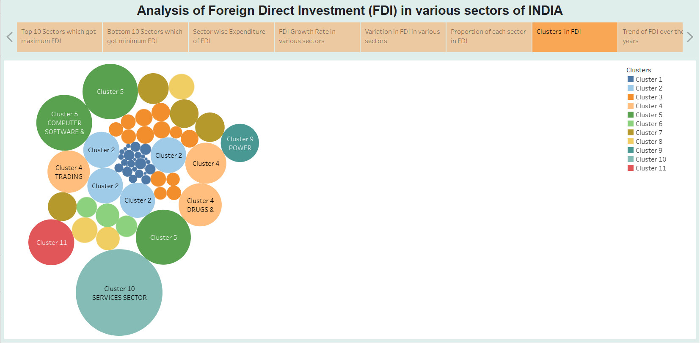

The economic benefits of strong clusters are well-established. They increase productivity, stimulate innovation and enhance competitiveness. In addition, clusters play an important role in establishing places as attractive locations for new foreign capital investments and retaining existing FDI.

**Forecast for next year**

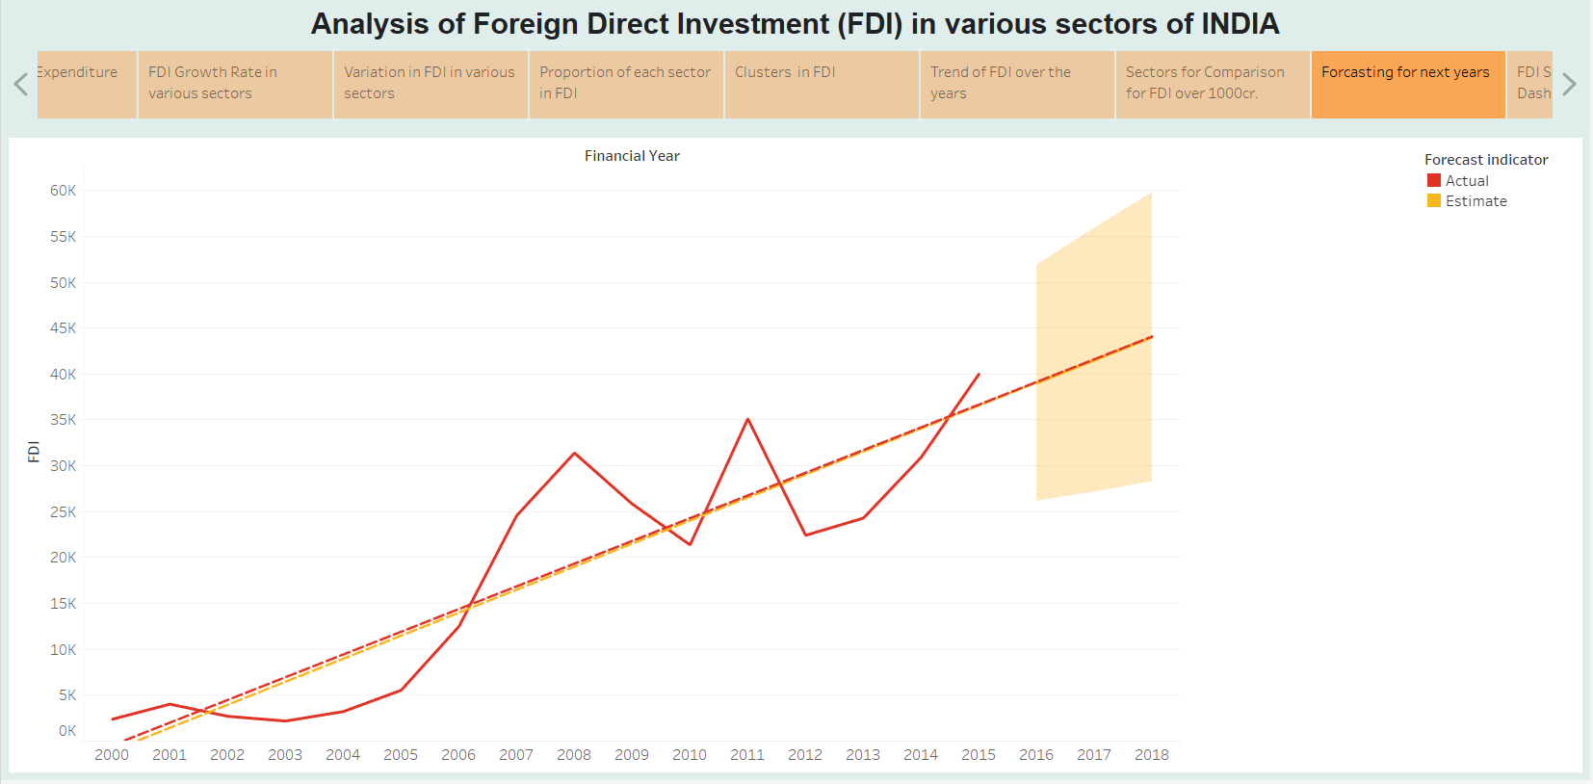

Global foreign direct investment (FDI) flows are forecast to decrease by up to 40% in 2020, from their 2019 value of $1.54 trillion, according to UNCTAD's World Investment Report 2020. In addition, FDI is projected to decrease by a further 5% to 10% in 2021 and to initiate a recovery in 2022.

**Investment Analysis in different Sectors**

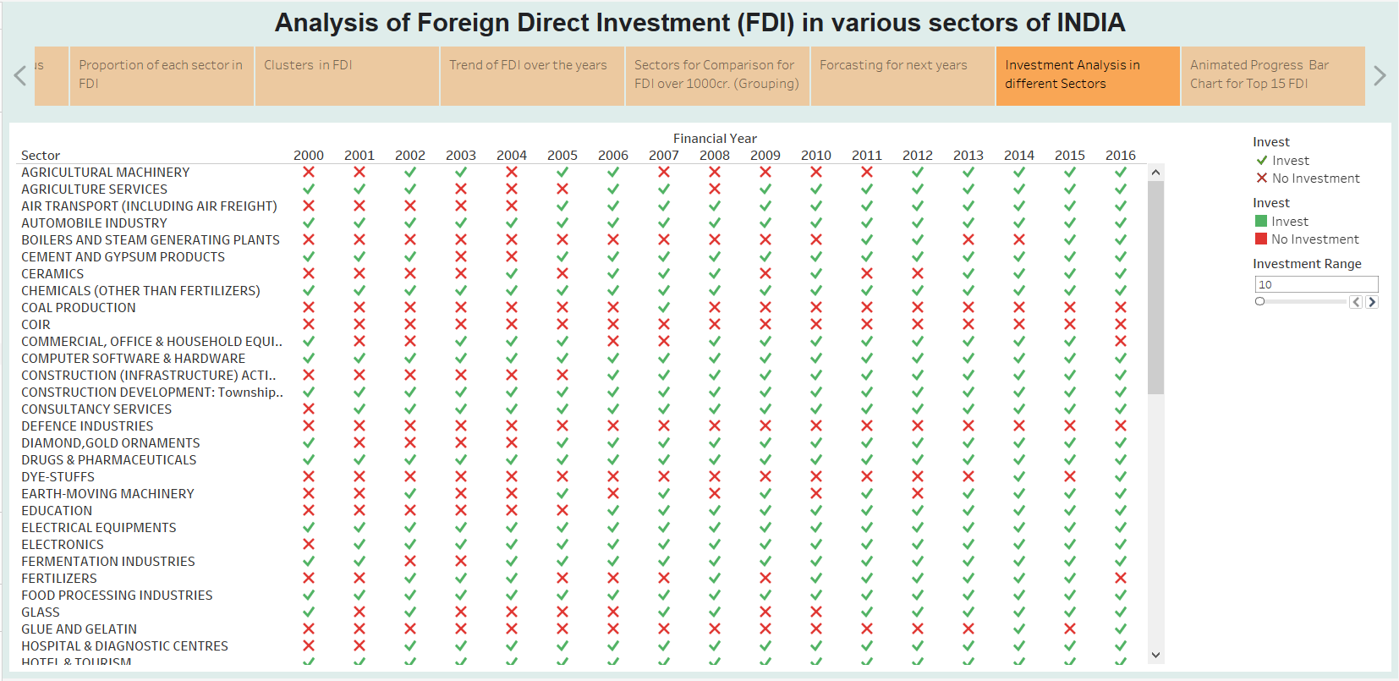

It shows the last 17 years investment of FDI in different sector of India by the help of below calculation we can change the investment.

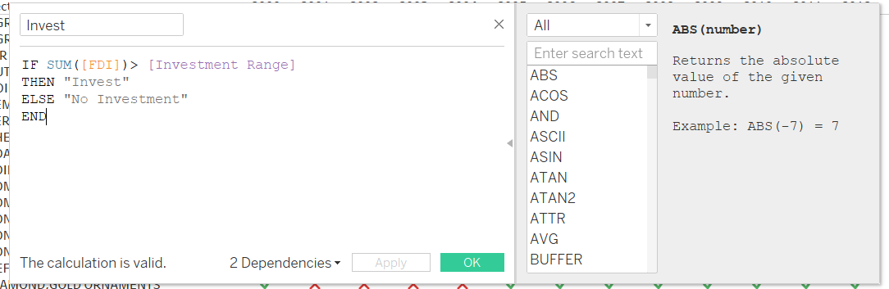

**Animated Progress Bar Chart for Top 15 FDI**

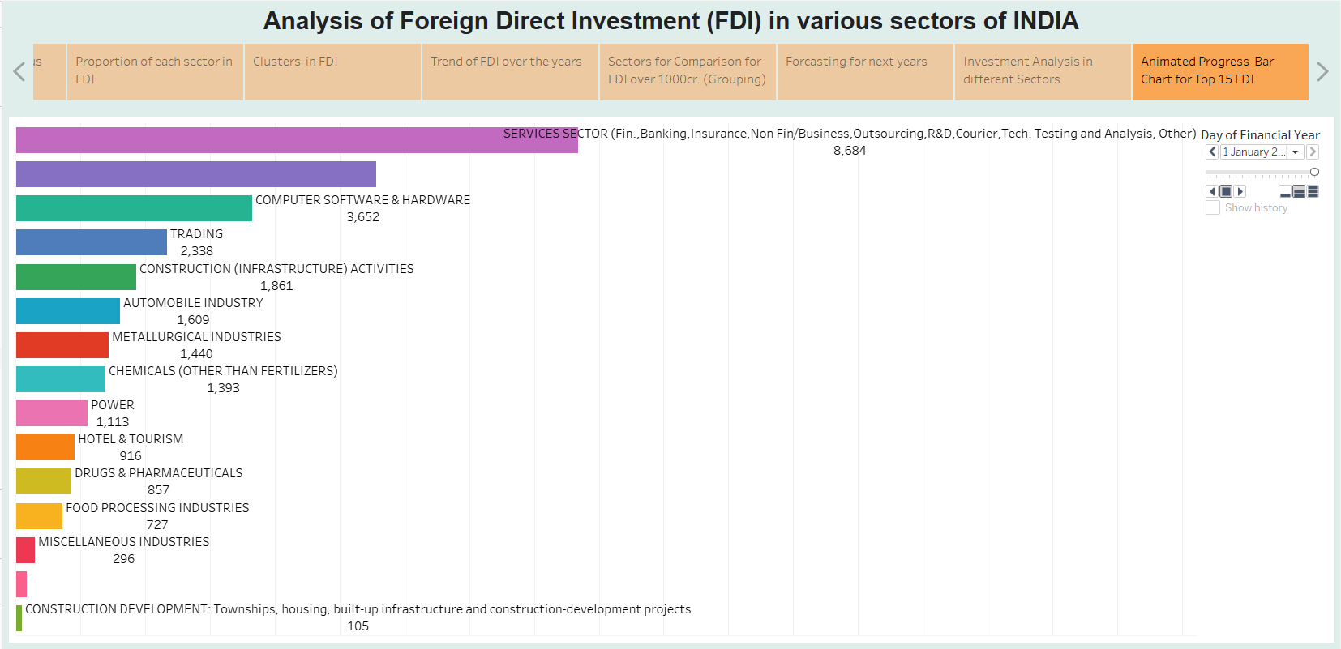

Foreign investments play a critical role in developing countries since they help bring in resources, latest technologies and best practices that help push economic growth on to a higher curve. In August 2019, India opened its doors further to FDIs by loosening its grip on the sourcing requirements for various sectors. The government also allowed 100 percent FDI in sectors like commercial coal mining and contract manufacturing, hoping to diversify its supply chains. These were just some of the measures being taken by the government in order to give a stimulus to the ailing economy.

**Dashboards**

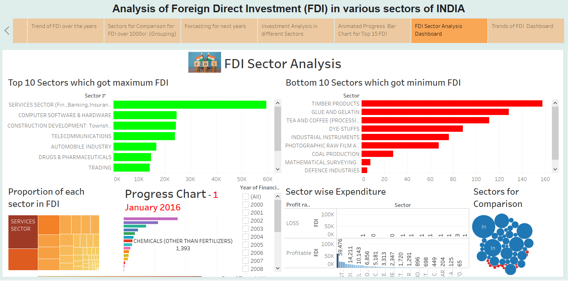

***FDI Sector Analysis Dashboard***

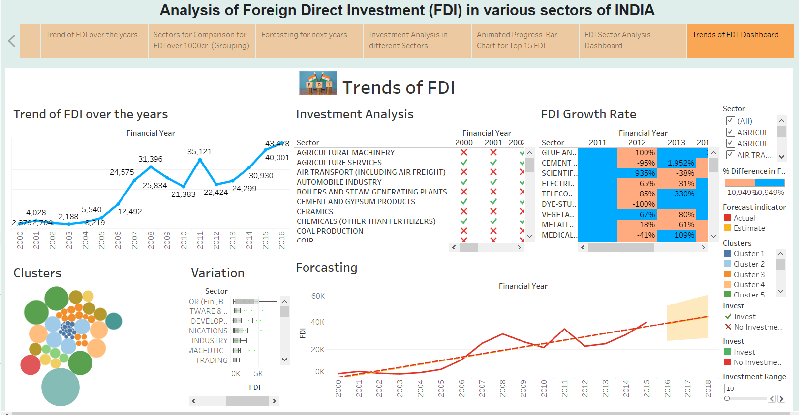

***Trends of FDI Dashboard***

**Conclusion**

This project focuses on theoretical aspects of FDI in India during the last 17 years, determinants and need of FDI in Indian scenario. It has comparatively performed well, then the average growth rate of world GDP. India has all the variables such as fine infrastructure, potential markets, abundant labour, availability of natural resources, and at last the economic and trades policies which has been favouring FDI.

There has been primarily FDI in Services, Computer, Telecom and Construction sector. Now, government should formulate the policies which can attract more foreign investment in manufacturing sector rather than service sector.

There hasn’t been much FDI in Defense but that is primarily because of India’s rules of FDI where there was a limit of 49% for investing into the defense secotor. As of writing this post though the cap has been raised to 74% so there should be an increase in the future in this sector. Coal, coir and leather industry also don’t see much of investment from outside.

All in all, the efforts should be directed to maintain India’s trajectory towards remaining the world’s most attractive destinations for foreign investment.

**REFERENCES**

**[1]** Ankit Misra & Rishabh Uppal, “A Study of Foreign Direct Investments”.

<http://home.iitk.ac.in/~ankitm/MacroEco_Project.pdf>

**[2]** Shikha Singh, “Foreign Direct Investment (FDI)in India : A review”

<https://www.researchgate.net/publication/333561209_Foreign_Direct_Investment_FDIin_India_A_review>

**[3]** Syed Azhar, “AN OVERVIEW OF FOREIGN DIRECT INVESTMENT IN INDIA”

<https://www.researchgate.net/publication/271729440_AN_OVERVIEW_OF_FOREIGN_DIRECT_INVESTMENT_IN_INDIA>