**WEB-BASED UEP-GSU JOB REQUEST SCHEDULING SYSTEM**

**A Capstone Project**

**Presented to The Faculty of the College of Science**

**University of Eastern Philippines**

**University Town, Catarman, Northern Samar**

**In Partial Fulfillment**

**of the Requirements for the Degree of**

**Bachelor of Science in Information Technology**

**(BSIT)**

**Guevara, Leo Arcky S.**

**Picardal, Vergel L.**

**Robiato, Rowell Cyril M.**

Proponents

**June 2022**

**UNIVERSITY OF EASTERN PHILIPPINES**

**COLLEGE OF SCIENCE**

This Capstone Project titled:

Approval sheet

“**Title**” prepared and submitted by List of Membershas been approved and accepted in partial fulfillment of the requirements for the degree **Bachelor of Science in INFORMATION TECHNOLOGY.**

**JIANN C. BALANLAY LPT, MBA**

*Capstone Project Adviser*

**PANEL OF EXAMINERS**

Approved by the College of Science Research Committee on Oral Examination with a grade of _______ on _____________________.

*Chairman*

*Member*

*Member*

**DR. CELESTE J. CHAN**

*Dean*

**Table of Content**

**Title Page i**

**Approval Sheet ii**

**Table of content iii**

**Chapter I – Introduction**

**Background of the study**

**Objectives of the Study**

**Scope and Limitation of the Study**

**Significance of the study**

**Definition of Terms**

**Chapter II - Review of Related Literature and Studies**

**Related Literature**

**Related Studies**

**Summary of Related Literature & Related Studies**

**Chapter III - Analysis and Design Phase**

**Design Method**

**Research Design**

**Data Gathering Tool**

**System Requirement, Analysis and Definition**

**System Hardware and Software Requirement**

**System and Software Design**

**Process Modeling**

**Event Diagram**

**Data Modeling**

**Data Dictionary**

**CHAPTER I**

**INTRODUCTION**

**Background of the Study**

Among the region's higher education institutions, the University of Eastern Philippines is a large public university that provides a wide range of degree programs, short-term courses, and certificates. As a result, the institution had to build a lot of structures and work on them. To do this, a service unit was developed to provide everything required for construction. Construction requires materials, equipment, and people that are physically strong and skilled. It is critical to have a dedicated office for this field, from obtaining goods to hiring staff.

In some cases, college departments struggle to complete such tasks. For university events and academic activities, preparations are underway, and labor is required. Construction materials are required, as are skilled craftsmen and workers. This could involve issues such as the organizer's lack of construction services. The UEP-General Services Unit, on the other hand, coordinates the bidding and awards committee for the acquisition of equipment, fixed assets, supplies, materials, and services (from consultancy, janitorial, security, electrical, air conditioning, specialty trades, painting, repairs, and maintenance of buildings, etc.). This unit provides what is required for the request of job forms towards their premises, which will be responded to immediately by their personnel.

UEP-GSU Job Request Scheduling System is a web-based efficient system for processing requested forms and directing them to the GSU office, where they will immediately receive orders, provide what is needed, and respond to what is unavailable. This system will include a database that will store all of the data that was entered. It also offers a selection of works as well as the availability of materials, which can be accessed by simply clicking on, send and receive messages from various colleges or university offices/units that require its services.

**Objectives of the Study**

In establishing the UEP-GSU Job Request Scheduling System, specific objectives are the following:

1. Design the “UEP-GSU Job Request Scheduling System” in terms of:

a. Data

b. Process

c. Programming language

2. Determine the level of acceptability of UEP-GSU Job Request Scheduling System in terms of:

a. Performance

b. Information

c. Economy

d. Control

e. Efficiency

f. Security

**Scope and Limitation**

This research is primarily intended for the University of Eastern Philippines-Main Campus's General Services Unit. The system will be able to provide an efficient and quick job request form through the departments, offices, and units of other colleges.

The proposed system's administrator will be able to receive and reply to requests, which will quickly inform the requesting unit of their materials and workers' availability. This system also detects flaws and complaints by informing users about the need of consistency in time tracking, putting up reminders, and establishing regular deadlines for completing timesheets. As a result, it will address them quickly in order to ensure the quality of the units' services. The function of this system includes a database that contains data to access and to simply provide information of the premises materials and workers.

This system can also save reviews, mark desired tasks, and estimate how many days or hours of work will be required. The system only applies to employees assigned to the GSU office.

**Significance of the Study**

The study's findings are useful not only to the researcher, but also to colleges, departments, offices, the General Services Unit, front desk officers, and future researchers.

**General Services Unit, University of Eastern Philippines:** They will make the operation go more quickly and smoothly. The proponent's method introduces them to a new technological trend that will benefit colleges and other campus facilities.

**Colleges/Departments:** Instead of doing it manually, the proposed system will provide the colleges and their departments with a dependable transaction, saving the UEP-GSU Job Request Scheduling System time and effort

**Future researchers:** The findings of the study will be used to generate new insights, ideas, and information about what system to provide and upgrade in relation to the UEP-GSU Job Request Scheduling System.

**Definition of Terms**

The following terminology have been conceptually and operationally clarified for greater clarity.

**Data.** It is a collection of facts such as numbers, words, and measurements. Observations or event just description of things.[1] Operationally defines as information gathered from different sources (e.g., books and internet).

**Information.** Operationally and conceptually this term is defined as the collection of facts and data about specific subject stored in the database.

subject stored in the database.

**Programming language**. Conceptually it is a special language programmers use to develop applications, scripts, or other set of instructions for computers to execute.[2] Operationally, this will be the tool to create a software/program of this study.

**Software**. Conceptually it is the program that runs on a computer and perform certain functions.[3] In this study, it is used as an interface to manipulate data or manage the resort.

**System**. Conceptually, is a general term for a computer or other piece of technology and all of its dependencies. System encompasses all working parts that are required to run a technical process.[4]Operationally, it is defined as the account management, service management, and reservation and billing system.

**CHAPTER II**

**REVIEW OF RELATED LITERATURE**

This chapter contains academic and professional literatures that are related to this study. This portion also aims to clarify and add up to the knowledge the researchers seek to study about, especially to the readers. Contained within are studies that would support the subject, as well as articles containing statistics, where relevance is considered to support the current study.

**Related Studies**

According to a study by Vaio and Varriale (2019) on the digitalization in the sea-land supply chain in 2 Italian ports with a research design of multiple case study, there is evidence that the adoption of an electronic or digital platform to organize bookings and inventory reduced time schedules in the waiting time of cargo and reduced the amount of paper documents needed, ultimately saving these ports money.

Digitizing systems bring the benefit of becoming paperless and efficiency in workflow. The study, after case analysis, found out that the performance of these ports improved after the adoption of the digital platform to organize their work processes. There is also an improvement in the relations of the port with its trade partners due to the efficiency in their logistics system. Along with this, the performance of the sea-land supply chain, according to the authors of this study, improved significantly after the adoption of the electronic platform.

This study of Italian ports adopting an electronic record system supports the researchers’ study in a way that the evidence of improvement in workflow and cost after adopting an electronic platform to organize job requests for the University of Eastern Philippines – General Services Unit’s will reduce the time needed to consolidate the applicants while saving cost in not printing a lot of documents with regards to organization.

In another similar study in South Africa, Booyse, Swart, Gouws, and Duvenage (2020) studied the effect of the introduction of an electronic booking system to appropriately prioritise gastroscopies at a regional hospital in South Africa. The researchers used a retrospective analysis of patients booked for urgent gastroscopies using the online booking system available in the hospital. There was a total of 1,589 gastroscopies performed while the researchers were conducting the study.

From the findings of the study, the digital platform used by the hospital was able to organize and prioritize gastroscopy appointments by up to 65% improvement. The algorithm-based booking system was effective in identify which patients to prioritize.

This study in South Africa supports the objectives of the study since there is evidence from this study that a digital, algorithm-based platform increased efficiency in identifying which patient candidates to prioritize first, which ultimately delivers optimum care to its patients. A similar platform can be utilized in the UEP-GSU to organize which candidates fit best in the vacant position relative to job requests.

From an optimistic differentiated job scheduling system for cloud computing by Shalmali Ambike, Dipti Bhansali, Jaee Kshirsagar, Juhi Bansiwal, International Journal of Engineering Research and Applications (IJERA) 2 (2), 1212-1214, 2012 Job scheduling is one of the major activities performed in all the computing environments. Cloud computing is one the upcoming latest technology which is developing drastically. To efficiently increase the working of cloud computing environments, job scheduling is one the tasks performed in order to gain maximum profit. In this paper we propose a system for scheduling the multiple requests. A web application is developed which provides authenticated users two types of service-uploading and downloading respectively. Multiple requests are processed by the use of non-pre-emptive priority algorithm. The service provider’s main aim is to provide fast services to the multiple requests. This paper gives the corresponding strategy and algorithm to gain optimistic value of service. This paper considers the goals of users and service providers to quality of service. The main aim of the system is to achieve an affirmative response at the user’s end. Utilization of resources is done in a very transient manner. The experimental studies show that the proposed scheme provides promising results.

Trace driven studies of deadlock control and job scheduling by Stephen W Sherman, John H Howard, James C Browne GI-4. Jahrestagung, 386-395, 1975 A trace-driven model is used to study the effects of various schedulers and deadlock control algorithms in a general-purpose operating system. Jobs’ requests for resources are extracted from a production load and used to drive a detailed simulation program. The simulation results show that the preemptive deadlock control algorithms give consistently good performance in terms of CPU utilization. The banker’s algorithm and the detection and recovery deadlock control algorithms are susceptible to “knotting” (holding of resources by a blocked process) when there is no preemption, but their performance can be improved significantly by 1) allowing a moderate amount of preemption and 2) by forcing the job scheduler to limit the number of jobs competing for resources. When “knotting” is limited by either of the above methods, non-preemptive jobs scheduling improves CPU utilization. This paper extends and develops previous work and summarizes the interaction between some characteristics of job schedulers and deadlock control algorithms.

Characterization of backfilling strategies for parallel job scheduling by Srividya Srinivasan, Rajkumar Kettimuthu, Vijay Subramani, P Sadayappan Proceedings. International Conference on Parallel Processing Workshop, 514-519, 2002 Although there is wide agreement that backfilling produces significant benefits in scheduling of parallel jobs, there is no clear consensus on which backfilling strategy is preferable e.g. should conservative backfilling be used or the more aggressive EASY backfilling scheme; should a first-come first-served (FCFS) queue-priority policy be used, or some other such as shortest job first (SF) or expansion factor (XF); In this paper we use trace-based simulation to address these questions and glean new insights into the characteristics of backfilling strategies for job scheduling. We show that by viewing performance in terms of slowdowns and turnaround times of jobs within various categories based on their width (processor request size), length (job duration) and accuracy of the user's estimate of run time, some consistent trends may be observed.

On the user–scheduler dialogue: studies of user-provided runtime estimates and utility functions by Cynthia Bailey Lee, Allan Snavely, The International Journal of High-Performance Computing Applications 20 (4), 495-506, 2006 Effective communication between user and scheduler is an important prerequisite to achieving a successful scheduling outcome from both parties' perspectives. In a grid or stand-alone high-performance computing (HPC) environment, this communication typically takes the form of a user-provided job script containing essential configuration information, including processors/resources required, a requested runtime, and a priority. Users' requested runtimes are notoriously inaccurate as a predictor of actual runtimes. This study examines whether users can improve their runtime estimates if a tangible reward is provided for accuracy. We show that under these conditions, about half of users provide an improved estimate, but there is not a substantial improvement in the overall average accuracy. Priority, as implemented in many production schedulers, is a very crude approximation of the value users may attach to timely job completion. We show users are capable of providing richer utility functions than most schedulers elicit. Thus, we explore two elements of the user–scheduler dialogue to understand if accuracy and completeness of information conveyed could be improved.

New challenges of parallel job scheduling by Eitan Frachtenberg, Uwe Schwiegelshohn Workshop on Job Scheduling Strategies for Parallel Processing, 1-23, 2007 The workshop on job scheduling strategies for parallel processing (JSSPP) studies the myriad aspects of managing resources on parallel and distributed computers. These studies typically focus on large-scale computing environments, where allocation and management of computing resources present numerous challenges. Traditionally, such systems consisted of massively parallel supercomputers, or more recently, large clusters of commodity processor nodes. These systems are characterized by architectures that are largely homogeneous and workloads that are dominated by both computation and communication-intensive applications. Indeed, the large majority of the articles in the first ten JSSPP workshops dealt with such systems and addressed issues such as queuing systems and supercomputer workloads. In this paper, we discuss some of the recent developments in parallel computing technologies that depart from this traditional domain of problems. In particular, we identify several recent and influential technologies that could have a significant impact on the future of research on parallel scheduling. We discuss some of the more specific research challenges that these technologies introduce to the JSSPP community, and propose to enhance the scope of future JSSPP workshops to include these topics.

Distributed job scheduling on computational grids using multiple simultaneous requests by Vijay Subramani, Rajkumar Kettimuthu, Srividya Srinivasan, S Sadayappan Proceedings 11th IEEE International Symposium on High Performance Distributed Computing, 359-366, 2002 Even though middleware support for grid computing has been the subject of extensive research, scheduling policies for the grid context have not been much studied. In addition to processor utilization, it is important to consider the response times of jobs in evaluating the performance of grid scheduling strategies. In this paper we propose distributed scheduling algorithms that use multiple simultaneous requests at different sites. Trace-based simulations show that the use of multiple simultaneous requests provides significant performance benefits. We also show how this scheme can be adapted to provide priority to local jobs, without much loss of performance.

References:

<https://www.tandfonline.com/doi/abs/10.1080/09537287.2019.1631464?journalCode=tppc20>

<http://www.samj.org.za/index.php/samj/article/view/13027s>

[https://scholar.google.com/scholar?hl=en&as_sdt=0%2C5&q=job+request+scheduling+system+studies&btnG=#d=gs_qabs&t=1654041261954&u=%23p%3DWFEgCchoOqwJ](https://scholar.google.com/scholar?hl=en&as_sdt=0%2C5&q=job%20request%20scheduling%20system%20studies&btnG=&fbclid=IwAR2pDscdP5w8nGxi8zpO0JWaVBuznE0qEP_ofSCSLmEYkrSAlRqh7EfNsZU#d=gs_qabs&t=1654041261954&u=%23p%3DWFEgCchoOqwJ)

<https://scholar.google.com/scholar?hl=en&as_sdt=0%2C5&q=job+request+scheduling+system+studies&btnG=#d=gs_qabs&t=1654041432714&u=%23p%3DL7jzi82Aby0J>

<https://scholar.google.com/scholar?hl=en&as_sdt=0%2C5&q=job+request+scheduling+system+studies&btnG=#d=gs_qabs&t=1654041538120&u=%23p%3D8N4ACKOMR_kJ>

<https://scholar.google.com/scholar?hl=en&as_sdt=0%2C5&q=job+request+scheduling+system+studies&btnG=#d=gs_qabs&t=1654041620501&u=%23p%3DAsD1E2FFgZQJ>

<https://scholar.google.com/scholar?hl=en&as_sdt=0%2C5&q=job+request+scheduling+system+studies&btnG=#d=gs_qabs&t=1654041706375&u=%23p%3DRoiciBCvB8YJ>

<https://scholar.google.com/scholar?hl=en&as_sdt=0%2C5&q=job+request+scheduling+system+studies&btnG=#d=gs_qabs&t=1654041784130&u=%23p%3DrGIRSK8bOOEJ>

**Summary of Related Literature and Studies**

**Table 1**

|  |  |  |  |  |  |
| --- | --- | --- | --- | --- | --- |
| **Year** | **Author/s** | **Title** | **Journal Name** | **Objectives** | **Findings** |
| 2019 | Assunta Di Vaio and Luis Varriale | Digitalization in the sea-land supply chain | Production Planning & Control | This paper investigates the executive modalities and implications of digital platforms for business process management to rethink and redesign the operational processes in the inter-organizational relationship systems among public and private players in seaports. | The digitalization in the sea-land supply chain in 2 Italian ports with a research design of multiple case study, there is evidence that the adoption of an electronic or digital platform to organize bookings and inventory reduced time schedules in the waiting time of cargo and reduced the amount of paper documents needed, ultimately saving these ports money. |
| 2020 | K Booyse, O Swart, J Gouws,  And  R Duvenage | The effect of the introduction of an electronic booking system to appropriately prioritize gastroscopies at a regional hospital in South Africa | South African Medical Journal  (SAMJ) | To evaluate the ability of the booking system to appropriately prioritise and accommodate clinically appropriate patients for an urgent gastroscopy within 2 weeks at WPH. | The volume of patients requiring urgent gastroscopy at WPH outstrips the available resources. The introduction of the online algorithm-based booking system was effective in prioritising patients. The use of this system facilitated a malignancy diagnosis rate which compares favourably with similar fast track endoscopy services in more developed countries. |
| 2012 | Shalmali Ambike, Dipti Bhansali, Jaee Kshirsagar, Juhi Bansiwal | Optimistic differentiated job scheduling system for cloud computing | International Journal of Engineering Research and Applications (IJERA) | The service provider’s main aim is to provide fast services to the multiple requests. This paper gives the corresponding strategy and algorithm to gain optimistic value of service. This paper considers the goals of users and service providers to quality of service. The main aim of the system is to achieve an affirmative response at the user’s end. | The experimental studies show that the proposed scheme provides promising results. |
| 1975 | Stephen W Sherman, John H Howard, James C Browne | Trace driven studies of deadlock control and job scheduling | Jahrestagung | Study the effects of various schedulers and deadlock control algorithms in a general-purpose operating system. | The simulation results show that the preemptive deadlock control algorithms give consistently good performance in terms of CPU utilization. |
| 2002 | Srividya Srinivasan, Rajkumar Kettimuthu, Vijay Subramani, P Sadayappan | Characterization of backfilling strategies for parallel job scheduling | Proceedings International Conference on Parallel Processing Workshop | Use trace-based simulation to address questions and glean new insights into the characteristics of backfilling strategies for job scheduling. | Shows that by viewing performance in terms of slowdowns and turnaround times of jobs within various categories based on their width (processor request size), length (job duration) and accuracy of the user's estimate of run time, some consistent trends may be observed. |
| 2006 | Cynthia Bailey Lee, Allan Snavely | The user–scheduler dialogue: studies of user-provided runtime estimates and utility functions | The International Journal of High-Performance Computing Applications | This study examines whether users can improve their runtime estimates if a tangible reward is provided for accuracy. | Show that under these conditions, about half of users provide an improved estimate, but there is not a substantial improvement in the overall average accuracy. |
| 2007 | Eitan Frachtenberg, Uwe Schwiegelshohn | New challenges of parallel job scheduling | Workshop on Job Scheduling Strategies for Parallel Processing | Study the myriad aspects of managing resources on parallel and distributed computers. | Identified several recent and influential technologies that could have a significant impact on the future of research on parallel scheduling. |
| 2002 | Vijay Subramani, Rajkumar Kettimuthu, Srividya Srinivasan, S Sadayappan | Distributed job scheduling on computational grids using multiple simultaneous requests | 11th IEEE International Symposium on High Performance Distributed Computing | Propose distributed scheduling algorithms that use multiple simultaneous requests at different sites. | Trace-based simulations show that the use of multiple simultaneous requests provides significant performance benefits. |

**CHAPTER III**

**SYSTEM ANALYSIS AND DESIGN PHASE**

**Design Method**

The UEP-GSU Job Request Scheduling System will be developed using methods that define a step-by-step process of constructing a system. The waterfall model shows the core activities of specification, development, validation, and assessment as different phases in this development procedure.

**Research Design**

The system will be developed using qualitative and experimental research design. The first will employ a scientific strategy for data collection via interviews. While the latter, a systematic scientific approach will be utilized to determine whether the system fits the requirements.

**Data Gathering Tool**

To successfully comprehend the questions and the context of the study, an interview and explanations from the GSU office were discussed. This greatly aided in locating, confirming, and categorizing the data processes required, as well as establishing the needs.

**System Requirement, Analysis and Definition**

The purpose of system requirements and analysis is to find the requirements for the entire system. It also gives a complete grasp of the problem and the system's requirement.

According to the interview, the following requirements must be met in order to construct the system:

**Inputs**

The required inputs or data needed for the system.

1. **Offices**

Includes different colleges or department.

1. **Job Request**

Includes the details of the request.

1. **Job Schedule**

Includes the schedule of the request

1. **Service offered**

This includes information regarding the type of job or service sought.

1. **Feedback**

Customer evaluations of the services offered.

1. **Job order**

Includes written authority given to the workers to perform a certain work.

1. **Request status**

Includes the current status of the job request.

**Outputs**

The result or data provided by the system.

1. **List of offices**

This includes the list of offices.

1. **List of job request**

Details of schedules.

1. List of job request
2. List of employees
3. **Jobs and services**

List of job or services available.

1. **Confirmation message**

The system will send the requestor an acknowledgement and confirmation message regarding the job request.

1. Accomplish report
2. Job request tracking report

**Process**

The process or action provided by the system.

1. **Create User accounts**

The administrator can create accounts to manage the system.

Login page for administration access only.

1. **Create job request record**

Adds job request record to the database such as schedule of job request, and other basic information.

1. **Receive job request schedules**

Inputs job request details on Job Schedule List.

1. Job order/ request tracking
2. Create accomplishment report

**Security**

1. **. Administrator**

The authorized employees who have access to and administer the entire system.

1. GSU Clerk
2. College/Units
3. GSU Manager
4. Performance**System Hardware and Software Requirement**

|  |  |  |
| --- | --- | --- |
| Hardware | Minimum | Recommended |
| Processor | 1 GHz | 2 GHz or more |
| Hard disk space | 32 GB | 64 GB or more |
| RAM | 2 GB | 4 GB or more |
| Ethernet or Wi-Fi connection | 2mpbs | 5mbps or more |

**Table 1.** Shows the list of hardware necessary and recommended for both system server and client environment.

|  |  |
| --- | --- |
| Software Description | |
| **Server Environment** | |
| Operating System | Microsoft Windows 7 and above |
| Programming tool | Atom |
| Database Server | Microsoft SQL Server 2019 |
| Web Server | Apache HTTP Server |
| **Client Environment** | |
| Internet browser | Microsoft Edge, Google Chrome, Mozilla Firefox |

**Table 2.** Shows the list of software recommended for both the system server and client environment.

**System and Software Design**

The proposed system will be a combination of hardware, software, and human operation. This system design approach is focused with how the different component systems deliver system functions.

The proposed system, UEP-GSU Job Request Scheduling System, will be designed to be user-friendly and accurate while still being simple to use.

**Process Modeling**

Process modeling is described as a strategy for organizing and documenting data in order to understand the structure and flow of data through a system process and procedure that will aid in its implementation in the system.

**Current system**

Before constructing the proposed system's process, the researchers first evaluated the present system to determine the process and phases involved. It describes the flow and structure of the system to help you understand it better. The current system is solely consisting of a written job request form. The requestor will transmit the form straight to the GSU office, where it will be reviewed and processed by a staff member. It is particularly difficult because of the absence of order and the likelihood of a request being misplaced or lost.

Client

Submit Job Request Scheduling form

Feedback

GSU Office

Assessment

Deployment of Worker

Execution of request

**Proposed system**

Client

Schedule a job request

Confirmation

Feedback

UEP – GSU Job Request Scheduling Web System

Job request schedule

Administrator

Deployment of Worker

Execution of request

**Functional Decomposition Diagram**

**Event Diagram**

**Fig.1 Process event diagram for user log in**

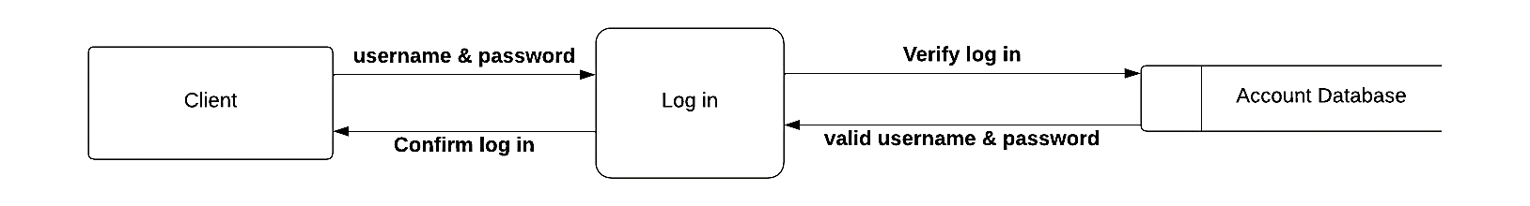

**Fig.2 Process event diagram for user log out**

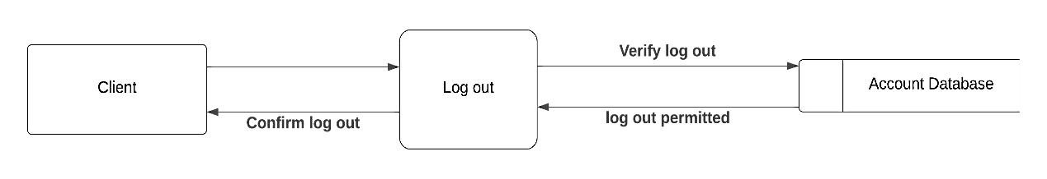

**Fig.3 Process event diagram for Creating new authorized account**

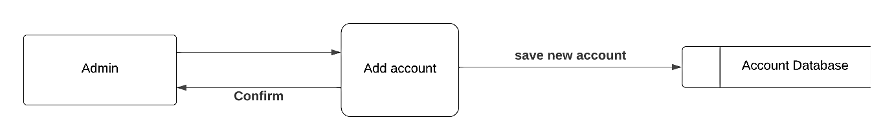

**Fig.4 Process event diagram for scheduling a job request**

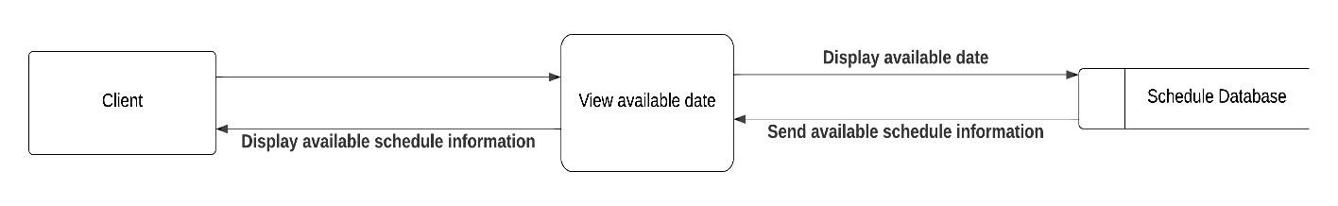

**Fig.5 Process event diagram for viewing list services or jobs offered**

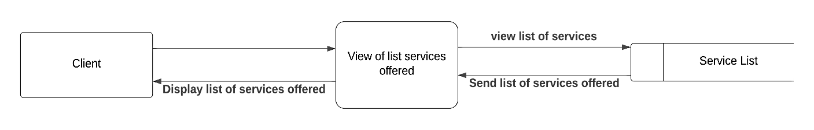

**Fig.6 Process event diagram for viewing list jobs request schedule**

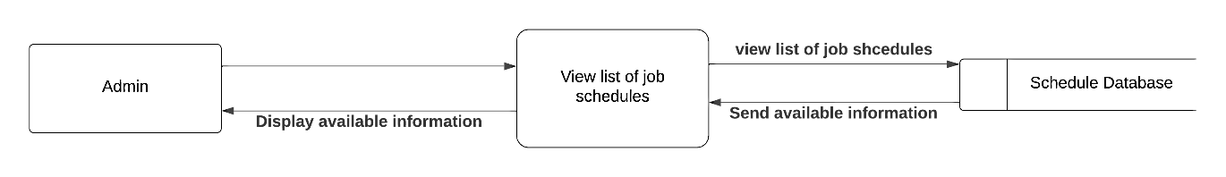

**Fig.7 Process event diagram for scheduling a job request**

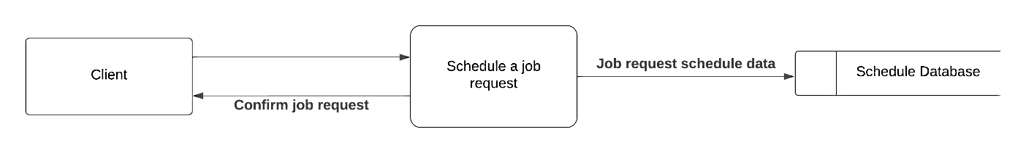

**Fig.8 Process event diagram for cancelling a job request schedule**

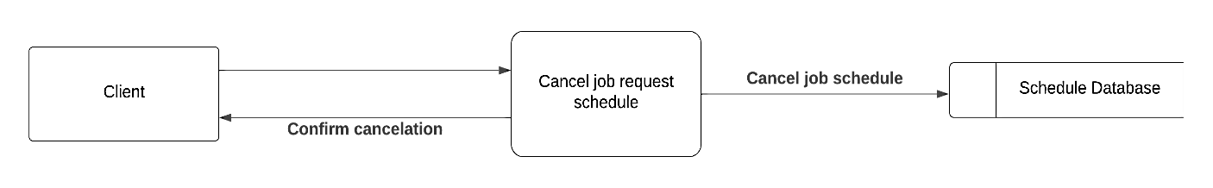

**Fig.9 Process event diagram for rescheduling a job request**

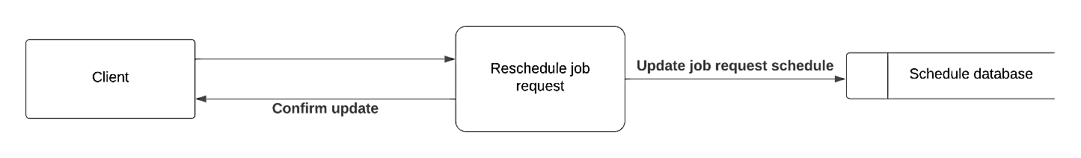

**Fig.10 Process event diagram for notifying the client confirming the job request**

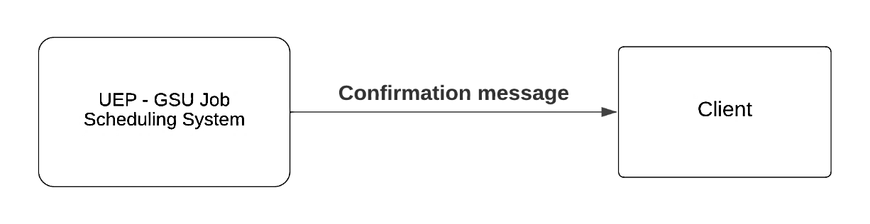

**Fig.11 Process event diagram for notify the client when the job request is being executed**

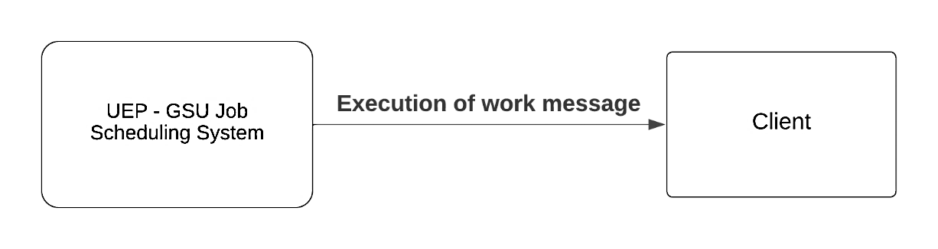

**Fig.12 Process event diagram for notifying the client when the job request is executed**

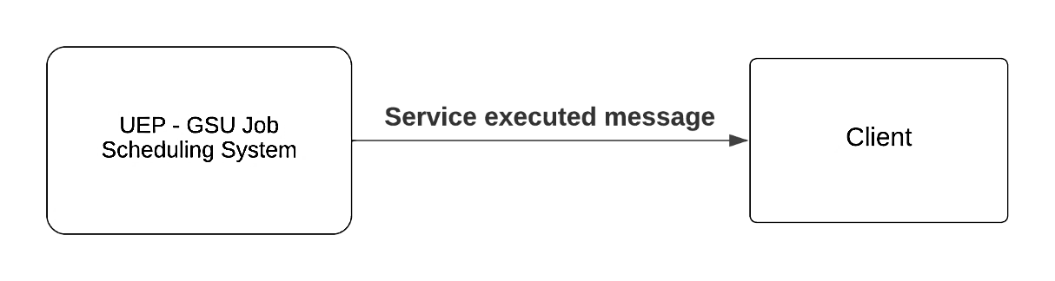

**Fig.13 Process event diagram for submitting feedback**

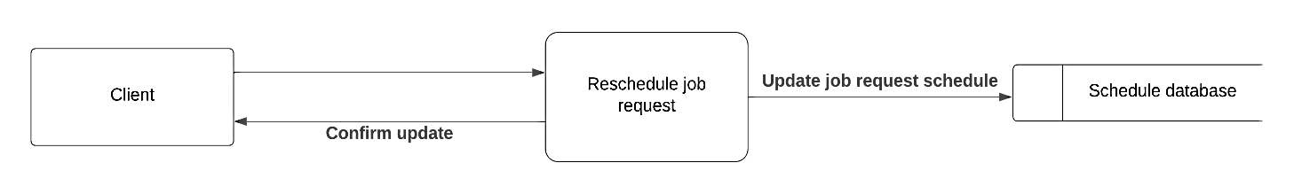

**Data Modeling**

Data modeling is a system data organization and documentation technique. Because a data model is fully implemented as a database, it is frequently referred to as database modeling.

**Context Data Model**

This context data model is used to explain each entity's relationship to other entities.

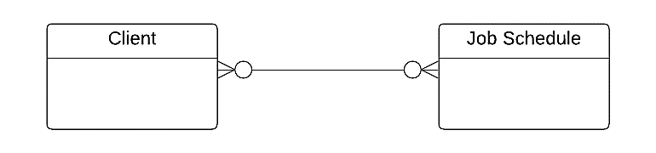

**Key-based Data Model**

The key attribute can build a relationship by keeping a record of each entity. This entity is assigned for the purpose of uniquely identifying each record for quick search and organization.

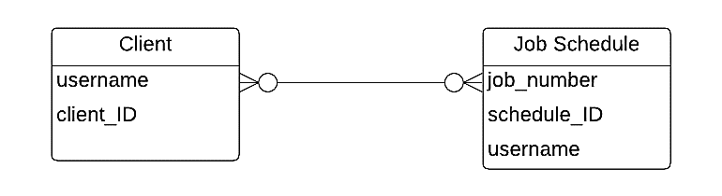

**Fully Attributed Data Model**

This data model depicts the unique characteristics of each item. Each entity is given a key that connects it to other entities.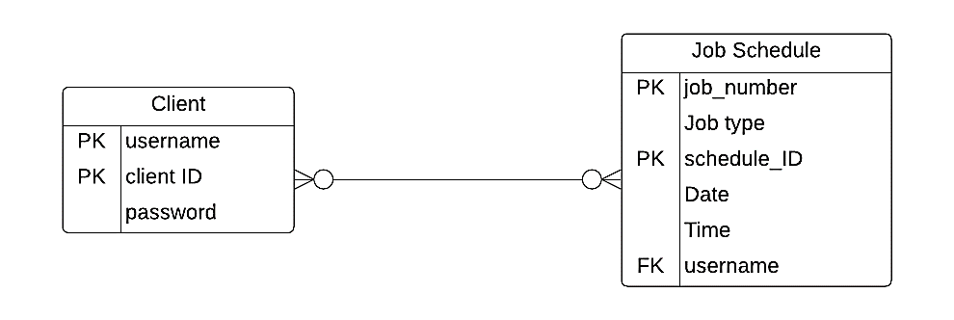

**Data Dictionary**

|  |  |  |  |
| --- | --- | --- | --- |
| **Field name** | **Data type** | **Field length** | **Field description** |
| username | String | 50 | Client username |
| client_ID | integer | 7 | Client ID |
| password | varchar | 15 | Client password |
| job_number | integer | 7 | Job number |
| Job type | String | 50 | Type of service |
| schedule_ID | integer | 7 | Schedule ID |
| Date | Date/Time | 10 | Date |
| Time | Date/Time | 10 | Time |

1. Mathisfun.com (2021)
2. Computer H. (2015)
3. Merriam-Webster. (2015)
4. Beal V. (2003)