Dispense Method Analysis Report
Generated: 2026-03-06 10:00

1. Feature Selection

Selected Features
wh_name, is_compound, unit_of_measure, level_3, is_rx, product_type, level_2

Chi-Square Scores
The chi-square test measures the strength of association between each candidate feature and dispense_method. It tests the null hypothesis that the feature and target are independent. A higher chi-square value indicates stronger association; a low p-value (typically < 0.05) means we reject independence and conclude the feature is useful for predicting dispense method. Chi-square is well-suited for categorical variables and helps identify which product attributes (e.g., product_type, unit_of_measure) are most predictive of how a product will be dispensed.
feature | chi2 | p_value
wh_name | 226546.7928042959 | 0.0
is_compound | 198221.1080755911 | 0.0
unit_of_measure | 109747.43040651236 | 0.0
level_3 | 62331.864977227466 | 0.0
is_rx | 60808.00178986044 | 0.0
product_type | 22500.613971510636 | 0.0
level_2 | 12858.524840692986 | 0.0

Mutual Information Scores
Mutual information (MI) measures how much knowing the value of a feature reduces uncertainty about dispense_method. Unlike chi-square, MI captures non-linear relationships and does not assume a specific distribution. A higher MI score means the feature provides more information about the target. MI is useful for ranking features when building prediction models because it identifies which attributes (e.g., level_3, product_type) best reduce uncertainty about whether a product will be dispensed via automation, manual, or mixture. Features with high MI are strong candidates for the prediction model.
feature | mutual_info
level_3 | 0.6832885050486769
product_type | 0.527169706069367
unit_of_measure | 0.384349169265626
wh_name | 0.3703865000061093
is_rx | 0.2652712927621079
is_compound | 0.2552489493177118
level_2 | 0.2540616197047373

Feature Selection Visualizations

Dispense Overview
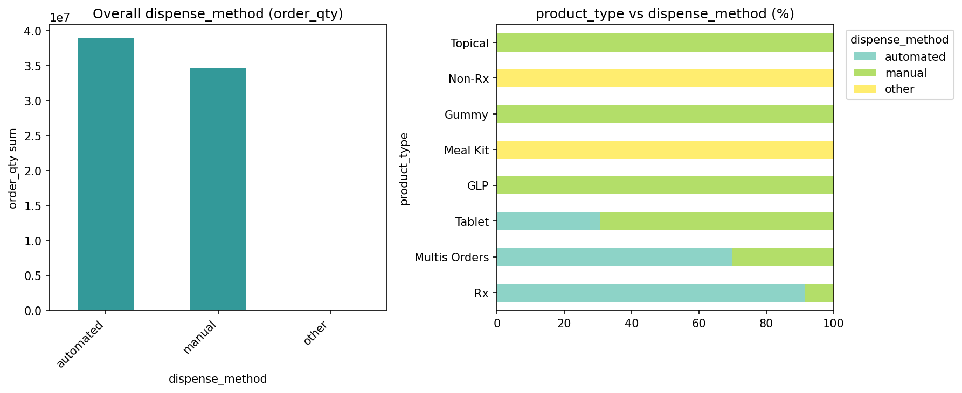

Feature Distributions
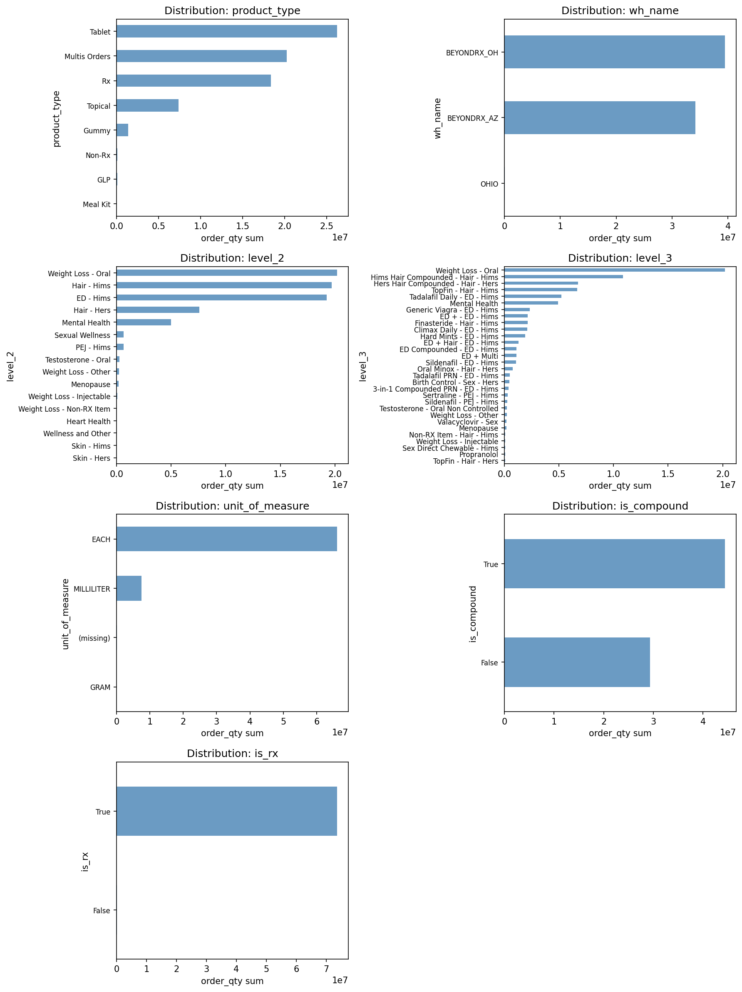

Association Strength
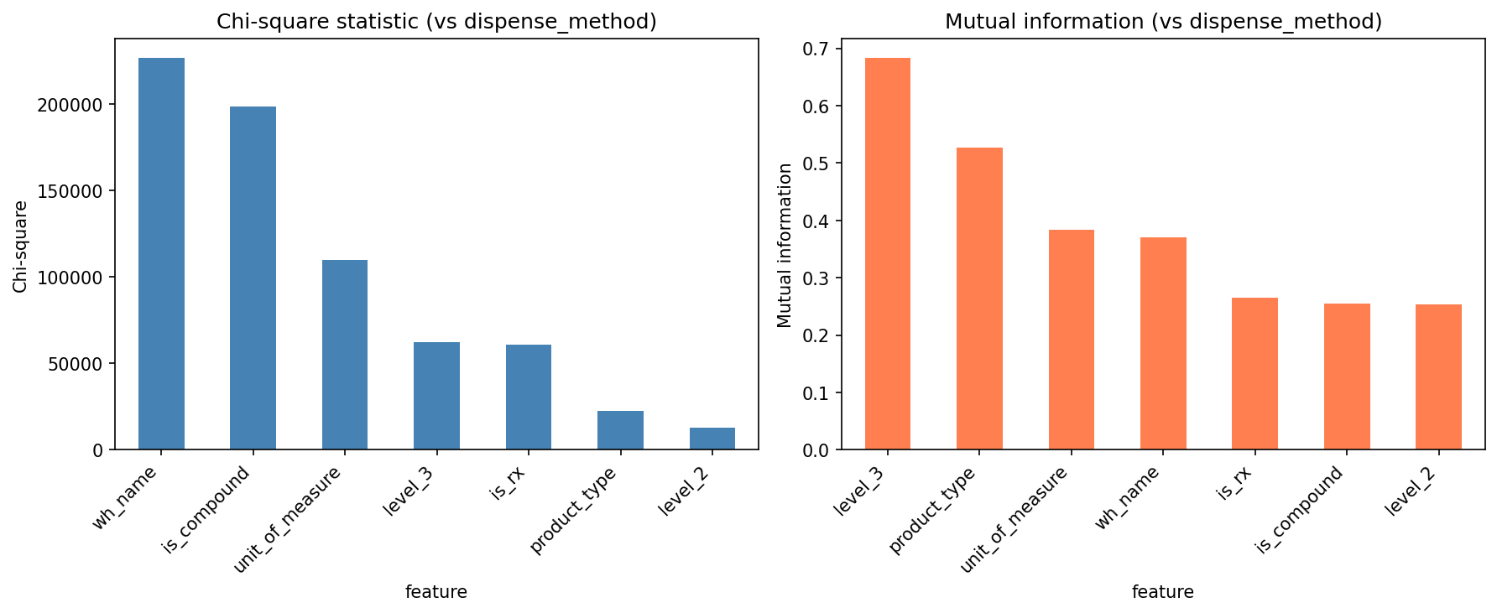

Is Compound vs Dispense Method
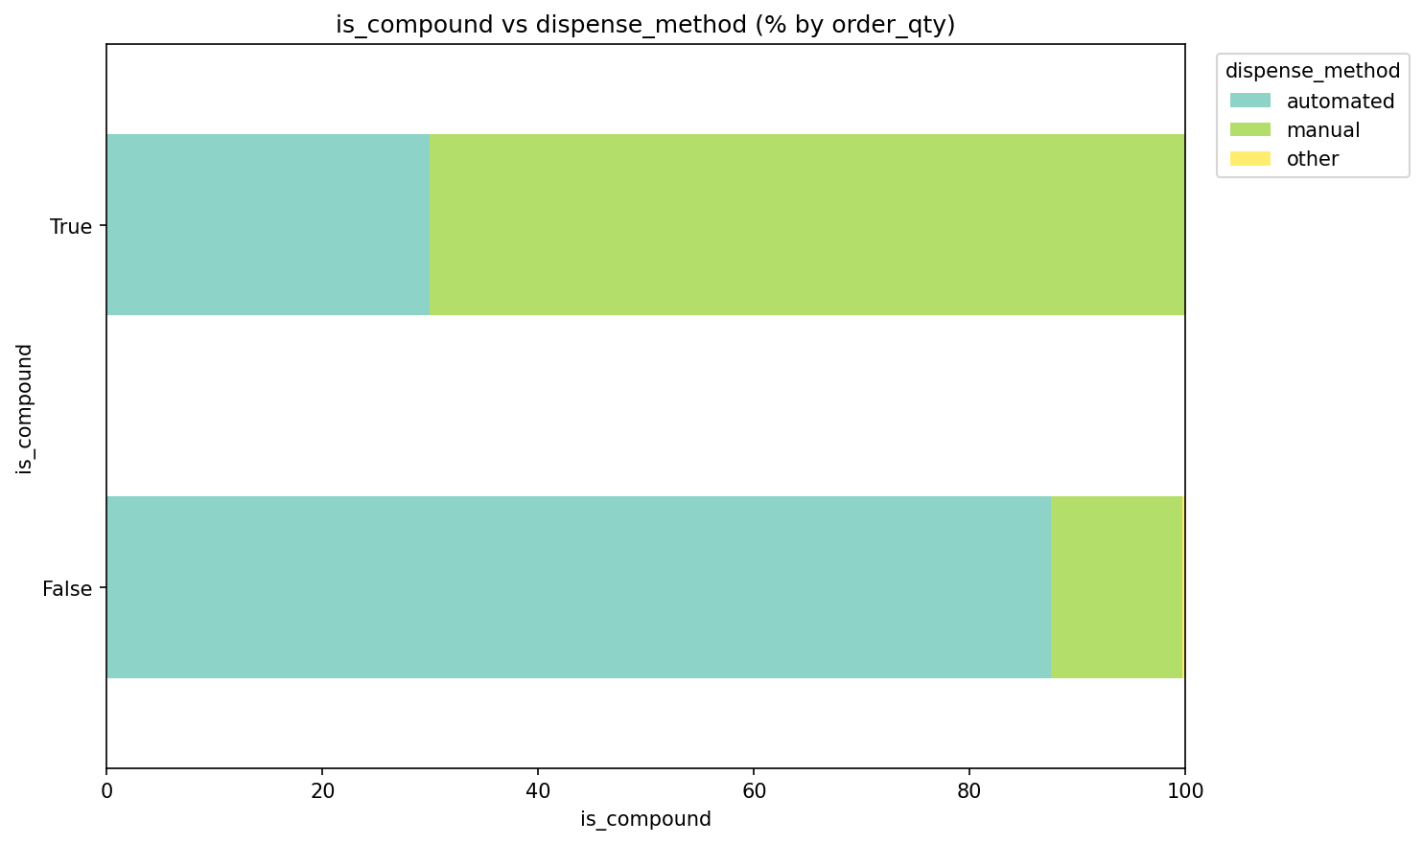
Is Compound distribution by dispense_method

Is Rx vs Dispense Method
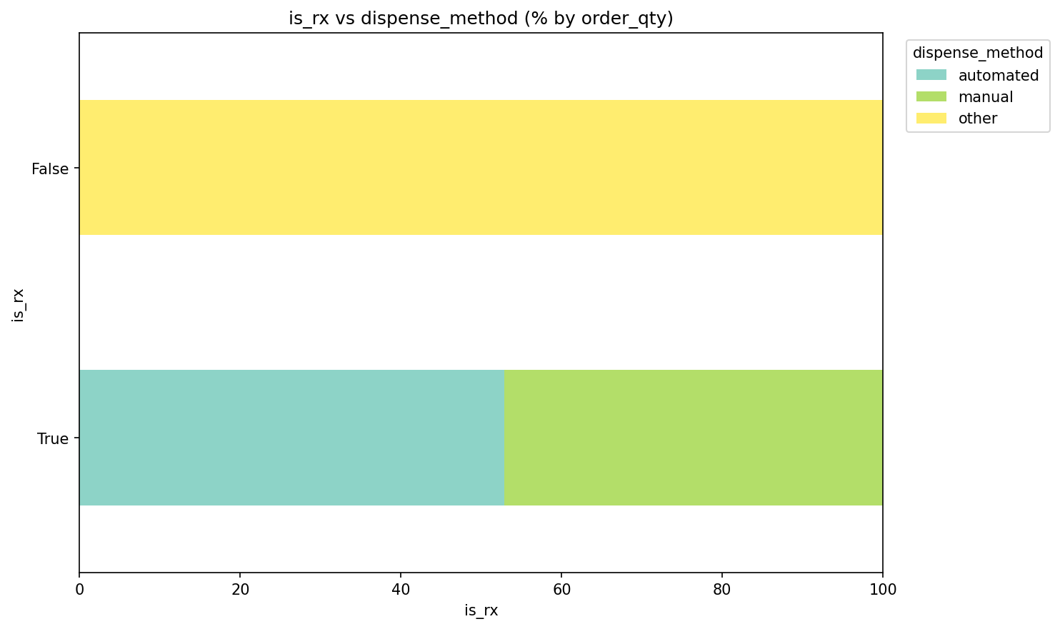
Is Rx distribution by dispense_method

Level 2 vs Dispense Method
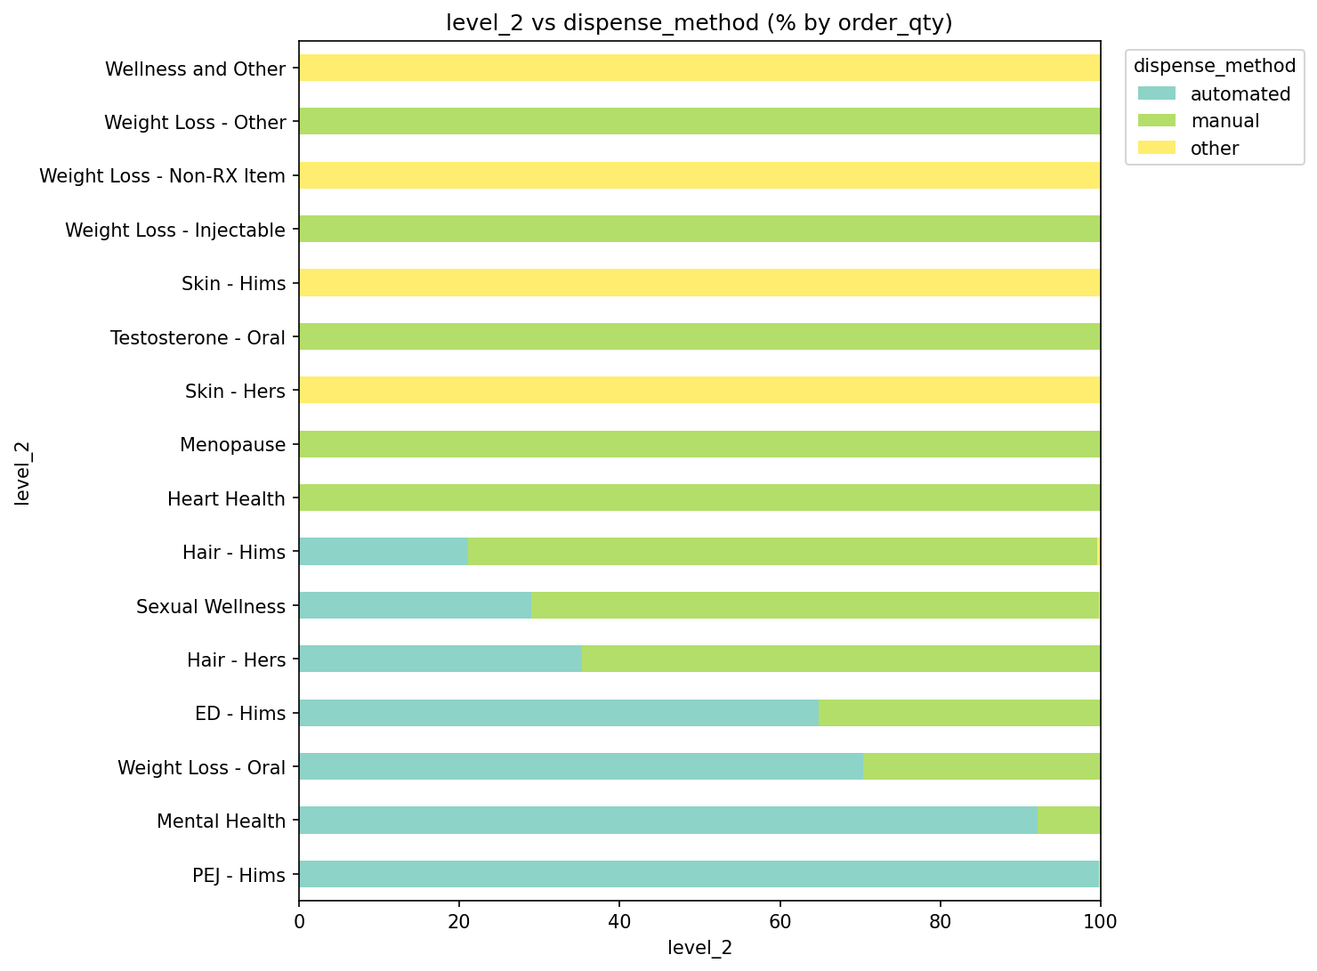
Level 2 distribution by dispense_method

Level 3 vs Dispense Method
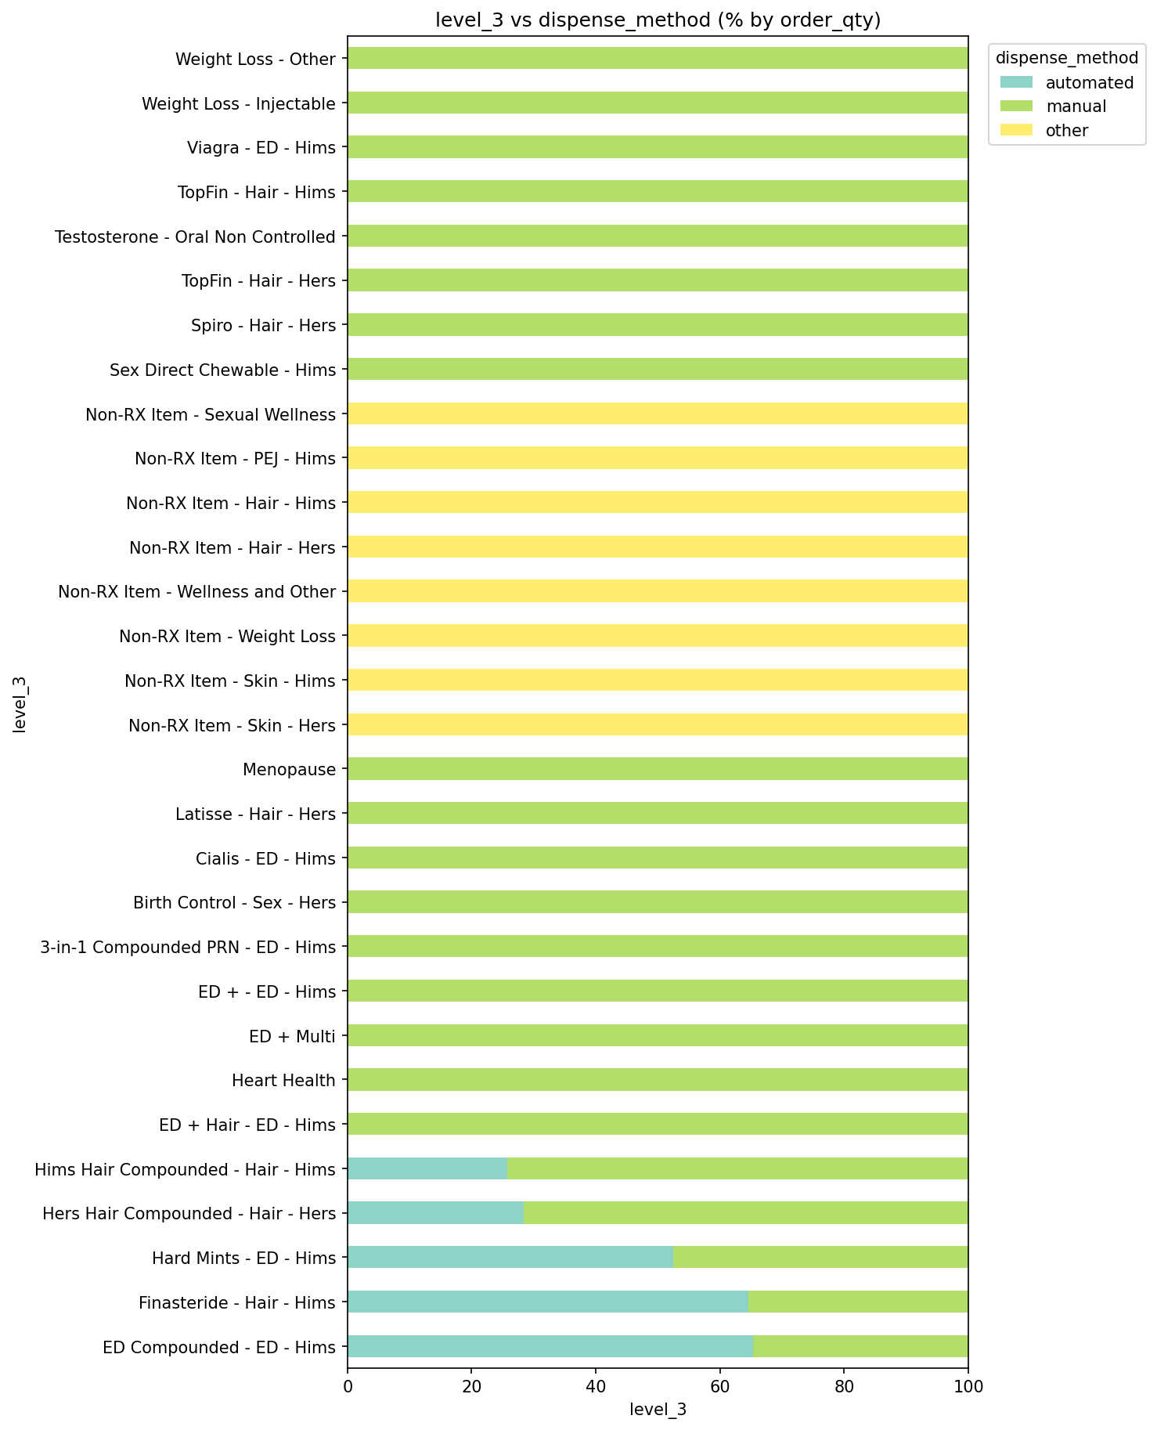
Level 3 distribution by dispense_method

Product Type vs Dispense Method
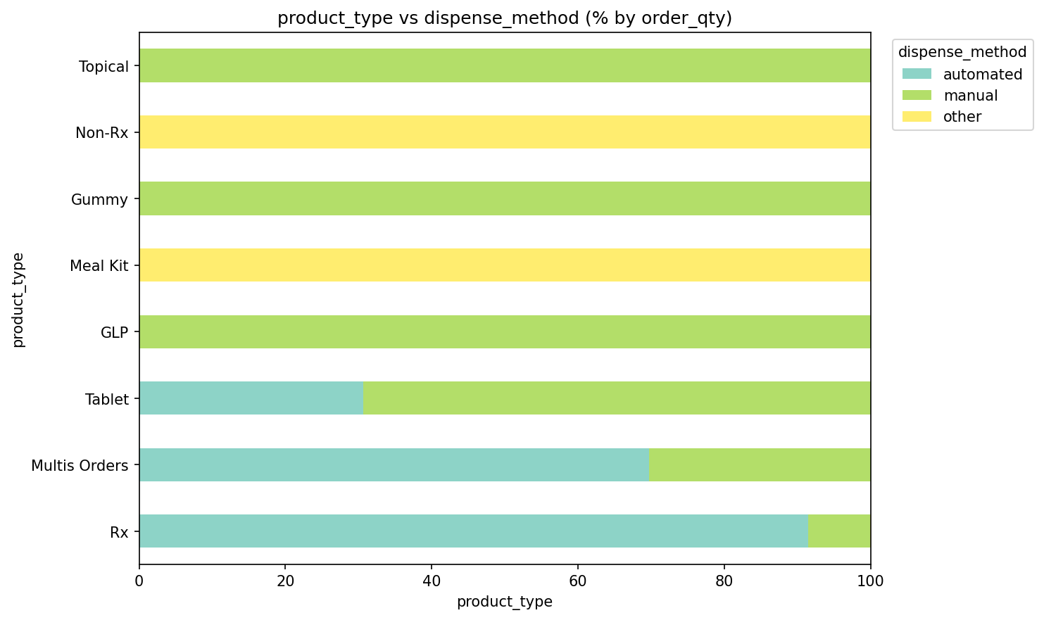
Product Type distribution by dispense_method

Unit Of Measure vs Dispense Method
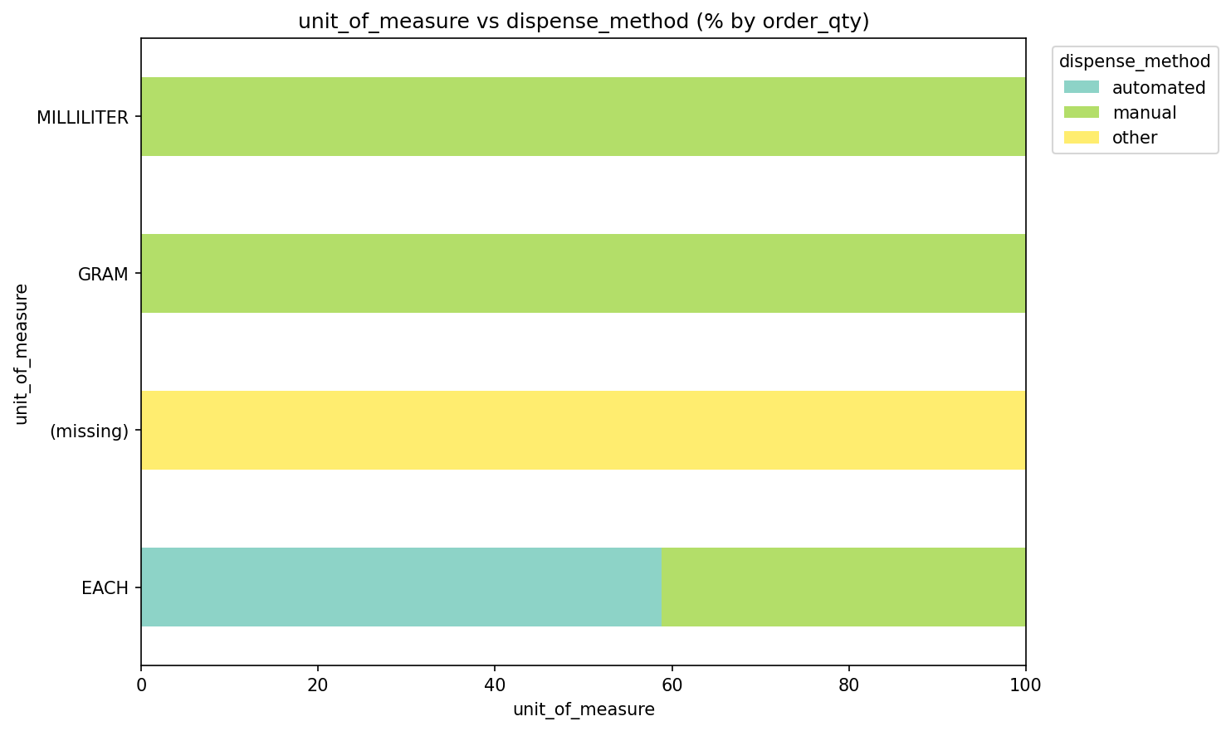
Unit Of Measure distribution by dispense_method

Wh Name vs Dispense Method
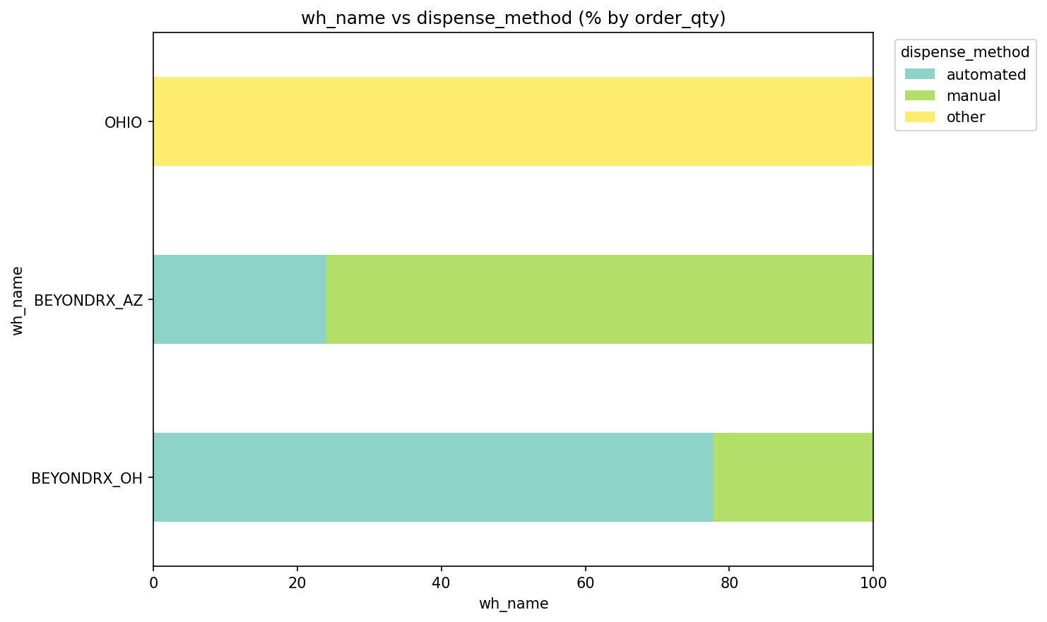
Wh Name distribution by dispense_method

2. Summary Statistics

Overall Dispense Method Summary
cut_dimension | dispense_method | fill_count | order_qty_sum | pct_of_total_fills | pct_of_total_order_qty
Overall | automated | 389265 | 38950899 | 57.07 | 52.81
Overall | manual | 292804 | 34707921 | 42.93 | 47.06
Overall | other | 0 | 95431 | 0.0 | 0.13

Summary by Product Type and Dispense Method
dimension | product_type | dispense_method | fill_count | order_qty_sum
product_type | GLP | manual | 9105 | 75970
product_type | Gummy | manual | 9940 | 1398420
product_type | Meal Kit | other | 0 | 3159
product_type | Multis Orders | automated | 58129 | 14114597
product_type | Multis Orders | manual | 36000 | 6125620
product_type | Non-Rx | other | 0 | 78717
product_type | Rx | automated | 261627 | 16786462
product_type | Rx | manual | 18830 | 1541224
product_type | Rx | other | 0 | 13555
product_type | Tablet | automated | 69509 | 8049840
product_type | Tablet | manual | 173924 | 18196947
product_type | Topical | manual | 45005 | 7369740

3. Distribution Analysis

Distribution by Product Type
dimension | product_type | dispense_method | fill_count | order_qty_sum | pct_within_product_type_by_fills | pct_within_product_type_by_order_qty
product_type | GLP | manual | 9105 | 75970 | 100.0 | 100.0
product_type | Gummy | manual | 9940 | 1398420 | 100.0 | 100.0
product_type | Meal Kit | other | 0 | 3159 |  | 100.0
product_type | Multis Orders | automated | 58129 | 14114597 | 61.75 | 69.74
product_type | Multis Orders | manual | 36000 | 6125620 | 38.25 | 30.26
product_type | Non-Rx | other | 0 | 78717 |  | 100.0
product_type | Rx | automated | 261627 | 16786462 | 93.29 | 91.52
product_type | Rx | manual | 18830 | 1541224 | 6.71 | 8.4
product_type | Rx | other | 0 | 13555 | 0.0 | 0.07
product_type | Tablet | automated | 69509 | 8049840 | 28.55 | 30.67
product_type | Tablet | manual | 173924 | 18196947 | 71.45 | 69.33
product_type | Topical | manual | 45005 | 7369740 | 100.0 | 100.0

Distribution by Warehouse (wh_name)
wh_name | dispense_method | fill_count | order_qty_sum | pct_within_wh_by_fills | pct_within_wh_by_order_qty
BEYONDRX_AZ | automated | 99510 | 8224605 | 32.04 | 24.05
BEYONDRX_AZ | manual | 211113 | 25962028 | 67.96 | 75.93
BEYONDRX_AZ | other | 0 | 5181 | 0.0 | 0.02
BEYONDRX_OH | automated | 289755 | 30726294 | 78.01 | 77.83
BEYONDRX_OH | manual | 81691 | 8745893 | 21.99 | 22.15
BEYONDRX_OH | other | 0 | 8374 | 0.0 | 0.02
OHIO | other | 0 | 81876 |  | 100.0

4. Next Steps
• Use selected features for prediction model training (04_prediction_training_data.sql)
• Implement Phase 1 lookup + rules for known (product_id, wh_name) pairs
• Optional: Build ML model (logistic or tree) using selected features

